Table of Contents
2)My E-Portofolio 2
3) Automatic Referencing Tool 2
Mendeley 2
Figure 1 Insert or Edit Citation 2
Figure 2 Select the citation from the Library 3
Zotero 3
Figure 3 Share the research. Figure 4 Sync the research 3
EndNote 4
Figure 5 The EndNote Application Desktop 4
4)Poster 4
Bibliography 4

2)My E-Portofolio

3) Automatic Referencing Tool

Mendeley

Mendeley, it’s a simple program to use that has a various range of journal styles that is available at your fingerprint. You can install the app from Web this is available for all software’s, or you can install the plug-in for Word or LibreOffice.
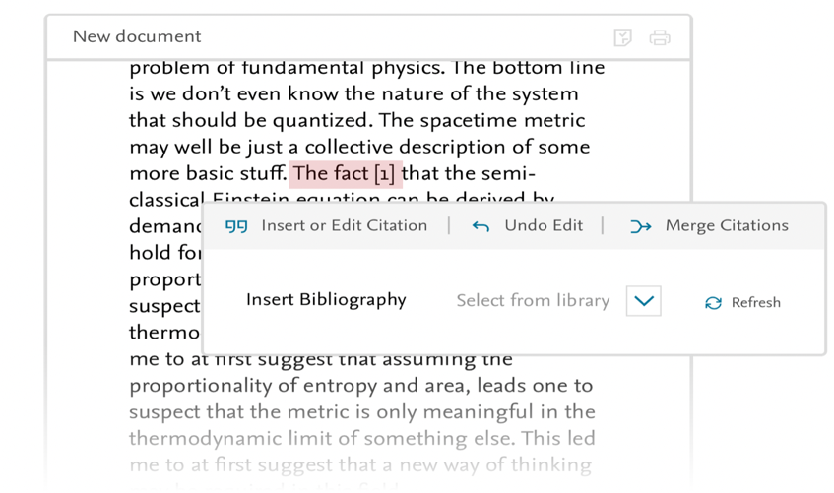
This program is free to use but you still need an account. If you’re using the Mendeley as a plug-in for Word, in the Reference tab, it’s situated the Mendeley Cite, after pressing it a new tab will open and requesting the user sign in.

Figure 1 Insert or Edit Citation
In the Mendeley Cite, you will now have the References with your library
and the citation style from where you can change the format for example to IEEE 2006 and the program will automatically format your references to it.

For inserting multiple citation into the Word document, you just need to tick the desired boxes.

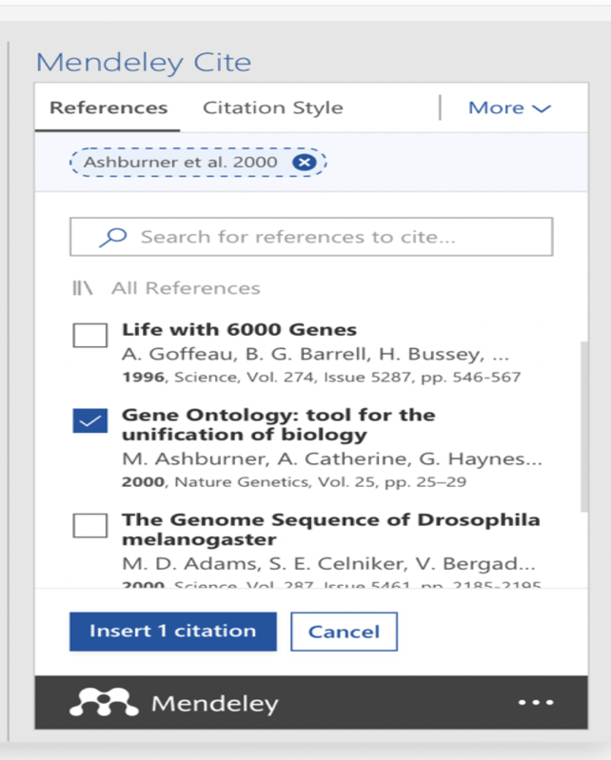
If you want to edit the citation from your library just move the cursor on the citation you want to edit and click to select it. In the edit panel you will see the citation and select the reference sphere you want to edit in the attributes panel. Inside the attributes panel you can add values to the reference or specific attributes, you can also eliminate the author from the reference.

Figure 2 Select the citation from the Library
If you want to Insert the Bibliography you will need to press the More button that will open a drop-down menu with the Insert Bibliography button.
The program will automatically detect the changes and save them therefore you don’t need to completely take it from zero. [1]

Zotero
Zotero application is also a free to use program for references that will help you to organize, cite, collect, and share research and is also available for all software’s. [2]
The best thing on this application is that you can collect from your browser the research and save it with just one click. You can organize the research with more tools, and you can find them easier in the library. If you will want to insert a citation, Zotero will create for you references and bibliographies, into  

Figure 3 Share the research. Figure 4 Sync the research

your work, in Word, Libre Office, and Google Docs.
Zotero, has over 9000 styles for you to choose the citation that matches with the publication. Zotero, also can sync all your work, if you decide to open it from another web browser.

EndNote
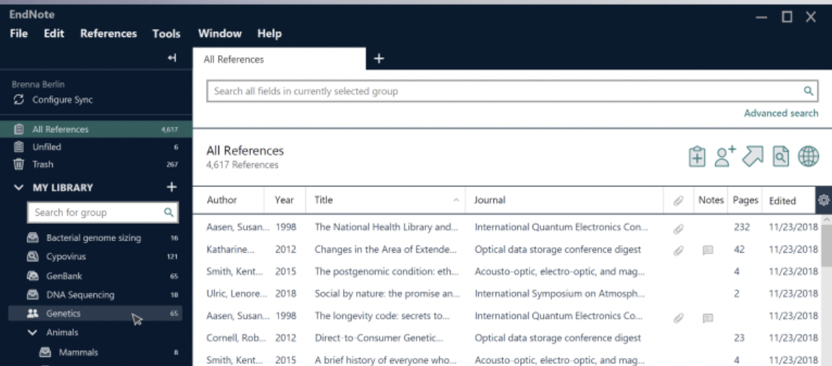

Figure 5 The EndNote Application Desktop
EndNote is a software that is designed to speed up you research, by searching from the online sources for references and PDFs, you will see the full text articles, you will have the option in the library to annotate, search, read and review. From the library you will organize the files how is more suitable for you, and to search faster.
EndNote is available for all the operating software’s, but if you want to run it from Word, you will have the option to insert in-text citation. The program has also more than 7000 styles for your own customized style. What is interesting in this application is that you will see the changes that another person is making on the file. [3]
These types of software’s are created to make our work easier with just one click.

4)Poster

Bibliography

[1] | "Free Reference Manager & Citation," [Online]. Available: https://www.mendeley.com/reference-management/mendeley-desktop. [Accessed 08 July 2021].
[2] | "Zotero | Your personal research assistant," [Online]. Available: https://www.zotero.org.
[3] | "EndNote | The best reference management tool," [Online]. Available: https://endnote.com. [Accessed 08 July 2021].

