

Faculty of Architecture, Computing and Engineering
School of Applied Computing

BSc Computer Networks
HND Computer Networks

IP Internetworking
M4X01123

Practical Lab Assessment
May 2015

Name :

Student ID :

Date & Time :

This is an individual practical lab-test, held under examination conditions. You will be assigned three Routers; you should configure these devices based on the given specifications.

This paper is marked out of 100.

You will have 2 hours to complete this task.

TOPOLOGY DIAGRAM

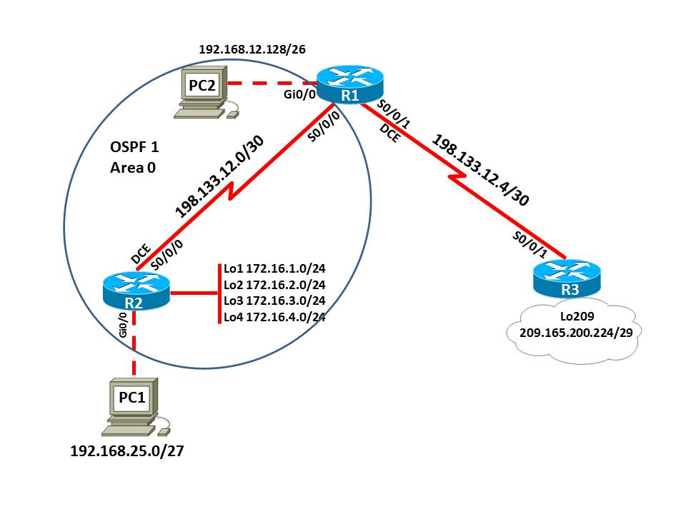

Task 1: Create an Addressing Scheme (15 marks)

Assign the first usable IP address of each subnet to each Router

Assign the last usable IP address of each subnet to each PC
Device | Interface | IP Address | Subnet Mask | Default Gateway
R1 | Gi0/0 |  |  | N/A
R1 | S0/0/0 |  |  | N/A
R1 | S0/0/1 |  |  | N/A
R2 | Lo1 |  |  | N/A
R2 | Lo2 |  |  | N/A
R2 | Lo3 |  |  | N/A
R2 | Lo4 |  |  | N/A
R2 | S0/0/0 |  |  | N/A
R2 | Gi0/0 |  |  | N/A
R3 | Lo209 |  |  | N/A
R3 | S0/0/1 |  |  | N/A
PC1
PC2
Task 2: Cable the network as shown in the topology. (10 marks)
Task 3: Basic Configuration. (20 marks)
Configure the R1, R2, and R3 according to the following guidelines:
- Configure the hostname.
- Disable DNS lookup.
- Configure an EXEC mode password.
- Configure a message-of-the-day banner.
- Configure a password for console connections.
- Configure synchronous logging.
- Configure a password for vty connections.
- Configure all interfaces with appropriate IP address.
- Configure line description.
Task 4: Configure Routing. (40 marks)
- Configure OSPF on R1 and R2 in the network and verify that routing tables are updated correctly.
- Configure R1 with router ID 1.1.1.1 and R2 with 2.2.2.2.
- Configure OSFP passive interfaces
- Configure the OSPF reference bandwidth to 1000 on routers R1 and R2.
- On Serial links between R1 and R2, set the bandwidth to 128Kb/s.
- Set the cost on the R1 WAN link to a value of 1 and R2 WAN link to a value of 150.
- Verify OSPF configurations that all networks are present in the routing table.
- Configure a static default route on R1 using next hop IP address.
- Propagate the default route on to OSPF.
- Configure static route on R3 to all the networks on R1 and R2.
- Verify that each router can see the static default route in their routing table.
Task 5: Verify Connectivity (15 marks)
Ping the loopback interface on the R3 router from:
Was PC1 successful? ___________
Was PC2 successful? ___________

Ping R2 Loopback interfaces from R3:
Was ping successful? ______________

If you are not successful, troubleshoot configurations using the appropriate show and debug commands.
Task 6: Document the Configurations
At the end of the test a flash memory will be given to you, the configuration files for all routers should be copied to the media and handed back to your invigilator. It is you responsibility that you copy the files correctly.
Issue the following commands on each Router and capture the configurations on to a text (.txt) file. All documentation for your solution should be submitted. Your name should be clearly printed on the documents. Save the file as devicename_surname_Pno.txt.
show run
sh ip int brief
sh ip route
sh ip ospf neighbor
sh ip ospf database

***************** End of Exam ******************

