

Policing domestic abuse: To what extent do police deal with domestic abuse investigations effectively?

Darcy Rees

Student ID: 2236662

BSc (Hons) Professional Policing Practice
Word Count: 8533

Declaration
This work has not previously been accepted in substance for any degree and is not being concurrently submitted in candidature for any degree.
Signed: Darcy Rees
Date: 6/10/2025

Statement 1:
This dissertation is being submitted in partial fulfilment of the requirements for the degree of BSc (Hons) Professional Policing Practice.
Signed: Darcy Rees
Date: 6/10/2025

Statement 2:
This dissertation is the result of my own independent work/investigation, except where otherwise stated.
Other sources are acknowledged by footnotes giving explicit references. A bibliography is appended.
Signed: Darcy Rees
Date: 6/10/2025

Statement 3:
I hereby give consent for my dissertation, if accepted, to be available for photocopying and for interlibrary loan, and for the title and summary to be made available to outside organisations.
Signed: Darcy Rees
Date: 6/10/2025

Statement 4:
I hereby give consent for my dissertation, if accepted, to be available on the university’s IT system to those who have consent to use the system.
Signed: Darcy Rees
Date: 6/10/2025

Acknowledgments
I would like to thank Jane Davies for leading this module of my degree and most importantly my Supervisor, Fay Cosgrove, for her exceptional support and dedication throughout the course of this dissertation process.
Finally, I would like to thank my family and friends for their never-ending kindness and encouragement throughout university. The time and help you all gave to ensure I could succeed is something I will forever be grateful for.

Abstract
Tackling domestic abuse (DA) in contemporary society has been an ongoing priority for Police Forces and Government in the UK. This dissertation explores the effectiveness of policing approaches when investigating DA, whilst acknowledging the sensitive and complex nature of such cases. This study begins with a comprehensive literature review which analyses existing research on UK policing practices, organisational challenges and how broad DA is. Primary research will be gathered through a quantitative approach will be used. Employees of Gwent Police were asked their views on officers' capability to investigate DA, the biggest challenges and recommendations for improving investigative practices. The analysis of collated data highlights thematic similarities such as the inconsistent ability to risk assess and variability of institutional training. The main findings from research reveal the insufficient use of protective measures, whilst officers balance case workloads and find time to gather evidence. This dissertation acknowledges the positive progression of new legislation related to DA. It concludes that systematic reforms are pivotal to improve investigative processes for both victims and police, recommended through revised risk assessment tools and specialist roles leading DA investigations. Overall, this research project advocates for a strengthened approach to police effectively investigating DA.

Table of Contents
Chapter 1: Introduction 7
1.1 Background 7
1.2 Research Rationale 8
1.3 Aims and Objectives 8
1.4 Research Structure 9
1.5 Conclusion 10
Chapter 2: Literature Review 11
2.1 Introduction 11
2.2 Recent History 11
2.3 Recommendations 13
2.4 Developing strategies 14
2.5 Conclusion 16
Chapter 3: Research Methodology 17
3.1 Introduction 17
3.2 Research onion 17
3.3 Philosophy of Research 18
3.4 Approach, Strategy and Choices 19
3.5 Time horizon 20
3.6 Techniques: Data collection and analysis 20
3.7 Limitations and ethical considerations 20
3.8 Conclusion 21
Chapter 4: Analysis of Data and Results 22
4.1 Introduction 22
4.2 Demographics and characteristics 22
4.3 Thematical Analysis from free text boxes 25
4.4 Conclusion 28
Chapter 5: Main Findings and Conclusion 29
5.1 Introduction 29
5.2 Accomplishment of objectives 29
5.3 Main findings 29
5.4 Limitations 31
5.5 Recommendations 31
5.6 Conclusion 32
Reference List 33
Appendices 37
Appendix 1: Blank Survey 37
Appendix 2: Responses to Survey 41
Appendix 3- Application for Ethical Approval 45
Appendix 4 – Research Proposal 45
Appendix 5 – Figure 1 45

Chapter 1: Introduction

1.1 Background
Domestic abuse (DA) continues to be one of the most pervasive demand drivers for policing and has become a national priority for police forces within the UK.
DA is defined within the Domestic Abuse Act 2021 (Gov Legislation, 2021) as-
- Behaviour of a person (“A”) towards another person (“B”) is “domestic abuse” if—
- A and B are each aged 16 or over and are personally connected to each other, and
- the behaviour is abusive.

(2) Behaviour is “abusive” if it consists of any of the following—
- physical or sexual;
- violent or threatening behaviour
- controlling or coercive behaviour;
- economic abuse
- psychological, emotional or other abuse.

An average of one million calls are made to police reporting DA annually, within England and Wales, with calls being made to police every 30 seconds reporting DA cases (ONS, 2024). The purpose of this dissertation is to critically assess the effectiveness of police forces' approach to investigating DA crimes. It is important to recognise the difference between an initial police response and a full investigation. Initial response policing often involves attending the scene of an incident, ensuring immediate safety and making efficient risk assessments (Maguire, 2012). An investigation within policing is a structured process. It carries depth by identifying and gathering evidence. This is a timely process which in a positive case leads to assembling a case file for prosecution.

1.2 Research Rationale
Despite being a priority for most forces, DA continues to rise, and 1 in 5 people are recorded as a victim of DA (Jacobs, 2025). The aim of this project is to explore how these investigations can be significantly impacted by organisational structure, officer training and resources available. Her Majesty's Inspectorate of Constabulary and Fire and Rescue Service (HMICFRS) highlighted the inconsistency across Police forces’ case handling, stating that there is a ‘chronic lack of funding’ and that the quality of DA investigations lacked (DA Commissioner, 2022). Understanding these inconsistencies is crucial to analyse how all forces follow the same legislation, however different departments manage DA investigations, ranging from DA specialist roles to frontline responders.
Understanding the increased proportion of DA investigations and the HMICFRS review has drawn this research project to gain an understanding of these variations and analyse officers' perception within the context of one specific police force. The relevance of this topic remains vital and feasible, with a substantial body of academic and statistical literature, including the Home Office, to support this project. Quantitative primary data will be analysed to gain an insight to Gwent Police employee’s perceptions and provide valuable context.
This dissertation therefore aims to answer a pivotal question relating to DA investigations: Are police forces meeting the national standard of expectation, and if not, what reforms are necessary to improve their effectiveness?

1.3 Aims and Objectives
The aim of this research project is to investigate and critically analyse the effectiveness of Gwent Police’ approach to investigating domestic abuse.

Objectives
- To critically analyse the proportion of domestic abuse and research how their cases should be handled effectively through recent literature.
- To establish a suitable research approach in order to gather and analyse data.
- To explore perspectives from individuals with different roles within Gwent Police and capture their recommendations. `

1.4 Research Structure
This dissertation will contain five chapters to achieve the objectives of this research project.
Chapter one introduces the nature of DA and briefly discuss the challenges faced within policing. It has also highlighted the objectives of this research goal which will be achieved in the following chapters.
Chapter two presents a review of existing literature covering the recent history of how DA investigations are handled and how factors such as time and resources available cause difficulty in case efficiency. It will analyse existing strategies that aim to improve the handling of DA investigations and identify a research gap which this dissertation aims to address.
Chapter three will present the research method and methodology by exploring the primary research techniques available. The chosen method will be applied through the collection of primary research.
Chapter four will analyse the data collected from the chosen method in chapter three. It will display results through pie charts and percentages. Open ended question answers will be interpreted by the researcher who aims to identify patterns and variations that are relevant to the dissertation research objectives.
Chapter five will be the final chapter that presents the main findings and provides a conclusion from analysed research and the review of this dissertation's aims and objectives. It will present limitations of this research project and provide recommendations for future research.

1.5 Conclusion
This first chapter has provided a background to the current legislation of DA and the standards expected to be held by police during DA investigations. It has also introduced the aim of this research project, and the objectives set to achieve. The next chapter will provide a review of literature focusing on the recent history of DA and the difficulties it presents.

Chapter 2: Literature Review

2.1 Introduction
This dissertation will examine whether creating a specialist domestic abuse (DA) department would be the most effective method of policing DA cases.
The aim of this chapter is to explore existing literature on the challenges encountered by officers when policing DA. It will examine research surrounding the effectiveness of training and resources provided to response officers. This dissertation will review literature which questions if officers are failing to recognise DA cases leading to inaccurate risk grading and safeguarding provided to victims of DA. It will present data of the volume of DA related incidents and crimes, and the pressures it puts upon police officers. Birdsall (2022) argues that police first responders should act as the ‘gatekeeper’ to DA investigations, and suggests they provide only an initial response. They recommend that specialists progress these cases. Gwent police do not have a specialist team to progress DA investigations, which leaves the question, what is the best to deal with DA investigations?

2.2 Recent History
Understanding DA can be challenging, as the Office of National Statistics (ONS) (2024) states that DA is not currently recognised as a specific offence making it difficult to understand what DA is. DA is currently defined by the Domestic Abuse Act 2021 as abusive behaviour in which the parties are personally connected and are both over the age of sixteen (Home Office, 2021). DA is not limited to physical violence: the behaviour described as ‘abusive’ includes, physical, sexual, threatening, economic, psychological, emotional or coercive and controlling. The ONS describe the difference between DA related incidents and a DA related crime. An incident of DA can range from a verbal altercation or controlling behaviours that do not meet the threshold to amount to any criminal offence. Alternatively, a DA related crime involves actions that lead to criminal consequences where an alleged offence is made out and an investigation is carried out, often leading to the arrest of a suspect. The ONS (2024) highlights the difference between DA related incidents and crimes, both having reflection on the demand this puts on police, with an estimate of 2.3 million DA victims in just England and Wales. Furthermore, 851,062 police reports of DA related crimes, with only 51,183 DA related prosecutions. The difference between these reports compared to the outcome of a prosecution highlights an immensely large gap where police are failing DA victims from start to finish, including police first response, evidence gathering and efficient case file submissions to the Crown Prosecution Service (Birdsall, 2022).
Despite the introduction of the Domestic Abuse Act in 2021, which marked a significant advancement in the policing of DA in the United Kingdom, there still remains uncertainty regarding the application of this legislation. The act broadened the scope of DA by enabling a more comprehensive definition and facilitating the prosecution of a wider range of DA-related offences, including those committed between British citizens abroad. However, as of 2025, uncertainty still persists regarding the need for additional legislative measures to address DA cases that may not align with the categories outlined in the Domestic Abuse Act 2021. Police officers continue to face challenges in progressing DA cases making it difficult to provide the best evidence, as the complexity of these situations often does not conform to the specific framework within current legislation. For example, under Section 76 of the Serious Crime Act 2015, coercive and controlling behaviour (CCB) is now recognised as a criminal offence that relies on evidence proving patterns of psychological manipulation instead of physical incidents. The ONS (2024) recorded 45310 police investigations into CCB within England and Wales between 2023-2024 and just 6% were convicted. This highlights the complexity of these cases that often do not conform to the specific framework within current legislation.
In 2021, HMIC published a report specific to how policing DA requires specialist knowledge and reviewed how investigations are managed (HMIC, 2021). The primary finding was that most police forces are still allocating DA cases based on the crime type and complexity, instead of the risk level of harm to the victim. Additionally, it found that the management of DA cases was a serious concern. It blamed the lack of specialised case workers within police forces and that each force does not take accountability for which department should be in charge of DA cases.

This recent history has collectively emphasised the need for specialist teams to effectively monitor ongoing cases, with accurate and regular risk assessments. This highlights the workload pressures, lack of training and resources supplied to UK police forces and recommends all forces to remodel resourcing of officer allocation to the different priorities of DA investigations, whilst acknowledging the budget challenges of each police force.

2.3 Recommendations
Davies (2024) acknowledges the complexities of domestic abuse cases in comparison to the lack of coordination from police dealings in cases. Davies argues mass funding is required, from analysing that the vast majority of police officers have stated in a survey they have felt extreme burnout, with the scrutiny towards their dealings with domestic abuse cases. The article highlights that the funding should be applied to training first responders, to allow them to recognise signs of abuse as they are expected to identify victims of domestic related crimes to prevent further offences to occur by expectation of the Home Office (2024). Police failures are represented as the main issue due to their lack of understanding of their responsibilities and the resources they need to adequately provide an effective police investigation and seek positive outcomes. She focuses on the need for systemic change and suggests that the training available is not adequate, describing it as generalised training when domestic abuse cases have individual complexities. She also highlights the issues affecting victims' relationship with police officers is that each encounter is often with a different officer, making it challenging for both victims and officers to build a rapport and uncover disclosures of incidents, which she states is a key role of a police officer to deal with domestic abuse cases effectively. However, she does not provide recommendations for how this funding will be sourced, utilised and how training is implemented to improve first responders' approach to deal with the estimated 2.2 million people who experienced domestic abuse in 2024 alone (Home Office, 2024).
Sebire (2016) wrote an article on the analysis of consistency of risk grading by police during domestic abuse investigations evaluates the reliability of risk assessments by police, despite certain models being introduced as a guide to risk grading. Sebire highlights there are grave concerns that there is a variability to each domestic case which has led to the article focusing on the issue that there is a pressing need to enforce more training and protocols to increase more precise risk assessments and provide a better outcome for victims. Her article relies upon the evaluation of the risk assessment tool suggesting that consistency could be improved by enforcing more training surrounding protocols.
The DASH is a tool that was sampled and deemed most appropriate when applying to every domestic related incident, made up of a 29-question checklist to help frontline workers to understand risks and pinpoint what support is needed (Turner, 2019). Depending on these answers, victims will fall within a category of standard, medium or high risk depending on the contributing and mitigating factors in their situation.
Sebire argues that the inconsistencies relate to how they are applied by officers. She suggests that officers personal experience, judgement and interpretation causes inaccurate gradings leading to a misled risk assessment. Not only does she highlight officers misuse, she suggests that reformation of the tool must be considered due to the categorisation being too limited, as the DASH is made up of just three categories of standard, medium and high risk, but poses the question, what does standard even mean? The article breaks down the DASH and how the questions are too generalised and rigid, even referring to it as a ‘tick box’ exercise rather than a meaningful assessment. Turner’s (2019) analysis agrees with Sebire, arguing that the DASH holds too much influence over officers’ perception of the risk, and that it is not fit for purpose as it is represented to outperform officers’ capability to understand the victim’s situation. Sebire argues that there is a need to create more of a victim centred approach, by clamping down on supervisor reviews and regular audits on the quality of use of the dash, as she also found that there is an organisational pressure when it comes to risk grading, including officers' response that they felt they shouldn’t grade an incident as high risk, due to lack of resources and workload volumes. As well as suggesting that not only is more training needed, but the training also already in place must be re-evaluated, to understand the complexity of each DA case to allow a consistent and accurate risk grading.

2.4 Developing strategies
These five articles are suggestive of recommendations based on analysis of police forces individual flaws, whereas the science and technology organisation for UK Policing for policing provide a practical recommendation to be developed and ‘user friendly’ for all forces. Rothwell (2024) focuses on the need for rehabilitation of policing systems when recognising the volume of domestic abuse in contemporary society. Her theory provides a strategy to utilise technology to reduce response times and create more efficient handling of cases including digital meetings with officers. Rothwell’s research has highlighted the reduction in time officers have spent completing written accounts of incidents and systems that provide more effective and efficient review of evidence. Thus, improving victim satisfaction, improved accessibility and time spent with victims and increasing positive outcomes of cases. Alternative to the Sebire (2016) and Davies (2024), Rothwell argues this method is general and simple, but effective and could benefit police response overall. This would suggest the pressure decrease to officers, allowing them to investigate cases more thoroughly and to be utilised by all policing roles, rather than just a specific team or department to tackle the mass volume of DA. However, the advanced technology is yet to be tested on a national scale, including the distribution and utilisation by all police forces.
College of Policing (2021) outlines that specialist domestic abuse roles are fundamental to provide the best service and ensure that officers are capable to safeguard, risk assess and thoroughly investigate domestic abuse. It highlights the volume of what is required from first responders, including recognition and understanding of offences, risk assessment, taking action and safeguarding. There is a vast expectation for first responders when it comes to domestic abuse, as well as their report explaining that police responders are most often the individuals who maintain the investigation, who are not in specialist DA roles, contrary to their recommendation that DA specialists are the pivotal role to improving efficient and effective attitudes and investigation work towards DA cases. This report does not highlight the regulations of each force including that not all police forces have specialist roles who participate in the investigation side of domestic abuse cases. It is hugely focused on the view that cases must be thoroughly investigated without demonstrating a clear strategy for how this will be implemented.
Walklate (2020) demonstrates the changes and continuities of policing DA, proposing a wide organisational and structure change. It acknowledges the variability of the volume of demand expected by police and suggests that forces do not prioritise and manage cases effectively. The author argues that police immediate responses are commendable, recognising the mass requirement that is expected from them, however, suggests that the lack of consistency in policing DA cases is rooted from outdated framework and structure from the organisation itself, opposed to individual officers’ responsibility. Walklate argues that alternative to the need for DA specialist teams, police forces should use proactive teams to use strategies to target known DA perpetrators in an attempt of using intervention for proactive, rather than response and reactive. The authors plead the need for systemic change to modernise procedures in place, such as repeat offenders being monitored better and for officers to conduct welfare checks at addresses where there is a history of DA, even if there are not live investigations or reports. Overall, the author argues that ‘short term fixes’ will not improve police response, and that change must be sought on an institutional level by reforming strategies already in place, instead of a utilising a DA specialist team, as she believes this would not be practical from a funding perspective and ownership of who would enforce this to all current UK police forces.

2.5 Conclusion
Research clearly suggests that UK police forces are failing at every stage of DA case dealing, including the emphasis on first responders lack of understanding and accurate risk grading, leading to incompetent longer-term investigations, passed the initial contact. This review has also demonstrated how the root cause may also be the outdated and generalised legislation, suggesting that it is responsible for misinterpretation of the complexity around DA and setting a precedence for police officers that each victim must fit within a certain rigid category, instead of acknowledging the risk to them. Resourcing and inadequate training appears to be highlighted by most authors to improve how DA cases are handled, from beginning to end. Additionally, policing attitudes and morale towards DA are to be held accountable for cases that do not meet the highest risk threshold. Both Sebire and Davies demonstrate this through their argument that training is fundamental and that restructure within policing is vital. Sebire argued that supervision and remodelling of the tools that are already in place. Davies argues that lack of rapport between victims and police leads to misjudgement of risk and severity, whilst Sebire finds inconsistency from officers as an organisational issue opposed to rapport building.

Chapter 3: Research Methodology

3.1 Introduction
This chapter will define the components of research methods and explain how the research will be carried out. The research process will be explained based on the objectives to explore perspectives of specialist domestic abuse (DA) roles and the volume of DA investigations. The purpose of the research will explore Gwent police employee views of the volume of requirements for DA investigations and whether victims’ needs are fulfilled. This chapter will also explore the research considerations and limitations throughout.
Primary research is new data collected by the researcher themself, which provides first-hand information from a specific question. Primary research involves the use of observational methods, surveys, interviews or experiments (Hox, 2005). Secondary research relates to data that has been collected by others. This includes statistics, literature, books and articles which are used to support beliefs and analyse topics that haven't been discussed (Hox, 2005). Collecting data can be carried out through quantitative and qualitative research. Qualitative research uses open ended questions which provide detailed answers to be able to analyse experiences often conducted through interviews. Alternatively quantitative research involves the use of closed ended questions and numerical data (Sheard, 2018).

3.2 Research onion
The ‘research onion’ is a systematic tool utilised to guide researchers navigate their choices of research methods and used comprehensively by being broken down into stages to consider and understand whilst decision making their research (Saunders, Lewis and Thornhill, 2009). The research onion is demonstrated through a chart containing the outer layer which is considered to be the starting point for researchers leading to the inner layers. Each layer’s section is categorised from philosophy approaches, strategies, choices and time horizons which will lead to the inner layer of embedding techniques and procedures which will allow data collection and analysis. The visualised version will be presented below.
Figure 1: The Research Onion (Saunders, Lewis and Thornhill, 2009)
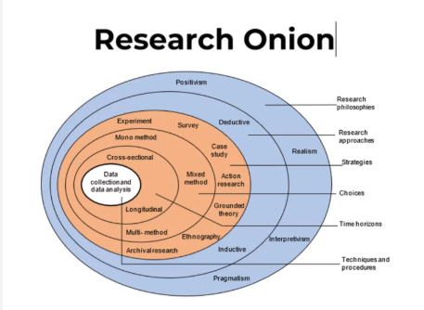

3.3 Philosophy of Research
Research philosophy shapes the understanding of finding research, by using knowledge, views and beliefs to choose which research methods are best suited (Priest, 2009). The diagram shows the four main philosophies as positivism, realism, interpretivism and pragmatism.
Positivism and realism relate to using quantitative research due to the belief in using objective data and real observations (Crossan, 2003). Interpretivism is a contrast to positivism, as is described by Crossan (2003) as ‘subjective’ as the researcher will gather their interpretation from values, beliefs and experiences. The researcher will commonly obtain this using qualitative research with the aim to obtain richness in their collected data, such as partaking interviews with research participants (Junjie and Yingxin, 2022). Pragmatism relates to the use of mixed methods as it can combine both positivism and interpretivism by understanding that flexibility is fundamental to understand ‘the bigger picture’ and can be utilised through qualitative or quantitative research (Saunders, Lewis and Thornhill, 2009). An interpretivist approach will be used in this dissertation to gather serving police officer and staff views and personal experiences which will then be analysed by the researcher.

3.4 Approach, Strategy and Choices
Deductive and inductive are the two approaches that can be adopted by the researcher. The deductive research approach relates to testing existing theories by also using new data to determine the reliability of theories in place (Tshitadi, 2024). In comparison, an inductive research approach focuses on creating new theories based on new observations or knowledge (Tshitadi, 2024). This study will use the inductive approach to build upon existing knowledge.
This study aims to analyse police employees’ opinions on whether response officers are fully equipped with adequate training and time to conduct DA investigations. The analysis aims to discover staff and officers personal experience, allowing the comparison of staff observing case handlings and officers who are in charge of the cases.

The researcher will choose a survey method to gather data as a mono-method research approach. This will be the most appropriate choice to collect numerical data along with including open ended questions to obtain a broadened analysis of responses. Using a survey will allow the research to gather wider perspectives from a greater number of participants rather than a qualitative approach like interviews. Using a survey will facilitate generalised findings providing the sample is representative of the population. Invitations to participate will be disseminated to police officers and staff via an internal police platform. The survey will be of digital format which is known to be user friendly (Uhlig, 2014) which will improve the opportunity to gain the maximum number of responses to the survey, as opposed to paper surveys. Online surveys automatically collate the data which is more efficient for the researcher. The survey will include both open and closed questions to obtain a balance of measurability and depth. Closed questions, with multiple choice options will achieve quantitative analysis and standardised responses. Around 2-3 open questions will be included within the survey to capture the participants' opinions and experiences in their own words. A blank copy of the survey can be found in the appendix which will be unanswered.

3.5 Time horizon
The research onion refers to the time horizon which is a decision of whether a longitudinal or cross-sectional time frame is used. Longitudinal research is a continuation of data collection obtained over a substantive period of time (Rindfleisch, 2008). Cross-sectional is a shorter term of research gathering (Rindfleisch, 2008) which is the chosen method this researcher will utilise by gathering data at one specific time and has a deadline of completion.

3.6 Techniques: Data collection and analysis
The results will be analysed through use of pie charts or graphs, and the researcher will ensure to use a reliable secure platform to ensure raw data can be accessed if necessary. The aim is to gather 60 responses, which will be made up of 20 responses from the three target departments: Response, Crime investigation and domestic abuse safeguarding team within Gwent Police.

3.7 Limitations and ethical considerations
A limitation that may occur is that the target response size is not achieved. Out of the 43 forces in England and Wales, Gwent Police is one of the smallest forces (HMICFRS, 2025) meaning the target audience is of a smaller size and may not be truly representative to views and opinions of all police officers/staff. Additionally, individual work commitments could lead to incomplete surveys within the expected time horizon. If the target sample is not achieved, follow up and direct emails will be sent internally to high-ranking roles such as sergeants, who manage a team of individuals and can disseminate it in this format.

3.8 Conclusion
This chapter analyses the methodology of research through using the research onion. This tool has assisted in deciding the method of a survey. The chosen methods will be used in the next chapter to analyse collected data.

Chapter 4: Analysis of Data and Results

4.1 Introduction
The purpose of this chapter is to utilise the primary research gathered and analyse it. Data analysis is the transformation of collected data to provide a representation of similar patterns and anomalies through quantitative and qualitative responses to questions (Brandt, 1998). This chapter will focus on analysing the questions asked in the survey by comparing the views of employees in different roles. The previous chapter of methodology outlines how a mono-method research approach will be used. The analyses of quantitative data which has been collected through numerical responses and qualitative data which was collected in free text boxes. This chapter will also achieve objective one and two, to evaluate and explore police employees' perspectives and any recommendations suggested towards the approach of policing DA. The survey was sent via email and teams to colleagues however this only reached 50% of the targeted sample size. Additional methods were used to increase the sample size through direct and follow up contact.

4.2 Demographics and characteristics
Participants were categorised through their gender, length of service, current department and role. The question of gender felt necessary for the researcher to observe whether gender affected the survey results. 50 responses were received from a nearly equal 50% of male, 46% female and 4% who preferred not to say. However, due to the majority of participants being from the response department, the researcher is unable to comment or draw analysis of comparison form each department. Next time, the researcher would limit the respondents to be more of an equal split between each department, for more representative results.

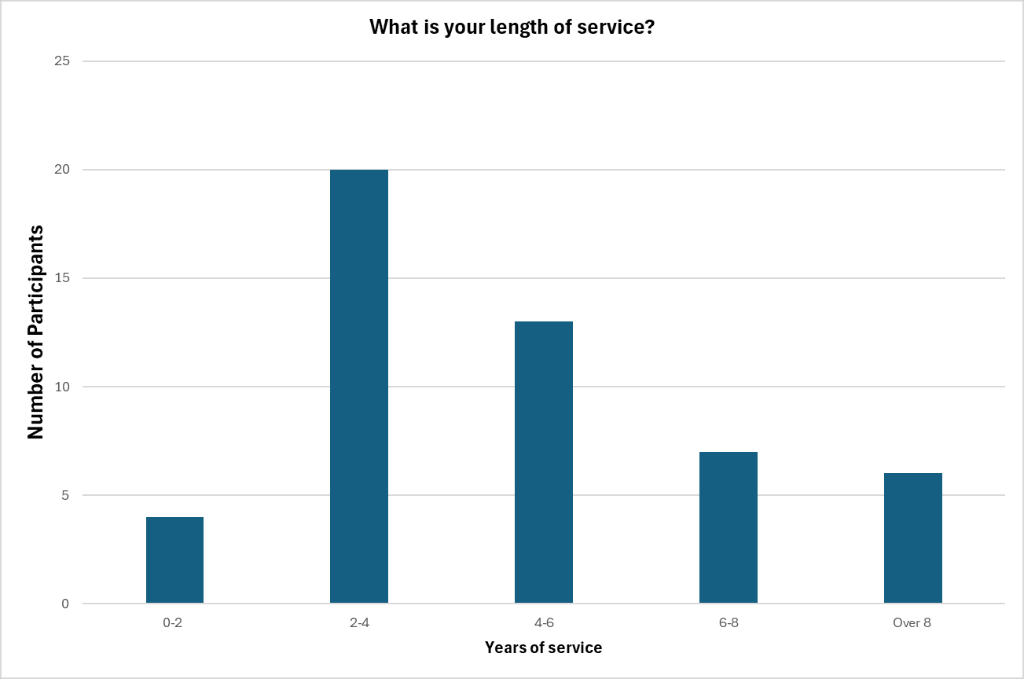

The question of participants' department and role was asked so the researcher could understand perspectives from front line officers, domestic abuse safeguarding team (DAST) and specialist roles in the crime investigation department. The difference between the roles of police officers and police staff is that officers' duty is to enforce criminal law and have legislative powers to carry out criminal investigations. Police staff are civilians who have specialist roles within certain departments that often include safeguarding and administrative purposes (Dick, 2021). They do not have policing powers and do not carry out police investigations. 82% of respondents were police constables in the response department, suggesting that any common threads identified were from those who respond to immediate call outs and retain most cases for the investigation process. Although only 4 respondents are police staff, results show that each of these participants stated that there is specific training for DA, and that response officers are overrun with call demand and the volume of crime. 100% of the police staff responses felt that Gwent Police should invest in creating a DA specialist team to improve victim service and efficiency of investigations. One of those respondents also noted the significant risk in domestic abuse cases of reoffending and how better case handling could prevent DA survivors from becoming repeat victims.
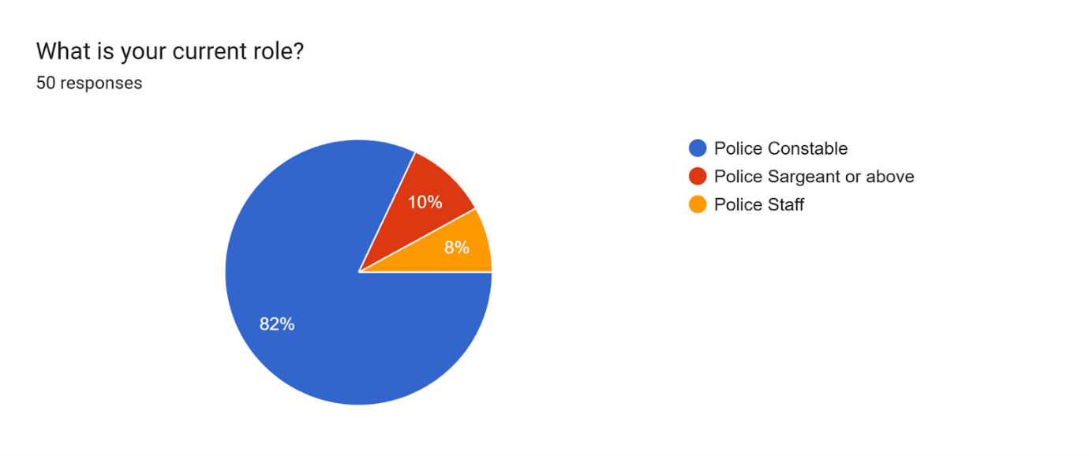

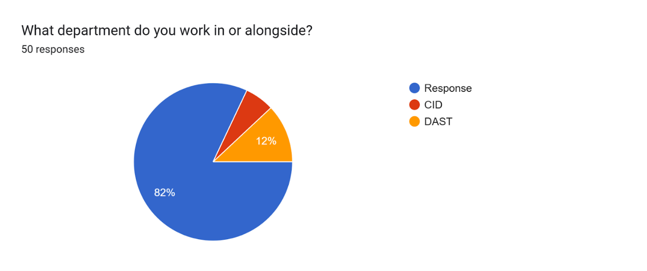

4.3 Thematical Analysis from free text boxes
What do you think are the biggest challenges when carrying out DA investigations?
The results of this question highlighted common themes of ineffective policing of DA including lack of time due to daily demand, a high volume of investigations to manage at one time and a lack of investigative training around the convolutions of DA. Most responses explaining the ‘pressure’ this would take off the response department, as they deal with regular call outs as well as managing ongoing investigations. Many responses highlight the complexity of DA and how it is not possible to be managed the same as lower risk crimes such as shoplifting. They describe that the lack of time and resources is what is responsible for ineffective policing of DA however, some participants feel Gwent Police force’ priorities are misplaced by senior management, as they focus on statistical outcome and rapid response to call outs rather than the operational reality of managing victims and cases throughout the entirety of the investigation. However, one respondent highlighted the Domestic abuse, stalking and harassment risk assessment tool (DASH) as the biggest issue. They stated that it is ‘overused and undervalued’ as it is used in any incident or crime, and covers a broad category of relationships, including any current or previous family member, partner or their family members. Respondents also highlight that the lack of training and effective use of the DASH tool are a main contributing factor to inaccurate risk assessments. This is similar to literature founded by Turner (2019) who argues that the DASH tool is not fit for purpose or represents accurate risk assessment by fitting each DA victim within one of three risk categories: standard, medium or high risk.

What recommendations (if any) would you suggest to improve Gwent Police' approach to handling DA investigations?
Out of the 50 responses, 18 respondents suggested the need for a DA specialist team would benefit Gwent Police’ ability to effectively investigate DA. Similar to Rothwell (2024), the majority of participants' responses explain that time is the biggest challenge. Rothwell suggested that police systems should be restructured, in comparison to participants' suggestion that either there is an uplift in recruitment of officers or that officers should be allowed protected time from being dispatched to live incidents.

Should Gwent Police form a specialist department to carry out DA investigations?
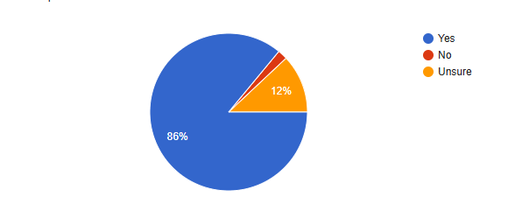

Out of 50 responses, just 1 respondent voted that Gwent Police should not invest in a specialist team for DA. In the follow up question of ‘Why or Why not?’ The same respondents opinion is that Gwent police is already divided into too many teams, with the suggestion this would overcomplicate the management of DA cases, and highlights that all officers, regardless of their role, should be proficient in investigating DA. Analysis shows that this respondent, is a male police constable, based on the CID department and has over 8 years of experience, suggesting his perspective is likely influenced by their knowledge and extensive length of service as they have dealt with a higher volume of DA cases. Overall, this respondent's answers demonstrate a less challenging experience when dealing with DA, as he states he never carries more than 3 DA investigations at one time and finds it ‘somewhat easy’ to make time to update their victims. However, in the final question of any additional comments to add he does state that Gwent Police could improve DA case handling by referring victims to specialist DA services.
43 out of 50 respondents stated that it would. The respondents were made up of 36 from the response department, 2 from CID and 5 from DAST. The majority of the 86% of respondents who suggested the need for a DA specialist team stated that the title of response officers is contradictory to their operational duties. The participant responses within this percentage were evenly split between male and female. Common conceptions were identified that consistency lacked on a case-by-case basis, similar to the HMICFRS review of policing (2021). However, the HMICFRS suggested that it varied from force to force, without the inspection of inconsistencies within just one police force. Participants suggested that protected time, extra resourcing and specialist knowledge around the complexity of DA cases is impossible to manage effectively whilst attending emergency incidents and being the first responders of every other type of incident reported to police.

6 of respondents selected that they were unsure whether a specialist team should be utilised, 5 participants being constables on response and 1 being within DAST. They share a common response with the majority of respondents who answered that a DA team should be implemented, that time and resourcing is responsible for ineffective policing of DA investigations. However, they highlight the impracticalities of having enough resources to form a DA specialist team. One of these respondents also expressed the importance of rapport building during DA cases, and to pass the case to a specialist team instead of the attending officer can inhibit rapport developments.

Is there anything else you would like to say about Gwent Police' approach to handling DA investigations?
This stage of the research has shown that DA is a huge topic of interest and employees are motivated to improve the situation. 23 of 50 responses chose to make a comment within the optional final question. The majority highlighted the pressure and scrutiny of dealing with DA investigations, efficiently and with wide knowledge around its complexities, however participants have stressed that they simply do not have enough time to fulfil what is expected of them, in line with government guidelines, force policy and stages of investigation. The common theme highlighted being completion of statements and the time duration of paperwork such as gathering the evidence into a file to send to the Crown Prosecution Service. Respondents have stated that police are not providing victims with enough support as they state that Gwent Police’ main priority is focusing on live demand and initial attendance to incidents, causing a delay in the evidence collection for investigations.

4.4 Conclusion
To conclude, this study has analysed the data collected which highlights the common perception that improvements are needed in the policing of DA cases. Participants responses have shown that the main challenges are contributed by lack of time, training and low staffing and resource levels. This chapter has demonstrated that for improvements and restructure to be made, additional training and resources must be attained. It has shown that most participants share the same beliefs and opinions that Gwent Police are failing to manage DA investigations efficiently and consistently.

Chapter 5: Main Findings and Conclusion

5.1 Introduction
The previous chapter analysed primary research gathered from participants within Gwent Police. The purpose of this chapter is to present key findings from gathered data and discuss the achievement of this dissertation's objectives, whilst drawing to conclusions from this research project. This chapter will also include recommendations for future research and suggestions for operational practices within policing.

5.2 Accomplishment of objectives
The first objective was achieved within the literature review as the researcher studied existing literature surrounding the volume of DA investigations and call outs, requirements and expectation of policing DA effectively.
Objective two was achieved when primary research was gathered through the selection of a survey research approach as the most appropriate method to gather data.
This chapter aims to achieve objective three; to provide recommendations collated from the analysis of primary research.

5.3 Main findings
The opinions of Gwent police staff and officers have been explored through primary research with the overall objective of to what extent these police force deals with DA investigations effectively.
Participants were asked what the biggest challenges were for policing domestic abuse, with common opinions being that there is a lack of adequate training, time and specialist knowledge required for policing DA. These findings from the primary research are consistent with the themes identified within the literature review, specially Sebire (2016) and Turner (2019) who express concerns for current risk assessment tools and how they are unable to be used effectively. Analysis of primary research from participants' responses highlighted the need for additional training, alternative to the literature found from Sebire and Turner who suggest that training that is already in place needs re-evaluating, in order to change officers' perception towards investigating DA. This includes enquiries such as victim statement training and adapting case file building for investigations that reach court, so that they are more user friendly and efficient.
As Walklate (2020) suggested that a DA specialist team would be impractical and unnecessary, the researcher wished to investigate this further by asking whether research participants thought that Gwent Police would benefit from creating a DA specialist team. 86% of participants stated that it would. The respondents were made up of 36 from the response department, 2 from CID and 5 from DAST. A recurring theme through primary research reviewed suggested that a specialist DA investigation team would benefit Gwent Police in situations being handled more sensitively, efficiently, and with greater knowledge. Participants justification for this was that members of this team would solely focus on policing DA, reducing demand on frontline officers, and providing victims with the best service as duration of DA cases would reduce and specialists would be well informed of current changes in legislation and policies. This finding highlights how officers are having difficulty utilising the current policies and procedures in place for investigating DA effectively. It also provides potential further research which will be recommended within this final chapter.
This research project has found that often sources go into depth about how training is not adequate enough, however, the success and need for a domestic abuse specialist team is not discussed. Therefore, I will use this existing literature as well as my research to explain how this may be an effective method of policing DA cases.
Overall, the creation of a team of specialist Gwent Police officers and staff is likely to improve the policing approach to DA. This finding has been concluded from the suggestions of improvement needed from literature and pressure that officers face as well as the primary research findings that time, resources and knowledge skills could be effectively invested into the creation of a specialist DA department.

5.4 Limitations
The duration of this study has been limited by dissertation deadlines. This researcher has managed the project completion alongside working full time as a frontline response police officer meaning that shift work has been difficult to balance in a timely manner. This researcher's original plans compared to the practicality of completing the research project within the timeframe were not aligned as the researcher had planned to complete interviews with research participants. This felt more suitable due to the sensitivity of the chosen topic of DA, however full-time shift work limited the feasibility of this research approach.
A limitation was the project size. This researcher could have explored other areas such as legislation and sentencing around DA, and charging decisions and guidelines set by the Crown Prosecution Service. However, the overall and chapter word count has left the researcher with restrictions in examining additional areas that may contribute to the overall effectiveness of investigating DA, such as the evidential difficulties and Crown Prosecution Service threshold for charging a subject of DA.
It is also likely that there is an unknown population of the policing community that isn't fully represented through the primary research. The chosen method of a survey meant that participation was voluntary and dependent on self-selection, suggesting that findings do not fully reflect policing perspectives within the entire of the UK.

5.5 Recommendations
For researchers interested in the topic of police investigations of DA, a recommendation would be to repeat qualitative primary research with a larger sample, as previously stated Gwent Police is one of the smallest forces within England and Wales, data may be considered to be less representative of the wider community of policing. A recommendation would include targeting multiple police forces in England and Wales to overcome this. With dissertation deadlines, the researcher could choose an alternative research method in order to obtain qualitative and rich data. They could do this by addressing a much smaller sample size and carry out interviews with around 2-3 participants.
A recommendation is proposed for deep research into scenario-based training and the transition and comparison of old to new policies. The literature review and primary research has been similar in the suggestion for improved police training and knowledge surrounding the sensitivity and complexity of DA. This dissertation has acknowledged police officers' attitudes when dealing with DA, within the literature review however has not examined what practical changes are implemented by policing bodies.

5.6 Conclusion
Existing literature has highlighted that there is a need for new and reformed approaches to policing DA investigations. The research has shown how police officers are aware of the importance of effectively investigating DA. This project has highlighted the reality and practicality of policing DA; from understanding and proving its complexities, to officers contending with high operational demands, expectations and low staffing. This researcher has acknowledged participants' views on how the majority of DA investigations are handled by front line response police officers who are faced with highly intense demands on a daily basis. This project has found that there is limited existing research on what the achievable outcome would be to improving the acknowledged challenges in investigating DA, however majority of participating police officers and staff, despite their department or role believe that a specialist team of professional policing roles should be implemented within Gwent Police to overcome the issues of efficiency, victim and risk management.
The police response to investigating DA remains under constant examination, with regular evaluation of its effectiveness. The ongoing assessments are fundamental to ensuring the protection and satisfaction of DA victims, while seeking justice of the accused. Future research is invited and vital so that policing policies and procedures can develop and be fully understood.

Reference List

- Birdsall, N. and Boulton, L., 2022. Theorising victim decision making in the police response to domestic abuse. International Review of Victimology, 28(3), pp.330-344

- Brandt, S. and Brandt, S., 1998. Data analysis. Springer-Verlag.

- College of Policing (2021). The role of domestic abuse specialists in supporting investigation and incident management. [online] College of Policing. Available at: https://www.college.police.uk/app/major-investigation-and-public-protection/domestic-abuse/role-domestic-abuse-specialists-supporting-investigation-and-incident-management [Accessed 1 Feb. 2025].

- Crossan, F., 2003. Research philosophy: towards an understanding. Nurse Researcher (through 2013), 11(1)

- Davies, P. and Barlow, C.F., 2024. Policing domestic abuse: the onus on first responders. Policing and society, 34(7), pp.627-640.

- Dick, G. and Metcalfe, B., 2001. Managerial factors and organisational commitment‐A comparative study of police officers and civilian staff. International journal of public sector management, 14(2), pp.111-128.

- Domestic Abuse Commissioner (2022). Exclusive new mapping data reveals a postcode lottery and patchwork of provision. [online] Domestic Abuse Commissioner. Available at: https://domesticabusecommissioner.uk/exclusive-new-mapping-data-reveals-a-postcode-lottery-and-patchwork-of-provision/ [Accessed 9 Sep. 2025].

- Gov Legislation (2021). Domestic Abuse Act 2021. [online] Legislation.gov.uk. Available at: https://www.legislation.gov.uk/ukpga/2021/17/part/1/enacted [Accessed 9 Sep. 2025].
- His Majesty’s Inspectorate of Constabulary and Fire & Rescue Services (HMICFRS). (2025). Gwent. [online] Available at: https://hmicfrs.justiceinspectorates.gov.uk/police-forces/gwent/ [Accessed 26 May 2025].

- HMICFRS (2021). Interim report: Inspection into how effectively the police engage with women and girls. [online] His Majesty’s Inspectorate of Constabulary and Fire & Rescue Services. Available at: https://hmicfrs.justiceinspectorates.gov.uk/publication-html/interim-report-inspection-into-how-effectively-the-police-engage-with-women-and-girls/ [Accessed 18 Feb. 2025].
- Home Office (2021). Domestic Abuse Act 2021. [online] Legislation.gov.uk. Available at: https://www.legislation.gov.uk/ukpga/2021/17/part/1 [Accessed 8 Apr. 2025].
- Home Office (2024). New Measures Set out to Combat Violence against Women and Girls. [online] GOV.UK. Available at: https://www.gov.uk/government/news/new-measures-set-out-to-combat-violence-against-women-and-girls [Accessed 18 Feb. 2025].
- Hox, J.J. and Boeije, H.R., 2005. Data collection, primary vs. secondary. Encyclopedia of social measurement, 1(1), pp.593-599.
- Junjie, M. and Yingxin, M., 2022. The Discussions of Positivism and Interpretivism. Online Submission, 4(1),
- Maguire, M., 2012. Criminal investigation and crime control. In Handbook of policing (pp. 430-464). Willan.
- Office for National Statistics (2024). Domestic Abuse in England and Wales Overview. [online] Office for National Statistics. Available at: https://www.ons.gov.uk/peoplepopulationandcommunity/crimeandjustice/bulletins/domesticabuseinenglandandwalesoverview/november2024 [Accessed 19 Feb. 2025].
- ONS (2024). Domestic abuse prevalence and trends, England and Wales. [online] Ons.gov.uk. Available at: https://www.ons.gov.uk/peoplepopulationandcommunity/crimeandjustice/articles/domesticabuseprevalenceandtrendsenglandandwales/yearendingmarch2024. [Accessed 8 Apr. 2025].
- Priest, G., 2006. What is philosophy? Philosophy, 81(2), pp.189-207.
- Rindfleisch, A., Malter, A.J., Ganesan, S. and Moorman, C., 2008. Cross-sectional versus longitudinal survey research: Concepts, findings, and guidelines. Journal of marketing research, 45(3), pp.261-279
- Rothwell, S. (2024). Delivering Justice for Victims of Domestic Violence. [online] Police.uk. Available at: https://science.police.uk/delivery/case-studies/delivering-justice-for-victims-of-domestic-violence/. [Accessed 20 Feb. 2025].
- Saunders, M., Lewis, P. and Thornhill, A., 2009. Research methods for business students. Pearson education.
- Sheard, J., 2018. Quantitative data analysis. Research Methods: Information, Systems, and Contexts, pp.429-452.
- Tshitadi, N. (2024). Understanding the Research Onion (Saunders et al., 2015) - Nephsonic. [online] Nephsonic. Available at: https://nephsonic.com/understanding-the-research-onion-by-saunders-et-al-2016-a-comprehensive-guide-for-writing-an-effective-research-methodology-chapter/ [Accessed 10 May 2025].
- Turner, E., Medina, J. and Brown, G., 2019. Dashing hopes? The predictive accuracy of domestic abuse risk assessment by police. The British journal of criminology, 59(5), pp.1013-1034.
- Uhlig, C.E., Seitz, B., Eter, N., Promesberger, J. and Busse, H., 2014. Efficiencies of Internet-based digital and paper-based scientific surveys and the estimated costs and time for different-sized cohorts. Plos one, 9(10), p.e108441.
- Walklate, S., Godfrey, B. and Richardson, J. (2021). Changes and Continuities in Police Responses to Domestic Abuse in England and Wales during the Covid-19 ‘Lockdown’. Policing and Society, [online] 32(2), pp.1–13. Available at: https://www.tandfonline.com/doi/full/10.1080/10439463.2021.1896514 [Accessed 18 Feb. 2025].

Appendices

Appendix 1: Blank Survey
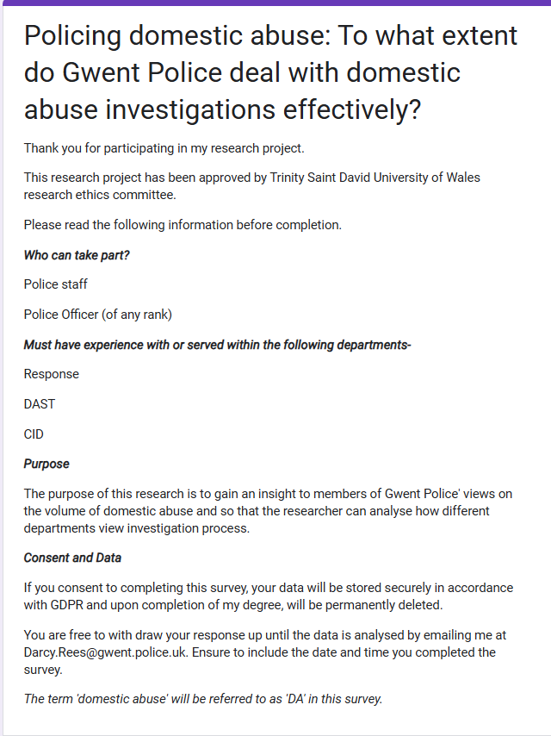

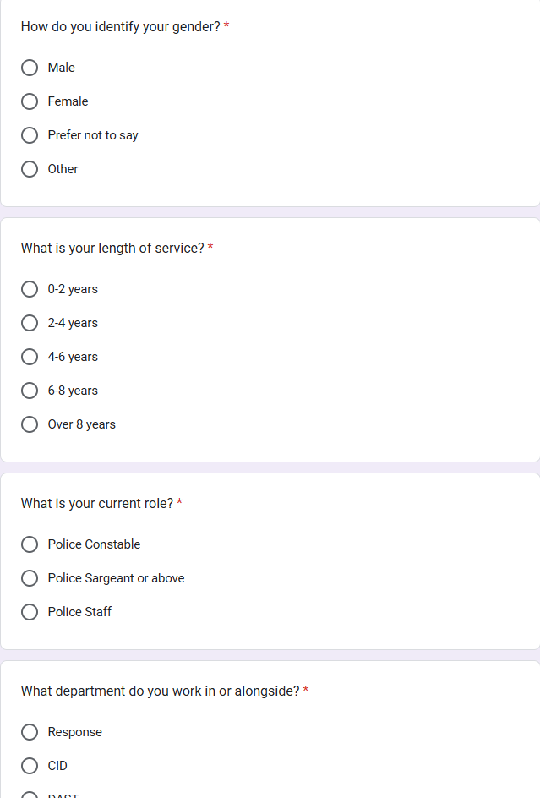
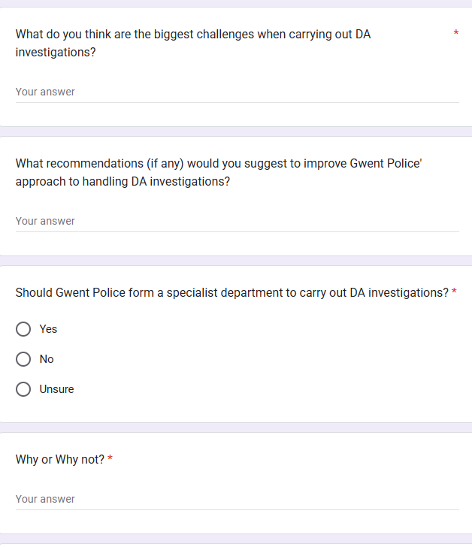

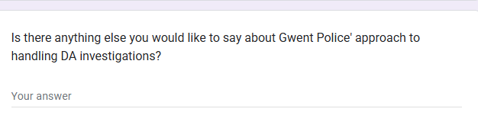
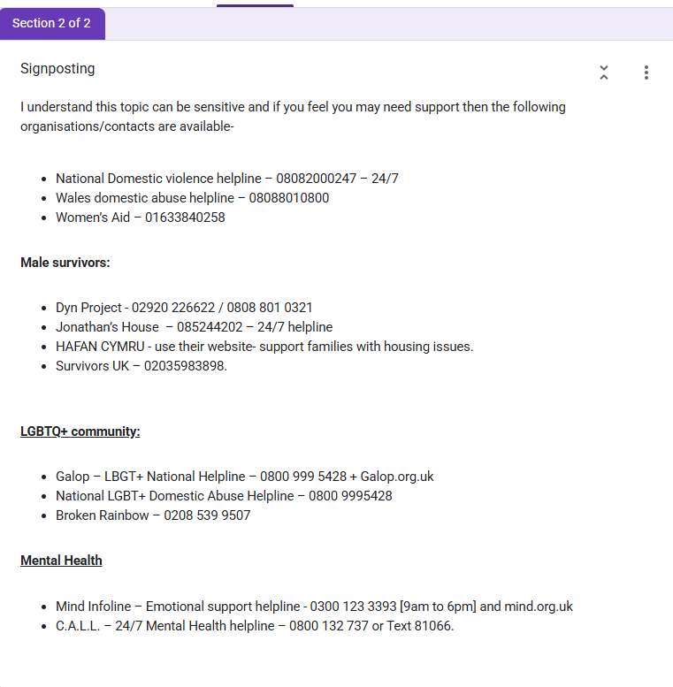

Appendix 2: Responses to Survey
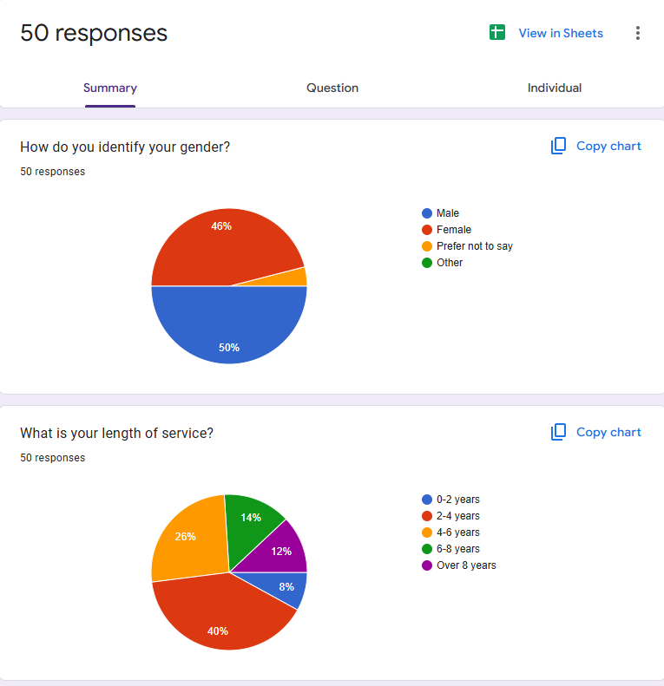
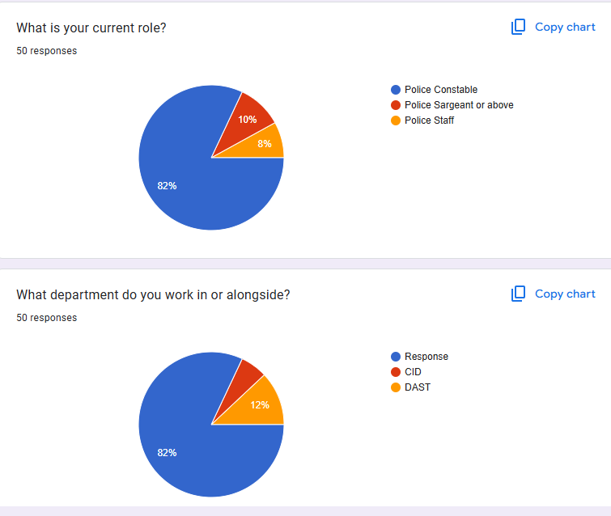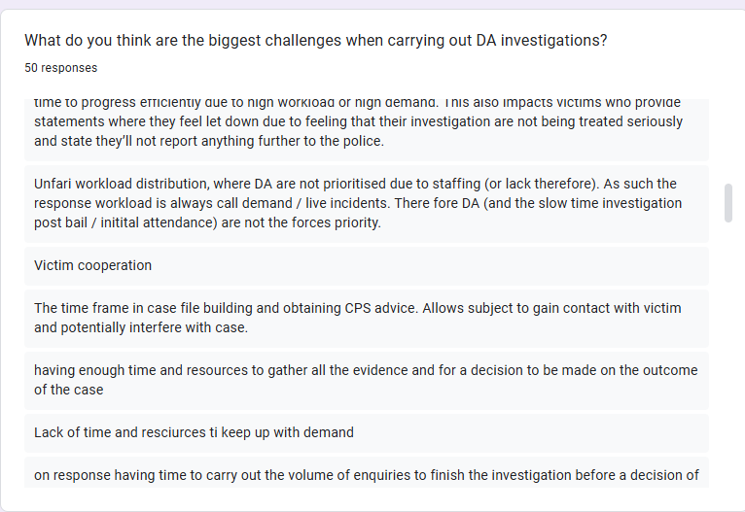
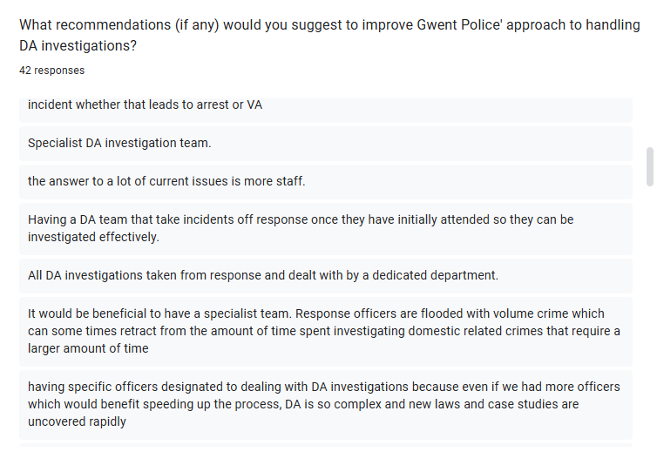
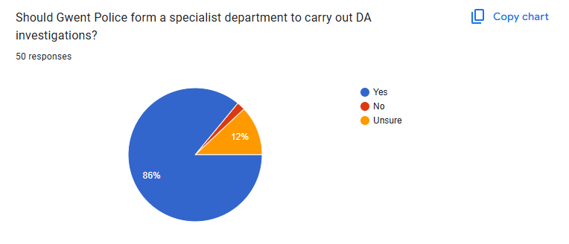

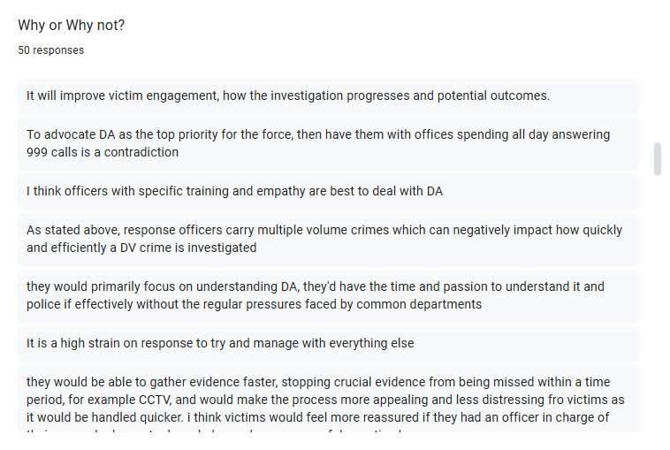
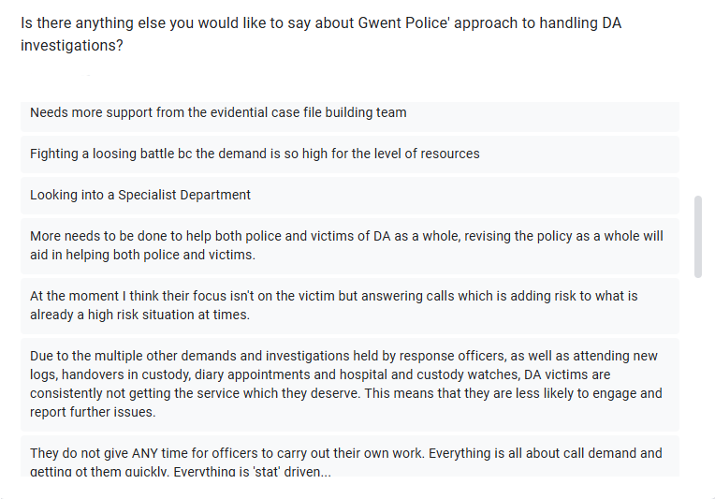

Appendix 3- Application for Ethical Approval
Application for ethical approval.docx

Appendix 4 – Research Proposal
Research Proposal Sheet (3) (2).docx

Appendix 5 – Figure 1
The Research Onion (Saunders & Lewis, 2009) | Download Scientific Diagram

