Module name: Enterpreneurship

Assignment 2
Module Code: LCBB5001

Name: Valentina Pituscanu
Student ID: 2124861

Table of Content

INTRODUCTION 3
BUSINESS DESCRIPTION / MARKET OPPORTUNITY 3
INDUSTRY ANALYSIS 7
Porter’s 5 Forces Analysis 7
OPERATIONS AND MANAGEMENT TEAM 11
Revenue Generation and Loss Prevention Method: 14
MANAGEMENT TEAM 15
MARKETING ANALYSIS 17
The Four P’s of Marketing: 17
FINANCIALS ANALYSIS 19
MARKET RESEARCH 21
REFERENCES 23

INTRODUCTION
This particular assessment aims to discuss a new business and provide a short overview regarding the plan of the business. While someone or an entrepreneur started a business there are several aspects that need to be discussed and highlighted in order to understand how successful the business will be considering its internal and external factors. This is the reason this particular assessment includes several types of industry analysis models that can help in providing a clear perception regarding the internal and external environment of the new business and how the business can overcome the challenges that the face regarding there internal and external factors and how they can make use of them positive factors or opportunities to achieve their goals. This study also includes the operation and team management plan so that people can understand the responsibilities performed by each team member to achieve positive consequences. The financial plan will help in understanding the resources from which the business can get its funds and the expenses they need to bear in order to achieve profit.

BUSINESS DESCRIPTION / MARKET OPPORTUNITY

An innovative private limited company, will produce indoor air filtration system called CleanAir Pro+ is intended to make residential and commercial areas safe and healthy.
The main purpose is to reinvent a technology which will help people breathe indoor air quality. In order to make indoor settings in homes, workplaces, schools, and public spaces safer, cleaner, and more comfortable throughout the UK, CleanAir Pro+ is committed to providing the best indoor air purification systems. These systems are supported by cutting-edge technology and environmentally friendly practices. Our goal is to be the top supplier of all-encompassing air quality solutions, driven by innovation, knowledge, and a strong dedication to enhancing the wellbeing of our clients and the environment."

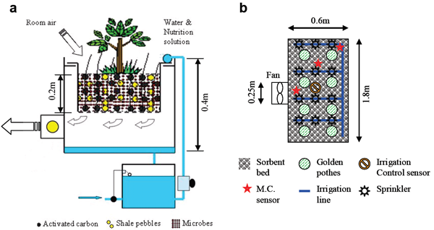
Figure 1: Air Purification System
(Source: WBDG, 2022)

Description of product or service with focus on the innovative element that makes it relevant in a post-Covid 19 and customer demand:
"The Best Indoor Air Quality Solution for the UK Market After COVID 19 is CleanAir Pro+"
Description of CleanAir Pro+:
An innovative, cutting-edge indoor air filtration system called CleanAir Pro+ is intended to make residential and business areas safe and healthy. CleanAir Pro+ provides a comprehensive solution to reduce indoor air pollutants and safeguard inhabitants from hazardous pathogens, such as viruses and bacteria, by utilising modern technology and scientific research.
Innovative Elements:
Elimination of Bacteria and Viruses: CleanAir Pro+ has ground-breaking UV-C light sterilisation technology in response to the Covid-19 outbreak. The Covid-19 virus is successfully neutralised by this potent UV light, which also renders other germs and viruses harmless and stops them from spreading inside of buildings (Bagheri et al. 2023).
Smart Monitoring of interior Air Quality:
CleanAir Pro+ includes a simple smart monitoring system that continuously assesses and monitors the interior air quality. Through a user-friendly app, users may obtain real-time data that offers insights into the levels of pollutants, temperature, humidity, and even pollen counts. To always provide the best possible purification, the system automatically modifies its performance based on the air quality that has been identified.
Integrity:
CleanAir Pro+ is made with adaptable sizes and contemporary looks that go with any décor, making it easy to incorporate into a variety of interior situations.
Eco-friendly and energy-efficient:
CleanAir Pro+ complies with the demands of customers who are ecologically concerned while still guaranteeing indoor air quality. The system uses environmentally friendly materials and components that cut down on electricity usage and carbon emissions.

INDUSTRY ANALYSIS

Porter’s 5 Forces Analysis
Threat of Substitutes:
Alternatives to CleanAir Pro+ include conventional air purifiers, plants that cleanse the air, and less complex air filtration devices. CleanAir Pro+ can do the following to eliminate the risk of substitutes:
- Product Life Cycle
The product is in its growth phase, according to the product life cycle. CleanAir Pro+ must maintain its position as a leader as the market becomes increasingly crowded by:
- Price Strategy
Special offers and deals to draw in budget-conscious clients and move out surplus stock.
Bargaining Power of Customers:
- Economic Crisis:
Customer sentiments may alter during an economic downturn, increasing price sensitivity. In order to solve this, CleanAir Pro+ is able to: Provide consumers with various payment choices and financing alternatives to lessen their financial strain.
Offer maintenance plans or value-added services to improve the entire client experience.
Utilise tailored marketing and advertising initiatives to draw in and keep clients in a time of economic uncertainty.
Bargaining Power of Suppliers:
Manufacturers of specialised components, UV-C light technology, and recyclable materials may be suppliers for CleanAir Pro+. CleanAir Pro+ can: Develop long-term partnerships with important suppliers to provide dependable access to crucial components. This will help control supplier negotiating leverage.
to maintain competitive pricing and lessen reliance on a single source, the company should diversify its supply base.
Monitor geopolitical and trade developments proactively, and think about sourcing from several places to offset any import/export limitations or currency swings.
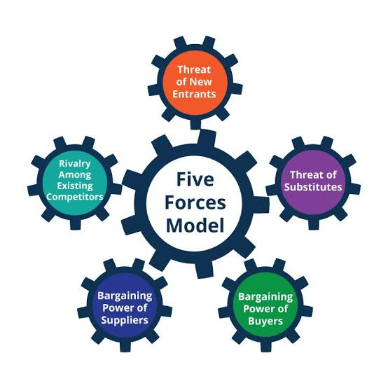
Figure 2: Porter Five Forces
Source: (HBS, 2023)
Competitive Rivalry:
- VRIO analysis
Value: CleanAir Pro+ provides clients with a considerable amount of value by giving an exceptional and cutting-edge indoor air quality solution with cutting-edge virus eradication technology, smart monitoring, and eco-friendly features.
Rareness: CleanAir Pro+'s products are rather uncommon on the market because of the combination of virus eradication and smart monitoring that sets it distinct from conventional air purifiers.
Copycat: Similar viral removal methods may be hard to design due to the technology and knowledge necessary, offering some defence against copycat.
Organisation: CleanAir Pro+ has proven to possess great organisational skills, including those in research, development, and marketing, which strengthens its competitive edge over new competitors.
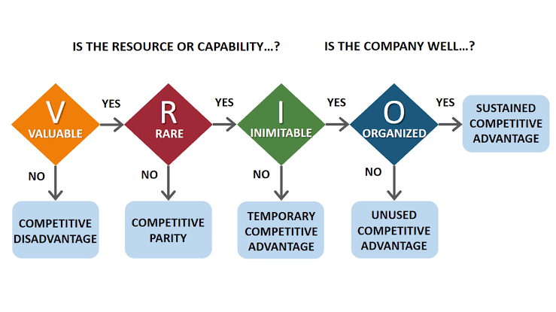
Figure 3: VRIO Analysis
Source: (Thinkinsight, 2023)

OPERATIONS AND MANAGEMENT TEAM
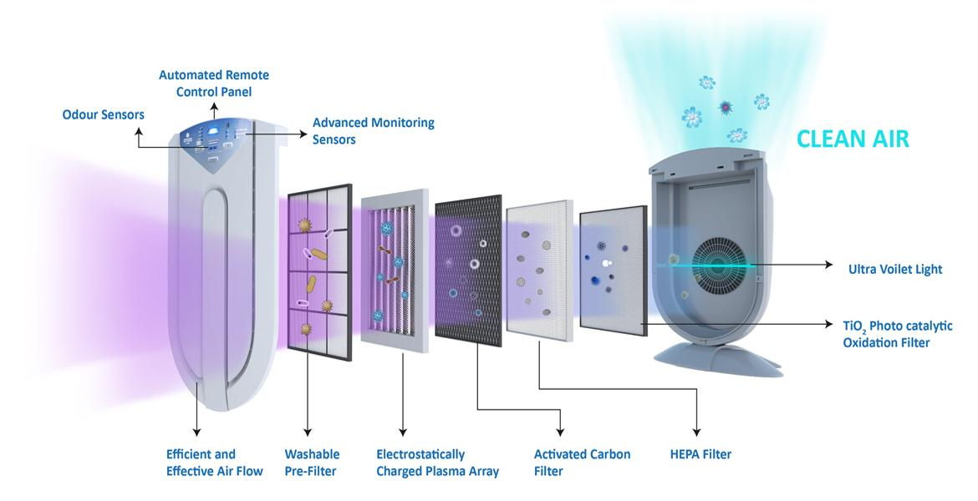
Figure 4: Air Purification Technology
(Source: Google, 2023)
Suppliers:
The providers of different parts, including HEPA filters, activated carbon filters, UV-C light technologies, electronics, and recyclable materials, will need to be cultivated by CleanAir Pro+.
Production Site:
CleanAir Pro+ will build and produce its indoor air filtration systems in a special production facility. This building will house the equipment, workers, and specialised labour required to complete the industrial process.
Production Process:
The filter system, UV-C light sterilisation technology, and smart monitoring components will all be assembled and integrated during the production process to form the finished air purification units.
Quality Control:
Each item will be examined and tested by a quality control team to make sure it satisfies the organisation's quality requirements and adheres to safety rules.
Packaging and Shipping:
Once the products have passed quality inspection, they will be safely packed for shipping. Transporting the goods to distribution centres or directly to clients will be coordinated by CleanAir Pro+ with logistical partners.
Distribution:
To assist effective delivery to consumers, CleanAir Pro+ may establish distribution centres in key locations around the UK. As an alternative, it might collaborate with reputable logistics firms to manage distribution.
Customer Delivery:
Customers may purchase the air purifying systems through authorised shops or the CleanAir Pro+ website. After processing orders, the products will either be delivered straight to clients' addresses or made accessible for collection.
Manufacturing Partners:
To create specific components or sub-assemblies, CleanAir Pro+ may work with specialised manufacturing partners.
Logistics Partners:
To get raw materials to the manufacturing site and deliver final goods to clients or distribution centres, CleanAir Pro+ will collaborate with logistical partners.
Retailers and Resellers:
To increase its market share, CleanAir Pro+ can collaborate with merchants and resellers. These associates will market CleanAir Pro+ goods via their individual channels.
Installation Partners:
For clients that need assistance setting up their air filtration systems, CleanAir Pro+ may enlist installation partners to offer qualified installation services.

Revenue Generation and Loss Prevention Method:
Generating revenue:
- Product Sales:
Sales of its indoor air filtration equipment will be CleanAir Pro+'s main source of income. To meet the demands and budgets of varied customers, the organisation may provide a variety of types and sizes.
- Upselling and Cross-selling:
To raise the average transaction value per client, CleanAir Pro+ might upsell extra features or services like extended warranties, maintenance plans, or smart home integration.
- Subscription Model:
The business may launch a subscription-based service that incorporates routine filter changes and system upkeep, giving clients continuing value and maintaining a consistent flow of income.
- B2B Partnerships:
In order to deliver large orders or offer special discounts, CleanAir Pro+ can form agreements with companies, educational institutions, healthcare facilities, and other commercial entities, increasing sales volumes.
- After-sales Services:
Outstanding after-sales services, such as quick customer support, help with problems, and user training, may increase recurring business by fostering client loyalty and favourable word-of-mouth.
Preventing Loss of Revenue:
- Total Quality Management (TQM):
Adopting TQM procedures guarantees that indoor air filtration systems constantly satisfy high requirements, lowering the probability of product flaws and pricey returns or refunds.
- Regular Cost Reviews:
It is possible to find opportunities for cost reduction and improved financial performance by periodically analysing and optimising costs across the supply chain, manufacturing, and distribution processes.
- Customer Retention Strategies:
The loss of potential recurring revenue from subscription-based services can be prevented by concentrating on client retention and satisfaction initiatives.
- Regular Product Updates:
By consistently enhancing and inventing the product line in response to consumer feedback and technology improvements, businesses can keep customers interested and avoid sales stagnation.

MANAGEMENT TEAM
Name | Skills | What do they bring to the firm
PERSON 1 | Product development  Innovation | A dynamic leader with a passion for developing cutting-edge indoor air quality solutions, advancing product innovation, and strategically directing business expansion.
PERSON 2 | Operations  supply chain Management | A seasoned expert skilled in improving business processes and the effectiveness of the supply chain, assuring smooth manufacturing and prompt delivery of CleanAir Pro+ goods.
PERSON 3 | Marketing  Branding | A marketing specialist with creativity who develops persuasive tactics to advertise CleanAir Pro+ in the marketplace, creating a strong brand presence and fostering customer interaction
PERSON 4 | Finance  Business strategy | A financial strategist at CleanAir Pro+ who has an eye for company prospects, advising financial choices and creating growth-oriented strategies.
PERSON 5 | Customer relations | A sales leader who prioritises the needs of the client by building trusting connections, delivering top-notch customer service, and boosting sales.
PERSON 6 | R&D  Technical expertise | An expert in product research and development who has added cutting-edge technology and creative solutions to CleanAir Pro+.

MARKETING ANALYSIS

The Four P’s of Marketing:
Product:
The most effective indoor air filtration system, CleanAir Pro+, was created to address air quality issues after COVID 19. With HEPA filters, activated carbon filters, and UV-C light technology, it has a multi-stage filtering system that is excellent at removing viruses. Real-time data on air quality is available through smart monitoring technologies.
Price:
Competitive pricing for CleanAir Pro+ will be based on a cost-plus-markup strategy. The objective is to find a balance between client affordability and corporate sustainability.
Promotional Mix:
To properly advertise the product, CleanAir Pro+ will use a variety of marketing strategies. To attract tech-savvy clients, online marketing will maximise brand awareness through social media campaigns and SEO. The advantages of the product will be highlighted through content marketing, seminars, and informative blogs (Prudnikov and Nazarenko, 2021). Collaborations with opinion leaders and health professionals will increase credibility.
Place (Distribution Strategy):
CleanAir Pro+ will make use of a multi-channel distribution scheme. For end-user direct sales, the product will be made available for purchase on the company website. Collaborations with retailers and e-commerce platforms will help to grow the industry.

Figure 5: 4 Ps of Marketing
Source: (Prudnikov and Nazarenko, 2021)

FINANCIALS ANALYSIS
Sources of funds:
Angel Investors will be the preferred funding source for CleanAir Pro+'s company concept plan. Angel investors are people who put their own money into start-up companies in exchange for ownership stock or convertible debt (Amruta and Chaithra, 2022).
Early-Stage Investment: Currently in its early phases of development, CleanAir Pro+ is a start-up with a ground-breaking product. At this point, when enterprises have a strong potential for development and may provide a sizable return on investment, angel investors frequently invest in them (Cornelius, 2020).
Expertise and Guidance: Their advice and insights can assist CleanAir Pro+ in overcoming obstacles, choosing the best course of action, and accelerating its growth.
Flexible Investment Terms: Compared to other financing sources like venture capital firms, angel investors may be more lenient when it comes to the terms of their investments (Capizzi et al. 2022). They could be willing to consider equity financing or convertible notes with conditions that fit CleanAir Pro+'s projected expansion.
Network and Connections: Their contacts may be able to provide CleanAir Pro+ chances for distribution, customer introductions, and commercial collaborations.

Use of funds (In Pounds):

 | Month 1 | Month 2 | Month 3 | Month 4 | Month 5 | Month 6
Revenue | £ 25000 | £ 30000 | £ 35000 | £ 40000 | £ 45000 | £ 50000
Fixed Costs  Rent  Insurance  Salary | £ 8000  £2000  £1000  £5000 | £ 8000  £2000  £1000  £5000 | £ 8000  £2000  £1000  £5000 | £ 8000  £2000  £1000  £5000 | £ 8000  £2000  £1000  £5000 | £ 8000  £2000  £1000  £5000
Variable Costs  Materials  Delivery cost  Packaging supplies  Utilities: Electric,gas, water | £ 12000  £10000  £500  £700  £800 | £ 14000  £11500  £700  £900  £900 | £ 16000  £13000  £1000  £1000  £1000 | £ 18000  £14500  £1100  £1300  £1100 | £ 20000  £16000  £1250  £1500  £1250 | £ 22000  £17850  £1300  £1600  £1350
Profit | £ 5000 | £ 8000 | £ 11000 | £ 14000 | £ 17000 | £ 20000

MARKET RESEARCH
Surveys will be used to acquire primary data. Surveys are a powerful research tool for obtaining candid input from prospective clients and learning about their wants and expectations. These are the inquiries:
1. How worried are you about the quality of indoor air, particularly in the post-Covid 19 era?
Very Concerned
Somewhat Concerned
Neutral
Not Concerned
2. Have you ever utilised a system or device for indoor air purification? If so, be specific about the kind and your background.

3. What characteristics should an interior air filtration system have, in your opinion?
Virus elimination technology (UV-C light)
Smart monitoring and real-time air quality data
High-efficiency HEPA filtration
Energy-efficient operation
Eco-friendly materials and sustainability
4. What price range for an indoor air purifying system do you prefer?
Under £100
£100 - £300
£300 - £500
Over £500
5. Would you be interested in signing up for a service that consists of consistent filter change and upkeep for best performance?
Yes
No
Maybe

REFERENCES
Airpure, 2023. _Airpure online store._ Available at: https://airpure.com/ (Accessed: July 23, 2023)
Amruta, N. and Chaithra, N., 2022. Financial Avenues for Start-Ups. Adarsh Journal of Management Research, 14(1), pp.56-68.
Bagheri, S., Julkapli, N.M., Yusof Hamid, M.R., Ziaei, R. and Sagadevan, S., 2023. Nanomaterials Aspects for Photocatalysis as Potential for the Inactivation of COVID-19 Virus. Catalysts, 13(3), p.620.
Barauskaite, G. and Streimikiene, D., 2021. Corporate social responsibility and financial performance of companies: The puzzle of concepts, definitions and assessment methods. Corporate Social Responsibility and Environmental Management, 28(1), pp.278-287.
Capizzi, V., Croce, A. and Tenca, F., 2022. Do Business Angels’ Investments Make It Easier to Raise Follow‐on Venture Capital Financing? An Analysis of the Relevance of Business Angels’ Investment Practices. British journal of management, 33(1), pp.306-326.
Cornelius, P., 2020. Sources of funding innovation and entrepreneurship. Global Innovation Index, pp.77-88.
Google, 2023. Indoor Air Purification System. Available at: https://www.google.com/search?rlz=1C1CHZN_enIN1047IN1047&sxsrf=AB5stBg-UeXMX3a77GGYGikqKZRxBSbmig:1690481508504&q=indoor+air+purification+system&tbm=isch&source=lnms&sa=X&ved=2ahUKEwjG8cCuvq-AAxVwl1YBHdstB7wQ0pQJegQICxAB&biw=771&bih=802&dpr=1.25#imgrc=6sOXo6sQrJd75M (Accessed: July 25, 2023)
GOV UK, 2023. _CLEANAIRTECH LIMITED_ . Available at: https://find-and-update.company-information.service.gov.uk/company/04132056 (Accessed: July 25, 2023)
HBS. (2023). Porter's Five Forces analysis. Available at. https://www.isc.hbs.edu/strategy/business-strategy/Pages/the-five-forces.aspx (Accessed: July 25, 2023)
OECD, 2023. _Compedium of indoor air quality._ Available at: https://www.oecd.org/sdd/47917288.pdf (Accessed: July 25, 2023)
Prudnikov, Y. and Nazarenko, A., 2021. The role of content marketing in the promotion of medical goods and services.
Rauterberg, G., 2021. The separation of voting and control: the role of contract in corporate governance. Yale J. on Reg., 38, p.1124.
Thinkinsight. (2023). VRIO analysis. Available at. https://thinkinsights.net/strategy/vrio-framework/ (Accessed: July 25, 2023)
WBDG, 2022. Phyto Air Purification System. Available at: https://www.wbdg.org/resources/phyto-purification-systems (Accessed: July 25, 2023)

