University of Wales, Trinity Saint David
Internet Security and Technology ACCA4018
Synthesize a solution to a potential real-life scenario
Anton Hall
Contents
1. Introduction 1
2. Related Work 1
2.1 Cyberattacks 1
2.2 Network Security 1
2.3 The Principles of Security 2
3. Problem Formulation 2
3.1 What is BYOD? 2
4. Results 3
4.1 BYOD DFD 3
4.2 Network 4
4.3 Three Layer model 5
4.3.1 Access Layer 5
4.3.2 Distribution Layer 6
4.3.3 Core Layer 8
4.3.4 Servers 8
4.3 BYOD Security Policy 9
4.3.1 Introduction 9
4.3.2 Permitted Devices 9
4.3.3 Security Incidents 9
4.3.4 Acceptable Usage 9
4.3.5 Leaving the company 10
4.3.6 Device Monitoring 10
4.4 Mobile Device Management 10
4.4.1 MDM Comparison 10
4.4.2 MDM Selection 11
Conclusion 12
Future Work 12
Bibliography 13

1. Introduction
The aim of this report is to inform Hyper-fort on how to implement a comprehensive security policy that will cover all areas of their network including online and offline resources. It will focus on the security risk that is present when a company such as Hyper-fort is put under pressure to allow employees to use their own devices. It will outline a potential physical network they can implement to help overcome security issues faced with employees using their own devices.

2. Related Work

2.1 Cyberattacks
The main issue a company like Hyper-fort faces when implementing a bring your own device policy is the potential of a cyberattack. Cyberattacks can come in many different forms and some are more damaging than others, Cisco, a networking hardware company, describe them as:
“A cyberattack is a malicious and deliberate attempt by an individual or organization to breach the information system of another individual or organization. Usually, the attacker seeks some type of benefit from disrupting the victim’s network.” [1]
Cyberattacks are normally delivered by cybercriminals to end devices in the form of malware:
- Viruses – a malicious executable code attached to an executable file (normally a legitimate programme) that require end user activation.
- Worms – malicious code that replicates itself by exploiting vulnerabilities in networks.
- Trojan horses – malware that disguises itself in user operations for example playing an online game or opening an image file.
- Ransomware – this type of malware normally encrypts a computer system or the data network hold until a ransom is funded by the effected user.

2.2 Network Security
Network security is the protection of networks, systems, hardware and the data that is held within these systems. Good network security is key to a company like Hyper-Fort to discourage and eliminate risks of cyberattacks. The impact of poor network security for a company like Hyper-Fort can have many negative factors such as the release of sensitive data or loss of communications and time, but ultimately, it can have devastating effects. There is legalisation in force that will hold organisations and individuals accountable for the loss of sensitive data, these were created to make sure company’s use proper security measures. The UK government released a new data protection act in 2018 “The Data Protection Act 2018 controls how your personal information is used by organisations, businesses or the government.” [1]

2.3 The Principles of Security
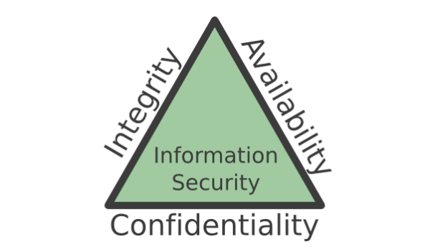
There are three main principles that directly relate to cyber security and these are referred to as the CIA triangle shown by figure 1 below: [2]
Figure 1: CIA Triad
The CIA triad describes the three main aims for achieving network security: Integrity, Availability and Confidentiality.
Integrity describes a need for consistency in the way information is stored with the aim of accuracy and consistency when it is stored, transferred or used.
Availability is the goal of making information available where and when it is required. Basically, if someone is authorised to access certain information then they should be able to access it wherever and whenever they need it and if someone is not authorised to access certain information then it should be impossible for them to do so.
Confidentiality is similar to availability in the fact that it should control which users can access certain pieces of information.
Confidentiality is achieved when unauthorised users are blocked from accessing information. This could include blocking access to hardware such are servers by simply keeping them in a secure environment.

3. Problem Formulation
Hyper-fort has recently come under pressure to allow both its staff and customers to use their personal devices to access the company’s network and resources. This is also known as bring your own device (BYOD for short), however this poses many security risks to the company around protecting their intellectual property worth billions of pounds.

3.1 What is BYOD?
BYOD allows employees to use their own personal devices to access company systems such as email. Most people now own a smartphone, so instead of having a personal phone as well as a work phone, implementing BYOD would allow them to just have a personal phone which they paid for and use this for work. BYOD encourages employees to work on a device of their own choosing, reducing costs for the company and potentially increasing productivity throughout. BYOD could put company systems at risk, but if it is implemented correctly these risks can be minimalised. Logicalis commissioned Ovum to author a white paper on BYOD behaviour and said the following:
“For businesses, and particularly those operating in multiple markets, the challenge is to set the right levels of governance and manage BYOD behaviour wherever it is happening: the risk of losing data via a personally owned device is very real and potentially very damaging from financial, reputational, and legal perspectives.”[3]
In the paper Logicalis discuss how achieving the right level of governance is key to gaining the potential benefit of BYOD. They follow this up by stating:
“IT should aim to use an appropriate level of management to ensure that data is secured without degrading the user experience for employees prepared to work in this flexible manner”[3]

4. Results
To implement a successful BYOD structure firstly you need a network that can securely allow employees and guest devices to connect with company systems. In this section a network will be proposed that is suitable for BYOD and will explain the different aspects of the network. Secondly, when implementing any new technology, you will need a policy. A BYOD security policy that should be enforced alongside the network will also be outlined in this section.

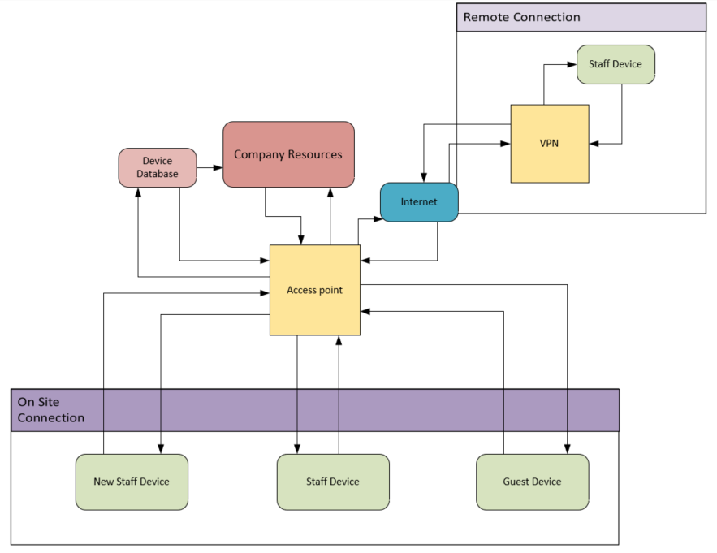
4.1 BYOD DFD
Figure 2 BYOD Data Flow Diagram

The above figure illustrates a data flow diagram of the BYOD architecture that is proposed to be implemented at Hyper-fort.

4.2 Network
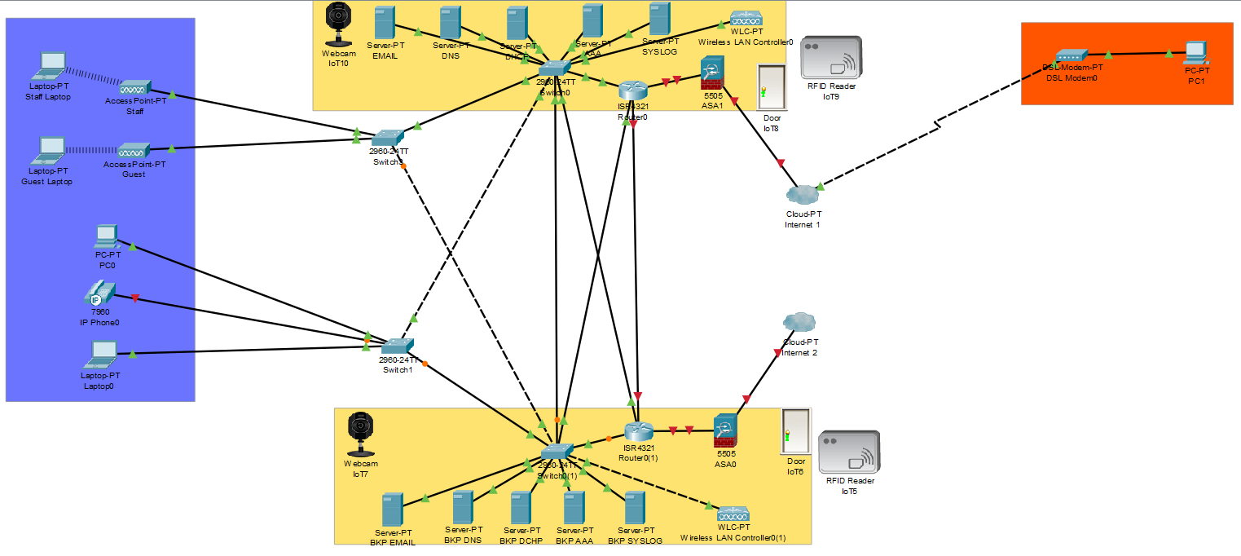
Figure 3 Proposed network created in Cisco Packet Tracer

4.3 Three Layer model

Designing a network can be very complicated, however a hierarchical approach can help us visualise a complex network in a more comprehensive and understandable model. The industry wide adopted Cisco hierarchical model will be used to explain the design of the proposed network above. Cisco explains this model as the following: “A hierarchical network model is a useful high-level tool for designing a reliable network infrastructure. It breaks the complex problem of network design into smaller and more manageable areas.” [4] Cisco defines the three layers as shown below:
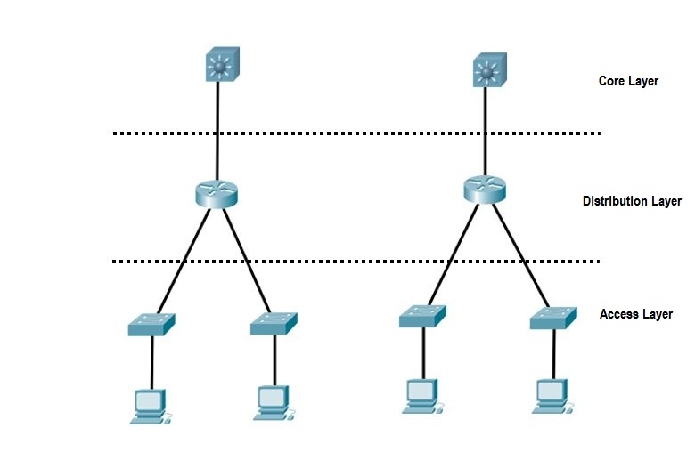

Figure 4 Three Layer model

4.3.1 Access Layer
The access layer of the network is where end devices such as laptops, computers and smartphones can connect to the network. The kind of hardware included in the access layer would be switches and access points. This would give connectivity between servers and end devices. Cisco describe the access layer as “one of the most vulnerable parts of the network.”[5] This is almost certainly because this is the most common place for users to gain access to a network. In the past, large companies relied on physical security features to stop unauthorised people connecting to a network, such as stopping certain people entering particular areas of the office for example. Physical security still plays a role in certain areas of a network, but it is harder to apply physical security to networks in modern times as most networks offer a wireless capability.
The physical protection that could be applied to the access layer is taking steps such as securing workstations with locks. In addition to this, idle timeouts and logout timers could be used to secure machines that haven’t been used in a certain about of time.
One way of making your access layer more secure is to secure the access points. Firstly, you will need to set the SSID (Service Set Identifier); it is recommended to use a combination of numbers and letters as this will be hard for another person to guess. Next, we could apply MAC (Media access control) address filtering. Every piece of hardware has a unique MAC address which we can use to identify what devices are connecting to a network. We can use this information to restrict certain devices from connecting to the access point. As well as this, we need to apply WPA2 (Wi-Fi protected access 2) security technology to our wireless network. It is an upgrade from the original WPA technology which replaced a much less secure WEP technology. [6] WPA2 uses a strong encryption method called AES encryption algorithm and 802.1x based authorisation. Itis based on the IEEE 802.11i standard. [7]
To enable users of Hyper-fort’s systems to connect from remote locations, users will need to use a VPN (Virtual Private Network.) The capability of this is highlighted in the proposed network by the orange box connected to the internet cloud in figures 2 and 4. A VPN is an encrypted connection over the internet from a device to a network. They allow users to securely connect remotely without anyone being able to see the traffic that is being shared. It is a technology that is widely used by corporate companies like Hyper-fort. The encrypted connection is normally referred to as a tunnel. Cisco suggest the following VPN solutions:
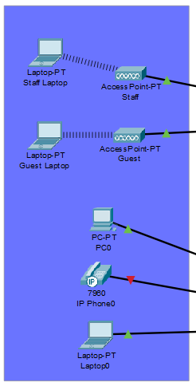
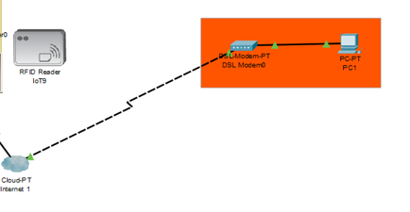
“An SSL VPN and an IPsec VPN have become the primary VPN solutions for connecting remote offices, remote users, and business partners”[8]
Figure 5

4.3.2 Distribution Layer
The distribution layer sits between the core and access layer and it is there to provide a connection to the core from the access layer and allow routing to the internet. As it is the main connection to the core of the network this is where security can be applied to decide what gets access to the core once connected via your network. The hardware involved at the distribution layer is normally switches and routers. It is said that this layer defines the policy for the entire network. These policies can include filtering traffic to only allow some devices to connect to other areas of the network.
The main form of security here is to activate some form of port security, this is also the simplest form of switch security. Using switch port security, you can control how each port on the switch is going to behave:
- Shut down ports altogether so no device can use redundant ports
- Configure MAC addresses. Only allow ports to accept certain device’s MAC addresses. There are three options for MAC configuration:
  - Statically
  - Dynamically
  - Sticky
The same port security protocols can be applied to the routers at this level.
Physical security is also present at this layer. Parts of the network in this layer should be kept in rooms where only certain access is allowed. These parts of the network should be kept in the server rooms, so they are under the same level of physical security as the servers. Server room security will be discussed at the core level of the network below.
The distribution layer plays a key part in having good redundancy within a network. As seen in the figure of the network below you can see that redundancy has been applied by using two sets of hardware, one primary and one secondary so that if there is a fault with the primary, the same networking ability can be achieved with the secondary devices. However, this can create network loops where packets are replicated infinite number of times, bringing down the network. To prevent loops we can introduce the STP (spanning tree protocol.) [9]
As a connection to the internet is made through the distribution layer, this is where we would implement a firewall. A firewall can be defined as “a system that provides network security by filtering incoming and outgoing network traffic based on a set of user-defined rules.” [10] Using a firewall we could prevent traffic from entering our network if we see it as potentially harmful. This is done by the administrators using a set of rules which direct what the firewall should drop or accept.

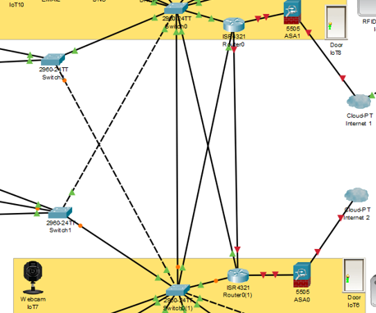
4.3.3 Core Layer
Figure 6 Distribution layer of proposed network
The core layer is responsible for the quick and reliable distribution of data across a network. It is often referred to as the backbone of the network as most other services will rely on the core layer. At this layer efficiency is key, so fewer and faster hardware systems are used, normally at a greater cost than the rest of the network. As speed is of great importance here network policies, firewalls or filtering should not be performed at this layer.

4.3.4 Servers
The core layer is responsible for connecting the network to the servers. A server is “a computer or computer program which manages access to a centralized resource or service in a network.” [11] Within the proposed network there are some common servers that would be found in a company like Hyper-fort:
Email Server – this server would solely be responsible for the companies email service. It would store all incoming mail to be distributed across a network.
DNS Server – the DNS server would translate hostnames to IP addresses and vice versa. For example, it would translate www.google.com to an IP address.
DCHP Server – the DHCP server provides and assigns IP addresses and default gateways to end devices. It uses a protocol called DHCP (dynamic host configuration protocol.)
AAA Server – This server is responsible to handling users’ requests for access to certain resources. It stands for Authentication, authorisation and accounting. This server would be used to hold all the BYOD device information.
Syslog Server – this is a system log server that records what is happening across the network. Syslog’s can be set up to send alerts to system admistrators about the status of the network.
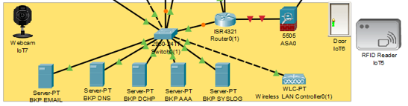
The core layer and servers should be stored in their own secure environment known as a server room. Physical security such as access control should be employed here, RFID access for example. Server rooms also have their own climate where the temperature and humidity is controlled by air-conditioning units. They are also protected by UPS (uninterruptable power supply) to protect expensive equipment from power surges and allow enough power for systems to shutdown if there is a power outage.
Figure 7 Core Layer

4.3 BYOD Security Policy

4.3.1 Introduction
This policy will cover the use of non-company owned devices which may be used to access company systems. Example devices include laptops, smartphones, tablets and similar devices. The use of such a device must comply with the following policy.

4.3.2 Permitted Devices
Only certain devices will be permitted to access the company systems and must be registered before use:
Smartphones- Apple and Android phones with the latest OS software installed
Laptops- Apple and Windows OS are allowed but must be up to date
Tablets- Apple and Android tablet with the latest OS software installed
Other devices- please contact your local IT administrator
Any device used to access company systems must be password protected and must have “find my phone” or similar settings activated. Devices should automatically lock after several minutes of inactivity. This is to mitigate the security risk against data at rest.

4.3.3 Security Incidents
If a device is lost or stolen it should be reported within 24 hours. The company will not reimburse the employee for the device and IT can wipe the device.
If a security threat is detected on a device, then IT has the power to remotely wipe that device.
IT will take steps to preserve personal information before a device is wiped but you are encouraged to keep personal data backed up.
IT can disconnect any device at anytime if they detect a security risk.

4.3.4 Acceptable Usage
Personal use of the device during company hours should be limited to a minimum.
Unapproved websites should not be accessed while working on site or remotely during business hours.
Apps downloaded outside of the App stores (iTunes and Google play) are not permitted.
Company resources that an employee may access will depend on your job role.
MDM (Mobile device management) software must be installed on the device and must be updated regularly.

4.3.5 Leaving the company
Upon leaving the company IT will remove your device information from the company systems. IT will also remotely remove any company information from your device.

4.3.6 Device Monitoring
MDM software will be utilised by the company for the management of devices.

4.4 Mobile Device Management
Mobile device management is key to deploying secure BYOD management. MDM is software that allows system administrators the ability to control end devices and enforce policies on them. MDM is used to improve the functionality and security of mobile devices to make it more secure when they access the company’s network. MDM is normally made up of an agent, the software that is installed on the endpoint, and an MDM server, that lives in a data centre or on a cloud. IT uses the MDM server to push policies to the MDM agent on the devices. Modern MDMs not only allow for the management of mobile devices but also for the management of PCs running windows 10 and macOS and tablets. This is normally referred to as unified endpoint management. Some common MDM features are:
- Tracking
- App distribution/ or an enterprise Appstore
- Password enforcement
- Data encryption enforcement
- Device wiping[12]

4.4.1 MDM Comparison
There are many mobile device management software packages on the market and they all offer different capabilities, so it is important to choose the right MDM software for the BYOD policy that you wish to enforce. Below will be a comparison of some of the leading tech companies offering MDM software at an enterprise level. There will be reviews from finance online used for reference. [13]

Table 1 MDM Comparison
Software | Features | Supported Devices | Price
Intune Enterprise Mobility+Security – Microsoft | - Mobile device & app management  - Advanced Microsoft Office 365 data protection  - Integrated PC management  - Integrated on-premises management  - Identity & access management  - Information protection  - Identity-driven security | iOS, Android, Windows and macOS | £4.50 per user per month
Cisco Meraki – Cisco | - Scalable endpoint configuration  - On-device content management  - Secure support for BYOD initiatives  - Automatic device classification  - Automatically apply network policies by device type  - Analyze network activity with automatic reporting | iOS, Android, Windows and macOS | N/A
AirWatch - VMware | - Quick configuration  - Open architecture and scalable system  - Flexible integration  - Automatic upgrades and same day support  - Device level encryption  - Real-time MDM deployment | Android, iOS | Ranges between $3.61 and $23.71 per month

4.4.2 MDM Selection
After some consideration of the available MDM software’s the one that best suits Hyper-fort and what they wish to gain from implementing BYOD is Microsoft Intune. This software has been selected as it will help hyper-fort enforce a comprehensive security policy. Intune supports a wide range of devices allowing Hyper-fort to accept a wide range of devices to be used as BYOD, also allowing for expansion in the future. Intune is deployed in the cloud so Hyper-fort would not need to spend money on on-site servers, instead it’s a monthly subscription fee of £4.50 per user per month.[14] Intune also offer 24/7 support from Microsoft.

Conclusion
The main concern for Hyper-fort is the security of company data. The main risk to this data comes from cyberattacks where breaches to the security of data may occur. Therefore, it is imperative for Hyper-fort to have a sound understanding of network security to prevent these attacks and potential security breaches. The three main aims for achieving cyber security are illustrated by the CIA triad: Confidentiality, Integrity and Confidentiality.
As Hyper-fort has come under recent pressure to allow the use of BYOD within its business, throughout this report recommendations have been made from both a network point of view and a policy point of view. Firstly, the network needs to have the correct hardware and configurations for it to be able to handle the use of BYOD. Mainly this requires security measures to be put in place throughout the different layers of the network. It also includes the implementation of a VPN so that employees can use their own devices from a remote location without jeopardising the company’s data. When implementing new technology, you need to implement a policy to illustrate how that technology should be used. In the report it outlines a BYOD security policy which states how employees’ devices can be used. The final piece of the puzzle for successfully implementing BYOD is a Mobile Device Management software. In the case of Hyper-fort, Microsoft Intune is recommended.

Future Work
Based upon the findings outlined in this report, for future work it would be beneficial to obtain more knowledge of this subject to provide alternate solutions to the scenarios that have been investigated. As well as this, it would be advantageous to understand how these virtual concepts are implemented in the real world.

Bibliography

[1] “Data protection - GOV.UK.” [Online]. Available: https://www.gov.uk/data-protection. [Accessed: 26-Dec-2018].
[2] Anthony Henderson, “The CIA Triad: Confidentiality, Integrity, Availability - Panmore Institute,” 2017. [Online]. Available: http://panmore.com/the-cia-triad-confidentiality-integrity-availability. [Accessed: 26-Dec-2018].
[3] “DIVERGENT RATES OF BYOD IN HIGH GROWTH VERSUS LOW GROWTH MARKETS.”
[4] “Hierarchical Network Design Overview (1.1) &gt; Cisco Networking Academy Connecting Networks Companion Guide: Hierarchical Network Design,” 2014. [Online]. Available: http://www.ciscopress.com/articles/article.asp?p=2202410&seqNum=4. [Accessed: 05-Jan-2019].
[5] “Cisco Service Ready Architecture for Schools Design Guide - Access Layer Security Design [Design Zone for Education] - Cisco.” [Online]. Available: https://www.cisco.com/c/en/us/td/docs/solutions/Enterprise/Education/SchoolsSRA_DG/SchoolsSRA-DG/SchoolsSRA_chap9.html. [Accessed: 06-Jan-2019].
[6] B. Mitchell, “Understanding Wireless Protected Access 2 (WPA2),” 2018. [Online]. Available: https://www.lifewire.com/what-is-wpa2-818352. [Accessed: 06-Jan-2019].
[7] V. Beal, “What is Wi-Fi Protected Access 2 (WPA2)? Webopedia Definition.” [Online]. Available: https://www.webopedia.com/TERM/W/WPA2.html. [Accessed: 06-Jan-2019].
[8] “Virtual Private Network (VPN) - Cisco.” [Online]. Available: https://www.cisco.com/c/en_uk/solutions/security/vpn.html. [Accessed: 06-Jan-2019].
[9] M. Portolani, “Fully Redundant Layer 2 and Layer 3 Designs &gt; Data Center Design Overview,” 2003. [Online]. Available: http://www.ciscopress.com/articles/article.asp?p=102268&seqNum=3. [Accessed: 06-Jan-2019].
[10] Ancias Mitchell, “What is a Firewall and How Does It Work? | DigitalOcean,” 2015. [Online]. Available: https://www.digitalocean.com/community/tutorials/what-is-a-firewall-and-how-does-it-work. [Accessed: 09-Jan-2019].
[11] “server | Definition of server in English by Oxford Dictionaries.” [Online]. Available: https://en.oxforddictionaries.com/definition/server. [Accessed: 08-Jan-2019].
[12] Rouse Margaret, “What is mobile device management (MDM)? - Definition from WhatIs.com,” 2017. [Online]. Available: https://searchmobilecomputing.techtarget.com/definition/mobile-device-management. [Accessed: 09-Jan-2019].
[13] “20 Best Mobile Device Management Software in 2019 - Financesonline.com.” [Online]. Available: https://financesonline.com/mobile-device-management/. [Accessed: 09-Jan-2019].
[14] “Microsoft Intune Pricing | Microsoft.” [Online]. Available: https://www.microsoft.com/en-gb/cloud-platform/microsoft-intune-pricing. [Accessed: 09-Jan-2019].

marking criteria and Student FEEDBACK

This section details the assessment criteria. The extent to which these are demonstrated by you determines your mark. The marks available for each criterion are shown. Lecturers will use the space provided to comment on the achievement of the task(s), including those areas in which you have performed well and areas that would benefit from development/improvement.

Common Assessment Criteria Applied (Assignment 1) | Marks available | Marks  awarded
1. Research-informed Literature
Extent of research and/or own reading, selection of credible sources, application of appropriate referencing conventions.
Whilst there is a number of references within this document the lack of journal, conference proceedings, and white papers makes the research difficult to justify. Remember to focus your sources from established credible locations such as the IEEE xplore database, accessible via the library or online. (Grade mark: 66.67%) | 15 | 10
2. Knowledge and Understanding of Subject
Extent of knowledge and understanding of concepts and underlying principles associated with the discipline.
The structure of the paper is sound and allows the reader to understand the concepts being identified and why the report has been completed. The lack of credible sources does somewhat detract from the good work that has been put in however. (Grade mark: 80.00%) | 15 | 12
3. Analysis
Analysis, evaluation and synthesis; logic, argument and judgement; analytical reflection; organisation of ideas and evidence
The DFD gives a very simple but effective overview of the connectivity for network and how a user will access the system. The discussion throughout the implementation does show a good understanding of key concepts to deliver a solution for Hyperfort. (Grade mark: 62.50%) | 40 | 25
4. Practical Application and Deployment
Deployment of methods, materials, tools and techniques; application of concepts; formulation of innovative and creative solutions to solve problems.
The implementation of the Hyperfort network is well demonstrated with the configurations seen in the packet tracer simulation. However some basic elements could have been introduced - Banners, SSH, and Encryption would have aided the security. (Grade mark: 80.00%) | 20 | 16
5. Skills for Professional Practice
Attributes in professional practice: individual and collaborative working; deployment of appropriate media; presentation and organisation.
The report looks very professional minor points have been highlighted in the comments within the document. Justify the paragraphs as this aids with the presentation and readability of the report. When you have large sections of writing that only contains 1 reference you do need to identify more research to justify the discussion topic. (Grade mark: 70.00%) | 10 | 7

Assignment Mark (Assessment marks are subject to ratification at the Exam Board. These comments and marks are to give feedback on module work and are for guidance only until they are confirmed. ) | Late Submission Penalties (tick if appropriate) |  | 70%
 | Up to four weeks late |  | 70%
 | First Attempt? |  | 70%

