IRONMAN

Consultancy Project Initiation Document

06/03/2020

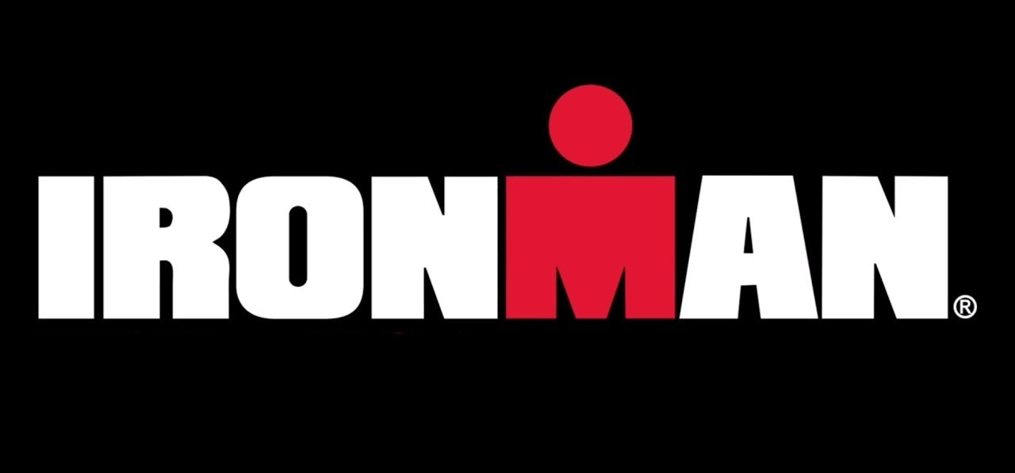

Consultant: Toby Mackie

Student I.D - 1707393

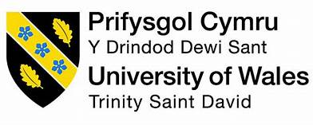

Contents
1. Project Justification 1
1.1 Background 1
1.2 Project Aim 1
1.3 Project Objectives 1
1.4 Interfaces 2
2.0 Project approach 2
2.1 Project Scope 2
2.2 Project Exclusions 2
3.0 Business Case 2
3.1 Potential Benefits 3
3.2 Potential Risks and Costs 3
4.0 Project Management Team Structure 3
5.0 Quality Management Strategy 3
6.0 Project Plan 4
6.1 Gantt Chart 4
7.0 Project Controls 5
8.0 Project Reporting 5
Bibliography 6

1. Project Justification

1.1 Background
IRONMAN is a globally successful triathlon event, however for the purpose of this project the consultant will be focusing the environmental sustainability of IRONMAN events in the UK (Wales and Bolton), and Ireland (Cork).
With each IRONMAN event acting as a huge tourism generator attracting thousands of competitors annually, who reportedly travel with an average of 4.6 supporters to the event in Wales alone, according to the Tenby Observer (2017), with many traveling from different points around the world.
Running these events involve operations that have the potential to leave some environmental impact, this can be seen through such areas as;
- Waste management process
- Use of single use plastics
- Resources required for an event
- Stakeholders, partners or local businesses
- Transporting of race day equipment/facilities along with the transportation methods of competitors and spectators

1.2 Project Aim
The overarching aim of this project is to undertake an overview of the operational policies for IRONMAN UK and Ireland events in order to provide the organisation with a recommended environmental three-year sustainability strategy, which would aim to support the IRONMAN UK and Ireland brand image in achieving recognition through stronger environmentally sustainable practices.

1.3 Project Objectives
The objectives to achieve the projects aim are:
- Develop a critical analysis of the environmentally sustainable efforts currently being undertaken at all IRONMAN events in the UK and Ireland.
- Study Ironmans current operational policies and analyse ways the brand image could benefit from an increase in environmental awareness at Ironman events.
- Following this, an environmental strategy recommendation will be suggested, offering changes or better practices in being more environmentally sustainable, to be applied at any further events held over the following three-year period.

1.4 Interfaces
When writing about project integration and interfaces, Stretton (2016) quotes “the need for integration of project processes is evident when interfaces must be established for the processes to interact” (Struen, 2011), and as such, when producing this project, it might be necessary to utilise the integration of other relevant projects or reports produced by other organisations that have a connection to IRONMAN, such as;
- Pembrokeshire County Council
- Bolton Council
- Cork County Council
- Princes Gate Water – water suppliers
- UWTSD – Educational partner – (UWTSD 2019)
- IRONMAN Boulder - 2016 sustainability report

2.0 Project approach

2.1 Project Scope
This project is to be approached through the use of secondary research, utilising industry awareness of the topic area as a guide to best practice in environmental sustainability. Such research will also be referred to as support for suitable recommendations when developing an environmental sustainability strategy.
Primary research methods will be utilised by producing a short competitors / spectators survey in order to apply both qualitative and quantitative research to the report. For this, specific social media pages such as Facebook for example, will be used as a method of targeting relevant groups, where race competitors can be directly canvased through a shared survey, once agreed by group admins.

2.2 Project Exclusions
- An agreed constraint is that the final report is NOT to be published, in order to keep confidential information private.
- It is assumed that some exclusions may be seen through limited access to information.

3.0 Business Case

W, Francis (2011) stated in the AMA Handbook of Project Management that “effectively and efficiently managing change efforts is the only way organizations can survive and grow in this modern world”. This quote demonstrates that should any aspects of change recommended in the final environmental sustainability strategy be applied, effectively and efficiently following completion, then justification for this project could be seen. One possible way this could be seen is through the additional strengths brought to the brand image through an increase in public awareness of the environmental efforts being made by IRONMAN events in the UK and Ireland.

3.1 Potential Benefits
One example of the type of benefits that this increased brand recognition could bring can already be seen by one of IRONMAN’s oversea events in Colorado, who have set the standard in this area through a sustainability report produced by the Urban Sustainability Directors Network (2016) for the IRONMAN Boulder 2016 event, which resulted in the event receiving an “Evergreen Certification, rated by the Council for Responsible Sport”, enabling the public to recognise the successful efforts being made by the IRONMAN brand. Therefore, it is reasonable for IRONMAN events in the UK and Ireland to take the same approach and become better recognised by the public and other organisations for their environmental awareness.
Further to this, in a world that is currently experiencing an environmental crisis, it is becoming increasingly beneficial for businesses to be aware that they have a responsibility to address their environmental impact, and so make efforts to reduce areas such as their carbon footprint. Therefore, the strategies produced in this project would have the potential to assist IRONMAN in doing just that.

3.2 Potential Risks and Costs
Should the organisation take on the projects final recommended strategy, then there is an element of risk to be aware of if the results are not satisfactory or if any suggested changes made are costly to the organisation. Further to this, as the project is to be produced by an inexperienced university student, there is a risk involved in taking on any recommendations. However, this is reflected in the cost of the project, which is to be provided free of charge.

4.0 Project Management Team Structure

- Toby Mackie – UWTSD Event Management student, to be undertaking the role of consultant throughout the project.
- Rachel Jackson – Operations Executive at IRONMAN, to be the consultants first and continued point of contact within the organisation.
- UWTSD – Consultants place of study and partner of IRONMAN, to be available as a point of contact between the consultant and the organisation if necessary.

5.0 Quality Management Strategy

In order to ensure an acceptable level of quality is applied to each aspect of the project, the consultant will ensure that the following criteria is always met;
- A professional attitude from the consultant is to be applied throughout all communications between the client and the consultant, from the initiation stage, through to the project’s final completion.
- The continued confidentiality of all private information provided to the consultant shall be upheld throughout the project and thereafter.
- The organisations request to not publicise any part of the project, at any time, shall be respected and adhered to.
- A high standard of service shall be applied to the consultancy project, and the work produced shall always be to the best of the consultants’ ability.

6.0 Project Plan

Initial contact with IRONMAN to discuss the project idea has been made, as has a request for any relevant information available from IRONMAN. A bid pitch by the consultant has been presented to the university tutors at UWTSD, gaining support for the project. Following on, development of the report structure and primary research has been established i.e. who will be contacted & through what methods. It is planned that the first report draft will be produced by the end of March, followed by a second to be produced by the end of April, with the consultant’s final project submission deadline being on the 13th May.

6.1 Gantt Chart
“Henry Gantt management theory incorporates the record of the work that has been done, balanced with the work that still needs to be completed” (Sullivan, J 2010)
The previous information has therefore been collated and formed into a Gantt Chart in order to display a graphic management tool of the plans and stages of the project.
Gantt Chart | Jan 17th | Jan 21st | Jan 29th | Feb (throughout) | March (throughout) | April (throughout) | May 13th
Initial contact
Information Request
Bid Pitch
Develop Report Structure
Develop Primary Research
First Draft
Second Draft
Final Submission

7.0 Project Controls

Ongoing self-monitoring will be applied throughout the project to ensure outlines are being met in a timely manner. The organisation must be happy with the projects progress, which they will be able to monitor through the project reporting stages.

8.0 Project Reporting

It is intend that the consultant will be reporting to IRONMAN with updates through email when appropriate to inform them of any substantial progress made.
Along with this, there will also be continued contact made between the university tutors and the student, with regular updates indicating any progress made throughout the project.

Declaration:

On behalf of IRONMAN UK & Ireland, I Rachel Jackson have read through the plans set out in this document and am happy for the consultant to continue with the proposed project.

Signed: RJackson

Bibliography

Francis, W et al. (2011) AMA Handbook of Project Management. 3rd ed. America: American Management Association. [Online] Available at: http://cde.unwe.bg/cdefiles/UG2006/50715/ucebnici/3_The%20AMACOM%20Handbook%20of%20Project%20Management.pdf (Accessed 01/03/20)

Stretton, A (2016) Project interfaces and their management. [Online] Available at: https://pmworldlibrary.net/wp-content/uploads/2016/08/pmwj49-Aug2016-Stretton-project-interfaces-management-series-article.pdf (Accessed 27/02/20)

Sullivan, J (2010) Management Theory of Henry Gantt. [Online] Available at: https://www.business.com/articles/management-theory-of-henry-gantt/ (Accessed 03/03/20)

Tenby Observer (2017) Pembrokeshire Secures Ironman Wales Until 2021. [Online] Available at: http://www.tenby-today.co.uk/article.cfm?id=112051&headline=Pembrokeshire%20secures%20Ironman%20Wales%20until%202021&sectionIs=news&searchyear=2017 (Accessed 29/02/20)

USDN (2016) ‘Ironman Boulder Sustainability Report’, Urban Sustainability Directors Network. [Online] Available at: https://www.eugene-or.gov/DocumentCenter/View/38411/IRONMAN-Boulder-2016-Sustainability-Report (Accessed 01/03/20)

UWTSD (2019) UWTSD Celebrates New Partnership with Ironman Wales. [Online] Available at: https://www.uwtsd.ac.uk/news/press-releases/press-2019/uwtsd-celebrates-new-partnership-with-ironman-wales-.html (Accessed 24/02/20)

