Tesco Report
Problem Solving and Decision Making
BMSK - 4004
Daniel Grasu
1805703
3-29-2019

Executive summary

The report is writing to analyze the development of TESCO and will include a description of its current product portfolio. Also, the report will include an analyze regarding the nature of Tesco issues. Further in his report the author will do a research regarding the scope and impact of Tesco issues and how they have monitored and reviewed the previous efforts to resolve their issues.
A no. of textbooks, journals, websites will be consulting on this topic. A conclusion will be drawn on the end regarding the issues faced by TESCO

Contents Page

1. Executive summary 1
2. Contents Page 2
3. Terms of Reference 3
4. Procedure 4
5. Findings 5
5.1. TESCO Overview 5
5.2. Planning, Communicating, Monitoring and Reviewing of TESCO problems 5
5.2.1. Tesco’s Profit Overstated 6
5.2.2. Tesco’s Fictional Farms 6
5.2.3. Tesco Clubcard 7
5.3. Nature, Scope and Impact of TESCO problems 7
5.3.1. Financial Instability 7
5.3.2. Bad Reputation 8
5.4. TESCO Analysis 9
5.4.1. SWOT Analysis 9
5.4.2. PESTLE Analysis 10
5.4.3. STAKEHOLDER Analysis 11
6. Conclusion 12
7. Recommendation 13
8. Appendices 14
9. Reference 20
10. Bibliography 22

Terms of Reference

On 20th February 2019, the Problem Solving and Decision Making teacher from UWTSD, Laura James, requested a report regarding TESCO problems.
The report was writing by Daniel Grasu and aim to analyze the TESCO issues and how TESCO attempt to resolve its problems. The report will include an analysis of all data and information found and the dead line is 29th March 2019.

Procedure

To identify the most important problems at TESCO the author has used many books, websites, textbooks, journals as a source of inspiration to study the issues and to determine the nature, scope and impact of them. In his report the author has made an analysis of all data and information found and will include an analysis regarding the problems at TESCO by using the SWOT, PESTLE and STAKEHOLDERS models.

Findings

5.1. TESCO Overview

It all started in 1919 when Sir Jack Cohen began to sell excess food from a stall at the East End of London. Sir Jack Cohen left the Royal Flying Corp at the end of the Great War and used his de mob money to purchase his first stocks. Sir Jack Cohen thought it's a great business opportunity to bring affordable food into everybody's reach. On £ 4 sales at the end of the first day, Sir Jack Cohen earned a profit of £ 1. (Ryle, 2013)
The first product sold by Sir Jack Cohen was ‘Tesco tea’ in 1924 and was sold under this name before Sir Jack Cohen named his business Tesco. In 1929 Sir Jack Cohen has opened his first Tesco store in Burnt Oak, Edgware, north London and he promised he will bring unparalleled values to his customers. The Tesco name is an association of letters from T.E. Stockwell's initials, who was his partner in the Tea business, and Sir Jack Cohen surname. (Simms, 2007)
Sir Jack Cohen have start to expand his business across the London in the 1930’, opening the new shops into the suburbs and new countries. The country's first modern food warehouse was open by Sir Jack Cohen in 1934 on Angel Road, Edmonton, north of London. A new idea regarding the stock control and a share price of 25 pence in 1940’, Sir Jack Cohen managed to help Tesco business to save money and to bring small prices on customers products. In 1948, after a visit in North America, Sir Jack Cohen decide to undertake customers self – service opening the new stores in St Albans, Hertfordshire, testing in this way the customers reactions.
In the last 5 years TESCO have been involved in many projects.
In 2015 TESCO is launching the Help Bags scheme. In England, Scotland and Wales TESCO have created or improved green spaces in local communities with money raised from the 5p bag charge. After the government have approved the bag charge Tesco customers from England have managed to save around 1.5 million single use bags in the first year.
In 2016 Tesco has been involved in a charity program for kids and start to offer free fruits in shops encouraging in this way the community to eat healthier and to be easier for kids to get the fruits they need. In the same year Tesco has focus his activity on launching new Tesco brands, including Redmere Farms and Boswell Farms and the aim was to offer fresh products with high quality at low prices.
The Tesco aim for 2018 is to launch another eight new products under his name including Stockwell & Co, Ms. Molly’s, Hearty Food Co., Creamfields, Eastman’s, H.W. Neville, Butcher’s Choice and The Grower’s Harvest.
In 2018 TESCO have launch a new business, named after Sir Jack Cohen, the founder of Tesco, and the aim of ‘Jack’s’ brand is to bring great and tasting food for customers at the lowest possible prices. By beating the lowest national price on products with similar quality, Jack’s’ brand will become the cheapest brand (Tesco plc, 2019)
For more information see appendices for Tesco products, services and brands table.

5.2. Planning, Communicating, Monitoring and Reviewing of TESCO problems

After a complex analysis and many researches, the author has identified three major problems over the last 5 years, in which the Britain’s biggest retailer Tesco name was involved. These issues had a big impact on Tesco profits, investments, suppliers, stockholders, creditors and customers.
For more information see appendices for Tesco Statements and Tesco Key Ratios.

5.2.1. Tesco’s Profit Overstated

In 2014 Tesco had a big issue regarding overstating its profits based on an accounting problem. Tesco predicted its half year trading profit would be around £1.1bn, but after an investigation he reduce his profit by £263m. Tesco have admitted an overstatement regarding his first half profit around £ 250 m in a statement sent to the stock market in September 2014. (The Independent, 2019)
An investigation based on this issue was conducted by the Serious Fraud Office and Financial Conduct Authority and he was found guilty for overstating its profits in 2014. The Britain’s biggest retailer Tesco have reached an agreement to pay the penalty and to not be prosecuted for the accounts which was misstated between February 2014 and September 2014. The Tesco supermarket said they had cooperated with the official investigators over the investigation time and they had initiated an extensive change program including changes in leadership, structures, financial controls and supplier partnerships. After the investigation, Tesco admitted that the profits from 2014 was overstated by £326m and they were agreed with paying a plus 24.5p per share and an interest at 1.25 % per year for institutional investors, a plus 4% per year for retail investors to all his investors who bought shares or bonds between 29 August and 19 September 2014. (Ruddick and Kollewe, 2019)
Dave Lewis, Chief Executive Officer at Tesco, said that he sincerely regretted the account issue from 2014 and committed himself to do everything he could to restore confidence in Tesco business and brand. (Mohamed and Handley-Schachler, 2015)

5.2.2. Tesco’s Fictional Farms

In March 2016, The Guardian reveals a marketing strategy in which Tesco name was involved called ‘Tesco's fictional farms. The Britain’s biggest retailer Tesco supermarket chain has been accused of using for using fictional brands like Boswell Farms’ and Woodside Farms’ to attract his customers. Tom Levitt write in his article how he was trying to contact Woodside Farm to find more information, but he found out that they provide children educational tours regarding farm animals. (Levitt, 2019)
Based on this information, the author assumed that a whole range of Tesco beef products would probably not come from the Woodside Farm. Another article is revealing how Tesco was under fire in 2016 regarding his fictionally farm names which sound British, but the products are imported. (Fredenburgh, 2019)
In that period, Tesco name and its virtual farms issue has been the main subject in many journals’ articles. (Lunardo, Roux and Chaney, 2016)
A spot check at Acre Lane, Brixton, London reveals a few fictional farms names such as:
- Rosedene Farms – where the apples are from UK, the pears are from Belgium, the strawberries are from Spain, the blueberries are from Chile
- Boswell Farms – which are including beef products from UK and Republic of Ireland
- Nightingale Farms - and are including celery from Spain, cherry tomatoes from Spain and Morocco
- Woodside Farms – which are including pig meat products from UK, Holland, Denmark, Germany and EU
- Suntrail Farms – which include imported fruit (oranges, lemons, avocados)
- Redmere Farms – which are include sprouts from UK, mushrooms from Holland, carrots from UK, parsnips from UK, spinach from Italy and Spain), spring greens from UK, cabbage from Spain, onions from UK, new potatoes from UK, sweet potatoes from US

Tesco responded to these charges and noted that all their British products have a clear marking, showing the country of origin clearly on the front of package, to help their customers, to know all the products details and to help them to make a good decision regarding the products what they want to buy.
Tesco confirmed that the brands have been named after farms to because they want to mark the quality stands for each product. Tesco notes that the exclusive Tesco brands for fresh food continue to resonate with customers’ demands. (Meat Management magazine, 2019)

5.2.3. Tesco Clubcard

Another issue when the Britain’s biggest retailer Tesco name was mention have occurred in 2018 and it was related to the Clubcard. Tesco has changed its Clubcard loyalty scheme, lowering the value of some rewards and raising others. Customers were notified via email of Tesco's changes, which were introduced immediately leaving customers unable to make changes to their accounts. On his website, Tesco said it simplified the rewards available so that people did not have to keep checking their accounts so often. After all these changes have been made, the customers have declared that they are victims of a pickpocket because the rewards for popular restaurant chains and days out rewards have dropped in value and it is totally unfair for those rewards to be withdrawn or reduced without a notice. (BBC News, 2019)
In the same time, Tesco is trying to defend its move by guaranteeing that the most Clubcard customers will redeem their vouchers at the current value, and all this change will only affect a small number of their Clubcard customers.

5.3. Nature, Scope and Impact of TESCO problems

After a complex analysis and many researches, the author has identified two main problems which the Britain’s biggest retailer Tesco is face to. The author has used two techniques from problem solving to identify the root of the problem. The first technique is known as ‘5 Whys’. By repeatedly asking the question why, the author was able to remove the layers of the problem and he have discovered the problem root. (Doggett, 2005)
The second technique for the problem analysis used by author is known as ‘Ishikawa diagram’ also called fishbone diagram, being the most common framework for root-cause. (Dziuba, Jarossová and Gołębiecka, 2014)

5.3.1. Financial Instability

Financial issues such as financial instability, due to tight credit conditions, are defined as inability to refinance debt. The author has identified this problem after he start from question: ‘Why Tesco is closing his branches?’. See appendices for more information about the 5 Whys regarding Tesco financial instability and the fishbone diagram regarding Tesco financial instability.
Based on those two techniques the author has identify the scope and the impact of this problem.
The Financial Instability will affect:
- The Retail branches how are going to become uncompetitive in that region and in time will no longer contribute to the company budget. In this case many companies will decide to close their branches if are unproductive for the business.
- Will affect stakeholders because the price per share will drop and the company will start to revile an unsecure future. In this case many stakeholders will reorient their money to another business.
- Will affect customers because they will not find competitive price on shelves and they will start to buy from another shop. In this case company will lose money.
- Will affect supplies because the company will not have money for paying the invoices and in this case the supplies will not be able to sale their stuff and they will start to reorient.
- Will affect the management team because they will not have to many possibilities to stay competitive on market and they will be forced to find not the best solution for growing up their business. Sometimes these solutions are not including big investments.
- Will affect the community because if a company will close a branch or they will have big prices the people from that area will be forced to travel more until they will find the suitable products and prices for them.
For more information see appendices ‘5 Whys’ regarding Tesco Financial instability and Fishbone diagram regarding Tesco Financial instability.

5.3.2. Bad Reputation

Reputational issues such bad reputation has accrue because the company have a poor customer service that received media attention. The author has identified this problem after he start from question: ‘Why Tesco have cancels thousands of home delivery orders?’. See appendices for more information about the 5 Whys regarding Tesco Bad Reputation and the fishbone diagram regarding Tesco Bad Reputation.
Based on those two techniques the author has identify the scope and the impact of this problem.
The Bad Reputation will affect:
- Customers because they will turn to a competitor if encountered with a bad service experience. They will never be satisfied with company products, no matter how amazing are, if the company does not meet the expectations of customer service.
- Suppliers will be affected by the company bad reputation because they don’t want to have a partnership with someone how can secure a better future for them. Many suppliers will avoid working with a company how have a bad reputation.
- Stockholders will be affected by the company bad reputation because they will start losing money from shares or from their investments. A bad reputation will decrease the company revenues and will push the stockholders to invest in competitors.
- Competitors will be affected because they will become more competitive and they will start to attract new customers. They can become a better competitor if they know how to use others bad reputation issue on their favor.
- Employees can be affected by company bad reputation because they don’t want to work for a bad employer, and they will search another job. A bad reputation can have a significant impact on recruitment process. Many employers will be struggling to find the best and skilled employees for them if the company have a bad reputation.
For more information see appendices ‘5 Whys’ regarding Tesco Bad Reputation and Fishbone diagram regarding Tesco Bad Reputation.

5.4. TESCO Analysis

Further on in his report the author will conduct a SWOT analysis, PESTLE analysis and STAKEHOLDERS analysis based on the information found regarding the Tesco business.

5.4.1. SWOT Analysis

After a research on Market Line the author has find out a SWOT analysis made by Tesco. (Advantage-marketline-com.ezproxy.uwtsd.ac.uk, 2019)

Tesco have identified as Strengths:
- Ratio of inventory turnover
- Portfolio of services complementing Tesco's core retail business
- A solid profit growth increases the ability to allocate optimal resources
Weaknesses:
- Product packaging errors
Opportunities:
- Strategic acquisition
- Growing e-commerce market in the UK
- Private labels gaining momentum
Threats:
- Information technology risk
- Changing fashion preferences
- Competitive pressures

After a few researches on the internet (Business Strategy Hub, 2019) the author has identified more Strengths as:
- Superior technology usage
- Efficient supply chain network
- Geographically diversified
Weaknesses:
- Unsuccessful business in the US and Japan
- Fraud Trial and Accounting issue
- Decrease in operating profits
- Financial errors
- Low-cost strategy
- Poor operational performance in specific markets
Opportunities:
- Online shopping
- Emerging markets
- Strategic alliances with other brands
- Expanding Jacks’ business
Threats:
- Britain leaving the EU with no trade deal
- Low market share prices because of his rivals Aldi and Lidl
- ‘Fake Farm’ legal threat

For more information see appendices for the full Tesco SWOT window.
From those tow analyses the author have noticed that Tesco has try to hide his weaknesses related with the management team. In the second SWOT analysis is mentioned the accounting issue who was the main issue in 2014 when Tesco have lost over £326m. Another issue who have push Tesco to a financial instability is mention on second SWOT analysis and is related to the financial errors. A threat hide by Tesco is mention on second analysis and is related by Tesco fake farm who was the main problem in 2016 when Tesco have started to face with a bad reputation. Another threat is the Brexit because more than 50% from Tesco products are imported.

5.4.2. PESTLE Analysis

Further in his report, the author has conducted a PESTLE analysis. The analysis was made based on the external environment which the Britain’s biggest retailer Tesco need to deal with. The author will analyses the unpredictable environment in which Tesco Plc operates by discussing the factors that affect Tesco's performance and functioning.

Political factors:

Since Britain’s biggest retailer Tesco is activating in 12 countries, it become more exposed to numerous political factors which could affect its activities. These include tax rates, current and forthcoming legislation, political instability, the unemployment rate and economic conditions of the countries in which the Tesco company is operating. Tesco may also be affected by import duties on products because he’s importing goods from China and East Asia. The local council proposed the "Tesco Tax" tax on large supermarkets, but the UK Government has dismissed it to prevent price rises. Similar initiatives could negatively affect Tesco business in the future.

Economic Factors:

Wage costs are an important financial factor which can affect the Tesco supermarket. The annual salary bill for Tesco is around £ 4.5 billion. Minimum wage in UK in 2018 had increased by 4.4% for people over 25 years, which means that Tesco have lost around £198 mil. Economic factors can affect the leadership strategy and brand reputation. The company's two important strategies for success are diversification and presence on the international market. It should be noted that Tesco continues to rely on the UK grocery market with a 27.7% share. (Farooq and Farooq, 2019)

Social Factors:

The shopping trend of consumers is constantly changing over time. People have tough schedules and prefer one stop shopping, quick delivery and in the same day, with a flexible return policy. Tesco depends by UK customers and needs to understand their problems and provide them good services at high quality. Tesco have start to focus on organic products because the customers have become more aware of their health.
For more information see appendices for the full Tesco PESTLE window

5.4.3. STAKEHOLDER Analysis

Further in his report, the author is writhing about the Tesco stakeholders. The stakeholders are any individual or group who or is affected by the organization and its processes, activities and functioning. (Friedman and Miles, 2006)
In his report the author has grouped the Tesco Stakeholders in two principal categories:
- Primary Stakeholders - Those who have a formal, official or contractual relationship with Tesco (suppliers, stockholders, creditors, customers, employees, local and national community, governmental agencies, unions)
- Secondary Stakeholders - All other stakeholders (environment, media, trade associations, competitors, social organization)
Based on influence level the stakeholders can be grouped in four categories (Clarke and Clegg, 2000):
- Primary social stakeholders – which are including local and national community, contractors, customers, stockholders, employees
- Primary non-social stakeholders – which are including environment and future generation
- Secondary social stakeholders – which are including governmental agencies, local and national community, unions, competitors, trade associations, social organization
- Secondary non-social stakeholders – which are including environment lobby, animal welfare

For more information see appendices for Tesco Stakeholders Power/Interest Matrix.

Conclusion

- The firs problem found by author is Tesco Financial Instability. The Tesco’s profit overstated problem from 2014 was the first step to its financial instability having a big negative influence on local and national community, social organization, customers, media, trade associations, suppliers etc. Tesco recorded a significant decrease regarding his Net Income in 2015 around £5,741 m. The main reason for this decrease in 2015 can be the decline of investors' interest, stockholders interest following the Tesco problem from 2014, when the Britain’s biggest retailer has overstating its profits. In 2015 the Net Income Growth has recorded a decrease rate of -689.43%.

- The second problem found by author is Tesco Bad Reputation. The Tesco’s fictional farms issue from 2016 was the first step to its bad reputation having a big negative influence on local and national community, social organization, customers, media, trade associations, suppliers etc.

Recommendation

Based on Tesco problems found in his report, the author will recommend:
- Try to establish well - developed investment plans to attract investors.
- Upgrading its e - commerce and online business sites to provide customers with an enjoyable shopping experience.
- To attract the media to his side and to create new deals for his own brands.
- A bigger transparency regarding its future changes and a stronger connection with its customers.
- Creating new labels for his own brands who will not hide the country of origin and to not confuse his customers with posh brands name.

Appendices

Tesco products, services and brands table:

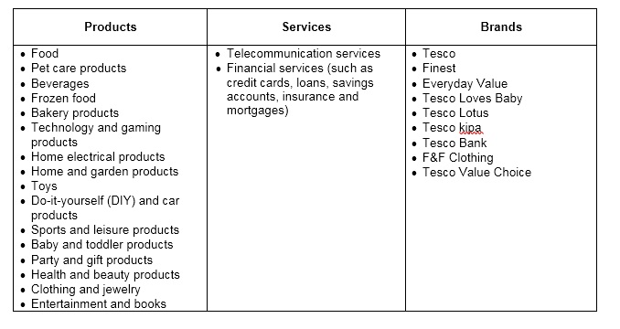

Tesco Statements:

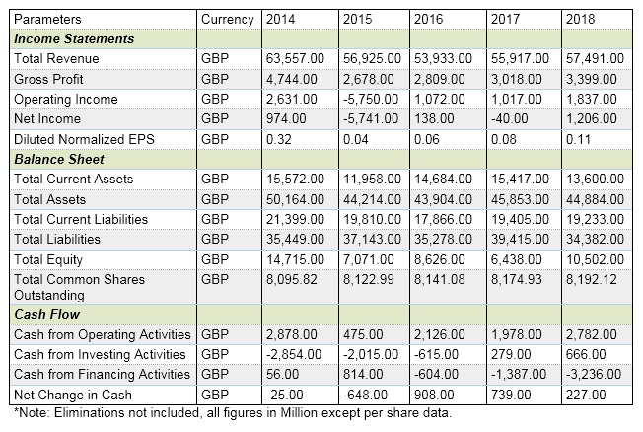

Tesco Key Ratios:

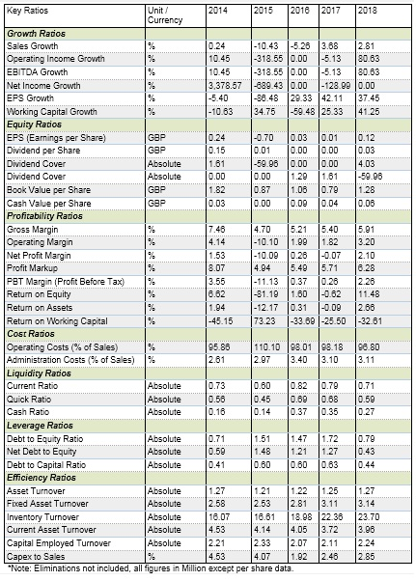

‘5 Whys’ regarding Tesco Financial instability

Question | Answer
- Why Tesco is closing its branches?  - Why Tesco have lost its customers?  - Why the products are more expensive?  - Why he doesn’t have the right suppliers?  - Why the management team is not paying the invoices on time?  - Why they don’t have money? | - Because he lost its customers.  - Because some products are more expensive in its stores.  - Because he doesn’t have the right suppliers.  - Because the management team don’t pay the invoices on time.  - Because they don’t have money.  - Because they are in a financial instability.

Fishbone diagram regarding Tesco Financial instability.

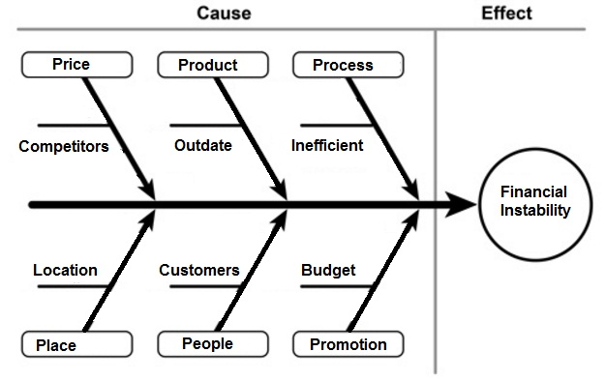

‘5 Whys’ regarding Tesco Bad Reputation

Question | Answer
- Why Tesco have cancels thousands of home delivery orders?  - Why they have problem with the online platform?  - Why they use an old system?  - Why they don’t have money?  - Why they have lost they customers? | - Because they have problem with the online platform.  - Because they use an old system.  - Because they don’t have money for new investments.  - Because they have lost their customers.  - Because they have a bad reputation.

Fishbone diagram regarding Tesco Bad Reputation

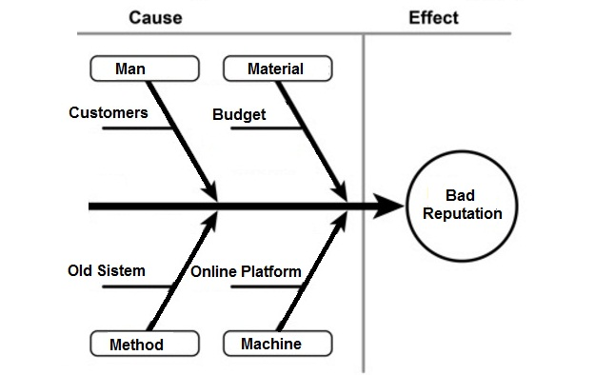

Tesco SWOT window:

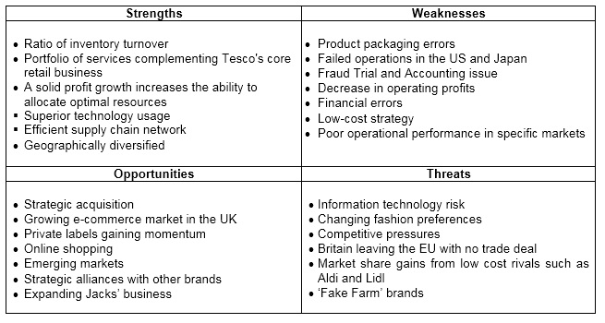

Tesco PESTLE window:

Political | Economic | Social | Technological | Legislative | Environment
- tax policy  - legislation  - political stability / instability  - unemployment rate  - labor law  - trade restrictions | - wage costs  - inflation rates  - interest rates  - unemployment rates  - demand/supply | - customers  - population trends  - lifestyle  - local workforce | - automation  - research and development  - products launch | - employment laws  - consumer protection laws  - health and safety laws  - legislation changes | - pollution

Tesco Stakeholders Power and Interest Matrix:

Level of Interest
Power |  | Low | High
Power | Low | Minimal Effort  - local and national community  - environment  - social organization | Keep Informed  - Customers  - Employees  - Media
Power | High | Keep Satisfied  - governmental agencies  - unions  - trade associations | Key Players  - Suppliers  - Stockholders  - Creditors  - Competitors

Reference

- Ryle, S. (2013). The Making of Tesco: A Story of British Shopping. London: Transworld Publisher.

- Simms, A. (2007). Tescopoly: How One Shop Came Out on Top and Why it Matters. London: Constable & Robinson.

- Tesco plc. (2019). History. [online] Available at: https://www.tescoplc.com/about-us/history/ [Accessed 7 Mar. 2019].

- The Independent. (2019). Tesco facing £129m fine by Serious Fraud Office. [online] Available at: https://www.independent.co.uk/news/business/news/tesco-fined-129-million-by-serious-fraud-office-overstating-profits-a7653166.html [Accessed 18 Mar. 2019].

- Ruddick, G. and Kollewe, J. (2019). Tesco to pay £129m fine over accounting scandal. [online] the Guardian. Available at: https://www.theguardian.com/business/2017/mar/28/tesco-agrees-fine-serious-fraud-office-accounting-scandal [Accessed 18 Mar. 2019].

- Mohamed, N. and Handley-Schachler, M. (2015). ‘Roots of Responsibilities to Financial Statement Fraud Control’, Procedia Economics and Finance, Vol.28, pp.46-52.

- Levitt, T. (2019). Tesco's fictional farms: a marketing strategy past its sell-by date?. [online] the Guardian. Available at: https://www.theguardian.com/lifeandstyle/wordofmouth/2016/mar/22/tescos-fictional-farms-a-marketing-strategy-past-its-sell-by-date#comments [Accessed 17 Mar. 2019].

- Fredenburgh, J. (2019). Tesco under fire for 'farm' brands which sound British but are imported - Farmers Weekly. [online] Farmers Weekly. Available at: https://www.fwi.co.uk/business/tesco-fire-farm-brands-sound-british-imported [Accessed 17 Mar. 2019].

- Lunardo, R., Roux, D. and Chaney, D. (2016). ‘The evoking power of servicescapes: Consumers' inferences of manipulative intent following service environment-driven evocations’, Journal of Business Research, Vol.69(12), pp.6097-6105.

- Meat Management magazine. (2019). Tesco responds to Woodside Farms legal dispute. [online] Available at: https://meatmanagement.com/tesco-responds-to-woodside-farms-legal-dispute/ [Accessed 18 Mar. 2019].

- BBC News. (2019). Tesco Clubcard changes anger customers. [online] Available at: https://www.bbc.co.uk/news/business-42700758 [Accessed 18 Mar. 2019].

- Doggett, A. (2005). ‘Root Cause Analysis: A Framework for Tool Selection’, The Quality Management Journal, Vol.12(4), pp.34-45.

- Dziuba, S., Jarossová, M. and Gołębiecka, N. (2014). ‘Applying the 5 Why method to verification of non-compliance causes established after application of the Ishikawa diagram’, Production Engineering Archives, Vol.2/1, pp.16-19.

- Advantage-marketline-com.ezproxy.uwtsd.ac.uk. (2019). [online] Available at: https://advantage-marketline-com.ezproxy.uwtsd.ac.uk/Product?pid=34972414-9A41-4048-A7B6-1B0017054743&view=SWOTAnalysis [Accessed 19 Mar. 2019].

- Business Strategy Hub. (2019). TESCO SWOT Analysis 2019 | SWOT analysis of TESCO | Business Strategy Hub. [online] Available at: https://bstrategyhub.com/tesco-swot-analysis-2019swot-analysis-of-tesco/ [Accessed 19 Mar. 2019].

- Farooq, U. and Farooq, U. (2019). PESTLE Analysis of Tesco | Marketing Tutor. [online] Marketing Tutor. Available at: https://www.marketingtutor.net/tesco-pestle-analysis/ [Accessed 19 Mar. 2019].

- Friedman, A. and Miles, S. (2006). Stakeholders: Theory and Practice. New York: Oxford University Press Inc., p.7.

- Clarke, T. and Clegg, S. (2000). Changing Paradigms: The transformation of management knowledge for the 21st century. London: Harper Collins Publishers.

Bibliography

- Advantage-marketline-com.ezproxy.uwtsd.ac.uk. (2019). [online] Available at: https://advantage-marketline-com.ezproxy.uwtsd.ac.uk/Product?pid=34972414-9A41-4048-A7B6-1B0017054743&view=SWOTAnalysis [Accessed 19 Mar. 2019].

- Alison, H. (2015). ‘Wrestling with unknown-the dilemma of the nonexecutive director in the UK’, Corporate Finance Review, Vol.19(5), pp.10-16.

- BBC News. (2019). Tesco Clubcard changes anger customers. [online] Available at: https://www.bbc.co.uk/news/business-42700758 [Accessed 18 Mar. 2019].

- Business Strategy Hub. (2019). TESCO SWOT Analysis 2019 | SWOT analysis of TESCO | Business Strategy Hub. [online] Available at: https://bstrategyhub.com/tesco-swot-analysis-2019swot-analysis-of-tesco/ [Accessed 19 Mar. 2019].

- Clarke, T. and Clegg, S. (2000). Changing Paradigms: The transformation of management knowledge for the 21st century. London: Harper Collins Publishers.

- Contributor, P. (2019). PESTLE Analysis for Tesco discusses its Business Environment. [online] PESTLE Analysis. Available at:
https://pestleanalysis.com/pestle-analysis-tesco/ [Accessed 19 Mar. 2019].

- Doggett, A. (2005). ‘Root Cause Analysis: A Framework for Tool Selection’, The Quality Management Journal, Vol.12(4), pp.34-45.

- Dziuba, S., Jarossová, M. and Gołębiecka, N. (2014). ‘Applying the 5 Why method to verification of non-compliance causes established after application of the Ishikawa diagram’, Production Engineering Archives, Vol.2/1, pp.16-19.

- Eden, S., Bear, C. and Walker, G. (2008). ‘Understanding and (dis)trusting food assurance schemes: Consumer confidence and the knowledge fix’, Journal of Rural Studies, 24(1), pp.1-14.

- Farooq, U. and Farooq, U. (2019). PESTLE Analysis of Tesco | Marketing Tutor. [online] Marketing Tutor. Available at: https://www.marketingtutor.net/tesco-pestle-analysis/ [Accessed 19 Mar. 2019].

- Fredenburgh, J. (2019). Tesco under fire for 'farm' brands which sound British but are imported - Farmers Weekly. [online] Farmers Weekly. Available at: https://www.fwi.co.uk/business/tesco-fire-farm-brands-sound-british-imported [Accessed 17 Mar. 2019].

- Friedman, A. and Miles, S. (2006). Stakeholders: Theory and Practice. New York: Oxford University Press Inc., p.7.

- Levitt, T. (2019). Tesco's fictional farms: a marketing strategy past its sell-by date?. [online] the Guardian. Available at: https://www.theguardian.com/lifeandstyle/wordofmouth/2016/mar/22/tescos-fictional-farms-a-marketing-strategy-past-its-sell-by-date#comments [Accessed 17 Mar. 2019].

- Lunardo, R., Roux, D. and Chaney, D. (2016). ‘The evoking power of servicescapes: Consumers' inferences of manipulative intent following service environment-driven evocations’, Journal of Business Research, Vol.69(12), pp.6097-6105.

- Maund, A., Schriek, M. and Tinkler, P. (2017). Certificate in higher education: Skills for the workplace. London: SAGE.

- Meat Management magazine. (2019). Tesco responds to Woodside Farms legal dispute. [online] Available at: https://meatmanagement.com/tesco-responds-to-woodside-farms-legal-dispute/ [Accessed 18 Mar. 2019].

- Mohamed, N. and Handley-Schachler, M. (2015). ‘Roots of Responsibilities to Financial Statement Fraud Control’, Procedia Economics and Finance, Vol.28, pp.46-52.

- Morgan, P. (2017). Business student’s guide to study and employability. Los Angeles: SAGE.

- Ruddick, G. and Kollewe, J. (2019). Tesco to pay £129m fine over accounting scandal. [online] the Guardian. Available at: https://www.theguardian.com/business/2017/mar/28/tesco-agrees-fine-serious-fraud-office-accounting-scandal [Accessed 18 Mar. 2019].

- Ryle, S. (2013). The Making of Tesco: A Story of British Shopping. London: Transworld Publisher.

- Simms, A. (2007). Tescopoly: How One Shop Came Out on Top and Why it Matters. London: Constable & Robinson.

- Tesco plc. (2019). History. [online] Available at: https://www.tescoplc.com/about-us/history/ [Accessed 7 Mar. 2019].

- The Independent. (2019). Tesco facing £129m fine by Serious Fraud Office. [online] Available at: https://www.independent.co.uk/news/business/news/tesco-fined-129-million-by-serious-fraud-office-overstating-profits-a7653166.html [Accessed 18 Mar. 2019].

- Turner, J. and Wilson, K. (2006). ‘Grocery loyalty: Tesco Clubcard and its impact on loyalty’, British Food Journal, Vol.108(11), pp.958-964.

