School of Engineering

Factory Control
Control Technology

Paul Benbow
2014803
30/06/2023



Executive Summary
This report details the importance of establishing the function of a machine and the equipment required before the specification of a Programmable Logic Controller is determined. Programmable Logic controllers vary in specification therefore, one type may not be suitable for all applications. Foresight must be used to establish future requirements for a machine, this will ensure that a programmable Logic Controller is neither under specified nor over specified.
A Programmable Logic Controller provides key features for the safe operation of a machine hence, adequate training an authorised hierarchy must be established to ensure the safe operation of a Programmable Logic controller and its associated Human Machine Interface.

Table of Contents
Executive Summary i
Introduction 1
Literature Review 1
Main Findings 1
Conclusion 2
Discussion 3
Appendix A 4
Appendix B 16
Appendix C 18
Appendix D 19
Appendix E 20
Appendix F 21
Bibliography 22

Table 1 A register of Equipment required. 2
Table 2 Pros and Cons of fixed and modular PLC's 3
Table 3 Pros and Cons of relay and solid state output modules 3

Introduction
This report will review various categories of Programmable Logic Controllers which are available to an engineering team during the design of an automated process. Their characteristics shall be explained and comparisons made to determine the authors opinion on positive and/or negative attribute.
An explanation of the decisions made during the design process shall be made and details given for alarm and warning strategies.

Literature Review
A Programmable Logic controller (PLC), facilitates automation of a manufacturing process with translation of ‘discrete’ or ‘analogue’ input signals to produce an appropriate output action.
A discrete input is binary, producing 1’s or 0’s to represent an “on” or “off” state; a proximity switch detecting an item’s position on a conveyor being a typical example. In contrast to a discrete input, An analogue input’s signal value varies infinitely to represent a dynamic measurement such as; temperature; distance.
Current PLC’s can be categorised in terms of physical structure, then classified by the components used to generate the required output action. This is so, as the characteristic of the component often influences the response of the PLC (Element14, 2023).
A PLC is constructed with four major hardware components; an Input Module; Power Supply; Computer Processor Unit; an Output Module. The manufacturer of the product will arrange these components to produce a fixed integrated or a Modular PLC (Philips, 2022). Additional types of PLC’s are available such as Soft or Distributed PLC’s but, are less common
A Fixed PLC is produced as an integrated unit with the quantity of Input/Output (I/O) modules and it’s memory size determined by the manufacturer. They are designed to be cost effective therefore, component specification is minimal and when repairs are required, they are made difficult because of the factory-assembled construction.
The Modular PLC can be adapted as the design engineer requires. A chassis or rack provides structure for the assembly, separate components such as; I/O modules; power supply and CPU added, to meet the specific requirements of the system. The complexity of these builds are costly and require containment which provides additional space with sufficient integrity.
Furthermore, components of Fixed and Modular PLC output modules are used to create a sub-category.
The first PLC, developed in the 1960’s to easily re-configure industrial sequential processes, used relay outputs. Relay Output PLC’s are current in today’s manufacturing industries, providing a physical electrical isolation for Alternative Current (AC) and Direct Current (DC) systems. However, the continuous switching action of mechanical parts imposes a short life expectancy for these PLC’s (Mortenson, 2021).
The evolution of electronic solid state components saw the introduction of Transistor Output and TRIAC Output PLC’s.
Transistor Output PLC enables current to flow through a DC circuit but, not through an AC circuit. Vise Versa a PLC with a TRIAC Output would allow current to flow through an AC circuit but, not through a DC circuit.
Solid state components used in an Output Module prolong a module’s life and reduces reaction times as these components do not have moving parts, they do not cycle between the “on” and “off” position. The component design means a physical isolation is not created when switching to the “off” position providing a route for current leakage to ground. The material used in such components introduces a negative element to the design which restricts the current carrying capacity to ~0.3 amps (Muthukrishnan, 2021).

Main Findings
Programmable Logic controllers were conceptualised to adapt sequential industrial manufacturing easily, allowing mass production of varied products using the same machinery.
The design of a PLC system such as that of which this report is reviewing, should have enough foresight to anticipate change. Allowing reasonable expansion to cater for future product changes. Modular PLC systems provide this facility however, cost for purchase and installation shall be greater than that of a fixed PLC.
A decision of; modular or fixed PLC cannot be constrained to cost, consideration must be made to the specification of output modules intended to be used. A relay output required to switch frequently shall require maintenance often. If contained within a fixed PLC a repair will be difficult to effect and a replacement PLC likely to be required incurring production downtime. The correct specification of an output module produces an optimal action. It would not, for instance be appropriate to use a Transistor Output module to switch an inductive load of 2 amps.

Conclusion
This report will review the conveyor system illustrated in Appendix B. Table 1 itemises the equipment required to construct the conveyor system. Standard belt conveyors supplied by csi-products (2023), require an electrical supply of 240 volts with a current loading of 10 amps therefore, a PLC producing an output to directly drive a conveyor of this type is impossible as.
Table 1 A register of Equipment required.
The current load of each conveyor will require the PLC to act as a “slave” relay to operate a contactor capable of switching current drawn by each motor. It is for this reason, that this application requires a Relay Output Module PLC.
The conveyor system which has been design for this brief is able to sort four types of boxes according to two specific weights and two specific sizes. Future demand for this system might require additional boxes to be sorted therefore, capacity for expansion is a necessity.
When designing a PLC programme Perkon (2017), draws attention to the possibility of the design engineer becoming confused and wasting time if the machines control modes have not been defined. Appendix F shows a process map created for this design brief to determine the steps of the process to aid in the design of the programme.
The programme has been written using PLC ladder logic as it’s language and consists of 13 networks. Each Network has been titled and has a brief description of its purpose (as shown in Appendix A)
To enable control of the system via the PLC a HMI has been created. The HMI consists of three screens; The Root Screen (Appendix C); Warning/Alarm Screen (Appendix D); Engineer’s Screen (Appendix F).
The Root Screen can be considered as the operators “Home Page”, allowing them to start and stop the system, review total and individual box counts, reset all counters and to determine whether an alarm or warning exists. The operator can navigate to other screens with the “arrow” or “engineer” icon.
The Warning/Alarm screen enables the operator to identify the reason for a master alarm or warning displayed on the Root Screen. The Screen has four categories; Engineering Alarms; Process Alarms; Warnings; Master Alarm Interlock.
There are five individual warnings that might arise, each will not stop the system, there purpose is to inform the operator if a pre-defined number of boxes fall from a section of the conveyor system.
Process alarms are to stop the conveyor system if the number of boxes which fall from a section of conveyor exceeds the “warning” value the “master alarm interlock” is activated.
Process alarms and warnings have not been designed to mitigate a safety threat but rather, to mitigate process losses.
Engineering alarms have been designed to mitigate safety threats and monitor three conditions; Emergency stop activated; Perimeter gate opened; scales overweighing.
If an emergency stop is activated or the perimeter gate is opened, the “master alarm interlock” activates. Ensuring that the emergency event has been normalised a person of authority who has an engineer’s login will need to access the Engineer’s Screen to reset the Master Alarm.
If the weigh scale conveyor weighs over a predefined limit the Master Alarm is activated. The cause of this might be multiple boxes on the scale at one time or a box which is out of specification regardless, an engineer is required to investigate therefore, only an authorised person can access the Engineer’s Screen with a User Login.
Warnings can be reset by operating the “counter reset” button on the Root Screen.
The Engineer’s Screen requires an authorised person with a User Login to access (User Login; Engineer, Password; 12345). An authorised person should know the alarm strategy of the system therefore, should know the consequence of an alarm that is reset without the alarm event being resolved.
The Engineer’s Screen enables the engineer to determine set points at which point warnings or alarms are triggered but, also facilitates further fault finding. A Default Setpoint button enables the engineer to reset pre-defined variables if the PLC losses power. The variables can also be adjusted manually by amending setpoint values.

Discussion
It is important to define the purpose of the machine which the PLC will be operating, before considering its type; model or manufacturer. The process flow chart should be a useful tool to aid this process with all stakeholders.
Once purpose of the machine has been agree, specification of electrical equipment such as motors need to be understood as this information shall be important when determining the specification of the PLC.
When specifying a PLC considerations must be made to each pros and cons of each attribute associated with a model. One type of PLC may be suited to provide the functionality of one machine but, poorly-suited for another. Table 2 and Table 3 itemises the Pros and Cons with first, the structure type and, then the type of output modules. It is the authors opinion that; a modular PLC would provide scope for future expansion, used in conjunction with Relay output modules would provide a versatile system hence, would be the most favourable.
Table 2 Pros and Cons of fixed and modular PLC's
Table 3 Pros and Cons of relay and solid state output modules
In systems that contain equipment that present hazards such as; entrapment or crushing, safety is paramount so, when devices that provide safety are activated, safety interlocks should be reset by personnel who are authorised and understand the alarm strategy of the system.
The HMI for this systems requires an authorised person to reset any alarm, adequate training should be given to such personnel.

Appendix A
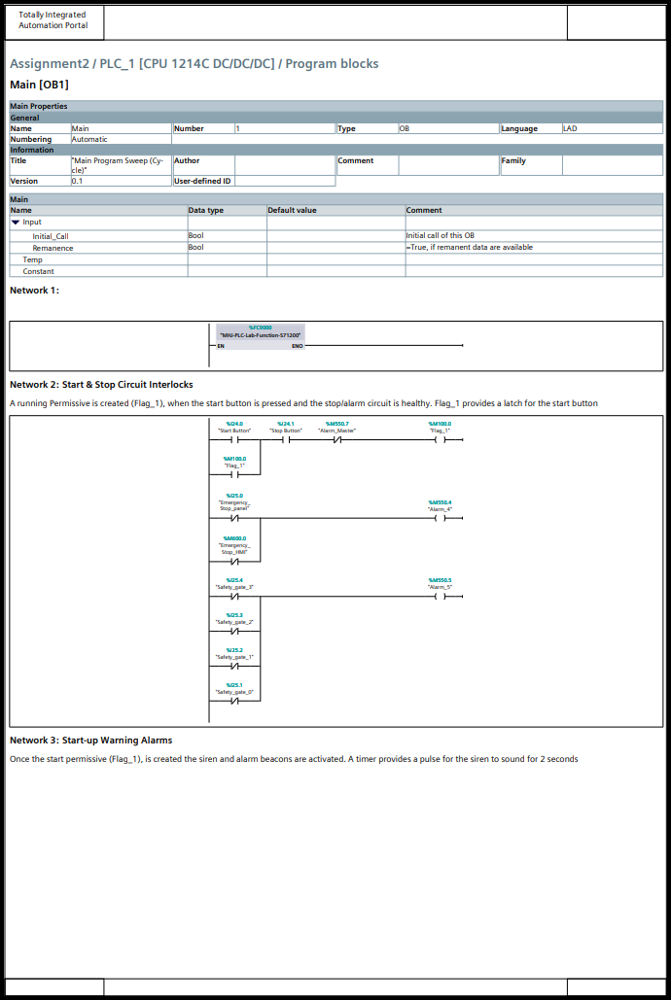
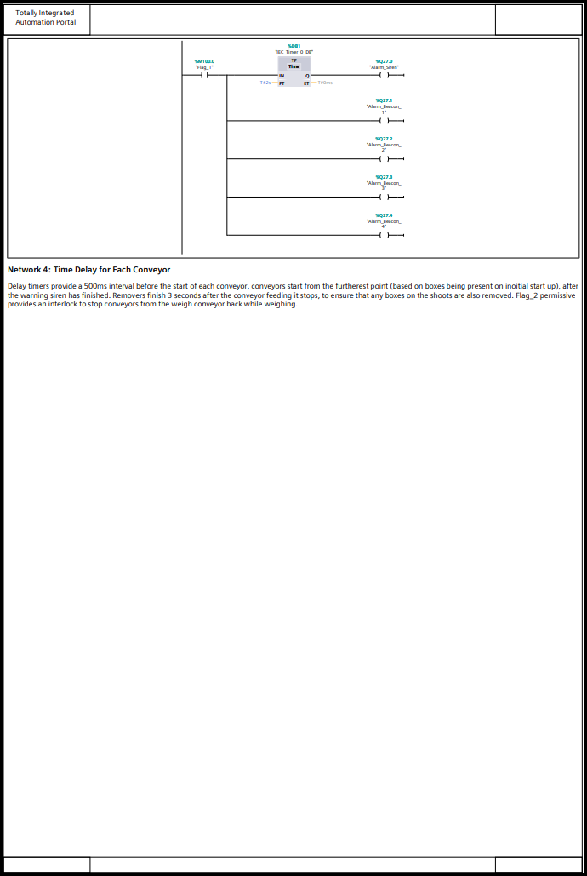
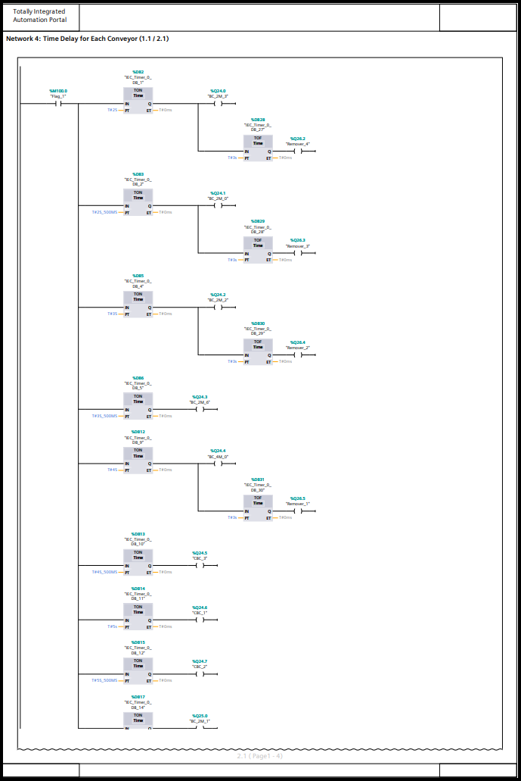
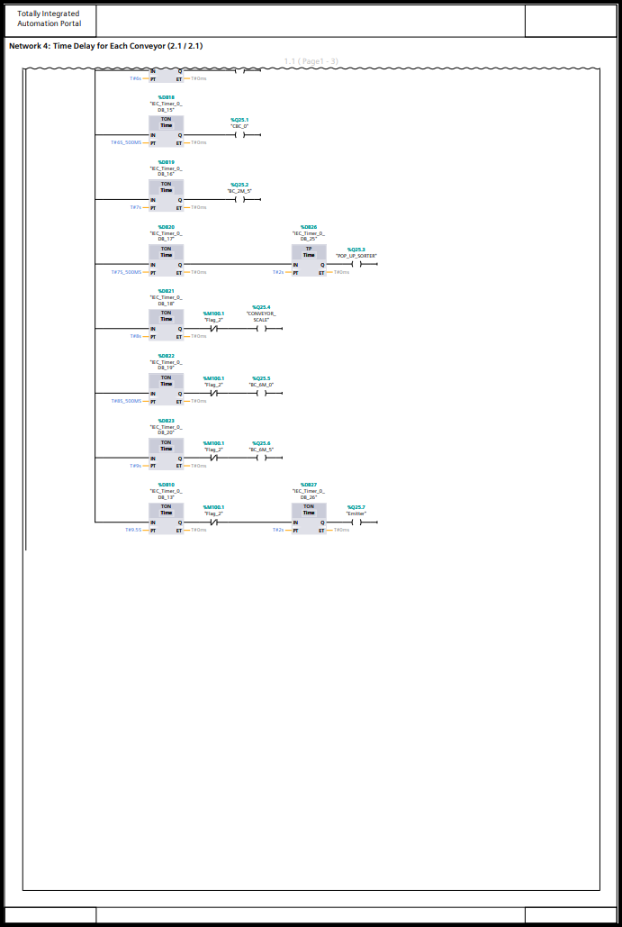
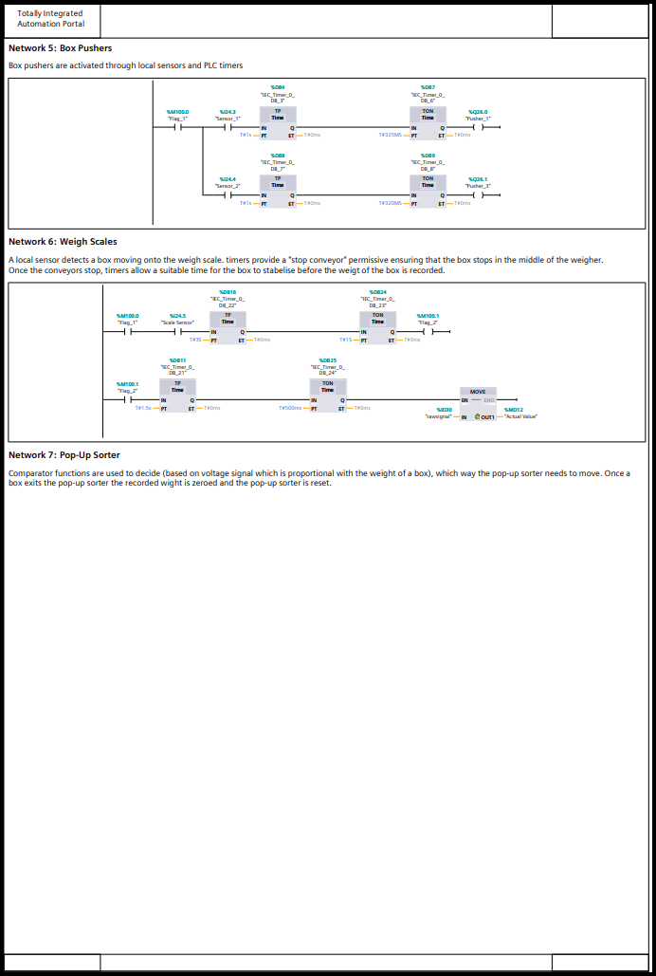
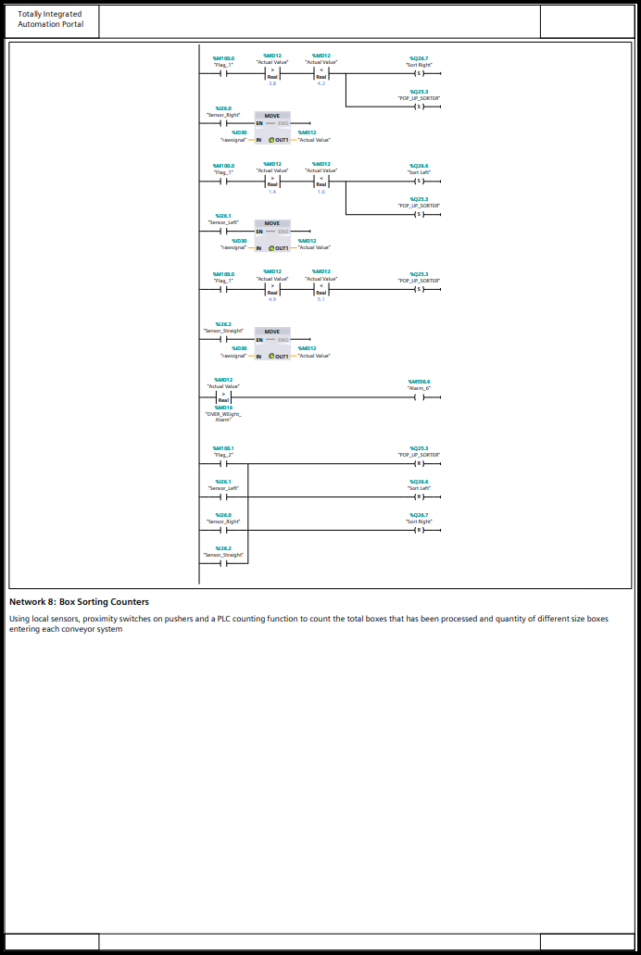
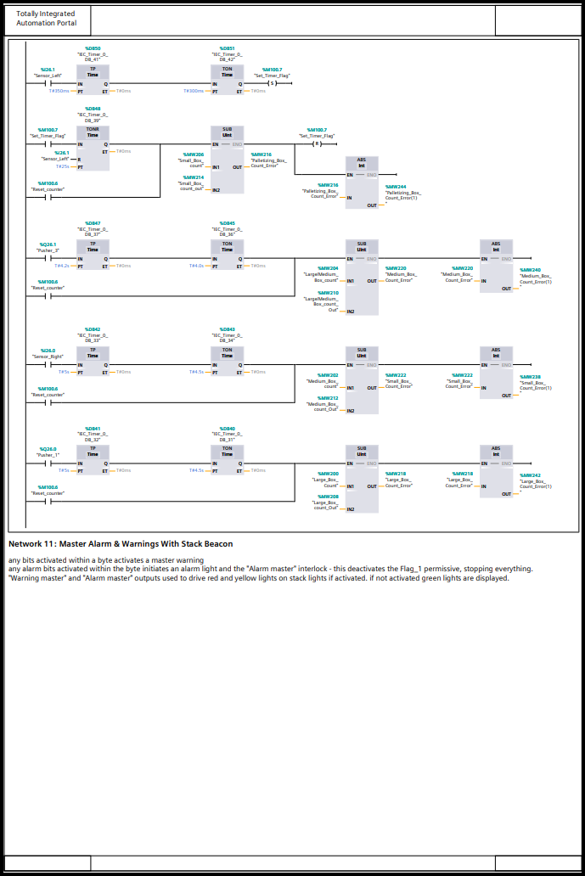
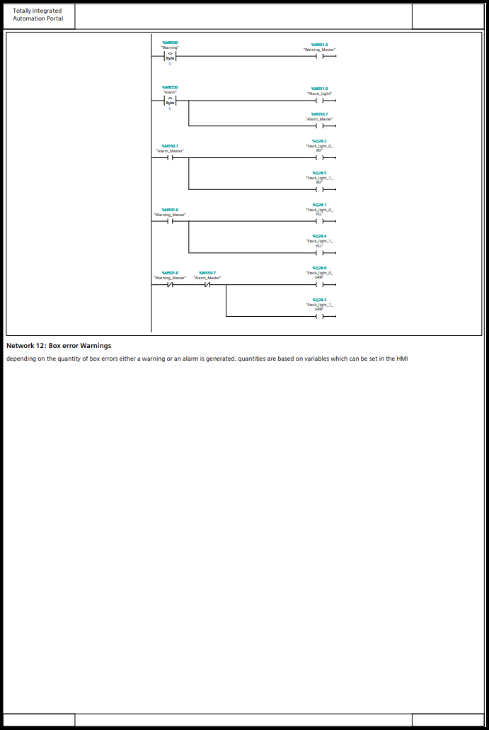
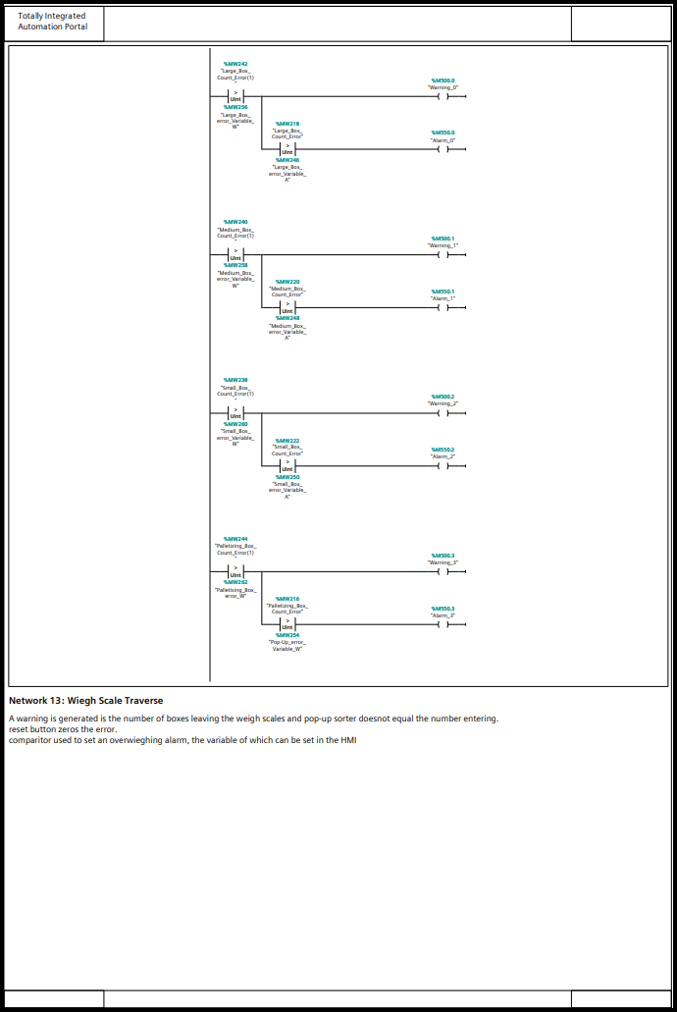
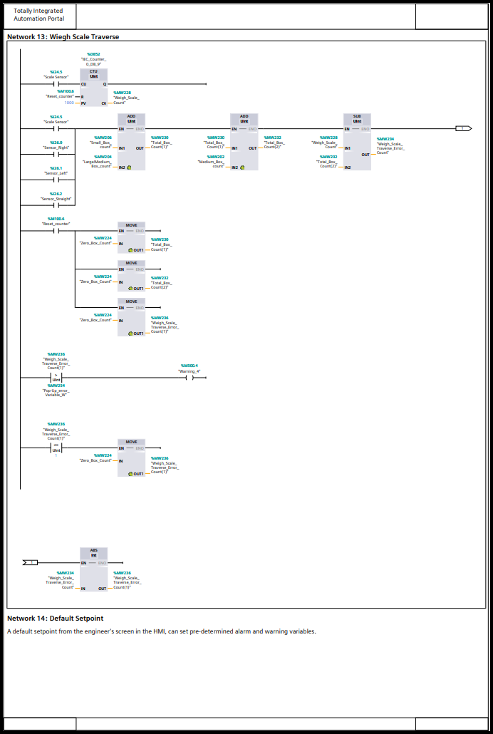
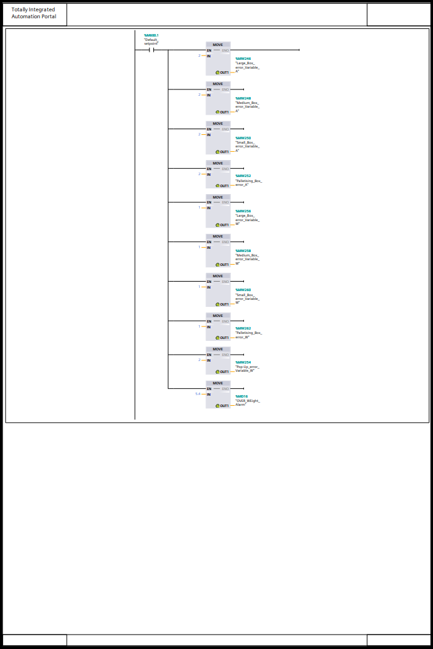

Appendix B
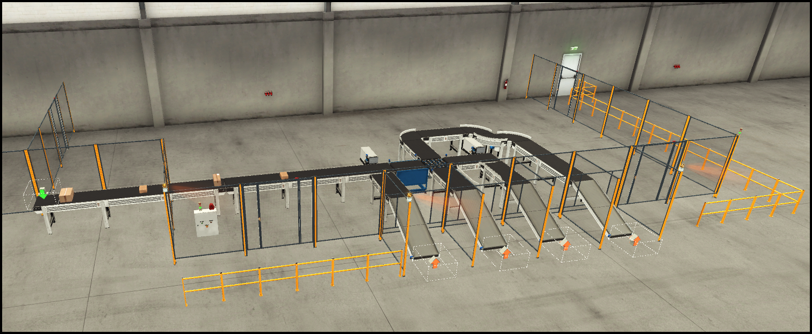
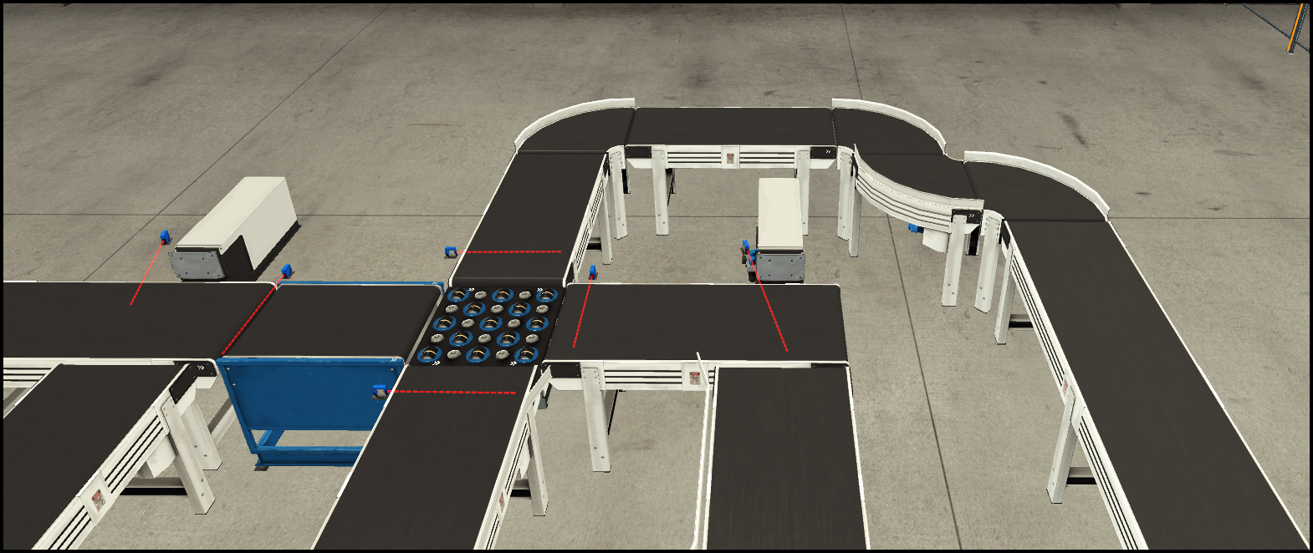

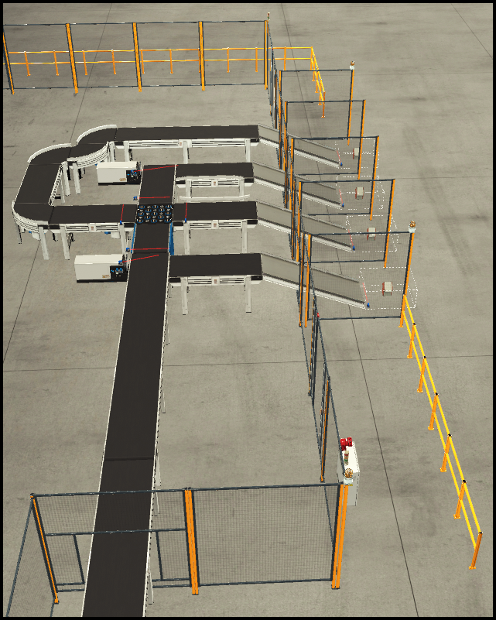

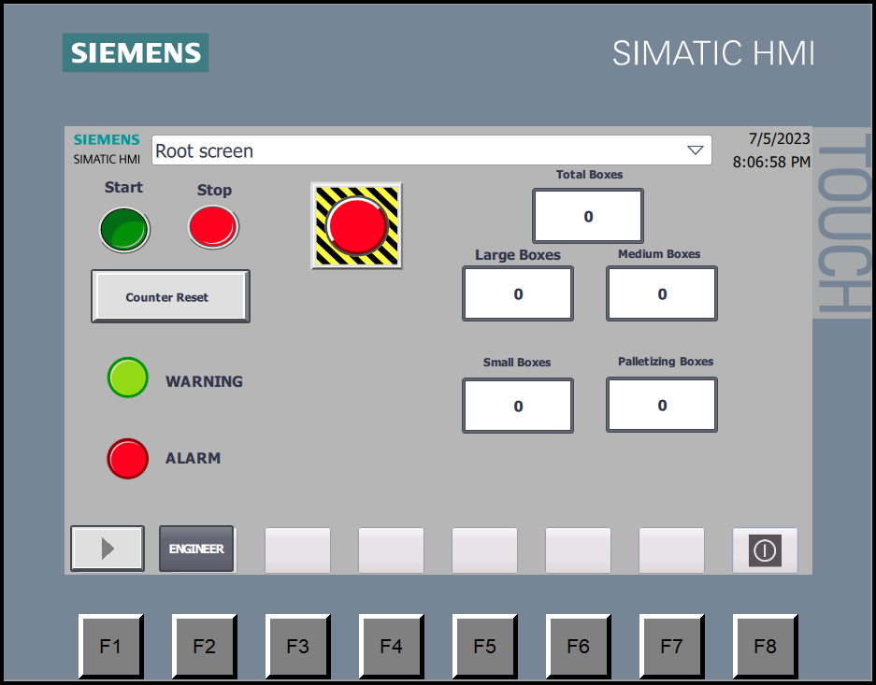
Appendix C

Appendix D
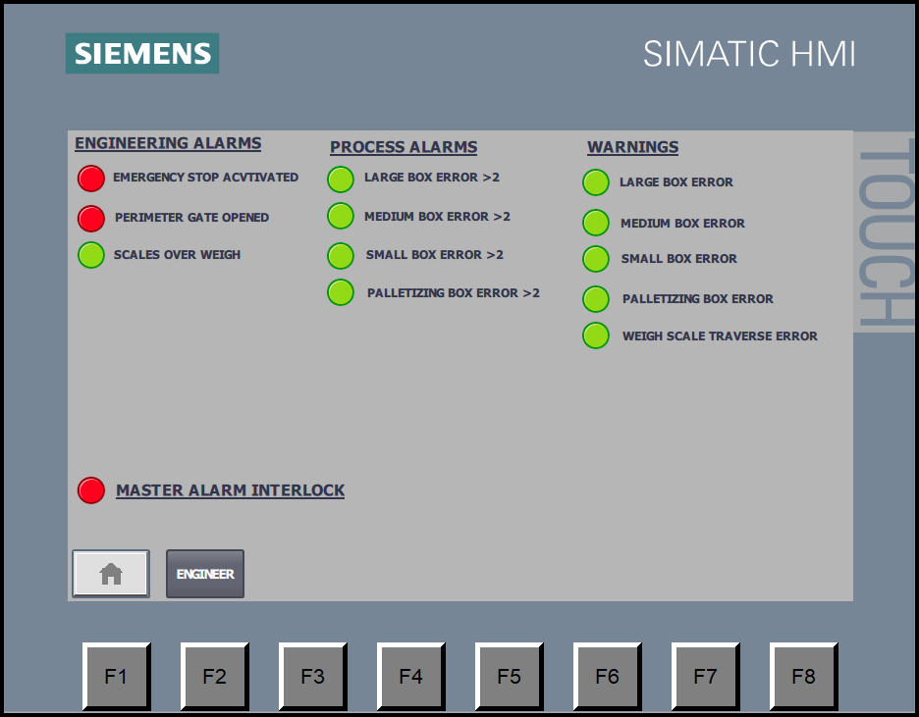

Appendix E
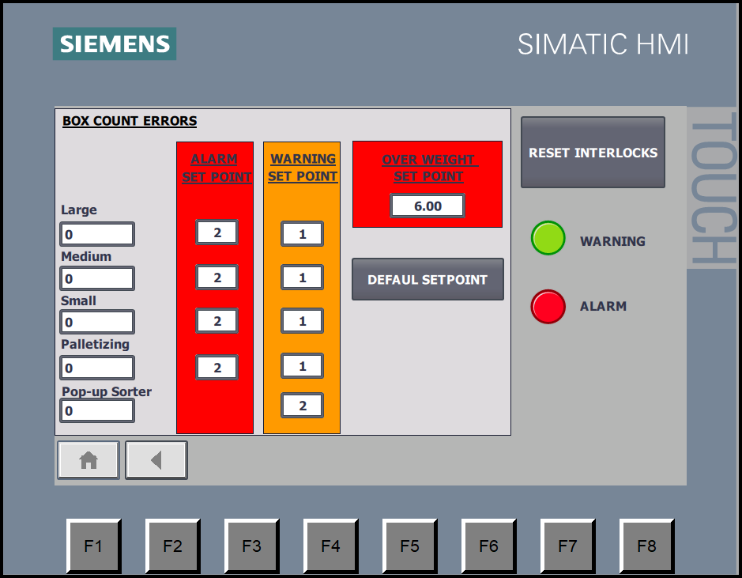

Appendix F
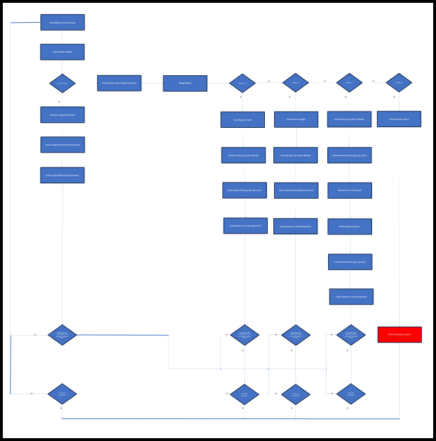

Bibliography
automationforum.co, 2023. What are the types of PLC?. [Online]
Available at: https://automationforum.co/what-are-the-types-of-plc/
[Accessed 4 July 2023].
csi-products, 2023. MEDIUM DUTY BELT CONVEYORS - 300MM WIDE. [Online]
Available at: https://www.csi-products.co.uk/warehouse/warehouse-equipment/conveyors/belt-conveyors/medium-duty-belt-conveyors-300mm-wide
[Accessed 06 July 2023].
Desouttler, 2023. Industrial Revolution - From Industry 1.0 to Industry 4.0. [Online]
Available at: https://uk.desouttertools.com/your-industry/news/1242/industrial-revolution-from-industry-1-0-to-industry-4-0-2
[Accessed 29 04 2023].
Element14, 2023. PLC design in Automation and Industrial Control Applications. [Online]
Available at: https://in.element14.com/industrial-application-plc-design#:~:text=PLCs%20are%20classified%20into%20three,output%2C%20and%20relay%20output%20PLC
[Accessed 04 July 2023].
Groover, M. P., 2008. Automation, Production Systems and Computer-integrated Manufacturing. Toronto: Pearson.
Mortenson, T., 2021. Realpars. [Online]
Available at: https://realpars.com/plc-output/
[Accessed 3 July 2023].
MRO-Electric, 2018. Modicon PLC History. [Online]
Available at: https://medium.com/@MROElectric/modicon-plc-history-60d78aade78e
[Accessed 29 04 2023].
Muthukrishnan, V., 2021. What is A PLC? (Programmable Logic Controller). [Online]
Available at: https://www.electrical4u.com/programmable-logic-controllers/
[Accessed 4 July 2023].
Perkon, D., 2017. How to write a PLC step sequence program. [Online]
Available at: https://www.controldesign.com/control/control-software/article/11317174/how-to-write-a-plc-step-sequence-program
[Accessed 06 July 2023].
Philips, R., 2022. Different Types of PLC. [Online]
Available at: https://basicplc.com/different-types-of-plc/
[Accessed 4 July 2023].
Rinalducci, S. N., 2023. Sustainability Sucess. [Online]
Available at: https://sustainability-success.com/industry-1-0-to-4-0-2-3-revolution/#industry%203.0
[Accessed 29 04 2023].
Stecke, K. E. & Parker, R. P., 1997. Cells and flexible automation: History and synergistic application, Michigan: University of Michigan Business School.
Zimmerman, G. P., 2008. Programmable Logic Controllers and Ladder Logic, s.l.: Department of Humanities South Dakota School of Mines and Technology.

