
BUSINESS REPORT
COMPARISON OF TWO
HOSPITALITY ORGANISATION
SHANGRI-LA HOTELS AND PREMIER INN HOTELS

Module Name: Financial Management for The Hotel Industry
Module Code: BMIH5007
Student Name: Vasilica Crenganis
Student ID: 2221600
Wordcount: 2000
Lecture Tristan Hawkins
I acknowledge the use of Grammarly (https://www.grammarly.com/) on 15.10.2024 to Check my assignment.
This prompt is used for the check the following text for readability, grammar and syntax
I confirm that I have not presented any AI-generated text as my own work. I confirm I have copies of my drafts, notes, and other resources I used before, and after the use of AI tools which I may be asked to provide in evidence.

Executive Summary
Application of the financial management concept of business is initiated for the general approach of accounting position approach including the value development initiative purpose that is Comprehensive for the development of business strategic growth. In the present situation, a proper comparative analysis related to two different businesses is provided with the initiative of which the general development including the contemporary progress can be measured. The primary analysis of such comparison has been initiated for the hospitality sector in the context of revenue position, market growth, share positions and also the CSR contribution initiated by the business prospect. The present revenue analysis indicates around 46.5% growth formulation for Shangri-La and 55.7% growth for Premier Inn. The initiated approach of Ansoff’s matrix is also structured for the evaluation and formulated initiative of business positioning growth reasons which ultimately provide a proper volume of strategic determination guidance to the business operation. The formulated initiative of present CSR contribution of both the business represents a proper volume of financial funding arrangement and accountability support mainly which is comprehensive for the standardized development in the upcoming. The applied formulations related to the presence strategic block approach also brings at comprehensive guidance support to the management of the business to maintain some proper market growth and competitor position analysis support.

Table of Contents
Introduction 4
Business revenue to identify business progressive growth position 4
Marketing position of business to identify operating progress 5
Marketing growth structure for business values 6
Recognition of CSR contribution by business with operating formulation 8
Recommendation 11
Conclusions 12
References 13

Introduction
The application of financial management for every individual organisation is relevant in the context of financial and non-financial performance analysis that ultimately supports in allocations of resources. In this report, a detailed evaluation related to approach of comparison between two hotel businesses has been provided which mainly belongs to the competitive market environment. To formulate a proper comparison mainly the benchmarking approach has been initiated which provides a focus on the revenue structure of the business, market growth of the business, and strategic formulation of both businesses including the initiated contribution towards the CSR processing. The applicability of the strategic clock including Ansoff’s matrix is also focused in this report that can be initiated for recognising the contemporary position in growth in a proper strategic basis.

Business revenue to identify business progressive growth position
According to the primary identifications the applications of the financial position of both the business an evaluated for the reasons of revenue positioning which will be a sustainable approach for the recognition of business progress. In relation to the present operating position the business structure of Shangri-La Hotels represents the following revenue structure.
 | 2018 | 2019 | 2020 | 2021 | 2022 | 2023
Revenue | 1924108.55 | 1857898.8 | 789732.47 | 948391.03 | 1117349.28 | 1636723.79
Growth |  | -3.4% | -57.5% | 20.1% | 17.8% | 46.5%

According to the primary analysis, the present progressive growth of the business indicates around 46.5% development with the involvement of 66% of the Occupancy rate initiated. The primary measurements related to the value of RevPAR of this particular business indicate the position of 401.74 GBP and the pricing structure per room is around 608.72 GBP. In the present situation, the applications of this type of development expansions of the pricing mainly indicate a progressive volume of supplying expansions in the Middle Eastern country which ultimately indicates a proper proportionate initiative of the law of supply (scmp.com, 2023).
The primary applicability related to the positioning structure of business revenue for the business of Premier Inn provides the following expanded results when the inclusions of the present level of 82% of occupancy support. The volume of this Occupancy represents a high volume of marketing development and contemporary positioning growth in general.
 | 2018 | 2019 | 2020 | 2021 | 2022 | 2023
Revenue | 3295.1 | 2049.1 | 2071.5 | 589.4 | 1703.4 | 2652.2
Growth rate |  | -37.8% | 1.1% | -71.5% | 189.0% | 55.7%

The primary measurement and the formulated level of this particular analysis indicate around 55.7% growth initiative structure of the business with the standardized level of ARR position up to 79.76 GBP per share support. The applied position of the RevPAR level of the business also indicates 65.56 GBP support which is comprehensive and indicates a proper level of marketing stability attribute support in the present operating structure (Whitbread PLC, 2023). Additionally, the approach of this type of engagement also indicates a formulated elasticity of demand concept which can be identified through the support of the present strategic initiative formulated by the management over the business expansions in Germany (PR Newswire, 2024).

Marketing position of business to identify operating progress
According to the present performance structure the applications of market position analysis for both the business in the context of share price in the market, branding of business and Customer demographics aspects that provide proper recognition including performance identification benefits.
Shangri-La Hotels:
- Market Share: The present volume of market share related to this particular business represents the level of 6.435 billion with the overall share pricing level of 49.50 per share. The overall computed EPS level of the business indicates 1.79 per share structure which represents contemporary growth in this business (Yahoo.com, 2024).
- Branding: The present initiative of this business is structured with the engagement of four branding engagements that include Shangri-La Hotels and Resorts, Kerry Hotels, JEN, and Traders which represents a contemporary initiative and value positioning growth for the business.
- Customer demographics: Depending on the market formulation the entire business mainly provides a focus on the upper-class customers with quality-initiated support which is basically identified through the presence of potential income basis. With a high level of quality, this business mainly provides a focus on the reach and potential customers which is supportive to provide luxury support to the customers. In the present situation, the primary demand in the Middle East market represents this particular initiated approach for the business which will be sustainable for the upcoming days (Mahathaven et al., 2023).
Premier Inn (Whitbread plc):
- Market Share: The present level of share prices for the parent company represents around 3137 GBP per share support with the inclusions of market capital level of 5.601 billion. The present initiative of Earning per share indicates the level of 1.60 per share with a PE ratio position of 19.61% position (finance.yahoo.com, 2024).
- Branding: The primary involvement of the parent company mainly structures the overall branding position of this particular business which represents a proper volume of marketing growth and stability formulation benefit.
- Customer demographics: As per the statistics analysis around 93% of customers are basically aware of the business position, 42% are generally aware of the services and the balancing position of 35% represents the loyalty-initiated structure. The primary engagement of value-based operating initiatives including the low price in structure with affordability mainly initiates different forms of operating formulation and customer engagement in his business which is one of the primary USPs for the business growth initiative purpose (whitbread-plc, 2024).

Marketing growth structure for business values
According to the managerial approach, the primary evaluations related to business positions can be evaluated with the support of Ansoff’s matrix that provides a proper significance to the application of the marketing position of the business with the consideration of business values. It mainly initiated to provide focused on four different strategies with two different approaches that are relevant for the stability measurements.
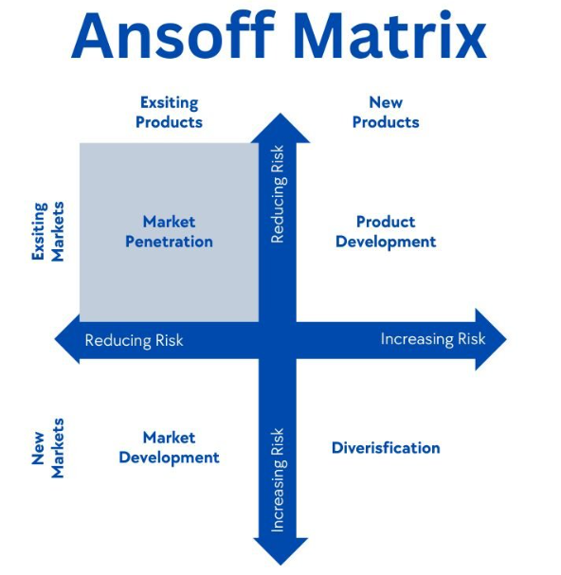
The primary measurements and formulated operating structure of Shangri-La represent a systematic volume of focus on the risk reduction approach through the formulated initiative of market penetration initiative. The present initiated strategy Pioneers of Asian Hospitality project mainly represents the formulation of this Strategic engagement for the business which is accountable for the stability (Hongkongbusiness.hk, 2024). Simultaneously the project of Iconic Global is initiated by the management of this business with the intention of providing a market development initiative in which a proper volume of importance to the new market initiative with the existing product has been structured by the management which increases the risk as well. In this aspect, the present initiative of business expansions in the Middle East countries can be recognised (Shangri-la.com, 2023). The applications of Holistic Programmes for the Modern Urbanite Mainly represent the initiated operating development concept with contemporary support in this business which generally provides a systematic focus on the product development structure which generally increases the volume of risk however also indicates a contemporary positioning growth for the business operation. The initiative of Asian culture in the Middle East represents this type of consequence also.
Applied the present operating position related to the business of Premier Inn with the support of the parent company to provide a significant volume of focus on converting 450 restaurants into the hotel business with a positive branding initiative which will be able to provide revenue progress and stabilities support (Baker, 2024). It can be identified as a product development initiative of this business with the consideration of operating growth and service formation. The present initiative of new strategic engagement of services in Ireland with the initiative of 5000 new hotel support represents a market development initiative where the new market initiative with a new product service is mainly identified (Anderson, 2024). The application of the present strategic initiative related to 400 new rooms in Germany indicates the same proportion of market development strategy which also brings comprehensive operating standardization and accountability support for the business operating benefit.

Recognition of CSR contribution by business with operating formulation
It is identified as one of the relevant attributes in present days which is structured for the development of business goodwill through recognising the initiated contribution formulated by the business for the environment and Society. According to the basic position, the entire business sustainability in Shangri-La is based on three different aspects related to Stay, Savour, and Shine. According to the provided ESG report, the present level of funding associated with sustainability-linked bank loans of this business is 2.98 billion pounds which indicates progressive operating support (Shangri-la.com, 2024).
For the reasons of initiating employed development, the business also initiated a contribution of 22189.64 GBP in the present period. In order to identify the sustainability initiative, the present contribution for the wildlife development in Marine Sanctuary in Cebu, Philippines is identified initiated by the business for the environmental progress. A primary contribution towards the Dan Yang School with educational support is initiated by the business for the social initiative purpose that formulates proper financial guidance to more than 200 learners (shangri-la.com, 2023). The primary analysis of the sustainability report also indicates the initiated carbon intensity level projected by the business is around 24% and energy intensity indicates around 12% which is progressive and stable for the upcoming.
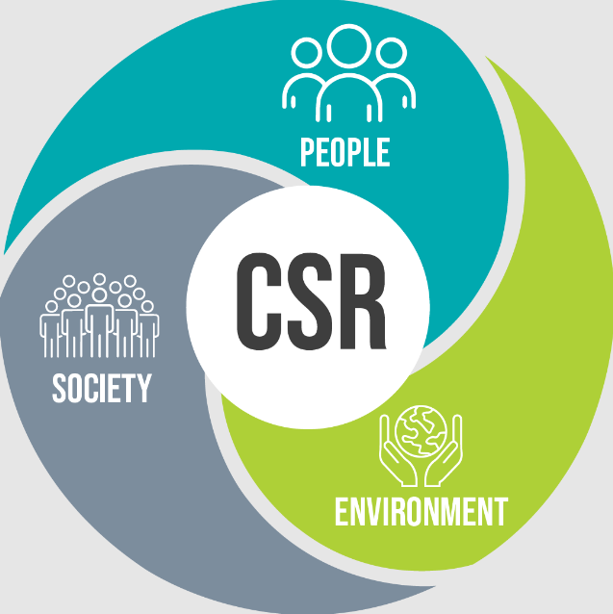
As per the sustainability report, the CSR initiative over the business of Premier Inn with the involvement of the parent company is mainly initiated through the new strategy of the Force for Good sustainability program. As per the analysis of the basics, this report indicates around 79% of employee’s satisfied with this business and the present generated funding volume for the employee development and sustainability approach is around 24.3 million GBP which indicates a progressive growth including the value positioning support in a formulated order (Whitbread PLC, 2024).
Apart from this initiative in the present year to provide a proper volume of sustainability formulations the management has decided to issue around 550 million GBP of green bonds which will be able to develop the present infrastructure of the environment and sustainability. The formulated initiative a present financial position of the business also indicates the financial arrangement of 2388767 GBP regarding disaster emergencies, 234 million GBP for Green Constructions and 38.5 million GBP for sustainability engagement approach (whitbread.co.uk, 2024).
Strategies of both businesses with Bowman's Strategic Clock
The applicability of this clock initiative is mainly structured for the reason of the identified approach about the position of both the business compared to the competitor so that stable growth including the contemporary initiative can easily be determined.
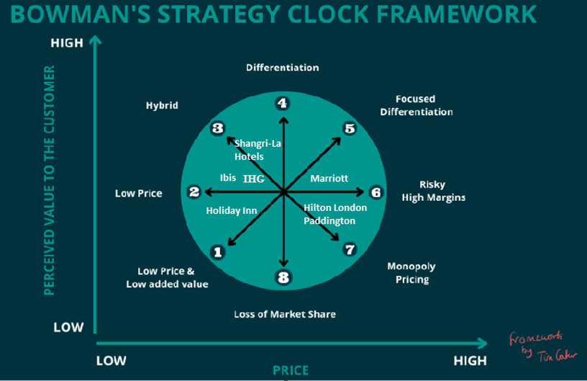
Application of this ever diagram represents the business Shangri-La Mainly belongs to the level of High Price / Differentiation approach with the processing of present marketing operations that indicates a proper level of strategic initiative for the business performance. The present strategic support of expanding the business operations in some iconic places like the Middle East represents a comprehensive guidance and stability attribute in a formulated order which also identifies the progressive structure of the business as well (scmp.com, 2023). The same market consequences are also noticed in IHG which is identified as one of the primary competitors of Shangri in an international aspect.
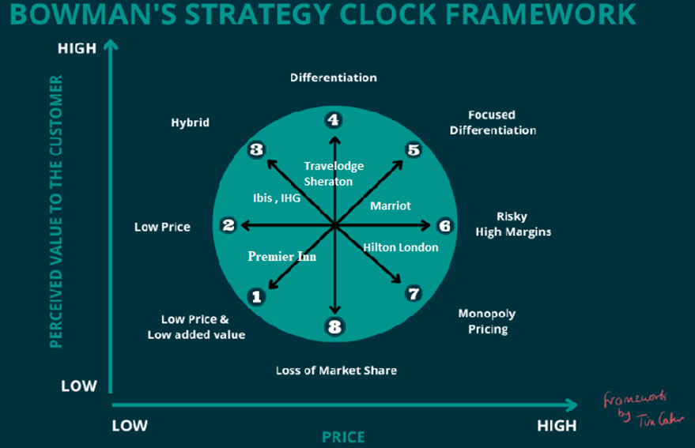
Application of the above diagram represents the same clock framework related to the business of Premier Inn Hotels That indicates currently the business holds the approach of low price / low added value approach which can be identified as cost leadership positioning. The formulation of generally the hybrid initiative and pricing structure depending on the customer demand initiative are mainly formulated in this business which represents a proper volume of stability support. For this aspect, the present initiative of initiating a new hotel business with the selling initiative of the previous restaurant represents a progressive type of low-added value positioning initiative for this business (Baker, 2024).
The primary structure of one of the largest competitors of this business Travelodge also used to follow this type of strategic formulation with the hybrid initiative that represents a positive standardisation structure and which is identified through the present initiative of the business regarding maintaining the price per room £39 or less support (Travelodge, 2024).

Recommendation
- Under the present position, the management of Shangri-La Hotel needs to provide a significant level of focus on the luxury eco-resorts in some of the relevant UNESCO World Heritage sites which will be sustainable and progressive for business expansions and development in an effective manner.
- Simultaneously the management of Premier Inn needs to provide importance to loyalty engagement including some positive value-based offers to the customers depending on their booking volume and also initiate the seasonal discount in support of a positive volume of customer retention and loyalty benefits.

Conclusions
The identified measurements related to different areas of performance mainly stated that at the present situation, each business represents a comparative and comprehensive value positioning support which is optimal for the maintenance of business growth. The presence of strategic formulations including the pricing structure of the business also represents a contemporary opportunity for the competitive performance-gaining approach which will be sustainable for the business stability development in the upcoming. The applied clock analysis including the matrix evaluations also represents a progressive value formulated attribute support for both the business which needs to focus on some specific strategic values for future compatibility.

References
Anderson, J. (2024). Whitbread grows its development team in Ireland as it doubles down on delivering its 5,000 bedroom target - Whitbread PLC. [online] Whitbread PLC. Available at: https://www.whitbread.co.uk/whitbread-grows-its-development-team-in-ireland-as-it-doubles-down-on-delivering-its-5000-bedroom-target/ [Accessed 15 Oct. 2024].
Baker, T. (2024). ‘Keep rinsing and repeating’: Whitbread’s quest to grow Premier Inn brand to 125,000 UK rooms. [online] CoStar. Available at: https://www.costar.com/article/567214170/keep-rinsing-and-repeating-whitbreads-quest-to-grow-premier-inn-brand-to-125000-uk-rooms [Accessed 15 Oct. 2024].
Elsworth, T., 2023. Understanding Strategic Analysis: A Simple Guide to Choosing, Developing and Implementing Business Strategy. Taylor & Francis.
finance.yahoo.com. (2024). Whitbread plc (WTB.L) Stock Price, News, Quote & History - Yahoo Finance. [online] Available at: https://finance.yahoo.com/quote/WTB.L/ [Accessed 15 Oct. 2024].
Hongkongbusiness.hk (2024). Pioneers of Asian Hospitality project by shangri-la. [online] hongkongbusiness.hk. Available at: https://hongkongbusiness.hk/co-written-partner/event-news/shangri-la-circle-pioneers-future-hospitality-innovative-technology [Accessed 15 Oct. 2024].
Mahathaven, M.T.W., Soleimani, M., Jayant, J., Anwar, M. and Quttainah, R.P., 2023. Shangri-La Hotels and Resorts’ People and Culture Strategy in Deriving Employee Satisfaction.
PR Newswire (2024). GLN International partners with SendMn and QPay, expands the QR cross-border payment network to Mongolia - Thailand Business News. [online] Thailand Business News. Available at: https://www.thailand-business-news.com/thailand-prnews/gln-international-partners-with-sendmn-and-qpay-expands-the-qr-cross-border-payment-network-to-mongolia [Accessed 13 Oct. 2024].
scmp.com (2023). Exclusive | Shangri-La Group’s expansion in the Middle East to start paying off. [online] South China Morning Post. Available at: https://www.scmp.com/business/article/3239583/shangri-la-poised-benefit-middle-easts-economic-rebound-after-decades-long-expansion-spree [Accessed 15 Oct. 2024].
shangri-la.com (2023). Malaysia Public Disclosures. [online] Available at: https://sitecore-cd.shangri-la.com/-/media/Project/Shangri-La-Group/Investor/Files/Malaysia-Public-Disclosures/Financial-Information/Malaysia-Financial-Reports/SHANG-Annual-Report-2023.pdf [Accessed 15 Oct. 2024].
Shangri-la.com. (2023). Shangri-La Group. [online] Available at: https://www.shangri-la.com/group/media/media_post?post=Global%20Brand%20Campaign [Accessed 15 Oct. 2024].
Shangri-la.com. (2024). From rocks to corals | Shangri-La Mactan, Cebu. [online] Available at: https://www.shangri-la.com/cebu/mactanresort/about/corporate-social-responsibility/from-rocks-to-corals/ [Accessed 15 Oct. 2024].
Shangri-la.com. (2024). From rocks to corals | Shangri-La Mactan, Cebu. [online] Available at: https://www.shangri-la.com/cebu/mactanresort/about/corporate-social-responsibility/from-rocks-to-corals/ [Accessed 15 Oct. 2024].
Simmons Jr, M., 2023. Retention Strategies Utilized by Hotel Managers to Retain Talent in Job Positions and Reduce Employee Turnover Within Small-and-Medium Enterprise (SME) Hotels: A Phenomenological Study. Northcentral University.
Villagrasa, J., Sánchez, F. and Donaldson, C., 2021. Deciphering the strategic clock hands: from theory to reality. In INTED2021 Proceedings (pp. 9571-9584). IATED.
Whitbread PLC. (2023). Year in review. [online] Available at: https://www.whitbread.co.uk/investors/annual-report/ [Accessed 15 Oct. 2024].
Whitbread PLC. (2024). Environmental impact. [online] Available at: https://www.whitbread.co.uk/sustainability/responsibility/environmental-impact/ [Accessed 15 Oct. 2024].
whitbread.co.uk (2021). Whitbread opens warehouse in Germany to support expansion plans. [online] Whitbread PLC. Available at: https://www.whitbread.co.uk/whitbread-opens-warehouse-in-germany-to-support-expansion-plans/ [Accessed 15 Oct. 2024].
whitbread.co.uk (2024). ESG analysis of business. [online] Available at: https://cdn.whitbread.co.uk/media/2024/05/Whitbread-PLC-ESG-Report-2023.pdf [Accessed 15 Oct. 2024].
whitbread-plc. (2024). Whitbread PLC Preliminary Results: Profit and cash flow soar with Premier Inn UK success. [online] Available at: https://www.directorstalkinterviews.com/whitbread-plc-preliminary-results-profit-and-cashflow-soar-with-premier-inn-uk-success/4121154066 [Accessed 15 Oct. 2024].

