

Student Name: | Charles Maxwell
Student Number: | 1814419
Module code: | BMHP 5003
Course: | BSc L5 T1_GRP
Assignment Title | Introduction to Physiology
Lecturer: | Dr Gulnar Ali

Contents

Introduction

What is High Blood Pressure (HYPERTENSION)

The most common causes of hypertension

Case study

Assessment Report

Care Plan

Medication and its side effects

Conclusion

References

Introduction
In this paper I decided to discuss high blood pressure also known as hypertension. Some members of my family have hypertension which means I can base my paper a person to analyse the causes, and to investigate further to understand various elements that contribute high blood pressure. My assessment report will allow me to ask question the lead to one having high blood pressure.

The study which I will share will be to individual's lifestyle, and how they were diagnosed. As there are different stages of hypertension, I will explain what it leads to and share my understanding of its health implications. My findings let me understand that high blood pressure also known as the "silent killer” because there are very few symptoms, and if not for a regular check-up with your General Practitioner (GP), will not be diagnosed with it. Therefore, leading to deadly diseases such as stroke, memory loss (dementia), heart attack, and many more. It has become a normal practice for all medical staff to check your blood pressure and advice patients of their level.

I will also discuss how the human anatomy, which will explain how the body works which further shed light on the blood stream.
For the purpose of this assignment I have discussed with an anonymous person of my intentions to learn more about my subject, gain the understanding of the causes and a care plan to help them control their blood pressure. I will also take that opportunity to explain to my (patient) how the body works and in respect of hypertension, the heart and blood vessels mainly contribute to hypertension. The three types of blood vessels which main aim is to carry blood through the human system, blood pressure complications can make it harder to pump blood through the vessels therefore causing complications in the arteries or atherosclerosis. This can lead to various problems to the human body leading from mild stoke to extreme stroke, heart failure, dementia and organ diseases such as kidney failure.

This paper is based on physiology, which according to, What is physiology? - The Physiological Society (2020) “Physiology is the science of life. It is the branch of biology that aims to understand the mechanisms of living things, from the basis of cell function at the ionic and molecular level to the integrated behaviour of the whole body and the influence of the external environment. Research in physiology helps us to understand how the body works in health and how it responds and adapts to the challenges of everyday life; it also helps us to determine what goes wrong in disease, facilitating the development of new treatments and guidelines for maintaining human and animal health. The emphasis on integrating molecular, cellular, systems and whole-body function is what distinguishes physiology from the other life sciences.” Below I will discuss my understanding of hypertension.

What is High Blood Pressure (HYPERTENSION)?
“Blood pressure is recorded with 2 numbers. The systolic pressure (higher number) is the force at which your heart pumps blood around your body.
The diastolic pressure (lower number) is the resistance to the blood flow in the blood vessels.
They're both measured in millimetres of mercury (mmHg).
As a general guide:
- high blood pressure is 140/90mmHg or higher (or 150/90mmHg or higher if you're over the age of 80)
- ideal blood pressure is usually considered to be between 90/60mmHg and 120/80mmHg
Blood pressure readings between 120/80mmHg and 140/90mmHg could mean you're at risk of developing high blood pressure if you do not take steps to keep your blood pressure under control.
Everyone's blood pressure will be slightly different. What's considered low or high for you may be normal for someone else.” NHS (2020)

Kittel, D. (2020), published the below chart as a guide, which I find in various publications to be consistent.

The most common causes of hypertension
The most common causes of hypertension according to various sources are the following:
- Family history is a common trend where members of the same family may experience high blood pressure. This due to their collective lifestyle, in diet, exercise routine or none. Ethnic backgrounds are also known to be consistent with high blood pressure, Especially Asian and Afro-Caribbean.
- Your diet can contribute to high blood pressure. High intake of salt is a contribution to your body functioning in a healthy way which can lead to hypertension. Excessive consumption of red meat and oily food can also be bad for you.
- Other contributing factors include the excessive consumption of alcohol.
- Smoking is also a highly contributor to high blood pressure.
- Otherwise unknown to many stress can contribute to hi BP
- The “three Ss” which are smoking, stress and salt consumption are also major factors that can contribute health mishaps and lead to high blood pressure. These allow your body to hold more fluid, therefore causing your heart to work more harder and eventually causing high blood pressure.
Further studies to understand hypertension led me know there are two types, according to (High Blood Pressure: Causes, Symptoms, Medication, Diet, and More, 2020),

”Primary hypertension
Primary hypertension is also called essential hypertension. This kind of hypertension develops over time with no identifiable cause. Most people have this type of high blood pressure.
Researchers are still unclear what mechanisms cause blood pressure to slowly increase. A combination of factors may play a role. These factors include:
- Genes: Some people are genetically predisposed to hypertension. This may be from gene mutations or genetic abnormalities inherited from your parents.
- Physical changes: If something in your body changes, you may begin experiencing issues throughout your body. High blood pressure may be one of those issues. For example, it’s thought that changes in your kidney function due to ageing may upset the body’s natural balance of salts and fluid. This change may cause your body’s blood pressure to increase.
- Environment: Over time, unhealthy lifestyle choices like lack of physical activity and poor diet can take their toll on your body. Lifestyle choices can lead to weight problems. Being overweight or obese can increase your risk for hypertension.

Secondary hypertension
Secondary hypertension often occurs quickly and can become more severe than primary hypertension. Several conditions that may cause secondary hypertension include:
- Kidney disease
- Obstructive sleep apnoea
- Congenital heart defect
- Problems with thyroid
- Side effects of medications
- use of illegal drugs
- Chronic use of alcohol
- Adrenal gland problems
- certain endocrine tumours”

Case study
One of my family member discovered that they had high blood pressure during a normal visit to their GP. They had symptoms of regular headaches and dizziness. The initial readings of their blood pressure results meant that their systolic and diastolic was 180 and 90 mm Hg respectively. This raised the concern of the GP as you will find that any healthy person of Afro Caribbean background, and under the age of 40 years, should not have systolic and diastolic more than 120 and 80 mm Hg.

In (appendix 1) the chart according to (Kittel, 2020) confirms the subject of my case study had hypertension.
Assessment Report
In appendix 2 of the assignment, there are various health care issues that contributed to my patient having high blood pressure.

The following were contributing factors:
- They did not have an exercise routine which meant that the exercise that is needed for the body to be able to regulate blood circulation was lacking. Less or no exercise routine can lead to obesity which can cause Cardiac complications. Cardiac arrest is a detriment to once life and mostly causes instant death. According to heart.org (2020), “Sudden cardiac arrest occurs suddenly and often without warning. It is triggered by an electrical malfunction in the heart that causes an irregular heartbeat (arrhythmia). With its pumping action disrupted, the heart cannot pump blood to the brain, lungs and other organs. Seconds later, a person loses consciousness and has no pulse. Death occurs within minutes if the victim does not receive treatment.

- Their alcohol intake was above the average recommendation.
“If you drink too much alcohol, this will raise your blood pressure over time. In addition, alcohol contains a lot of calories which can make you gain weight and as a result increase your blood pressure.
If you keep to the recommended limits for alcohol, this will help to keep your blood pressure down. The current UK guidelines are that all adults, men and women, consume no more than 14 units of alcohol a week.
Keeping within these guidelines will help you control your blood pressure.
One unit of alcohol is the equivalent of 10ml or 8g of pure alcohol. But because alcoholic drinks have different strengths and come in different sizes, knowing what counts as a unit is not always easy - it’s often a lot less than you think.
The alcohol content of wine ranges from 11%-14% which means a single 175ml glass can contain between 1.9 and 2.4 units and a 250ml glass can contain between 2.8 and 3.5 units.” Blood pressure UK (2020).

- The lifestyle question also led me to dietary concerns.
The increase in blood pressure comes from the combination of various factors which include environment and general factors a. A significant evidence from animal studies, and other random controlled trials has shown that certain dietary ways and individual dietary elements can play a prominent role in the development of hypertension. Changes in once diet can lower blood pressure, prevent the development of hypertension, and reduce the risk of hypertension-related complications. Dietary strategies for the prevention of hypertension include reducing sodium intake fat and other collaborative elements which lead to high blood pressure.
Fast food which contain high cholesterol was evident during my investigation. According to “(What’s the Connection Between High Blood Cholesterol and Hypertension?, (2020)
Having one risk factor for heart disease means you need to be careful. Having two means you need to make some significant changes in your life.
Scientists have found that when people have more than one risk factor, like high blood cholesterol and high blood pressure, these factors work together to make risk of heart disease much worse.
Even if your cholesterol and blood pressure levels are only mildly elevated, when they are both present in your body, they can interact with each other to more quickly damage your blood vessels and your heart. If not controlled, they eventually set the stage for heart attack and stroke, as well as other problems like kidney malfunction and vision loss.
If you’ve already been diagnosed with high blood cholesterol, watch those blood pressure numbers like a hawk! These two risk factors like to hang out together. But if you’re aware of what’s happening, you can win the battle for your health.
If you’re diagnosed with high cholesterol, it means that the level of cholesterol in your blood is higher than what is believed to be healthy. Cholesterol is a type of fatty substance that your body uses to make certain hormones, produce vitamin D, and build healthy cells. We manufacture some of it in our bodies and get some of it from the foods we eat.”

Care Plan
My care plan included the following:
- Regular exercise to burn fat in order to reduce cholesterol. “The American Heart Association and the American College of Sports Medicine recommend that people exercise most days of the week in an aerobic fashion. This type of exercise is repetitive in nature and uses multiple muscle groups. Examples of aerobic exercises include cycling, swimming, walking, elliptical machines and step machines.
- Start slowly. If you are new to an exercise program, start with a short amount of time, and slowly increase. Start low, and go slow! You could start out with 15 to 20 minutes, or in some cases even less.
- Try to build up over time so that the exercise lasts at least 30 minutes, even if you have to split this up into several smaller activities throughout the day. Do not forget to include a warm-up and a cool-down consisting of about 5 minutes each. These periods are in addition to your 30 minutes.
- The optimal goal is to achieve approximately 200 minutes per week of exercise. This can be accomplished by doing 30 minutes of exercise 7 days per week or doing 40 minutes of exercise 5 days per week.
- The exercise should feel moderate to somewhat heavy so that you can still carry on a conversation without being too breathless. However, you should feel breathless enough to not be able to sing comfortably.” Cholesterol-lowering Exercise Tips, (2020).

- Healthy diet. Publishing (2020)
- “Fiddling with diet to control cholesterol makes perfect sense. After all, some of the cholesterol that ends up in arteries starts out in food. Changing your diet to control blood pressure doesn't seem quite so straightforward. Yet food can have a direct and sometimes dramatic effect on blood pressure.
- Salt certainly plays a role. But there is far more to a blood pressure–friendly diet than minimizing salt intake. Fruits, vegetables, low-fat dairy foods, beans, nuts, whole-grain carbohydrates, and unsaturated fats also have healthful effects on blood pressure.
- There isn't a single "magic" food in this list. Instead, it's the foundation for an all-around healthful eating strategy that is good for blood pressure and so much more. Rigorous trials show that eating strategies such as the Dietary Approaches to Stop Hypertension (DASH) diet, DASH variants like the OmniHeart diet, and Mediterranean-type diets lower blood pressure in people with hypertension (high blood pressure) and those headed in that direction. They also help prevent some of the feared consequences of high blood pressure.”

- I also advised the patient to strictly adhere to their medication as it will immensely help regulate their blood pressure and avoid further or worse diseases.

- They should also attend their GP appointments, and let them know of any new symptoms.
- To seek help if the consumption of alcohol become excessive, as there are many support agencies available.

Conclusion
As I keep regular contact with my patient and encourage them on the above, however it their priority to enchure the keep up with the reccomendations I have suggested. A healthy lifestyle is mainly the best best way to avoid hypertension, however its inevitable, due to most of the key points I have mentioned in this essay.
Following these steps according to the british heart foundation (2010)
“Following these tips can help to reduce high blood pressure, or help to control it if you’ve already been diagnosed with the condition.
High blood pressure significantly increases the risk of coronary heart disease, stroke and kidney disease.
High blood pressure is not usually something that you can feel or notice, and it can go undiagnosed because there are usually no symptoms. Regardless, high blood pressure can lead to kidney damage, stroke or a heart attack. Therefore, it's important you get your blood pressure checked regularly. Check with your GP or nurse how often to get it checked.

1. Regular physical activity
Try to do some moderate-intensity activity every day and build up to at least 150 minutes per week, in bouts of 10 minutes or more.
- Read more about being active.
- Read why sitting too much could be bad for your health.

2. Keep to a healthy weight
For some people, losing weight is all they need to do to get their blood pressure down to a normal level
For some people, losing weight is all they need to do to get their blood pressure down to a normal level.
- Read our dietitian's 8 secrets of long-term weight loss.
- Read how three people have transformed their lives since losing weight.

3. Eat a healthy balanced diet
Use the Eatwell plate to guide the proportions you include from each food group. In particular, include a variety of fruit and vegetables.
- Read more about healthy eating.
- Visit the Eatwell plate to check your proportions.

4. Cut down on salt
Don’t cook with salt or add any to your food at the table
Don’t cook with salt or add any to your food at the table, and cut down on processed foods, which contain a lot of salt.
- Watch our animation explaining why too much salt is bad for you.
- Get more tips for reducing your salt intake.
- See our list of 7 surprisingly salty foods.

5. Don't drink too much
If you drink alcohol, stick within the recommended limits. No more than 3–4 units a day for men and no more than 2–3 for women.
- Read more about alcohol and your heart.

6. Take your medicines as prescribed
Most people will need to take more than one type of medicine to control their blood pressure. Don’t stop taking your medication without consulting with your GP first”

References

Blood Pressure : Drink less alcohol to avoid high blood pressure (2020). Available at: http://www.bloodpressureuk.org/BloodPressureandyou/Yourlifestyle/Eatingwell/Alcohol (Accessed: 3 May 2020).

Cholesterol-lowering Exercise Tips (2020). Available at: https://my.clevelandclinic.org/health/articles/12111-cholesterol-guide-exercise-tips (Accessed: 11 May 2020).

Heart Attack or Sudden Cardiac Arrest: How Are They Different? (2020). Available at: https://www.heart.org/en/health-topics/heart-attack/about-heart-attacks/heart-attack-or-sudden-cardiac-arrest-how-are-they-different (Accessed: 3 May 2020).

High blood pressure (hypertension) (2020). Available at: https://www.nhs.uk/conditions/high-blood-pressure-hypertension/ (Accessed: 1 May 2020).

High Blood Pressure: Causes, Symptoms, Medication, Diet, and More (2020). Available at: https://www.healthline.com/health/high-blood-pressure-hypertension#causes (Accessed: 2 May 2020).

How to reduce your blood pressure: 6 top tips (2020). Available at: https://www.bhf.org.uk/informationsupport/heart-matters-magazine/research/blood-pressure/blood-pressure-tips (Accessed: 11 May 2020).

Kittel, D. (2020) Blood Pressure - What is normal? - NHS - Healthy Bracknell - please sign up below, NHS - Healthy Bracknell - please sign up below. Available at: https://nhsevents.info/blood-pressure/ (Accessed: 1 May 2020).

Publishing, H. (2020) Beating high blood pressure with food - Harvard Health, Harvard Health. Available at: https://www.health.harvard.edu/newsletter_article/beating-high-blood-pressure-with-food (Accessed: 10 May 2020).

What is physiology? - The Physiological Society (2020). Available at: https://www.physoc.org/explore-physiology/what-is-physiology/ (Accessed: 1 May 2020).

What’s the Connection Between High Blood Cholesterol and Hypertension? (2020). Available at: https://www.healthline.com/health/high-cholesterol/treating-with-statins/hypertension#1 (Accessed: 9 May 2020).

Appendix
1.
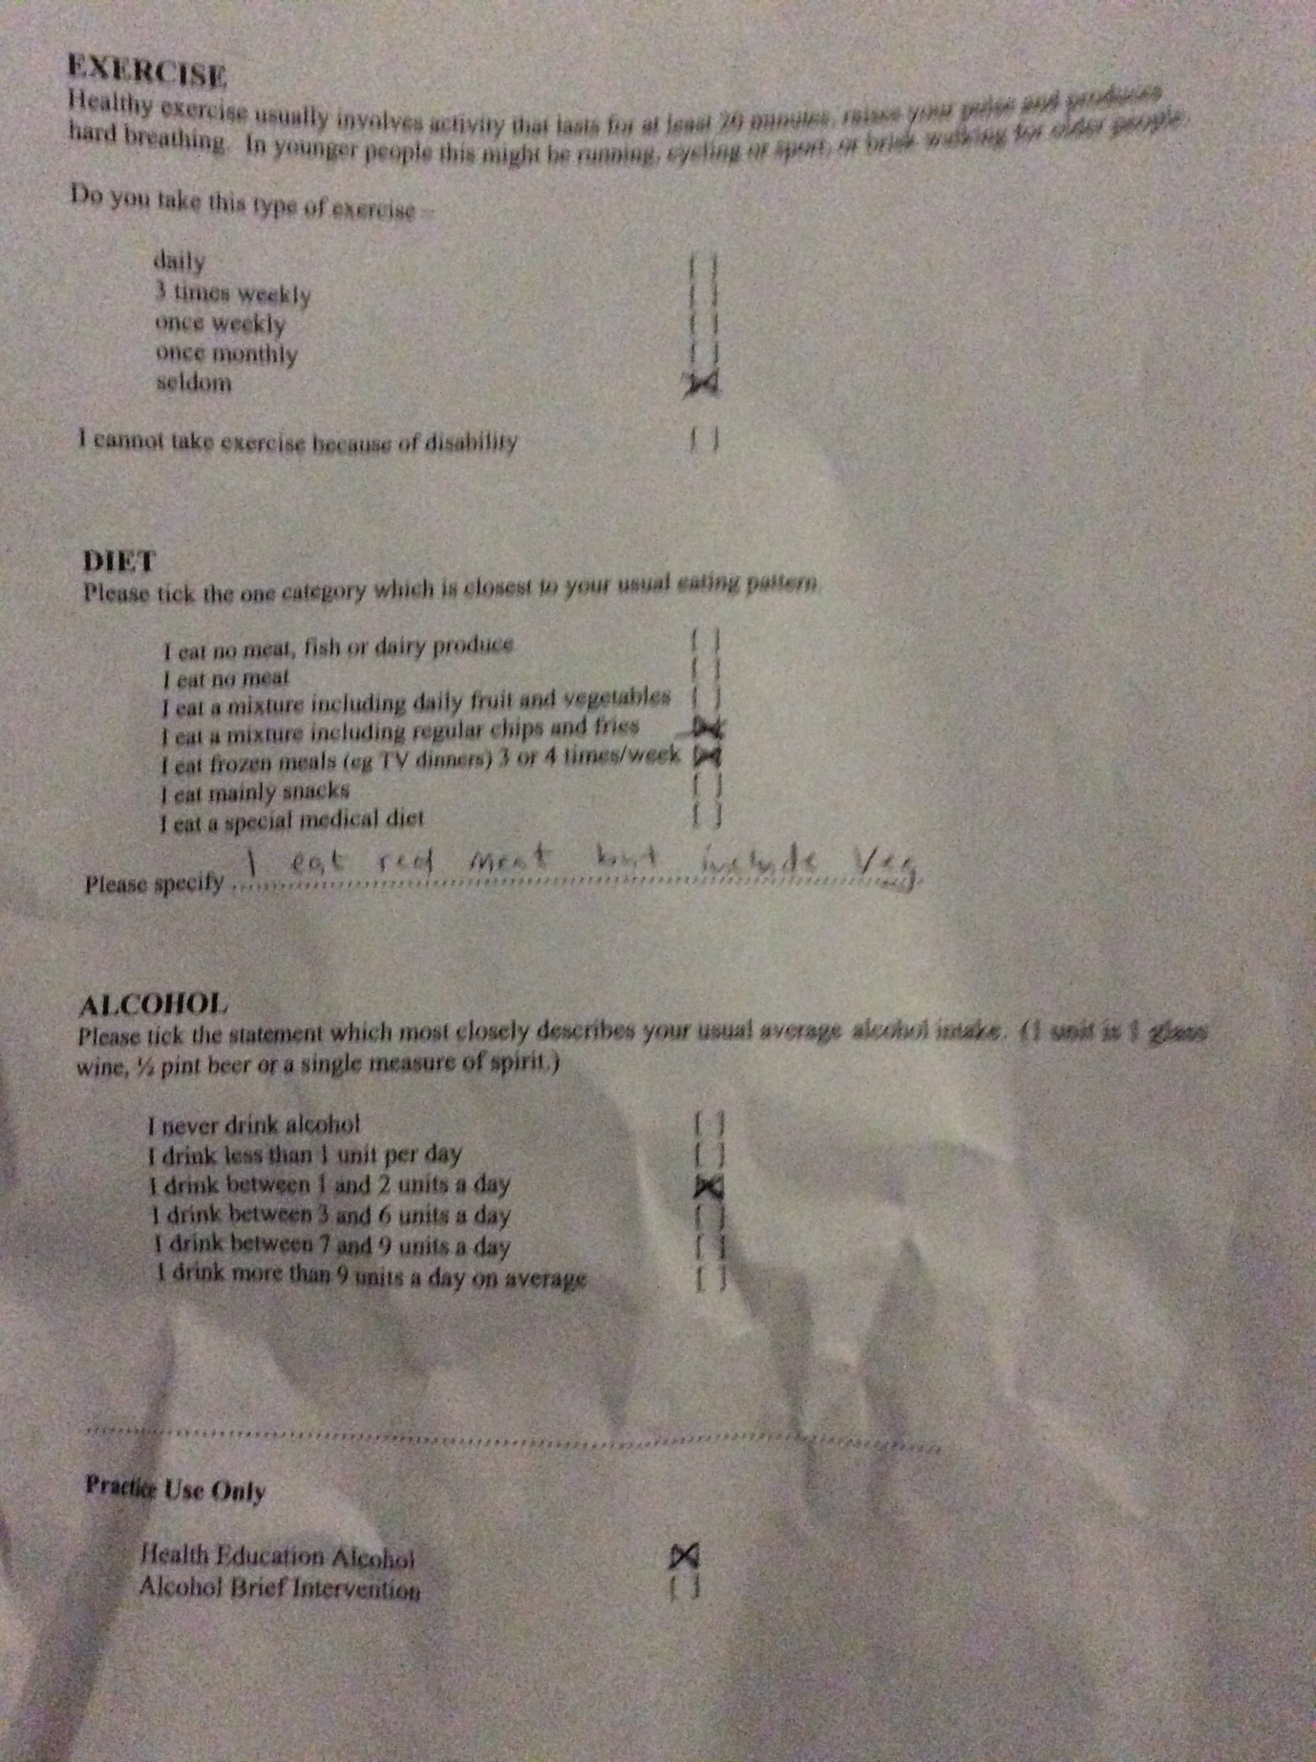

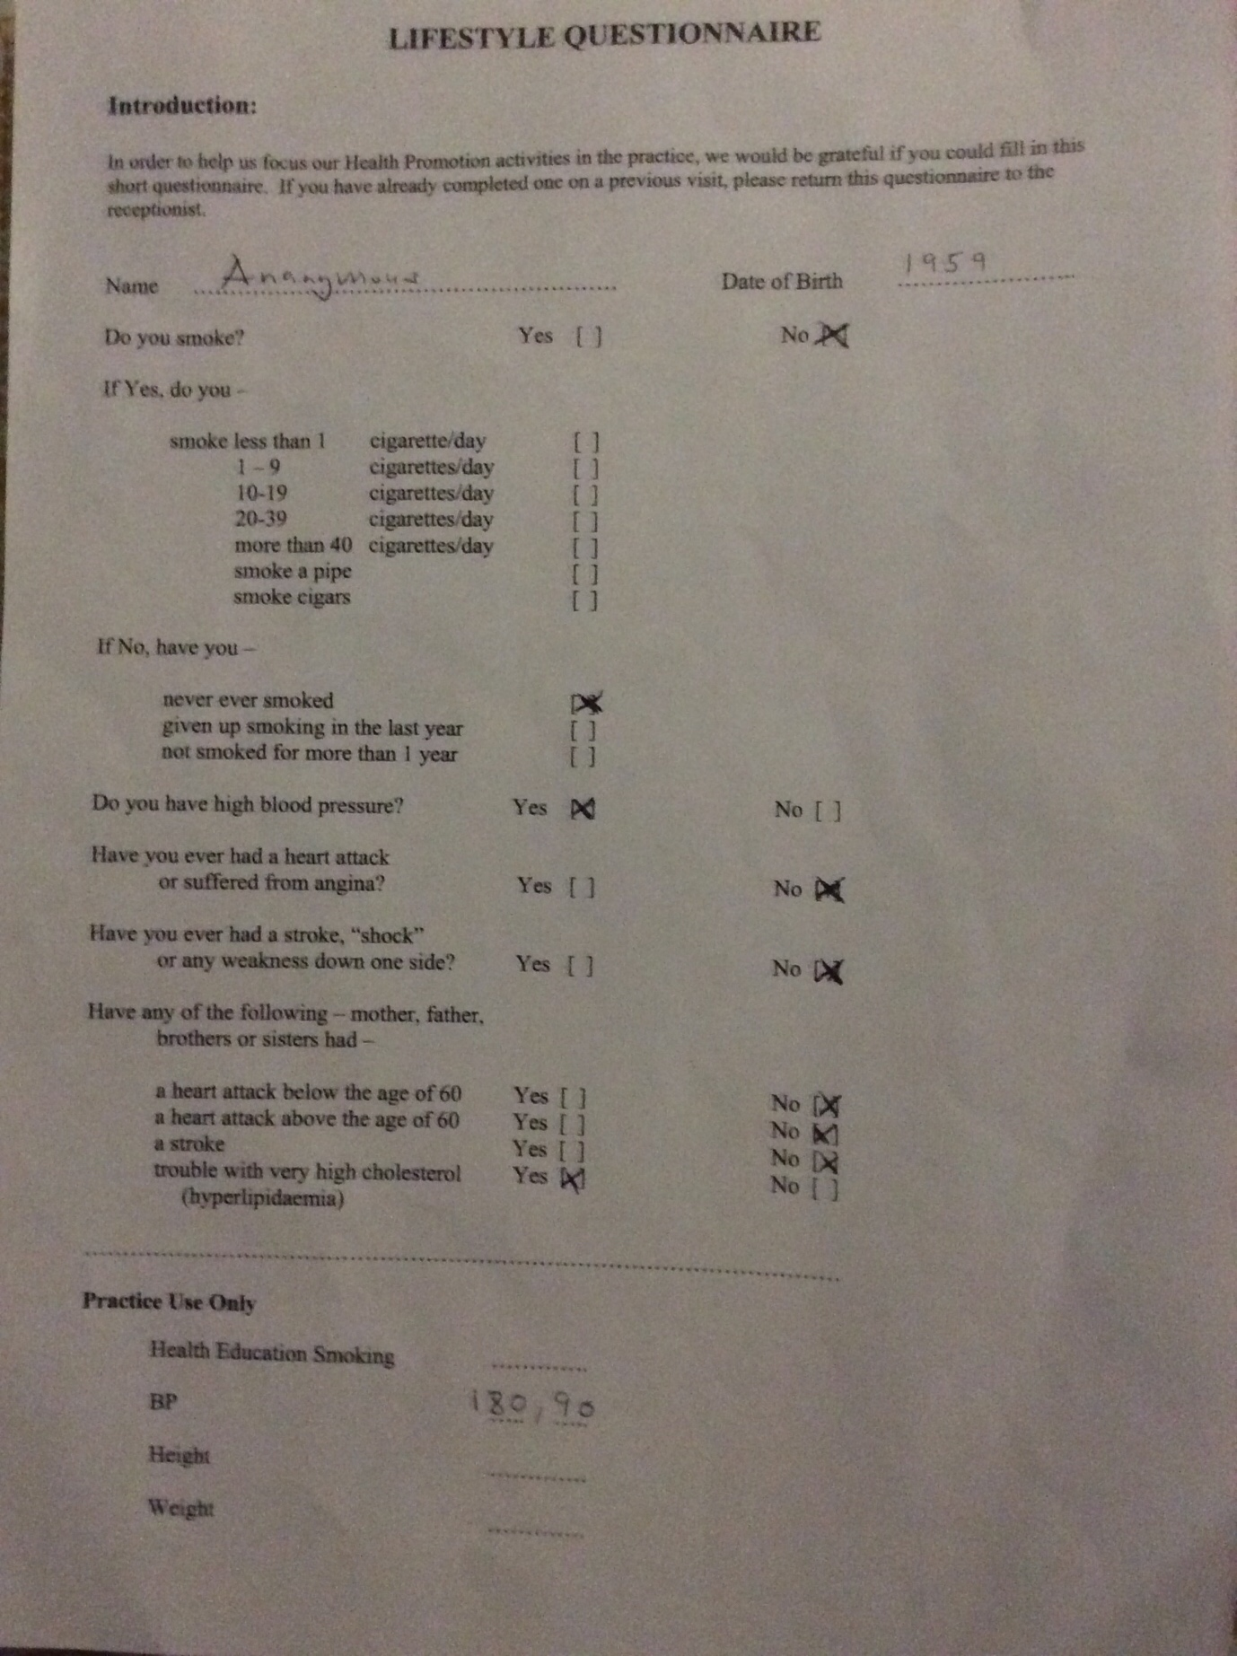
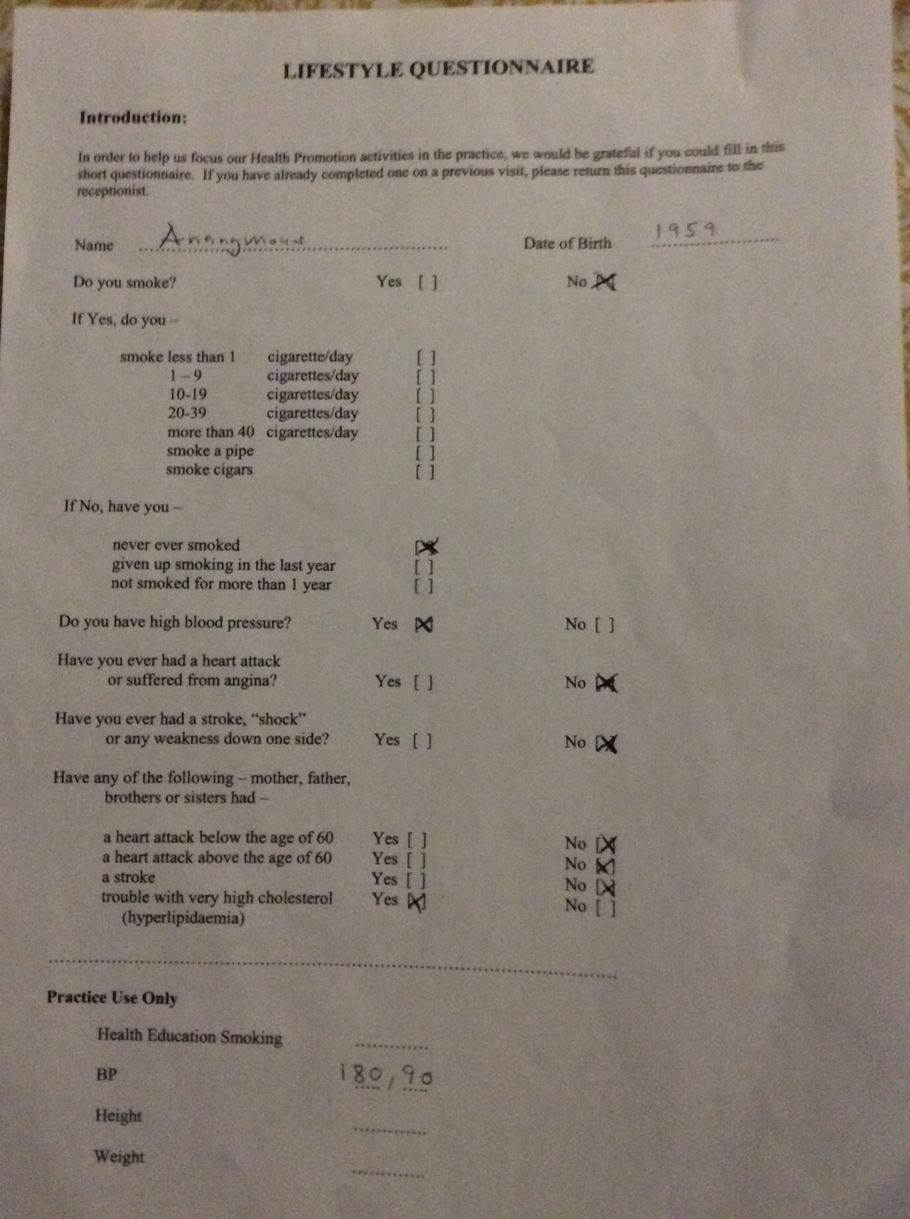
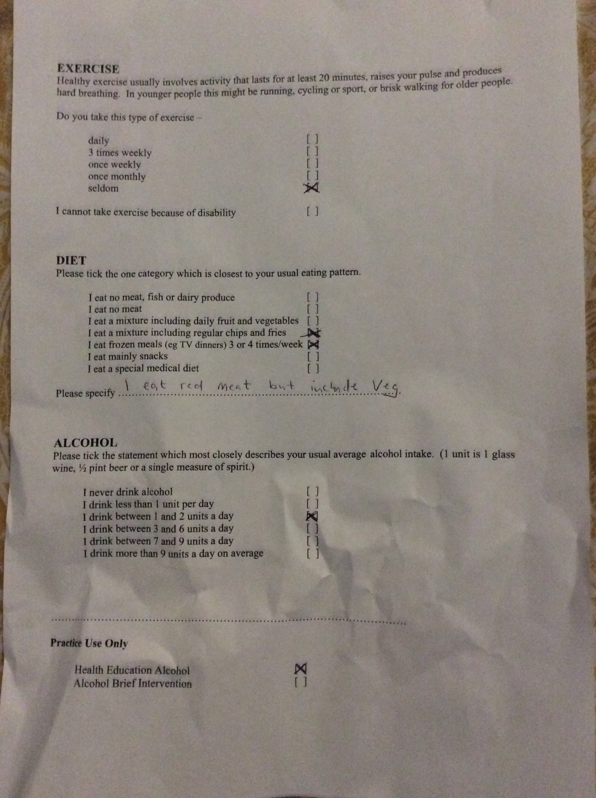
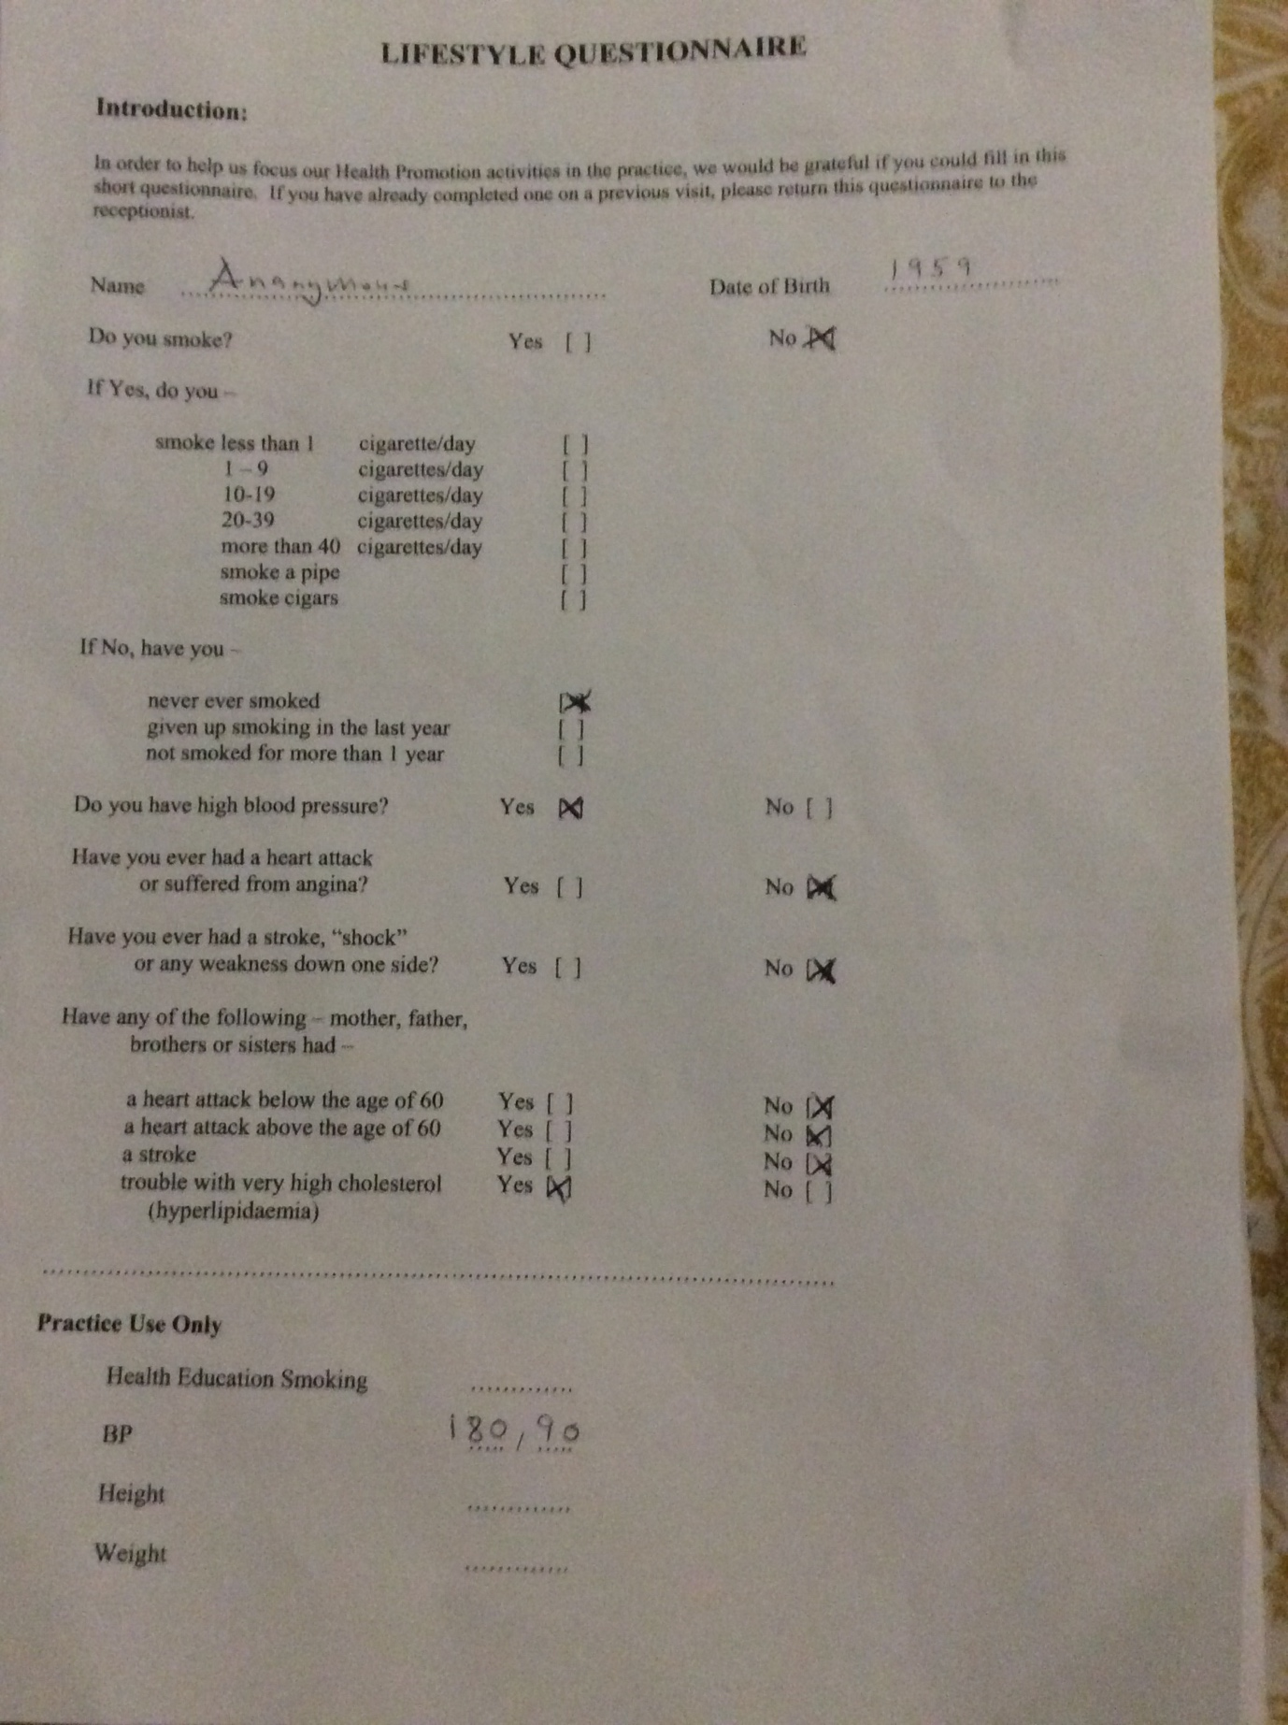

2.


