6a Selection in Python (2) – if/elif/else statements (SOLUTIONS)

1. Write a program to allow the user to enter their age. If their age is between 18-30, print a message on the screen. If they are outside this age group, print a different message.

Don't forget to test your program on the boundaries!

Sample output:

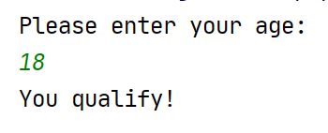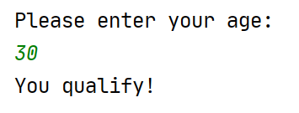

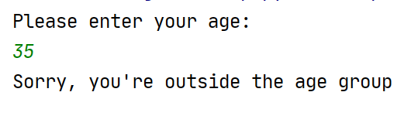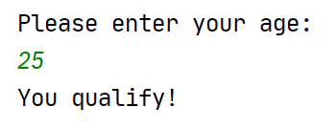

Solution:

print("Please enter your age: ")
userAge = int(input())
if userAge >= 18 and userAge <= 30:
print("You qualify!")
else:
print("Sorry, you're outside the age group")

OR

print("Please enter your age: ")
userAge = int(input())
if userAge < 18 or userAge > 30:
print("Sorry, you're outside the age group")
else:
print("You qualify!")

2a+b. Write a program that allows the user to enter two pizza toppings. Print a message on the screen to state whether the user has chosen Hawaiian pizza (ham and pineapple!) or not. (Note: the user should enter everything in lower case)

Remember, the user could enter pineapple first and then ham, or vice versa, so you will need to check both combinations.

Sample output:

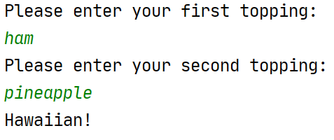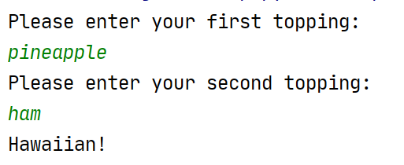

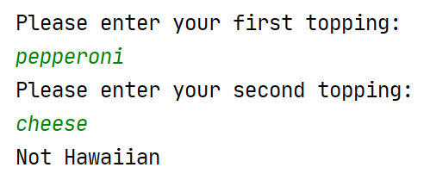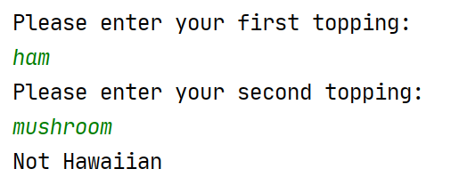

Solution: (2 a +b)

print("Please enter your first topping: ")
topping1 = input()
print("Please enter your second topping: ")
topping2 = input()
if topping1 == "ham" and topping2 == "pineapple":
print("Hawaiian!")
elif topping1 == "pineapple" and topping2 == "ham":
print("Hawaiian!")
else:
print("Not Hawaiian")

topping1=topping1.lower()
topping2=topping2.lower()

if (topping1 == "ham" and topping2 == "pineapple") or(topping2 == "ham" and topping1 == "pineapple"):

3a. Write a program which allows the user to input a date in a form similar to the following:

9 February 2021

Print the date on the screen, showing the contraction for the day (eg 1st 4th 22nd)

Sample output:

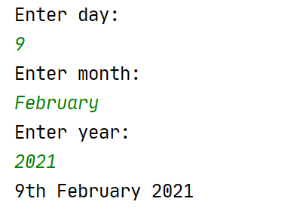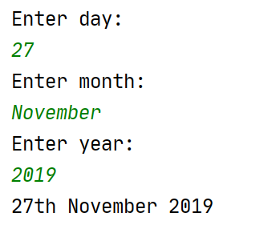

Solution:

print("Enter day: ")
day = int(input())
print("Enter month: ")
month = input()
print("Enter year: ")
year = int(input())
print (day, end="")
if day == 1 or day == 21 or day == 31:
print("st", end=" ")
elif day == 2 or day == 22:
print("nd", end=" ")
elif day == 3 or day == 23:
print("rd", end=" ")
else:
print("th", end=" ")
print(month, end=" ")
print(year)

4. Write a calculator which looks something like the below. Think about the variable types in advance and decide how to cast your variables (Remember, if you don't cast, Python will consider the inputs to be strings!)

Sample output:
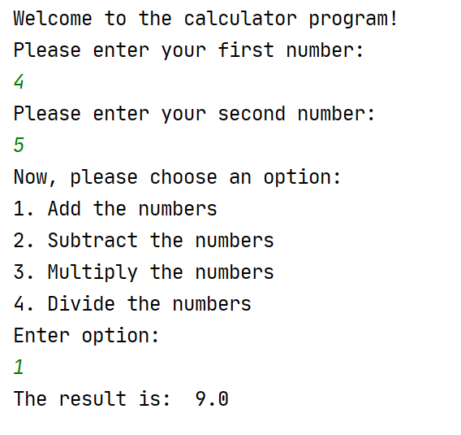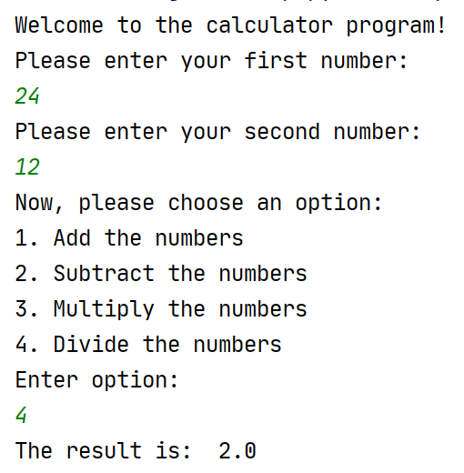

Remember to test your calculator thoroughly, making sure it works for all options (and invalid ones too!)

Solution:

# Calculator program
print("Welcome to the calculator program!")
print("Please enter your first number: ")
firstNo = float(input())
print("Please enter your second number: ")
secondNo = float(input())
print("Now, please choose an option:")
print("1. Add the numbers")
print("2. Subtract the numbers")
print("3. Multiply the numbers")
print("4. Divide the numbers")
print("Enter option:")
userChoice = int(input())
if userChoice == 1:
total = firstNo + secondNo
elif userChoice == 2:
total = firstNo - secondNo
elif userChoice == 3:
total = firstNo * secondNo
elif userChoice == 4:
total = firstNo / secondNo
else:
print("That was not an option!")
total = 0
print("The result is: ", total)

EXTRA 5a. Ask the user to guess what my favourite number is (for the purposes of this program, my favourite number is 15) Tell the user whether they guessed right or wrong.

(Note: one guess only, but the user can re-run the program to try again if they want)

Sample output:
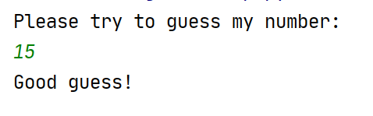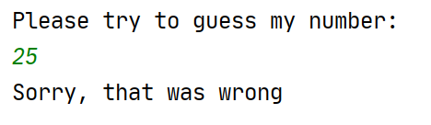

Solution:

faveNumber = 15
print("Please try to guess my number: ")
myGuess = int(input())
if myGuess == faveNumber:
print("Good guess!")
else:
print("Sorry, that was wrong")

5b Extend the game from 5a so that instead of the player being told they are wrong, they get told if they are warm or cold. You can consider "warm" to be a guess within 5 of my favourite number.

Sample output:
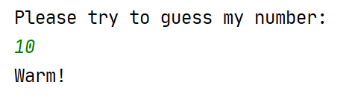

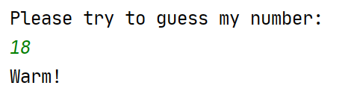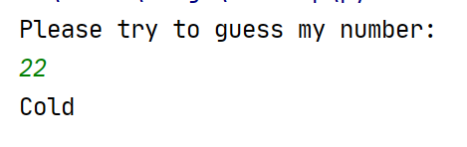

Solution:

faveNumber = 15
print("Please try to guess my number: ")
myGuess = int(input())
if myGuess == faveNumber:
print("Good guess!")
elif myGuess >= 10 and myGuess <= 20:
print("Warm!")
else:
print("Cold")

