Targedau / Targets | Sut rydych wedi gweithio ar hwn /  How you have worked on this | Ceir enghraifft ar /  An example can be found on
Targed/Target 1  Aim to be more critical of what you read and find authors that challenge and oppose. | I have critically analysed theories regarding Maslow’s hierarchy of needs. | In my literature review.
Targed/Target 2  Read even more relevant and peer reviewed books and journal articles when researching. | I have read and engaged with numerous journals more consistently throughout my assignment. | In my literature review.

Research Project: Case Study based on an Electives Experience An exploratory case study arising from practice (noticing) and investigated further through identified research tools. The assignment concludes with the identification of an intervention which can be piloted throughout Professional Teaching Experience and evidenced through reflection in the Professional Learning Standards

The intention of this assignment is to conduct a case study that investigates the impact of Nurture groups in relation to child wellbeing. The study will be carried out in a nearby primary school in Rhondda Cynon Taff. The school recently received the 'Healthy Schools Phase 4' award and strives to improve the wellbeing of all learners and staff (Gwauncelyn Primary School, 2023). Health and wellbeing are fundamental within the Welsh Curriculum and is embedded within the four purposes of ‘healthy, confident individuals.’ Throughout enabling learners to express emotions, develop and maintain healthy relationships and take on different roles and responsibilities, pupils will soon become creative contributors ready to play a full part in life and work (Welsh Government, 2020). It is pivotal for professional practitioners to carry out research as it identifies and addresses issues through reflection and feedback (Hilton, 2017). Research results may cause stakeholders to make decisions based on the outcomes that are found in the study (Wilkinson and Dokter, 2023).
Teachers are professional learners and commit to continuous engagement in career-long development, collaboration and innovation. It is important for them to research as part of the professional standards, values and dispositions (Welsh Government, 2019).

The aim of this study is to acquire a deeper understanding of how pupils experience nurture groups and its impact on wellbeing. The purpose of examining the views of learners and staff is to gain significant information regarding the effectiveness of nurture groups in enhancing overall student wellbeing. The study's findings will ideally add to existing knowledge and possibly inform the establishment of successful interventions and support systems for learners in educational environments. According to research, over 20% of children in school suffer from mental health issues, notably depression and anxiety. The COVID-19 pandemic has heightened awareness of this issue, with many children experiencing decreased emotional wellbeing and motivation. (European Education Area, 2022). Promoting mental health in schools has been found to produce a virtuous circle in children's attainment and accomplishment, which increases their wellbeing, allowing them to thrive and reach their full potential (Public Health England, 2014). This research promotes the case study project as pupil wellbeing is essential in aiding progression in education and it is crucial to gather pupils’ views on the interventions that are implemented in school. Therefore, the research question being proposed is “What are the experiences of pupils in nurture groups in relation to wellbeing?”

Do you hope to fill a gap in current literature?
Are you taking the research of another author further within the school?

Child wellbeing is multidimensional and should include physical, emotional, and social elements. It ought to focus on the immediate lives of children while also considering their future lives, and it should contain both subjective and objective metrics. (Statham and Chase, 2010). According to the government office for science and foresight report on mental capital and wellbeing (2008), wellbeing is a dynamic state that improves when people can achieve their personal and social goals and have a feeling of purpose in society. Wellbeing develops from how people engage with their surroundings at various stages of their life (Statham and Chase, 2010). Learners should be encouraged to acquire healthy practices that benefit their overall physical health and wellbeing. Growing up has a significant impact on students' health and wellbeing, and school settings should address how they will help students understand and manage developmental changes, as well as how those changes affect students in a variety of ways. (Welsh Government, 2020).

A child's academic progress is dependent on his or her level of wellbeing. Maslow's Hierarchy of Needs (1943) is a framework for comprehending the significance of child wellbeing. This idea holds that children have a hierarchy of needs that must be addressed in order for them to thrive. The pyramid begins with physiological demands, which are critical for the survival and overall wellness of children. Following that are safety requirements, which include a stable and secure environment. Social needs, esteem needs, and self-actualisation needs, which involve realising one's full potential and pursuing personal improvement, are further up the pyramid. This argument from Maslow (1943) says that a child's wellbeing can be improved if these diverse needs are fulfilled (Mcleod, 2023 and Research History, 2012). However, this may be difficult for children who are unable to have these needs met due to various circumstances. Children living in poverty or facing neglect may not have their physiological and safety needs fulfilled consistently which can have an impact on their overall wellbeing and development (Henwood et al, 2014). This indicates that every child will have different needs and will require extra support in school through provisions and interventions.

Erikson's theory (1950) of child well-being focuses on individuals' psychosocial development throughout their lives. To improve the wellbeing of children, his approach emphasises the importance of meeting both physical and emotional needs, developing meaningful relationships, and promoting a sense of purpose and identity. Erikson believes that children go through a succession of stages, each marked by a distinct psychological crisis that must be resolved for good development. Erikson highlights the significance of navigating these stages successfully in order to attain a sense of self-identity and purpose. Educators can support learner development and overall wellness by giving children opportunity to explore, make choices, and build a sense of competence through these stages (Batra, 2013 and Mcleod, 2023). By allowing children to have these opportunities, they will feel a sense of belonging within their community and be provided with chances to succeed in education. Moreover, some children may experience distinct psychological crisis that may not be resolved. For example, children who have difficult home lives, who have experiences bereavement, neglect or poverty may struggle to find a sense of belonging and self-identity. This could cause a child to have low wellbeing which effects their overall progression (Wilkinson and Bowyer, 2017). Practitioners may find it beneficial to present learners with interventions to support their wellbeing.

Nurture groups (NGs) were founded in the 1960s by educational psychologist Majorie Boxall with the goal of improving the emotional wellbeing of troubled children through reparative attachment experiences (Hughes and Schlösser, 2014). This intervention is a contemporary approach to inclusive education and is designed to increase the access to learning for children with social, emotional and behavioural difficulties. The aim is to replace missing early experiences by developing positive pupil relationships in a supportive environment (Nurture UK, 2023). It hopes to provide children with a safe and predictable structured environment to explore nurturing experiences (Estyn, 2021). These interventions allow children to connect with others and develop a sense of self-worth. They are able to learn, play and communicate, enabling them to thrive in mainstream classrooms (Education Scotland, 2022).

There are six basic principles of Nurture Groups; children’s learning is understood developmentally, classroom offers a safe base, nurture is important for development of self-esteem, language is understood as vital means of communication, all behaviour is communication and transitions are significant in the lives of children (Welsh Assembly Government, 2010). There are numerous long-term mental health improvements for pupils who attend Nurture groups. Pupils with social, emotional and behavioural difficulties are more likely to improve in social and emotional functioning by attending the provision than remaining in their mainstream classrooms. The independent evaluation found that Nurture group provisions are ‘highly successful in its primary aim for achieving improvements in the social, emotional and behavioural skills of children’ (UK Parliament, 2022).

The role that schools play in improving the welfare and resilience of their students is critical, especially for some students who come from less supportive homes. As a result, school should be a safe and affirming environment for children, where they may develop a feeling of belonging and feel comfortable trusting and openly discussing their difficulties with adults (Department for Education, 2014). Therefore, this literature has led to the specific research study of discovering how pupils experience nurture groups. The researcher is interested in observing how nurture groups run in schools and how its provision is able to aid pupil’s progression. The impact of the Nurture groups on wellbeing is significant to find by exploring the views of children directly who attend the groups. This leads the researcher to question whether literature is correct about the importance of pupils with social, emotional and behavioural difficulties attending a provision outside of the mainstream classroom.

To conduct this research project, an exploratory case study was utilised. A case study technique enables in-depth, multi-faceted studies of intricate problems in everyday settings. Robert K. Yin (2003, p. 13) states that a case study is “an empirical inquiry that investigates a contemporary phenomenon within its real-life context, especially when the boundaries between phenomenon and context are not evident.” (Drew, 2023). This indicates that the case study approach is useful for exploring an interesting subject, event, or phenomena (Crowe et al, 2011). It may cover a wide range of topics, allowing researchers to get a better understanding of patterns, correlations, and underlying mechanisms that lead to knowledge and understanding. (Van de Ven, 2016).

A case study consists of two parts; the subject (the person) and the object (topic of interest). These are key to the structure of a case study (Thomas, 2021). The design of a case study primarily uses qualitative and quantitative methodology, used to investigate an individual, group of people, organisation or event (Daines, 2023). Stoecker (1991) explained that case studies allow a researcher to explore different outcomes of general processes suggested by theories depending on different contexts. In addition to this, Stake (1995) states that an intrinsic case study is carried out when one wants to understand a particular case through a specific research question (Rhee, 2004). The purpose of using a case study approach in this research project enables a rich understanding of pupil’s experiences towards nurture groups and wellbeing. This style of research may help generate practical recommendations and implications for educational practices and interventions which will enhance professional practice (Darling-Hammond et al, 2020). Findings from a case study can have direct implications for real world practices and helping inform decision making (MindTools, 2023).

Some benefits of using the case study approach in research is the flexibility to collect data through various means. It allows researchers to adapt their approach based on the specific needs of the study. They can also illustrate how theory and practice interact in specific contexts and how different stakeholders experience and respond to the phenomenon (Derakhshan and Turner, 2022). Case studies can help to understand a topic holistically and from multiple angles. Lee and Saunders (2017) notes that case study researchers develop a deep, holistic understanding of a particular topic. (Drew, 2023). However, case studies are frequently subjective, biased, or lacking in rigour. They rely significantly on the researcher's interpretation and selection of data, which might be impacted by personal beliefs, preconceptions, or preferences (Johnson, Adkins and Chauvin, 2020). The case studies are not usually generalisable because they tend not to look at a broad enough corpus of data to be able to infer that there is a trend across population. Yang (2022) argues that by definition case studies can make no claims to be typical as they focus on one specific instance (Yang, 2022). Utilising a case study approach in research may be time-consuming as it involves in-depth investigation. There is a significant amount of time collecting data through observations, interviews and questionnaires which needs to be thoroughly analysed to draw meaningful conclusions (Sutton and Austin, 2019).

During this specific research project, pupils who attend nurture groups and staff members will be included in the case study. The object is the pupils who attend nurture groups and staff that receive a questionnaire. The subject is nurture groups in relation to wellbeing.

The methods that will be applied in this research project are observations, questionnaires and focus group interviews. Observations will be carried out during two nurture group sessions. This research tool is a qualitative method and is used to examine what is happening in a setting and document what is observed (Urban Institute, 2022). A questionnaire will be sent to the staff via google forms, who carry out the Nurture group sessions. This research instrument will consist of a set of questions that aim to collect information regarding the research focus (Europe PMC, 2016). Finally, a focus group interview will be conducted with four pupils who attend nurture groups on a regular basis. Focus group research is a qualitive method and it is performed by planned discussion. It allows pupils to offer their opinions on the specific topic presented (Bojlen and Lunde, 1995).

The pupils will be made aware that they are being observed which is an overt observation, following the BERA 2018 guidelines (BERA, 2018). There are numerous strengths to conducting observations during research. Firstly, this tool allows data to be collected while the activity is occurring. It enables a direct observation of what the object is doing, rather than relying on what they say they did. This provides the researcher with reliable and valid results as no information will be missed as the results are being recorded at that specific experience (Centres for Disease Control and Prevention, 2018). On the other hand, observations may have some critics. Due to the pupils being made aware that they are being observed, it could lead to the Hawthorne effect. This is when people perform better when they know they are being observed (Sedgwick and Greenwood, 2015). This could give misleading information to the researcher which is seen as being unreliable as it does not show a fair result.

There are also strengths and limitations when conducting questionnaires during a research project. A strength of this method is that it provides anonymity and confidentiality. Anonymity ensures that respondents can provide honest and unbiased answers without fear of repercussions or judgement. When respondents remain anonymous, they are more likely to express their true opinions, feelings and experiences (Lelkes et al, 2012). It is essential that the researcher receives honest results to guarantee a more reliable research project. Questionnaires are also cost-effective data collection as they are able to be sent out online with no charge. They are easily accessible for respondents and the results are able to be collected quickly (Mcleod, 2023). However, one major downfall of using questionnaires in research may be their lack of flexibility. Unlike other methods, adjustments cannot be made on the spot as once they are sent out it becomes challenging to make changes without risking data integrity (Cornell, 2023). Data integrity ensures the accuracy and validity of data which guarantees accurate and correct results. By damaging this, the results from the questionnaire would not be valid to use in the research project (Baerlocher, 2010).

Lastly, some benefits of using focus group interviews in research is that it provides rich data from the object specifically in their own language. The moderator can interact with the participants which allows follow up questions to be asked if needed. It provides in depth answers as the pupils are able to give their own views and opinions and they can expand or change their answers if needed (John Hopkins University, 2023). In contrast to this, the moderator’s perspective may influence the results given by the pupils through leading the answers. It may become easy for the researcher to ask specific questions in hope for an answer, rather than allowing the pupils to give their own opinions (Elliot and Associates, 2005). This may also make it difficult for the data to be analysed as multiple answers could be shared (National Science Foundation, 2019).

Through observing two groups of pupils in nurture groups, the researcher will use the Leuven Scale to gather data. The Leuven Scale is a five-point scale used to measure children’s wellbeing and involvement (Structural Learning, 2021). The observation schedule will measure the pupil’s wellbeing at the start, middle and end of the session. Their wellbeing will be measured from extremely low, low, moderate, high and extremely high (see appendix 1). Key notes from the observations will also be noted to enrich the data.

The questionnaire that will be sent out to staff who organise the nurture group sessions at School A, will consist of open-ended questions (see appendix 2). These are questions that cannot be answered with ‘yes’ or ‘no’ and require the respondent to elaborate on their answers. This style of questioning will allow the researcher to see the staffs perspectives from feedback in their own words instead of stock answers (Reja et al, 2003).

An interview schedule has been created which will be utilised during the focus group interview (see appendix 3). The focus group will consist of four pupils who attend nurture groups and they will be asked five questions. However, due to the attainment and behaviour of the children, it is important to be aware that some questions may be difficult for the pupils to answer. The age of the pupils will also have an impact on whether they understand the questions being asked. Yet, it is essential that the researcher can amend the questions to fit the needs of the learners.

To analyse the methods utilised in the case study, the researcher will clearly present the data. Data presentation allows complex information to be clear and concise. This may be done through charts or schedules to make it easier to read and understand (Bothra, 2022). Data can be extremely complicated to decipher and to extract meaningful insights from the findings, it should be presented and analysed (Ningi, 2022).

The data conducted from the observations will be formulated into a bar chart. Due to using the Leuven scale, a bar chart would show the results clearly to indicate any correlations between the findings. Bar charts are useful to present data as they summarise large set of data in its simple visual form which clarifies the trend of data easier than from a table (Riedel et al, 2022). The bar chart will show how pupils experience nurture groups in relation to wellbeing and gather data which will indicate if the provision has a positive or negative impact on the learner’s overall wellbeing.

The data collected during the focus group interview will be presented using the interview schedule. Each student's material will be transcribed and arranged to capture all responses and discussions. This will allow trends to be detected through recurring thoughts that are shared (Nowell et al, 2017). The responses from the pupil’s viewpoints may be compared to previous academic studies to elaborate on the importance of wellbeing and nurture groups. These could be from notable quotes or significant patterns found in the data.

Similarly, the responses from the questionnaires will be arranged to sort through the findings. Firstly, the data will be cleaned; checking for inconsistent or duplicate responses. By doing this, the most important and useful data will be clearly read which allows the researcher to find any repetitive patterns without getting lost in irrelevant information (Ponto, 2015). The responses will be collected and formulated into a table to ensure that it is easily read for the researcher. This allows the data to be organised to enable the information to be analysed effectively.

When attending School A to conduct a research proposal, it was crucial to gain the assent from the pupils who would be involved in the study. In doing so, the researcher sent out letters to the pupils in nurture groups to ask for their parents/guardians consent to allow their children to be observed and interviewed if needed (see appendix 4). Asking pupils for their assent meant that they aren’t fully able to understand the consequences of taking part, but they are able to express willingness to participate (NSPCC, 2023). Therefore, the parental permission is to serve the ethical obligation to respect and protect vulnerable individuals (Field, 2004).

Following the BERA (2018) guidelines it was highly important to remain ethical during the research study. It was significant to ensure that all pupils and staff remain anonymous and their information shared stays confidential to protect the privacy of those who voluntarily agreed to participate in the research (Allan, 2017). Another guideline that was followed was the right to withdraw. All pupils and staff were made aware that they do not have to answer any questions asked to them and can remove themselves from the situation whenever they feel the need to do so without any reason. Any individual who initially agrees to participate in a study has the right to withdraw at any point (Finegold and Singer, 2005). Lastly, to ensure that the privacy of participants remain, the information shared is kept password protected and all will be deleted at the end of the research study to protect everybody involved (BERA Guidelines, 2018). While following the ethical guidelines, the researcher completed an ethics form (see appendix 5). This form allowed the researcher to provide information to ensure that the ethical standards were being met during the study (Bowers-Joseph, 2023).

After completing the research project, the researcher analysed the data that was collected. The aim of data analysis is to derive meaningful insights from raw data in order to support decision making, find patterns, and extract useful information (Lau and Adams, 2019). The primary objective of the data evaluation, which was done through observations, interviews, and questionnaires, was to determine how students experience nurture groups in relation to their well-being. It was critical for the researcher to collect direct responses from staff and students to determine whether nurture groups positively or negatively affect learners' overall wellness.

Utilising the Leuven scale during the observation sessions, provided simple data that was able to be generated into a bar chart (see appendix 1b). Each pupil had been levelled on their wellbeing at the start, middle and end of the session (every bar on the chart shows this). For example, Pupil A on chart 1 started with ‘low’ wellbeing and positively rose to ‘high’ by the end of the session. This result was the same for pupil D. Both pupil B and C were placed at ‘moderate’ at the start and middle of the session and ended with ‘high’ wellbeing. These results were very similar during the second observation as the same pattern occurred (see appendix 1c). The key finding from examining the data from the bar chart was that nurture group sessions boost pupil wellbeing because every learner's wellbeing level grew during the sessions. It highlights how supporting students' emotional and mental well-being, as well as creating an enjoyable atmosphere may help children thrive in their overall wellness. The data provided clearly illustrates the use of nurture groups and their importance to many children in schools. These results are supported from relevant literature that state how children with social and emotional difficulties are most likely to improve in their wellbeing by attending an intervention than remaining in the mainstream classroom (UK Parliament, 2022).

In correlation to the findings from observations, the interview data also indicates the significance of nurture groups on children (see appendix 3). The interview schedule includes transcribed information from four pupils. However, the pupils experience behavioural and emotional difficulties which found some questions difficult to answer. Although their responses were limited, the data received clearly indicates that the pupils enjoy attending the. nurture group sessions. When the pupils were asked “what feelings do you experience during nurture group sessions” they answered with positive emotions such as happy and calm. These responses are intertwined with the data received from the observations as the researcher was able to observe these feelings occurring during the sessions. The pupils were able to explain what activities they complete in the provision and express what they enjoy the most. This implied to the researcher that nurture groups offer a fun environment for learners which allows them to be nurtured and find a sense of belonging. This will hopefully allow the pupils to build their confidence and lead them to learn independently in mainstream classrooms (Huppert and Johnson, 2010).

In agreement to the data collected from the pupils, the staff who run the nurture groups shared information via a questionnaire which shows the effectiveness of nurture groups on pupil wellbeing. Both staff members had stated that the nurture group run in their school has had a positive impact on their learners as they are able to work in groups and access many activities that improve pupil wellbeing. By analysing the findings, it was proved that there are long term benefits of the intervention as pupils are able to take their confidence into their classroom and use their wellbeing strategies independently when needed. To keep track of pupil progress in the provision the class teacher works closely with the nurture group mentors and the parents/guardians are also informed. It is extremely important to keep the whole team around the child informed on their progress to ensure they are supported in every environment they encounter. It is found that a pupils personal, social and emotional development are all influenced by the nature of parent-teacher relationships (Hawthorne, 2022).

Finally, the data analysed supports the relevant literature read by the researcher. It was significant that the researcher gathered the view points from those who were directly connected to the nurture group provision to allow a in depth, reliable case study. The main finding that was shown through all three research methods was that pupil wellbeing is supported through attending nurture groups and the intervention provides them with opportunities to progress effectively. Both pupils and staff were able to state that nurture groups are important in the overall wellness of learners with emotional needs as it provides learners with different activities and strategies that are not within a mainstream classroom.

To conclude, within the context of evaluating the wellbeing of pupils in nurture groups, the methods of data collection can be considered reliable. The data collection process involved validated measures that were specifically designed to assess wellbeing in an educational provision. There were multiple methods utilised which provided a comprehensive understanding on the viewpoints from staff and pupils. The data that was collected from the case study can be generalised to some extent. Every school and child are unique which require many different needs, yet the positive impact on wellbeing observed in this context suggests that similar nurture groups in other educational settings could have similar outcomes. Although the data collection process could have been conducted over an extended period of time allowing for a more accurate and reliable trend to be identified, it is essential to notice that within a week of research it was clear to identify the positive effectives of nurture groups on wellbeing. The findings emphasised the importance of creating a safe and nurturing environment where children can thrive emotionally and mentally, which allows them to develop according to their individual needs. This reinforces the need to continue implementing and supporting nurture groups as a valuable resource for student wellbeing. It would be interesting to explore long term benefits of nurture groups by visiting other schools who run the intervention. This could involve conducting follow up studies to see of the positive impact on wellbeing is sustained overtime. By doing this, rich in-depth data would be received making the results more reliable. This research project empathises the importance of evidence-based practice and continuous professional development. By conducting this case study, the researcher actively engaged with evidence-based practice by collecting data and analysing it to inform teaching strategies. Additionally, the research project can contribute the wider educational community by sharing findings and insights, which align with the professional teaching standards of collaboration and professional engagement (Welsh Government, 2019).

Based on the research findings, it would be beneficial to implement nurture groups in more educational settings. It would be useful to provide training and resources for educators to effectively run the intervention. Additionally, fostering a collaborative approach among teachers, parents and support staff can further enhance the effectives of the provision. By incorporating these recommendations, a more nurturing and supportive environment may be created for children to thrive and succeed in education.

Appendix

(1)

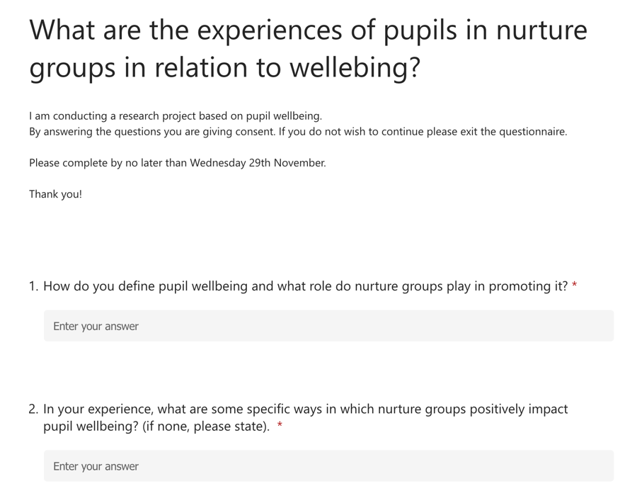

(2)

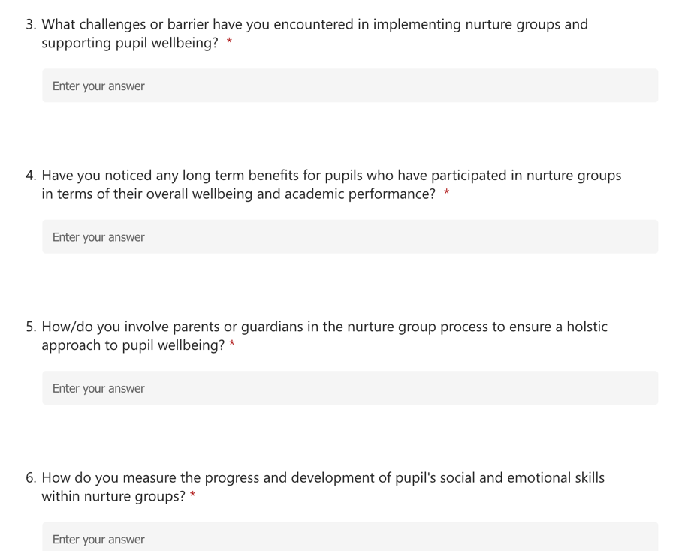

(3)

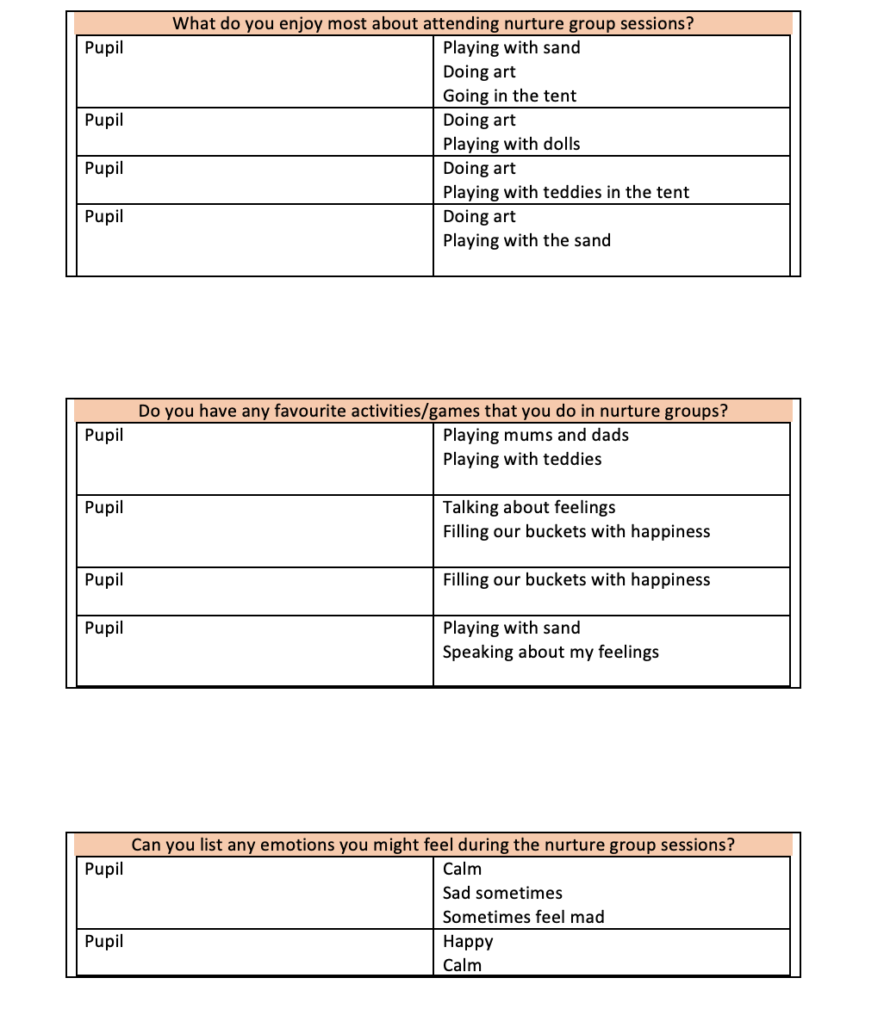

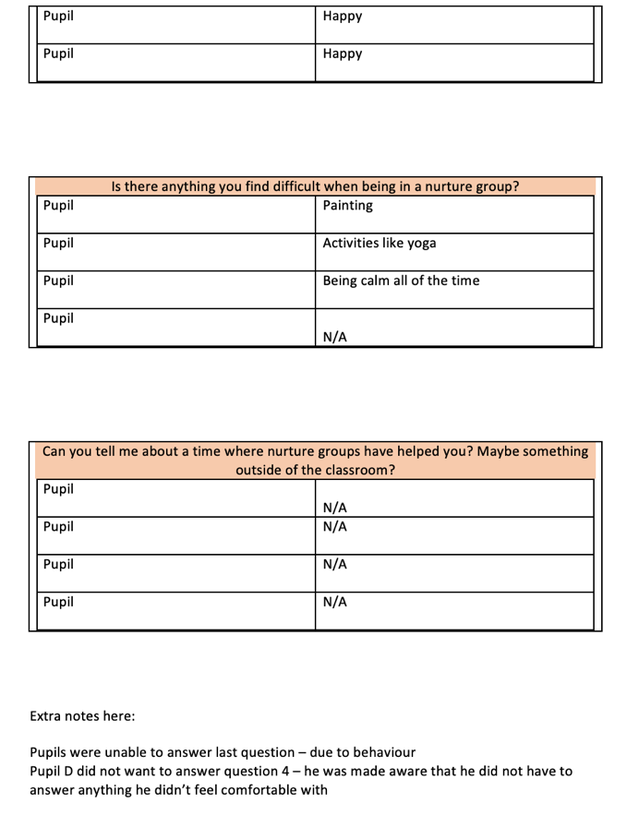

(4)



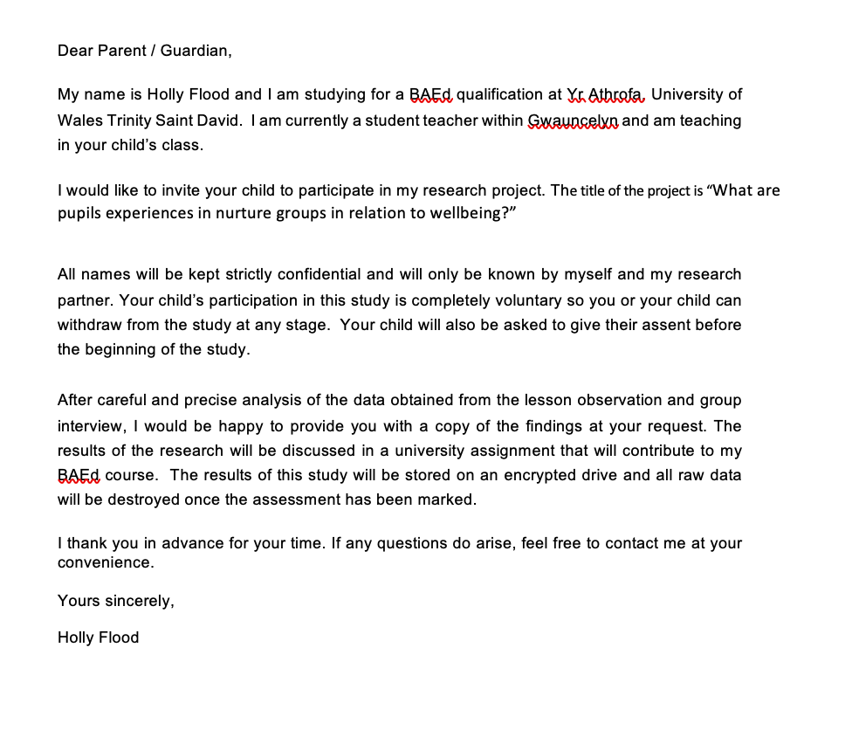

(5)

























Rhee, Y. (2004). The EPO chain in relationships management: a case study of a government organization. Unpublished doctoral dissertation, University of Maryland, College Park.

