
Community Engagement Assignment 2 – ReflectiveReport


Code of the module : LCBB4002
Lecturer: Dale Clarke
Student: Maria Mihaela Chircusi 2019258

TABLE OF CONTENT

- Introduction………………………………………………. 2
- Main Body ……………………………………………….. 2
The Experiential Learning Cycle………….……………. 3
Why is Kolb a good reflective model?.......................... 5
- Conclusion ……………………………………………….. 7
- References ………………………………………………. 8
5. Appendix …………………………………………………...9

- INTRODUCTION

In this report I will talk about the reflective practice and I will give an example from my life using Kolb’s learning style. As part of this report, I will try to demonstrate my personal understanding on the nature and reason for reflective practice concerning one hypothetical model of reflection, ponder the improvement of powerful self-administration, correspondence and relational abilities.
Reflective practice is “a dialogue of thinking and doing through which I become more skillful.” (Schön, Donald,1983).
Reflective practice is the capacity to think about my own behaviour to take part during the time spent consistent learning. Reflection is an articulation used to portray the demonstration of pondering occasions and it is one of my jobs in my training to consider whatever I do to improve. Reflection can be interpreted as thought, thinking, contemplation, investigation of what occurred before. It tends to be situated in much angle like mishap or passionate inclination and some more. It is a fundamental piece of my obligation and an expertise of being intelligent. It also indicates that I gain from both failures and successes, such as paying basic consideration to the functional features and assumptions that guide common exercises by brilliantly and compliantly assessing practice.

- MAIN BODY

Intelligent practice leads to an understanding of one's strengths and weaknesses, and as a result, I chose the Kolb model to determine my strengths and weaknesses in terms of demonstrating abilities and improving information.
David A. Kolb is an educational theorist who focuses on experiential learning, individual and societal change, career development, executive and professional education. He was born in America in 1939. He became famous across the world after publishing his experimental learning cycle in 1984. Many other models, such as the Gibbs model, have been inspired by the Kolb model.
The criteria of reflection demonstrate that the focus is on the professional and their actions. The following rule states that it is permissible to use, offer some incentive, and gain for a fact.
It provides specific knowledge and relevant experiences in order to determine the issues. The following are the standards I follow: Plan my meetings to identify figuring out how to apply to fresh experiences that will aid me in furthering my education as a health and social consideration instructor and it also assists me in planning activities for all the students in my group, valuing the experience that my students gain from their learning, encouraging students to set their own goals, and creating a well-organized and welcoming environment.

There are four fundamental standards of intelligent practices which could successfully use in our act of appearance in learning and educating. This incorporate responsibility, challenge and backing, mindful and developing individual information by and by.
Kolb (1984) identified and promoted an experiential learning hypothesis that provides a valuable way for enhancing our training. The Kolb Cycle, often known as the Experiential Learning Cycle, is the name given to this interaction. According to Clark (2008), the cycle consists of four distinct stages of learning knowledge, any of which can be invaded at any time. Each of the four phases should be carried out in order for successful planning to take place. According to the Learning Cycle, it is challenging enough to have a significant experience "DO" to adapt, but it is also necessary to reflect on the experience "Notice" to summarize and generate concepts "Figure" that can be applied to new situations. As a result, the learner must build a connection between the hypothesis and the activity by arranging a "PLAN," which refers to the hypothesis.

THE EXPERIENTIAL LEARNING CYCLE

Kolb's experiential learning style hypothesis is sometimes shown as a four-stage learning cycle in which the student 'touches all the bases:
1. Concrete Experience - (a new experience of scenario is experienced, or a reinterpretation of previous experience and the key to learn is to be involved) (a new experience of situation is encountered, or a reinterpretation of existing experience and the key to learn is to be involved). 2. Observation (of the new experience) with reflection. Any discrepancies between experience and knowledge are particularly important.

3. Conceptualization of the Abstract (Reflection gives rise to a new idea, or a modification of an existing abstract concept).4. Active Experimentation (the learner applies them to the world around them to see what results).
When a person learns well, they go through a cycle of four stages:
(1) having a concrete experience,
(2) observing and reflecting on that experience, and
(3) forming abstract concepts (analysis) and generalizations (conclusions) that are then applied to new situations.
(4) Can be used to test hypotheses in the future, leading to new experiences. Learning, according to Kolb (1984), is an integrated process in which each stage is mutually supportive of and feeds into the next.
In other words, you can enter the cycle at any point and continue it through its logical progression. Effective learning, on the other hand, happens when a student can complete all four stages of the model.

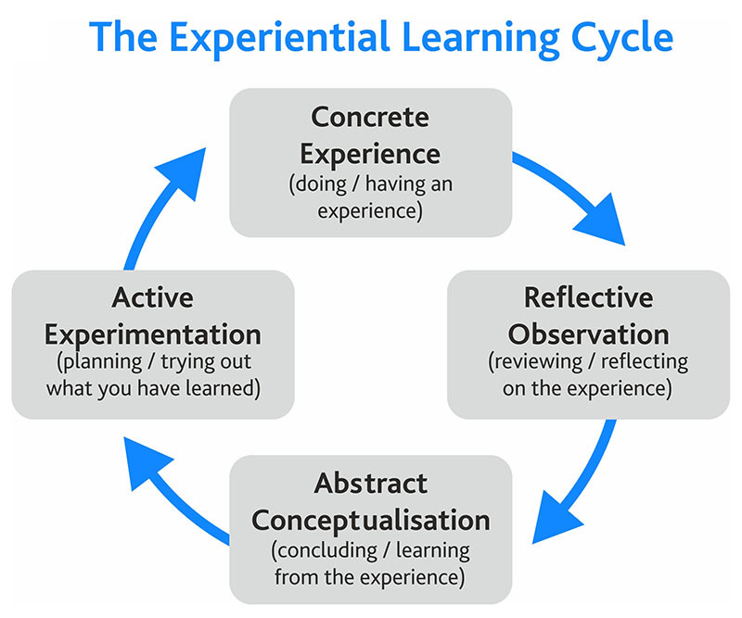
As a result, no one stage of the cycle can be used as a learning method in and of itself. The 4-stage approach, in particular, helps customers like the linkages between encounters, feelings, thoughts, and practices, resulting in all-around excitement for the learning process (Kolb and Kolb, 2017). Kolb's intelligent model is illustrative of the principles suggested in intellectual conduct treatment in this regard (Creeks, 2019). Furthermore, Kolb's approach encourages clients to evaluate their understandings and practices for the motives for self-improvement from the inside out, point by point, and on a frequent basis Because it does not require the client to reflect while 'in real life,' it is an especially good model for people who are just starting started with sensible practice. Perhaps the student will be able to put aside the effort to reflect on their interactions without feeling pressured.

Why is Kolb a good reflective model?

Kolb's reflective practice model has been a foundational and compelling premise. Regardless of its significance, this paradigm has necessitated considerable study, which will be explored in the following section. In general, Kolb's model is appropriate since it emphasizes slow, insightful, and precise contemplation. Furthermore, because of its individualized focus, it encourages clients to believe in their ability to 'handle with' their set of circumstances (Dennison, 2009).

Kolb model of reflection advantages and disadvantages

Advantages | Disadvantages
It is enabling and fulfilling because it puts the student at the focal point of their turn of events – This was very exceptional during the 1980s as instructional method was more educator drove during this time (Dennison, 2009). | Reflective models can put passionate strain on the client in case they are not upheld by a pioneer or companion (UOL, 2018).
Flexible and willing to try new things.  Excited to be put in different circumstances. | The reflection cycle itself is very individualistic in nature (it does not need the student to request others' input); consequently, the outcomes may be excessively uneven.
Good at taking in information and listening to other people's ideas.  Good at asking tough questions and comprehending the answers. | Take unnecessary risks.  Get bored with implementation.  Slow to make up their minds and reach a decision.
Get right to the point, as if you were in a business meeting.  Technique-focused. | Uncertainty is not tolerated well.  Anything subjective or intuitive is intolerable to him.  A propensity to jump to the most convenient answer to a situation.
It features the connection between encounters, sentiments, considerations, and practices – it gives an all-encompassing outline of the learning interaction and assists clients with understanding the connections. | The four-stage technique has been criticized as being overly simplistic and unrepresentative of human comprehension (Heron, 1992).
It empowers top to bottom and kind self-reflection (because the intelligent cycle requires some investment to finish). | There are a few observational examinations assisting the well worth of intelligent practice, but relatively few helping the well worth of Kolb's version explicitly (Dennison, 2009).

- Example of the reflection using Kolb (1984) model of reflection:
During my first year, I decided to get active and a started to play sports. Because of that I joined the High School’s Women football Team. I had to go through a selection procedure in the Sports Hall before being chosen, when we were instructed to form a team and play a friendly match. Despite the fact that it was my first time, I was unfazed because I had been playing football since childhood.
The game began with the blowing of a whistle. That game lasted 90 minutes and was the worst I had ever experienced.
I did not meet my expectations, according to my observations. Several regulations were broken during the game, including fouls, traveling, double dribbling, shoving, tugging, and out of bounds. During the game, there was no sign of a team, only individual players attempting to prove a point. To my astonishment, I was chosen at the end of the selection, despite the fact that I considered I had not played to my full potential. Dribble skills are one of the most important skills in the game. Goals are the only way to win in football, therefore if you cannot score, you are out. I attempted to score twice but failed both times. This revealed a flaw in my shooting abilities.
I spoke with the team's coach and vice coach about increasing my shooting talents, and they gave me some advice on scoring strategies that will help me in future. The coach showed the fundamentals of appropriate shooting technique to me. It gave me a quick overview of how to shoot, which boosted my confidence. I intend to practice and develop my technique using the coach's suggestions as well as my own experience.
Reflective practice module has increased my skills of reflection to my practice, according to my observations and experiences, with the main goal of developing my professional practice. The goal of the reflection is to have an Active Experimentation in my next game and apply the new ideas that I have learn to different situations and so I will improve as a result of my experiences and reflections.

- CONCLUSION
This report has portrayed and assessed Kolb's intelligent model. It started by arranging the significance of reflection inside the more extensive learning cycle, to show how Kolb considered intelligent to be as a fundamental pre-essential for certified turn of events. In conclusion the Kolb's intelligent cycle of learning is a whole process and to show that a model was given. By and large, it is obvious to perceive how intelligent practice enables students. More especially, it is clear to perceive how Kolb's model urges students to embrace an exhaustive and painstakingly thought to be intelligent methodology.
A student can also create their own abstract model to help them better grasp a real event or job. It is crucial not to restrict your learning opportunities to the level at which you think they are at and to try to develop new skills all the time. These learning technique opened new opportunities for me to achieve goals in my personal life.

References:
Dennison, P. (2009) Reflective practice: The enduring influence of Kolb’s Experiential Learning Theory. Compass: Journal of Teaching and Learning, 1(1).
Heron, J. (1992). Feeling and Personhood: Psychology in another key. London: Sage
Kolb, D (1984). Experiential learning: Experience as the source of learning and development (Vol. 1). Englewood Cliffs, NJ: Prentice-Hall.
Kolb, A. & Kolb, D. (2017). The Experiential Educator: Principles and Practices of Experenital Learning. US: EBLS Press.
Piaget, J. (1969/18). The Psychology of the Child. London: Basic Books.
UOL (2018). David Kolb. [Online] Available at: https://www2.le.ac.uk/departments/doctoralcollege/training/eresources/teaching/theories/kolb [Accessed 18 July 2021].
Skillshub ,2020. skillshub.com[Online]

Available at: / https://www.skillshub.com/what-are-kolbs-learning-styles/ [Accessed 19 07 2021]
Donald A. Schön, The Reflective Practitioner: How Professionals Think in Action (New York: Basic Books Inc., 1983) at 31.

APPENDIX


