STUDENT NAME | DENNIS ALDHAIR CALERO ANDRADE
STUDENT NUMBER | 1810249
MODULE NO: | BMSK4003
MODULE TITLE: | DIGITAL SKILLS & RESEARCH METHOD
LECTURER | ZEE ZOOK

INTRODUCTION

Technology has become an integral part of our daily life, if we look around literally, at every instant of time, we are surrounded by technology, weather we are working or resting, we are always using technology , were in today’s society technology is anew trend and impressively growing were business cannot achieve certain goals with out technology , furthermore , users of technology and social media are highly motivated clients , in others words consumers ,stated by Nielsen’s ( 2011) , “ technology reports that 70% of social media and technology are engaged in app such as twitter , Facebook , and many more services .
Technology has increased our standards of living, advancements and development. Technology have led to the evolution of newer and faster modern of transport and communication, therefore, businesses, small and big, need technology to thrive. They are growing and expanding across countries owing to technological advancements, it is technology that grants organizations the valor to spread the wings.

COMPARING AND CONTRAST
Social media has expanded as a category of online debates where millions of people around the world create content, share it, bookmarks, at vast rate, all types of casual media provide at opportunity to present itself and one’s product to dynamic communities and individuals that maybe interested reported by: Robert & Karnak (2008) where individuals uses technical terms ‘like’,’post’,’tag’,’ ’blog’ and many more , following will we analyzing and showing a report of the advantages and disadvantages
APPLE IPAD & SAMSUNG GALXAY TAB are two devices taking different approaches to their respective devices in terms of specs and features and quality:
To begin with in terms of size: the iPad has a slightly bigger form factor( H.240mm,Width 170mm ) whereas Samsung is a few millimeters larger than Samsung Galaxy Tab (H.238mm,W.169mm) meanwhile in terms of weight; the iPad weighting (469g) is nearly 9% heavier than Samsung Tab weighting (429g) that’s a difference of 40g but of course it will make a difference if you hold it and compare them at the same time , on the other hand In terms of model build : the Samsung’s Tab is made of two different materials (glass and aluminum) frame which seems a bit more sophisticated than the iPad familiar (aluminum) body ,following now In terms of display size : both tablets acquire the same display size and aspect (9.7”), additionally in terms of fingerprints sensors both of these devices offer biometric logins through a home button-integrated sensor .
Now within this characteristics there’s disadvantages and advantages which makes this two devices competitive in the market such as: Affordability ,along the years thanks to development of technology and accessories within the systems along the years prices have raised for both devices at a competitive prices with offer which made both devices competitive and popular ,apps battery life and charging according to the google app store and android app store having a roughly 3.5 million app in android unlike app store 2.2 million ,updates for most people is a huge factor as they in constant use we could say both Android an IOS allows us to see the battery at a glaze and both offer power saving modes that can extend the life by limiting performance connectivity and other features now within this characteristic following ,customizability, accessibility calls and messaging has always been androids main strength very easy to theme and set any layout you want add widget or shortcuts or customizing any whereas IOS there’s limited support for widgets , but easier to use emails also android every bit is
based on current traffic conditions either walking or driving along with ride booking integration and public transport, the point is they both effective and they should get you to your destination. In terms of camera this has been a difficult topic as both these devices upgrade on than another however IOS have the reputation of doing the best job in capturing coloring lighting and other details in addition to this both platforms are fast, but to conclude for ease of use and best result without tweaking IOS in in the top, apart from that cloud services google drive offers 15GB for free and has a cross platform along with 5GB iCloud , if you need additional then there’s extra cost per month depending the (GB) required for the user alternatively android is more effective than iCloud due to the fact that is just IOS. In conclusion Android and IOS varies depending on the user’s perspectives and experience, therefore is vital to the importance and their interrelatedness reported by: Stephen & Galak (2009). In general technology has changed the dynamics of the social mobilization and the current situation its that they want to speak out.
PRODUCT MARKETING
There is an actual study that companies , 93% present on Facebook or Twitter , well , this certain percentage offer and market their products in this two particular social media , fakebook is a part of the less active sector included in the study , while twitter , despite of being part of a sector with a relatively high presence , offer a high variability in high profiles , as an example coca cola international account is far by most successful , in fact , it is so successful that it is capable of determining by itself the fate of any media we aim to use , however If we stick to the absolute daily contribution , we can see that companies have a very low presence on their Facebook account ,. Although this information should be taken with some caution
There are numerous social platforms such as Facebook and twitter, users use more than once social media platform, were individuals are increasingly open to the selection of determining where they browse or post certain content. Survey and studies of social media users indicate that the usage of Facebook is to connect with family and friends, while Twitter is to connect with personalities and topics of interest stated by (Jonson 2008; Perrin 2015) in general Facebook was found to be associated with the wellbeing but honest self-presentation, example posting messages with anger, sadness and anxiety) , therefore while both Facebook and twitter are platforms for social media ( technology ) they are differently used for self-disclosure and information sharing , where Facebook account are based on real identities , were friends typically comprises existing friends and acquaintances from consumers or individuals real lives reported by; Lampe , Ellison and Steinfeld (2008). On Facebook consumers identify the things that matter the most to them, such as their home and their emotional connections to their family and friends, They also project positive emotion to their family and excitement , together , these characteristics suggest that on Facebook appear to be driven by a high need for belong meaning to form or maintain current and new relationships ( Baumeister and Leavy 1995 ) , it has been suggested that users receive more social support on social media when they are able to communicate their needs through-disclosure facilitated by honest self-presentation ( Kim and Lee 2011) , whereas , twitter does not require any in identity information , where previous students have found that social connections on twitter tend to be more open and comprise more strangers than those on Facebook, because users feel more comfortable sharing their ambitions and goals on twitter,.

EVIDENCE
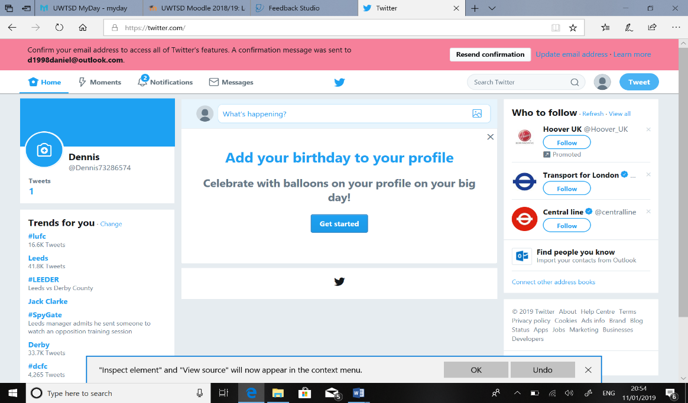
LINK:
https://twitter.com/Dennis73286574

EVIDENCE
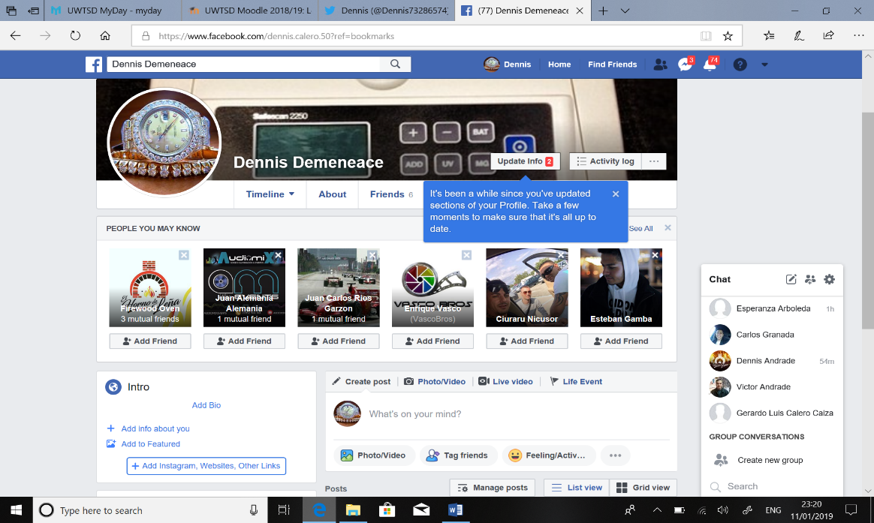
https://www.facebook.com/dennis.calero.50?ref=bookmarks
CONCLUSION

The focus of this reports is on comparing devices and social platforms, Apple, Android and Facebook and Twitter where users with multiple social media accounts may strategize their self-disclosure on each platform to suit their self and social identity and where businesses can market certain products thought this devices and social platforms to a limited extent where the presence of companies in social networks is more than noticeable , more than 93% of the studies companies worldwide are owners of actual official accounts in the two important roles this is mainly due to the different communication policies of the studies companies , however we cannot stablish a direct relationship between the sectors and the social network accounts , since the exceptions often exceed the norms that we can detect .
We can affirm is that Facebook is the most widespread social network , sin addition there s is a clear difference in the types of social networks , Facebook is the most chosen to post intercommunity messages , e.g. written by users and directed no to one subject in particular , but to the accounts community of followers, thanks to this platforms , the activity of companies in these amounts is generally lower , since it is users who tend to keep the account active , twitter in the other hand ins mainly used to stablish relations between the company and the user through customer service message , in simple words social platforms such as the ones mentioned helps in growth of businesses .

REFERENCES
- Robert, R.R., and J. Kraynak. (2008). “Walk like a giant, sell like a madman”. Hoboken,NJ:Wiley
- Stephen, A. T., and J.Galak. ( 2009 ). “ the complementary roles of traditional and social media in driving marketing performance” .[ online ] available from : http://bear.warrington.ufl.edu/weitz/mar7786/Articles/social%20and%20traditional%20media.pdf
- Nielsen.( 2011).”State of the media: the social media report”, Nielsen Company [ONLINE], Retrieved from http://blog.nielsen.com/nielsenwire/social ( accessed 12th December 2018 )
- Joinson,A.N (2008). Looking at, looking up or keeping up with people? motives and use of Facebook. In proceedings of the SIGHCI conference on human factors in computing systems, 1027-1036.ACM
- Lampe.Cc; Ellison, N.B and steinfield, C. (2008) “changes in use and perception of facebook “in proceedings of the 2008 ACM conference on computer supported cooperative work, 721-730.ACM.
- Baumeister, R.F., and Leary,M.R 1995 . The needs to belong: desire for interpersonal attachments as a fundamental human motivation. Psychological bulletin 117(3):497.
- Kim, J., and Lee, 2011. 2 “The Facebook paths to happiness: Effects of the numbers of Facebook friends and self-presentation on subjective well being. Cyberpsychology, behavior, and social networking 14(6):359-364).

