- If x = 2.0 and y =3.0
use Matlab to evaluate: -

  - 3x² – 2y³
  - ln(x*y)
  - √(x/y)
  - e^{y}
  - e^{-x} +log(y)
Answer:
- >> x=2.0;
>> y=3.0;
>> 3*x^2-2*y^3
ans =
-42

>> log(x*y)
ans =
1.7918

>> sqrt(x/y)
ans =
0.8165

- >> exp(y)
ans =
20.0855

- >> exp(-x)+log10(y)
ans =
0.6125

- Draw the graphs, in the same window, of

y = e^{- x}
y = 0.75x

from x= 0 to x = 4
Copy the graph window to your Word file.
Use the zoom tool to locate either of the points of intersection and then use and the data cursor tool to find its coordinates correct to three decimal places. State the coordinates in your Word file.
Copy the final graph window to your Word file.
Answer 2.
Graph 1 plotted:
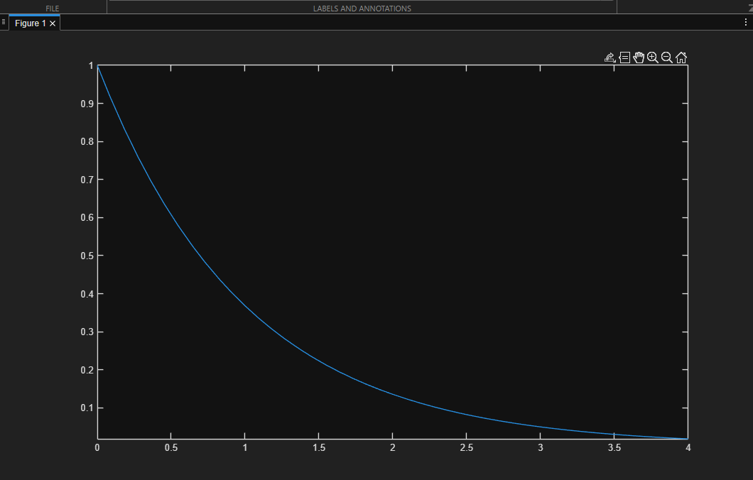
Graph 2 plotted:
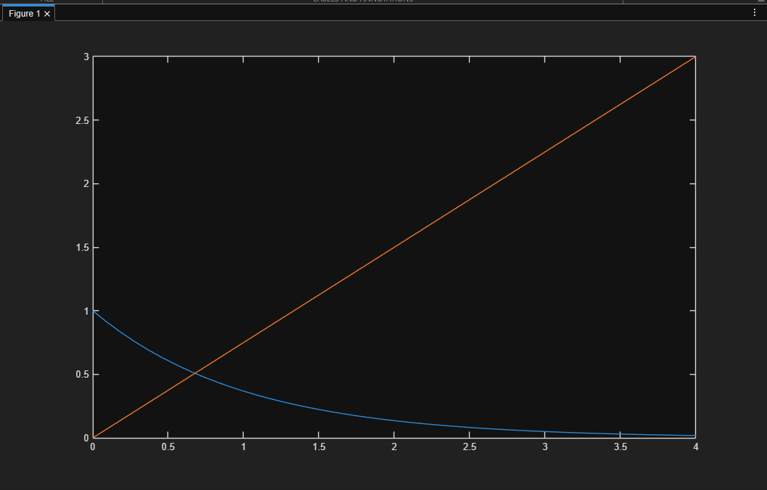
Zoomed in to find (x, y) at point of intersection:
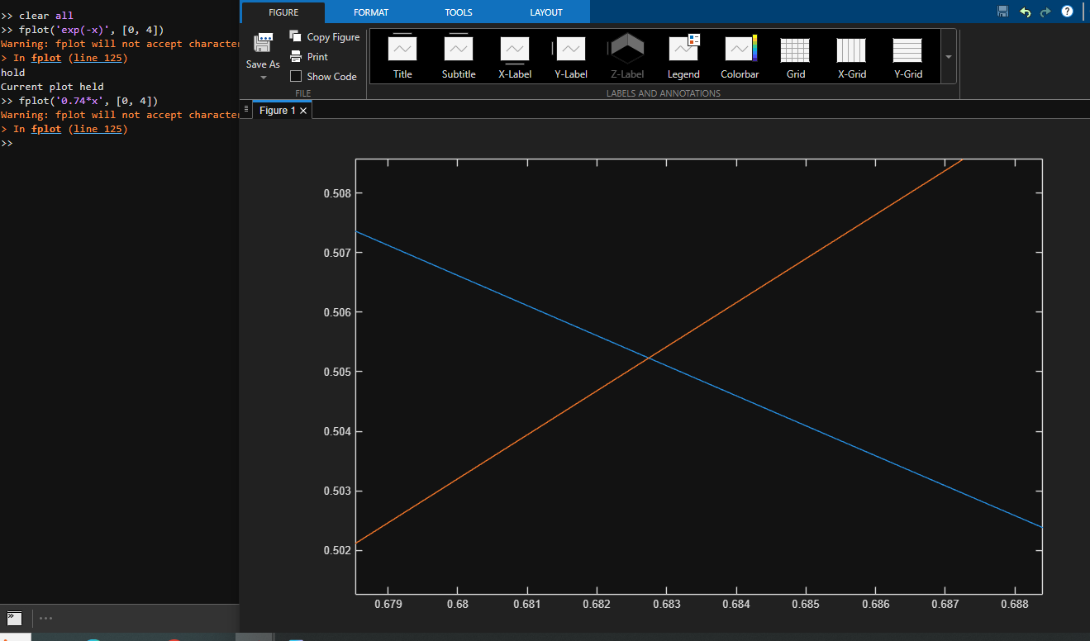
X=0.6827
Y=0.5052
3. Use solve to find all roots of the equation

X³ - 6x² +11x – 6 = 0
(Start with clear all and syms )
Answer 3.
>> clear all
>> syms x
>> solve(x^3-6*x^2+11*x-6)
ans =
1
2
3

4. Find the gradient m and constant c in the equation of the straight line which
is a least squares approximation to the data given in following table.

x | 1.0 | 2.0 | 3.0 | 4.0 | 5.0 | 6.0
y | 4.1 | 6.7 | 9.9 | 13.3 | 16.4 | 19.3

Estimate the value of y at x = 4.5
Answer 4.
>> x=[1.0 2.0 3.0 4.0 5.0 6.0];
>> y=[4.1 6.7 9.9 13.3 16.4 19.3];
>> P=polyfit(x, y, 1)
P =
3.1000 0.7667
>> y1=polyval(P, 4.5)
y1 =
14.7167
5. Find the second derivative of
y= sin(6x)
Show that y satisfies the equation
d²y/dx² +36y = 0
(Start with clear all and syms )

Answer 5.
>> clear all
>> syms x
>> y=sin(6*x)
y =
sin(6*x)
>> y2=diff(y, 2)
y2 =
-36*sin(6*x)
>> y2+36*y
ans =
0

6. For the two vectors a = (2, -2, 3) and b = (2, -3, 2) find:-

  - The dot product of a and b and
  - The cross product of a with b.

Answer 6.
>> a=[2 -2 3];
>> b=[2 -3 2]
b =
2 -3 2

>> dot(a, b)
ans =
16

>> cross(a, b)
ans =
5 2 -2

7. Find the determinant |A| and (ii) A⁻¹ the inverse of matrix A

A = 1 1 2
1 2 1
3 -1 -1

Answer 7.
>> clear all
>> A = [1 1 2; 1 2 1; 3 -1 -1]
A =
1 1 2
1 2 1
3 -1 -1

>> det(A)
ans =
-11.0000

>> inv(A)
ans =
0.0909 0.0909 0.2727
-0.3636 0.6364 -0.0909
0.6364 -0.3636 -0.0909

8.The following simultaneous equations are represented by the matrix equation AX = B ,
where A is the matrix of question 7, X=[x y z]^{T} and B = [4, 4, 1]^{T}

x + y + 2z = 4
x + 2y + 1z = 4
3x -1y - 1z = 1

Use Matlab to solve for x, y and z by using the following matrix equation.
X=A⁻¹B^{T}
Answer 8.
>> B=[4; 4; 1]
B =
4
4
1

>> solution = inv(A)*B
solution =
1.0000
1.0000
1.0000

