STUDENT NAME: ANDREEA MARIANA IORDACHE
STUDENT ID: 1918418
MODULE: EMERGENT LEADERSHIP SKILLS FOR THE WORKPLACE
MODULE CODE: BMSW 6101
LECTURER: SUJEEWA HERATH

TABLE OF CONTENT

Table of Contents
INTRODUCTION: 3
Leadership and Management 4
Effective Leadership styles 5
Autocratic 5
Democratic 5
Laissez-faire 5
Theory X 5
Theory Y 5
Theory Z 6
Effective Leadership skills 7
Administrative 7
Interpersonal 7
Conceptual: 8
Leadership Style in COVID-19 era and other emergencies 9
Ethical Leadership 10
Conclusion 10
Description: 11
Feelings: 12
Evaluation: 12
Analysis: 12
Conclusion: 13

REPORT

INTRODUCTION:

This report will talk about leadership. The difference between leadership and management will be shown. Leadership styles such as autocratic, democratic, and laissez-faire will be defined, along with leadership theories X, Y and Z. A short application to the case study will be done. The three leadership skills administrative, conceptual and interpersonal will be defined and then applied to the case study. We will discuss leadership in uncertain times, transactional and transformational styles and how can they apply to our case study. Ethical leadership and what problems come with it will be discussed. A short conclusion will be given.

Leadership and Management

To start will first define what is leadership. According to Kruse (2013), ‘’Leadership is a process of social influence, which maximizes the efforts of others, towards the achievement of a goal.’’ A leader in our times is Volodimir Zelensky, Gotian (2022) for Forbes gives us his traits as a leader ‘’courage, authentic, simple language, and relatable’’ The president is a real leader for a whole country, he leads by example and his followers trust him till death literally.
While management is ‘’ the activity or job of being in charge of a company, organization, department, or team of employees’’ (Cambridge Dictionary, 2022). An example of a manager is the manager I had at my previous workplace, he would not care much about the people and their needs, what he would care about was the finances and the goals to be achieved, no matter who had to go down.
Kotterman, (2006), gave us a table with the differences between leadership and management. He says the main four differences we can find them in vision establishment, human development and networking, vision execution and also vision outcome, as the following image shows:
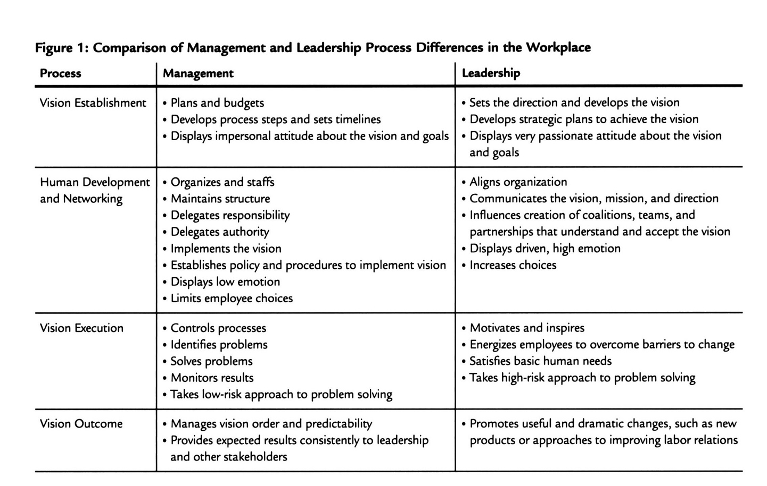

Effective Leadership styles

- During this module, three leadership styles were shown as being leaders' behaviours within an organisation:
Autocratic or authoritarian, which has the same characteristics as Theory X, believes that people need to be pushed in order to reach a goal, or simply to work. It can become depressive for the followers and has in general negative outcomes.
Democratic style, pairs with theory Y, and believes in equality. It is based on communication mostly and feedback. Gives people motivation and makes them feel appreciated. This one can be time-consuming, and inefficient in giving a quick solution.
Laissez-faire style, as translated as laid back, with minimal interaction and influence, it implies that no one has authority. This style fits perfectly the people that do not need directions, are self-starters and are independent. The main problem with this style is that no one puts the effort to accomplish goals, people do not have a direction, and this might feel exhausting and chaotic. (Lewin, 1944). When conducting leadership style tests in class (annexed), it showed that my leadership style is democratic, which means I have the needed skills to be a leader in our times. When working for a big company where I had to manage around a hundred people daily, showed me that I do have what it takes to be a good leader. The change did not happen overnight but in a few weeks, people trusted me and would call the office and ask for me on the phone, they knew that I was there for them and that I cared. Within a few weeks, a high number of people started to be interested to come back to work with the workforce agency I was at the time working, which lets me understand that the reason they did not work anymore with that workforce agency was not the actual job, but the management, and once it changed, they started believing in the organisation again.
- The leadership theories learned in class are X, Y and Z.
Douglas McGregor (2006) gave us the fundamental theories (X, Y,) that organizations still use when determining what type of leadership should they approach.
Theory X is based on the assumption that people do not like to work, they need directions, and to be controlled in order to perform. Here leaders have a big importance. Advantages of this philosophy would be the fact that work gets done quickly, a disadvantage would be the fact that it becomes stressful, and followers cannot keep up with the requirements.
Theory Y assumes that people like to work, are self-motivated when they do a task, and like and want responsibilities. Here leaders are not as important as it assumes people have the capacity to self-direct. The advantage of this theory is the fact that is long-term, and durable, and people feel comfortable and at ease with this way of working. The disadvantage is the fact that it is not a quick solution to an urgent problem, as people first have to gain trust in their leader.
William Ouchi in 1981, gave us a third theory:
Theory Z is more about group work, the collaboration between people, and the acceptance of values, and differences. This philosophy has advantages for people that are self-starters, entrepreneurs, and usually people that do not need directions. The big disadvantage is that it does not imply rules, people tend to. not collaborate if they are not told to do so, which means this theory is time-consuming, and might not reach its goals when applied.
To be able to apply the above to the case study, the following paragraph has been selected to give evidence on the before used style and the style that is about to start once the new Chief Executive starts the job: ‘’ the response must be a renewed, long-term vision for the NHS. Not a drastic overhaul, but sustained and progressive evolution towards a health system that is designed and funded to meet the change’’. From this paragraph, one can understand that the old style was autocratic, workers were exhausted, and there were drastic changes constantly. What Pritchard seems to want to do, is to apply the democratic style, which is long-term and sustainable and grows healthy and stable within the organisation.

Effective Leadership skills

Leadership skills are ‘’ the abilities when organising others to accomplish a common goal. Leadership abilities are needed whether you are managing a team or overseeing a project since you must inspire others to fulfil a list of responsibilities, frequently on time’’ (Ford, 2021), it refers to the capabilities leaders have, in order to perform.
During the module, three core leadership skills were emphasised:

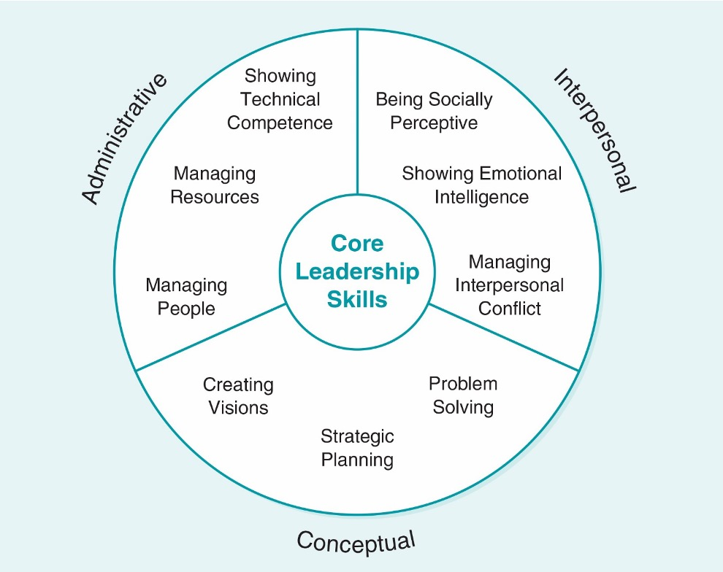

Based on the above diagram the three skills are:
Administrative: that shows technical competence, and the ability to manage resources and people. Katz, (1974) divides the administrative skill into three approaches: technical skills the proficiency in conducting a specific task, human skills, which means the way one interacts and understands the people around or the ability to manage the human capital. And lastly, conceptual skill implies the capability to see an organisation as a whole.
Interpersonal: which means one must be able to show emotional intelligence, manage interpersonal conflicts, and be socially perceptive. This skill is divided into four concepts: communication as in written and verbal skills, and active listening. Collaboration is the ability to build relationships, gain trust and build a reputation. Cultural awareness means understanding other cultures, values beliefs and being tolerant of each of them. Conflict resolution describes the solving of problems and conflict management within the workplace. (Febrianita & Hardjati, 2019)
Conceptual: create visions, make strategic planning, and solve problems. Leaders should inspire a vision for the future and have strong principles. Identify the issues, generate solutions and implement the best one to solve problems, and for strategic planning, one should develop plans to achieve goals.
Pritchard should make use of all the above leadership skills in order to reach her goal. She knows what she wants and the statement that she is ‘’respected and seemingly well liked’’ we can understand that she has already the interpersonal skills, and when she took the responsibility of being the Chief Executive of NHS, she must have already had a plan in her mind, which means she already has the conceptual skills. The administrative skills are the ones that at the moment she needs the most as the NHS lacks resources, and it does not look like the situation is going to change overnight.

Leadership Style in COVID-19 era and other emergencies

The two leadership styles for uncertain times are Transactional and Transformational.

TRANSACTIONAL | TRANSFORMATIONAL
-Is based on exchanges between leaders and followers  -Followers get motivated by incentives  -Once the rewards are not available anymore the followers lose interest  -If the outcome is not satisfactory sanctions on the followers are implemented  -Trades rewards, or fear of consequences  _{-It is a mutual exchange}  _{-Extrinsic motivation}  -Long term is not benefic neither for the company or the people | _{- Is inspirational}  - Followers get attached to the leader  - Leaders put the followers’ needs above themselves  - Generates acceptance and motivation  - Followers are treated as equals with the leader  - Values, visions, and individuality are respected and of great importance  - It is all about the need of the people  _{Intrinsic motivation}  - Can result in not being useful for crisis situations where immediate action is required
Adapted from (_{Den Hartog et. al, 1997)}

When talking about the health system of a country, it means lifetime, and even if the system is in big need in this moment of time, transactional leadership will not solve the problems, what it can do if applied, is maybe give a temporary solution, but it will collapse again in no time. The transformational leadership is needed in order to have a long strategy in place, something that even if it will take some time to achieve will be beneficial for everyone. A system that changed its way of acting, thinking and dealing with problems, is a system that in the future will be able to prevent the situation that the organisation is deep in now.

Ethical Leadership

‘’Ethical leadership is the influence of a moral person who moves others to do the right thing in the right way for the right reasons’’ (Ciulla, 2003)
The issues Pritchard might face when trying to implement an ethical conduit within NHS are not new, since 1983 there was a report saying that the management within NHS is harsh. ‘’ Chairman of Sainsbury's supermarkets suggested that the managerial control of hospitals should be given to appropriately trained managers, working closely with doctors, the issue of management and leadership in the NHS has been a contentious and poisonous one. Despite the government approving the suggestion that doctors be involved in health management (including budgeting), the NHS looked to the health managers for leadership only’’ (Nicol, 2012). On an appointment with my GP, he told me that the GP practices budgets are managed and decided by the GPs and not by anyone else. The spending is entirely decided by the doctors and not by the Chief Executive. They do get an incentive if the amount spent is low. The problem with this way of dealing with the finances is the fact that surgeries, take a long time to determine a patient's health problem, just because they do not want to spend too much money if the patient is not showing aggravating symptoms.

Conclusion

In conclusion, we can say that the NHS needed a change, and it needs a leader, not just a manager, as the difference between them can make an organisation collapse. To be able to be a good leader and manage such a big organisation Pritchard should be a democratic leader that knows when is needed to be autocratic if is for the well-being of everyone. She seems to have the skills needed for success; it only remains that she implements them right and successfully. As discussed, the best leadership she can implement is the transformational one, she has the power to do it, and when she took on the job, she knew there is a need for a core change. The NHS is a very big organisation, where it is usually hard to keep an ethical leadership, but with the right leader, this is possible.

REFLECTIVE ESSAY

Gibbs Reflective Circle: ‘’ It is not sufficient simply to have an experience in order to learn. Without reflecting upon this experience, it may quickly be forgotten, or its learning potential lost. It is from the feelings and thoughts emerging from this reflection that generalisations or concepts can be generated, and it is generalisations that allow new situations to be
tackled effectively’’ (Gibbs, 1988)

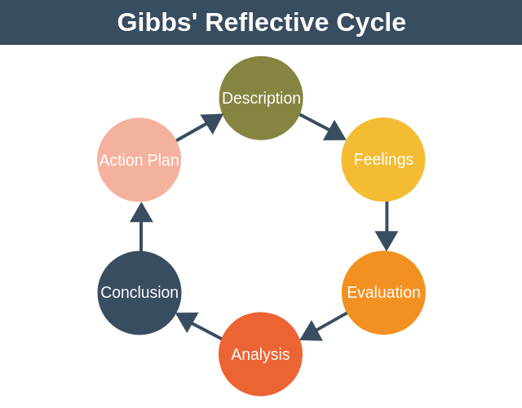

Description:
During this module, I have learned about the different styles, theories and skills that leadership can have. The classes were very interactive, as the lecturer, kept asking relevant questions, and made us do class activities and homework. My favourite ones were the leadership tests we did in order to see what types of leadership we all have individually. For some, the results were shocking, as they did not expect the eventual results. I was one of the active students during classes as I really enjoyed the module and everything we had learned throughout the module. Throughout the module, I have discovered the need that the world today has when it comes to leaders, and we have discussed about some influential people in our times that are real leaders.

Feelings:

While doing the traits and styles lesson, I discovered that I do have most of the important leadership traits such as confidence, charisma, determination, sociability and integrity, I did know that I have those traits before, but what I never knew was the fact that they are linked to a leadership style, when discussing about the different world know leaders and researching about them I realised that I have a lot in common with some of them. I now know I am a good leader, and I am thinking seriously on taking the role of manager at my current workplace after some of my colleagues already asked me if I have ever thought of being the leader there. Apparently, they have already seen the potential I have, but I have not realised it until this module. I feel like this module brought a plus to my life and a change on how I will see leaders from now on. Made me understand the difference between a leader and a manager and what a manager lacks to become a leader. I do not want people to see me as the bad guy that forces them to do certain activities in order to reach a goal that maybe is not even theirs.

Evaluation:

This module helped me understand that I am a people person, and this is a trait that most actual leaders lack. I understood that people like me are needed, even if we lack the experience. About leadership, I have also learned that one does not get the skills from birth nor gets them overnight, it takes time to develop the traits, and a lot of encounters with different people, cultures, beliefs and values. I think that the fact that I have lived my life in multiple countries, made me the person that I am today, the fact that during my life so far I have come across a multitude of different people, and I have learned a little bit from each.
A negative thing I can say is procrastination, which I still used as an excuse to this day, but as learned the best leadership style is not the rushed one, so I will not be to harsh on myself with this one.

Analysis:

To be able to be a good leader one must have an open mind and be inclusive of everyone, even if sometimes, there is nothing to understand in some people's behaviour, still we have to be emphatic with the world around us and understand that no one is the same. The more inclusive one is the more followers he can gain, if people see that they can trust you, you will become confident, and if people trust and relate to you will feel at ease and will have the courage to become a follower. In order to be able to do that, first one person has to be a good listener. I will certainly think twice before taking action toward a goal and will take in consideration what people that help reach the goal have to say and how they feel about the methods.

Conclusion:

Everything mentioned above will definitely have an impact on my personal life, but also and most important in my work life, I now know that I have what it takes to be a leader and not just any manager in a company, but a leader for the people working within the organisation. I have absorbed the leadership module to the core, and I know it is something I will use my whole life. I want to expand my knowledge in knowing different people, get to know them and get to know their beliefs, values, and backgrounds. In conclusion, one day I will be a leader and I promise to be a good one, a leader for the people, not just a manager in a company. It is not easy to become a leader, but if you feel like you can be one, just do it. Change is the only certain thing, so to be able to always keep up with the change, one has to periodically revise himself. If new change is needed the leader has to be the first one on doing the change, then lead by example. If you want a change first do it to yourself then expect the people around, you to take action.

REFERENCES

Cambridge Dictionary, (2022) management. Available at: https://dictionary.cambridge.org/dictionary/english/management (Accessed on 03/08/2022)
Ciulla, J. B., (2003) The ethics of leadership Wadsworth/Thomson Learning, Belmont, CA
Den Hartog, D. N. et. al (1997) Transactional versus transformational leadership: An analysis of the MLQ. Department of Work and Organizational Psychology, van der Boechorststraat 1.
Febrianita, R. & Hardjati, S., (2019) The Power of Interpersonal Communication Skill in Enhancing Service Provision. Journal of social science research 14. 3192-3199. 10.24297/jssr.v14i0.8150.
Ford, R., (2021) Leadership Skills: Definitions and Examples. LinkedIn Available at: https://www.linkedin.com/pulse/leadership-skills-definitions-examples-robert-ford (Accessed on 03/08/2022)
Gibbs, G. (1988). Learning by doing: A guide to teaching and learning methods. Further Education Unit
Gotian, R., (2022) Why People Follow Certain Leaders: Lessons from Ukraine’s President Zelensky. Forbes Available at: https://www.forbes.com/sites/ruthgotian/2022/03/08/why-people-follow-certain-leaderslessons-from-ukraines-president-zelensky/?sh=7a49c008755c (Accessed on: 03/08/2022)
Katz, R. L., (1974) Skills of an Effective Administrator. Harvard Business Review. Available at: https://hbr.org/1974/09/skills-of-an-effective-administrator (Accessed on: 03/08/2022)
Kotterman, J., (2006) Leadership Versus Management: What's the Difference? The Journal for Quality and Participation, 29(2), pp. 13-17.
Kruse, K. (2013) What is Leadership? Forbes. Available at: https://www.forbes.com/sites/kevinkruse/2013/04/09/what-is-leadership/?sh=2339a72f5b90 (Accessed on 06/07/2022)
Lewin, K. (1944) A Research Approach to Leadership Problems. The Journal of Educational Sociology, edn. 17(7), 392–398. https://doi.org/10.2307/2262546
McGregor, D. and Cutcher-Gershenfeld, J. (2006) The human side of enterprise. Annotated ed. New York: McGraw-Hill.
Nicol, E.D., (2012) Improving clinical leadership and management in the NHS. Journal of Healthcare Leadership, 4(1), pp.59-69.
Ouchi, W.G. (1981) Theory Z: how American business can meet the Japanese challenge. New York: Avon Books USA.

ANNEXE:


