

MASTERS OF BUSINESS ADMINISTRATION
LCMB7024 – MARKETING MANAGEMENT
CONTRIBUTION TO THE OVERALL MODULE ASSESSMENT – 50%
LECTURER – LAILA MAAZOUZ
ASSESSMENT COMPONENT 1 – MARKETING ENVIRONMENT ANALYSIS
_____________________
SUBMITTED
BY
Student Name :- Neel Manishbhai Korat
STUDENT ID – 2523741
TABLE OF CONTENTS
Task 1 3
Macro-environment framing of competitive position (Tesla as pioneer, BYD as follower) 3
Macro actor 1: Government and regulation 3
Incentive architecture as a competitive filter, not a simple demand stimulus 3
Trade defence and market access volatility in Europe 4
How policy is already shifting competitive trajectories 5
Macro actor 2: Technology ecosystem (battery economics and charging infrastructure) 6
Battery price dynamics are compressing differentiation while amplifying scale advantages 6
Charging infrastructure is becoming a standard-setting contest that favours Tesla’s network logic 7
US infrastructure utilisation data shows the ecosystem is turning into a volume flywheel 7
Task 2 8
Strategic responses mapped to Porter’s Generic Strategies 8
Strategic responses through Ansoff’s Growth Matrix 10
References 12

Task 1

Macro-environment framing of competitive position (Tesla as pioneer, BYD as follower)
The macro marketing environment does not only determine the rate at which EV is going to be adopted, but also the value sharing among firms and regions. By 2024, the global electric cars sales were above 17 million vehicles and above 20% of new car sales, which has changed competition between niche early-adopter and mass-market contestability with the policy eligibility, cost curve and infrastructure access directly moving share (IEA, 2025). Here, the leader status of Tesla is more and more fortified due to regulatory compatibility and ecosystem standardisation, and the follower status of BYD is more and more commercialised due to scale, supply-chain dominance, and export growth. It is crucial that the same two macro players, government and regulation, and the technology ecosystem generate asymmetric opportunities and threats since Tesla and BYD are dependent on divergent profit pools across geographic boundaries and divergent sources of advantage.
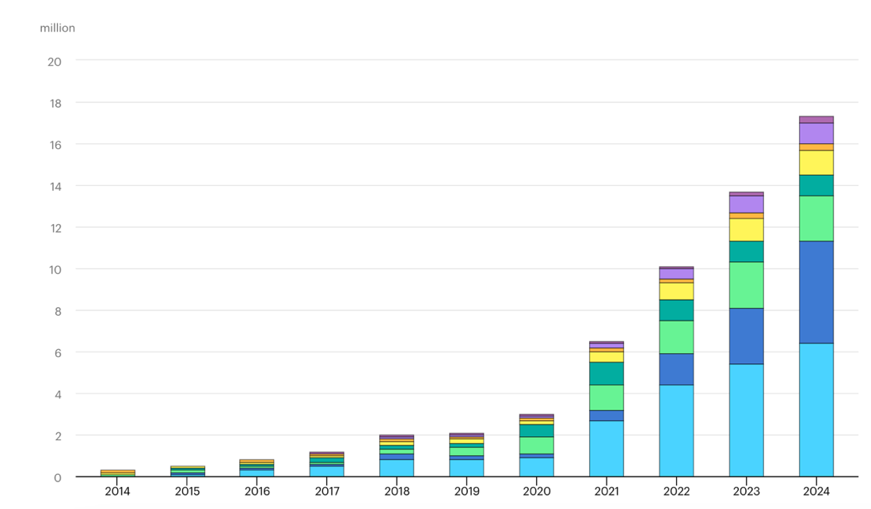
Figure 1: Global electric car sales 2014-2024 (IEA, 2025).

Macro actor 1: Government and regulation

Incentive architecture as a competitive filter, not a simple demand stimulus
The US has changed its extensive promotion of EVs to an incentive system that can act as a market entry filter. The Department of Energy displays the critical inflection: since 2025 qualified vehicles to receive the Section 30D credit will not be able to contain applicable critical minerals extracted, processed, or recycled by a foreign entity of concern narrowing the range of competitively priced, incentive-eligible offerings (U.S. Department of Energy, 2025). This redefines the value-to-money in the US because the credit eligibility partly defines the consumer affordability, and the eligibility is further demarcated by the supply-chain provenance (Vazquez et al., 2024). The fact that Tesla can authoritatively sell continuity of eligibility on the basis of supply-chain redesign and domestic capacity signalling reinforces its competitive position, a protection of conversion rates in price-sensitive segments. This has a weakness because the cost leadership of BYD is tied to China-centred minerals refining and battery provision, which is a liability in FEOC-style screening and prevents it from entering or scaling passenger market in the US in case its sticker price lowers the prices of the incumbents (Aghaie et al., 2024).
This tightening logic has extended beyond vehicles to clean-energy investment rule making that has an impact on upstream manufacturing economics. In February 2026, the IRS published Notice 2026-15, which operationalises the concept of a prohibited foreign entity and interim safe harbours to decide whether or not material assistance provided by a prohibited foreign entity makes a tax credit relating to energy eligible (Internal Revenue Service, 2026). Even though this notice is not an EV sales document, it matters strategically for Tesla and BYD because it shapes the economics of US-located battery, materials, and energy projects that support EV value propositions (Farrell et al., 2025). In the case of Tesla, it is both an opportunity and a threat: on the one hand, it predisposes a local ecosystem that can support the Tesla story of localisation, on the other hand, it increases compliance friction and the audit load among suppliers, which can increase the cost-to-serve and sluggish capacity growth (Islam, 2025). In the case of BYD, the same policy direction enhances the likelihood that US-facing projects must be structurally decoupled with China-linked inputs, which compromises a follower strategy on the foundation of integrated Chinese scale.

Trade defence and market access volatility in Europe
In Europe, the regulatory landscape is clearly controlling exposure to the cost structures in China by adding to the import tariffs on the EVs made in China, but it is possible to negotiate exemptions. Reuters reporting in February 2026 describes the EU framework as the existing 10% car import duty plus additional tariffs on China-made EVs, and highlights that the Commission has already allowed model-specific exemptions and adjusted certain duty levels through the process (Reuters, 2026a). This creates a non-price barrier that affects BYD more directly than Tesla because BYD’s Europe growth is structurally tied to exporting China-made vehicles at scale. The competitive consequence is that BYD’s marketing mix in Europe becomes constrained: it cannot rely on simple undercutting without either absorbing margin loss, facing volume risk, or accelerating local manufacturing partnerships (Berezina, 2024).
For Tesla, the EU tariff regime has a two-sided effect because it can protect Tesla’s European competitiveness against the lowest-cost China-made entrants, but it also increases uncertainty for any firm that uses China-based production as part of its European supply chain (Dehghanimadvar et al., 2024). The fact that there is uncertainty is relevant to strategic marketing as it destabilizes pricing strategy, promotional intensity, and dealer or direct-sales forecasting. As far as practical competition is concerned, the EU has shifted to a comparatively stable demand environment of rules to a negotiated trade environment in which product-country-of-origin and compliance narrative are now a part of brand risk management alongside cost management (Glover et al., 2023).

How policy is already shifting competitive trajectories
Market performance depicts the interplay between policy and regulatory turbulence and firm capabilities. Tesla’s official release for the full year 2025 reports 2025 deliveries of 1,789,226 vehicles, with Q4 2025 deliveries of 418,227 (Tesla, 2026). BYD’s 2025 performance, by contrast, reflects scale and export reliance under rising trade constraints. Reuters reports that BYD’s 2025 total vehicle sales were 4.6 million, with overseas sales rising to 1,046,083 in 2025 and BYD surpassing Tesla in EV sales, supported by aggressive overseas expansion (Reuters, 2026b). The strategic implication is that it is neither a question of policy of assisting EVs or harboring EVs. It is re-allocating the geographical privilege. Tesla has a less defensible position regarding the intensifying policy screens in the US whereas BYD has a less defensible position regarding where it can turn scale into access without punitive tariffs or restrictive sourcing regulations. This is aligned to the perception that industrial policy in this case may help reconfigure competitive advantage by reorganizing value chains and market boundaries in lieu of fixing externalities (Petricevic and Teece, 2019; revisited in recent strategy literatures, see Oqubay, 2025).
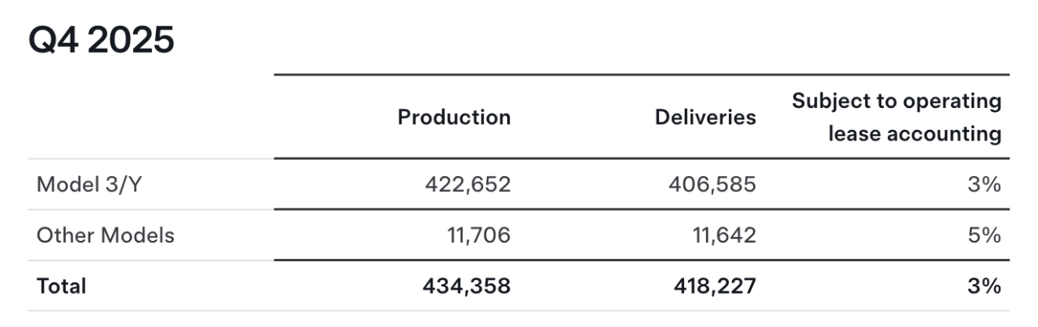
Figure 2: Tesla Fourth Quarter 2025 Production, Deliveries & Deployments (Tesla, 2026).

Macro actor 2: Technology ecosystem (battery economics and charging infrastructure)

Battery price dynamics are compressing differentiation while amplifying scale advantages
The EV cost frontier is moving quickly, and the benefits accrue differently to Tesla and BYD. BloombergNEF’s 2025 battery price survey reports a new low, with average lithium-ion battery prices in 2025 falling 8% to $108/kWh (BloombergNEF, 2025). This is a big opportunity for both companies since it contributes to lower entry prices and higher headroom of the margin.
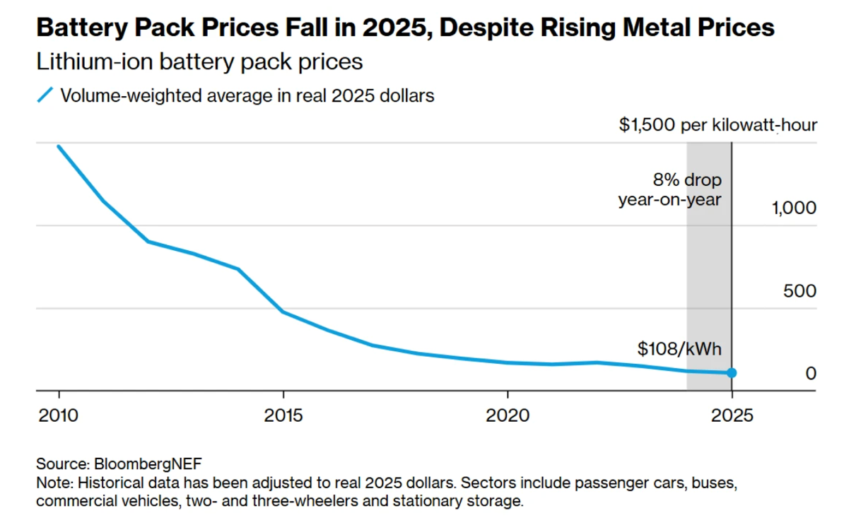
Figure 3: Lithium-ion battery prices dropped again in 2025, with average prices coming down 8% to $108 per kilowatt-hour (BloombergNEF, 2025).
However, it also creates a threat to Tesla’s pioneer differentiation: when industry-wide costs fall, product parity rises, and it becomes harder to justify premium positioning solely on efficiency and manufacturing learning. Tesla must therefore lean more heavily on ecosystem assets, software value, and brand trust to protect price realisation (Basile, 2026). For BYD, declining battery prices amplify a follower advantage rooted in scale because cost reductions can be translated faster into mass-market pricing moves, expanding volume share and forcing competitors into margin compression (Gaccione, 2024).

Charging infrastructure is becoming a standard-setting contest that favours Tesla’s network logic
The idea of charging availability has ceased to be the matter of opening the market; it has become the matter of the default ecosystem creation. In 2024, it also adds over 1.3 million public charging points around the world, over 30 percent, and it emphasizes that access to public charging is central to mass adoption in segments who lack home charging (IEA, 2025). In the case of Tesla, the strategic marketing opportunity is scale charging growth enhances the value of interoperability, and Tesla North American Charging Standard pathway places it as a de facto gatekeeper of a key complementary resource (Sheng, 2025). The Tesla NACS page itself mentions that during the course of 2025, the Tesla North American Supercharging network is being opened to other automakers as they switch to NACS (Tesla, 2025). This puts Tesla in a new competitive stance whereby it is not one of many automakers, but one of eco system orchestrators, as access to charging affects vehicle consideration and low-switching friction.

US infrastructure utilisation data shows the ecosystem is turning into a volume flywheel
The US charging ecosystem is not only expanding, but it is also used extensively, which increases first-mover network effects. According to the Full Year 2025 report of Paren, 141 million fast-charging sessions are projected in 2025, a growth of about 30 percent annually, which means that infrastructure is turning into a lifestyle and not a capacity lay idly (Paren, 2026). This helps Tesla to be competitive as the high utilisation enhances the economics and political legitimacy of charging networks, fostering further growth and enhancing the consumer dependence on the network (Prakhar et al., 2025). It is also a threat: with increasing utilisation, reliability will be a reputational battlefield, and failure of operations will harm the ecosystem benefit of Tesla to a greater degree than a traditional product malfunction would.
The way federal programme is implemented also has an effect on competitive positioning since it will define the areas where coverage gaps will be filled. A policy brief reports that as of February 2025, 48 states had committed a total of 526 million dollars through NEVI and contracted close to 4,000 DC fast charger ports, which is an indication that public funding is actively causing corridors to be covered (Atlas Public Policy, 2025).
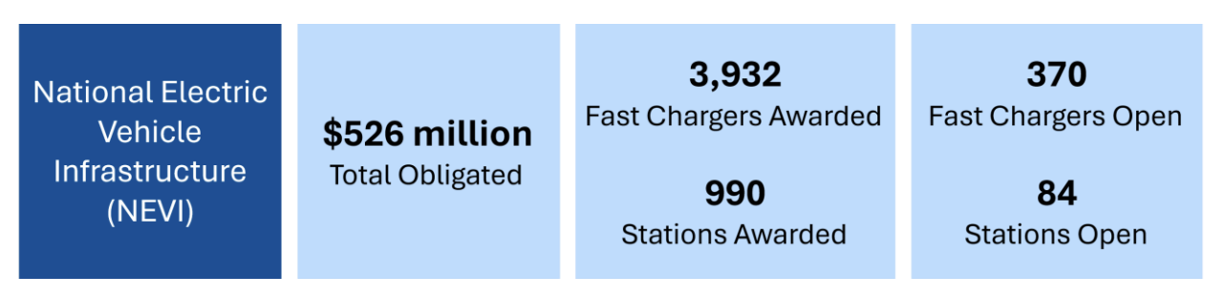
Figure 4: Federal EV Charging Programs Status (Atlas Public Policy, 2025).
In the case of Tesla, the buildout of the public corridors can become an opportunity and a threat at the same time: it will increase the category, yet lessen the exclusivity of Tesla-only charging access over time (Tang, 2024). In the case of BYD, publicly-funded interoperability can lessen the drawback of not having a proprietary network as an entrant provided that BYD can work on those networks without issue and that connector standards, roaming, and payment experience are consumer-compatible.

Task 2

Strategic responses mapped to Porter’s Generic Strategies
Growth reaction response to decreasing industrial policy and charging ecosystem competition in Tesla has been to strengthen a differentiation approach with alternative selective cost leadership leveraging in order to defend volume in incentive-sensitive segments. Tesla has considered charging a justifiable complement and an influence channel, not just a cost centre, on differentiation. The announcement of the connector design to the industry and supporting interoperability under the North American Charging Standard make Tesla an ecosystem organizer, shifting the benefit on the vehicle characteristics itself to the accessibility and convenience of the network (Tesla, 2022). This is operationalised in the following way; that by 2025, the Tesla North American Supercharging network is opening up to additional automakers as they switch to NACS, in effect making the Tesla standard the default and decreasing perceived risk of owning a non-Tesla EV by consumers (Tesla, 2025). It is system-value differentiation and switching-cost differentiation, and the differentiating value is the reliability in charge and access, as opposed to product design (Johnson et al., 2023). At the same time, Tesla also applies cost leadership logic by lowering end-to-end cost and protecting it’s right to receive US purchase incentives by localisation and supply chain compliance due to the increasing tendency towards consumer willingness to pay after credits instead of list price in EVs (Kotler et al., 2022).
BYD’s growth response is more clearly anchored in cost leadership combined with adaptive portfolio positioning as regulation fragments markets. The firm’s structural advantage is battery and manufacturing scale, and the macro environment has pushed BYD to translate that advantage into rapid international expansion and aggressive entry pricing, while also hedging policy risk through localisation plans in tariff-exposed regions. Reuters reports that BYD forecast exports would account for about 20% of global sales in 2025, with 800,000 to 1 million deliveries outside mainland China, indicating that growth is being pursued via cross-border volume and not just domestic deepening (Reuters, 2025a). In Europe, where countervailing duties and political scrutiny can tax away China-based cost advantages, BYD’s strategic response has been a stated pivot to local production. Reuters reports BYD’s intent to produce its EVs for Europe locally within three years, citing leadership commentary linked directly to avoiding EU tariffs (Reuters, 2025b). This is aligned with the cost leadership logic of Porter since it retains the capacity of pricing low than the existing players after factoring in the trade frictions and retains an adequate margin to finance market entry and dealer-network establishment (Datta, 2022).
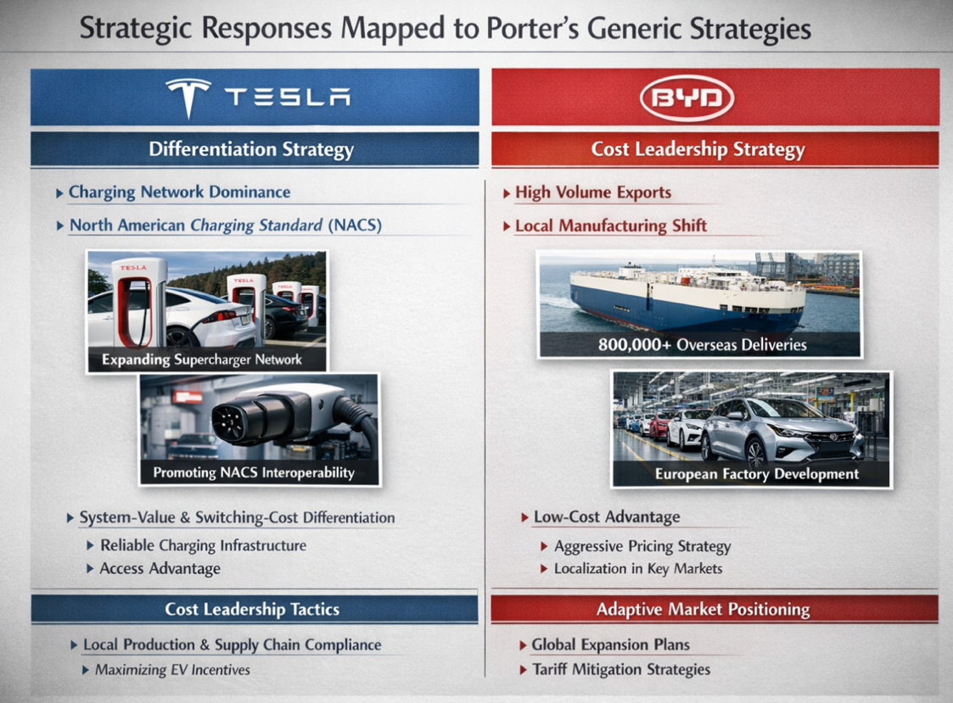
Figure 5: Application of Porter's generic strategies model on BYD and Tesla (Author, 2026).

Strategic responses through Ansoff’s Growth Matrix
The core Ansoff direction of Tesla is market penetration in the existing core markets through ecosystem support and selective product development to preserve premium positioning. In Tesla, penetration is evident in the further expansion of physical and digital entry points that lower the barriers to purchases. The annual report submitted to the SEC by Tesla in 2024 demonstrates that it continues to expand Supercharger network coverage and the infrastructure behind it, reducing entry barriers to first time buyers since it indicates network sufficiency (SEC, 2025). This plan aligns with the finding that the presence of charging infrastructure significantly enhances the propensity to pay and lowers the behavioural obstacle to EV adoption, hence the network is a source of demand-side growth instead of a neutral input in the industry (Ahmad et al., 2025). The response of Tesla product development is associated with the software-enabled value, energy technology and manufacturing process innovation, which ensure the differentiation despite battery costs being shrinking and the competitors approaching minimum performance (Di Maro, 2025). The industry forecasts that EV production is going to be cheaper as a result of manufacturing innovations like gigacasting, where Tesla is generally well-known as a leader, which can help Tesla to resist margins as well as preserve price points (Reuters, 2024). This is a strategic paired Ansoff action, protect penetration at low price and availability, create product and process differentiation to ensure that the perceived value of the brand remains superior to the commoditisation of the competitors (Loutraris, 2025).
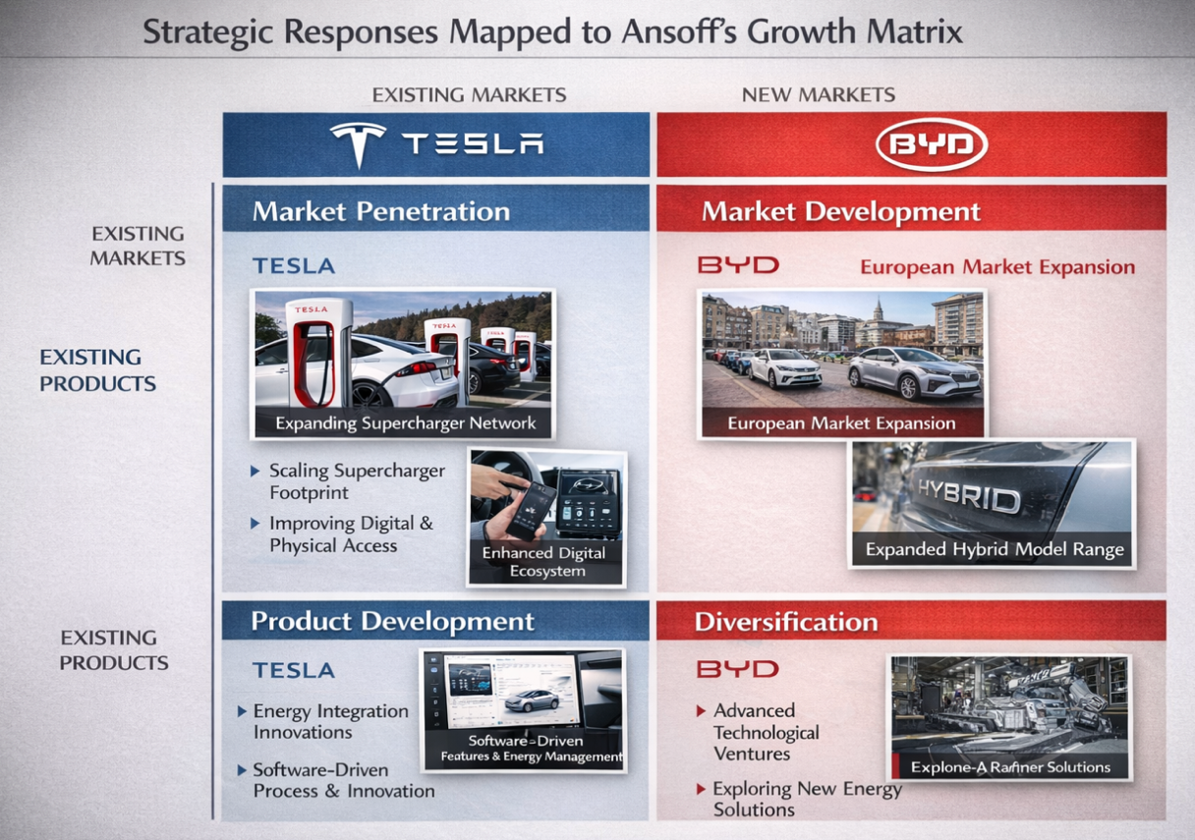
Figure 6: Application of Ansoff's matrix on BYD and Tesla (Author, 2026).
BYD’s dominant Ansoff pathway is market development through geographic expansion plus product development via portfolio broadening to match heterogeneous regulatory and infrastructure conditions. Europe is treated as a growth market where BYD can scale its share through competitive pricing and broadened distribution, and Reuters data show Chinese brands nearly doubled their combined European share to 5.1% in H1 2025, demonstrating that demand is available for low-price, feature-competitive entrants even amid tariff uncertainty (Reuters, 2025c). BYD’s product development is evident in its stated near-term European mix emphasis, where plug-in hybrids are positioned as a bridge for markets with uneven charging availability and price sensitivity, thereby reducing adoption risk for mainstream buyers while maintaining BYD’s electrified brand identity (Reuters, 2025b). The methodology is appropriate to the body of empirical research that the barriers to EV adoption are multi-dimensional and need to be addressed with a set of fiscal incentives, infrastructure preparedness and product-market fit, and not just a technology push (Qadir et al., 2024).

References
Aghaie, S., Kamran-Disfani, O., Darani, M., and Saljoughian, M. M. (2024). Incumbents’ marketing deterrence strategies and potential entrants’ time-to-entry: evidence from the US airline industry. European Journal of Marketing, 58(10), 2265-2287.
Ahmad, S., Chaveesuk, S., and Chaiyasoonthorn, W. (2025). Impact of charging infrastructure on willingness to pay for EV: Mediating role of driving experience and behavior intentions. Acta Psychologica, 254, 104833.
Atlas Public Policy (2025) The Next Steps with Federal EV Charging Programs (PDF). Available at: https://atlaspolicy.com/wp-content/uploads/2025/10/The-Next-Steps-with-Federal-EV-Charging-Programs-1-1.pdf (Accessed: 15 February 2026).
Basile, V. (2026). Strategy and Competitive Advantages. In Resilient Business Models: Innovating Through Global Challenges to Creating Sustainable Futures (pp. 5-81). Cham: Springer Nature Switzerland.
Berezina, P. (2024). The Electric Revolution from China: Impact of Chinese Electric vehicles on Logistics and Market in Europe.
BloombergNEF (2025) ‘New record lows for battery prices’. Available at: https://about.bnef.com/insights/clean-transport/new-record-lows-for-battery-prices/ (Accessed: 15 February 2026).
BloombergNEF (2025) Lithium-ion battery pack prices fall to $108 per kilowatt-hour (Press release, 9 December). Available at: https://about.bnef.com/insights/clean-transport/lithium-ion-battery-pack-prices-fall-to-108-per-kilowatt-hour-despite-rising-metal-prices-bloombergnef/ (Accessed: 15 February 2026).
Consumer Reports (2025) ‘Tesla Superchargers open to other EVs: what to know’. Available at: https://www.consumerreports.org/cars/hybrids-evs/tesla-superchargers-open-to-other-evs-what-to-know-a9262067544/ (Accessed: 15 February 2026).
Datta, Y. (2022). A Critique of Porter's Cost Leadership and Differentiation Strategies: An Update. New Innovations in Economics, Business and Management Vol. 9, 165-181.
Dehghanimadvar, M., Egan, R., and Chang, N. L. (2024). Quantifying the costs of diversifying silicon PV module assembly with local economic policies. Joule, 8(5), 1322-1349.
Di Maro, A. (2025). Business Model Innovation in the Renewable Energy Storage Market: An Empirical Analysis of Leading Global Battery Energy Storage System Companies (Doctoral dissertation, Politecnico di Torino).
European Commission (2024) EU Commission imposes countervailing duties on imports of battery electric vehicles (BEVs) from China (12 December). Available at: https://trade.ec.europa.eu/access-to-markets/en/news/eu-commission-imposes-countervailing-duties-imports-battery-electric-vehicles-bevs-china (Accessed: 15 February 2026).
Farrell, H., Newman, A., POSEN, A. S., WANG, D., KROEBER, A., FROMAN, M. B., ... and ZOFFER, J. P. (2025). The weaponized world economy. Foreign Affairs. https://www. foreignaffairs. com/united-states/weaponized-world-economy-farrell-newman.
Gaccione, V. (2024). Driving Change: a comprehensive analysis of technological, strategical and economical shifts in the Automotive Industry.
Gawer, A. (2022). Digital platforms and ecosystems: remarks on the dominant organizational forms of the digital age. Innovation, 24(1), 110-124.
Glover, N., and Higgins, D. M. (Eds.). (2023). National brands and global markets: An historical perspective. Taylor and Francis.
IEA (2025) Global EV Outlook 2025. Paris: International Energy Agency. Available at: https://www.iea.org/reports/global-ev-outlook-2025 (Accessed: 15 February 2026).
Internal Revenue Service (2026) Notice 2026-15: Guidance to Apply Interim Safe Harbors for Purposes of Prohibited Foreign Entity Rules (PDF). Available at: https://www.irs.gov/pub/irs-drop/n-26-15.pdf (Accessed: 15 February 2026).
Islam, M. M. (2025). The Impact of Green Supply Chain on Organizational Performance.
Kotler, P., Keller, K. L., and Chernev, A. (2022). Marketing management 16ed.(16). Harlow: Pearson.
Loutraris, P. (2025). Quantifying Product/Service Value: A Framework for Modeling Perceived Value to Pricing. Available at SSRN 5449996.
MotorTrend (2025) ‘The Great NACS migration: who switches to Tesla’s charging plug’. Available at: https://www.motortrend.com/news/tesla-nacs-charging-port-automaker-compatibility/ (Accessed: 15 February 2026).
Oqubay, A. (2025). The theory and practice of industrial policy. Industrial Policy and Economic Development, 7-58.
Paren (2026) State of the Industry Report: US EV Fast Charging, Full Year 2025. Available at: https://www.paren.app/reports/state-of-the-industry-report-us-ev-fast-charging-full-year-2025 (Accessed: 15 February 2026).
Prakhar, P., Gupta, S., and Jaiswal, R. (2025). Battery technology and charging infrastructure for EVs: a resource-based and dynamic capability view of entrepreneurial opportunities. Information Discovery and Delivery.
Qadir, S. A., Ahmad, F., Al-Wahedi, A. M. A., Iqbal, A., and Ali, A. (2024). Navigating the complex realities of electric vehicle adoption: A comprehensive study of government strategies, policies, and incentives. Energy Strategy Reviews, 53, 101379.
Reuters (2024) ‘EVs will be cheaper to produce than gas-powered vehicles by 2027, Gartner says’ (7 March). Available at: https://www.reuters.com/business/autos-transportation/evs-will-be-cheaper-produce-than-gas-powered-vehicles-by-2027-gartner-says-2024-03-07/ (Accessed: 15 February 2026).
Reuters (2025a) ‘China’s BYD forecasts exports to top 20% of 2025 sales, SCMP reports’ (29 September). Available at: https://www.reuters.com/world/china/chinas-byd-forecasts-exports-top-20-2025-sales-scmp-reports-2025-09-29/ (Accessed: 15 February 2026).
Reuters (2025b) ‘BYD needs battery plant in Europe to support auto production increase, special adviser’ (24 September). Available at: https://www.reuters.com/world/china/byd-needs-battery-plant-europe-support-auto-production-increase-special-adviser-2025-09-24/ (Accessed: 15 February 2026).
Reuters (2025c) ‘Chinese automakers gain ground in contracting European market, data shows’ (23 July). Available at: https://www.reuters.com/business/autos-transportation/chinese-automakers-gain-ground-contracting-european-market-data-shows-2025-07-23/ (Accessed: 15 February 2026).
Reuters (2026a) ‘EU tariffs on imports of China-made EVs’. Available at: https://www.reuters.com/world/china/eu-tariffs-imports-china-made-evs-2026-02-11/ (Accessed: 15 February 2026).
Reuters (2026b) ‘China’s BYD posts weakest sales growth in five years on headwinds at home’. Available at: https://www.reuters.com/world/asia-pacific/byd-posts-weakest-sales-growth-five-years-headwinds-home-2026-01-01/ (Accessed: 15 February 2026).
SEC (2025) Tesla, Inc. Annual Report on Form 10-K for the year ended December 31, 2024 (Filed 2025). Available at: https://www.sec.gov/Archives/edgar/data/1318605/000162828025003063/tsla-20241231.htm (Accessed: 15 February 2026).
Shen, L., Shi, Q., Parida, V., and Jovanovic, M. (2024). Ecosystem orchestration practices for industrial firms: A qualitative meta-analysis, framework development and research agenda. Journal of Business Research, 173, 114463.
Sheng, Z. (2025, August). A Comparative Company Analysis and Financial Assessment of ChargePoint and Tesla in the US EV Charging Market. In 2025 5th International Conference on Enterprise Management and Economic Development (ICEMED 2025) (pp. 46-57). Atlantis Press.
Sun, L., and Yang, Q. (2025). Strategic Synergy between Financial Leverage and Technological Innovation: Analysing BYD's Competitive Edge in the Global EV Market: A Mixed-Methods Study Integrating Porter's Five Forces Analysis with a Financial Strategy Matrix (2018--2024). Financial Economics Research, 2(1), 57-66.
Tagliapietra, S., Trasi, C., and Sebastian, G. (2025). A smart European strategy for electric vehicle investment from China (No. 21/2025). Bruegel Policy Brief.
Tang, Y. (2024). Network Industries With Spatial Data (Doctoral dissertation, Boston University).
Tesla (2022) Opening the North American Charging System (11 November). Available at: https://www.tesla.com/blog/opening-north-american-charging-system (Accessed: 15 February 2026).
Tesla (2025) ‘NACS: North American Charging Standard’. Available at: https://www.tesla.com/NACS (Accessed: 15 February 2026).
Tesla (2025) NACS: North American Charging Standard. Available at: https://www.tesla.com/NACS (Accessed: 15 February 2026).
Tesla (2026) ‘Tesla Fourth Quarter and Full Year 2025 Production, Deliveries and Deployments’. Available at: https://ir.tesla.com/press-release/tesla-fourth-quarter-2025-production-deliveries-deployments (Accessed: 15 February 2026).
U.S. Department of Energy (2025) ‘30D New Clean Vehicle Credit’. Available at: https://www.energy.gov/mesc/30d-new-clean-vehicle-credit (Accessed: 15 February 2026).
Vazquez Melendez, E. I., Bergey, P., and Smith, B. (2024). Blockchain technology for supply chain provenance: increasing supply chain efficiency and consumer trust. Supply chain management: An international journal, 29(4), 706-730.
Whittington, R., Angwin, D., Regner, P., Johnson, G., and Scholes, K. (2023). Exploring strategy . Harlow.
Zhang, Z. (2025) ‘The European Union’s countervailing duties on electric vehicles from China: disputes and prospects’, USAEE Working Paper No. 25-657 (SSRN). Available at: https://ssrn.com/abstract=5554080 (Accessed: 15 February 2026).

