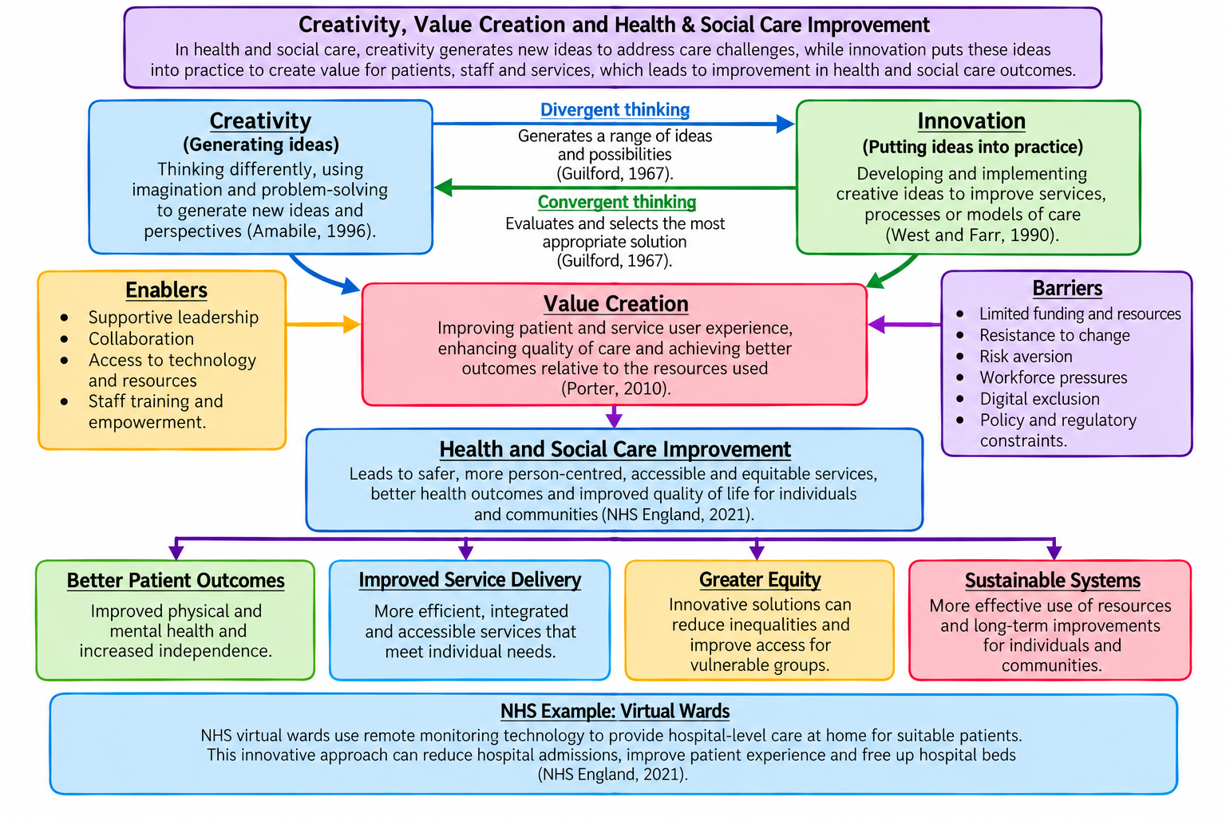
Task 1: Concept Map

Task 2: Self-Reflection of Group Activity

Description
During the group activity, we explored alternative uses for a paperclip, including a bookmark, cable organiser and SIM card tray opener. We then evaluated their practicality, usefulness and safety.

Feelings
Initially, I felt confident but recognised my tendency to dismiss unfamiliar suggestions. Hearing different perspectives challenged my assumption that familiar solutions were necessarily more effective.

Evaluation
Collaboration encouraged diverse ideas; however, premature criticism risked discouraging quieter members. I questioned whether group agreement reflected genuine evaluation or the influence of more confident individuals.

Analysis
Using Gibbs' (1988) reflective cycle helped me examine how personal assumptions influenced my judgement. Divergent thinking encouraged originality without immediate restrictions, whereas convergent thinking required evaluating feasibility and suitability. I favoured the cable organiser because it was simple and reusable. However, the SIM card opener addressed a specific need, demonstrating that value depends on context rather than convenience alone. I recognised that prioritising practicality could suppress innovation, while pursuing originality without considering risks could produce unsuitable solutions. This tension is particularly relevant in healthcare, where creative improvements must balance patient safety, accessibility and resources.

Conclusion
I learned that effective collaboration requires challenging assumptions rather than simply reaching agreement. Next time, I would separate brainstorming from evaluation and actively encourage quieter contributions.

Action Plan
As an NHS Pathway Coordinator, I will encourage colleagues to propose appointment improvements. With managerial approval, I will assess feasibility, safety and accessibility before trialling a change. Comparing appointment delays and patient feedback before and after implementation will help evaluate its effectiveness.

Task 3: Case Study of a UK innovation

Innovation and Creativity
Introduced in England in 2024, Martha's Rule responds to failures in recognising and escalating patient deterioration by enabling patients, relatives and staff to request independent clinical reviews (NHS England, 2024). Its creativity lies in reframing deterioration as both a clinical and communication problem. Rather than developing new technology, the NHS redesigned escalation procedures to incorporate patient and family knowledge. However, adapting existing safety principles does not automatically overcome the organisational barriers responsible for previous failures.

Critical Comparison and Analysis
Conventional systems, including the National Early Warning Score (NEWS2), prioritise physiological observations, whereas Martha's Rule additionally recognises patient and family concerns. Subbe et al. (2024) suggest this approach could challenge hierarchical communication and encourage earlier intervention. Nevertheless, their behavioural framework explains potential benefits rather than proving clinical effectiveness.

NHS England (2025) reported 4,906 escalation calls and 241 potentially life-saving interventions. Although these figures suggest clinical value, they cannot establish that deaths were prevented. Increased calls may indicate greater confidence in speaking up or, alternatively, persistent failures in routine escalation. Welch et al. (2025) emphasise reliable implementation and organisational learning, highlighting that introducing a pathway differs from demonstrating improved outcomes.

Value Creation for Patients and Services
For patients, Martha's Rule potentially creates value through greater autonomy, improved communication and earlier clinical intervention. For NHS services, identifying deterioration sooner could reduce avoidable complications, intensive care admissions and associated costs. However, these anticipated efficiencies require evaluation; additional independent reviews may initially increase staffing demands.

Furthermore, patients with language barriers, cognitive impairments or limited health literacy may experience unequal access. NHS England's (2026) core standards emphasise accessibility and accountability, yet formal guidance alone cannot guarantee equitable implementation. Consequently, the initiative risks benefiting confident, well-informed patients more than those experiencing disadvantage.

Conclusion and Recommendations
Martha's Rule demonstrates how creative organisational redesign can translate patient experiences into healthcare innovation. However, sustainable value depends on measurable outcomes rather than escalation activity alone. NHS trusts should compare deterioration rates, response times, unplanned intensive care transfers and patient experiences before and after implementation, accounting for differences between hospitals. Auditing access across patient groups and using escalation findings to improve routine practice would help establish whether the initiative delivers equitable improvements in safety and service efficiency.

Task 4: A Critical Comparative Evaluation of Workforce Shortages in Health and Social Care
Workforce shortages threaten sustainable health and social care provision in England. However, prioritising recruitment without addressing retention risks increasing staffing numbers without improving workforce stability. Comparing Moscelli et al. (2024) and Teo, Vadean and Saloniki (2022) reveals important differences in how workforce challenges develop across sectors.
Both studies highlight retention, yet their findings challenge standardised solutions. Moscelli et al. (2024) found that part-time employment was associated with greater retention among nurses but lower retention among doctors. Conversely, Teo et al. (2022) identified a negative relationship between care-worker turnover and employment growth, particularly within expanding establishments. Whereas Moscelli et al. expose differences between professional groups, Teo et al. demonstrate that recruitment cannot independently sustain social care expansion when experienced workers continue leaving.
Methodologically, Moscelli et al. analysed individual NHS employment records, whereas Teo et al. examined longitudinal data from social care establishments. Although both provide substantial quantitative evidence, their differing populations and outcome measures restrict direct comparison. Furthermore, neither establishes causation. For example, declining turnover might enable organisational growth, but expanding services could also improve employment stability.
Importantly, the studies reveal different structural pressures. NHS retention varies according to professional and contractual characteristics, while social care employment growth depends on balancing recruitment against departures. Nevertheless, neither study directly measures patient safety, independence or care quality. Therefore, assuming improved staffing automatically produces better outcomes would exceed the available evidence.
Consequently, workforce strategies should reflect sector-specific challenges rather than impose uniform recruitment targets. Flexible employment arrangements warrant investigation within healthcare, while reducing turnover alongside recruitment is particularly relevant to social care. However, these recommendations require evaluation against patient and service-user outcomes. Future research should compare continuity, accessibility and quality of care across both sectors. Ultimately, workforce success must be judged by sustainable, equitable care rather than employment growth alone.

Task 5: Podcast – CareConnect 360: Connecting Older Adults to Better Health and Social Care
Imagine being an older person living with several health conditions, needing support from your GP, community nurses and social care services, but struggling to coordinate them. Unfortunately, navigating different services can be confusing, particularly for individuals with complex care needs.
My proposed innovation, CareConnect 360, aims to address this problem by improving coordination between health and social care services for adults aged 65 and over.
The initiative would introduce a named care coordinator who could help individuals navigate referrals, access community support and communicate with relevant professionals. A secure digital tracking system would support coordination, while telephone and face-to-face options would remain available for those experiencing digital exclusion.
The creative element is not simply introducing technology but redesigning how services communicate around the individual rather than expecting individuals to navigate fragmented systems themselves.
However, CareConnect 360 must offer something beyond existing integrated care arrangements. Introducing another coordination service could increase costs or duplicate professional responsibilities without necessarily improving outcomes.
Therefore, I would propose a small community-based pilot, developed collaboratively with older adults, carers, healthcare professionals and social care providers. Its effectiveness would be evaluated through referral times, service-user experiences and continuity of care.
The potential value extends beyond convenience. Better coordination could support independence, improve access and reduce avoidable delays. Nevertheless, these benefits must be demonstrated rather than assumed.
Ultimately, CareConnect 360 aims to create a more accessible, person-centred approach to health and social care, where older adults receive coordinated support based on their individual needs.

Task 6: NHS Leadership Framework Analysis

Part A: Short Summary of the Key Components
The NHS Leadership Framework identifies seven interconnected domains that guide effective leadership and improve healthcare delivery (NHS Leadership Academy, 2011). Demonstrating Personal Qualities emphasises self-awareness, integrity and professional development, while Working with Others promotes communication, teamwork and collaborative relationships. Managing Services focuses on planning, resource allocation and maintaining safe, efficient care.
Improving Services encourages leaders to evaluate existing practices, support innovation and prioritise patient safety. Setting Direction involves using evidence to identify organisational priorities and guide decisions. Creating the Vision establishes shared goals that motivate staff, whereas Delivering the Strategy translates these ambitions into practical actions and measurable improvements.
Together, these components connect individual leadership behaviours with organisational performance. However, their application requires balancing competing priorities. For example, encouraging innovation may conflict with financial constraints, while achieving efficiency targets could restrict opportunities for staff creativity.
West and Dawson (2012) highlight associations between staff engagement and NHS performance, supporting collaborative leadership. Nevertheless, engagement alone cannot guarantee better patient outcomes, particularly when organisational barriers prevent ideas from being implemented.
Therefore, the framework provides a structured approach to leadership, but its effectiveness depends on how successfully leaders translate its principles into meaningful improvements in patient care.
Part B: Using Improving Services to Encourage Creativity and Improve Care
The Improving Services component encourages leaders to question established practices and develop innovative approaches to care (NHS Leadership Academy, 2011). For example, an NHS pathway team leader could invite administrative and clinical staff to identify causes of appointment delays and suggest improvements to patient communication.
This collaborative approach encourages creativity by valuing frontline knowledge and allowing staff to challenge inefficient procedures. Compared with imposing managerial solutions, staff involvement may generate more practical ideas. However, creativity alone does not guarantee improvement, particularly when limited resources or organisational resistance prevent implementation.
A leader could pilot a revised appointment communication process and evaluate its effectiveness through waiting times, patient feedback and staff workload. Importantly, any changes must maintain confidentiality, accessibility and clinical safety.
Although West and Dawson (2012) associate staff engagement with improved performance, measurable outcomes remain essential. Ultimately, effective leadership encourages creativity while ensuring that innovative ideas translate into safer, more responsive and person-centred NHS care.

Task 7: Self-Reflection Journal Entry
Reflecting on this module, I recognise that my initial understanding of creativity was limited. I associated innovation with originality, overlooking whether new ideas genuinely improve health and social care experiences. I now appreciate that creativity only creates value when solutions address meaningful needs and produce demonstrable benefits.
The paperclip activity challenged my assumptions by revealing how collaboration generates alternative perspectives. However, I initially prioritised the quantity of ideas over their practicality, highlighting a weakness in my evaluative thinking. Exploring Martha's Rule reinforced this learning by demonstrating how established procedures can overlook patients' concerns. Nevertheless, I recognise that introducing innovation does not automatically establish its effectiveness.
This shift has encouraged me to reconsider my NHS Pathway Coordinator role. Previously, I underestimated how administrative communication could influence patients' experiences. I now recognise opportunities to identify inefficiencies, although limited authority and competing demands may restrict improvements.
To develop professionally, I intend to identify a recurring communication difficulty, discuss potential solutions with colleagues and propose a manageable improvement. I will evaluate its impact through appropriate service measures and patient feedback, rather than assuming success.
Ultimately, this module has taught me to question established practices while recognising that meaningful innovation requires evidence, collaboration and accountability.

References
Amabile, T.M. (1996) Creativity in context. Boulder, CO: Westview Press.
Gibbs, G. (1988) Learning by doing: A guide to teaching and learning methods. London: Further Education Unit.
Guilford, J.P. (1967) The nature of human intelligence. New York: McGraw-Hill.
NHS England (2021) A guide to setting up technology-enabled virtual wards. Available at: https://www.england.nhs.uk/long-read/a-guide-to-setting-up-technology-enabled-virtual-wards/ (Accessed: 22 October 2026).
Porter, M.E. (2010) 'What is value in health care?', New England Journal of Medicine, 363(26), pp. 2477–2481. Available at: https://doi.org/10.1056/NEJMp1011024.
West, M.A. and Farr, J.L. (1990) 'Innovation at work', in West, M.A. and Farr, J.L. (eds.) Innovation and creativity at work: Psychological and organizational strategies. Chichester: John Wiley & Sons, pp. 3–13.
NHS England (2024) Implementation of first phase of Martha's Rule. Available at: https://www.england.nhs.uk/long-read/implementation-of-first-phase-of-marthas-rule/ (Accessed: 23 October 2026).
NHS England (2025) Martha's Rule rolled out to all acute hospitals. Available at: https://www.england.nhs.uk/2025/09/marthas-rule-rolled-out-to-all-acute-hospitals/ (Accessed: 23 October 2026).
NHS England (2026) Martha's Rule: core standards. Available at: https://www.england.nhs.uk/long-read/marthas-rule-core-standards/ (Accessed: 23 October 2026).
Subbe, C.P., Steinmo, S.H., Haskell, H. and Barach, P. (2024) 'Martha's rule: applying a behaviour change framework to understand the potential of complementary roles of clinicians and patients in improving safety of patients deteriorating in hospital', British Journal of Hospital Medicine, 85(2), pp. 1–6. Available at: https://doi.org/10.12968/hmed.2023.0422.
Welch, J., Murkin, J., Edwards, E., Inada-Kim, M. and Subbe, C. (2025) 'Giving patients, families and staff a reliable voice in acute care: Expert guidance for implementation of Martha's Rule in UK hospitals', Future Healthcare Journal, 12(1), article 100223. Available at: https://doi.org/10.1016/j.fhj.2025.100223.
Moscelli, G., Nicodemo, C., Sayli, M. and Mello, M. (2024) 'Trends and determinants of clinical staff retention in the English NHS: a double retrospective cohort study', BMJ Open, 14(4), e078072. Available at: https://doi.org/10.1136/bmjopen-2023-078072.
Teo, H., Vadean, F. and Saloniki, E.-C. (2022) 'Recruitment, retention and employment growth in the long-term care sector in England', Frontiers in Public Health, 10, article 969098. Available at: https://doi.org/10.3389/fpubh.2022.969098.
NHS Leadership Academy (2011) Leadership framework. Available at: https://www.leadershipacademy.nhs.uk/wp-content/uploads/2014/11/Leadership-Framework.pdf (Accessed: 24 October 2026).
West, M.A. and Dawson, J.F. (2012) Employee engagement and NHS performance. London: The King's Fund. Available at: https://assets.kingsfund.org.uk/f/256914/x/f7572997c3/employee_engagement_nhs_performance_west_dawson_leadership_review2012_paper.pdf (Accessed: 24 October 2026).
National Institute for Health and Care Excellence (NICE) (2015) Older people with social care needs and multiple long-term conditions. NICE guideline NG22. Available at: https://www.nice.org.uk/guidance/ng22 (Accessed: 22 October 2026).
National Institute for Health and Care Excellence (NICE) (2016) Multimorbidity: clinical assessment and management. NICE guideline NG56. Available at: https://www.nice.org.uk/guidance/ng56 (Accessed: 22 October 2026).

