ASSESSMENT 1

LEVEL 5 ASSESSMENT SPECIFICATION

Student name: |  | Student ID number:
Programme: | IUMW Business Administration (Dual Award)
Module: | Changemakers: Creativity and Value Creation
Module code: | IUBA5002 | Contribution to Overall Module Assessment (%): | 50%
Lecturer: | Emma Roberts | Internal Verifier: | Vic Saunders
Assignment Title: | E-Portfolio Evidence of Learning | Word count (or equivalent): | 2000 words or equivalent
Submission deadline: | 30th July 2024 | Return date of provisional marks & written feedback: | 50%
Submission method: | All written assessments, where practical and possible, must be submitted via Turnitin unless otherwise instructed by the Lecturer. (Please DO NOT put this assessment specification into Turnitin or it will match many similarities with other students’ submissions.)  Alternative submission method (if applicable):  Late submission of the assessment will result in a late penalty mark:  Work which is submitted up to 1 week late will be capped at 40% for the first attempt and will be awarded a mark of 0% for re-assessment. Late submission penalties may be lifted only if there is an approved extenuating circumstances claim.  Work submitted more than 1 week late will be considered as a non-submission and will not be marked. The work may be considered as a submission for reassessment if offered by an Examining Board or if there is an approved extenuating circumstances claim.
Academic honesty / referencing: | Academic honesty is required. In the main body of your submission you must give credit to authors on whose research and ideas your work is based. Append to your submission a reference list that indicates the books, articles, etc. that you have used, cited or quoted in order to complete this assessment.

Module Learning Outcomes
(from module syllabus)
- Demonstrate knowledge and critical understanding of innovation, creativity and enterprising mindset, recognising the values and the contribution creativity makes to the common good.
- Conceive, articulate and apply creative thinking within a work-based or academic context to develop novel solutions and/or value creation.


Davina Wyn Evans

Changemakers: Creativity and Value Creation

Content Page
Task 1 – Research Question………………………………………….Pg.1
Task 2 – Research Techniques………………………………………Pg.2
Task 3 – Presentation of Idea……………………………………….Pg. 3
Task 4 – Data Analysis………………………………………………….Pg. 4
References

Task 1 – Research Question
INTRODUCTION
Internships are one of the vital steps when it comes for the beginner stages for students and recent graduates in today’s competitive job market. Internship programmes provides them practical experiences and a pathway towards full-time employment. To develop a large pool of future potential employment opportunities companies need to make large investments in their internship programs. These programs effectiveness varies with the influence on the organization as well as the interns. Through an analysis and research of the advantages and identification of best practices that brings a success, this research attempts to investigate the impact of successful onboarding and internship programs on the success of interns and organizations.

RESEARCH QUESTION: How does effective internship programmes impact interns?

PROBLEM STATEMENT
Although internship programs are widely used, little is known about how intern happiness and organizational outcomes are impacted by the caliber of onboarding and internship experiences. Developing programs that not only draw in top people but also guarantee their growth, engagement, and retention is a difficult task for many firms. Conversely, interns frequently face challenges like poor training, hazy expectations, and a lack of meaningful work, which can cause them to become dissatisfied and perform poorly. Resolving these issues is essential to increasing organizational success and making the most of the internship investment.

VALUE OF THE RESEARCH
This study is very valuable from an academic and practical standpoint. It advances academic understanding of organizational behavior and human resource management by presenting empirical data on the benefits of successful onboarding and internship programs. In practical terms, the results can help firms create and administer more successful internship programs, which will eventually boost retention rates, enhance intern performance, and increase overall organizational success. Through the identification of critical elements that lead to fruitful internships, this study seeks to improve intern experiences and provide real value to host organizations.

RESEARCH APPROACH SELECTION
The chosen research approach for this research is the implications of abductive reasoning. With this reasoning method, it helps to form such hypotheses based on the collected data (Oliver‐Hoyo & Sloan, 2014) towards the guidance of investigating what are the challenges faced by interns. By generating hypotheses through this approach, it offers a deeper understanding of the stated complex issues.

Figure 1.0 Types of reasoning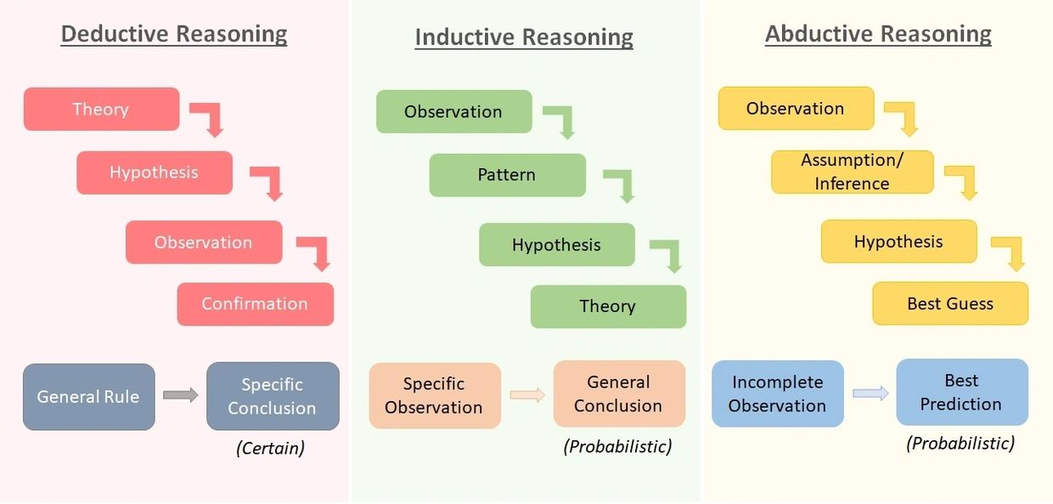

Moving on, the chosen method is the mixed-methods approach that includes the combination of qualitative and quantitative research. Qualitative data refers to the collection of non-numerical data that serves a valuable purpose to gain in-depth understanding towards emotions, social situations and human experiences. Quantitative data deals with measurable evidence that bring numerical value to obtain quicker and precise results. With accordance to the research question, a survey form was distributed that contains the mixed-methods (qualitative and quantitative) the qualitative data collected is in a form of open-ended survey answers as for the quantitative data is collected through a set of close-ended questions that can be measured. Researchers can combine the advantages of qualitative and quantitative approaches to ensure that findings are both highly contextualized and statistically accurate (Allen et al., 2015).

The chosen data collection method shows a mixture of both primary and secondary methods. The combination of both data collection methods offers a comprehensive approach where it allows a detailed firsthand data collection exploration of the experiences of the targeted audience and involving literature reviews that identifies the gaps in existing knowledge.

As for the sampling method, the suitable method is purposive sampling where it allows the specific selection of participants that have particular characteristics that is relevant towards the research question. Given that the selection of participants who possess the greatest depth of knowledge on the research issue, purposeful sampling is especially useful in qualitative research, yielding extensive and comprehensive data (Palinkas et al., 2013).
Along with the sample size of 30 respondents. Hence, by collecting data by individuals whom are knowledgeable about the internship experience, purposive sampling guarantees the collection brings details and insightful information capturing a diverse range of perspectives of the challenges faced by interns. As an experienced HR intern myself, this allows me to connect with participants on a deeper level where it creates a sense of personal investment and driving motivation to uncover meaningful solutions and recommendations in the future of HR as I develop my career.

Task 2 – Research Techniques
The appropriate research technique selected is the distribution of survey forms. It was created in a structured questionnaire with the combination of both close and open-ended questions targeting current and former interns. The survey was distributed through the online platform of Google Forms. Hence, this research technique brings value and an advantage towards the collection of quantitative and qualitative data (literature review). Based on my chosen research approach which are mixed methods (qualitative and quantitative) this gives the ability of the research to conduct primary and secondary research.

PRIMARY RESEARCH
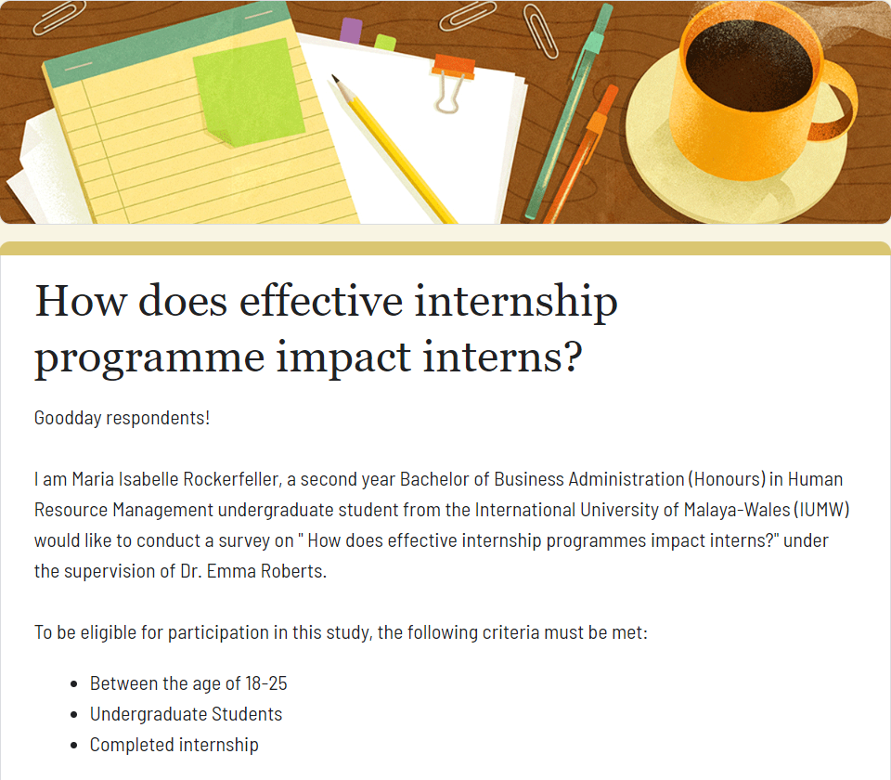
Objective: Gathering firsthand data with the goal of generating new information and knowledge about the challenges faced by current and former interns they faced during their internship.
Method: Survey
Design: A structured questionnaire with both open-ended and close-ended questions for qualitative and quantitative data. Using online survey platforms such as Google Forms.

Sample Questions:
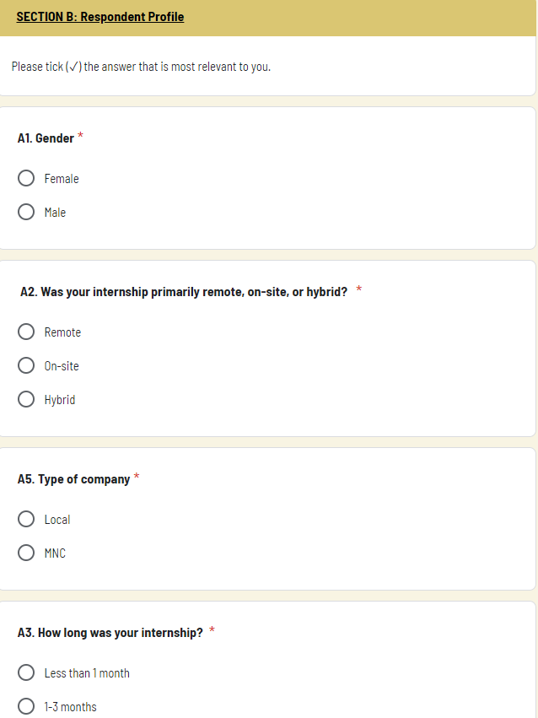
- SECTION B: DEMOGRAPHIC INFORMATION

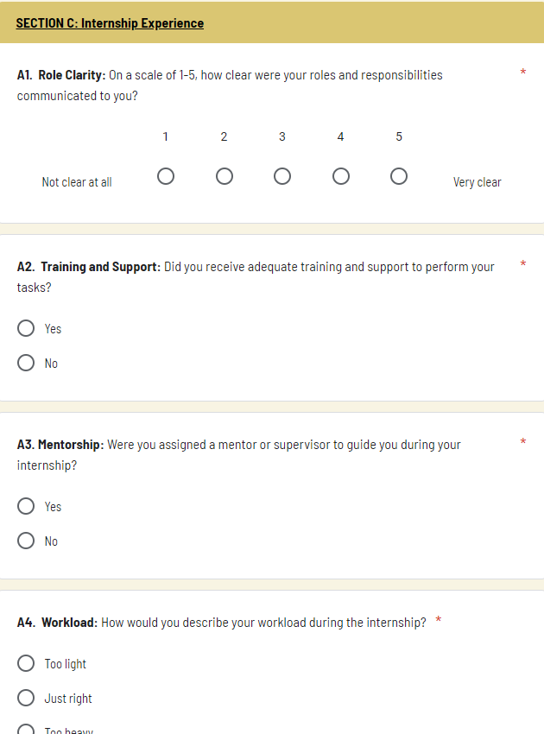
- SECTION C: Internship Experience

- SECTION C: CHALLENGES FACED
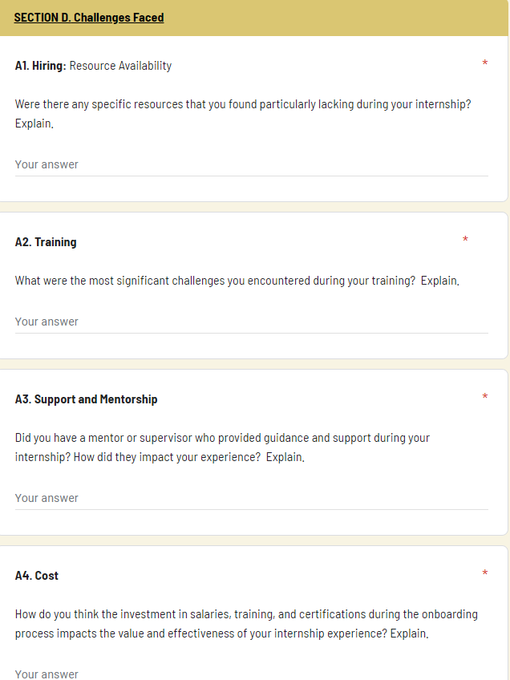

Distribution: To reach out a varied set of interns, the survey was distributed via word of mouth where it ensures that survey has reached the relevant audience where individuals are likely to share with others that have the same experiences and also university networks where the survey is distributed among students that have recently completed internships.

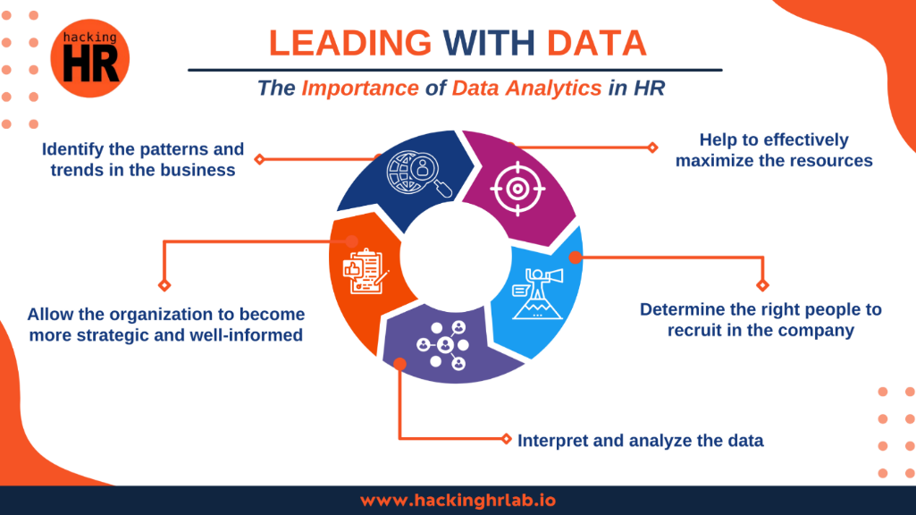
Figure 2.0 Data Analytics in HR
Without the collection of data, organizations are not able to come out with strategic decisions. Hence, with relevance in primary data collection method, collecting firsthand data brings value towards the organization and a smoother process that eliminate such risks (Rubio, 2024)

SECONDARY RESEARCH
Objective: Examine reports and material already in existence to determine typical issues encountered by interns, then contrast these conclusions with data from primary research.
Method: Literature Review
Sources:
Academic Journals | In search for peer-reviewed publications about difficulties and experiences with internships in resources such as Google Scholar
Online Articles | Analyze articles from reliable publications such as the Harvard Business Review, Forbes, and blogs.
Online Databases | Statistical databases such as Statista and World Bank to obtain regional information on various topics

Task 3 – Presentation on Ideas (TO BE DONE)
- Produce a 3-minute video elevator pitch that presents your area of research to identified stakeholders and obtain feedback that should be reflected upon in no more than 200 words.
- Put script
- Why is my research flexible and useful and valuable? And reflect on it

Task 4 – Data Analysis
In this study, the data collected was analysed as a descriptive statistical analysis that includes questions such as the demographic information, internship experience to the challenges faced. With the collection of 30 respondents of the mixture of both qualitative and quantitative data, this helped the research a clear analysis of the findings.
The data was analyzed using descriptive statistics, with an emphasis on measures like satisfaction levels and issues mentioned.
- Demographic Information
The demographic data collected offers insightful information on the effects of successful internship programs. Several important conclusions are drawn from the internship data analysis. The mode of internship shows that (63%) of respondents strongly prefer on-site work, with hybrid (27%), and remote (10%) employment being less common. This shows that on-site internships provide the opportunity to develop their skills and build networks (Hora & Thompson, 2017). The company type indicates a limited exposure to global work exposure, reflecting the majority of local companies at (80%). MNC internships offer more chances for career advancement because big businesses frequently give better organized training programs, cutting-edge technology, and resources. The duration of internships varies; most are short-term at (57%), which may have an effect on the breadth of experience that could diminish their employability.

- Experiences
There are 6 close-ended question in the context of the experiences of interns. Out of 6 factors influencing the internship experience, the key highlights that the interns experienced were:

- Inadequate Role Clarity and Communication
Out of various experiences questioned towards the participants in the areas of role clarity, training and support, mentorship, workload, pressure of completion, skill development and salary, it was founded that role clarity was the most significant finding that interns experienced. On a scale of 1 to 5, almost half of the respondents at (47%) stated their roles and duties were not clearly defined (1 or 2). This suggests that there are widespread difficulties in successfully expressing job expectations. It is alarming that there is a general lack of clarity for roles because it compromises the internship experience as a whole and points to a fundamental gap in the onboarding and management procedures.

Although some interns indicated that role communication was adequate, the significant percentage of interns who had difficulty understanding their roles highlights the urgent need for improved communication techniques. Enhancing role clarity is crucial for creating a more productive and interesting internship environment in addition to making sure interns are aware of their tasks while also reducing stress that can increase the likelihood of post-internship job offers (Rutman & Catharines, 2022). By addressing this problem, internship programs may become more productive and increase overall satisfaction by resulting in more consistent experiences throughout internships.

- Disparity in Skill Development Opportunities
A wide range of experiences can be seen in the skill development statistics; 33% of interns gave their skill development an outstanding scale of 5, while 30% gave it a very low scale of 1. This discrepancy shows that some interns greatly benefit from their internships, others just had a few opportunities to pick up new skills. The finding emphasizes the necessity of creating uniformity in skill enhancement prospects among internships to guarantee that every participant can acquire significant and applicable experience that increases their chances to secure full time employment (Jackson & Wilton, 2016).

- Challenges Faced
Under this section, the data collected are in a form of 7 open-ended question. As mentioned in the survey, the various factors that influences internship programmes are hiring, training, mentorship, cost, recognition and rewards, personal development plans, culture and technology. Out of all factors, below are some of the significant factors that influences the challenges faced by interns.
- Mentorship, Training and Support
Significantly better experiences, improved abilities, and increased motivation were reported by interns who got appropriate direction and assistance from their mentors. On the other hand, a lack of this kind of assistance resulted in emotions of demotivation, and a lost chance for career advancement. This emphasizes how crucial it is for companies to fund the right kind of training and support networks in addition to structured mentorship programs, in order to make sure interns get the most out of their experiences. A large number of interns expressed the need for more extensive training materials, especially for industry-specific equipment, software, and overall business functions. A prevalent issue was the lack of proper paperwork and training, which left some interns feeling abandoned or unprepared for their jobs. The need of receiving quality instruction and direction from mentors or supervisors was emphasized as being essential to the interns' success. An approach towards quality improvement is applying the Six Sigma methodology. It is a practical use of quality management concepts that improve analytical and problem-solving abilities to real-world situations (Singh & Sharma, 2020).

- Importance of Recognition and Rewards
Interns placed a high priority on rewards and recognition since they observed that these factors had a big impact on their engagement and motivation. Encouraging excellent performance and preserving morale were perceived to require regular recognition, competitive allowances, and well-defined career pathways. On the other side, the lack of these elements resulted in feelings of frustration and demotivation. Apart from monetary rewards, other examples of recognition and rewards that motivate interns are certification or public recognition where they may feel more confident and know that their efforts are appreciated as a result of this validation (Aruna, 2018). As mentioned, this can help towards career development that interns seek.

Conclusion
The survey's main conclusions emphasize how crucial it is to have enough resources, mentorship, and support when interning. The interns expresses their difficulties with staffing since they were overworked due to insufficient team guidance. Particularly challenging was the absence of training materials. Problems with training included having busy or strict mentors, having skill gaps, and having trouble networking with more experienced professionals. While some interns had helpful mentors, others had inadequate direction, which hindered their ability to learn and develop. Many interns felt that their abilities and commitment were improved by the investment in salary, training, and certificates, which was important for keeping them motivated. Motivation was increased by effective recognition and rewards, yet some felt underappreciated. Lack of coaching on stress management and communication hampered personal development.

References
Oliver‐Hoyo, M., & Sloan, C. (2014). The development of a Visual‐Perceptual Chemistry Specific (VPCS) assessment tool. Journal of Research in Science Teaching, 51(8), 963–981. https://doi.org/10.1002/tea.21154
‌Allen, N. E., Walden, A. L., Dworkin, E. R., & Shabnam Javdani. (2015). Mixed Methodology in Multilevel, Multisetting Inquiry. Oxford University Press EBooks, 335–344. https://doi.org/10.1093/med:psych/9780190243654.003.0033
‌ Palinkas, L. A., Horwitz, S. M., Green, C. A., Wisdom, J. P., Duan, N., & Hoagwood, K. (2013). Purposeful Sampling for Qualitative Data Collection and Analysis in Mixed Method Implementation Research. Administration and Policy in Mental Health and Mental Health Services Research, 42(5), 533–544. https://doi.org/10.1007/s10488-013-0528-y
‌Rubio, E. (2024). Leading with Data: The Importance of Data Analytics in HR. Linkedin.com. https://www.linkedin.com/pulse/leading-data-importance-analytics-hr-part-9-enrique-rubio-he-him-/
‌
Hora, M., & Thompson, S. (2017). RESEARCH BRIEF #2 What do we know about the impact of internships on student outcomes? Results from a preliminary review of the scholarly and practitioner literatures. https://ccwt.wisc.edu/wp-content/uploads/2022/04/CCWT-report-Designing-Internship-Programs.pdf
‌ Rutman, J., & Catharines, S. (2022). Exploring the Role of Internships in Personal and Professional Development. https://dr.library.brocku.ca/bitstream/handle/10464/17544/Brock_Rutman_Jeremy_2022.pdf?sequence=5
Jackson, D., & Wilton, N. (2016). Developing career management competencies among undergraduates and the role of work-integrated learning. Teaching in Higher Education, 21(3), 266–286. https://doi.org/10.1080/13562517.2015.1136281
Aruna, G. (2018). Impact of Rewards and Recognition on Employee Motivation. International Journal of Creative Research Thoughts, 6(1), 2320–2882. https://ijcrt.org/papers/IJCRT1801559.pdf
‌ Singh, A., & Sharma, P. (2020). Implementation of DMAIC Methodology of Six Sigma in Vocational Education and Training for Quality Improvement. ResearchGate; unknown. https://www.researchgate.net/publication/347973477_Implementation_of_DMAIC_Methodology_of_Six_Sigma_in_Vocational_Education_and_Training_for_Quality_Improvement
‌

