LCMB7006 Assignment 1

Maya Todorova
Student Number: 2009851
MBA – LCMB 7006
Lecture name: Tushara Balendran

Table of Contents
Abstract...................................................................................................................................4
Introduction.............................................................................................................................4
Analysis environmental marketing for external influence, keys and internal environment and marketing role into the brand and related countries…….…………….………......…….…………………..4
Critical analysis of similarities and differences between the USA and UK and given
explanation and comparison of the market entry method…………………………………........11
Conclusion...............................................................................................................................18
Reference................................................................................................................................19
Weblinks..............................................................................................................................…19

Abstract
The following report present a short history of establishing, growth and using a marketing strategy for one of the most successful skincare brands in the world – Olay. Part of well-known global company such as Procter and Gamble are, Olay are one of the leading cosmetic brands, and here we will follow the various marketing strategies which positioned the brand as one of the world leaders in skincare.

Introduction
The choice of millions of people around the world to use P&G products only proves their global impact and success. The introduction of the skincare brand named” Olay”, which phenomenal success worldwide as a best-seller in facial skincare, proves not only the quality of the products they offer to consumers, but also shows an ambitious marketing strategy in bringing diversity on the market and deliver one of the highest of quality products, which no doubt has been accepted quite well from consumers. And the latest statement has been strongly supported in one of the latest reports from P&G, claiming that as of 2020 “Olay” has been holding 6% global market share in skincare, which is equal to $5.6 bn in retail sales. It deserves to mention that “Olay” has introduced to the market a various type of products, which allows a greater choice of products to the consumers.
Looking back in the history of the brand, I discovered that the history of “Olay” is quite interesting and when the product was initially created, the purpose of use was for Royal Air Force pilots suffering from burn injuries. Invented during World War II by Graham Gordon Wulff, as a glycerin-based rehydration treatment. Soon after the war ended, Wulff joined forces with Shaun "Jack" Adams Lowe and both discovered the existence of a mysterious tropical plant which they called the Ulan, from which their "oil" was derived, and they called it a "mysterious beauty fluid that makes you look younger” and began selling the product literally door to door in South Africa.
The sell of Oil of Ulan began has increased, and in 1950s, the company began exporting to Australia and the UK, followed by North America and Mexico in the early 1960s. It’s important to note that as part of their marketing strategy the pair has transformed the product's branding and packaging to the charm of local tastes. As a result, Oil of Ulan became Oil of Ulay in the UK and Australia, Oil of Olay in North America, Oil of Olaz or Ulaz in Latin America and so on.
By 1980, regardless that the brand had faced tough competitor in the face of Estee Lauder, it was firmly established in US as a mid-market brand, which had boosted the sector to sales of around $225m.
As per Keller 2008 ”Consumers may receive many different types of risks in buying and consuming a product. Purchasing a product is considered a process, which is intrinsic, such as taste or design or extrinsic such as price or brand to evaluate or purchase a product brand (Nes and Bilkey 1993, Samil 1994).
From the research we found out that consumers' choice is affected by the information they receive about the products, country origin. All the global brands known in the business would have permission for suitable competitive advantage in the global market.
Keller(1993) shared his views that a core factor for establishing brand is the knowledge, and that was further analyzed in his study. If we need to look into the international and environmental marketing and their defining role in establishing the brand in UK and US, we need to look into the main drivers, which have impact over the process.
To start analyzing the environmental marketing and taking it into consideration, we would need to explain the factors of external influence and internal environment. We will present an information about two chosen countries, such as UK and US, and explain the favorable and unfavorable factors affecting the business. Before we jump into analyses, first we need to give a definition of marketing environment.
“A company’s marketing environment consists of the factors and forces outside marketing that affect marketing management’s ability to build and maintain successful relationships with target customers.” (Kotler 1997).
Another subject, connected to the discussion is the macro- environment. The factors included into to the macro-environment are economic, demographic forces, technological factors, natural and physical forces, political and legal environment as well.
As we mentioned above the “Olay” was introduced in South Africa and that’s the place where the business has started, and nowadays became one of the best global sellers in facial skincare. The revenue figures from 2008 are showing that the brand reached sales of $2 bn and further $3.3 bn was reached in 2013.
The CEO of P&G Alexandra Keith is the master mind behind the Olay marketing campaigns and product innovations. In order to keep the consumer’s interest in mind she had launched “flash in the plan” items. This is result in what she described as ”a suburban sprawl “of too many products. The strategy to focus on anti – aging products has brought the business to a higher level. It’s interesting to know that before Alexandra was promoted to CEO, she was the Brand Manager of P&G. That’s one of the reasons why the brand has expanded and turn into one of the most successful skincare brads worldwide. The decisive and creative mind of their CEO located Olay in a leader with the best anti-aging products. It’s also worth to know that for every country Olay have different strategy and business plan.
Let’s have a look in their marketing here in UK. The brand introduction of Olay here in UK is linked with the direct and indirect communication to their consumers and presenting innovation products with stylish packaging design. By taking into consideration the consumer insight Olay has turn their anti-aging into the best-selling product in UK bringing one of the highest figures in revenue and sales. Without any doubt we can say that currently Olay is one of the best retail brands in UK.
Another interesting fact is that Olay has been a leader in the coffee market for a long time, and that has been achieved due to brand’s strong resources through aggressive marketing strategies globally. For every country and regions Olay have developed different strategy. As a global brand they have different targets in different countries.
The plan is the brand to become one of the best-selling in the world according to the Adams national group. The marketing strategy of the brand is to introduce collection of product, price, place, and promotion.
One of their marketing strategies is product planning using collection of product pricing, advertising and distribution. Also, the brand wants to send a message to the customers that the products are made for different type of needs and customers.
We can recognize macro-economic factors connected and affecting the business. Their impact is mainly on the business strategy, decision making and performance. The first step OLAY did before take any plan on decision is to investigate the macro and micro-environment. The factors affecting the business in micro- environment are its customers, competitors, employees, shareholders, media and social media. We are going to analyze and introduce the diagram and give a differentiation for each factor if it’s favorable or unfavorable.
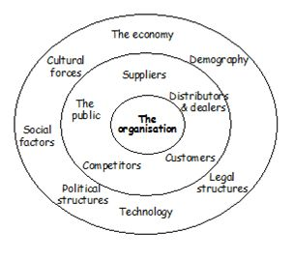

Diagram 1: The micro and macro environment.
It’s crucial for every business and organization to pay attention of the surrounding factors and atmosphere. From the above we can see how that in the macro and microenvironment small forces within the company can affect its ability to serve its customers (micro) and large social forces can affect the microenvironment (macro external). Here we will introduce PESTLE analysis for both countries UK and US and each factor will be analyzed separately. We will give a definition for the factors and analyze them if they are favorable or unfavorable. Oley PESTLE analyses include external factors such as political, economic, social, technological where they are in relationship with the legal and environmental factors.

- Social Factors - the success for Olay brand start with the logo. Everything in the business is a connected to a group factor, which are the attitudes towards buying behavior, changing demographics and how all of them affect the business. The brand Olay have offered a different choice for each customer. These factors are Favorable, and they bring positive benefit into growing up the business. The model of Hofstede is great example for the connection between values and behavior, where they help the structure based on factor analysis. The theory of Hofstede introduces dimensions value explaining that the people’s behavior with different cultural background and the way they will potentially behave when placed in a work-associated context. Here is six cultural dimensions:

- Power Distance
- Uncertainty Avoidance: Describing which people in society are not at ease with ambiguity and uncertainty.
- Individualism vs. Collectivism
- Masculinity vs. Femininity: The dilemma between the preference for assertiveness, heroism, achievement, and material reward for attaining success.
- Long-Term vs. Short-Term Orientation: Long-term orientation describes the inclination of a society toward searching for virtue.
- Indulgence vs. Restraint: This revolves around the degree to which societies can exercise control over their impulses.
- Political factors – the company operates in 190 countries. When they include more countries in the business then they can face business change and maybe this can affect the future growth and expand of the business.
- Economic factors- The brand is worldwide known, and it’s been using foreign exchange rates and prices. Following economic event, the exchange rate could go up and down, which would reflect over the prices in GBP and USD.
- Technological factors – The scientific progress in technologies would increase the production line and will allow the company to focus on creating new products.
- Environmental factors- Increasing of popularity topic. It’s important for every organization to have a plan for environmentally friendly environment not only for their workers, but for the disposals as well.

CONCLUSION
Olay is very popular brand worldwide and their consumers are satisfied and well informed about the quality of the product. The company have plan to work on improving technology and adopt them in order to create and introduce a new type of competitive and high-quality skin care products. The effect of PEST is a legal environment issue, and many companies are affected by that. We can see that the above factors are important for the success of the business in many ways. Looking into the political factors we can say that they can be sometimes unfavorable, economic are favorable, social are favorable and technological are favorable. Those factors reflect to both country USA and UK equally in the business.

Another method for analyzing competition of a business is a PORTER'S FIVE FORCES analysis

Olay is a global name. The brand has been successful in satisfying customers by innovation of their products, which is another strength. Posters five models are especially important to evaluate the internal and external environment of the company (Porter 2008).
Diagram 2: Porter's 5 Forces
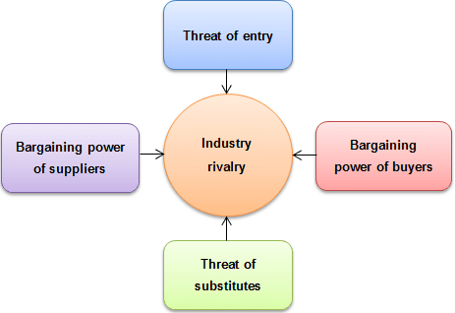

We can see from the diagram we have different subjects, and we are going to explain the importance for each of them. In every business the industry parameters are very important so they can help bring the business strategy. We will introduce the five forces and start them if they are high, medium and low.
1) Threat of new entrants – Olay has a strong name in the skin care industry. They have been a leader on the market for almost a century now, and new entrants means that they must plan new strategies and ideas.
2) Threat of substitute - a good substitute line has always been there on the market and works against competition.
3) Bargaining power of suppliers – this is an important factor considering each business.
4) Bargaining power of customers - the customer’s power has always been important in the company’s performance, and so in the value of the company’s position.
5) Competitive rivalry - within the industry the competition can bring success but also destroy the business. That is why the competition always should be healthy.

SWOT Analysis
Another similar strategy to Porters five analysis is the SWOT analysis. They are the first stage that plan and focus on key issues. From that point of view SWOT stands for strengths, weakness, and threats. Strengths and weakness are considered as internal factors at the same time opportunities and threats are external factors. A strength is a positive internal factor. A weakness is a negative internal factor and opportunity is a positive external factor. A threat is a negative external factor. To achieve success, we must transfer weakness into strengths and our threats into opportunities.
SWOT Analysis include both countries. Olay is owned from P&G and have strong logistic network.
SWOT Analysis included both the UK and US
→ STRENGTH– Olay is one of the strongest brands in the world. They build reputation by offering high quality products suiting different choices, hence strengthen the brand portfolio.

→ OPPORTUNITIES – The expanding of the business in new countries and the innovation of their products open more opportunities for bringing new customers to the business

→ WEAKNESS - The product of Olay has high prices. Therefore, sometimes they lose customers. Another weak point is that the sales are related to the retail store.

→ THREATS – Main threat for every business are its competitors. Also, if the prices of the supplies pipeline increase that could lead to higher prices in the final product, which could reflect over in the consumers purchases.

We going to analyze similarities and differences between the US and UK related to ST. Also, we will give explanation and comparison of the market entry method.

The following diagram gives a better understanding of the business plan strategy.
Diagram3: Segmentation, targeting and positioning
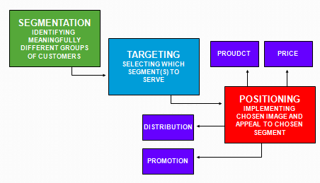

As a global company Olay have accepted a strategy where global thinking works hand-to hand with local acting. Good quality products, which makes customer happy are part of their global vision of success

SEGMENTATION
The marketing segmentation is about a group of people who have the same understanding of developing a brand by using all forces of Geographic, psychographic and behavioral aspects.
→ Geographic: Olay has found a strong marketing nishe for facial crème and cosmetics for women over 30’s.
→ Psychographic: What is the lifestyle of the potential consumers? What is their personality? Answering those questions paint a picture of the local psychographic layout.
→ Behavioral: The brand has enough knowledge about the preferences of their consumers, partially brought from the above factors. Also, we look into the awareness, and attitude of the consumer.

MARKETING TARGETING
Here the segmentation is based on customer variables, which are bolt useful and important. When we have our customers by targeting, and targeting is same as selection, we will target them to success. We analyze the marketplace, our strengths, and our competitors, and after that we will have some idea of the environment.
→ Differentiated: Oley introduce different product for different type of skincare concentrated on the quality of the products.

→ Concentrated: Focusing on the customer’s preferences, demands, behavior and attitude has effect over the concentrated marketing
MARKET POSITIONING
Important part in establishing the business. What market the company is occupying? How reliable are the products of the company? How satisfied are the customers? Answering all these questions would give a great idea how the company is positioned in the local market.

CONCLUSION

In the market of skincare, the Brand has the customers loyalty. Oley have different type of products which they can offer to their customers. They follow the idea “now we are being more international about what the skin needs and how we are living.
“Olay wants to make sure we are relevant and tell the brand stories that make sense to our customer. We understand what our CEO is doing and where she is doing, and we have a skin-care brand that can come along for the ride” Rodertson said.
UMBRELLA BRANDING

Every brand market is investing mostly in searching for innovative ways to achieve and retain competitive advantage. One of the ways is to launch a new product on the market or increase the sales volume and bottom line. The cost of developing a new product in a fast – moving consumers market includes innovating new goods and categories.
One of the branding strategies is the so called “umbrella branding”, also known as family branding. The brand is connected to the competitors. One of the Olay brand strategies is to meet the needs of constant lifestyle. Also, they use several marketing strategies like product innovation, pricing, approaching, promotion, and planning. This is part from marketing mix, which would help the brand to succeed.
For example, OLAY introduce oil to the world like a part of “powerful umbrella” strategy.
Olay have view of Individual product branding but in mean time is a part of the umbrella, we can see that customers are more likely to prefer single brand, and respectfully give more positive feedback about the products of that single brand. Umbrella brand has advantage, but the product of OLAY is well known as a single brand. The studies around this area are showing that Umbrella type of brand can affect all the products under that Umbrella.
We can introduce branding strategies. One of the main points is that the brand is connected to its competitors. OLAY to the general skincare market is to capture customers positioning for the brand and create big view for the possible positioning strategies into group. One of the strategies OLAY uses is to meet the needs of the modern consumers with convenient products for customers with busy lifestyle. Another strategy is to bring innovations to the market filled by consumers.
Lines of the brand, promotions, and sales
We will introduce the successful lines of the brand OLAY. The first one is Olay anti-aging, another one is Olay Regenerate Retinol, Face Regena reteno, Olay 6 anti-aging. The brand lines exist in each market including US and UK. Another important and successful part are the promotions. If years ago, the only way for promotion was an advert on the TV or newspapers, nowadays the social media and the so-called influencers are pretty good and successful way to promote the brand and its new products. The rising power of the social media became probably the most powerful way to reach out to the consumers and notify in the production of new products, price reduction and amazing delas for various occasions. We can say that the digital marketing through the social media became long-term advertising model in a sale promotion when new product is introduced on the market.
If we must analyze the sales like a different subject also is very important part of the structure of the business. Each organisation that creates a business must use advertising and sales promotion. The sale promotion is a type of marketing strategy to raise the sales on temporary plan. Includes paid and free marketing activities like sales or sponsorship help the business to grow. Olay trusts both way of keeping the name and standard of the company. To increase the popularity and the public relationship the big business uses the idea of sponsorship. The role of sponsorship is to sponsor events, teams, or brand awareness. Most of the sponsorships have a commercial objective.
Direct marketing
Let’s have a look into the Direct Marketing and the benefits it brings to the business growth. Here we can talk about all the direct communication channels, which the business would use to promote their products to the consumers – we talk about a TV/ Radio/ Newspaper advertisement and so on. As we live in the times of more social media contact, that form of Digital Marketing has become very important and hugely successful channel of communication of the businesses to their customers. By using all the possible channels Olay has proved that they have innovative thinking towards the type of communication with the consumers. They have very strong position worldwide and the Direct Marketing channels through social media are one of the main contributors to that impressive success nowadays. Let’s not forget that by using the social media, the company actually has direct access to their customers opinions/ complains, and in this way the company appear to be more approachable, which is also adding to their strong position. All the method and opportunity for success been using for both country US and United Kingdom.
Product mix
The brand line of Olay has a purpose and be categorized by targeting and product mix. We can observe extended marketing mix. The elements which are include into marketing mix cover is a product, price ,place and promotion. Here are marketing strategies like service innovation, marketing investment and customer service, which all of them help the brand to grow.
The Olay produce many types of blend coffee which is their marketing mix product and all of them are on non-price competition. The products are keeping in warehouse and from there are send to consumer distributors and then are send to the retailers. Also, the brand follow the distribution channels. Here we can see how they are connected to each other.
Manufacturing – C&F agent -Distributors – Retailers and Manufacturing – Bulk buyers - consumers

In the business of Olay, we can see that the volume oﬀered to the customers were the prices are aﬀordable and according to the packaging. Price of the products is based on the quality of the product. You could ﬁnd in the market that the competitor products are less expensive as compared to Olay products belonging to the same category. Very important method to make stable position in each market in US and United Kingdom and all around the world is franchising and licensing.
Franchising is another way of expanding the business, hence increasing its popularity among consumers. In regards with Olay this is not a strategy, which can be used as the company sales its products in Boots and Superdrug. They do not operate by franchising or brochure catalogue such as companies like Oriflame and Avon.
The part of license of Olay is a strictly following up for both country US and United Kingdom. Licensing of intellectual property (IP) is at the heart of a franchise contract. So, in fact, a franchise is licensing of a business format in a particular way. Typically, this will comprise giving permission to the licensee to use its know-how and other confidential information, trademarks, logos and designs, and copyright materials. For some businesses, there may be patents, too. In return, the franchisee follows instructions and operates their business in the agreed way. The copyright information about the brand Olay is allowed to be used only from the owner. The logo and term and conditions are strictly prohibited.
Here we will introduce and recommend strategies for the future of Olay
Probably because their CEO is the ex-brand manager of the company, Olay has always impressed with unique marketing ideas. The promotional strategy for is best described in Ansoﬀ Matrix, which shows us that a business growth depends on entering new markets or promote new products on existing markets. The Ansoﬀ product/market matrix is picturing the suggested growth strategies, which would path the way of business strategy and growth, shown below as follows:
Diagram3: Ansoff matrix

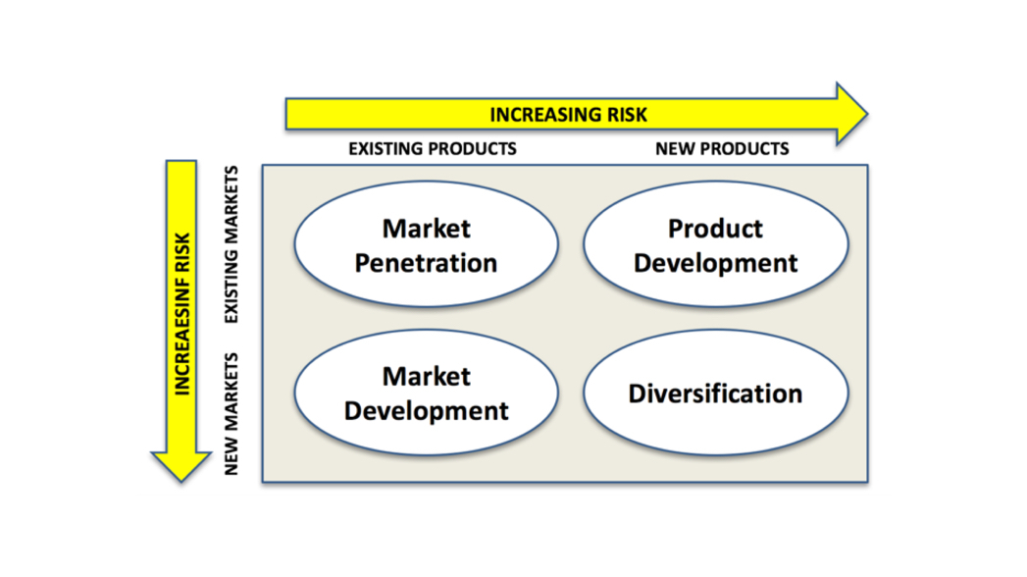

We going to give explanation how each part of the diagram work.
Market penetration: As mentioned above this is describing the marketing strategy adopted when business enters a new market
Here it’s important to consider that the business can face a tough competitor. Therefore, the business should think about aggressive promotional campaign and pricing strategy, design to attract new consumers. Also, feedback from existing customers through social media would be quite beneficial on this step.
Market development: Once the previous step is successfully achieved it’s time to think about the direction of how to develop the newly achieved market. Here would be valuable to promote the existing products and trying to bring the consumer attention to them. Another way is exporting a product to a new country.
Product development: That stage can be linked to the knowledge of the local preferences, demands and needs and trying to adopt the product, and its packaging and design, to the local tastes. More finance needs to be invested in research and development, but that would definitely align the product to the needs of the local consumers, hence raise the sales and further down the line firmly establish the brand.
Diversification: Linked to the growth strategy, this is the stage where a business is introducing a new product in new markets. This is a risky step as because of the lack of experience on this market can play a not so positive role when introducing the new product.
A vital part of recommended strategies is the diagram of Product Life Cycle Model.
To explain it best this is the overall process from the introduction of a new product to the end of its life and removing it from the shelves. The process has four stages—introduction, growth, maturity, and decline. That strategy is successfully implemented in many businesses by the Management and Marketing team, and is helping to the decision of when advertising to be increased is necessary, or product reduction, or design re-branding.
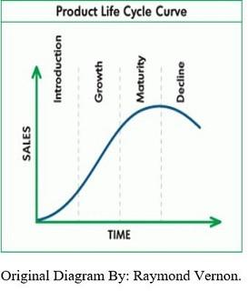
Diagram 4:product life cycle management.
Products move to the cycle of introduction, Growth, Maturity and Decline in different speeds. The sale volume and the unit profit are connected to the growth stage. To be successful product management need dynamic functional approach and to meet satisfactions of the sales. The introduction is the most important stage in the life of the product. When the product been introduce to the market have a way of destiny where is connected to the with the rise of the sales and profit of the direct competitors. The high production and marketing cost, narrow product line, sales promotions are all approachable by the customers.
Decline - when the satisfaction point is reached then the product enter 4th stage and we can introduce to new stage of innovation, which can change the behavior of the consumers. In the stage where the price became a main point we can work on the control of the product against competitors. From the diagram we can see how the product related to the marketplace move from the stages of growth, maturity, situation, and work on the production for better satisfaction of customer’s needs.

There is a different strategy for pioneers in the Growth stage of the pic.
To improve the business of Olay can be chosen between different strategies:
-position defense strategy - here we can build forces around the business who protect the business against competition.
-flanker strategy - here we create a brand where some of the competitions appeal to use a different market. Example is Proctor and Gamble - they create another flanker Cheer to appeal more cost effective to the customers. To be able in the market company require company to have fulfilled existing marketing.
Another very powerful strategy is market expansion strategy, growth strategy that growth strategy that involve selling product, in the new market and when is the peak in the company and existing sales channels.
Attack strategies for followers in the Growth stage of the PLC
The front attack strategy in the marketing is focuses on competitors, strengths and matching your own product, marketing and promotions connected to the brand. This strategy can be risky because the competitors put the best of the best connected to a product, sales, customers and imagine.
Another strategy is a ‘flanking strategy ‘where they are concentrating on competitors against competitors using their weakness. This strategy is less risky because they are moving from stealing to entry.
The result of using the following strategies such as in the different stages of the business growth, such as fortress strategy, promotion strategy, expansion pricing strategy, pioneer strategy, follower strategy, channel strategy, and which now is popularly called as “leapfrog strategy.”

STRATEGIES IN THE MATURITY STAGE OF PLC
In the maturity stage we are looking into a well position brand with a stable sales volume and revenue figures, which would allow to reduce the cost of production.

Adding to the above is the extension strategy in order to increase the market share and keep the maturity stage of existing product rather than going into decline and removing from the shelves. That would be rebranding, price discounting and seeking new markets.

Market expansion is logically linked to the business growth strategy and is one of the base line for the success of the company, regardless of the nature of business.

Olay has successfully adopted any of the above strategies. Therefore, the business has growth to a high global level, and turn the brand into one of the most well-known brands in the world.

CONCLUSION
The above research has been reported and analyzed environmental marketing in the comparison between US to United Kingdom. Internal environment has been explained and the way it’s been adopted by Olay. We been also explaining the brand line products, price and place and how they positive work on the plan for marketing strategies. The research of this report was performed as per the requirements.

References:
The mathematical theory of communication by Cloude Shannon and Waren Weaver
Push & Pull strategy Third Edition by Gerardus Blokdyk
Strategic Brand Management by Richard -Elliott, Larry Percy, Professor Simon Pervan
Strategic Brand Management: Building, Measuring, and Managing Brand Equity, Global Edition by Kevin Keller and Vanitha Swaminathan
Stakeholder Engagement Analysis 101: Five Simple Models to Create Your Project / Business Template
Customer Engagement Contemporary Issue And Challenges By Roderick J.Brodie, Linda H. Holleebick And Jodie Conduit

Marketing Strategy and Competitive Positioning, 7th Edition by Graham Hooley

The Customer Success Professional′s Handbook: How to Thrive in One of the World′s Fastest Growing Careers―While Driving Growth for Your Company by Ashvin Vaidyanathan
The brand mapping strategy by Karen Tiber Leland

International Marketing Strategy Analysis, Development and Implementation by Isobel Dool, Robin Lowe , Alexsandra J.Kenyon

Nestlé: The Secrets of Food, Trust and Globalization by Friedhelm Schwarz
Strategic Customer Service by John A . Goodman
Web links:
https://globalriskcommunity.com/profiles/blogs/stop-pushing-and-start-pulling-it-s-more-satisfying
https://michellemathiasfsp.blogspot.com/2018/11/shannon-and-weavers-model-of.html
https://studylib.net/doc/9038546/the-shannon-weaver-model
https://surabhiudas91.wordpress.com/2014/08/17/nestle-slim-milk-distribution/
https://www.smartinsights.com/marketing-planning/marketing-models/push-pull-product-distribution-model/
https://www.mindtools.com/pages/article/keller-brand-equity-model.htm
https://www.chegg.com/learn/business/introduction-to-business/brand-equity-in-introduction-to-business
https://www.salaamgateway.com/story/nestle-egypts-world-exports-record-egp-50m-annually-regional-official
https://www.salaamgateway.com/story/nestle-egypts-world-exports-record-egp-50m-annually-regional-official
https://www.grosvenor.com.au/resources/key-to-effective-stakeholder-engagement/
https://www.ngdata.com/how-to-find-customer-touchpoints/
https://www.tutor2u.net/business/reference/sales-promotion
https://prezi.com/ksxpnnsuwh7g/nestle-growth-strategy/

