University of Wales Trinity Saint David
School of Engineering


Analysis of student grades using statistical methods in Matlab
Engineering applications and study skills
ACMA4007
Lily Mather
2306724
24/05/24

Contents
1 Introduction 1
1.1 Aims 1
1.2 Objectives 1
2 Data import and summary statistics 2
3 Correlation analysis 4
4 Grouped data Exam 1, Exam 2 and O/ALL results 6
5 Discussion and Conclusion 8
6 Reference 9
7 Appendix 11

Introduction
Matlab is a powerful programming language and environment that is widely recognised for its numerical computing, visualisation, and algorithm development capabilities. It plays a role in many diverse fields, including engineering, mathematics, and scientific research. Matlab can perform a handful of matrix manipulations, plotting functions, and developing algorithms, with many more capabilities.
For this assignment, the user used Matlab to perform several different tasks using an Excel table with student data. Which included a list of student IDs, exam results, gender, age, and attendance. This data set is a mix of quantitative and qualitative data.
Using the student data set they plotted a table with the mean, median, mode, range, and average test score. They also performed a correlation analysis to investigate whether there is a link between gender and exam results. They created a visual representation using corrplot, alongside a hypothesis test that displayed the results of the investigation. Finally, they visualized the grouped data, creating a histogram for exam 1, exam 2, and the average test score, as well as a cumulative frequency graph.

Aims
The primary aim of this assignment was to explore the use of Matlab in the application of statistical methods. Investigating how they can analyse data and what Matlab offers.

Objectives
Using student's grades to investigate the factors affecting students’ performance and understand the statistical techniques that Matlab can perform. Using those techniques to analyse the data sets and the Process of importing data/ limitations of summary statistics.

Data import and summary statistics

There are a few different ways to transfer data, but in this case, the "redactable" method was used. This allowed Matlab to detect the data in the table and identify the desired elements of the data. (MATLAB readtable, n.d.) To create a table from an Excel file, the code used the following method: "RT = readable(student.data.xlsx);" which was then followed by "RT. "the column name that you want Matlab to read"". This allowed Matlab to retrieve information from the selected column. For example, "RT.age", which resulted in Matlab retrieving information from the column labelled "age".
Using the ‘RT. ”Column name” ’ function allows the user to link multiple types of summary statistics such as mean, median, mode, range and standard deviation.
The mean is represented by $\overline{x}$=$\frac{Σ variable values }{Σ observations}$=$\frac{Σ x_{i}}{n }$ . The mean also known as the average is a mathematical calculation that determines the middle value in a set of numbers in a dataset. The mean can be calculated by dividing the sum of observed values by the total number of values in the dataset. (Define mean for math, 2009)
The median is the middle number in a sorted list of numbers, whether in ascending or descending order. It divides the higher half from the lower half of the data. When there is an even number of observations, resulting in the absence of a single middle value, the median is typically determined as the mean of the two middle values. (Median definition, n.d.) In Matlab, the function ‘median’ sorts the data into order and then works out the middle value.
The mode is the most frequently occurring value in each set of data. It is one of three measures of central tendency, alongside the mean and median. (Mode in statistics, 2021) When the function ‘mode’ is used in Matlab it determines the most frequently occurring number in the data set.
The range of a dataset helps to understand how the data is spread out or varied. It provides valuable insights into the extent of variation among the values in the dataset by quantifying the difference between the highest and lowest values. (Range in statistics, 2023)
Standard deviation is a measure of the amount of variation in a set of values. It measures how much each value in the dataset differs from the mean (average) of the dataset. A low standard deviation indicates that the values tend to be close to the mean, while a high standard deviation indicates that the values are spread out over a wider range. (National Library of Medicine, 2012)

To find the standard deviation find the variance first; $variance= \frac{Σ(x_{i – \overline{x }})^{2}}{n}$, $x_{i}$ is the variable values, $\overline{x}$ is the mean value and $n$ is the observation. After the variance is found the standard deviation can then be calculated by finding the square root of the variance; $σ= \sqrt{\frac{Σ(x_{i - \overline{x } })^{2}}{n}}$
The results from the mean, median, mode, range and standard deviation are shown in Figure 1. These summary statistics provide a concise and informative overview of the student data table. It allows for easy comparisons of different data sets, revealing any outliers or anomalies and making it effective in analysing trends.
Summary statistics do have their negatives although they provide a quick overview of the data, they may miss out on key information due to the potential oversimplifying. This can lead to misleading interpretations as it's influenced by extreme values or skewed data, missing out on key anomalies.
Overall summary statistics are successful in showing general comparisons and potential trends but should be used alongside more technical analysis to get a full understanding of the data.

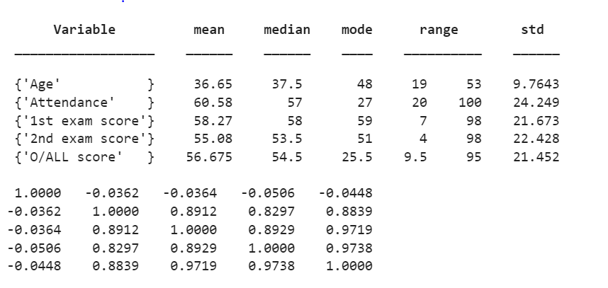
Figure 1 - summary statistics.

Correlation analysis
The corrplot function was utilised for the correlation analysis. This function generates a visual display of the data in the correlation matrix, offering a graphical representation of the correlation coefficients between the variables. (Plot variable correlations, n.d.)
Correlation analysis allows for an understanding of relationships between variables. This understanding can provide a new perspective on the variables and give an idea of how they react to each other and the implications it has on the opposing variables. Helping to group the data and give an overall understanding. (Anodot, 2021)
Correlation analysis does however come with its limitations, one of which is that the correlation doesn’t simply imply causation even though two variables may have the same correlation it doesn’t necessarily mean that they have any relationship. Correlation is also impacted by data outliers which can have a skewed effect on the results making them potentially inaccurate and giving a false linear pattern. (Damyanov, 2023)
When looking at the trends in the correlation matrix shown in Figure 2 there is a positive linear correlation between attendance and exam results that can be hypothesised that the better the attendance the better marks received in the exams.
Before the data was laid out in a correlation matrix, inferential statistics which is a tool that involves making predictions about data collected from a sample of the population data would be used. it aims to draw conclusions and make predictions about the group of data; it helps to generalise the findings. This works alongside the null hypothesis which is a hypothesis that states there is “no variance between groups or no correlation between variables.” (Daines, 2023)
It’s the hypothesis that is assumed to be true unless there is significant evidence to contrary it. It usually represents the default position that the is no relationship between two measurements. In this situation it’s the hypothesis that none of the coefficients in the student data correlates with each other, the null hypothesis aims to assess the credibility of the hypothesis. The goal is to reject the null hypothesis by ensuring that there is strong evidence to disprove that the correlation only happened by chance (Hayes, 2020)
Within the code, a hypothesis test was conducted as shown in figure 3 and 4. Figure 4 shows the code used in the hypothesis test which consisted of using the P value of the hypothesis test which returns as the scalar value, with the p as the probability of the observed test statistics “as extreme as, or more extreme than, the observed value under the null hypothesis”. Using ttest “returns a test decision for the null hypothesis test. “ using these functions creates hypothesis test results shown in Figure 3 which states that there are no significant differences in scores between genders. (Matlab ttest , n.d.)

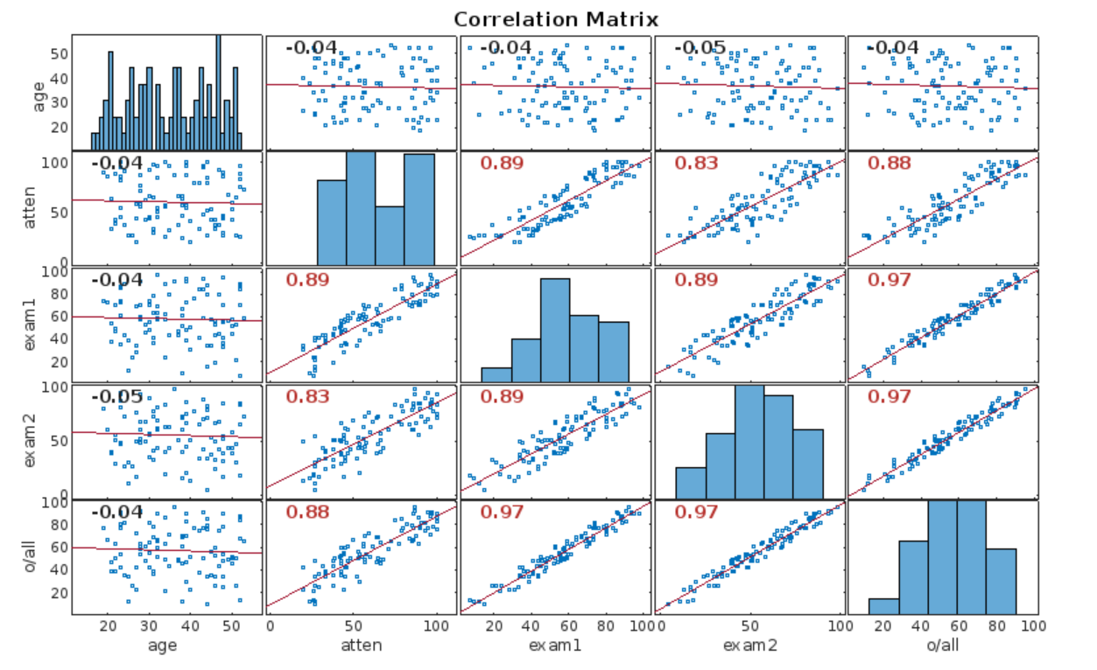
Figure 2 - Correlation Matrix

Figure 3 - Hypothesis test

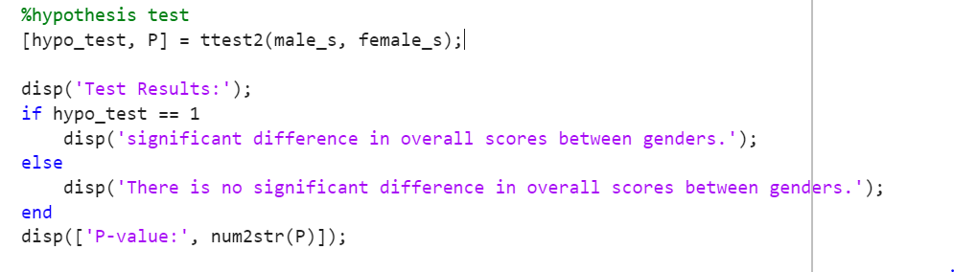
Figure 4 - Hypothesis test code

Grouped data Exam 1, Exam 2 and O/ALL results

In the code, two forms of grouped data were performed using Exam 1, Exam 2, and O/ALL results Figure 5 shows histograms created using the ‘histogram’ function which produces a bar chart using the frequencies as the Y axis and class limits for the X axis. Figure 6 shows an Ogive graph this was made by finding the cumulative and inverse cumulative frequency of each of the data variables using the functions ‘Cumsum’ and ‘cumsum, “reverse”’. The Y axis consists of cumulative relative frequency and the X axis consists of the class limits.
Having grouped data has a great advantage as it allows for easy understanding, by simplifying potentially complex datasets. It helps show patterns and trends by condensing the data size and making it more obvious to visualize, meaning it's easier to spot differences or anomalies. (VEDANTU, n.d.)

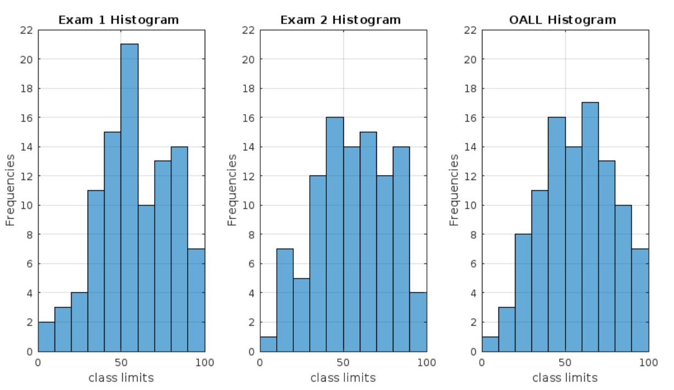
Figure 5 - Histogram

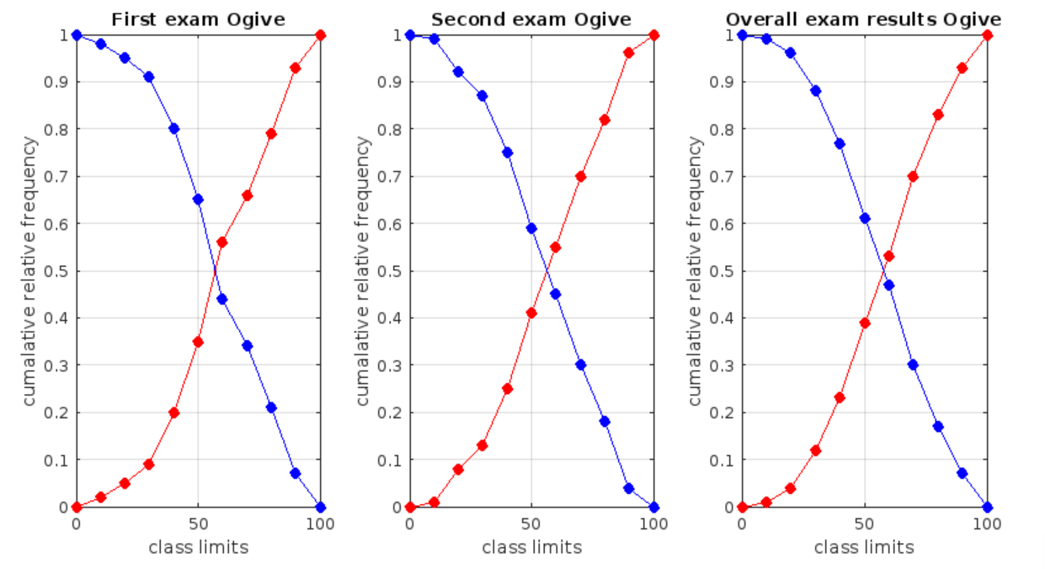
Figure 6 - Ogive

Discussion and conclusion
A few key findings were made during the student data analysis. One of which is that there isn’t a correlation between gender and exam results meaning your gender doesn’t have a negative or positive effect on what exam results you get.
To analyse the student data statistical methods were used. Descriptive statistics allow an overall understanding of the data in a simple format that allows trends to be seen and compared. However, there are limitations as they are affected by outliers and data extremes which can alter the actual results and they can over-simplify the data making it potentially misleading.
Another statistical method used was the correlation matrix which allows for the analysis of how variables react to each other and provides a new perspective on the data. However, correlation doesn’t necessarily mean causation and like descriptive statistics, it's affected by outliers and data extremes, and you can’t compare categorical data. Alongside the other statistical methods, inferential statistics were used which allows for the results to be generalised and compare categorical data however using ‘ttest’ only shows an overall score and not exam 1 and exam 2 separately therefore potentially missing key values.
Grouping was another statistical method used to analyse exam 1, exam 2 and o/all it’s a simplistic way of comparing grouped data to see trends and outliers however it only shows a basic overview of the data meaning information may be missed or misinterpreted.
The combination of all these methods allowed for an analysis of the student data which helped pick out key points and locate trends within the data.

Reference
Anodot (2021). Why Use Correlation Analysis in Data Analytics? [online] Anodot. Available at: https://www.anodot.com/blog/correlation-analysis-in-data-analytics/.
Daines, R. (2023). LibGuides: Statistics Resources: Null & Alternative Hypotheses. [online] resources.nu.edu. Available at: https://resources.nu.edu/statsresources/hypothesis.
Damyanov, M. (2023). What Is Correlation Analysis: Comprehensive Guide. [online] dovetail.com. Available at: https://dovetail.com/research/what-is-correlation-analysis/.
Define mean for math (2009). Define Mean for Math. [online] Sciencing. Available at: https://sciencing.com/define-mean-math-5412437.html.
Hayes, A. (2020). Null Hypothesis Definition. [online] Investopedia. Available at: https://www.investopedia.com/terms/n/null_hypothesis.asp#:~:text=A%20null%20hypothesis%20is%20a.
MATLAB readtable (n.d.). Create table from file - MATLAB readtable - MathWorks United Kingdom. [online] uk.mathworks.com. Available at: https://uk.mathworks.com/help/matlab/ref/readtable.html.
Matlab ttest (n.d.). One-sample and paired-sample t-test - MATLAB ttest - MathWorks United Kingdom. [online] uk.mathworks.com. Available at: https://uk.mathworks.com/help/stats/ttest.html.
Median definition (n.d.). What is Median? Definition of Median, Median Meaning. [online] The Economic Times. Available at: https://economictimes.indiatimes.com/definition/median.
Mode in statistics (2021). Mode in Statistics: Definition, Calculation, Types, and Examples. [online] GeeksforGeeks. Available at: https://www.geeksforgeeks.org/what-is-mode/.
National Library of Medicine (2012). Finding and using health statistics. [online] www.nlm.nih.gov. Available at: https://www.nlm.nih.gov/oet/ed/stats/02-900.html.
Plot variable correlations (n.d.). Plot variable correlations - MATLAB corrplot - MathWorks United Kingdom. [online] uk.mathworks.com. Available at: https://uk.mathworks.com/help/econ/corrplot.html#description [Accessed 24 May 2024].
Range in statistics (2023). Range in Statistics: Formula, Meaning, Examples | How to Find? [online] GeeksforGeeks. Available at: https://www.geeksforgeeks.org/range-in-statistics/.
VEDANTU. (n.d.). Grouping of Data. [online] Available at: https://www.vedantu.com/maths/grouping-of-data.

Appendix

clc
clear
close all

% 1. Data import and summary statistics

RT = readtable("student_grades.xlsx");
RM = readmatrix("student_grades.xlsx");
Exam_1 = RM(:,5);
Exam_2 = RM(:,6);

%table headers
S = {'Variable','mean','median','mode','range','std'};

%column 1
VR = {'Age','Attendance','1st exam score','2nd exam score', 'O/ALL score'};
OVS = (Exam_1(:,:)+(Exam_2(:,:)))/2;

%Column 2 mean
mean_age = mean(RT.age);
mean_attendance = mean(RT.attendancePercentage);
mean1 = mean(RT.Exam_1);
mean2 = mean(RT.Exam_2);
mean_overall = mean(OVS);

%Column 3 median
medium_age = median(RT.age);
medium_attendance = median(RT.attendancePercentage);
medium_1 = median(RT.Exam_1);
medium_2 = median(RT.Exam_2);
medium_av = median(OVS);

%Column 4 Mode
mode_age = mode(RT.age);
mode_attendance = mode(RT.attendancePercentage);
mode_1 = mode(RT.Exam_1);
mode_2 = mode(RT.Exam_2);
mode_av = mode(OVS);

%column 5 Range
range_age = [min(RT.age); max(RT.age)];
range_attendance = [min(RT.attendancePercentage); max(RT.attendancePercentage)];
range_1 = [min(RT.Exam_1); max(RT.Exam_1)];
range_2 = [min(RT.Exam_2); max(RT.Exam_2)];
range_av = [min(OVS); max(OVS)];

%column 6 standard deviation
std_age = std(RT.age);
std_attendance = std(RT.attendancePercentage);
std_1 = std(RT.Exam_1);
std_2 = std(RT.Exam_2);
std_av = std(OVS);

% table values
meanValues = [mean_age mean_attendance mean1 mean2 mean_overall];
medianValues = [medium_age medium_attendance medium_1 medium_2 medium_av];
modeValues = [mode_age mode_attendance mode_1 mode_2 mode_av];
rangeValues = [range_age range_attendance range_1 range_2 range_av];
stdValues = [std_age std_attendance std_1 std_2 std_av];

% table
T = table(VR', meanValues',medianValues', modeValues', rangeValues', stdValues','VariableNames',S);

disp(T)

%%%%%%%%%%%%%%%%%%%%%%%%%%%%%%%%%%%%%%%%%%%%%%%%%%%%%%%%%%%%%%%%%%%%%%%%%%%%%%%%%%%%%%%%%%%%%%%%%%%%%%%%%%%%%%%%%%%%%%%%%%%%%%%%%%%%%%%%%%%%%%%%%%%%%%%%%%%%%%%%%%%

% 2. correlation anaylis

%correlation matrix
figure("Name","correlation matrix")
CM = corr([RT.age(:,:), RT.attendancePercentage(:,:), RT.Exam_1(:,:), RT.Exam_2(:,:), OVS]);
disp(CM)

corrplot([RT.age(:,:), RT.attendancePercentage(:,:), RT.Exam_1(:,:), RT.Exam_2(:,:), OVS], TestR="ON", VarNames={'age','attendance','exam1','exam2','o/all'})

%organising data
header = {'Gender', 'overall score'};
Gender = RT.gender;
Exam_scores = OVS;
%separate
male_s = Exam_scores(strcmp(Gender, 'Male'));
female_s = Exam_scores(strcmp(Gender, 'Female'));

%hypothesis test
[hypo_test, P] = ttest2(male_s, female_s);

disp('Test Results:');
if hypo_test == 1
disp('significant difference in overall scores between genders.');
else
disp('There is no significant difference in overall scores between genders.');
end
disp(['P-value:', num2str(P)]);

%%%%%%%%%%%%%%%%%%%%%%%%%%%%%%%%%%%%%%%%%%%%%%%%%%%%%%%%%%%%%%%%%%%%%%%%%%%%%%%%%%%%%%%%%%%%%%%%%%%%%%%

%Visualisation of grouped data for Exam 1, Exam 2 and O/ALL results

%histcount

Exam1 = RT.("Exam_1");
Exam2 = RT.("Exam_2");
OALL = OVS;
classlimits = 0:10:100;
Classwidth = 0:100;
figure("Name","Histograms")
H1 = histcounts(Exam1,Classwidth);
H2 = histcounts(Exam2,Classwidth);
H3 = histcounts(OALL,Classwidth);

%plot histogram

tiledlayout('horizontal')
nexttile
histogram(Exam1,classlimits);
title('Exam 1 Histogram ');
xlabel('class limits');
ylabel('Frequencies');
grid,xlim([0 100]),ylim([0 22]);

nexttile
histogram(Exam2,classlimits);
title('Exam 2 Histogram ');
xlabel('class limits');
ylabel('Frequencies');
grid,xlim([0 100]),ylim([0 22]);

nexttile
histogram(OALL,classlimits);
title('OALL Histogram ');
xlabel('class limits');
ylabel('Frequencies');
grid,xlim([0 100]),ylim([0 22])

%OGIVE
%cumalative and inverse cumalative frequency
CFexam1 = (cumsum(H1/100));
ICFexam1 = (cumsum(H1/100,"reverse"));
CFexam2 = (cumsum(H2/100));
ICFexam2 = (cumsum(H2/100,"reverse"));
CFoall = (cumsum(H3/100));
ICFoall = (cumsum(H3/100,"reverse"));

figure("Name","Ogive")
tiledlayout horizontal
nexttile
x1 = Classwidth;
y1 = [0,CFexam1];
YI1 =[ICFexam1,0];
limits1 = min(Classwidth):10:max(Classwidth);
interpExam1 = interp1(x1,y1,limits1,'spline');
interpinverseExam1 = interp1(x1,YI1,limits1,'spline');
plot (limits1,interpExam1,'Marker','o','markerfacecolor','r','markeredgecolor', 'r','markersize',6,'color','r');
hold on
plot (limits1,interpinverseExam1,'Marker','o','markerfacecolor','b','markeredgecolor', 'b','markersize',6,'color','b');
xlabel 'class limits';
ylabel 'cumalative relative frequency';
title ('First exam Ogive');
grid;
ylim(0:1);

nexttile
x2 = Classwidth;
y2 = [0,CFexam2];
YI2 =[ICFexam2,0];
limits2 = min(Classwidth):10:max(Classwidth);
interpExam2 = interp1(x2,y2,limits2,'spline');
interpinverseExam2 = interp1(x2,YI2,limits2,'spline');
plot (limits2,interpExam2,'Marker','o','markerfacecolor','r','markeredgecolor', 'r','markersize',6,'color','r');
hold on
plot (limits2,interpinverseExam2,'Marker','o','markerfacecolor','b','markeredgecolor', 'b','markersize',6,'color','b');
xlabel 'class limits';
ylabel 'cumalative relative frequency';
title ('Second exam Ogive');
grid;
ylim(0:1);

nexttile
x3 = Classwidth;
y3 = [0,CFoall];
YI3 =[ICFoall,0];
limits3 = min(Classwidth):10:max(Classwidth);
interpExam3 = interp1(x3,y3,limits3,'spline');
interpinverseExam3 = interp1(x3,YI3,limits3,'spline');
plot (limits3,interpExam3,'Marker','o','markerfacecolor','r','markeredgecolor', 'r','markersize',6,'color','r');
hold on
plot (limits3,interpinverseExam3,'Marker','o','markerfacecolor','b','markeredgecolor', 'b','markersize',6,'color','b');
xlabel 'class limits';
ylabel 'cumalative relative frequency';
title ('Overall exam results Ogive');
grid;
ylim(0:1);

