Applied PLCs Assignment ACDA6000

By

Robbie Herbert 2405914

Contents
Table of Figures 3
Table of Tables 3
Acronyms, Abbreviations and Units 4
Task 1 5
Literature review 5
Introduction 5
Task 2 9
Process design 9
Task 3 9
Ladder Logic Program & Tag Table 9
Task 4 21
HMI Integration 21
HMI Tag Table 21
Root Screen 21
Error Screen 22
Engineers screen 22
Task 5 23
Formal Report 23
Literature Review 23
Process Design 24
Flow Chart 24
Factory I.O Explanation 25
Rung Explanations 26
HMI Integration 31
References 33

Table of Figures
Figure 1 Factory I.O System 8
Figure 2 PLC Tag Table 9
Figure 3 PLC Tag Table 2 9
Figure 4 PLC Rung 1 & 2 10
Figure 5 PLC Rung 3 11
Figure 6 PLC Rung 3 12
Figure 7 PLC Rung 3 13
Figure 8 PLC rung 4, 5 & 6 14
Figure 9 PLC Rung 7 & 8 14
Figure 10 PLC Rung 9 15
Figure 11 PLC Rung 10 15
Figure 12 PLC Rung 11 & 12 15
Figure 13 PLC Rung 13 & 14 16
Figure 14 PLC Rung 15 & 16 17
Figure 15 PLC Rung 17 18
Figure 16 PLC Rung 18 18
Figure 17 PLC Rung 19, 20 & 21 19
Figure 18 HMI Tag Table 20
Figure 19 Root Screen 20
Figure 20 Error Screen 21
Figure 21 Engineers Screen 21
Figure 22 PLC System Flow Chart 23

Table of Tables
Table 1 Abbreviations, Acronyms and Units table 4
Table 2 advantages and disadvantages of three different types of industry used PLCs 7

Ω | Ohms
% | Percent
N/O | Normally Open
NC | Normally Closed
AC | Alternating Current
HMI | Human Machine Interface
PLC | Programmable Logic Controller
DC | Direct Current
ms | Milli-seconds
Hz | Hertz
TON | Timer ON delay
TOF | Timer OFF delay
TP | Time Period
SCADA | Supervisory Control And Data Acquisition
I/O | Input/Output

Acronyms, Abbreviations and Units

Table 1 Abbreviations, Acronyms and Units table

Task 1

Literature review

Introduction

Within Industry, there are Programmable logic controllers (PLCs). The three main PLCs that are used can be seen below. PLCs are used within industry as controllers for processes, which are automated. Within certain applications such as the steelworks there are very harsh environments, this is where PLCs can be used, as they only require minimal human incorporation. Minimal human incorporation, meaning there may be adjustments needed to the system if something goes wrong or standards and regulations are changed. PLCs are extremely robust and adaptable. The PLCs use their own ‘languages’ to be able to carry out a process. [3]
PLCs are often the most important piece within an automated system for keeping quality of the product to its highest. Due to the way that the PLCs can work, there are functions that will be able to monitor the progress of the process and ensure quality. With the monitoring of the system there will also be logs to look through for an Engineer/Operator to make sure of their quality. [3]
One of the main reasons that a PLC is used within industries is that, tasks will become repetitive. Most people when doing the same thing will become disinterested and may cause quality issues which is why a PLC will be better at the job because of its efficiency and lack of human emotion/error. Due to the automation of tasks that PLCs can take over, people are then able to move into roles that are more technical and allow the companies to move to a higher utilisation of the workforce that is at hand. [3]
PLCs in general within todays standards are suffering with improvements of the internet. The PLCs are suffering because they need to be involved with Wi-Fi and incorporate speed increases which are required by customers.
Finally, PLCs are used within industry much more than other types of control systems. Another type of control system would be a Microcontroller. These processors are expensive in comparison to a PLC. The PLCs are much more cost effective due to how cheap and effective they are. Although they may not be as cheap as possible when first automating a system. The PLC will bring in a large profit due to the automation of the system. [2]
Along with the microcontroller being much more expensive than a PLC, the micro controller will need multiple within the system to work rather than just a single micro controller as one microcontroller will only work with one output increasing the price of the system by a large amount. [1]

Siemens Logo! 8
This PLC is the most common and utilised PLC within industry because of its user-friendly interface. All of the languages that are used on PLCs to make a system work can be used on this PLC. With the series 8 model of the Logo! There are eight versions of the device. These eight devices will be able to work on different voltages. Some of these devices also have a display that can be used on them. The unit uses an Ethernet port/interface for the unit for linking a PC/Laptop to the PLC. Memory for the unit has been increased from previous generations to 400-block memory. The unit also has 40 functions, which have been preset for users to use within their programmes. [10]

Allen Bradley ControlLogix 5580
This PLC is a new model, Rockwell’s Allen Bradley PLCs however are common within older industry with many conveyors because it is able to force contacts on and off so the engineers will be able to go through the PLC code and make sure that the outputs/components are working. The ControlLogix 5580 has a large user memory at 40 MB. The I/O points are also a large amount at 128,000 digital points and 4,000 analog points at the PLCs maximum. For its site use the PLC has a working temperature range of -25 ºC to 75 ºC. This PLC has been tested to ANSI and ISA Class G3 standards with many other certifications alongside such as, CE and IEC 62443-4-2. [11]

Gem80
This is the oldest type of PLC within the three that have been chosen, these PLCs are often seen within steel works due to their rugged make-up. These PLCs began their life in the 70’s. the PLCs became a large part of industry such as mining, food, gas, oil and automotive within a short space of time and are still used in todays applications. The Gem80 will connect to all of the inputs and outputs within a system similarly to that of a PLC of another brand. The highway of inputs and outputs will be used so the input data can be stored and the output can be assigned and moved to the system. Whilst the Gem 80 is an old PLC, there have been many updates within the lifespan of the PLC. The PLC can now work on almost all versions of windows with windows 10 being the latest available update supported. [6]

Advantages & Disadvantages

PLC | Pros | Cons
Siemens Logo! 8 | - Modular PLC  - Display  - Fast installation time  - Directly connect outputs  - Internal timers  - Smaller footprint  - Easily modified systems  - Easy set up  [4] | - Affected by the environment  - Although cheap the quality is not as good in comparison to other PLCs  - Extension needed if there are more outputs in the system  [4]
Allen Bradley ControlLogix 5580 | - Easily expanded  - High availability for training  - Good failsafe operability  - Linking with other software or systems  - Process biased PLC  - Reliable  - Long life span  [5] | - Expensive initial cost  - Long lead times for replacement parts  - Licensing and maintenance is expensive  [5]
Gem80 | - Low Cost  - Small footprint  - Reliable  - Long life span  - Backwards compatibility with older systems and programs  [6] | - Out of date software  - Out of date hardware  - The environment will affect the performance of the PLC  [7]
Table 2 advantages and disadvantages of three different types of industry used PLCs

Task 2

Process design
Factory I.O screen shot
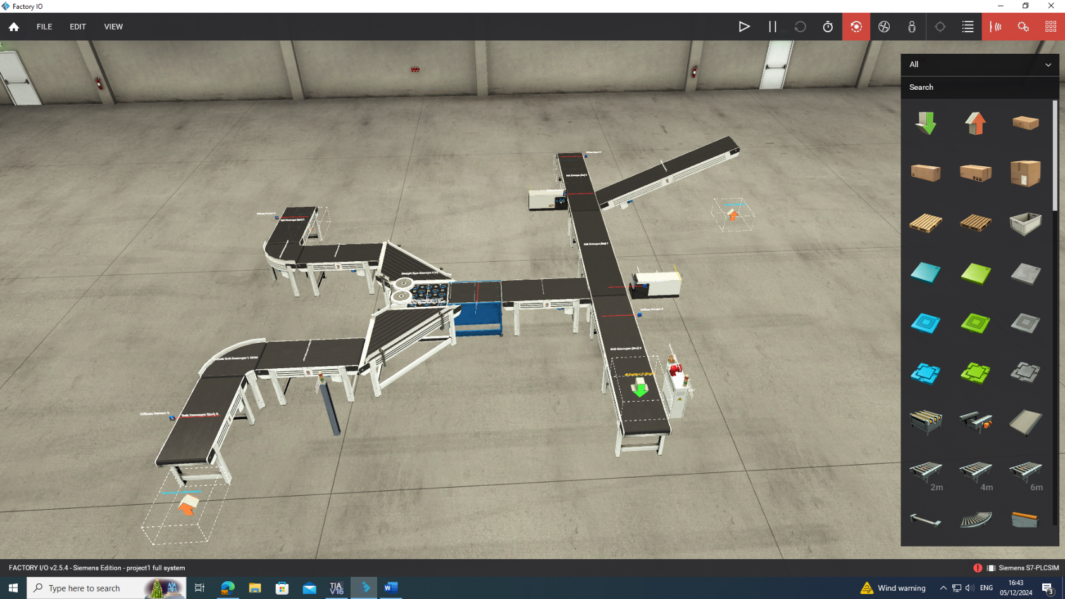
Figure 1 Factory I.O System

Task 3

Ladder Logic Program & Tag Table
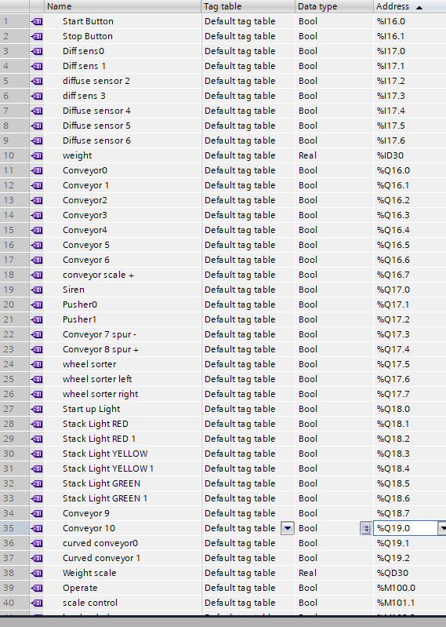
Figure 2 PLC Tag Table
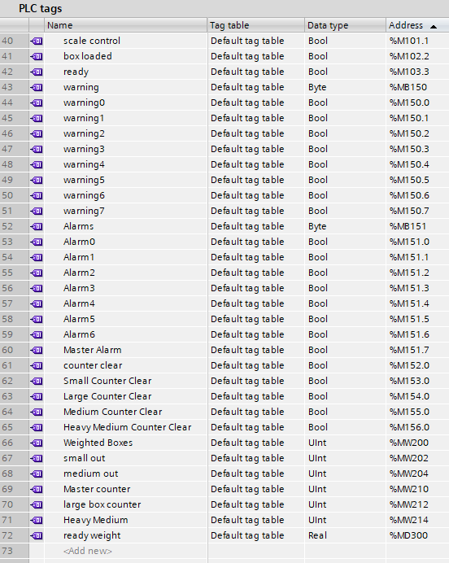
Figure 3 PLC Tag Table 2

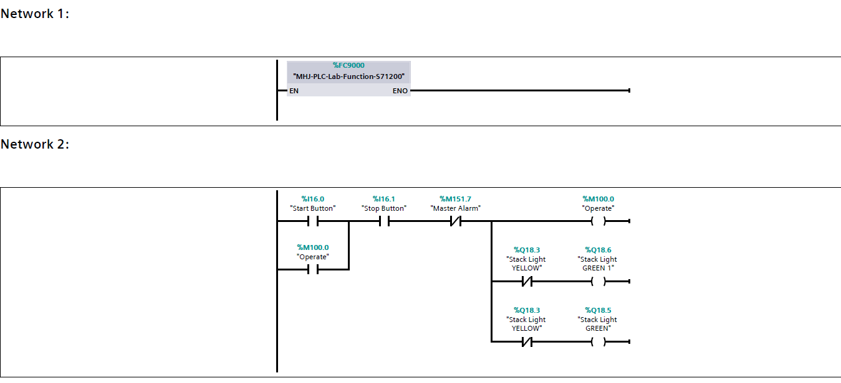
Figure 4 PLC Rung 1 & 2
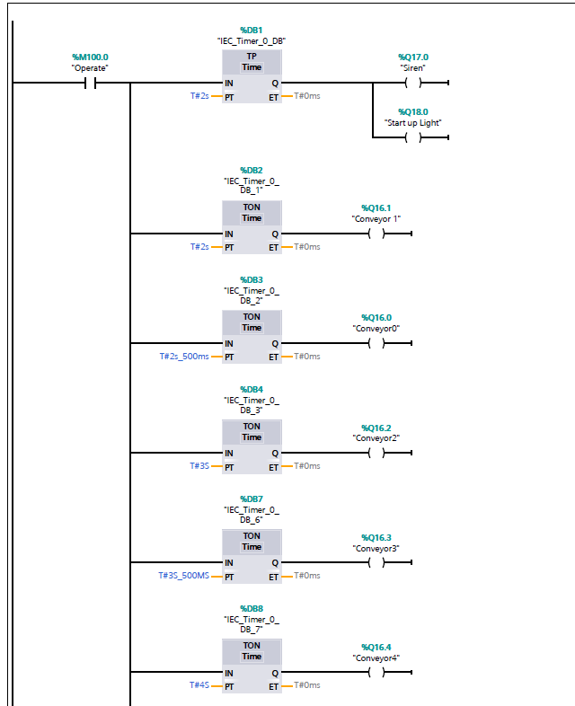
Figure 5 PLC Rung 3
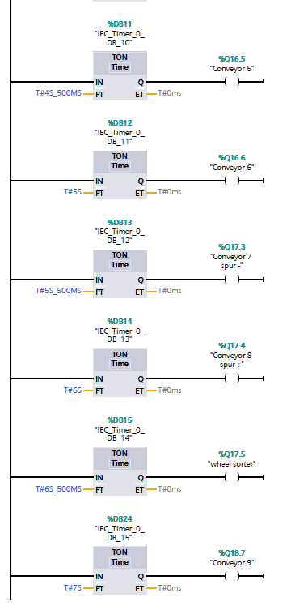
Figure 6 PLC Rung 3

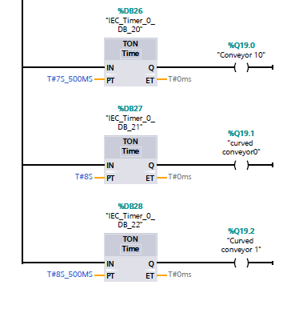
Figure 7 PLC Rung 3
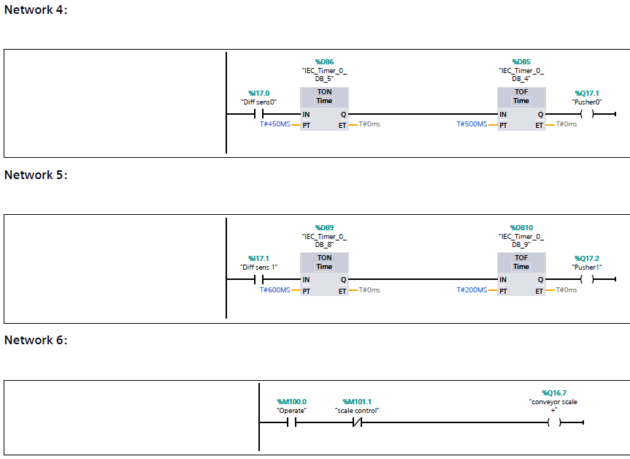
Figure 8 PLC rung 4, 5 & 6
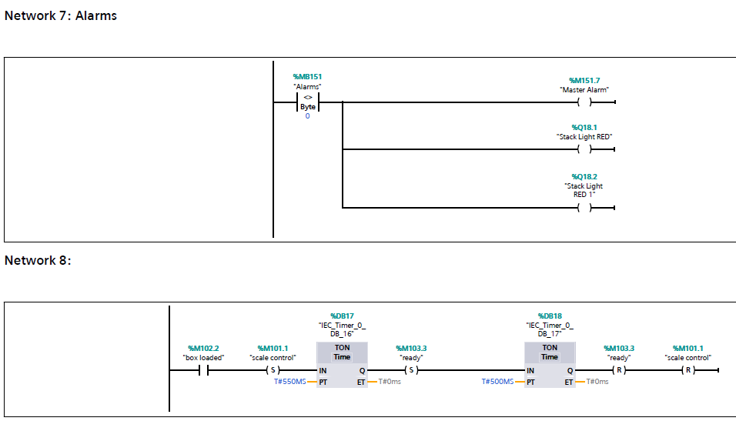

Figure 9 PLC Rung 7 & 8
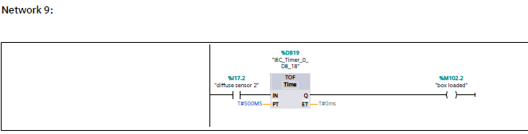
Figure 10 PLC Rung 9
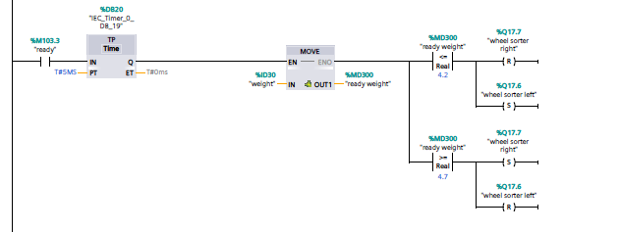

Figure 11 PLC Rung 10
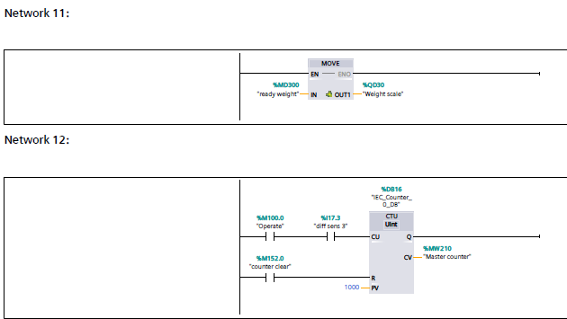
Figure 12 PLC Rung 11 & 12
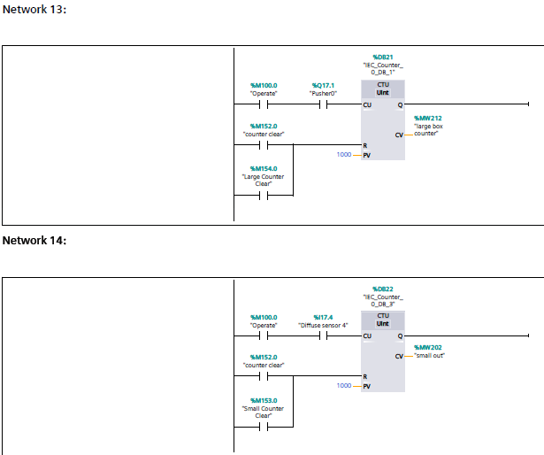
Figure 13 PLC Rung 13 & 14
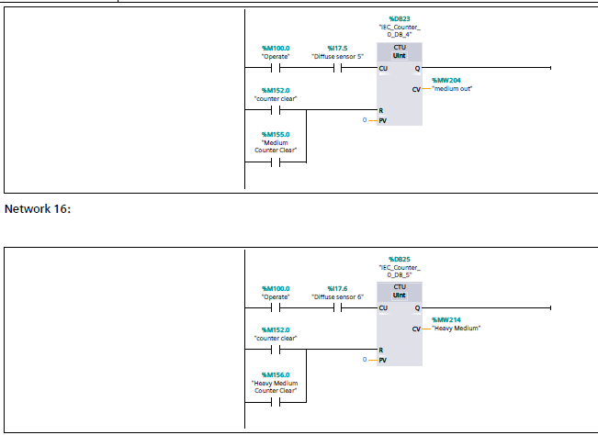
Figure 14 PLC Rung 15 & 16
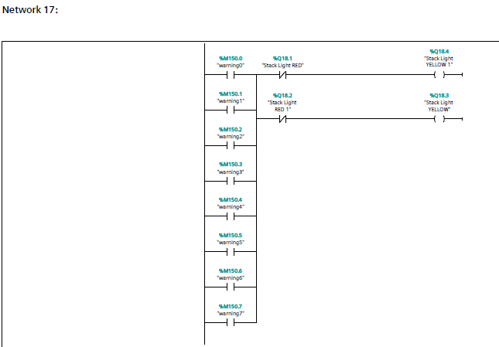
Figure 15 PLC Rung 17
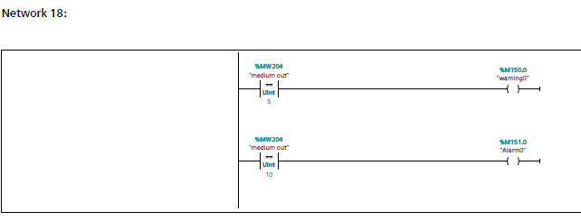
Figure 16 PLC Rung 18

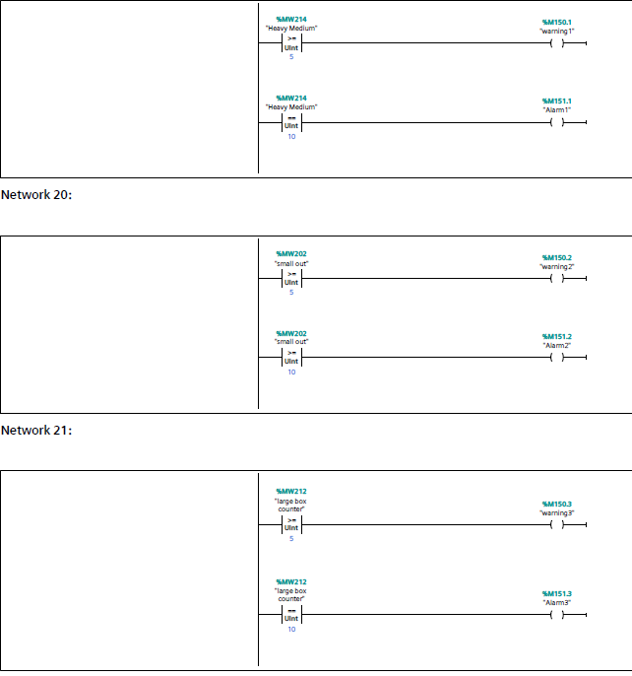
Figure 17 PLC Rung 19, 20 & 21

Task 4

HMI Integration

HMI Tag Table
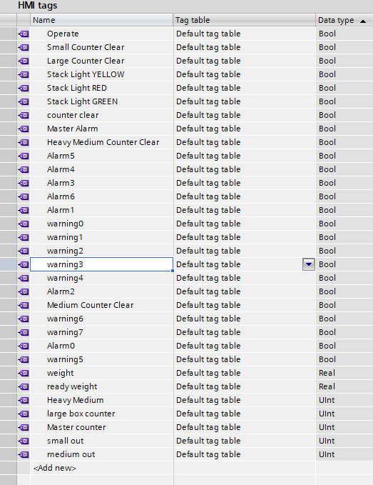
Figure 18 HMI Tag Table

Root Screen
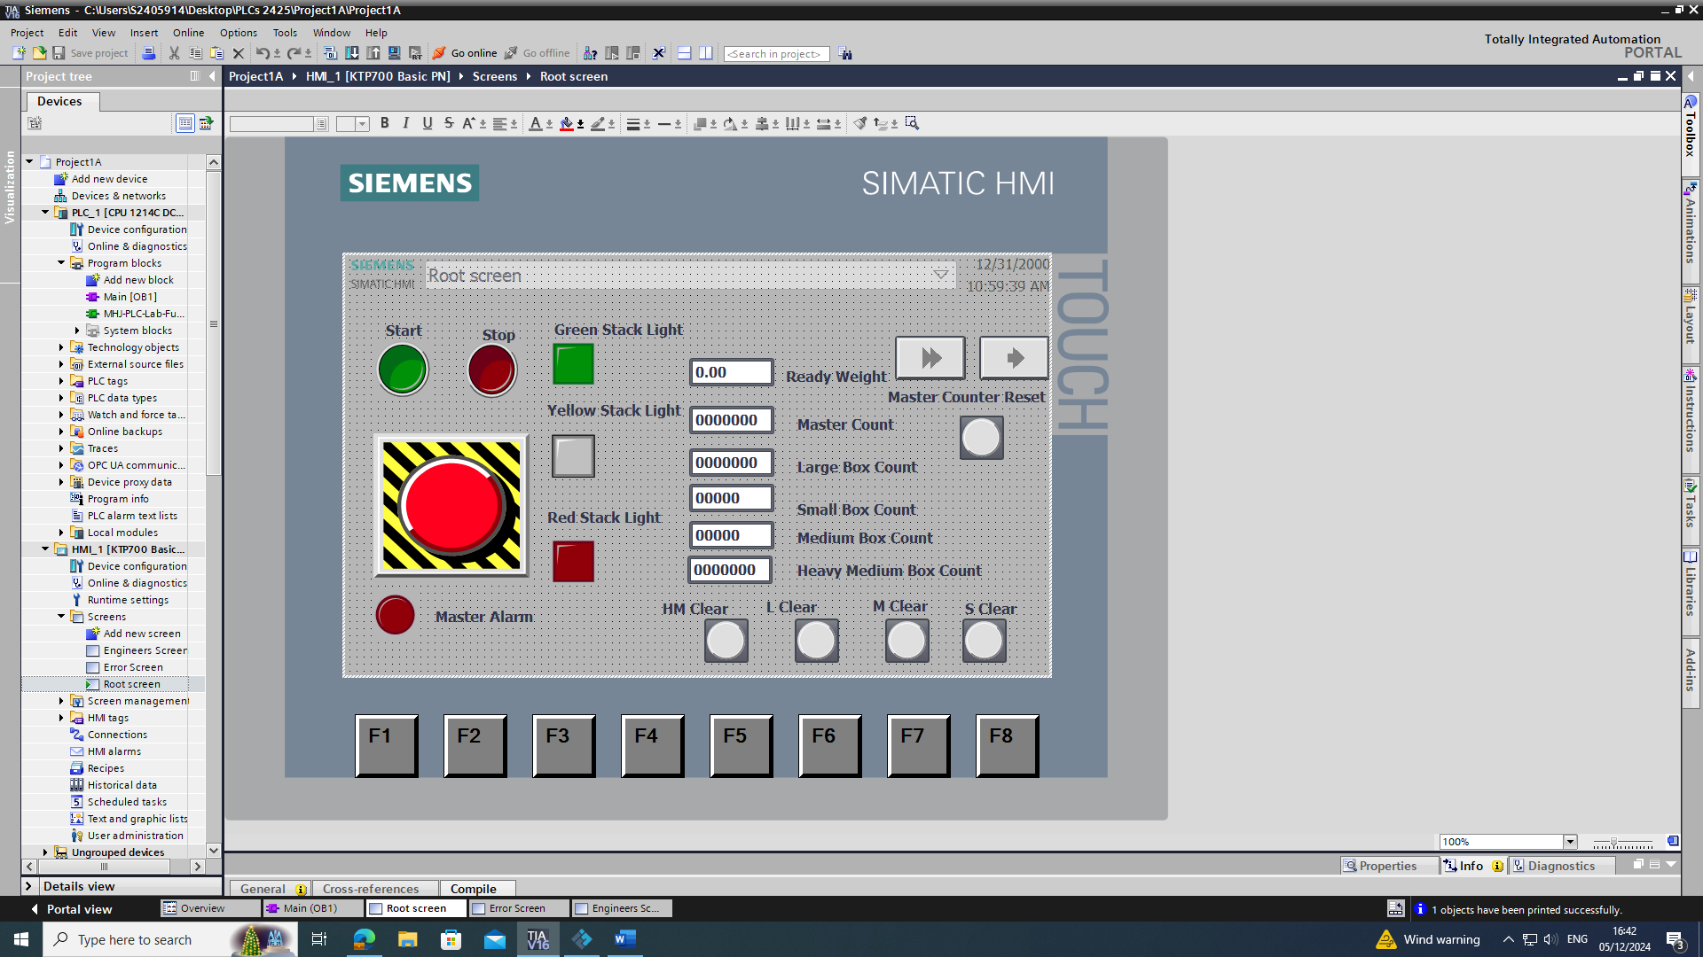
Figure 19 Root Screen

Error Screen
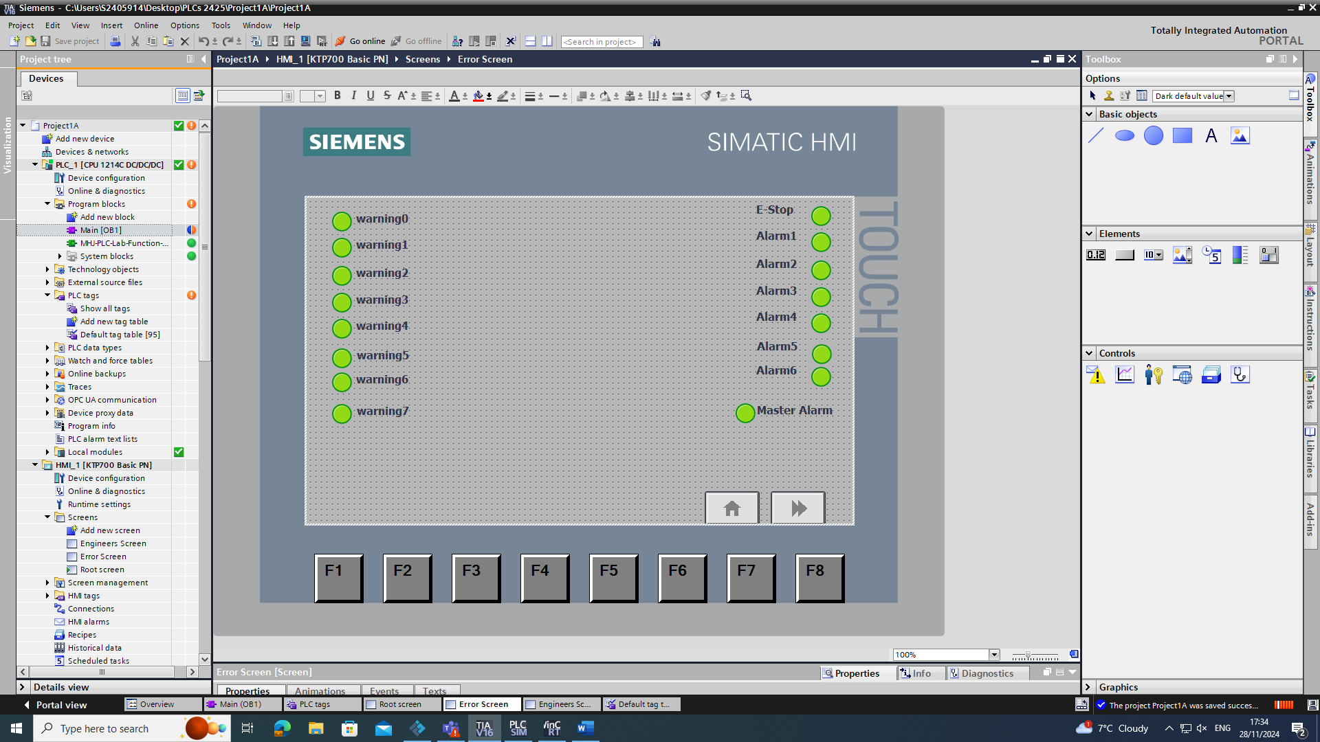
Figure 20 Error Screen

Engineers screen

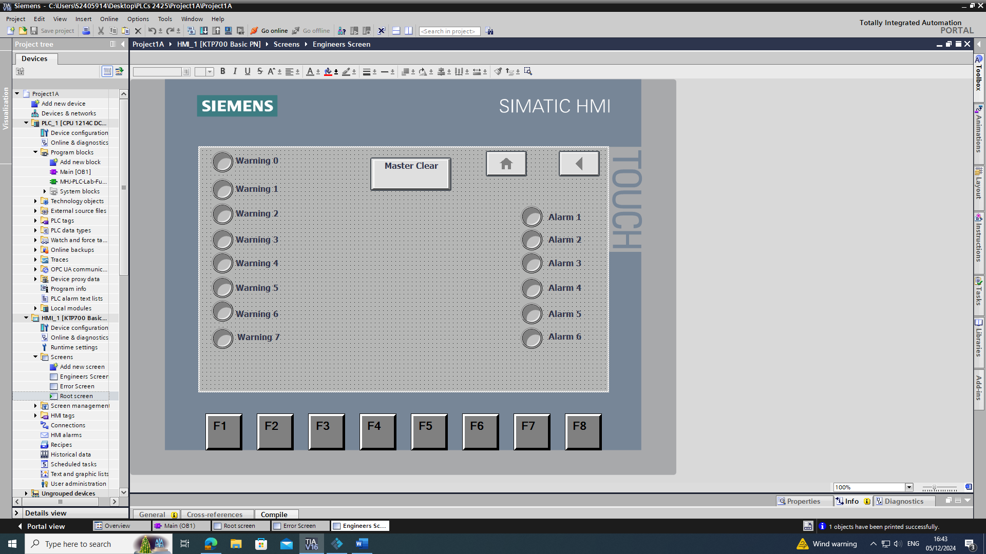
Figure 21 Engineers Screen

Task 5

Formal Report

Literature Review

Within the literature review there were a few small sections, firstly what is a PLC, which is explained by using references and some prior knowledge from previous classes. Secondly, there were different types of PLCs, which have been explained, and then their advantages and disadvantages were given. All of the reading material that have been used within the report has been placed in the references. Within the literature review some basic applications of PLCs has been explained with different types of PLCs being able to link to the application, this is to show which is best at a particular process.
The PLCs have also been spoken about in ways of their reliability for example the environments that the PLCs will be used within.
Within the Literature, review there is also a section on advantages for people. As a PLC can work alone majority of the time after a button is pressed, people can move into other job roles and could get upskilled into higher roles to improve the workforce.
Also the Literature review shows, there are other options that are not PLCs. These options are microprocessors. Advantages to using a PLC was given in the way that a microprocessor is much more expensive than a PLC. Also within the current state, the Microprocessors will take an extremely long time; some may take up to 50 weeks to come depending on their structure and their system that they will control.
Advantages and disadvantages of the three types of PLC are then put into a table. These PLCs advantages and disadvantages were found on reputable websites and PDF documents by using search techniques along with google scholar.

Process Design

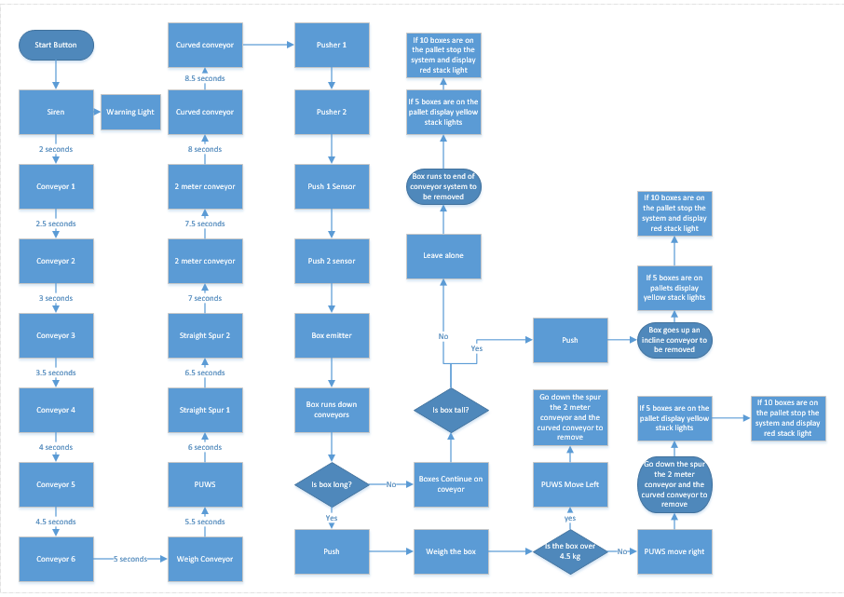
Flow Chart

Figure 22 PLC System Flow Chart

Factory I.O Explanation

Within the Factory I.O, there are many components. These include
- Conveyors
- Curved Conveyors
- Incline Conveyor
- Weigh Scale
- Pop Up Wheel Sorter
- Diffuse Sensors
- Stack Lights
- Warning Light
- Siren
- Pushers
- Removers
- Emitter
- Start Button
- Stop Button
- Emergency Stop
- Box
These components are placed in a specific order due to what is happening in the order of the program. However have been changed order to create a more streamlined system for example removing the Medium boxes first. The stack lights, start stop buttons, the warning light and the siren were all placed on the box. The start button, stop button and emergency are on the box to start the system without the HMI if needed. All of the conveyors will come on in sequence to avoid overcurrent. The pushers will push two types of boxes. Pusher 0 will push the largest box that is on the system, the boxes will then go up the incline conveyor. Pusher 1 will push the medium sized boxes regardless of their weight, which will then go through the weigh system. The smallest boxes will not be getting pushed at all and will go through the conveyor system fully to the remover.

Rung Explanations

Rung 1

This first rung is to connect the PLC ladder diagram to the Factory I.O software. This will ensure that the system works.

Rung 2

This second rung is the start of the full PLC ladder diagram. The rung includes a start button (N/O), a Stop Button (N/O) which is switched to N/C. A master alarm contact, which is N/C, which turns off the system if there is an error. An operate contact which is N/O to act as a retain to keep the circuit powered. Finally there are three coils which are the operate, stack light Green and a second stack light which is also green. Two N/C contacts are in the system also to turn off the green stack lights when the yellow ones are energized when there are 5 boxes in the palletising section.

Rung 3

The third rung within the system is the startup sequence; each item will come on half a second after the other; however, the siren and the startup warning light will stay on for two seconds and then in sequence the conveyors will come on. This whole sequence will last for eight and a half seconds.

Rung 4

This Fourth rung will make use of a diffuse sensor, two timers, one TON and one TOF and a pusher. . The diffuse sensor will be highly placed so the larger boxes will be the only ones to be pushed. The diffuse sensor is a N/O contact, The first timer is used to ensure the correct box is pushed. The second timer that is used will make sure that the box is center when the pusher is operated.
Rung 5

The Fifth rung is the same as the fourth rung, except there is a different pusher with a different diffuse sensor for the medium sized longer boxes.

Rung 6

The sixth rung is used for the conveyor scale to operate. There is an N/O contact, which is tagged to operate which will close when the start button is pressed. There is a second contact which is a N/C which will stop and start the conveyor when the medium boxes need to be weighed. The coil is then the scale conveyor.

Rung 7

This rung is connected to the master alarm, this is also connected to the warnings on the HMI, the contact will energize when something has gone wrong such as boxes falling off the conveyor system. The master alarm coil will then activate which is also tagged to a contact in the second rung, which will stop the system. Two red stack lights will come on to indicate that there is a problem within the conveyor system.

Rung 8

This rung is the weigh conveyor control network. This network uses a N/O contact which is tagged to box loaded, this will energise when there is a box that is on the weigh scale. This will then set the scale control contact, this is tagged in the operate rung for the weigh scale which will turn the conveyor off for 550ms. The timer will then set the ready contact used for the pop up wheel sorter, which is used in a later rung. a second timer will then be used for 500ms to then reset the ready contact and the scale control contact to start the weigh conveyor back up and reset the pop up wheel sorter. [8]

Rung 9

Within this rung there are three elements. The first of which is a N/O contact which is connected to another diffuse sensor. This is in the middle of the weigh conveyor. A TOF timer will activate and then activate the coil, which is box loaded will then energise and stop the previous rung within the system.

Rung 10

This network is used for the pop up wheel sorter control system. The N/O contact ready within the older rung for the weigh conveyor will energise and close the contact, a TP timer is then used which will pulse when the ready contact has been energised for 5ms. The next element within the rung is a move operation, the weight that is on the weigh scale will move out and close one of the next contacts, if the contact is less than 4.2 then the wheel sorter will set to move left and reset moving right. If the weight is more than 4.7 then the wheel sorter will set the wheel sorter to the right and reset to the left so it is able to move each way depending on the weight of the medium sized box. [8]

Rung 11
This rung has a move operation; this will be used for the HMI to be able to see the weight of the box on the root screen using a small display.

Rung 12

This is the first counter operation within the system this will be used to count all of the boxes, using a diffuse sensor. The master counter clear button will also clear the counter.

Rung 13

This rung has the second counter within the system. The network has a pusher, an operate and a counter clear contact. One operate, the pusher and the counter clear are all N/O contacts. The other operate contact is a N/C. the operate will be constantly energized when the system is running, the pusher contact will then close and the counter will count up. This will be shown on the HMI. If the counter clear button is pressed then the counter will clear its value and go back to zero.

Rung 14

This rung is very similar to the master counter, except when pusher 0 is activated the counter will count for the smallest boxes. The counter will also clear when the system is turned off or the counter clear button is pressed.

Rung 15

The next rung is another counter, this is a counter for the medium boxes This is tagged to a medium out which will be counted by a diffuse sensor at the end of the conveyor and will appear on the HMI.

Rung 16
This is another counter system, which will count the heavy medium boxes at the end of the conveyor system similarly to the previous network.

Rung 17

This network is used to bring on the yellow stack light if there is a warning. The yellow stack lights will turn off because of the N/C contact for the stack light red if the stack light red is energized.

Rung 18

This network is used to bring on the warning light and the alarm for the medium boxes. Using a mathematical operation for a contact for equal to, as soon as the medium out contact has counted to 5 the warning 0 will energise. This will turn on the yellow stack light. As the system keeps counting the counter will count to 10 and then an alarm will come on, this will stop the system and bring on the red stack lights turning off the yellow stack lights.

Rung 19, 29 & 21
These networks are also the same as the previous network using different boxes. When the heavy medium boxes count to 5 the yellow stack light will come on and when they count to ten the red stack light will come on and the system will stop. Each network will count a different box and bring up the warning or the alarm within the system.

HMI Integration

A root screen was created, this screen has all of the important information for a person operating the system to see. Six buttons are on the root screen, four lights are on the root screen also. Finally, there is also five displays that will show the box count, and there is one display which will show the weight of the box. The four buttons are as follows; the green button is the start button which will start up the whole system.
The red button is the stop button, which will turn off the system.
The third button is the emergency stop button. This button is used when there is something that has gone wrong. This will stop all of the system and will bring up alarms.
The fourth button is the counter clear button, this will clear all of the counters on the display for the root screen.
The fifth button on the screen is the double arrow. This button change the screen appearing on the HMI, this button will take the operator to the engineers screen.
The final button on the screen is the single arrow. This button will change the screen so that the alarm and warning screens will show.
The lights on the screen will also show depending on the situation. The green stack light will be lit when the system is operating normally. The yellow stack light will turn on when there is a warning that has been triggered within the system. The red stack light will come on when the system is stopped because of an error/alarm. An example of an alarm would be if the emergency stop button were to be pressed. The final light that is on the root screen is a visual aid for the button counter clear being pressed so that it can be seen that it works and if the counters don’t clear then something is wrong.

The Error Screen

Within the error screen there are 16 lights, these are connected to separate things. The warning lights will show and cause the yellow stack light to come on. These warnings will not stop the system; they will only alert the operator that can go wrong.
The other side of lights are the alarms. The emergency stop is also on the alarm side. This is because the alarms will stop the system from working, as will the emergency stop. If any of these lights are shown it is because of a fatal error and the system needs to be looked at.
The master alarm will come on when any of the alarms are triggered and will cause a shutdown to the system. Two buttons on the screen include the home button, which will take the operator to the root screen. The second button is the double arrow forwards, which will take the operator to the engineers screen.

The Engineers screen

This screen will consist of 17 buttons. The 17 buttons will all clear a warning or an alarm depending on what it is tagged to. Warning one will clear the light warning one for example and so on. There is also a button on the engineers’ screen that will clear the master alarm. The master alarm on the error screen will not go back to green unless the master clear button is pressed on the engineers screen. There are also two other buttons on the screen that do not correlate to warnings or alarms, these two buttons are to change the scree, the one will change to the root screen. The other button is the single back arrow, which will take the operator to the error screen.

References
[1] Process Solutions, “Microcontroller vs. PLC: What’s the difference,” Process Solutions, Inc., https://processsolutions.com/microcontroller-vs-plc-whats-the-difference/ (accessed Oct. 9, 2024).
[2] George Brown College, “Importance of PLCS in manufacturing,” Importance of PLCs in Manufacturing | PLC Technician, https://www.plctechnician.com/news-blog/importance-plcs-manufacturing (accessed Oct. 9, 2024).
[3] A. PLC Direct, “PLCS in manufacturing? Here’s why it’s important,” PLC Direct, https://plc-direct.com/blogs/news/plcs-in-manufacturing-heres-why-its-important (accessed Oct. 9, 2024).
[4] Siemens, “Siemens,” Welcome to LOGO!, https://cache.industry.siemens.com/dl/files/864/1160864/att_37175/v1/logo_e.pdf (accessed Nov. 29, 2024).
[5] DO supply, “Omron plc vs Allen Bradley plc,” DO Supply, https://www.dosupply.com/tech/2022/09/26/omron-plc-vs-allen-bradley-plc/ (accessed Nov. 30, 2024).
[6] Automation Academy, GEM 80 PLC Systems, https://www.automation-academy.uk/wp-content/uploads/GEM-80-pricelist-2010-AA.pdf (accessed Nov. 30, 2024).
[7] John, “Advantages and disadvantages of Programmable Logic Controller (PLC),” Engineers Community, https://engineerscommunity.com/t/advantages-and-disadvantages-of-programmable-logic-controller-plc/6238 (accessed Nov. 30, 2024).
[8] Liam, “Ton / TOF / TP timers and different use cases - PLC & automation with Liam Bee,” PLC & Automation With Liam Bee - Learn Siemens TIA Portal, Allen Bradley, Schneider, Node-Red and More!, https://liambee.me/siemens/ton-tof-tp-timers-and-different-use-cases/ (accessed Dec. 2, 2024).
[9] M. Sehr, “Programmable logic controllers in the context of industry 4.0 | IEEE Journals & Magazine | IEEE Xplore,” Programmable Logic Controllers in the Context of Industry 4.0, https://ieeexplore.ieee.org/abstract/document/9134804/ (accessed Dec. 19, 2024).
[10] Siemens, “Logo! basic modules,” siemens.com Global Website, https://www.siemens.com/global/en/products/automation/systems/industrial/plc/logo/logo-basic-modules.html (accessed Jan. 2, 2025).
[11] Rockwell, “Controllogix 5580 controllers: Allen-Bradley: US,” Rockwell Automation, https://www.rockwellautomation.com/en-us/products/hardware/allen-bradley/programmable-controllers/large-controllers/controllogix/1756controllogix5580.html (accessed Jan. 2, 2025).

