Bryoni Keighley
1908160
Abstract
Assessing the potential benefits that the implementation of Artificial Intelligence and Machine Learning could have on Teronix going forward, in a data-driven world.

Word Count: 2699
Artificial intelligence and machine learning
Teronix AI/ML Appraisal

Table of Contents

Table of Figures 1
Teronix AL/ML Appraisal 1
Introduction 1
Literature Review 2
Data 4
Methodology 5
References 9
Appendix 11

Table of Figures

Figure 1 | Teronix Data Types
Figure 2 | Comparison of statistical tools
Figure 3 | Pre-processing – Removal of postage data
Figure 4 | Pre-processing – Removal of blank values
Figure 5 | Pre-processing – Removal of incomplete data
Figure 6 | Pre-processing – Lookup tables
Figure 7 | Pre-processing – Notepad ++

Teronix AL/ML Appraisal

Introduction

Teronix Online have contracted an analyst to produce a report exploring the viability of deploying Artificial Intelligence and Machine Learning techniques, to support Teronix in understanding their data. The analyst has been provided with a dataset previously created by a former consultant, to assist with the appraisal.
Artificial Intelligence (AI) is the ‘science and engineering of making intelligent machines’ [1]. It tries to train machines to mimic the intelligence of a human brain. This can include learning, reasoning, problem solving and acting upon the environment to achieve goals.
Machine Learning (ML) is a ‘branch of AI which focuses on the use of data and algorithms’ [2]. ML focuses on the development of systems that will learn from the data. It is about predicting the future based on the past [3]. Therefore, it can serve a significant purpose in the supermarket sector by collecting, understanding, and acting upon the vast amounts of data available, to increase profits and decrease waste.
This data can be collected in various ways from multiple different sources. The first step to collecting meaningful data is to establish data requirements. What data does the company need and why? For Teronix, this will be focused on sales reports, a customer database, stock reports etc. To understand which customers are buying certain products and whether this is affected by location, seasonality, or other contributing factors.
This report will first give some context to what AI/ML is and how it is being used in the supermarket sector. It will then discuss the methods and tools used by the consultant to evaluate the data provided. Before presenting the AI/ML model and explaining how this type of analysis could benefit Teronix in the future.

Literature Review

The consultant undertook a literature review to understand the extent of work already being explored using AI and ML in the supermarket sector. The use of AI and ML in the supermarket sector has been growing in demand in recent years. Supermarkets have the opportunity to collect vast amounts of data regarding customer spending and trends. It has also become a lot cheaper and more accessible to store larger amounts of data. Companies are now becoming aware of the benefits that this may provide to them if they know how to exploit it properly.
AI is a ‘widely used emerging technology’ helping businesses use real-time data to gain insights on customer behaviours and operational improvements [4].
There are three main uses for AI in businesses:
1. Customer-focused – How businesses understand and interact with customers
2. Products/Services – To offer more intelligent products and services
3. Business processes – Automate and improve business processes [4]
In the supermarket sector, this may sometimes be split into just two areas [5]. For this literature review, we will look into these two areas to understand how supermarkets are using AI/ML for:
1. Customer experience
In the supermarket sector, AI can use the data collected to understand more about customer behaviour and what impacts purchasing decisions. AI can be used to improve customer experience and customer service [5].
Market basket analysis
A popular AI approach used in the supermarket sector is market basket analysis. This is used to understand customer behaviour ‘by identifying relationships between the items that people buy’ [6]. It uses association rule mining to simply build a set of rules describing the trends in the data.
The most famous use case for this AI tool was ‘Walmart’s infamous beer and diapers association anecdote’ [6]. This study found that men who go into Walmart to buy diapers on a Friday afternoon are also likely to buy beer [7].
Analysis techniques can explore patterns within the data that may or may not be expected.
This data exploration will help Teronix classify different products and customers into clusters, allowing for more informed predictions which will provide the expert assistance required for dealing with increased requests.
Loyalty Cards
Many supermarkets offer loyalty cards to its customers as a way of collecting more customer-focused data and providing a more personalised experience for every member.
An article stated that Tesco uses their Clubcard to collect data, then applies ‘data analytics and clustering methods’ to gain insights from this data [8]. The insights gained from this data are then able to inform stock decisions to ensure the right products are stocked in the right places according to the data predictions.
Retailers such as Tesco are ‘increasingly using big data, predictive analytics and machine learning to gain insight into customer’ behaviours [9]. Following this would help Teronix understand behaviours and plan ahead for them.
Chatbots
Chatbots are a type of Machine Learning application, using Natural Language processing to provide ‘human-like conversations to customers’ [10]. Chatbots have been developed to mimic the role of a customer service assistant, by answering queries, providing resources, and making amendments to customer orders.
The increased use of chatbots throughout many customer-focused industries has provided many benefits to customers. Increased availability (sometimes 24/7) improves customer engagement and customer satisfaction as it takes away the reliance on human resource [11].
This could add an element of customer service for Teronix to deal with the increased requests.
Recommendation Engine
Recommendation engines are a machine learning tool implemented to predict which products or services a customer is likely to be interested in based on previous activity [12]. The recommendations create a more personalised experience for each customer, increasing customer engagement and therefore sales. Recommendation engines use a form of classification algorithm based on customer behaviours and the behaviours of those similar to them.
It was reported in 2021 that 31% of businesses were using predictive analytics in ways such as recommendation engines to ‘enhance operations’ [12]. This figure will continue to rise as other businesses catch up. One of the most well-known businesses offering this feature to all of its customers is Amazon. Amazon was one of the first to implement content-based filtering, and now the recommendations account for around ‘35% of their total sales’ [12].
As an online retailer this could improve customer engagement on the website, promoting certain recommended products.
Smart Supermarkets
Teronix is an online retailer – but some online retailers have branched out to smart stores. The most well-known is Amazon Go. In 2017, Amazon shared their ideas for an AI powered grocery store [13]. Customers can purchase the items they need without queueing for the tills and paying for their items manually. AI features such as computer vision and the assistance of smart phones are used to create a seamless experience for the customer. ‘Improving the customer experience by creating personal and convenient shopping experiences’ [14].
Gartner predicted in 2021 that ‘By 2023, five Tier 1 grocery retailers will have adopted hybrid store models, installing “go-style” smart check-out formats within their larger superstores.’ [15]. Following on from the success of Amazon Go. This may be an option for Teronix in future.
2. Operating efficiencies
Business operations should aim to be as efficient as possible to reduce waste and improve sales. AI’s predictive capabilities can be used in the planning, distribution, and delivery functions to offer a more streamlined approach.
Supply Chain Management (SCP)
Gartner predicted that at least 50% of global companies will be using AI technologies to support their supply chain operations by 2023 [16].
The use of AI in SCP helps businesses make informed operational decisions, reduce costs, plan logistics and make use of forecasting. This could include prediction techniques and also robotics for the monitoring of products visually. This would benefit Teronix when planning for their imports and exports in Europe and the Americas.
Fulfilment Robots
Just as robotics can be used for SCM, it can also support fulfilment tasks. Mobile robots can work alongside human employees to support the picking and sorting of products [17].
This would help Teronix speed up the packing and distribution process, allowing them to process more requests at once.
‘One thing is very clear, AI is going to change our world forever’ [18]. Analysts are continuing to make predictions on the future of AI in certain industries, and this highlights how fast changing it can be for the supermarket sector keeping up with AI developments [19].
Companies like Teronix will have to keep evolving alongside future AI developments to keep up with the industry. But to begin with, Teronix need to build the foundations for deploying AI and ML techniques to the data available. Once a better understanding of the data is achieved, Teronix can explore what else they can achieve using the data.

Data

The consultant was tasked with analysing the dataset previously created by a former consultant to Teronix. Following on from this, to clearly explain to senior management what insights could be gained from this data.
Companies can collect various forms of data in various different ways. Customer data can be collected using the POS (Point of Sale) systems in the stores, or through customer accounts or loyalty cards. Stock data can be collected through a POS system or a localised database.
Emerging data sources describe the potential new data sources companies can use in ‘prediction, forecasting and decision-making using AI’ [20]. These sources include social media where companies can learn a lot about their target demographic by analysing their social media activity using natural language processing.
From the data provided by the previous consultant, the company has access to various types of data. This data can be split into either categorical or numerical. Categorical data represents characteristics [21]. This could be in the form of a nominal value or an ordinal value, for example age, gender, country. Numerical data can be discrete - where the value is of a certain distinct value such as quantity sold. Or it can be continuous – usually a measurement for something such as height or profit.
The data provided to the consultant was collated from sales information from 2009 – 2011, describing the quantity of products sold and at what price. The data types found in the Teronix Data are as follows:
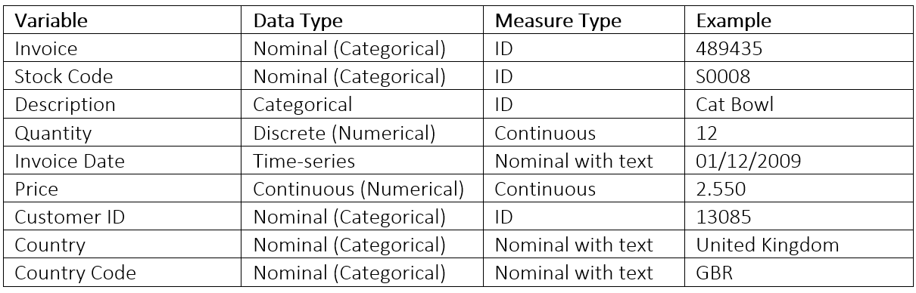
Figure 1. Teronix Data Types
There are many open-source statistical analysis tools available to analyse this data. Open source tools make code available for use of modification by other users, for free [22]. A business like Teronix could use statistical analysis to discover customer trends and behaviours through their data [23]. Four of these tools are introduced below:
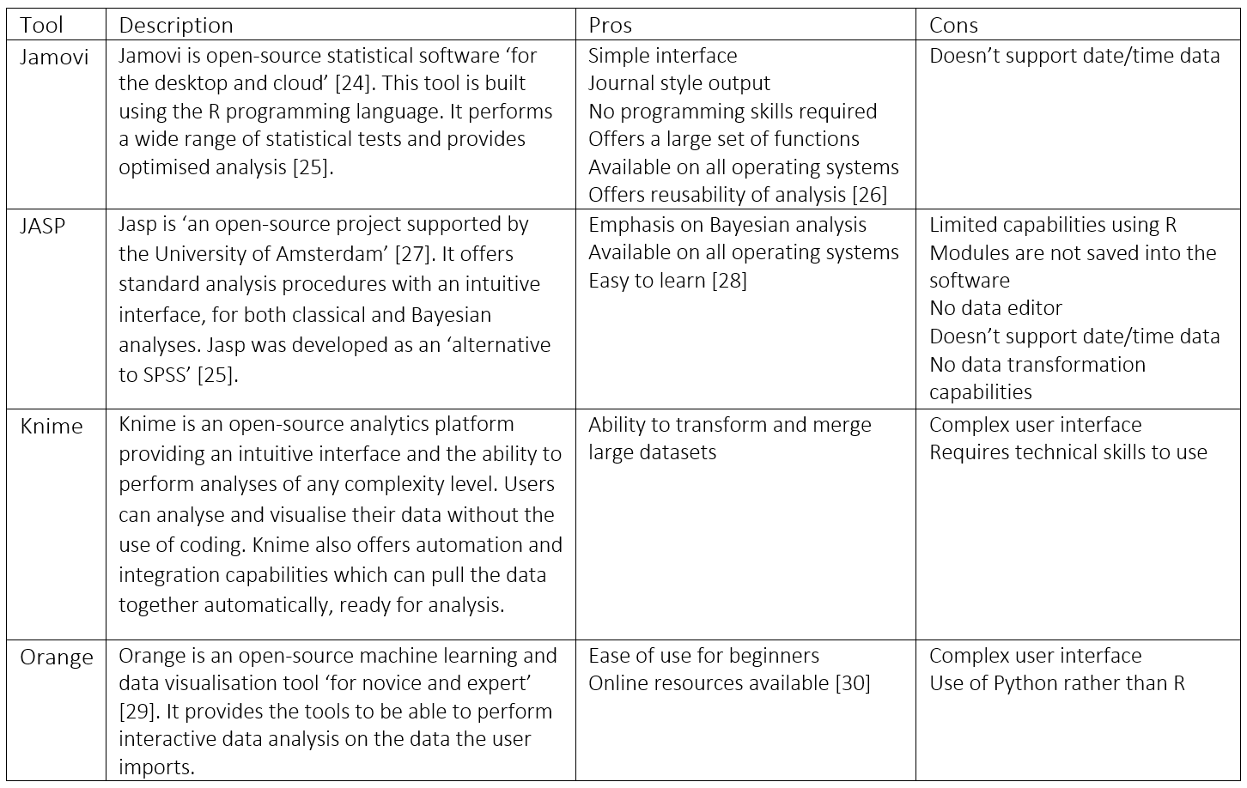
Figure 2. Comparison of statistical tools
The consultant decided to use Jamovi for the statistical analysis of Teronix data. This is due to the simple interface, variety of functions, and presentation of results. Jamovi also offers the reusability of analysis, so Teronix can import new data for analysis without any manual analysis setup.

Methodology
Before importing the dataset into Jamovi to run the analyses, the data needed to go through ‘pre-processing’. This involves evaluating the data to ensure it is as accurate and consistent as possible. Data quality and consistency are important considerations when it comes to data analysis. If the data being analysed is not up to standard, then the results of the analysis will not be reliable. The consultant faced some challenges with the data provided, as it was over ten years old, contained large amounts of blank or inconsistent values, and contained adjustments. These factors reduced the quality of the data and therefore the quality of the results.
Pre-processing
Removing Postage and Test products - Not relevant when analysing sales data
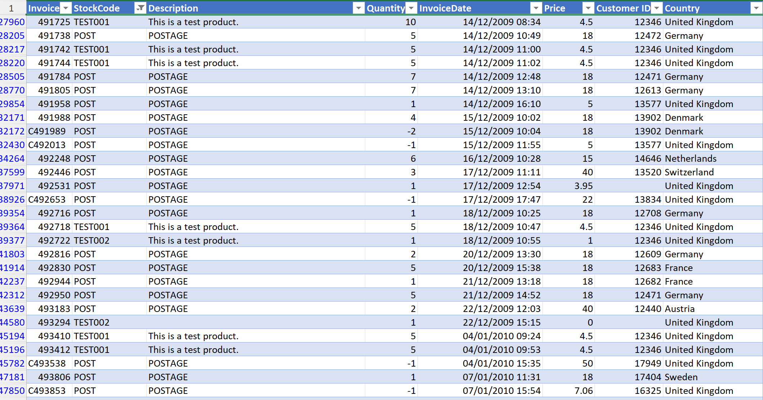
Figure 3. Pre-processing – Removal of postage data
Removing blank values - Although these blank values could impact the analysis, they provide no context, so not accurate enough to be included in the analysis.
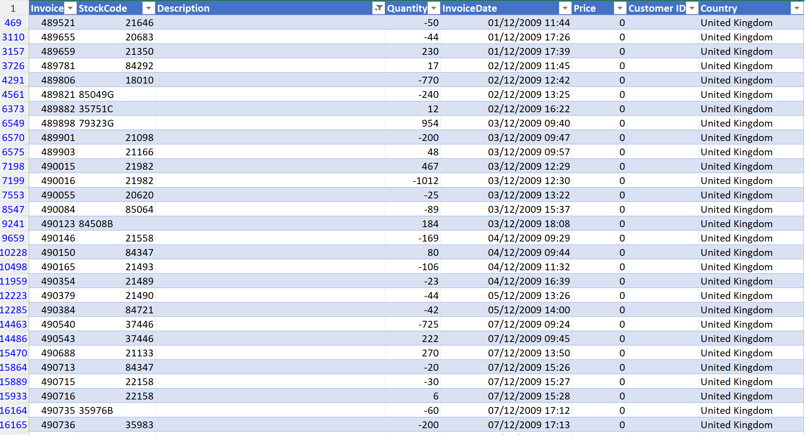
Figure 4. Pre-processing – Removal of blank values
Removing inconsistent/inaccurate values - The consultant did not want to remove any other low quality values from the dataset other than question marks, as this would skew the analysis. However, in future the data needs to be complete and follow consistent naming conventions.
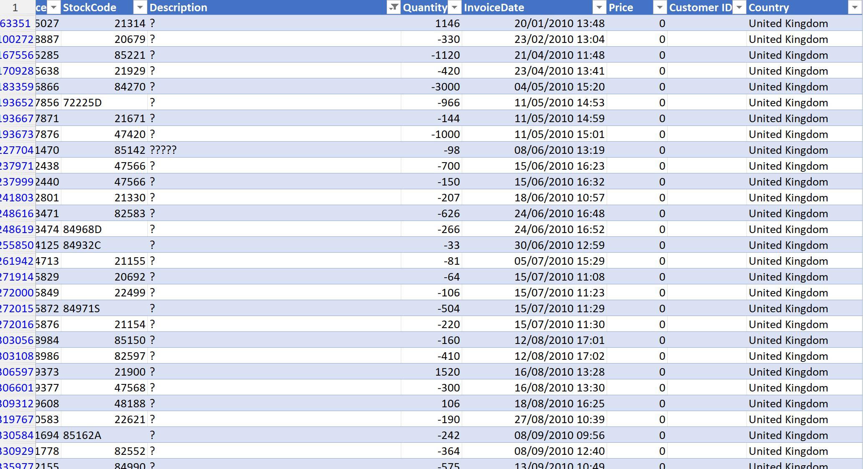
Figure 5. Pre-processing – Removal of incomplete data
Creating lookup tables – Providing consistent naming conventions within the data for country code and product code [31].
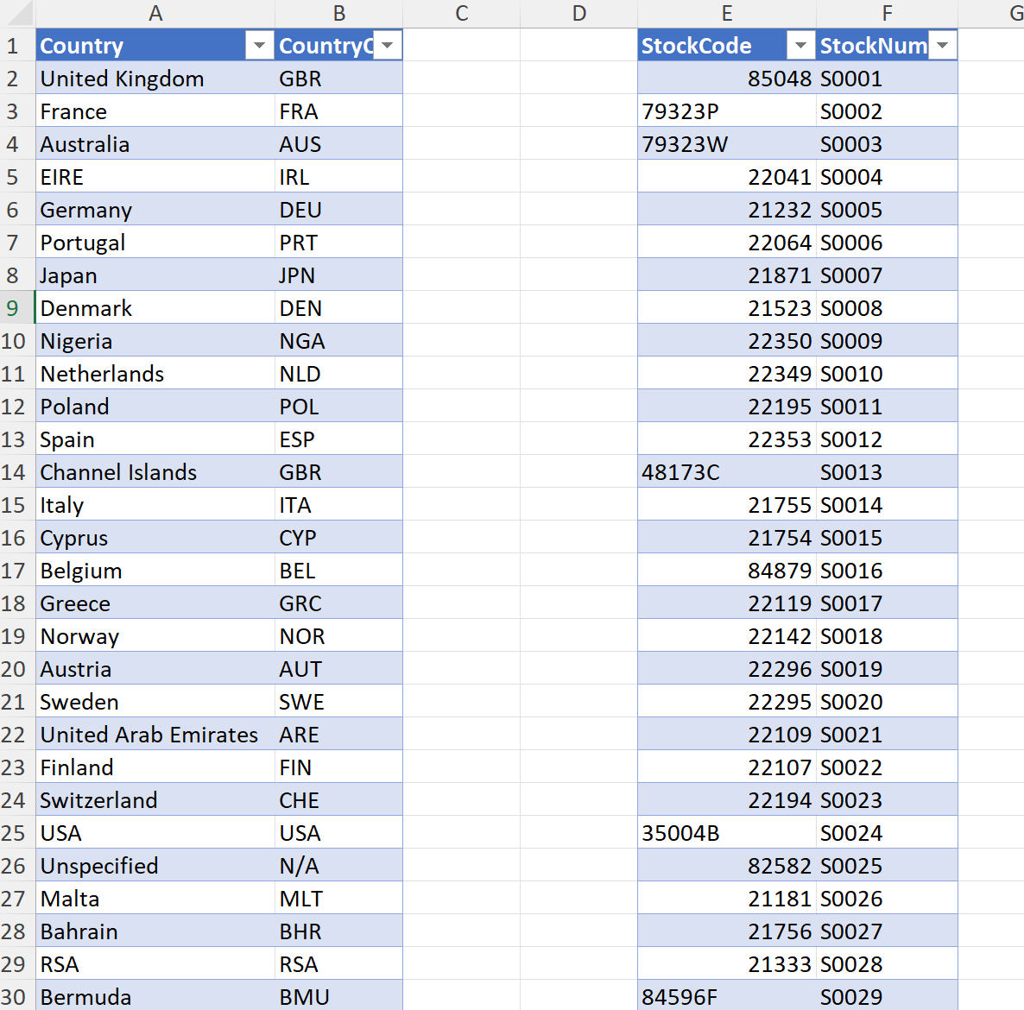
Figure 6. Pre-processing – Lookup tables
Convert the Excel files into CSV and merge the two datasets together in Notepad ++
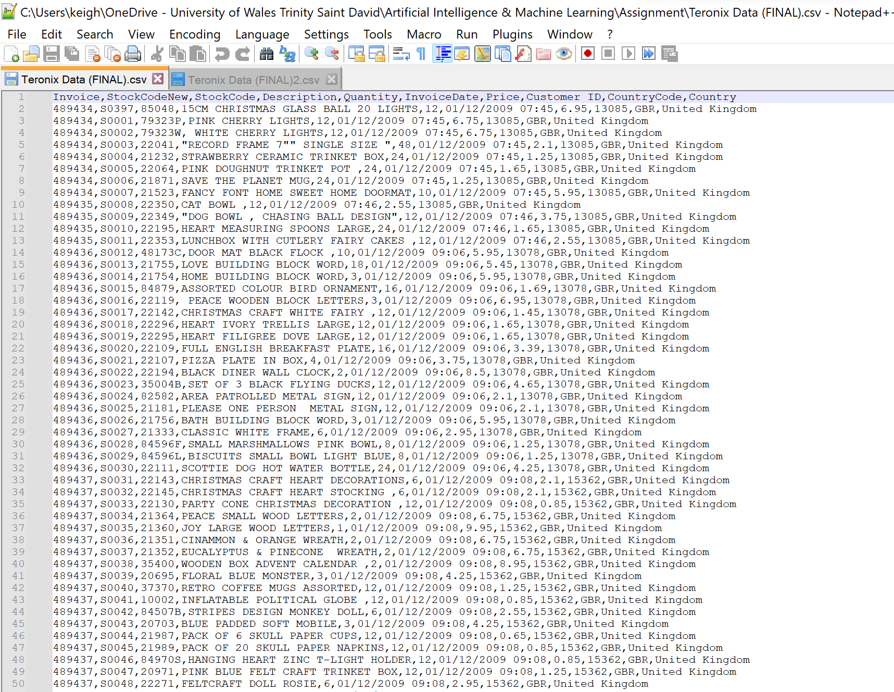
Figure 7. Pre-processing – Notepad ++
Once the dataset had been pre-processed, it was ready to import into Jamovi.
From an initial evaluation of the data, this snapshot of company activity will be able to give insights into the sales and quantity of products in different locations. We may be able to identify trends and correlations between the products or the locations. However, the snapshot is over ten years old so the value this will have going forward may not be significant. Teronix needs to develop a data capture procedure to collect up-to-date and complete data, which can then be analysed to inform future decisions.
Jamovi
The consultant completed a set of statistical tests within Jamovi. Please find the results under the appendix.
The AI/ML Model for Teronix Online should contain classification followed by linear regression.
Classification can be used to categorise products into clusters to show which products are likely to be purchased together, or which products are more likely to be purchased in different countries. This can inform promotion materials, as well as inform stock decisions.
Linear regression can take the data produced from the classification and predict future sales for those clusters.
Please see Appendix for examples of linear regression and classification with complete data samples.

Results and Discussion
From analysing the data provided, it is clear that it requires a supervised learning algorithm to uncover the trends within the data, which can lead to informed business decisions [32].
Teronix can apply a classification algorithm to the data, to categorise the data items that are not of numeric value. This will attempt to classify the attributes based on their similarities and predict the value of certain outcomes. This could classify Teronix customers by their location, or by their purchasing habits. It will group customers based on what they buy and when for example. This will help to inform marketing decisions and stock decisions. This could be in the form of a decision tree, logistic regression, or naïve bayes.
Teronix can apply a regression algorithm to the numerical data in order to predict future data based on previous data points. An example of this is linear regression. This could be used to predict sales, or predict the quantity sold.
The consultant recommends that Teronix applies classification algorithms to their data in order to categorise similar data items as a means of understanding the customers. This will allow for a more tailored marketing approach to certain target audiences based on their purchasing behaviours or demographics. From this analysis, the consultant then recommends linear regression to forecast future sales. Both supervised learning techniques used in parallel will provide forecasting abilities, but also with some context. As an international company, this context is needed to inform decisions on stock and distribution.
From the data analysed, it shows customers are mainly from the UK, Ireland then other European countries such as France and Germany. However, this has probably changed significantly over the last 10 years. The dataset also contains price and quantity which could be analysed to predict sales over time, if only the data was more accurate. Product codes can be classified based on their descriptions or their ‘frequently bought with’ similarities.
Conclusion
To conclude, AI and ML can add immense value to Teronix in terms of improving sales and efficiency and reducing waste. However, Teronix will not experience any benefits of AI and ML if they do not collect up-to-date and complete data for the tool to analyse. The world of AI and ML has changed significantly over recent years, so analysing data from over 10 years ago is not relevant in today’s climate. This data can provide a proof of concept to follow but does not ensure the model will still be applicable today.
From the information above, Teronix should be able to get an idea of what they could achieve with these tools. Companies like Amazon are leading the way and Teronix should follow suit. The consultant would recommend for Teronix to develop a consistent procedure for collecting data, and then analyse this data using classification then linear regression.

References

[1] | L. Monostori, “Artificial Intelligence,” in CIRP Encyclopedia of Production Engineering , 2019, pp. 47-50.
[2] | “What is Machine Learning?,” IBM, [Online]. Available: https://www.ibm.com/topics/machine-learning. [Accessed 2023].
[3] | H. D. iii.
[4] | S. Verma, “Artificial Intelligence in marketing: Systematic review and future research direction,” International journal of information management data insights , vol. 1, no. 1, 2021.
[5] | “Artificial intelligence in groceries and produce - 4 current application areas,” emerj, [Online]. Available: https://emerj.com/ai-sector-overviews/artificial-intelligence-in-groceries-and-produce-current-applications/. [Accessed 2023].
[6] | J. Vadakkanmarveettil, “Market Basket Analysis - A complete overview,” Jigsaw, 2021. [Online]. Available: https://www.jigsawacademy.com/market-basket-analysis/. [Accessed 2023].
[7] | M. Whitehorn, “The parable of the beer and diapers,” The register, 2006. [Online]. Available: https://www.theregister.com/2006/08/15/beer_diapers/. [Accessed 2023].
[8] | N. Tyagi, “5 ways Tesco uses big data analytics,” analytic steps, 2020. [Online]. Available: https://www.analyticssteps.com/blogs/5-ways-tesco-uses-big-data-analytics. [Accessed 2023].
[9] | B. Rossi, “How Tesco is using AI to gain customer insight,” Information Age, 2017. [Online]. Available: https://www.information-age.com/tesco-using-ai-gain-customer-insight-5845/. [Accessed 2023].
[10] | “The ultimate guide to machine learning chatbots and conversational AI,” IBM, 2022. [Online]. Available: https://www.information-age.com/tesco-using-ai-gain-customer-insight-5845/. [Accessed 2023].
[11] | P. Suta, “An overview of machine learning in chatbots,” International Journal of mechanical engineering and robotics research, vol. 9, no. 4, 2020.
[12] | N. Franklin, “What is a recommendation engine? How recommenders work,” Amplitude, 2022. [Online]. Available: https://amplitude.com/blog/recommendation-engine. [Accessed 2023].
[13] | K. B. Alex Polacco, “The Amazon Go Concept: Implications, Applications, and Sustainability,” Journal of Business and Management, vol. 24, no. 1, pp. 79-92, 2018.
[14] | M. M. C. R. U. K. Rupa Dash, “Application of Artificial Intelligence in Automation of Supply Chain Management,” Journal of Strategic Innovation and sustainability , vol. 14, no. 3, 2019.
[15] | S. Sicular, “Gartner Predicts the near and not so obvious future of AI in the Enterprise,” Gartner, 2021. [Online]. Available: https://blogs.gartner.com/svetlana-sicular/gartner-predicts-the-near-and-not-so-obvious-future-of-ai-in-the-enterprise/. [Accessed 2023].
[16] | P. Helo, “Artificial intelligence in operations management and supply chain management: an exploratory case study,” The management of operations, vol. 33, no. 16, pp. 1573-1590, 2022.
[17] | “Rise of robotics in fulfilment centers,” Radial, 2020. [Online]. Available: https://www.radial.com/insights/robotics-fulfillment-centers. [Accessed 2023].
[18] | B. Marr, Artificial Intelligence in Practice, John Wiley & Sons, 2019.
[19] | R. Hetu, “Gartner Predicts: Retail Requires mastery of inventory,” Gartner, 2021. [Online]. Available: https://blogs.gartner.com/robert-hetu/the-future-of-retail-requires-the-reevaluation-of-inventory-capabilities-in-order-to-create-and-evolve-digitally-driven-business-models-that-drive-customer-trust/. [Accessed 2023].
[20] | A. A.-B. Asharul Islam Khan, “Emerging Data sources in decision making and AI,” Procedia Computer Science, vol. 177, pp. 318-323, 2020.
[21] | N. Donges, “A guide to data types in statistics,” built-in, [Online]. Available: https://builtin.com/data-science/data-types-statistics. [Accessed 2023].
[22] | “What is open source?,” [Online]. Available: https://opensource.com/resources/what-open-source. [Accessed 2023].
[23] | M. Dixit, “10 best free statistical software for data analysis,” TechJockey, 2022. [Online]. Available: https://www.techjockey.com/blog/free-statistical-software. [Accessed 2023].
[24] | “Jamovi,” Jamovi, [Online]. Available: https://www.jamovi.org/. [Accessed 2023].
[25] | “10 best free and open source statistical analysis software,” good firms, [Online]. Available: https://www.goodfirms.co/statistical-analysis-software/blog/10-best-free-and-open-source-statistical-analysis-software. [Accessed 2023].
[26] | R. Muenchen, “A comparative review of the jamovi GUI for R,” r4stats - data science software reviews, 2022. [Online]. Available: https://r4stats.com/articles/software-reviews/jamovi/.
[27] | “JASP,” JASP, [Online]. Available: https://jasp-stats.org/. [Accessed 2023].
[28] | R. Muenchen, “A comparative review of the JASP statistical software,” r4stats , 2022. [Online]. Available: https://r4stats.com/articles/software-reviews/jasp/. [Accessed 2023].
[29] | “Orange,” Orange, [Online]. Available: https://orangedatamining.com/. [Accessed 2023].
[30] | “Data mining tools for better data analysis,” ionos, 2022. [Online]. Available: https://www.ionos.com/digitalguide/online-marketing/web-analytics/a-comparison-of-data-mining-tools/. [Accessed 2023].
[31] | ISO, “ISO Country Codes,” 2018. [Online]. Available: https://www.gov.uk/government/publications/iso-country-codes--2. [Accessed 2023].
[32] | “Regression and Classification: Supervised Machine Learning,” Geeks for Geeks, 2023. [Online]. Available: https://www.geeksforgeeks.org/regression-classification-supervised-machine-learning/. [Accessed 2023].

Appendix

Appendix A – Jamovi results for Teronix data
Linear Regression
Model Fit Measures
Model |  | R |  | R²
1 |  | 0.0152 |  | 2.32e-4

Model Coefficients - Price
Predictor |  | Estimate |  | SE |  | t |  | p
Intercept ᵃ |  | 3.2741 |  | 12.6 |  | 0.25996 |  | 0.795
CountryCode:
ARE – #N/A |  | 1.7260 |  | 13.8 |  | 0.12546 |  | 0.900
AUS – #N/A |  | 0.6497 |  | 12.9 |  | 0.05034 |  | 0.960
AUT – #N/A |  | -0.1365 |  | 13.2 |  | -0.01031 |  | 0.992
BEL – #N/A |  | 0.7837 |  | 12.8 |  | 0.06125 |  | 0.951
BHR – #N/A |  | 0.2140 |  | 16.7 |  | 0.01280 |  | 0.990
BMU – #N/A |  | -0.7829 |  | 24.6 |  | -0.03179 |  | 0.975
BRA – #N/A |  | -0.5474 |  | 17.9 |  | -0.03057 |  | 0.976
CAN – #N/A |  | -1.0399 |  | 15.0 |  | -0.06922 |  | 0.945
CHE – #N/A |  | -0.3824 |  | 12.8 |  | -0.02991 |  | 0.976
CYP – #N/A |  | 2.0874 |  | 13.1 |  | 0.15934 |  | 0.873
DEN – #N/A |  | -0.8070 |  | 13.3 |  | -0.06051 |  | 0.952
DEU – #N/A |  | -0.0972 |  | 12.6 |  | -0.00770 |  | 0.994
ESP – #N/A |  | 1.3218 |  | 12.8 |  | 0.10361 |  | 0.917
FIN – #N/A |  | 0.1055 |  | 13.2 |  | 0.00800 |  | 0.994
FRA – #N/A |  | 0.8844 |  | 12.6 |  | 0.06998 |  | 0.944
GBR – #N/A |  | 1.2596 |  | 12.6 |  | 0.10000 |  | 0.920
GRC – #N/A |  | 0.3061 |  | 13.5 |  | 0.02270 |  | 0.982
HKG – #N/A |  | 54.1344 |  | 14.2 |  | 3.82126 |  | < .001
IRL – #N/A |  | 3.7386 |  | 12.6 |  | 0.29604 |  | 0.767
ISL – #N/A |  | -0.7280 |  | 14.8 |  | -0.04921 |  | 0.961
ISR – #N/A |  | 0.2932 |  | 14.1 |  | 0.02075 |  | 0.983
ITA – #N/A |  | 1.1630 |  | 13.0 |  | 0.08952 |  | 0.929
JPN – #N/A |  | -1.1115 |  | 13.6 |  | -0.08177 |  | 0.935
KOR – #N/A |  | -0.8893 |  | 20.0 |  | -0.04445 |  | 0.965
LBN – #N/A |  | 2.3214 |  | 20.6 |  | 0.11250 |  | 0.910
LTU – #N/A |  | -0.6581 |  | 15.5 |  | -0.04255 |  | 0.966
MLT – #N/A |  | 18.3042 |  | 14.5 |  | 1.26237 |  | 0.207
N/A – #N/A |  | 1.2450 |  | 13.4 |  | 0.09311 |  | 0.926
NGA – #N/A |  | 0.1409 |  | 25.2 |  | 0.00560 |  | 0.996
NLD – #N/A |  | -0.5304 |  | 12.7 |  | -0.04171 |  | 0.967
NOR – #N/A |  | 24.4103 |  | 13.0 |  | 1.87635 |  | 0.061
POL – #N/A |  | -0.0600 |  | 13.7 |  | -0.00439 |  | 0.997
PRT – #N/A |  | 2.7682 |  | 12.8 |  | 0.21578 |  | 0.829
RSA – #N/A |  | 16.5712 |  | 15.8 |  | 1.05072 |  | 0.293
SGP – #N/A |  | 70.3716 |  | 14.2 |  | 4.94351 |  | < .001
SWE – #N/A |  | 1.6271 |  | 13.0 |  | 0.12470 |  | 0.901
THA – #N/A |  | -0.2745 |  | 18.9 |  | -0.01449 |  | 0.988
USA – #N/A |  | -0.8072 |  | 13.7 |  | -0.05898 |  | 0.953
WIN – #N/A |  | -1.0005 |  | 21.0 |  | -0.04766 |  | 0.962
ᵃ Represents reference level

Scatterplot
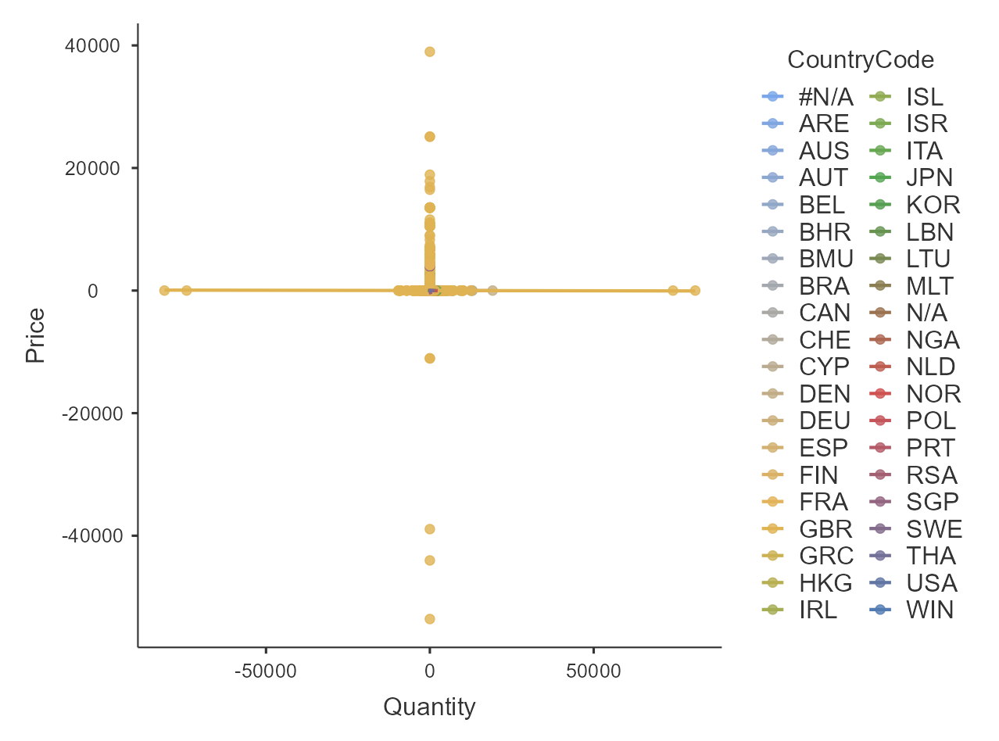
Linear Regression
Model Fit Measures
Model |  | R |  | R²
1 |  | 0.0570 |  | 0.00325

Model Coefficients - Quantity
Predictor |  | Estimate |  | SE |  | t |  | p
Intercept ᵃ |  | 12.03732 |  | 17.29596 |  | 0.69596 |  | 0.486
Price |  | -0.00185 |  | 0.00133 |  | -1.39081 |  | 0.164
CountryCode:
ARE – #N/A |  | 1.50314 |  | 18.89269 |  | 0.07956 |  | 0.937
AUS – #N/A |  | 42.23788 |  | 17.72507 |  | 2.38295 |  | 0.017
AUT – #N/A |  | 0.39217 |  | 18.19116 |  | 0.02156 |  | 0.983
BEL – #N/A |  | -0.35585 |  | 17.57280 |  | -0.02025 |  | 0.984
BHR – #N/A |  | -1.91181 |  | 22.95809 |  | -0.08327 |  | 0.934
BMU – #N/A |  | 70.26142 |  | 33.82025 |  | 2.07750 |  | 0.038
BRA – #N/A |  | -6.23439 |  | 24.58994 |  | -0.25353 |  | 0.800
CAN – #N/A |  | 4.07255 |  | 20.63160 |  | 0.19739 |  | 0.844
CHE – #N/A |  | 4.65622 |  | 17.55920 |  | 0.26517 |  | 0.791
CYP – #N/A |  | -2.91826 |  | 17.98980 |  | -0.16222 |  | 0.871
DEN – #N/A |  | 284.87129 |  | 18.31422 |  | 15.55465 |  | < .001
DEU – #N/A |  | 1.08873 |  | 17.34484 |  | 0.06277 |  | 0.950
ESP – #N/A |  | 0.06150 |  | 17.51830 |  | 0.00351 |  | 0.997
FIN – #N/A |  | 2.18395 |  | 18.10714 |  | 0.12061 |  | 0.904
FRA – #N/A |  | 1.24337 |  | 17.35586 |  | 0.07164 |  | 0.943
GBR – #N/A |  | -3.01386 |  | 17.29681 |  | -0.17424 |  | 0.862
GRC – #N/A |  | -0.32855 |  | 18.51473 |  | -0.01775 |  | 0.986
HKG – #N/A |  | 7.60782 |  | 19.45477 |  | 0.39105 |  | 0.696
IRL – #N/A |  | 6.52267 |  | 17.34237 |  | 0.37611 |  | 0.707
ISL – #N/A |  | 0.95554 |  | 20.31408 |  | 0.04704 |  | 0.962
ISR – #N/A |  | 2.75366 |  | 19.40511 |  | 0.14190 |  | 0.887
ITA – #N/A |  | -1.88795 |  | 17.84013 |  | -0.10583 |  | 0.916
JPN – #N/A |  | 42.64366 |  | 18.66801 |  | 2.28432 |  | 0.022
KOR – #N/A |  | -2.54084 |  | 27.47723 |  | -0.09247 |  | 0.926
LBN – #N/A |  | -3.99186 |  | 28.33694 |  | -0.14087 |  | 0.888
LTU – #N/A |  | 3.61832 |  | 21.23910 |  | 0.17036 |  | 0.865
MLT – #N/A |  | -3.58713 |  | 19.91234 |  | -0.18015 |  | 0.857
N/A – #N/A |  | -3.14534 |  | 18.36130 |  | -0.17130 |  | 0.864
NGA – #N/A |  | -10.28099 |  | 34.59192 |  | -0.29721 |  | 0.766
NLD – #N/A |  | 63.76522 |  | 17.46003 |  | 3.65207 |  | < .001
NOR – #N/A |  | 6.87734 |  | 17.86555 |  | 0.38495 |  | 0.700
POL – #N/A |  | -1.38297 |  | 18.79995 |  | -0.07356 |  | 0.941
PRT – #N/A |  | -1.15058 |  | 17.61690 |  | -0.06531 |  | 0.948
RSA – #N/A |  | -0.34371 |  | 21.65830 |  | -0.01587 |  | 0.987
SGP – #N/A |  | 8.29290 |  | 19.54892 |  | 0.42421 |  | 0.671
SWE – #N/A |  | 54.98703 |  | 17.91850 |  | 3.06873 |  | 0.002
THA – #N/A |  | 21.54719 |  | 26.01969 |  | 0.82811 |  | 0.408
USA – #N/A |  | -5.07230 |  | 18.79452 |  | -0.26988 |  | 0.787
WIN – #N/A |  | -4.71829 |  | 28.82660 |  | -0.16368 |  | 0.870
ᵃ Represents reference level

K-means clustering method
Clustering vector
Sum of squares Table
 |  | Value
Cluster 1 |  | 2.30e0+7
Cluster 2 |  | 3.46e+10
Between clusters |  | 1.20e+10
Total |  | 4.67e+10

Clustering Table
Cluster No |  | Count
1 |  | 2
2 |  | 1060651

Centroids of clusters Table
 |  | Cluster No |  | Price |  | Quantity
1 |  | 1.00 |  | 1.560 |  | 77605.000
2 |  | 2.00 |  | 4.608 |  | 9.949

Plot of means across clusters
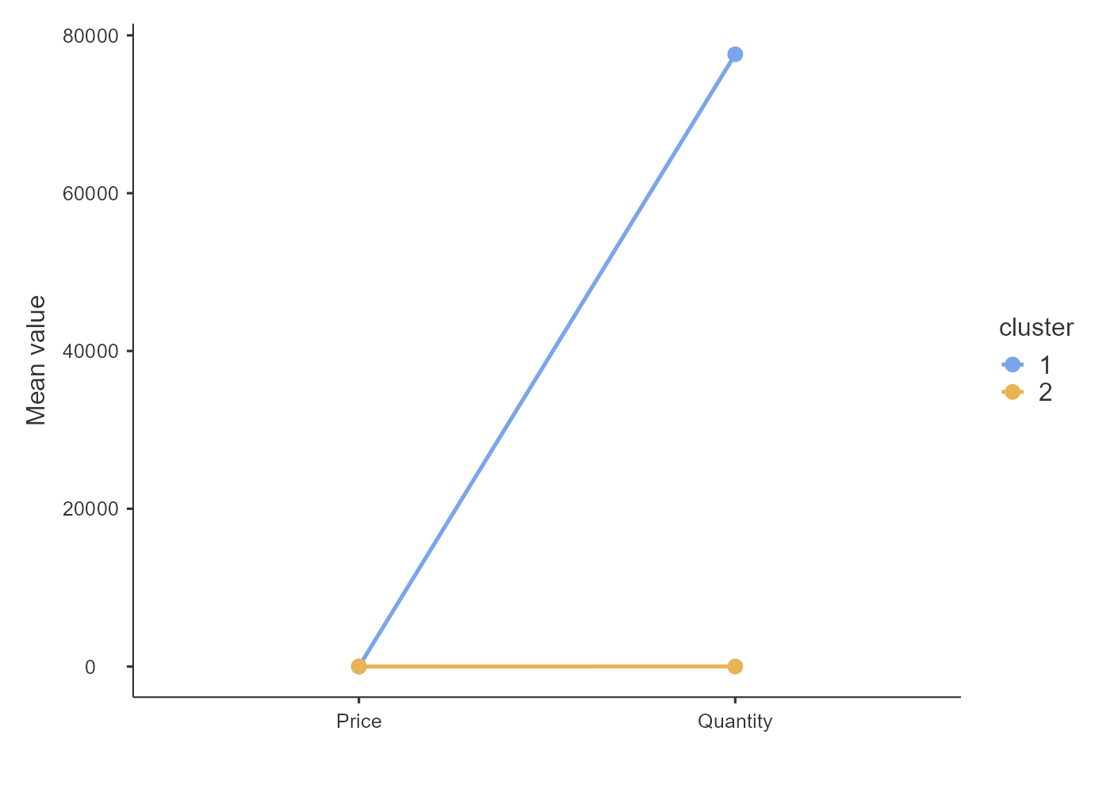
General Linear Model
Analysis plot
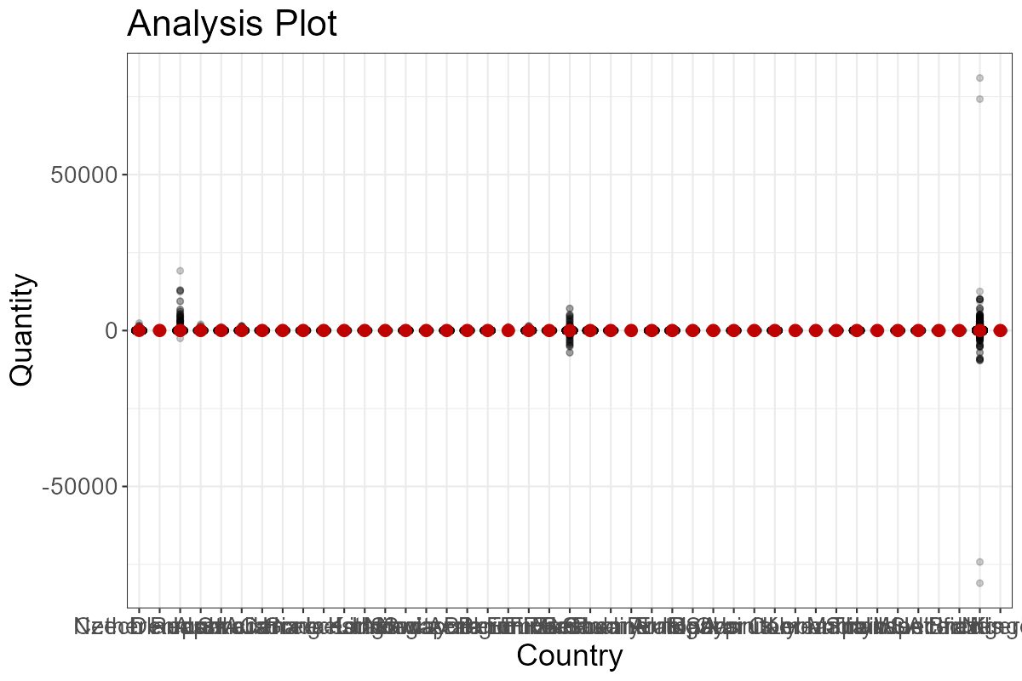
Estimates and effect sizes for categorical predictors
 |  |  |  |  |  | 95% Confidence Interval
Variable |  | Level |  | Estimate |  | Lower |  | Upper
Factors (Estimates reported are means)
Country |  | United Kingdom |  | 9.01 |  | 8.67 |  | 9.35
 |  | France |  | 13.27 |  | 10.45 |  | 16.1
 |  | Australia |  | 54.27 |  | 46.67 |  | 61.87
 |  | EIRE |  | 18.55 |  | 16.06 |  | 21.03
 |  | Germany |  | 13.12 |  | 10.57 |  | 15.67
 |  | Portugal |  | 10.88 |  | 4.31 |  | 17.44
 |  | Japan |  | 54.68 |  | 40.91 |  | 68.44
 |  | Denmark |  | 296.9 |  | 285.1 |  | 308.71
 |  | Nigeria |  | 1.75 |  | -56.97 |  | 60.47
 |  | Netherlands |  | 75.8 |  | 71.12 |  | 80.48
 |  | Poland |  | 10.65 |  | -3.79 |  | 25.09
 |  | Spain |  | 12.09 |  | 6.64 |  | 17.54
 |  | Channel Islands |  | 12.3 |  | 4.16 |  | 20.45
 |  | Italy |  | 10.14 |  | 1.57 |  | 18.71
 |  | Cyprus |  | 9.11 |  | -0.59 |  | 18.81
 |  | Belgium |  | 11.67 |  | 5.58 |  | 17.76
 |  | Greece |  | 11.7 |  | -1.25 |  | 24.65
 |  | Norway |  | 18.86 |  | 10.09 |  | 27.63
 |  | Austria |  | 12.42 |  | 1.38 |  | 23.47
 |  | Sweden |  | 67.02 |  | 57.84 |  | 76.19
 |  | United Arab Emirates |  | 13.53 |  | -1.37 |  | 28.43
 |  | Finland |  | 14.22 |  | 3.71 |  | 24.72
 |  | Switzerland |  | 16.69 |  | 10.75 |  | 22.63
 |  | USA |  | 6.96 |  | -7.45 |  | 21.37
 |  | Unspecified |  | 8.88 |  | -3.2 |  | 20.96
 |  | Malta |  | 8.41 |  | -10.93 |  | 27.75
 |  | Bahrain |  | 10.12 |  | -19.47 |  | 39.71
 |  | RSA |  | 11.66 |  | -13.89 |  | 37.21
 |  | Bermuda |  | 82.29 |  | 25.33 |  | 139.26
 |  | Hong Kong |  | 19.54 |  | 2.08 |  | 37
 |  | Singapore |  | 20.19 |  | 2.34 |  | 38.05
 |  | Thailand |  | 33.58 |  | -4.52 |  | 71.68
 |  | Israel |  | 14.78 |  | -2.46 |  | 32.03
 |  | Lithuania |  | 15.65 |  | -8.51 |  | 39.81
 |  | West Indies |  | 7.31 |  | -37.88 |  | 52.51
 |  | Lebanon |  | 8.04 |  | -35.96 |  | 52.03
 |  | Korea |  | 9.49 |  | -32.35 |  | 51.34
 |  | Brazil |  | 5.8 |  | -28.46 |  | 40.06
 |  | Canada |  | 16.11 |  | -5.94 |  | 38.15
 |  | Iceland |  | 12.99 |  | -7.89 |  | 33.87
 |  | Saudi Arabia |  | 7.5 |  | -97.53 |  | 112.53
 |  | Czech Republic |  | 21.14 |  | -41.63 |  | 83.91
 |  | European Community |  | 8.41 |  | -35.2 |  | 52.03

Difference between factor levels for categorical predictors
 |  |  |  |  |  | 95% Confidence Interval
Variable |  | Comparison |  | Difference |  | Lower |  | Upper |  | Cohen's d
Country |  | France-United Kingdom |  | 4.2600 |  | -33.680 |  | 42.20 |  | 0.0300
 |  | Australia-United Kingdom |  | 45.2600 |  | -41.190 |  | 131.71 |  | 0.2700
 |  | EIRE-United Kingdom |  | 9.5400 |  | -18.020 |  | 37.09 |  | 0.0600
 |  | Germany-United Kingdom |  | 4.1100 |  | -158.510 |  | 166.73 |  | 0.0200
 |  | Portugal-United Kingdom |  | 1.8700 |  | -97.430 |  | 101.17 |  | 0.0100
 |  | Japan-United Kingdom |  | 45.6700 |  | -20.320 |  | 111.65 |  | 0.2700
 |  | Denmark-United Kingdom |  | 287.8900 |  | 256.380 |  | 319.41 |  | 1.7000
 |  | Nigeria-United Kingdom |  | -7.2600 |  | -42.120 |  | 27.60 |  | -0.0400
 |  | Netherlands-United Kingdom |  | 66.7900 |  | -112.140 |  | 245.71 |  | 0.3900
 |  | Poland-United Kingdom |  | 1.6400 |  | -38.080 |  | 41.36 |  | 0.0100
 |  | Spain-United Kingdom |  | 3.0800 |  | -19.540 |  | 25.70 |  | 0.0200
 |  | Channel Islands-United Kingdom |  | 3.2900 |  | -121.980 |  | 128.57 |  | 0.0200
 |  | Italy-United Kingdom |  | 1.1300 |  | -35.550 |  | 37.82 |  | 0.0100
 |  | Cyprus-United Kingdom |  | 0.1000 |  | -22.840 |  | 23.04 |  | 0.0000
 |  | Belgium-United Kingdom |  | 2.6600 |  | -20.020 |  | 25.34 |  | 0.0200
 |  | Greece-United Kingdom |  | 2.6900 |  | -39.790 |  | 45.18 |  | 0.0200
 |  | Norway-United Kingdom |  | 9.8500 |  | -44.020 |  | 63.73 |  | 0.0600
 |  | Austria-United Kingdom |  | 3.4100 |  | -59.470 |  | 66.30 |  | 0.0200
 |  | Sweden-United Kingdom |  | 58.0100 |  | 4.680 |  | 111.33 |  | 0.3400
 |  | United Arab Emirates-United Kingdom |  | 4.5200 |  | -27.890 |  | 36.93 |  | 0.0300
 |  | Finland-United Kingdom |  | 5.2100 |  | -39.290 |  | 49.71 |  | 0.0300
 |  | Switzerland-United Kingdom |  | 7.6800 |  | -112.680 |  | 128.03 |  | 0.0500
 |  | USA-United Kingdom |  | -2.0500 |  | -128.390 |  | 124.29 |  | -0.0100
 |  | Unspecified-United Kingdom |  | -0.1300 |  | -71.800 |  | 71.54 |  | 0.0000
 |  | Malta-United Kingdom |  | -0.6000 |  | -59.400 |  | 58.20 |  | 0.0000
 |  | Bahrain-United Kingdom |  | 1.1100 |  | -24.140 |  | 26.36 |  | 0.0100
 |  | RSA-United Kingdom |  | 2.6500 |  | -164.890 |  | 170.19 |  | 0.0200
 |  | Bermuda-United Kingdom |  | 73.2800 |  | 40.450 |  | 106.12 |  | 0.4300
 |  | Hong Kong-United Kingdom |  | 10.5300 |  | -35.650 |  | 56.71 |  | 0.0600
 |  | Singapore-United Kingdom |  | 11.1800 |  | -17.220 |  | 39.59 |  | 0.0700
 |  | Thailand-United Kingdom |  | 24.5700 |  | -50.860 |  | 100.00 |  | 0.1400
 |  | Israel-United Kingdom |  | 5.7700 |  | -292.230 |  | 303.78 |  | 0.0300
 |  | Lithuania-United Kingdom |  | 6.6400 |  | -48.270 |  | 61.56 |  | 0.0400
 |  | West Indies-United Kingdom |  | -1.6900 |  | -28.160 |  | 24.77 |  | -0.0100
 |  | Lebanon-United Kingdom |  | -0.9700 |  | -34.690 |  | 32.74 |  | -0.0100
 |  | Korea-United Kingdom |  | 0.4800 |  | -26.800 |  | 27.77 |  | 0.0000
 |  | Brazil-United Kingdom |  | -3.2100 |  | -113.150 |  | 106.73 |  | -0.0200
 |  | Canada-United Kingdom |  | 7.1000 |  | -39.010 |  | 53.20 |  | 0.0400
 |  | Iceland-United Kingdom |  | 3.9800 |  | -43.350 |  | 51.31 |  | 0.0200
 |  | Saudi Arabia-United Kingdom |  | -1.5100 |  | -23.030 |  | 20.01 |  | -0.0100
 |  | Czech Republic-United Kingdom |  | 12.1300 |  | -28.250 |  | 52.52 |  | 0.0700
 |  | European Community-United Kingdom |  | -0.6000 |  | -130.300 |  | 129.10 |  | 0.0000

R² and semi-partial R² estimates
Source |  | Estimate
model |  | 0.00330
Country |  | 0.00325

Descriptives
Descriptives
 |  | Country |  | N |  | Missing |  | Mean |  | Median |  | SD |  | Minimum |  | Maximum
Price |  | Australia |  | 1911 |  | 0 |  | 3.92 |  | 1.85 |  | 24.99 |  | 0.0000 |  | 662.25
 |  | Austria |  | 904 |  | 0 |  | 3.14 |  | 1.65 |  | 7.83 |  | 0.1200 |  | 130.00
 |  | Bahrain |  | 126 |  | 0 |  | 3.49 |  | 2.95 |  | 2.82 |  | 0.4200 |  | 14.95
 |  | Belgium |  | 2975 |  | 0 |  | 4.06 |  | 1.95 |  | 39.18 |  | 0.0000 |  | 1508.65
 |  | Bermuda |  | 34 |  | 0 |  | 2.49 |  | 1.95 |  | 2.59 |  | 0.2100 |  | 12.75
 |  | Brazil |  | 94 |  | 0 |  | 2.73 |  | 1.95 |  | 2.32 |  | 0.2100 |  | 10.95
 |  | Canada |  | 227 |  | 0 |  | 2.23 |  | 1.65 |  | 2.24 |  | 0.1000 |  | 12.75
 |  | Channel Islands |  | 1664 |  | 0 |  | 5.44 |  | 2.10 |  | 25.81 |  | 0.1900 |  | 934.66
 |  | Cyprus |  | 1173 |  | 0 |  | 5.36 |  | 2.95 |  | 16.88 |  | 0.1200 |  | 320.69
 |  | Czech Republic |  | 28 |  | 0 |  | 1.58 |  | 1.45 |  | 1.14 |  | 0.2900 |  | 4.95
 |  | Denmark |  | 792 |  | 0 |  | 2.47 |  | 1.65 |  | 2.60 |  | 0.0600 |  | 16.95
 |  | EIRE |  | 17865 |  | 0 |  | 7.01 |  | 2.10 |  | 64.90 |  | 0.0000 |  | 2736.16
 |  | European Community |  | 58 |  | 0 |  | 4.24 |  | 2.95 |  | 3.62 |  | 0.5500 |  | 14.95
 |  | Finland |  | 1000 |  | 0 |  | 3.38 |  | 1.95 |  | 9.79 |  | 0.1200 |  | 275.60
 |  | France |  | 13836 |  | 0 |  | 4.16 |  | 1.65 |  | 71.09 |  | 0.0000 |  | 4161.06
 |  | Germany |  | 16961 |  | 0 |  | 3.18 |  | 1.69 |  | 14.70 |  | 0.0000 |  | 715.02
 |  | Greece |  | 658 |  | 0 |  | 3.58 |  | 2.55 |  | 3.68 |  | 0.1200 |  | 39.95
 |  | Hong Kong |  | 362 |  | 0 |  | 57.41 |  | 1.95 |  | 353.26 |  | 0.2100 |  | 2653.95
 |  | Iceland |  | 253 |  | 0 |  | 2.55 |  | 1.95 |  | 2.16 |  | 0.2500 |  | 12.75
 |  | Israel |  | 371 |  | 0 |  | 3.57 |  | 1.95 |  | 7.83 |  | 0.0600 |  | 125.00
 |  | Italy |  | 1502 |  | 0 |  | 4.44 |  | 2.17 |  | 20.34 |  | 0.1200 |  | 660.86
 |  | Japan |  | 582 |  | 0 |  | 2.16 |  | 1.65 |  | 2.61 |  | 0.2100 |  | 45.57
 |  | Korea |  | 63 |  | 0 |  | 2.38 |  | 2.10 |  | 1.49 |  | 0.1200 |  | 5.95
 |  | Lebanon |  | 57 |  | 0 |  | 5.60 |  | 3.75 |  | 5.99 |  | 0.5500 |  | 39.95
 |  | Lithuania |  | 189 |  | 0 |  | 2.62 |  | 2.10 |  | 1.63 |  | 0.1400 |  | 8.50
 |  | Malta |  | 295 |  | 0 |  | 21.58 |  | 2.55 |  | 166.91 |  | 0.1900 |  | 1868.56
 |  | Netherlands |  | 5036 |  | 0 |  | 2.74 |  | 1.45 |  | 15.32 |  | 0.0000 |  | 947.08
 |  | Nigeria |  | 32 |  | 0 |  | 3.42 |  | 1.80 |  | 5.04 |  | 0.4200 |  | 27.82
 |  | Norway |  | 1434 |  | 0 |  | 27.68 |  | 1.65 |  | 397.76 |  | 0.0000 |  | 6958.17
 |  | Poland |  | 529 |  | 0 |  | 3.21 |  | 1.65 |  | 3.49 |  | 0.1900 |  | 39.95
 |  | Portugal |  | 2563 |  | 0 |  | 6.04 |  | 1.95 |  | 55.04 |  | 0.1200 |  | 1241.98
 |  | RSA |  | 169 |  | 0 |  | 19.85 |  | 1.69 |  | 155.38 |  | 0.0000 |  | 1435.29
 |  | Saudi Arabia |  | 10 |  | 0 |  | 2.41 |  | 2.30 |  | 1.39 |  | 0.4200 |  | 5.49
 |  | Singapore |  | 346 |  | 0 |  | 73.65 |  | 2.10 |  | 421.92 |  | 0.1900 |  | 3949.32
 |  | Spain |  | 3710 |  | 0 |  | 4.60 |  | 1.95 |  | 40.38 |  | 0.0000 |  | 1715.85
 |  | Sweden |  | 1310 |  | 0 |  | 4.90 |  | 1.45 |  | 47.91 |  | 0.0900 |  | 874.84
 |  | Switzerland |  | 3130 |  | 0 |  | 2.89 |  | 1.69 |  | 3.07 |  | 0.0000 |  | 39.95
 |  | Thailand |  | 76 |  | 0 |  | 3.00 |  | 2.10 |  | 2.81 |  | 0.4200 |  | 12.75
 |  | USA |  | 531 |  | 0 |  | 2.47 |  | 1.65 |  | 2.47 |  | 0.4200 |  | 16.95
 |  | United Arab Emirates |  | 497 |  | 0 |  | 5.00 |  | 1.65 |  | 33.91 |  | 0.1400 |  | 503.90
 |  | United Kingdom |  | 976490 |  | 0 |  | 4.53 |  | 2.10 |  | 126.51 |  | -53594.3600 |  | 38970.00
 |  | Unspecified |  | 756 |  | 0 |  | 4.52 |  | 1.95 |  | 43.29 |  | 0.1200 |  | 1189.94
 |  | West Indies |  | 54 |  | 0 |  | 2.27 |  | 1.25 |  | 2.25 |  | 0.1900 |  | 7.95

References
[1] The jamovi project (2022). jamovi. (Version 2.3) [Computer Software]. Retrieved from https://www.jamovi.org.
[2] R Core Team (2021). R: A Language and environment for statistical computing. (Version 4.1) [Computer software]. Retrieved from https://cran.r-project.org. (R packages retrieved from MRAN snapshot 2022-01-01).
[3] Seol, H. (2022). snowCluster: Multivariate Analysis. (Version 6.8.0)[jamovi module]. https://github.com/hyunsooseol/snowCluster.

Appendix B – Linear regression with house price data
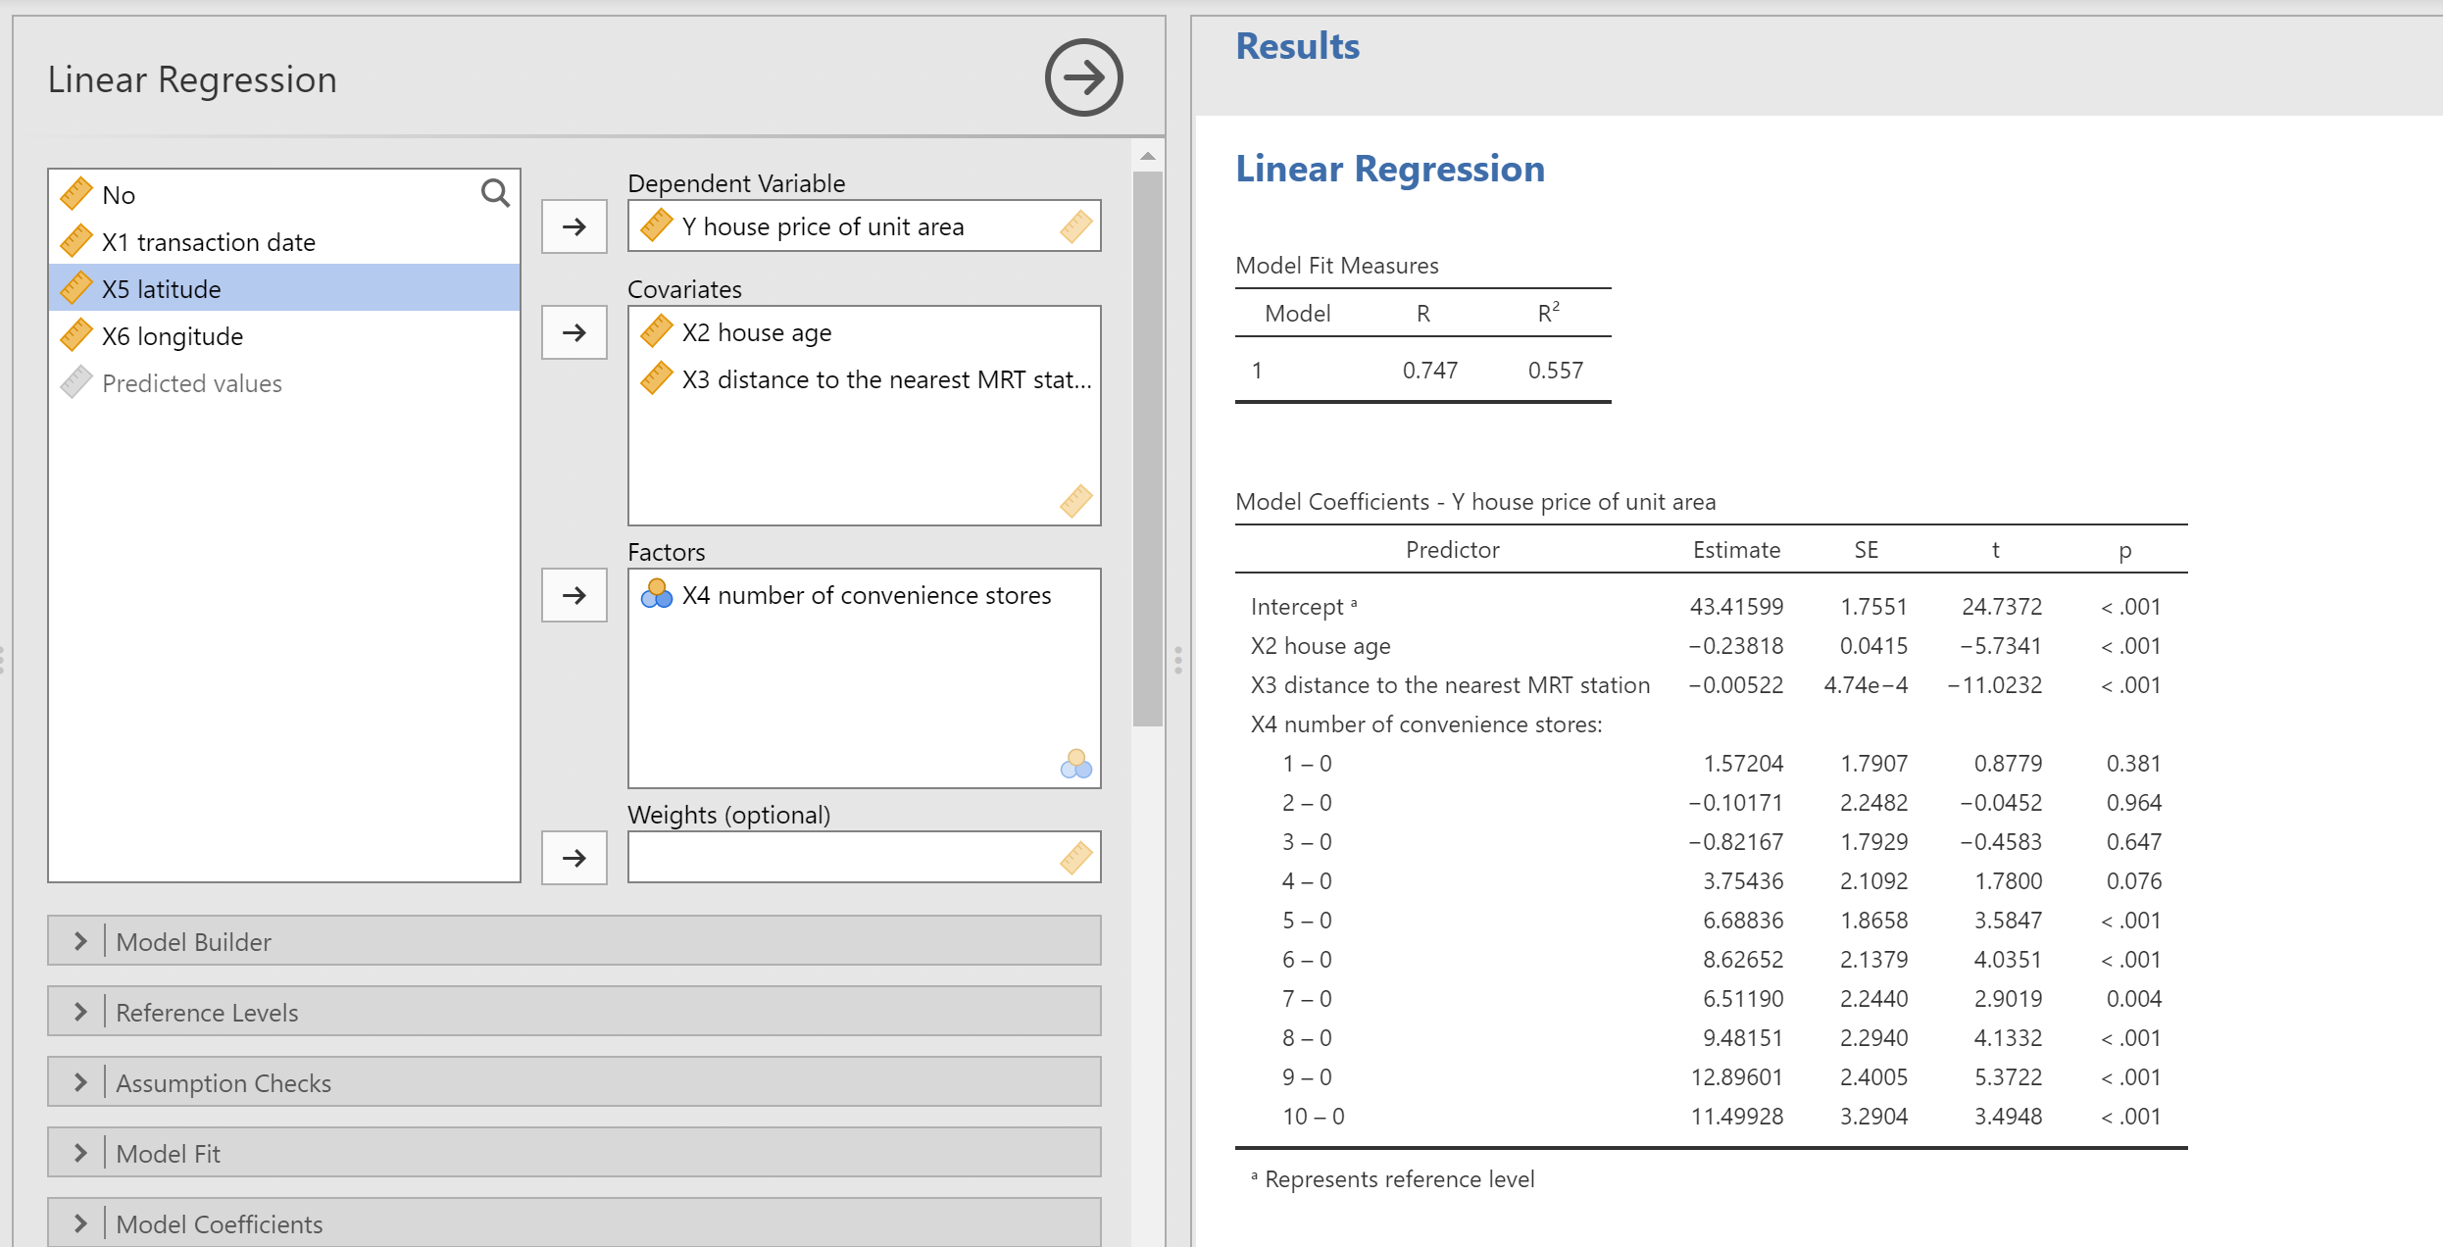

Appendix C – Decision tree classification with Jamovi sample data
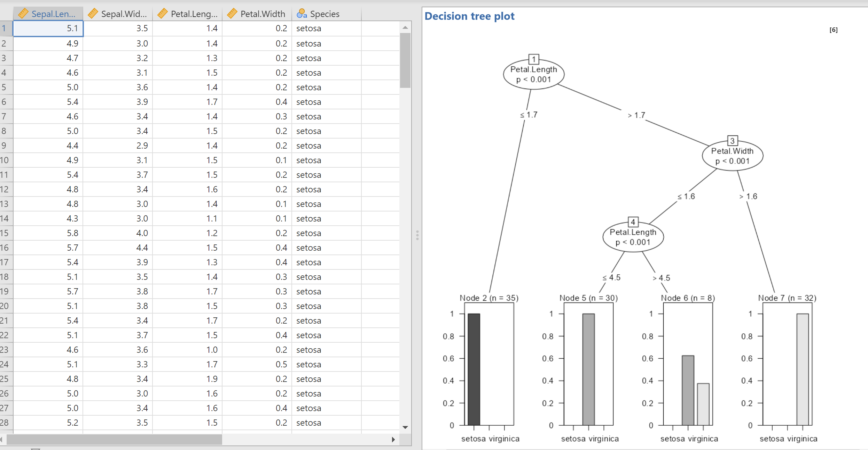

Appendix D – Linear Regression graph
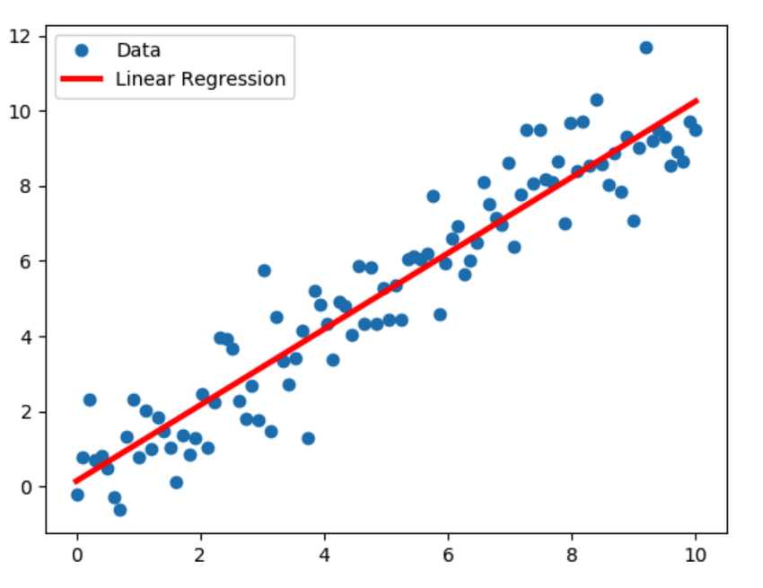
Linear Regression model sample illustration | Download Scientific Diagram (researchgate.net)

