Module Name: Learning in Digital Era
Assignment Name: Assignment 1: E-Portfolio
Student Name: Carol Cernea
Student Number: 2113437
Course Title: BSc Cloud Computing

Table of Contents
E-Portfolio 3
Task 1: Writing summary 4
Task 2: Video presentation 5
Task 3: Automatic reference tool 5
Task 4: Academic Poster 9
References 11

E-Portfolio

Link E-Portfolio Home Page:

Carol Cernea Portfolio (google.com) at: https://sites.google.com/view/ccernea/home
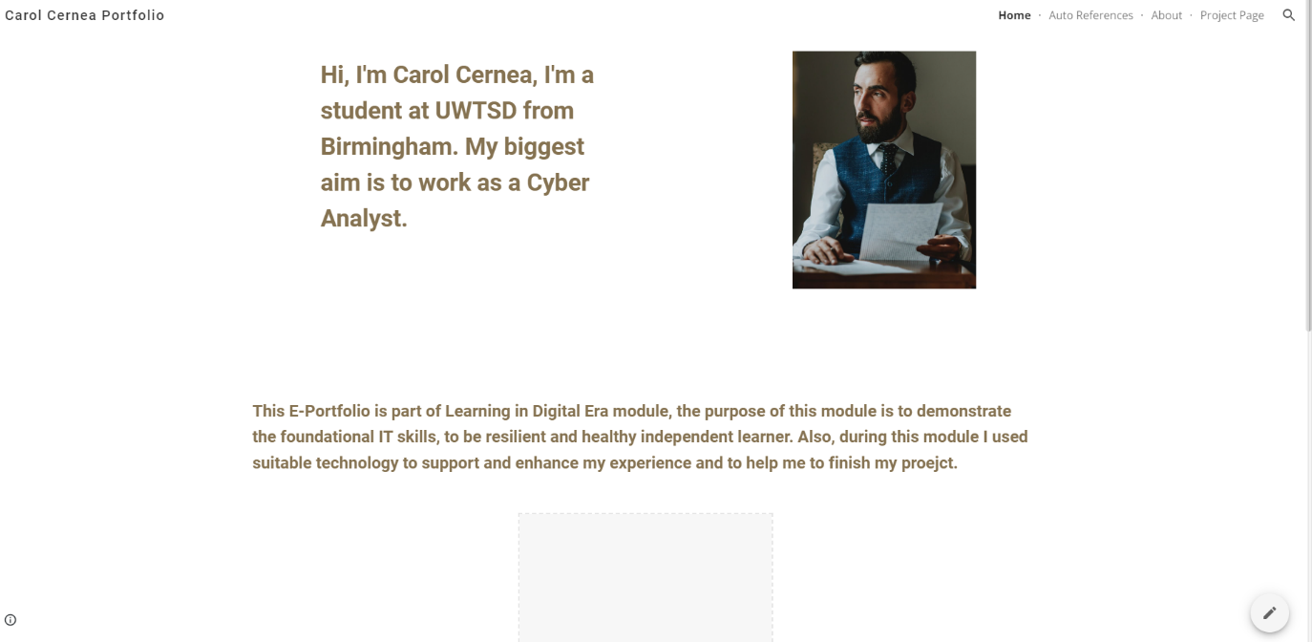
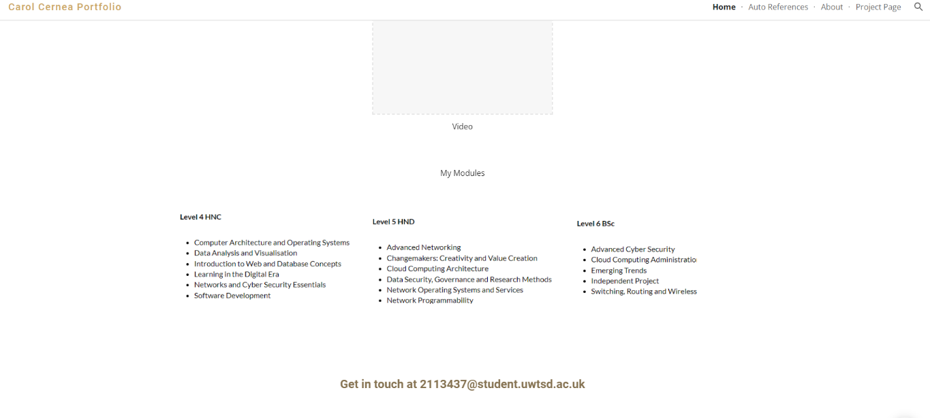

Task 1: Writing summary
Link E-Portfolio Project Summary:
Carol Cernea Portfolio - Writing Summary (google.com) at
https://sites.google.com/view/ccernea/writing-summary
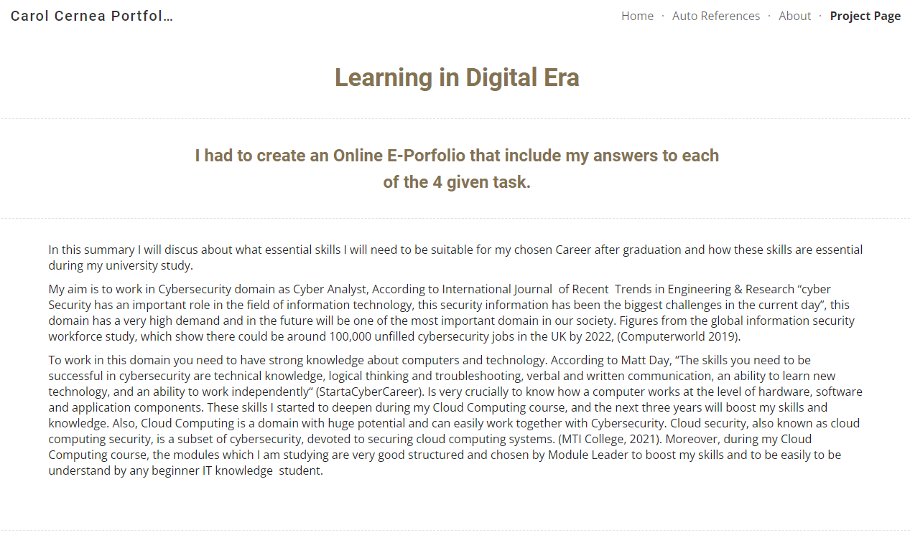
In this summary I will discus about what essential skills I will need to be suitable for my chosen Career after graduation and how these skills are essential during my university study.
My aim is to work in Cybersecurity domain as Cyber Analyst, According to International Journal of Recent Trends in Engineering & Research “cyber Security has an important role in the field of information technology, this security information has been the biggest challenges in the current day”, this domain has a very high demand and in the future will be one of the most important domain in our society. Figures from the global information security workforce study, which show there could be around 100,000 unfilled cybersecurity jobs in the UK by 2022, (Computerworld 2019).
To work in this domain, you need to have strong knowledge about computers and technology. According to Matt Day, “The skills you need to be successful in cybersecurity are technical knowledge, logical thinking and troubleshooting, verbal and written communication, an ability to learn new technology, and an ability to work independently “(StartaCyberCareer). Is very crucially to know how a computer works at the level of hardware, software and application components. These skills I started to deepen during my Cloud Computing course, and the next three years will boost my skills and knowledge. Also, Cloud Computing is a domain with huge potential and can easily work together with Cybersecurity. Cloud security, also known as cloud computing security, is a subset of cybersecurity, devoted to securing cloud computing systems. (MTI College, 2021). Moreover, during my Cloud Computing course, the modules which I am studying are very good structured and chosen by Module Leader to boost my skills and to be easily to be understand by any beginner IT knowledge student.

Task 2: Video presentation

Link Video sources:
https://web.microsoftstream.com/video/c81ce84a-bf5e-4637-af71-133f44aeaa01
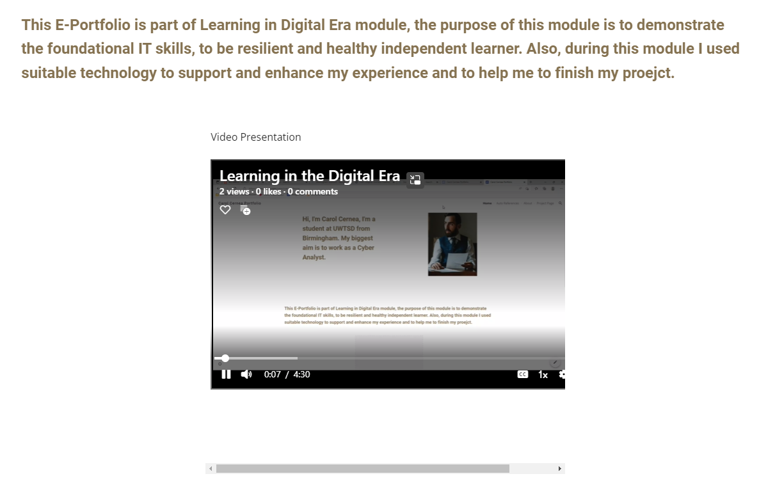

Task 3: Automatic reference tool

Link Auto References page:
Carol Cernea Portfolio - Auto References (google.com) or https://sites.google.com/view/ccernea/auto-references
For this part of project, I choose to use RefWorks. This software is a web-based commercial reference. For me was easier than the other tools. And the register process was very smoothly and strait forward.
Figure 1. As you can see in image below, first field we have to choose for what style we want to use it. Is very important to check exactly what type of reference the lecturer asked for. For my project I chosen Harvard References
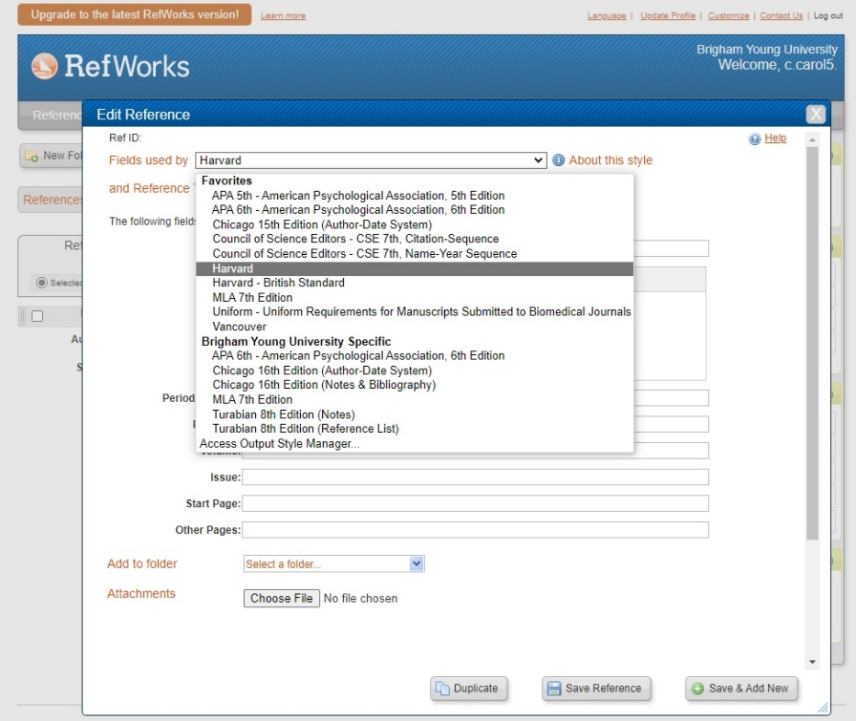

Figure 2. The second field, we have to choose from which type of source we want to create the reference, in this picture I have chosen Journal Article, because one of my references has mandatory to be a Book text.
I would like to mention that books can sometimes be stored in Journal Article website.
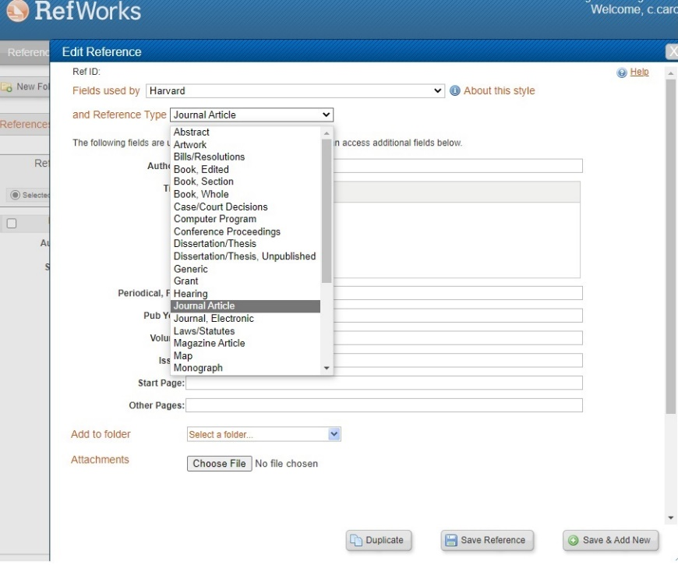
In Figure 3, I would like to show what types of information we need to put in, and also, as you can see for this figure, I chosen Web Page as Reference Type.
Moreover, as you can see when you have to put information about Authors and source, all fields are very easily to be understand by everybody and tell you exactly what need to be in. After all information you only need to press Save References
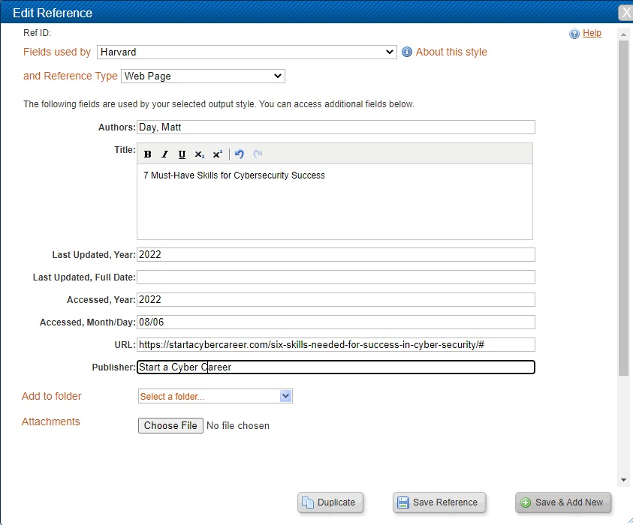

Figure 4. This image is similar with Figure 3, only Author and Source are different. I would like to mention that all References what we save it, can be easily edited in case of any mistake.
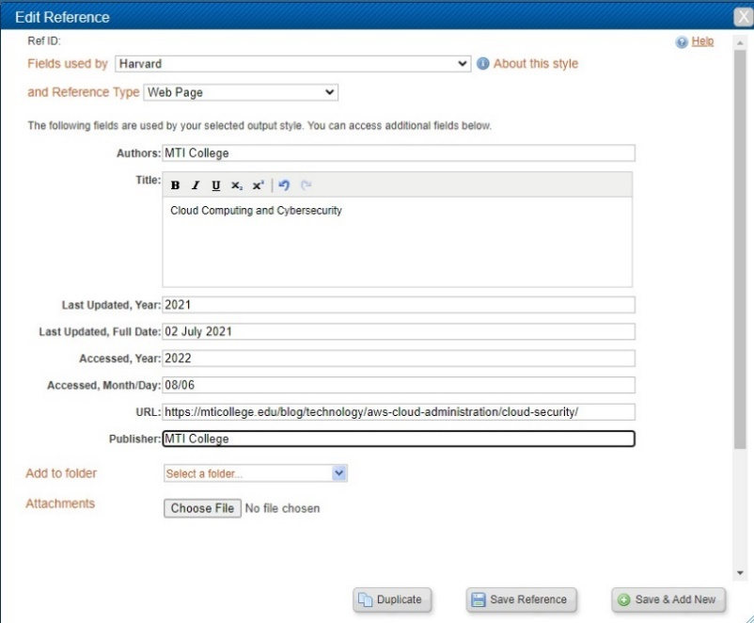
Figure 5. After finishing with references, we have to create a Bibliography. We can do this easily pressing the "Create Bibliography". After that, you will receive same message asking you if you want to include in this Bibliography all the references.
You need to choose Output style, for me was Harvard, and select the file type what you will view the Bibliography. I choose Text and press Create Bibliography.

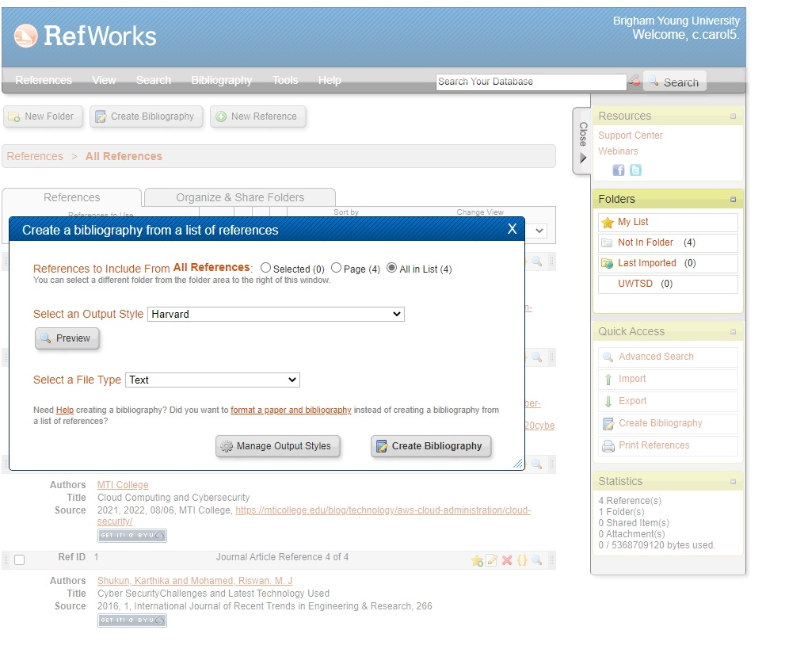

Task 4: Academic Poster
Link Poster source:
Poster A3_0.jpg
Link 1:
https://uowtsd-my.sharepoint.com/:i:/g/personal/2113437_student_uwtsd_ac_uk/EW0krFRJoClJriFD2npyXIsBiWoN_t2R5wmyCm_docYDSA?e=PA3Xq4
Link 2:
https://uowtsd-my.sharepoint.com/:i:/g/personal/2113437_student_uwtsd_ac_uk/EW0krFRJoClJriFD2npyXIsB18JNfFKe0CmWLcMKhJ_gYA?e=mlIgYt

Link Life is a Team Sport page:
Carol Cernea Portfolio - Life is a Team Sport (google.com)
or
https://sites.google.com/view/ccernea/life-is-a-team-sport

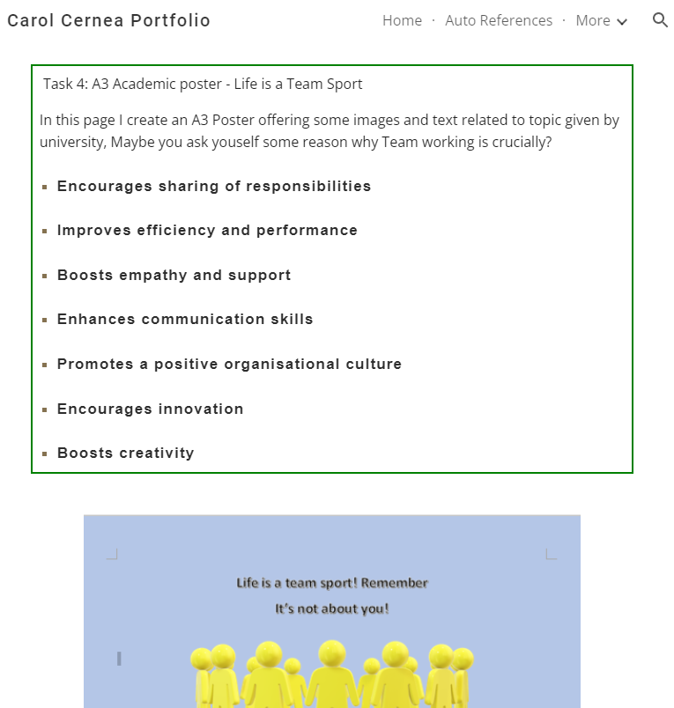

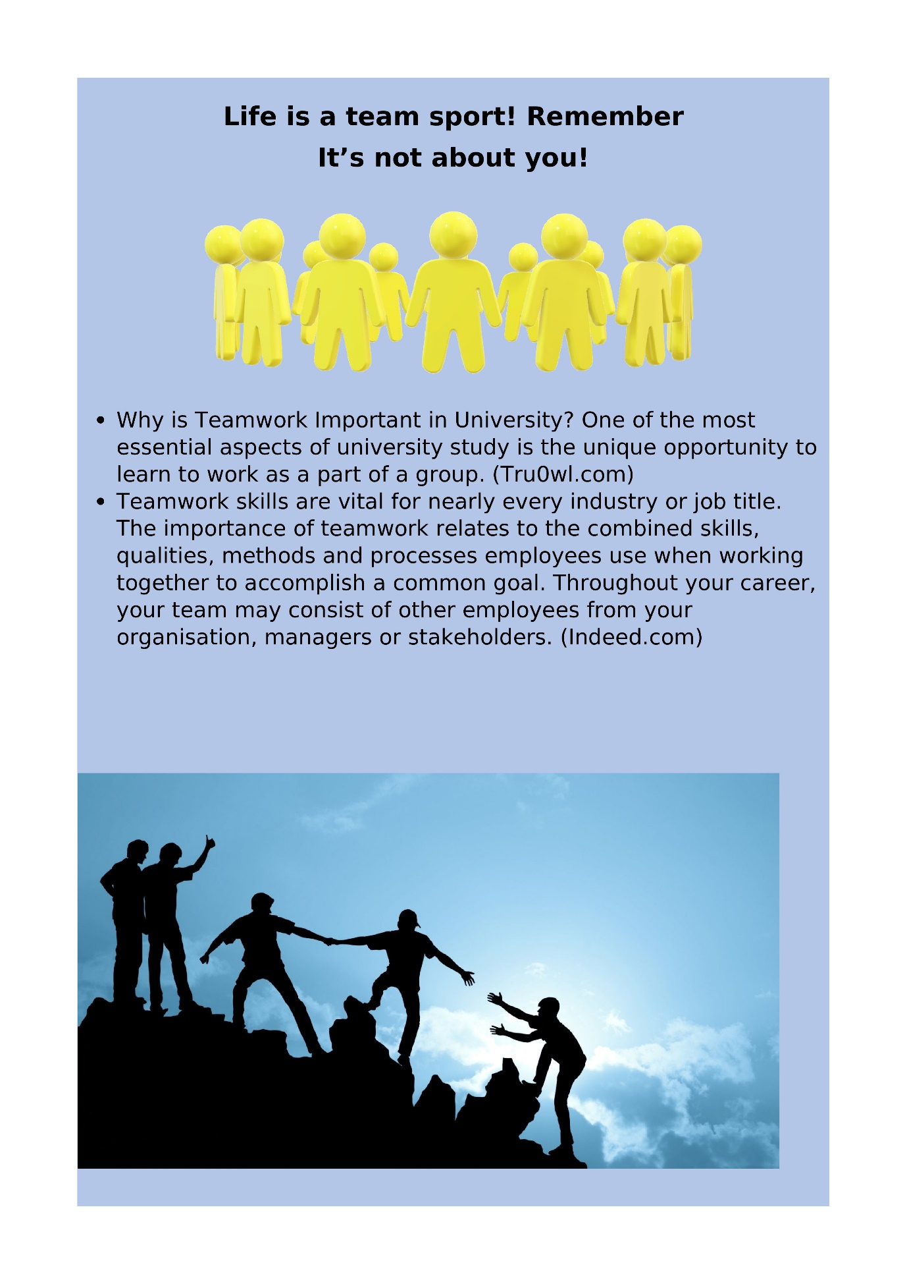

References

Day, M. 2022,, 7 Must-Have Skills for Cybersecurity Success [Homepage of Start a Cyber Career], [Online]. Available : https://startacybercareer.com/six-skills-needed-for-success-in-cyber-security/# [2022, 08/06].

Mercer-Myers, C. 2 August 2019-last update, Audience Development Editor [Homepage of Computerworld], [Online]. Available: https://www.computerworld.com/article/3412198/most-in-demand-cyber-security-jobs-in-the-uk.html#:~:text=Cybersecurity%20jobs%20remain%20in%20high%20demand%20in%20the,unfilled%20cybersecurity%20jobs%20in%20the%20UK%20by%202022. [06 August 2022.

MTI College 2021, 02 July 2021-last update, Cloud Computing and Cybersecurity [Homepage of MTI College], [Online]. Available: https://mticollege.edu/blog/technology/aws-cloud-administration/cloud-security/ [2022, 08/06].

Shukun, K. and Mohamed, R. M. J 2016, "Cyber SecurityChallenges and Latest Technology Used", vol. 1, no. International Journal of Recent Trends in Engineering & Research, pp. 266.

Truowl.com. 2022. Why is Teamwork Important in University? | truowl.com. [online] Available at: <https://truowl.com/university/why-is-teamwork-important-in-university/#:~:text=Why%20is%20Teamwork%20Important%20in%20University%3F%20One%20of,a%20team%20is%20highly%20relevant%20to%20any%20workplace.> [Accessed 7 August 2022].

Indeed Career Guide. 2022. 14 Reasons Why Teamwork Is Important in the Workplace. [online] Available at: <https://au.indeed.com/career-advice/career-development/why-teamwork-is-important#:~:text=Teamwork%20skills%20are%20vital%20for%20nearly%20every%20industry,other%20employees%20from%20your%20organisation%2C%20managers%20or%20stakeholders.> [Accessed 7 August 2022].

