BSc (Hons) Health and Social Care
BMHP6026: Digital Transformation in health, and social care professions
Component 1: Written Report
Title: “Digital Transformation in the Health and Care Professional through Remote Patient Monitoring (RPM) via Wearable Devices”
Student Name: Dana Zaharia
Student ID: 2241343
Lecturer: Humza Saeed

Table of Contents
1.0 Introduction 3
2.0 Chosen digital transformation 3
3.0 Workforce management strategy 5
4.0 Impact of technology usage on patients and service providers 6
5.0 Community impact 8
6.0 Conclusion 9
7.0 References 10

1.0 Introduction
Health and social care in the UK have gone through severe changes due to technological improvements to aid patients and family members over the last 10 years. The UK healthcare industry has gone through radical changes due to technological advancements in healthcare services. As per the report of 2021, digital health services have contributed 11% of total employment in the UK, whereas single-use technology accounts for 7% of total employment (GOV UK, 2023). The concept of remote patient monitoring and diagnosis was first proposed after the COVID pandemic to mitigate social contact and contamination. This report focuses on digital health and social services that align with current technological trends.
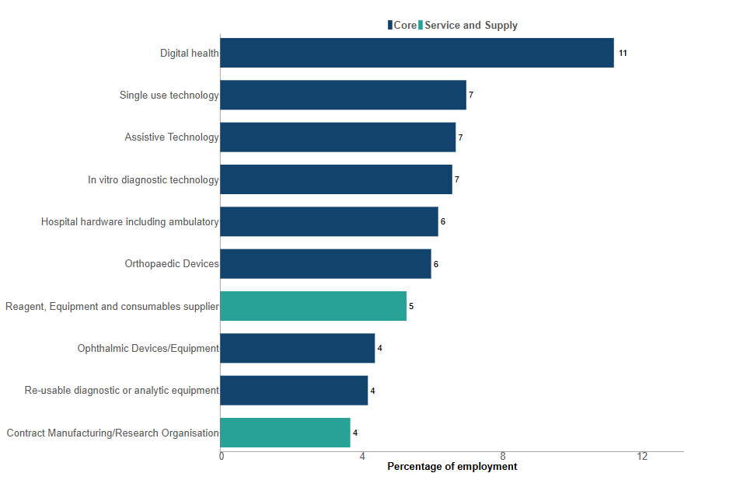
Figure 1: Contribution of the medical technology sector to the UK employment rate
(Source: GOV UK, 2023)

2.0 Chosen digital transformation
This report focuses on “Remote Patient Monitoring (RPM) via Wearable Devices” technology for aligning digital health care services with the market trend of the past 10 years. This technology can be utilised to monitor the health condition of patients from distant lands; as a result, people from different countries can also benefit from UK-standard health services. As opined by Serrano et al. (2023), RPM technology used by healthcare professionals has increased patient confidence and self-confidence through effective communication, prompt care, and visualising health trends. This technology utilises a wearable device to contact and video conference with distant patients. The notion of RPM has taken inspiration from telemedicine services of astronauts while accomplishing space missions, and during the COVID-19 pandemic, it was integrated with regular patient-centred care. RPM technologies can be used for tracking symptoms associated with heart disease, blood pressure, diabetes and critical pulmonary conditions (HHS GOV, n.d). The proposed technology embodiment idea in the health service has helped track critical health conditions at the
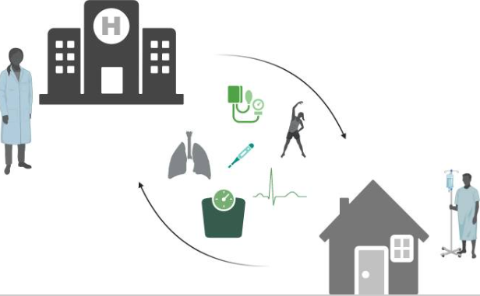
Figure 2: Remote Patient Monitoring technology
(Source: Serrano et al., 2023)
Doctors are appointed to check patients' conditions via video conferencing, tele calling facilities to contact patients and visualise health issues. The global market size of RPM technology had approximately 11.02 billion pounds in revenue and is expected to grow by 3% as it emphasises personalised patient-centred care, improving engagement (Global Data, 2023). It has benefited patients with early detection of critical health conditions, facilitating preventive care. The personalised care feature of RPM technology has strengthened user-friendliness, lowering healthcare costs and customised intervention plans for chronic health conditions. It has been reported that UK healthcare professionals have reduced healthcare accommodation costs by 20-40% by accessing real-time patient conditions (Doccla, 2025). The real-time services through RPM technology have helped many patients address critical health conditions. Thus, RPM has crafted a new dimension of health services in the era of digital transformation and remote services.

3.0 Workforce management strategy
The workforce management strategy of RPM technology consists of job roles and competencies associated with each role. It offers real-time management of chronic health diseases, monitors patients' risks, and also provides virtual support for pregnant patients. Job roles associated with RPM services are telehealth technicians, RPM specialists, coordinators, nurses, and data analysts. The responsibilities of patients onboarding, data monitoring, analysis, effective communication with patients, documentation, and administration. As opined by Pannunzio et al. (2024), experienced staff presence is required to increase the effectiveness of patience centred in RPM technology. Moreover, a sensor-based patient monitoring system is required, claiming the need for remote sensing technicians in delivering effective health services. Health care professionals and nurses are required to have effective communication competency to understand health issues and make an intervention plan as per the preferences of consumers.
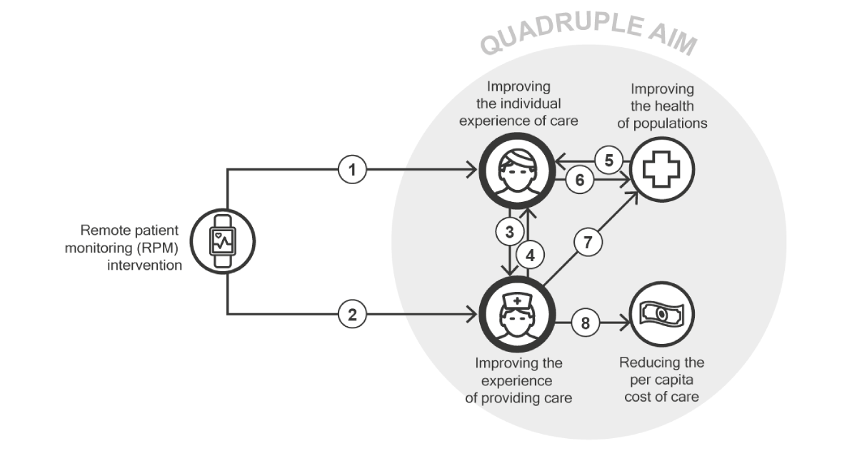
Figure 3: Role of patients and healthcare staff in RPM frameworks
(Source: Pannunzio et al., 2024)
The job role of RPM specialist includes identifying chronic health systems, educating patients about the adverse impact, and guiding daily routines to address the disorder. As opined by Pritchett et al. (2021), RPM clinical nurse specialists, physicians, patient education specialists, and COVID-19 physicians were employed by Mayo Clinic in the COVID-19 RPM program. The strategy embedded with RPM intervention consists of designing a clinical workflow, parameter escalation. Patients receive a technology package after enrolling in distant RPM technology. Technology associated with RPM services is cellular-enabled tablets with “Resideo Life Care Solutions,” preconnected and Bluetooth-enabled devices for: cuffing and monitoring blood pressure, pulse oximeter, thermometer, and scaling. These Bluetooth-enabled technologies passively collect physiological data. Moreover, a manual EHR review is performed by healthcare professionals to obtain predetermined clinical and demographic data of patients for making an intervention plan. Based on the seriousness of a chronic health condition, the RPM specialist determines whether the patient has to be admitted into the hospital or take care from home; medication support might be sufficient for addressing the health disorder.

4.0 Impact of technology usage on patients and service providers
The usage of RPM technology via Bluetooth enables wearable devices to benefit patients with real-time healthcare support that might address critical health risks. As opined by Serrano et al. (2023), RPM technology benefits patients and service providers through continuous monitoring with prompt care, improving self-care, efficiencies, effective communications, and visualising health trends. Remote health monitoring facilities have gained relevance to embed health services with future digital technology trends. On the other hand, health service providers have the flexible working opportunity from anywhere else, considering technology availability. Cost savings from the establishment of equipment are another major benefit of RPM technology for healthcare professionals. A detailed analysis of RPM-enabled health and social services is described as follows.
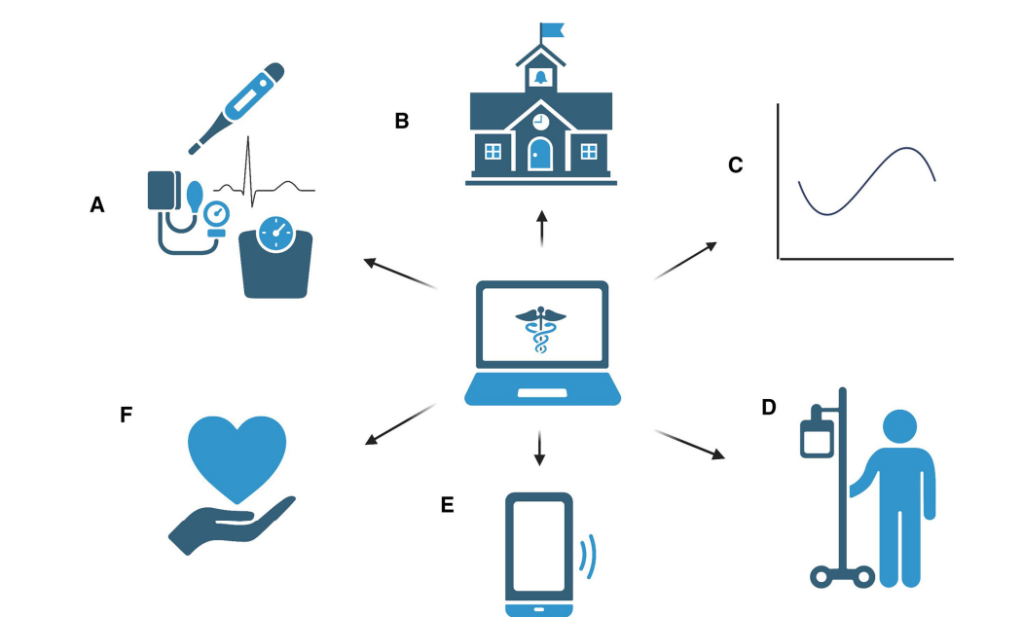
Figure 4: Benefits of RPM for perceived healthcare practitioners
(Source: Serrano et al., 2023)
Impact of RPM on patient and service provider relations
The intervention of RPM technology has established positive outcomes when it comes to safety and medical protocol adherence. As opined by Tan et al. (2024), mobility and functional status of patients have been improved by the implementation of RPM. For example, Mayo Clinic utilises RPM strategy to deliver comprehensive health care at home for patients diagnosed with COVID-19 19 as these patients require isolation till the infection is cured completely (Mayo Clinic, 2021). A cellular-enabled tablet is used by patients to automatically receive kits suggested by RPM specialists. Moreover, patients having mild symptoms of recording vital signs were suggested to use the “Mayo Clinic app.” Through this application, patients receive notifications about their health updates. More voice call facility embedded with RPM technology for patients to communicate with nurses for determining critical health conditions such as nausea, shortness. Thus, RPM has a significant contribution to overcoming chronic health diseases of contaminated diseases in the digital transformation era.
NHS England has also implemented advanced, cloud-based telephony solutions associated with healthcare services throughout the UK. The features of NHS England RPM solutions are 24/7/365 (24 hours, 7 days a week, 365 days a year) service access, automatic patient queue management, call routing, patient signposting, team integration, consolidation of visual reception, and flexibility of service cancelling (NHS UK, n.d). A full consultative approach is being provided by RPM service for addressing the evolving demand of the healthcare environment. An end-to-end communication framework is established by the RPM system to work according to requirements, practices, PCN’s and ICBs. The following features of RPM technology of RPM have contributed positive experience for the patients and service providers.
The popularity of RPM, telephony health services has increased after COVID-19 safety protocols. Diseases that could be cured by RPM services are diabetes, hypertension, and heart diseases. Moreover, this technology is also useful for respiratory illness management, suggesting an intervention plan after surgery. Most chronic disease is rooted in lifestyle factors of an individual, such as using tobacco, smoking, poor nutritional quality, physical activity absence, and consumption of alcohol (Wanda Health, n.d). According to the Wanda Health clinic, these chronic diseases can be managed through addressing risk behaviour that contributes to the progression of diseases. RPM has enabled a virtual care platform for patients to actively take control of their health and wellness without routine physical visits to the clinics. As a result, long stays in hospitals have been reduced by 25% along with 19% fewer admissions due to RPM technology (Wanda Health, n.d). Thus, RPM has positively improved the quality of health services for patients and service providers.
Experience embodied with patient care through RPM services
A mixed patient experience has resulted due to the integration of RPM technology in health services. As opined by Tan et al. (2024), patient care has been improved by real-time health service through RPM that has reduced frequency of hospital admission, re-admission, long-term stays in hospitals, outpatient visits, and other non-hospitalisation costs. The global market size of RPM is expected to have a compound annual growth rate of 18.8% from 2021 to 2028 (Tan et al., 2024). In the era of Industry 4.0, the embodiment of remote sensors, the Internet of Things (IoT), networking, data centres, cloud computing, and blockchain technology has strengthened patient experience in the RPM system. Various types of RPM services are designed for adult patients suffering from “chronic obstructive pulmonary disease (COPD),” “hip osteoarthritis and arthroplasties,” and “diabetes.”
RPM is also helpful for designing interventions for patients undergoing home dialysis and other neuro-psychiatric conditions. However, RPM intervention has claimed mixed experience in treating acute diseases such as cardiovascular disorders. In contrast, “randomised controlled trials (RCTs)” have enabled wearable biosensors that have demonstrated limited clinical impact compared to usual healthcare (Tan et al., 2024). As opined by Hailu et al. (2024) lack of digital health literacy among patients puts a limitation on RPM usage in remote healthcare services. Other than this, technology introduction to monitoring and analysing day-to-day activities also becomes challenging for physicians and RPM specialists. Thus, a mid-experience in anticipation of the implementation of RPM technology in distance healthcare services.

5.0 Community impact
Service location
The incorporation of RPM technology has offered location flexibility as both service providers and patients can access health services from anywhere in the UK, as the RPM framework of the NHS offers 24/7/365 (24 hours, 7 days a week, 365 days a year) health services. As per the studies of the NHS, more than 100,000 have benefited from safe technology-enabled remote monitoring health services across England (NHS England, n.d.). The “NHS Dorset’s Digital Access to Services at Home (D@SH) programme” of the NHS has integrated multidisciplinary clinical and non-clinical team members to deliver the best quality service through community support in the South West of the UK (NHS England, n.d). NHS is offering funding support for the expansion of RPM services for heart failure, COPD and COVID-19 patients of Leicester, Leicestershire, and Rutland in the Midlands. Thus, RPM has a cross-regional service location across the UK. Moreover, thanks to this technology, patients are able to access convenient health services from anywhere else in the world.
Effect on family members
The implementation of RPM technology in patient-centric care has relieved the responsibility of family members by offering real-time care services to chronic patients. The burden of family for continuous caregiving has been reduced due to effective communication with medical providers. Home care service by RPM technology offers a promising approach to leveraging technology by tracking the health details of patients in real-time. For example, RPM care of Mayo Clinic requires a cellular tablet through which essential kits are delivered to patients (Mayo Clinic, 2021). Thus, the co-production of technology enabled the RPM system to demonstrate a comprehensive approach to strengthening patient-centred care in public health. More research, strengthening patients' digital health technology knowledge, would be required to successfully embed RPM technology in all sorts of health intervention plans.

6.0 Conclusion
This report has analysed the impact of remote patient monitoring via wearable Bluetooth devices that have strengthened patient experience by delivering comprehensive care during the COVID-19 pandemic. Flexibility, time saving and cost-efficiency are potential benefits of implementing RPM. This technology is especially beneficial for making an intervention plan for chronic diseases such as diabetes, COPD, and respiratory conditions. Effective communication between patients and RPM specialists strengthens patient experience by providing a customised care plan. In conclusion, a sheer need to improve digital health literacy programs to ensure patient engagement and the success of RPM services in the public health system of the UK.

7.0 References
Doccla (2025) UK’s Remote Patient Monitoring Programs should be 20x bigger. Available at: https://www.doccla.com/post/remote-patient-monitoring-programs-should-be-20x-bigger (Accessed: 27 October 2025).
Global Data (2023) Remote Patient Monitoring Devices Market Size, Share, Trends and Analysis by Region, Device, Key Players and Segment Forecast to 2033. Available at: https://www.globaldata.com/store/report/remote-patient-monitoring-devices-market-analysis/ (Accessed: 28 October 2025).
GOV UK (2023) Bioscience and health technology sector statistics 2021. Available at: https://www.gov.uk/government/statistics/bioscience-and-health-technology-sector-statistics-2021/bioscience-and-health-technology-sector-statistics-2021 (Accessed: 28 October 2025).
Hailu, R., Sousa, J., Tang, M., Mehrotra, A. and Uscher-Pines, L. (2024) ‘Challenges and facilitators in implementing remote patient monitoring programs in primary care’, Journal of General Internal Medicine, 39(13), pp. 2471-2477.
HHS GOV (n.d) Telehealth and Remote Patient Monitoring. Available at: https://telehealth.hhs.gov/providers/best-practice-guides/telehealth-and-remote-patient-monitoring/using-remote-patient (Accessed: 27 October 2025).
Mayo Clinic (2021) Remote patient monitoring: Comprehensive care at home. Available at: https://www.mayoclinichealthsystem.org/hometown-health/speaking-of-health/remote-patient-monitoring-comprehensive-care-at-home (Accessed: 28 October 2025).
NHS England (n.d) Supporting care with remote monitoring. Available at: https://transform.england.nhs.uk/covid-19-response/technology-nhs/supporting-the-innovation-collaboratives-to-expand-their-remote-monitoring-plans/ (Accessed: 28 October 2025).
NHS UK (n.d) RPM Business communications - patient contact. Available at: https://digital.nhs.uk/services/digital-services-for-integrated-care/digital-tools-to-support-modern-ways-of-working-within-general-practice/advanced-telephony-better-purchasing-framework/suppliers-on-the-better-purchasing-framework-list/rpm (Accessed: 27 October 2025).
Pannunzio, V., Morales Ornelas, H.C., Gurung, P., van Kooten, R., Snelders, D., van Os, H., Wouters, M., Tollenaar, R., Atsma, D. and Kleinsmann, M. (2024) ‘Patient and staff experience of remote patient monitoring—what to measure and how: systematic review’, Journal of Medical Internet Research, 26, p. e48463.
Pritchett, J.C., Borah, B.J., Desai, A.P., Xie, Z., Saliba, A.N., Leventakos, K., Coffey, J.D., Pearson, K.K., Speicher, L.L., Orenstein, R. and Virk, A. (2021) ‘Association of a remote patient monitoring (RPM) program with reduced hospitalizations in cancer patients with COVID-19’, JCO Oncology Practice, 17(9), pp.e1293-e1302.
Serrano, L.P., Maita, K.C., Avila, F.R., Torres-Guzman, R.A., Garcia, J.P., Eldaly, A.S., Haider, C.R., Felton, C.L., Paulson, M.R., Maniaci, M.J. and Forte, A.J. (2023) ‘Benefits and challenges of remote patient monitoring as perceived by health care practitioners: a systematic review’, The Permanente Journal, 27(4), p. 100.
Serrano, L.P., Maita, K.C., Avila, F.R., Torres-Guzman, R.A., Garcia, J.P., Eldaly, A.S., Haider, C.R., Felton, C.L., Paulson, M.R., Maniaci, M.J. and Forte, A.J. (2023) ‘Benefits and challenges of remote patient monitoring as perceived by health care practitioners: a systematic review’, The Permanente Journal, 27(4), p. 100.
Tan, S.Y., Sumner, J., Wang, Y. and Wenjun Yip, A. (2024) ‘A systematic review of the impacts of remote patient monitoring (RPM) interventions on safety, adherence, quality-of-life and cost-related outcomes’, NPJ Digital Medicine, 7(1), p.192.
Wanda Health (n.d) RPM for Chronic Disease. Available at: https://www.wandahealth.com/disease-programs/rpm-chronic-disease (Accessed: 28 October 2025).

