George Welham
2410225@Student.uwtsd.ac.uk
Engineering and project management– Assignment
ACDA5025 – July 2025

Contents
1 Introduction 3
2 Project proposal 3
2.1 Scope 3
2.2 Summary of requirements 3
2.3 Requirements 3
2.4 Design specification 4
2.5 Proposed Block Architecture 5
2.6 Possible components and alternatives 5
2.7 Work Packages Breakdown 6
2.7.1 Work Package 1 – Project Management 6
2.7.2 Work package 2 - Electronics 6
2.7.3 Work package 3 – Mechanical 6
2.7.4 Work package 4 – Software 6
2.7.5 Work package 5 – Testing and assurance 7
2.7.6 Closing 7
2.8 Gantt Chart 7
2.9 Cost breakdown 12
2.9.1 Nonrecurring engineering cost (NRE) 12
2.9.2 Personal resource, description and responsibilities 12
2.10 Risks and mitigation 14
2.11 Safety 16
2.12 Environmental and societal impact 16
2.13 Ethical impact 16
References 17
3 Appendices 18
3.1 Prevent 18
3.2 Equality and Diversity 19

Introduction
The following report outlines the project proposal to design an Internet of Things (IoT) water sensor for commercial use. This will include the requirements, specification, breakdown of tasks, ethical impact, environmental impact and societal impact.

Project proposal

Scope
This project will design and test an IoT water sensor. The project will be considered a success when the design meets the requirements, is successfully tested, and meets the criteria for manufacturing. This project will not commence manufacturing outside of small-scale batch prototype production.

Summary of requirements
The sensor device will be a small, battery-powered, and user-friendly device that works with existing and commercially available Internet of Things (IoT) hubs. The sensor will be able to alert the user via push notification on an app or email when it detects the presence of water.
The envisaged use case for the product would enable users to place the sensor in areas of a building where water leaks are likely, such as around or under industrial equipment, on the roof of a building, or in utility rooms. The value to the user is that the sensor will detect the leak quickly and accurately, allowing for a faster response to mitigate any damage caused by the leak. The sensor’s wireless capability allows for easy placement without the need for a qualified electrician and seamlessly works with standardised IoT hubs that the user may already have purchased.

Requirements
The following table outlines the main requirements for the product, along with justification to explain the rationale behind each requirement and the corresponding pass/fail criteria.
The requirements use the following MosCoW terminology [1] to assess the prioritisation.
MUST / MUST NOT – Mandatory requirement
SHOULD / SHOULD NOT – Priority but not mandatory, failure to meet this should be discussed with the stakeholders
COULD HAVE – Low-priority features of requirements, if resources allow.
WON’T Have
Table 1 Requirements Table
Requirement | Justification | Pass/Fail method or Criteria
The sensor MUST accurately detect the presence of water when in contact with the sensor. | This is the primary function of the device. Therefore must, in order to avoid reputational damage to the brand and exposure to litigation, the device must function accurately. | Pass if: Has an accuracy of over 95% when in the presence of over 5mm of water
The sensor MUST be safe in all aspects of the product's lifespan. | To be safe in transport, operation and product end of life (disposal), Must Not cause harm or damage to property. | Pass if: Meets all relevant safety regulations during testing
The sensor MUST be battery-powered | For user usability and commercial competitiveness with other similar devices. | Pass if; has a battery as a primary power source
The sensor MUST be able to communicate with pre-existing and commercially available IoT Hubs and Controllers. | Reduce the cost of implementation, increasing commercial competitiveness. Meets additional environmental concerns, reducing materials and power. | Pass if; can seamlessly and reliably interoperate with current IoT hubs.
The sensor MUST conform to all relevant product standards and laws | For commercial competitiveness and legislation. | Fail if: Breaks any relevant legislation at any state in the process.
The sensor SHOULD be rechargeable with a standard connector interface. | User usability and Environmental impact of non-standard connectors | Fail if; does not comply with EU Directive 2022/2380. [2]
The sensor SHOULD NOT be any larger than 50mm (W) x 50mm (H) x 30mm (D) | User usability and commercial competitiveness with similar products. | Pass if: when completed all parts of the design are smaller than 50mm x 50mm x 30mm
The sensor SHOULD be made from environmentally friendly or recyclable materials. | Environmental and life cycle considerations to reduce environmental impact in the creation and disposal of the product. | Pass if: more than 75% of the material by weight is used

Design specification
Based on the requirements in Section 2.2, the following specifications have been developed.
Table 2 Design Specification Table
Name | Optimal
Size | 50mm (W) x 50mm (H) x 30mm (D)
Weight | Less than 200g
Battery Lifespan | >180 Days
Charging rate | 5V 2A USB PD standard
Charging type | USB C
Ingress protection (IP) rating [3] | IP67

Proposed Block Architecture
Figure 1 Proposed Block Architecture
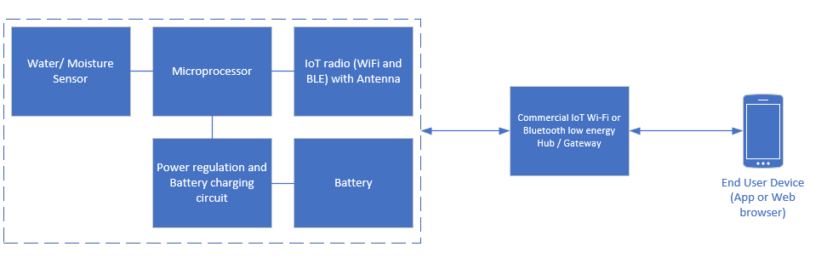
Figure 1 illustrates the main internal components of the sensor as well as the connection to the commercial IoT hub and the end user device

Possible components and alternatives
The following table identifies possible main components and costs associated with the design, and an alternative if the primary selection is not available or in the electronics design find that the primary component is not available.
Table 3 Possible Components and Alternatives
Component | Name and price | Alternative
Water Sensor | Adafruit Industries LLC 4965 - £1.72 Each [4] | Custom design – Extra 7-day electrical RDE
Microprocessor | ESP32-C5NF4 - £3.14 Each [5] | STM32WBA52CEU6 – £3.41 Each [6]
Power regulator | Texas Instruments BQ25620 - £1.07 Each [7] | Monolithic Power MP2663 - £1.59 [8]
Radio/connectivity | Built in with - £0.00  ESP32-C5NF4 | Built in with STM32WBA52CEU6 - £0.00
Battey | LP502540 3.7V 500mAh - £1.11 each | LP503035 3.7V 500mAh - £1.16 Each
Passive components | 20 Resistors, 30 capacitors, inductors – estimate £1.00 per board. | N/A
PCB | PCB printing and assembly for 2-layer 50mm x 50mm - £1.43 each | PCB printing and assembly for 4-layer 50mm x 50mm - £3.55 each

Estimate component cost per unit of £9.47 with consideration to price reduction due to large quantity ordering.

Work Packages Breakdown

Work Package 1 – Project Management
This work package encompasses management activities that support work packages 2–5, including aspects such as planning, resource identification, workshops and meetings, compliance with regulations and standards, and stakeholder engagement. Additionally, this work package establishes and maintains quality standards throughout the project.

Work package 2 - Electronics
This involves circuit and schematic design, PCB design, prototyping, firmware programming, and small-scale production, in collaboration with an external manufacturing house.
Physical resources required:
- Computer-aided design software and computer
- Electronics tools and equipment
- Solder station
Estimated cost/budget: £500 as most resources are already owned.
Possible contracts:
PCB manufacturing contract – estimated cost is £1000, therefore below the tender threshold so single source justification is applicable.

Work package 3 – Mechanical
Creating the mechanical IP67 or better enclosure to house the electronics and battery, creating a mounting/placement system for easy deployment by the user, prototype enclosures and space models for demonstration. Small-scale manufacturing test with an external company for a set of enclosures
Physical resources required:
- Computer-aided design software and computer
- Mechanical hand tools and equipment
- Workshop environment
- 3D printer and supplies
Estimated cost/budget: £500, as most resources are already owned.
Possible contracts:
PCB manufacturing contract – estimated cost is £1200, therefore below the tender threshold so single source justification is applicable.

Work package 4 – Software
Creating a web app for Android and a browser version, this will likely utilise a framework like Expo with React to provide setup functionality and alerts. Using a web app framework instead of fully designing it allows for a reduction in development time, and therefore, a cost reduction.

Physical resources required:
- Computer and development server
- Commercially available IoT hubs

Work package 5 – Testing and assurance
This activity covers the testing of the electronics, mechanical, and software aspects individually, as well as CE certification from a third-party test house. At the end of each testing phase, there is a feedback opportunity for the technical reviewer, principal engineer, and project manager.
Physical Resources required:
- Testing equipment
- Test lab/workshop

Closing
Allocated resources to close the project, allowing for contractual closure and recommendation of feature work if the project was deemed to be valued by the stakeholders.

Gantt Chart
Most activities within WP2 can run in parallel to WP3 and WP4 due to the use of different personnel and resources within the project, which reduces the estimated finish time of the project.
Figure 2 shows the summary timeline of the work packages
Figure 2 Work Package Summary Timeline
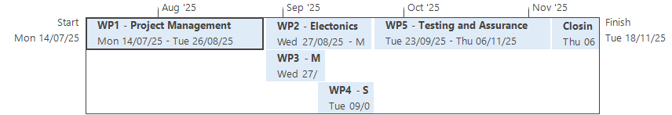
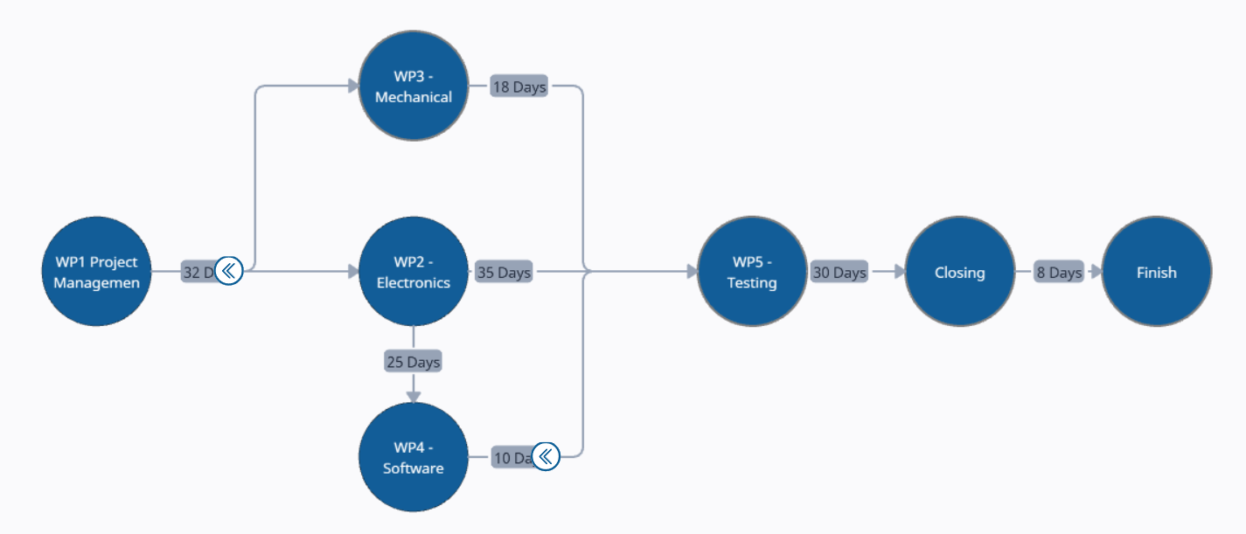
The following Gantt chart shows the project in Microsoft Project, resources are allocated to each task as are displayed by the resources’ initial right of the ‘bar’ . Table 4 on page 11 is a resource key which will aid in identifying the resources in the Gantt chart.
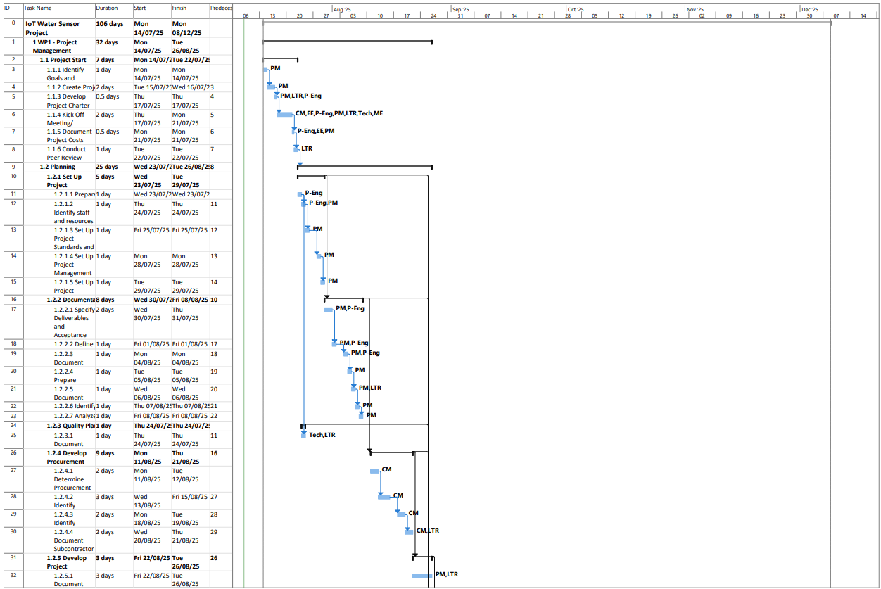
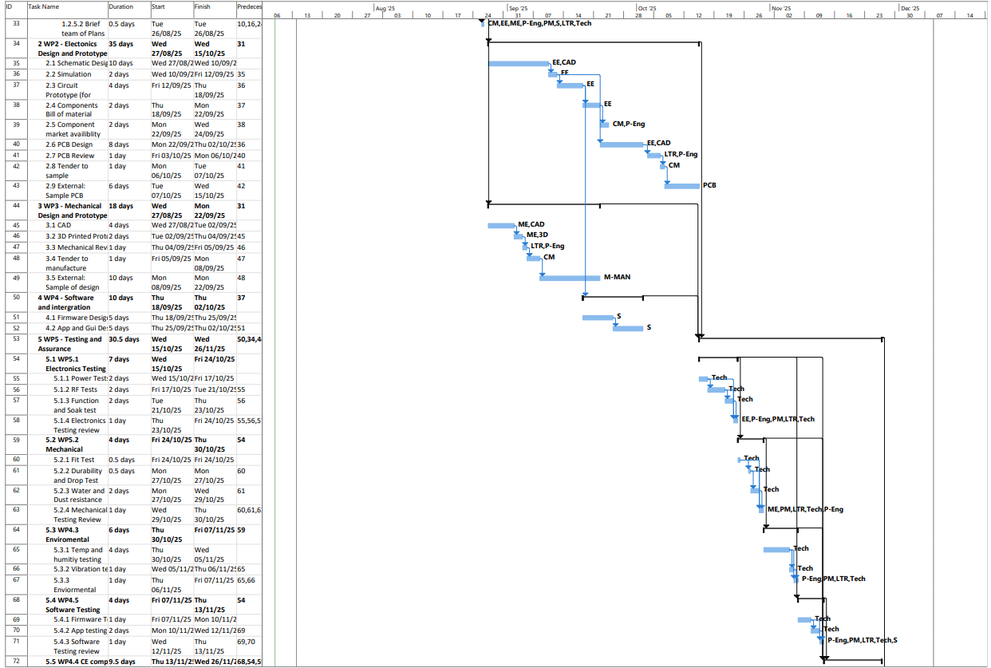
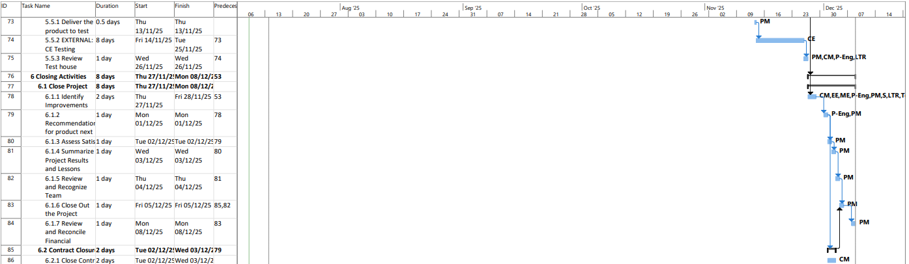
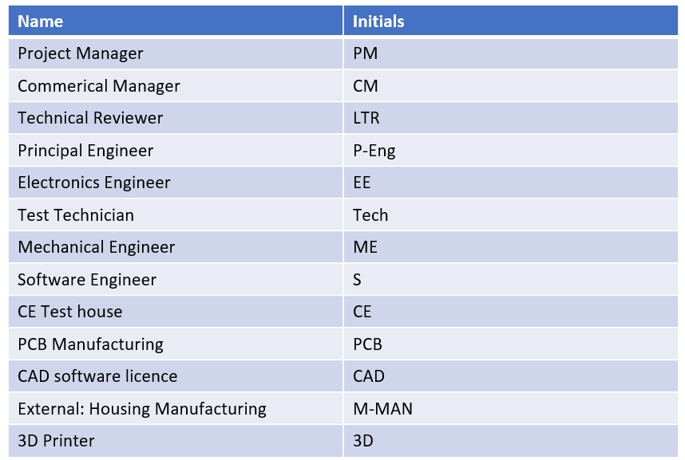
Table 4 Resource Key

Cost breakdown
The exact cost breakdown is shown in the following tables. This is a generated report from Microsoft Project, which will allow tracking the use of resources once the project progresses.
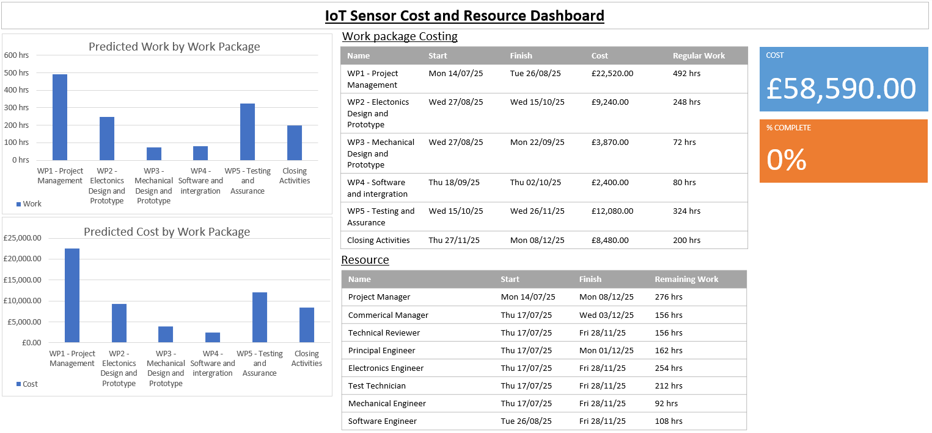
Table 5 Cost Breakdown Dashboard

Nonrecurring engineering cost (NRE)
This is based on the £58590 estimate to design the project, not including a 10% tolerance/overrun fund that may be required.
Table 6 Non-recurring Engineering Cost
Quantity | NRE per Item
10000 | £5.859
50000 | £1.1718
100000 | £0.5859

Personal resource, description and responsibilities
Project manager – responsible for the overall delivery of the project. This includes tracking progress, finances, and all aspects identified as priorities to stakeholders.
Commercial manager – responsible for selecting suppliers and managing the contact relationships. Responsible for assessing tenders (if applicable) with technical advice from the principal engineer.
Principal Engineer – A senior-level technical expert responsible for advising and guiding the direction of the project. It is key to creating the ideas behind the project.
Technical reviewer – A senior-level Technical expert who is independent of the decisions and direction of the project. Is responsible for ensuring quality and that the requirements have been met.
Electronics engineer – a technical expert with a sound background and knowledge in circuits, PCB design, and embedded firmware. Responsible for the design of the circuit and electronics.
Mechanical engineer – a technical role with knowledge in the robust construction of mechanical enclosures for commercial use.
Test technical – technical role responsible for conducting predefined tests on all aspects of the design to report any failures or shortcomings in the design, which could lead to a failure of the sensor.

Risks and mitigation
Risk | Impact | Likelihood | Consequence | Overall | Mitigation
Personal unavailable to complete tasks in time | Delay, cost overrun, missed milestones | Medium | Low | Low-Medium | All activities are planned and started as early as possible, with work in parallel where possible
Material Budget Overrun | Cost overrun, reduction in scope | Medium | Low | Low-Medium | Additional finance tolerance given to materials.
Regulatory Non-Compliance | Fine, Liability | Low | Medium | Low-Medium | Regulations identified as part of WP1, any noncompliance identified as part of the expensive tests in WP5
Safety Risks | Injury, liability | Medium | High | High-Medium | All work must comply with applicable laws, regulations, and local safety mitigation measures. All workers are aware of the safety plan outlined in section 2.11
Design Flaws or Errors | Delay, cost overrun | Low | Low | Low | Design reviews and feedback meetings as part of WP2-4. As well as testing WP5.
Scope Creep | Delay, cost overrun | Low | Low | Low | Adhere to clearly defined requirements and specifications, with an independent overview from a technical reviewer.
Unable to meet specifications/ requirements | Customer dissatisfaction | Medium | Medium | Medium | Technical feasibility was established as part of WP1, and the principal engineer and technical reviewer will conduct an ongoing review as part of the review and quality process.
Interoperability challenges | Disatisfaction | Medium | Medium | Medium | Designed to use common industrial standards and robust testing
Data security and privacy | Liability, reputational damage | Low | High | Medium | Extra testing is given in WP5 to ensure the design meets industrial standards.
Robustness to the environment over time | Customer dissatisfaction | High | Medium | High-Medium | Tested extensively in WP5, and robustness is considered part of the design.

Safety
No activities in the design, development or manufacture of the sensor will involve any activities which may be reasonably considered dangerous or unsafe. All work must follow the relevant law and regulations, including but not limited to;
- Health and Safety at Work etc Act 1974
- COSHH (Control of Substances Hazardous to Health) 2002
- ISO9001
- British standards
- IEC 61010
Under the Health and Safety at Work etc Act 1974 the employer has a responsibility to ensure that the environment is safe.
Delegated safety responsibility:
As part of WP1, the principal engineer is responsible for ensuring safe work facilities and identifying suitably trained personnel to complete the work.
As part of WP2-5, the use of third-party contractors to enable manufacturing and testing is delegated to the commercial manager. As part of this work, the commercial manager will ensure that the contractors used comply with all relevant UK legislation and adhere to all applicable regulations and standards.

Environmental and societal impact
Environmental – materials used in the development are likely to have a minimal overall impact; however, any materials used that are not sustainable or recyclable should be minimised or replaced with alternatives.
The design should, as per requirements, incorporate environmentally friendly materials which are recyclable for the product's end of life.
The PCB must comply with the Restriction of Hazardous Substances (RoHS) and contain no hazardous substances to health or the environment.
Societal impact – the design of the product will use internal labour but will also employ businesses to carry out manufacturing and certification testing. If the product is commercially manufactured, there will be additional job opportunities and local business support to facilitate materials, education and trade.

Ethical impact
The ethical impact of the sensor's design is minimal. All regulations must be followed, and where applicable, industrial best practices should also be adhered to.
The full life cycle of the product will be considered at the design stage to ensure that materials used can be safely disposed of or recycled.
Where there is a possibility for personal data of users to be stored on or through the device, these will apply in accordance with the relevant data protection regulations and the GDPR. Breach of personal data will be handled in accordance with the law and thoroughly investigated; those affected will be notified immediately.

References

[1] | Association for Project Management, Association for Project Managenent (APM) Body of Knowledge, 7th Edition ed., Association for Project Management, 2022.
[2] | European Union, “EUR-Lex - Directive (EU) 2022/2380 of the European Parliament and of the Council of 23 November 2022,” [Online]. Available: https://eur-lex.europa.eu/eli/dir/2022/2380/oj/eng. [Accessed 11 July 2025].
[3] | International Electrotechnical Commission, “IP Ratings,” [Online]. Available: https://www.iec.ch/ip-ratings. [Accessed 10 July 2025].
[4] | DigiKey, [Online]. Available: https://www.digikey.co.uk/en/products/detail/adafruit-industries-llc/4965/14302510?srsltid=AfmBOoptX_QOGa_9jPjY01uOodoT4YIOt8xtguqJsctlUUBqE4InV9vh. [Accessed 10 July 2025].
[5] | Espressif, “ESP-32 SOC Product Range,” [Online]. Available: https://www.espressif.com/en/products/socs. [Accessed 10 July 2025].
[6] | DigiKey, “STM32WBA 32-Bit MCU Wireless Series,” [Online]. Available: https://www.digikey.co.uk/en/product-highlight/s/stmicroelectronics/stm32wba-32-bit-mcu-wireless-series. [Accessed 10 July 2025].
[7] | Texas Instruments, “BQ25620,” [Online]. Available: https://www.ti.com/product/BQ25620#order-quality. [Accessed 10 July 2025].
[8] | Monolithic Power , “MP2663,” [Online]. Available: https://www.monolithicpower.com/en/products/battery-management/chargers/1-series-cell-chargers/mp2663.html. [Accessed 10 July 2025].

Appendices

Prevent


Equality and Diversity


