

LOCATION: Swansea | LLEOLIAD: abertawe
LEVEL 6 | LEFEL 6
EXAMINATION PERIOD | CYFNOD ARHOLIADAU
may 2022 | mai 2022

MODULE CODE: ACHA6012
AUTOMOTIVE MATERIALS AND SUSTAINABILITY

TIME: 2 HOURS

answer all of section A

answer TWO out of THREE in section B

Equipment or materials required – None
Adnoddau neu ddefnyddiau sydd eu hangen - Dim

SECTION A

ANSWER ALL QUESTIONS IN SECTION A

- It is proposed that in 2025 the Euro vii emissions standards will be release and that they are likely to be even more stringent that the current road vehicle emissions standards.

Given that some road vehicles already struggle to meet present legislation, critically review 2 possible alternative types of fuel, using case studies to illustrate points with specific attention to:
- How these fuels might help to meet this new set of regulations, [5 marks]
- How they might impact on the end user in terms of practicalities, and [[8 marks]
- What developments and infrastructure needs to be in place in order for these fuels to be environmentally and economically successful. [12 marks]

SECTION B
ANSWER TWO OUT OF THREE QUESTIONS IN SECTION B

QUESTION 2

- Explain the differences between ionic bonding, covalent bonding and metallic bonding? State what is meant by the valency of an atom.
[10 marks]

- Atoms can be arranged in either body-centred cubic, face-centred cubic or hexagonal close packed arrangements within a material structure. If you consider a unit cell of Copper, which has a total of 4 atoms per unit cell. Using the correct equation from the equation list at the end of the exam paper, calculate the atomic radius, R, of copper, if the a = 0.362nm.

[3 marks]

- Within the crystalline structure of a material there are 3 main groups of defects; points, line and area. Explain the different types of defects that are covered by these areas and identify the effect they have on the crystalline structure.
[10 marks]

- Creep can be a major issue in engine components and it has 3 clear stages. Identify and explain the creep failure mechanism that is controls the speed of creep in the secondary phase.

[2 marks]

QUESTION 3

- Analyse 3 major manufacturing process within the automotive industry, the suitability for a range of materials and the limitations of the processes.

[6 marks]

- When designing components it is important that Failure Mode Effect Analysis (FMEA) is considered and a Risk Priority Number (RPN) is calculated. Identify the 3 stages of FMEA that are used to determine the RPN and explain how they are calculated.
[6 marks]

- When there are geometric features within a component, the stress concentration factor can have a significant impact on the stress value around the feature.
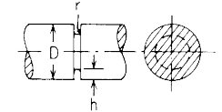
Figure 1 – U notch in a circular shaft

Figure 1, shows a circular shaft with a U-shaped notch in it. The shaft has a diameter of 10mm, notch height of 1.Emm (where E is the 5th digit of your student number) and a notch radius of 0.5mm. The shaft is under bending and has a bending force of 55Pa applied to it. Using the ‘Roark’s Equation for Stress and Strain’ information given in the formula sheet calculate;

  - Calculate the value for the stress concentration factor K_{t} when loaded in bending
[5 marks]
  - With this stress concentration factor, calculate the peak stress experienced in the component
[2 marks]

- Sometimes materials will develop cracks and it is important to know a materials resistance to brittle fracture when a crack is present. A sheet of steel has been provided with a 3.Emm (where E is the 5th digit of your student number) central crack through the thickness. A stress of 625 MPa is reached on the point of fast fracture toughness for the sheet. If the Young’s Modulus of the steel is 200GPa, what is it’s toughness G_{c}?
[6 marks]
QUESTION 4

- Aluminium and Steel are produced in a range of grades and are identified by a number code.
  - In the case of the Aluminium 7XXX series group, state what is the main alloying element in this aluminium and critically evaluate the benefits and limitations caused by this element.
[3 marks]

  - In case of Steel 1045, identify what the first, third and fourth digit of the grades tells the user.
[2 marks]

- Composites can be broken down into three classification groups. Critically analyse how these three classifications differ in terms of their structure, material properties and uses.
[14 marks]

- A fibre reinforced composite is being loaded in the longitudinal direction, using the data supplied below, calculate the force on the fibre and matrix elements when a stress of 30MPa is applied evenly across the cross section
[6 marks]

Variable | Value
Volume of Fibre | 0.45
Modulus of Elasticity Fibre | 65 GPa
Modulus of Elasticity Matrix | 3.2 GPa
Cross section Area | 300mm²

Formula Sheet

Composites
$$E_{c}A_{c}= E_{m}A_{m}+ E_{f}A_{f}$$

$$\frac{F_{f}}{F_{m}}= \frac{E_{f}V_{f}}{E_{m}V_{m}}$$

$$F_{c}= F_{f}+ F_{m}$$

Crystalline Structure

Body Centred Cubic Dimension
$$a=\frac{4R}{\sqrt{3}}$$
Face Centred Cubic Dimension
$$a=2\sqrt{2}R$$

Fracture Toughness
$$K= σ\sqrt{πa}$$

$$K_{c}=\sqrt{G_{c}E}$$

Formula sheet continues on the next page

Stress Concentration

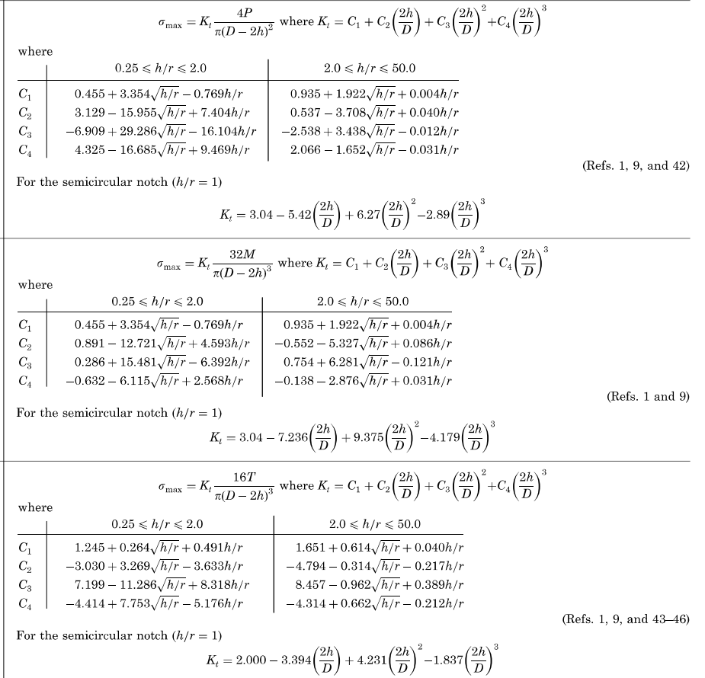
Torsion
Bending
Axial Tension

Diwedd/End

