BRAC Construction
Unit 4, Cathedral Way, SA12 6ST
01639 888226
Enquiries@BRACconstruction.live.co.uk
BRACConstruct.co.uk

Swansea Council
Swansea Civic Centre
New Developments
SA1 3GB

Dear Recipient,
As lead consultant for the new development of Ysgol Bae Abertawe, I wanted to take the time to contact you with our draft BIM Execution Plan (BEP) for the project and explain our understanding of the requirements for the BIM level 2 and detail how the information will be shared and managed through the appropriate standards.
Building Information Modelling can be wrongly described as a piece of software. It is a process of a shared digital representation of a built asset to facilitate design, construction, and operation processes to form a reliable basis for decisions (ISO 19650:2019).
Our design team understands how important BIM Level 2 is to collaborative working and is a major part of sharing information, data, processes and prevents errors occurring through mis interpretation and loss of data by sharing multiple files. BIM also is becoming a much-improved way of continuing future improvements and management of the asset which can be utilized by the client in the future years.
The purpose of this BIM Execution Plan (BEP) is to clearly define the actions required of each member of the project team to successfully deliver the BIM process on the Ysgol Bae Abertawe project.

The BEP gives the project the information required for the pre contract requirements at a strategic level that are defined by PAS1192-2:2013 – (specification from the information management for the capital/delivery phase of the construction projects using BIM), and at the technical level for the needs defined by PAS 1192-2:2013.

The requirements for BIM at a strategic level for the methods for the delivery of the project through BIM. It will also deliver the technical levels required for the project to be delivered through the building information modelling.

The BEP will ensure that the client (Swansea Council) and all other parties involved will be aware of all the accountabilities of each of the phases throughout the project, this will include design, construction, costs, and all aspects of the development throughout its life-cycle.

Please find attached the BEP, following approval the document will be implemented and can all be transferred through the CDE (Common data environment). We trust this will be sufficient information and if you have any queries please do not hesitate to contact.

Warm regards,
Brett Thomas
Lead Consultant
BRAC Construction

BRAC Construction
BIM Execution Plan

Document Ref - 5010_BRAC_XX_XX_BEP_LC_0001_BEP_A
Revision 1

BIM Execution Plan (BEP)
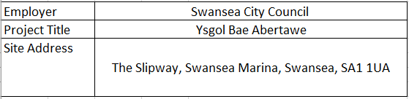

Abbreviations
The list below includes all common BIM related abbreviations, for a more wide-ranging list please
consult the Lead Consultant.

BCF BIM Collaboration Format
BEP BIM Execution Plan
BIM Building Information Modelling
BCM BIM Coordination Meeting
CDE Common Data Environment (e.g. Viewpoint)
IFC Industry Foundation Classes
TK Toolkit
PAS Publicly Available Specification
SMP Standard Methods and Procedures
WIP Work in Progress

Contents
Abbreviations 2
1. Project Information 4
1.1 Project BIM Objectives 4
1.2 Applicable Standards 5
2. Management 5
3. Planning, Documentation, Standards and Procedures 8
4. IT Solutions 12
5. References 13

Project Information

Ysgol Bae Abertawe is a new Infant Primary School which has been proposed by Swansea City Council in partnership with the Welsh Government under the 21st Century school’s programme. The school is proposed for a 1 form entry infant school for 90 pupils. Located at The Slipway, Swansea Marina, the proposed scheme will consist of 3 classrooms, ICT suite, Main Hall and Library resource centre. The green field site has some in situ structures which will require removal prior to build.

Project BIM Objectives

Based on the BIM Maturity requirements, BRAC construction has selected a number of key BIM deliverables that is essential in achieving the targets of the construction stages of the project. Employ the Government’s Construction 2025 strategy by reducing:
- The capital and whole life cost of the project
- Project delivery time (inception to completion)
- Waste and environmental impact
- Drive consistency in the approach to project delivery by all contributing parties
- Design freeze at contract close that avoids rework on site
- Design models used to add value throughout the design development and construction phases (e.g. stakeholder and community engagement) to enable better decision making
- To deliver an integrated and collaborative workflow
- Multi-disciplinary design coordination using 3D BIM models
- Clash avoidance
- Avoid spatial conflicts between disciplines using 3D BIM models developed
progressively, reducing design and construction risks
- Reduce scope gaps – using 3D BIM models to understand and communicate contractors’ scope
- Develop well-coordinated design documents
- All design documents to be derived direct from 3D models
Enhanced project communication and understanding
- 3D BIM visuals to communicate with the client, contractor and other project stakeholders
- 3D BIM visuals to communicate the design intent
- 3D BIM to improve collaboration
- 3D BIM to analyse ‘what if’ scenarios and design optimization
- Health and safety briefings including regular tool box talks and sub contractor briefings.
- Quantification
- 4D Construction sequencing
- Use of 3D BIM models and data for logistics, installations, and construction sequencing

Applicable Standards
The BIM Execution plan is structured with reference to several standards which are listed below. These standards are in place to maintain a consistent approach to the collaboration of information. The BEP requires all team member to adapt to the standards listed.
Standard | Title
BS 1192:2007+A2:2016 | Collaborative production of architectural, engineering and construction information.
PAS 1192-2:2013 | Specification for information management for the delivery phase of construction projects using BIM.
BS 1192-6:2018 | Specification for collaborative sharing and use of structured Health and Safety information using BIM.
CIC BIM Protocol | Standard protocol for use in projects using BIM.
ISO 12006-2 | Uniclass 2015 – Standardised classification system to align to BS1192 documentation. Htto://toolkit.thenbs.com/articles/classification
BIM Forum | Level of Development Specification 2017
Digital Plan of Works | Discipline independent plan of works to align to the BIM process
BS8541-1 | BSI Library objects for architecture, engineering and construction, Part 1:identification and classification - Code of Practice
BS8541-2:2011 | Recommended 2D symbols of building elements for use in BIM
BS8541-3:2012 | Shap and measurement code of practice
BS8451-4:2012 | Attributes for specification and assessment code of practice
BS8451-5:2015 | Assemblies code of practice
BS8451-6:2015 | Product and building declarations code of practice.
BS 8536:2010 | Building management briefing – code of practice.
BS 8587 | Guide to building information management
BS 7000 Series | Design Management Systems
BS 8534:2011 | Construction Procurement Policies
BS10012 | Data protection. Specification for a personal information management system
ISO 8000-150:2011 | Master data: Quality management framework
ISO 16739:2013 | Industry Foundation Classes (IFC) for data sharing in the construction and facility management industries.

Management
Building Information Modelling Role Descriptions
The responsibilities of project participants defined in this section do not reflect any pre-existing,
established job roles. These roles can be fulfilled by multiple individuals and an individual can fulfil
multiple roles. Also, throughout the course of the project the roles may move between different individuals. All parties will engage to work collaboratively to follow the guidance set in this document for benefits of the whole project to be delivered
For all those who hold a design responsibility for the project, their duties will include:
- The production of 3D design modelling with all information for the project and asset with the guidelines set out in this BEP
- Producing 2D drawings taken from the design models
- Constant updates of the BEP and regular feedback on any changes that will be needed for the specific project aspects
- Model uploads to be completed every two weeks to the common data environment
- Make sure attendance of the regular BIM meetings and provide any feedback to the lead consultant/designer

BIM Strategic Lead
Responsible for project strategic direction from tender stage, provides guidance for project set up and gives advice during the project when needed.
This role is responsible from the pre contract tender and is available for advice for the project development from set up and as and when required.
The main duties includes:
- Creation of the Tender document and checklist
- Develops the deliverables as part of the BIM project
- Assists with the completion of the Building Information Modelling Execution Plan.
- Responding to tender responses specific to BIM
- Assessing costs for the BIM application throughout the project.
- Identifies the key challenges for the project
- Takes lead on all BIM meetings
- Attends strategic meetings and offers advice throughout the life cycle of the project.
- Completes feedback and peer review sessions

Project BIM Manager
The BIM manager will oversee ensuring the BIM process has been correctly established and followed by the team during the start of the project.
The main duties include:
- Leads on the kick off meetings making sure that all the team members understand their individual roles and the requirements of them as published I the BEP.
- Develops the pre and post contract BEPs.
- Makes sure that any changes to the BEP are correctly updated throughout the project.
- Implements quality control and compliance to the protocols, model and data management as set out in the BEP.
- Manages the client requirements and advises on the impact to the timetable of the project.
- Agrees all BIM uses for planning and the schedules etc.
- Confirms that the CDE has been created.

Project BIM Coordinator

The BIM coordinator is responsible for the management, and completion during the design stages and manages any clash detection of the model. This is for all project models including consultants and trade contractors.
The main duties include:
- Review of all single discipline models and approve when uploaded to the common data environment.
- Merge the models and complete regular reviews in preparation for meetings and the BEP collaboration and timetables.
- Regularly update the Design manager and the Lead designer with any identified issues and suggest any resolutions of the issue.
- Plan and attend regular design coordination meetings.
- Make sure that the model structures are suitable and available for the extraction of data for the uses of BIM.
- Complete and agree actions on all clash reports which can be issued to the team via CDE on a regular basis.
- Regular feedback and updates to the BIM manager.
- Be the main point of contact for all members of the BIM teams.
- Offer technical assistance to the BIM delivery and design team.

Specialist BIM Coordinator

The duties of the specialist BIM coordinator reflect those of the project coordinator but the duties will be specific to that of the discipline or trade specific models.
The specialist coordinator will be responsible for the checks, reviews, and approval of the information for their specific discipline and organisation.
The main duties include:
- Ensures the integrity of the model and the reliability in compliance with the BEP.
- Makes sure that the models and data are submitted within schedule.
- Complete quality checks before issuing to BRAC Construction.
- The specialist coordinator will complete clash detection when comparing the models from other third parties.
- Confirm all models are completed to the correct standards
- Makes sure the models and the data within the model is suitable for the CDE.
- Liase with the design manager, bim coordinator, and lead deasigner/consultant with any design issues and relevant rectifications/solutions.
- Provide updated “As Built” models.
- Attend the required BIM meetings.

Document Controller
The document controller is the lead for the setup of the Common Data Environment. They also manage the CDE.

Lead Designer
The Lead designer manages all of the design disciplines and coordinates the output for the project.

Planning, Documentation, Standards and Procedures
When planning the information of the model, there should be consideration made for the practicality of the construction. When completing the model data, the model should take into account how the elements are typically constructed, for example the structures of the floor, the span of walls and the levels.
Any changes to the designs will be completed in 3D. The elements of the model shall be created which adhere to the boundaries of the project.
With there being several contributors to the model, each discipline will make sure that:
- All elements of the model will be illustrated on drawings which are from the model data.
- Each contributor will utilise the model to deliver the design.
Each of the contributors will adopt the same systems to ensure an efficient collaborative design. This will be achieved using the same coordinate system.
- The use of the same Project origin will be implemented.
- Will have the correct levels and datum point.
- Ensure that all the measurements in the model follow the correct standard from the below table.

Project Origins
Component | Value
Survey Point | 192364.7N, 265976.9E
Project Level datum (elevation) | 0 Elevation

Project Levels
Floor Level/Orientation | Code | FFL (meters)
Datum - Base Level | 00 | 0
First Floor Level | 01 | 2.5
Second Floor Level | 02 | 4.5

Naming Conventions
All model information project files will adopt a uniformed approach to the convention standards. This will be based on the industry standard BS 1192:2007+A2:2016 – Collaborative production of architectural, engineering and construction information Code of Practice, this will assist in the uniformed workings of the project.
The model files will be consistent throughout the project and will not have any revision numbers as this can add to complications when using the CDE.
Any changes to the structure can only be allowed following prior approval and the required formats and codes can be requested through the design control team.

Naming of Objects Standards

The objects in the model will be named in accordance with BS8541-1:2012 using concise descriptions for all the objects and family types. A list will be provided with company reference. Below is a worked example of the requirements and levels required.

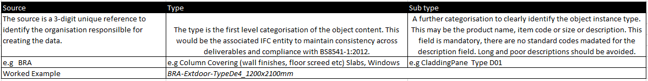
Classification Codes
Metadata is to be applied to objects within the models utilising the following UniClass 2015 (UK) classification system, which can be found at https://toolkit.thenbs.com/.

Uniclass 2015 (UK) is to be used for the following:
- Uniclass 2015 Systems Classification to be embedded into the parametric data for all objects.
- Uniclass 2015 Product Classification to be embedded into the parametric data for all maintainable objects.
- Any object reference on a schedule or schematic or BIM Object shall have the same reference code to enable cross referencing and consistency.

Room and Area naming
The rooms and areas will be generic and taken from the lead consultant’s model. These will also be distributed in advance.
Units and Measurements
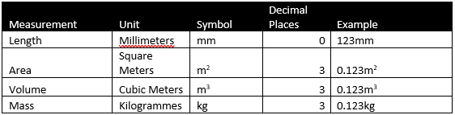

Start up of the model file
The management of the files will be required to the rest of the design team. All files that are published to the model team will require the “Project Name”, “Date of Issue” and any Key changes from the previous model.

CDM Strategy

It is the role of the PC (principal contractor) that the project and BIM deliverables will address the requirements of CDM regulations 2015.
The Design Consultants also to comply with PAS 1192:6 which compliments CDM 2015.

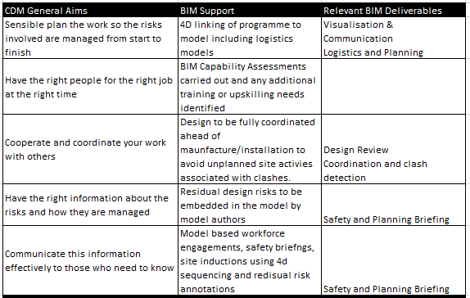
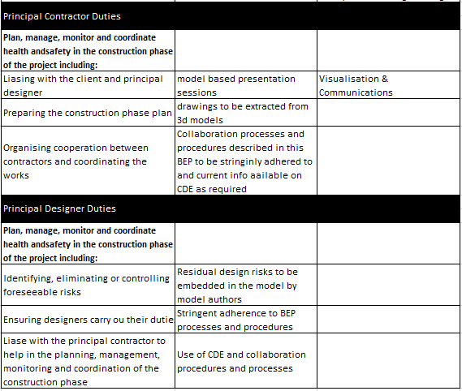

Common Data Environment (CDE)
The Common Data Environment (CDE) is a central location where the project construction information is stored. This approach will allow information for be shared between the many different disciplines which allows the sharing of early information which will hopefully reduce the risk of double handling and duplication.
The CDE for this project will be held on Viewpoint.

There will be 4 main categories to the CDE, These are:

MIP (Model in Progress)
The information should not be shared until approved by the author and the respective BIM coordinator.
SHARED
This can be used by the whole of the project team, this may still require checking by the CDE manager.
PUBLISHED
The model has now been approved by the manager of the CDE, this means it is suitable to use for all aspects and is ready to be used for pre tender contacts.
ARCHIVE
Historical project information which has been archived.

IT Solutions
Depending on the project and/or organisation there can be different versions and different software’s available. To utilise a conformed approach the below table will set out the packages and software to be utilised for this project.

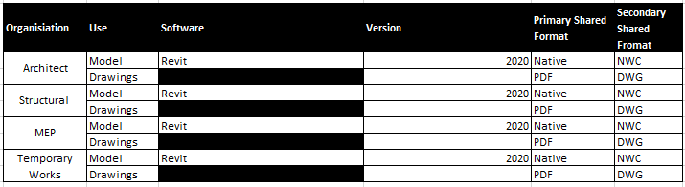

References
Google Docs. 2021. 7001-BBH-XX-XX-SP-Z-0001_BEP.doc. [online] Available at: <https://docs.google.com/document/d/1GyEwzyXayPuRx08ZhdKnC2zsaAKFydiIcPxYn1-z2aE/edit> [Accessed 27 April 2021].
There's no BIM like home. 2021. PLQ2.5 – BEP Revisited. [online] Available at: <https://bimblog.house/2016/10/24/plq2-5-bep-revision/> [Accessed 27 April 2021].
Blog for everyone interested in BIM - Bim Corner. 2021. Creating a successful BIM Execution Plan: Part 1 – Blog for everyone interested in BIM - Bim Corner. [online] Available at: <https://bimcorner.com/creating-a-successful-bim-execution-plan-part-1/> [Accessed 27 April 2021].
McPartland, R. and McPartland, R., 2021. What is a BIM Execution Plan (BEP)?. [online] NBS. Available at: <https://www.thenbs.com/knowledge/what-is-a-bim-execution-plan-bep#:~:text=The%20pre%2Dcontract%20BIM%20Execution,decisions%20need%20to%20be%20made.&text=It%20should%20also%20set%20out,will%20be%20assembled%20and%20delivered.> [Accessed 27 April 2021].
Eadie, R., Browne, M., Odeyinka, H., McKeown, C. and McNiff, S., 2013. BIM implementation throughout the UK construction project lifecycle: An analysis. Automation in Construction, 36, pp.145-151.

