Research report
Student Name: Tomas Gina
Student Number:2120162
Lecture Name: Seyed Nasirpourosgoei
BMSW4003_BIRM
Digital Skills and Research Methods.

Abstract
Microsoft's application software is highly taken into process in the current educational system for gaining significant level of efficiency & effectiveness. The present study is based on assessing impact of Microsoft application software on collaboration within education sector by conducting study on UWTSD. The current investigation has given focus on formulating research question that is helpful in ascertaining the crucial aspects to carry forward the particular research. The study has concentrated on using qualitative research type and thematic analysis so that proper information for accomplishing the objective of ascertaining influence of Microsoft tools on collocation. Ethical consideration by filling consent form, inclusion of references, etc. for making research report reliable and validate. Findings from results and discussion is indicating that there is significant positive impact of Microsoft application software on collaborative working in UWTSD.

TABLE OF CONTENTS
INTRODUCTION 4
RESEARCH METHODOLOGY 4
RESULTS 6
DISCUSSION 8
CONCLUSION 10
REFERENCES 11

To analyse the impact of Microsoft applications software on the collaboration within UK educational sector: A study on UWTSD

INTRODUCTION
Microsoft software are highly taken into consideration for accomplishing the different requirements such gaining the greater productivity via completing task on computer. In the current era, educational practices are highly conducted effectively with using the spreadsheets, data base, PPT, etc. techniques so that achieving the better results can become possible. The current study is based on assessing impact of Microsoft application software on collaboration within educational industry. There are different kinds of the significance which can be derived by application of these tools that involves gaining data retention, flexibility, the latest updates, easy collaboration, less time-consuming procedure, etc. UWTSD is University of Wales Trinity Saint David that is multinational educational institute. The present report will give emphasis on formulating the research questions and methodologies for having the reliable study. This will focus on having results from the conducted research and discussion so that depth evaluation of impact of various tools like words, presentation, etc. on collaboration with other can be estimated. The present study will shed light on gaining the detailed information in turn accomplishing the objective via using qualitative research type and thematic analysis will be conducted.
Aim:
The main aim of the study is to ascertain impact of Microsoft applications software on the collaboration within UWTSD.
Research objectives
- To develop understanding relating to the concept of using Microsoft tool.
- To analyse the different features relating to Microsoft and its collaboration with UWTSD.
- To assess the impact of using Microsoft software on the performance of UWTSD.
- To recommend some improvement with respect to improving the use of Microsoft for enhancing the performance of UWTSD.

RESEARCH METHODOLOGY
Research questions
- What is the impact of using different Microsoft features (MS Team, MS Word, MS PowerPoint, OneDrive) on collaboration with UWTSD?

Research type
there are two types of research type which includes qualitative and quantitative. Qualitative type of search is concerned with assessing the theoretical information for accomplishing objectives and quantitative is based on numerical data collection (Goldstein, 2022). The particular report is based on assessing the impact of Microsoft application on collaboration which is theoretical topic so qualitative study is highly preferable. This can help in accomplishing the predetermined objectives in turn significant study in fair manner can be derived.
Research approach and philosophy
Inductive and deductive are the two approaches which ids in assessing the information about the procedure followed for carrying forward the research interpretivism and positivism are the two philosophies that are related with gaining insights about data collection, analysis and interpreting the data. For the present research inductive approach and interpretivism philosophy is suitable as qualitative study.
Data collection
there are two ways in which the data can be gathered such as primary and secondary. the primary data is related with gaining the information which has not been used previously (Pandey and Pandey, 2021.). In addition to this, secondary sources of information are related with using the data from articles, journals and books that has been already published. For the current investigation the researcher will focus on ascertaining the information from both primary and secondary for getting the detailed understanding accomplishing the objectives. In primary method survey has been conducted by spreading questionnaire and in secondary articles, journals & books has been used
Sampling
its refers to the selection of group of people from the total population in respect to gather the accurate insights. There is different form of techniques for selecting the sampling size which involves probability and non-probability. In the current investigation the scholar has given emphasis on using the simple random technique for selecting 8 teachers of UWTSD. This will helpful in gaining the opinions and views so that relevant information to get the higher effective information so that accomplishing the objectives has become possible (Lambert and Frye, 2018).
Data analysis
There are two techniques which involve SPSS and thematic analysis that are helpful in accomplishing objectives in turn significant processing of research can be conducted (Snyder, 2019.). For the current research, the scholar has given emphasis on using the thematic analysis technique in respect to analyse and interpreted the data in accurate manner. On the basis of this, it can be specified that data has been interpreted in most precise and accurate manner so that accomplishing the objectives has become possible.
Ethical consideration
In order to meet the requirement of the particular research report it is essential for the researcher to give emphasis on having significant practices that can enable to do fair conducting. The crucial actions which are taken by researcher involves having consent form sign so that willingness in participation can be assessed. Inclusion of references for giving credit to the scholars, data are paraphrased for avoiding misconduct and having significant data privacy in the particular procedure. These all the course of actions are ensuring the proper compliance with the ethical requirements in turn reliable & validate report has been formulated.

RESULTS
Theme 1
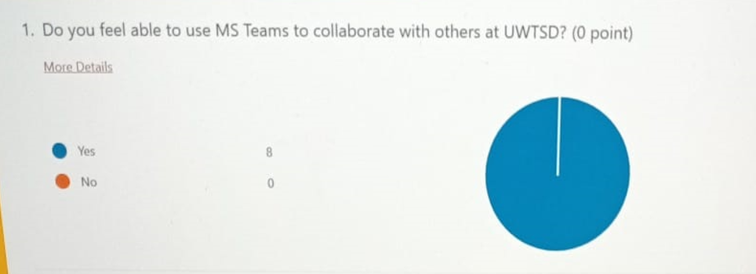
Interpretation- with the help of the primary data gathered from respondent it was analysed that the all the people are efficient to use the MS Teams for collaborating with others at UWTSD. This is particularly because of the reason that currently all people are technology friendly and this improves the working efficiency of the people working in university.
Theme 2
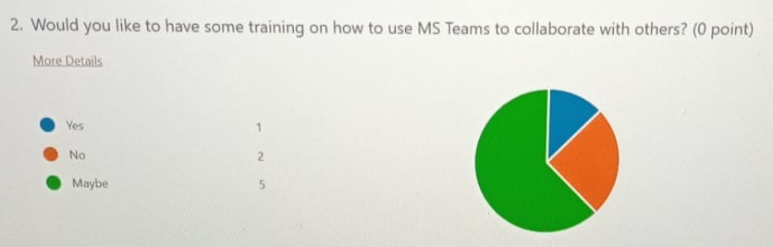
Interpretation- by evaluating the data gathered it was examined that majority of the people stated that maybe they like to have some training on how to use MS Teams. The reason underlying this fact is that many a times there are some changes and this need to be implemented. Hence, for this proper training need to be taken in order to improve the working.
Theme 3
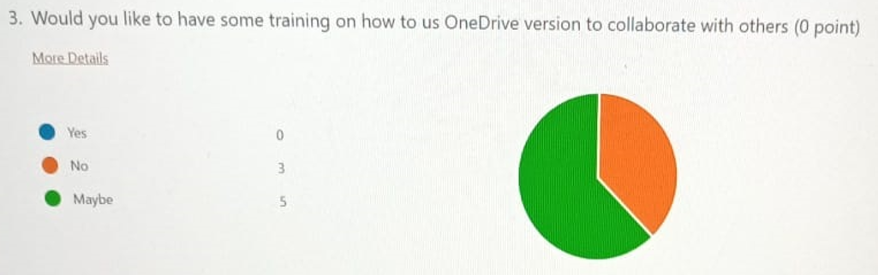
Interpretation- in case of using OneDrive as well it is necessary for the people of UWTSD to have good training as well. In case the training will not be provided then this will be affecting the working efficiency of the employees and it will be affecting the working to a great extent.
Theme 4
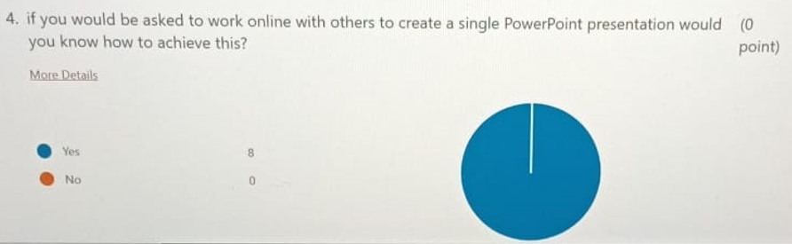
Interpretation- on the analysis it was clear that all the respondent stated that they know that in case they have to work online with others for creating PowerPoint presentation then in that case they know how they can achieve success.
Theme 5
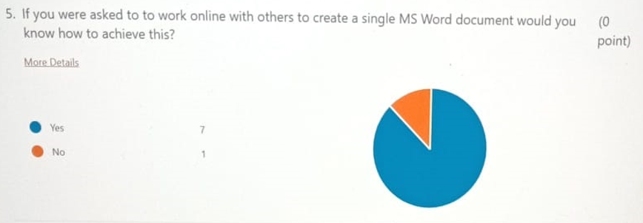
Interpretation- further with the analysis it was analysed that when the people wants to work online on MS Word project the also the know how they can attain success. This is beneficial as it will improve the overall working of university.
Theme 6
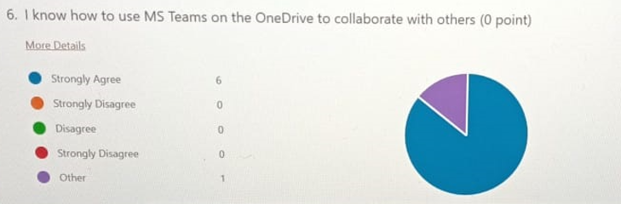
Interpretation- also on the analysis of the data it was also clear that almost all people knew that how to use MS Team on OneDrive and this is good for the university.

DISCUSSION
With the finding it was analysed that most of the people within UWTSD are having proper knowledge relating to the use of Microsoft software within the working. This is essential for the reason that use of Microsoft provides for better working base and also smoothen the working. Hence, this use of software also assists in tutors within the university to improve the working efficiency of the company. this is necessary to be used because it assist the use of technology as this makes the working becomes more simple and easier. Also the use of Microsoft is essential for the reason that it will improve the working efficiency of tutors and other teachers working.
In support of this Venter and Swart (2018) states that use of MS Teams and other MS software features is very important. This is particularly because of the reason that it provides different types of the benefits to the users and because of this the working is improved. The use of MS Teams helps the UWTSD in streamlining the work and this improves the working efficiency and also improves the operational efficiency of the whole university as well (10 Benefits of Microsoft Teams (To Make Life a Whole Lot Better), 2022). also, MS Team help UWTSD in saving the time as when the work is done with help of MS Team then it is more effective and also third party tool is being centralised at one location.
Along with this, the finding also evaluated that when working with others most of the people know that how they can attain success. This is necessary because when a person knows that how to use different features of Microsoft like MS Word, PowerPoint then this can improve the working efficiency of them. Also when the people work in collaboration with others then they might become conscious that whether they know how to use these software and applications or not. In case they will not be knowing how to use these applications then this will be affecting the working efficiency and people will not be working in better manner.
In accordance to the views of Diniya and et.al., (2020) the use of Microsoft is very important as it provides different types of the benefits and also boost productivity of the employees and people working in university. The use of Microsoft is important for the reason that when it is used then it increases the intelligent process automation and this increases new and innovative ideas for development. This is important for the university that they always use the latest tools and software in order to improve the working efficiency of the business. this is necessary for the reason that it improves the knowledge base of the tutors and they will effectively train the students as well for learning the different features of Microsoft.
Along with this it was also evaluated that use of proper training is also necessary in order to improve the working efficiency. The reason underlying this fact is that in this competitive environment there are many different changes and this can affect the working of people in case they do not comply with all these working. Hence, with respect to this, there are also many changes and upgradation being taking place in software as well. Thus, for this UWTSD also need to provide continuous training to the employees so that their efficiency is increased. Also the providing of continuous training ensures that the working is in accordance to the latest trends and this will improve the overall working condition of the university. Hence, it can be stated that the use of different features of Microsoft is assistive in improving the collaborative practices of UWTSD. This is important as the use of this software helps the company and other users in working in better manner and attain the objectives of the business.

CONCLUSION
From the above report it can be concluded that there are different types of Microsoft software such as power point presentation, etc. that assist in gaining the precise ability to accomplish the objectives of conducting practices with maintaining collaboration in working. The current report has given emphasis on having research question formulation so that significant road map for carrying forward the research can be identified. Present study has given emphasis on using qualitative research type, inductive approach, interpretivism philosophy, primary & secondary data collection, simple random sampling technique and thematic analysis for gaining the accurate insights to accomplish the objective of study. In addition to this, discussion of findings obtained from research is indicating that there is positive impact of these specified tools on collaboration in the mentioned industry.

REFERENCES
Books and Journals
Diniya, D. and et.al., 2020. Analysis of Pre-service Science Teachers' Digital Literacy Through Workshop of Optimization Microsoft Office Software Usage. THABIEA: JOURNAL OF NATURAL SCIENCE TEACHING. 3(1). pp.70-78.
Goldstein, S. B., 2022. A systematic review of short-term study abroad research methodology and intercultural competence outcomes. International Journal of Intercultural Relations. 87. pp.26-36.
Pandey, P. and Pandey, M. M., 2021. Research methodology tools and techniques. Bridge Center.
Snyder, H., 2019. Literature review as a research methodology: An overview and guidelines. Journal of business research, 104, pp.333-339.
Venter, M. and Swart, A. J., 2018, April. An integrated model for the continuous use intention of Microsoft Office simulation software. In 2018 IEEE Global Engineering Education Conference (EDUCON) (pp. 320-329). IEEE.
Online
10 Benefits of Microsoft Teams (To Make Life a Whole Lot Better). 2022. [Online]. Available through: < https://www.bemopro.com/cybersecurity-blog/10-benefits-of-microsoft-teams>

