

Contents
I. INTRODUCTION 4
II. INTRUSION DETECTION PLACEMENT 4
III. DETECTION METHODS 4
IV. WHY DO MODERN ORGANISATIONS REQUIRE INTRUSION DETECTION? 5
V. CURRENT CHALLENGES FOR ORGANISATIONS IN OPTIMISING INTRUSION DETECTION 5
A. Requirement of better data sets 5
B. Lack of centralised data sharing 6
C. Internet of Things 6
VI. SOLUTIONS, LIMITATIONS, AND FUTURE RESEARCH 6
VII. Conclusion 7
VIII. Task 2 – Case Scenario 8
IX. References 15

Improving Intrusion Detection – An analysis of the current issues for organisations
Mr Luke Paul Davies
Undergraduate Computing Student
University of Wales Trinity St David
2315714@student.uwtsd.ac.uk

Abstract—This paper seeks to analyse the current difficulties faced by organizations in maintaining a secure IT environment using intrusion detection and prevention technologies. The paper outlines common methods of intrusion detection formats and methods, why intrusion detection is important to the modern organization, the current challenges to intrusion detection and suggested solutions, and concludes by highlighting why intrusion detection is essential for organizations to safeguard their IT infrastructure.
Keywords—IDPS, machine learning, IOT, deep learning, blockchain

INTRODUCTION
A recent UK Government study identified that 50% of UK businesses had successfully identified a cyber-attack in the prior year [1]. In prior years, the survey had sought to explain the low attack identification by suggesting that there is a likely underreporting issue in “less cyber mature organizations” [2].

In contrast to the reporting rate, the survey records how these organizations perceive the importance of cyber security, where in 2024 “three-quarters of businesses (75%) … report that cyber security is a high priority for their senior management” [1].

Given it is unlikely that 50% of the UK companies surveyed have experienced no security incidents, the survey results highlight a gap between the perceived importance of cyber security and its practical implementation. To bridge this gap, better intrusion detection methods need to be implemented in modern organizations to meet managerial expectations on cyber security, which in today’s security environment presents unique challenges for organizations.

This paper will discuss the varied types of intrusion detection systems, associated challenges faced by current intrusion detection models, and outlines why organizations must be aware of these challenges to establish a safe and secure IT environment. The conclusion will provide observations on the best way forward for intrusion detection to be robustly implemented.

INTRUSION DETECTION PLACEMENT
Intrusion Detection and Prevention Systems (“IDPS”) is a system used by an organization to provide internal notification of unintended entry into the organizational systems (the ‘detection’ aspect) and subsequently can take action to halt or prevent the intrusion (the ‘prevention’ aspect).
Whitman and Mattord describe that such systems can react to such threats “without human intervention” [3], including by terminating a user’s session, modifying firewall rules, or quarantining network packet contents [3].

Two primary types of IDPS provide such protection – these can be broadly broken down into network and host based IDPS. Bhati and Rai write that a host based IDPS “monitors traffic… for attack detection” [4] whereas a host-based IDPS “monitor traffic on their specific host machine” [4].

The following diagram displays a typical placement of both types of IDPS within an organizational network:

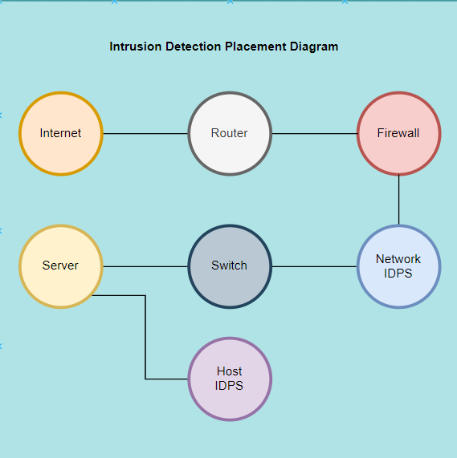
Figure 1 – Intrusion Detection Placement

The difference between the two is therefore a matter of scope – the host IDPS monitors the broader range of incoming network traffic and the host IDPS, with a narrower scope, monitors the integrity of its host system.

In tandem, the two types of IDPS allow for a dual layer of protection for an organization in that both the network and specific devices as hosts are being monitored. The importance of the effectiveness of such systems cannot be understated, especially in industrial settings where, for example, Denial of Service and spoofing attacks may cause physical systems to work improperly, resulting in “unacceptable physical damage” [5] which, naturally, could have serious health and safety consequences.

DETECTION METHODS

The IDPS formats described above detect system anomalies through two primary methods – signature and anomaly-based detection [(6)-(8)]. The diagram below outlines the techniques used by each and in addition highlights Stateful Protocol Analysis techniques:

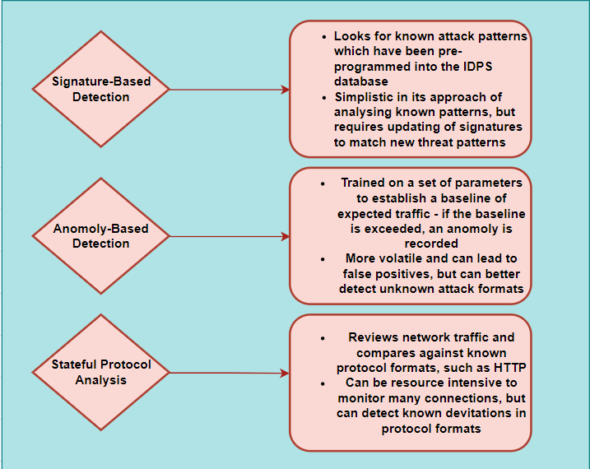
Figure 2 – IDPS Detection techniques

The pros and cons highlighted in the above diagram demonstrate that there is no ‘one size fits all’ method for practical intrusion detection to suit organizational needs.

Clearly a combination of the techniques described is required, which is tailored to each individual organization’s attack surface – for example, Kumar and Sharma propose a hybrid detection system which has the dual benefit of being “easily adaptable to unseen attacks” [8] (i.e. employing anomaly-based practice) and “can take advantage of the knowledge base” [8] (i.e. employing signature detection).

Implementing such systems has revealed positive results, as noted by Agoramoorthy et al [9] who upon analysis of a system combining signature and anomaly techniques note that “the synergy... enables a detection system which is both flexible and resilient” [9].

Clearly, flexibility is important in intrusion detection in order for systems to deal with the array of threats organizations face – but what are these threats?

WHY DO MODERN ORGANISATIONS REQUIRE INTRUSION DETECTION?

Literature about intrusion detection cautions organizations on the imperative of effective detection and prevention. Kumar et al aptly describe that the sophistication of attacks made against organizations is increasing, including ‘double extortion’ in ransomware attacks where compromised data is threatened to be published and is also encrypted [10].

Such sophistication puts a dual layer of pressure on organizations in challenging the attack once it has taken place, increasing the likelihood that demands will be met. Ransomware has been described as “often permanent and difficult to reverse” [11] and so companies must ensure that such attacks do not come to fruition through effective intrusion detection and prevention technology.

Fortunately, ransomware is not considered a major attack method in the latest UK cyber security survey. Phishing is described as the most common type of cybercrime [1] and is described by academics as the “number one attack vector” [12] faced by companies.

Phishing is a form of deceptive social engineering, where attackers create seemingly legitimate links or pathways to malicious programs or encourage users to share sensitive data, which is then used for malicious purposes by the attacker.

The risk to companies inherent in phishing is significant given the attackers prey on the naivety of its less cyber-aware users – Leonov at al succinctly describe that “one of the weakest elements in the protection of any system is its users” [13], and so intrusion detection is but one facet of an effective security system for an organization – clearly, effective training and awareness is also paramount to avoid employees becoming the weakest link’ in an organization’s security chain.

The above demonstrates that organizations should be focused on effective intrusion detection before a threat is carried out, leading to swift prevention, as this will result in threats not reaching the stage where internal systems are compromised.

This should be the core focus of the organization’s Security, Information, and Event Management (“SIEM”) team within its information security department.

CURRENT CHALLENGES FOR ORGANISATIONS IN OPTIMISING INTRUSION DETECTION

Whilst the above highlights the traditional formats of detection and why detection is required, several challenges are present for organizations to overcome to ensure such technologies work as intended.

Requirement of better data sets

When deploying the various types and detection methods of intrusion detection, organizations must ensure that the systems deployed understand the current threat landscape for them to function appropriately.

Rani and Kumar write that the ever-evolving security threats to organizations naturally lead to a requirement for more sophisticated and cutting-edge data sets [14] – the quality of which will ultimately be reflected in the effectiveness of the IDPS used. Given this requirement, there exists a constant requirement of continued programming to update the current datasets of an IDPS in its understanding of new threats, creating a risk to organizations that have not fed the latest threat data into their systems.

The data gap described above has led to research on the benefit of machine and its subset of deep learning [(15) – (19)] in analysing and handling larger and more sophisticated data sets to better inform IDPS of emerging threats.

Abraham and Bindu describe how machine learning algorithms “use pre-categorized training datasets and a variety of algorithms to classify future data sets” [17]. Singh et al conclude in their machine learning study that such algorithms can “detect unknown attacks by learning from normal and malicious behaviour patterns [15].

With regards to deep learning, the creation of neural networks to react to new threats has also shown promise and have been recorded as surpassing the effectiveness of signature and rule-based detection methods in research literature [19].

Lack of centralised data sharing

The implementation of the aforementioned ‘self-learning’ detection methods will, over time, allow cyber security professionals within individual organization to fine-tune these new technologies and optimize their ability to detect new security threats.

This will naturally lead to valuable data insights into the practical effectiveness of deep, machine and artificial intelligence learning models and structures which could be of interest to other organizations.

The sharing of cyber security data is considered a cautious endeavour by many organizations. Various reasons exist for this, including a perception that a competitive advantage is lost in sharing data, alongside liabilities which could arise with sharing sensitive data centrally [20].

Focusing on liabilities in particular, organizations may be concerned that shared data is inaccurate and may be concerned about phasing in such data into their own intrusion detection technology. In order to overcome this concern, research has been conducted on methodologies for more secure data sharing – for example, Hautamäki et al discuss a model implementing a Peer-to-Peer data transmission with differing protection levels for different categories of data [21] which allows inter-transfer of data between organizations in a more secure manner.

A promising option with regards to data sharing to improve IDPS exists in the emergence of blockchain technology ([22]-[23]). Such technology involves the creation of nodes formulating a data network which form a largely ‘immutable ledger’ of information, which can only be modified “after more than half of the nodes agree to it” [22].

As such, data stored on the blockchain can be used to create a “tamper-proof database” which, as noted by Li et al, can be utilized to establish a trusted centralized data network which can then be made available to other interested parties [23].

Internet of Things

A further challenge to optimizing intrusion detection lies in the ever-evolving number of devices now connected to an organizations network. The so-called Internet of Things (“IOT”) ([24]-[26]) refers to various interconnected network devices such as cameras, lighting, or sensor technology.

Whilst such technologies provide a human-based benefit of, for example, automatic reaction to stimuli or automatic environmental changes based on parameters set, they also provide a multitude of routes for attacks to infiltrate an organizational network.

Coupled with such devices having “diverse protocol stacks” [24], a “lack of security standards and guidelines” [25], and “limited computing resources” [26], IOT devices allow attackers to pick and choose pathways of attack into an organization based on the vulnerabilities of each IOT device.
The IOT presents a challenge for organizations in optimizing intrusion detection – how can the traditional IDPS be programmed to detect intrusion through the multitude of routes of attack that the IOT presents?

SOLUTIONS, LIMITATIONS, AND FUTURE RESEARCH
The research outlined above highlights the many configurations available for organizations with regards to intrusion detection. It is clear that the modern organization must combine methods to protect itself from new and emerging threats and should remain close to current research in the field of intrusion detection in order to maintain its security landscape.

It is recognized that there is a strong interplay between the 3 issues highlighted above, insofar as the IOT creates an increased attack surface for organizations, which requires improved data sets to program IDPS (and thus deep and machine learning detection is being developed). Further and as our world becomes more interconnected generally, every organization will wish to benefit from the other’s data gained from implementing these new methods of intrusion detection, as threats to one organization will present threats to all others.

Considering this research there is a promise in how blockchain technology could, in the future, be utilized as a shared resource for publishing immutable data obtained from developing machine, deep and artificial intelligence detection techniques and, as such, better protect organizations from emerging threats, as imaged in the diagram below.

It is recognized that implementing blockchain as a shared data source in this matter would be challenging, given companies’ fear for sharing data as outlined above, and potential regulatory or legal consequences of sharing sensitive data (for example, data protection regulations may not allow for such data to be shared). Further legislative or regulatory change may be required to implement the methods suggested (perhaps to anonymize any personal data stored on the blockchain), but nonetheless the immutability of blockchain technology presents a promising option for sharing data to improve IDPS performance, as highlighted in the diagram below.

Figure 3 – Suggestion to improve data sharing
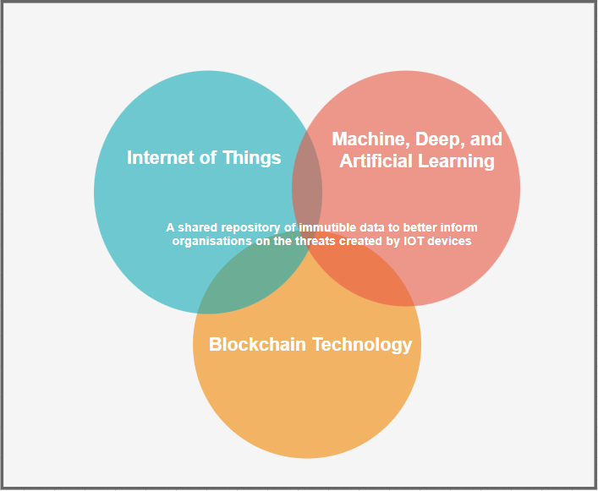

Conclusion
This paper has sought to dissect the common methods of intrusion detection, their limitations, and describe promising future research to expand the benefit of detection for modern organizations.

The paper’s research suggests that signature and anomaly-based detection methods may lack the sophistication needed to detect the sophisticated attack methods being used and, crucially, lacks the self-learning elements of emerging detection technologies developed through deep and machine learning, which now more than ever are required for organizations to keep up with the constantly changing threat landscape posed by the IOT and other such threats.

It is proposed that, to take matters further, companies must share data with each other to remain informed on current threats which they individually face, and in this endeavour blockchain technology stands as a promising method for effectively sharing data. The author seeks to develop a corporate culture where intrusion detection methods meet the expectations of organizational management, thus creating a safer IT environment for organizations going forward.

Task 2 – Case Scenario
Proposal for new Information Security Unit – Drive Happy Insurance

Abstract

This report seeks to advice Drive Happy Insurance (“DHI”), a UK-based motor insurance company, on the approach to be taken in the creation of a new Information Security Unit within the organization. DHI has recently taken on a new portfolio of insurance work from an acquisition of another motor insurance company. Consequently, DHI is now expanding its operations to additional UK sites and plans to expand its insurance offerings multi-nationally. The report will detail the need for a dedicated Information Security function with DHI, including guidance on the function’s structure, implementation, and continued management, with the aim of protecting DHI’s information assets and IT infrastructure.

Introduction

DHI is a motor vehicle insurance company based in Port Talbot, Wales, employing around 100 staff and insuring approximately 80,000 motor vehicles across the United Kingdom. DHI began operation in 2014 and has now secured sufficient funding to take over management of Smooth Drive Insurance, a competitor, which stands to increase DHI’s workforce by 150 staff and its insurance book by 100,000 vehicles nationally. UKI intends to expand its offices nationally and in time globally, with immediate plans to secure office properties in Newport and Cardiff to house additional staff.
The need for additional cyber security measures will now increase for DHI given its plans for office expansion and an increased workforce.

In the UK Governments 2024 cyber security breach survey [1], 74% of large businesses (those with 250 employees) experienced a form of cyber security breach in the last 12 months. This figure is 24% higher than the average of 50% for all UK businesses surveyed. In addition, a recent study of the insurance and financial sector within the UK by Paul Kumpes have revealed that an eight-fold increase has occurred in the cost of data breaches within the UK between 2017 and 2022, with a 5 fold increase in the total number of cyber incidents reported to the FCA in the same period [27].

These statistics demonstrate a clear need for UKI to re-evaluate its cyber security measures in light of its expansion efforts.
To date and whilst UKI employs a dedicated Information Technology team within its organization, the company (and the company it is acquiring) has historically outsourced its cyber security auditing to consultancy firms. This report will outline to UKI that in consideration of its office expansion and increased workforce, the company should now create a dedicated Information Security Unit (“InfoSec”) and house this directly within its new business structure.

The report will then outline how this Unit should create policies or follow industry security standards to dictate best practices for cyber security within UKI, and outline why these are essential to meet UKI’s legal requirements for protecting data. The report will touch on practical implementation of security technologies within the business, and how the new practices implemented should be disseminated amongst staff and reviewed to ensure ongoing compliance.

Corporate Structure

The current corporate structure of DHI’s IT department is outlined in Figure 1 below. The IT department and its various employees presently report to the Chief Information Officer (“CIO”). The CIO’s focus is on maximizing company efficiency through management and improvement of IT processes [28]. The CIO then reports to the CEO of UKI, who is responsible for making high level management decisions and overseeing the company’s vision [29].

Figure 1 – Current Corporate Structure (IT)

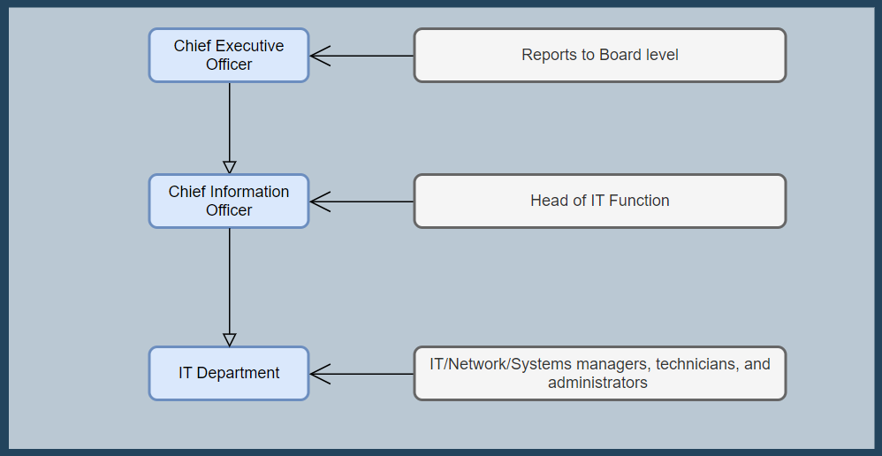

In terms of placing the new cyber security function, this report recommends that DHI amends the above structure by incorporating a new role within its IT hierarchy. A new managerial position of Chief Information Security Officer (“CISO”) should be created, reporting directly into the CIO, with the CISO being responsible for DHI’s new InfoSec department. The CISO will be responsible for “governing risk to enable scalable company operations in a high-risk business territory” [30] which given the studies outlined above will be essential in mitigating cyber security risks against DHI’s expanded organization.

This approach is suggested for several reasons, including the following:

- Separating the IT and InfoSec departments avoids competing aims of efficiency of data movement (IT) versus its security (InfoSec). If InfoSec is housed within IT, its aims could therefore be compromised.
- Separate business audits can occur for the two departments to ensure both can work together effectively; and
- The managerial burden on the CIO is reduced as the CISO holds responsibility for the new InfoSec department.
A proposal for the new structure is outlined in Figure 2 below.

Figure 2 – Proposed Structure for Information Security Department

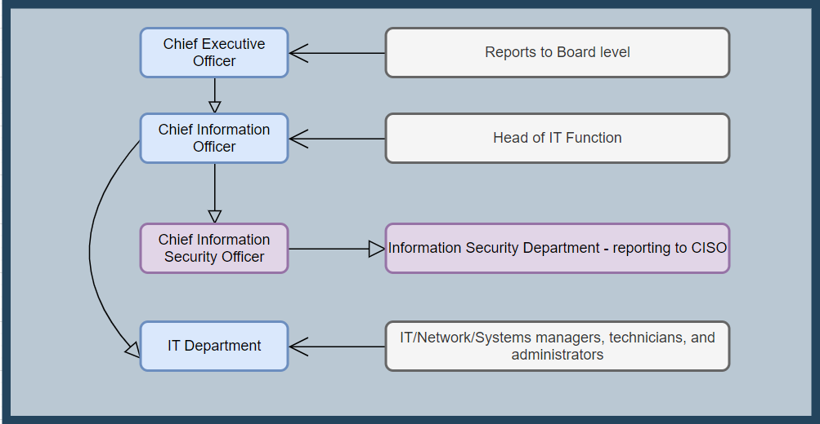

Policies and Procedures

Following creation of the new unit and hiring of new security personnel, this report recommends that a structured process is followed to ensure employees of DHI understand what is expected of them in upholding the companies’ cyber security requirements.

Literature focusing on policy implementation outlines that companies may benefit from creating an overarching control baseline for implementing information security, which can then inform the specific controls implemented [31]. DHI could commence this process by drafting a high-level document outlining the core philosophy of DHI’s security framework. An Enterprise Information Security Policy (“EISP”) would achieve this aim, and could, for example, focus on the corporate need to safeguard customer data obtained through motor insurance business practices.

The EISP can then be used to help inform the companies particular policies for specific areas requiring data security considerations. For example, systems- specific policies may inform end users within DHI as to rights of access to critical and sensitive servers housing customer data within DHI, and issue specific policies may cover topics such as external storage device guidance for company computers.

It is important that DHI ensures that the standards and policies set are drafted with input from interested parties within the organization. To do so, this report advocates a ‘top-down’ approach utilizing a Systems Development Life Cycle (“SDLC”) to involve said parties in the policy drafting and review process. This approach involves management overseeing the implementation of the policy drafting and using the SDLC stages (including investigation and analysis of issues, moving onto design and implementation) to guide the policy creation and implementation process.

A team within the new InfoSec unit could be created with the purpose of managing and overseeing the policy implementation project, with a view of exploring appropriate practices with HR, legal, and various communities of interest (such as end users) through-out the new organization. This approach will have the dual benefit of ensuring a well-rounded policy is created (given input from various communities), whilst also acting as an early litmus test for the organizations attitudes towards new security policy, which will help form the basis of the policies set (for example, budgetary considerations raised).
The below diagram outlines the suggested approach.

Figure 3 – Overview of Policy creation approach

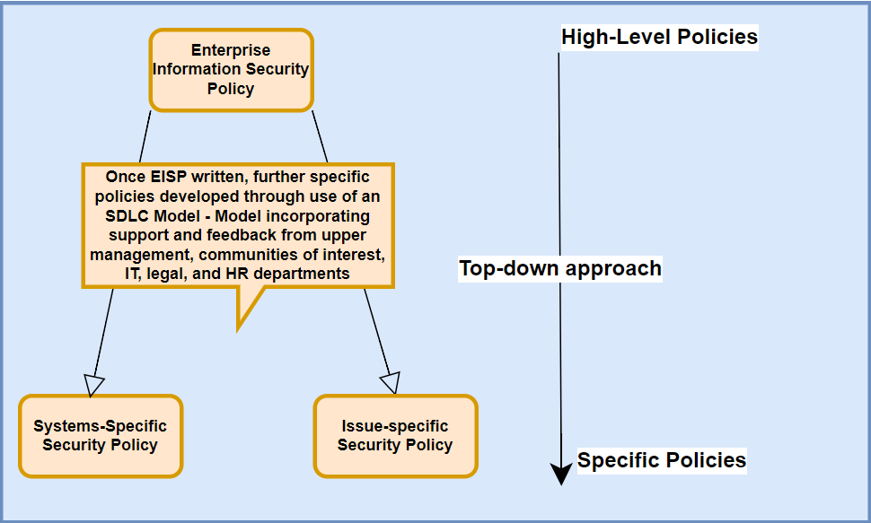

Security Framework

Once policy has been drafted, DHI should focus its attention on translating its policies into a working security framework. Various frameworks exist ([32]-[33]) with the major frameworks being the NIST and ISO formats. Whilst both standards provide organization-wide guidance on implementing a security framework, research suggests that there is no ‘one-size fits all’ approach and best practices should be adopted from each framework as suits the organization in question [34]. As such, this report recommends that DHI purchase the ISO standard and, in conjunction with the freely available NIST standard, devise a framework which suits its particular market and budgetary needs.

Data Protection Compliance considerations

It is important at this stage of this report to remind DHI of its regulatory and legal responsibilities when continuing to expand its operations and in creation of its InfoSec unit.

Given DHI processes customer data as part of its insurance offerings, attention should be drawn to the UK General Data Protection Regulations (UK GDPR) [35] which is implemented in the UK by the Data Protection Act 2018 [36]. The Regulations provide a set of legal obligations to companies in the handling, processing, and transferring of personal data for ‘data subjects’ – these are specified in the Regulation as “natural persons” [35] which would include the customers to which DHI offers motor insurance.

Failure to comply with the provisions of the GDPR – including, for example, failing to ensure adequate security is in place resulting in a breach of personal data – can result in significant fines for DHI. In the first tier and for more minor breaches, DHI may face a fine up to €10 million or 2% of DHI’s annual worldwide turnover. More significant breaches (for example, failing to act on an individual right to erasure) can result in a higher fine of €20 million, or 4% of worldwide annual turnover.

Other relevant regulations for DHI to consider include the Network and Information Systems Regulations 2018 [37]. These Regulations apply to digitally critical UK sectors including digital infrastructure, which could reasonably apply to DHI as an insurance company given their operations are essential for ensuring valid and legal motor insurance within the UK. The Computer Misuse Act 1990 [38] is also relevant to DHI, which prohibits unauthorized access to computer systems and as such can be utilized by DHI in the prosecution of any persons found compromising their systems.

DHI should also be aware of its requirement to comply with regulations set by the Financial Conduct Authority, and that alternative laws/regulations will apply if it expands its operations internationally.

Security Standards – Implementing policy and framework

Once appropriate policies and a security framework has been adopted in line with DHI’s legal and regulatory responsibilities, DHI must turn its focus on implementing the policies and framework set.

This report recommends that DHI instructs members of the InfoSec team to oversee the implementation and dissemination of its policies and frameworks – a Security, Education, Training, and Awareness (“SETA”) program. Academics have outlined that a SETA program is considered one of the most effective strategies for ensuring employees understand security policies [39]. It is recommended that for security principles and standards to be understood by its employees quickly, the SETA program implements the ‘awareness’ portion of the program swiftly, with the other sections flowing from this stage later.
The below diagram outlines the need to create an ‘awareness baseline’ within DHI to ensure, at a minimum, that employees appreciate the security risks associated with their day-to-day roles.

Figure 4 – SETA Program implementation

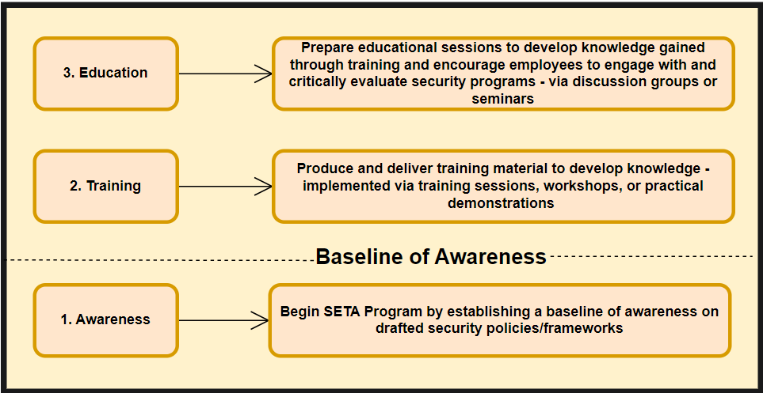

Security Standards – Technology to maintain standards

DHI’s security frameworks should refer to specific technological controls which assist in maintaining its security standards. The InfoSec team will then be responsible for creating a route map for implementing said controls, and this report recommends that a structured project management approach is utilized to do so.

Given that the implementation of controls will ultimately require stratification into digestible steps, this report recommends that a Work Breakdown Structure is utilized by members of the InfoSec team when preparing project plans. For example, DHI will no doubt wish to implement Intrusion Detection Technologies within its business to monitor access to networks and critical systems.

Its project plan should confirm the steps required to reach this goal (e.g. researching an appropriate host-based detection system and seeking approval of purchase from finance) and should outline the cost and likely time required to complete each step of the plan. This report cautions DHI that ‘over-planning’ for projects which may require flexibility, such as where various approval stages are required, may result in an over-stratified plan and should be avoided. Instead, general details can be provided until further information is gathered.

Turning to specific technologies, DHI is advised to ensure projects are prepared to implement the following logical and physical security controls within its business:

- Intrusion detection technology – including host and network-based methods given DHI will offer its services over the internet and house sensitive customer data on its servers. DHI should set up a Security and Event Management (“SIEM”) system to centralize and interpret information obtained from intrusion detection and prevention technology and should operate on a partially distributed control strategy for its systems, which allows for teams of security engineers to identify and review detected threats, and then report these to a central body within the InfoSec department to help detect company-wide attacks. Consideration should also be given to the implementation of alternative intrusion detection methods such as honeypots, port scanners and packet sniffer technology.

- Cryptographic controls – DHI should ensure it has adequate protocols for encrypting data in various states (transit, storage, and processing) – technologies such as multi-factor authentication are recommended for secure logging into systems, and Secure File Transfer Protocols are recommended to ensure larger bundles of data are transferred securely.

- Firewall technology – DHI should ensure it operates suitable firewall technology. DHI may wish to consider implementing Unified Theat Management or Next Generation Firewall technology depending on its budgetary constraints, as these technologies combine many elements of firewall technology such as packet filtering and application later proxies.

- Physical security – DHI should ensure appropriate security ID passes are used by employees and physical access is limited to what is required (for example, non-IT staff members should not have access to data server rooms). Depending on its budgetary constraints, DHI may wish to outsource its security operations for its new offices with the benefit of bringing external expertise but risking a loss of control in hiring its own security staff.
Contingency Planning

Once DHI has drafted policy documents confirming how logical and physical security threats should be managed, its attention must turn to policies and procedures which address its reactions when these threats materialize.

Figure 5 outlines several plans which must be implemented following the fact-finding process of Business Impact Analysis. To meet the needs of DHI in the event of an incident, priority should be given to systems which allow continued contact with customers (e.g. telephony systems and web services) given the nature of DHI’s business.

Figure 5 – Contingency Planning Chart

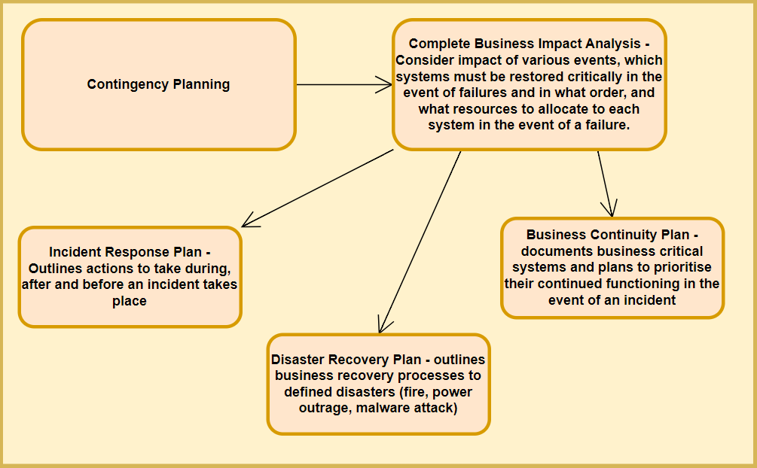

Risk Management

In order to mitigate the realization of threats, DHI must ensure that risk management is developed by the new InfoSec department, and it must draft risk management policies in the stages outlined above.

Various frameworks for risk management exist, including within the ISO and NIST [40] frameworks described earlier, and DHI may wish to consult with similar organizations to discern which approach is best suited for an insurance company. However, this report suggests that any implemented framework covers the following:

- Conducting a risk assessment and identification exercise – this could be completed in conjunction with relevant communities of interest within the organisation, who may be better placed to confirm risks to differing technologies and roles within DHI. Within this assessment, DHI should identify its tolerance to risks or ‘risk appetite’ for all of its assets (technological and persons). Given the sensitive nature of data held by DHI, it is likely the risk appetitive will be minimal for systems housing customer data, considering the GDPR requirements noted in this report.
- Risk analysis – this would involve outlining the potentiality of the risk identified. For example, a risk matrix could be created, and scores allocated to different levels of risk faced by DHI, which will help inform the remainder of the risk assessment process.

- Risk evaluation – Once risks have been charted and categorised in the analysis stage, they can be evaluated in terms of priority. Risks which require action (falling above DHI’s risk appetite) will then need to be assessed in the final stage.

- Risk treatment – Risks falling above risk appetite level must receive some action depending on how DHI wishes to deal with the risk. Various strategies exist including efforts to mitigate risks, share them, or accept them.
See Figure 6 below for an example vulnerabilities assessment which could be completed at identification stage and contains possible solutions (risk treatment). Figure 7 outlines considerations when reviewing risk treatment.

Figure 6 – Example Vulnerabilities Assessment – Telephony System

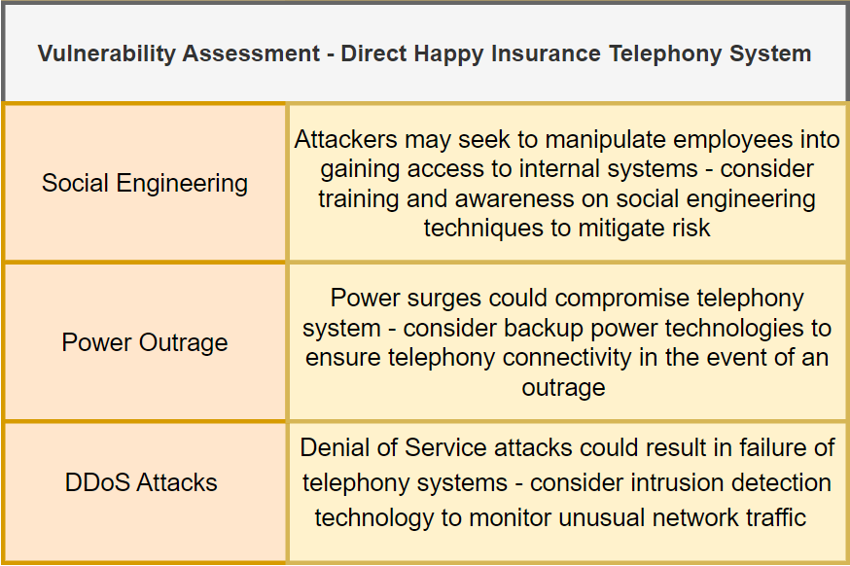

Figure 7 – Risk Treatment and Cost vs Benefit Analysis

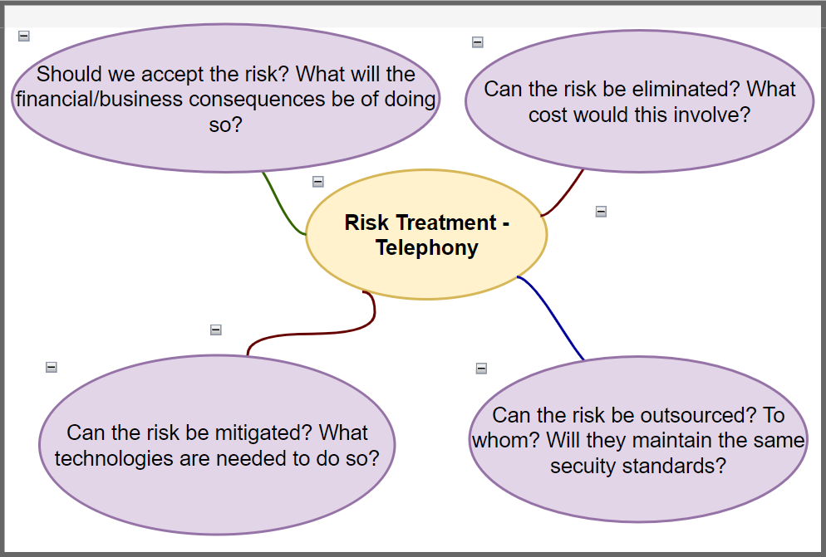

Conclusion

This report seeks to outline to DHI a formulated approach in structuring its new InfoSec Department.

References
[1] Department for Science, Innovation and Technology, “Cyber security breaches survey 2024,” GOV.UK, Apr. 09, 2024. https://www.gov.uk/government/statistics/cyber-security-breaches-survey-2024/cyber-security-breaches-survey-2024

[2] Gov UK, “Cyber Security Breaches Survey 2022,” GOV.UK, Mar. 30, 2022.
https://www.gov.uk/government/statistics/cyber-security-breaches-survey-2022/cyber-security-breaches-survey-2022

[3] M. Whitman and H. Mattord, *Principles of Information Security*, 7th ed. Boston, MA, USA: Cengage Learning, 2022.

[4] B. S. Bhati and C. S. Rai, "A Survey on Intrusion Detection Tools," 2019 6th International Conference on Computing for Sustainable Global Development (INDIACom), New Delhi, India, 2019, pp. 806-810.

[5] Q. Ao, "An Intrusion Detection Method for Industrial Control System against Stealthy Attack," 2020 7th International Conference on Dependable Systems and Their Applications (DSA), Xi'an, China, 2020, pp. 157-161, doi: 10.1109/DSA51864.2020.00028.

[6] I. P. Saputra, E. Utami and A. H. Muhammad, "Comparison of Anomaly Based and Signature Based Methods in Detection of Scanning Vulnerability," 2022 9th International Conference on Electrical Engineering, Computer Science and Informatics (EECSI), Jakarta, Indonesia, 2022, pp. 221-225, doi: 10.23919/EECSI56542.2022.9946485.
[7] D. Usmanbayev, "Improving and Evaluating Methods Network Attack Anomaly Detection," 2021 International Conference on Information Science and Communications Technologies (ICISCT), Tashkent, Uzbekistan, 2021, pp. 1-5, doi: 10.1109/ICISCT52966.2021.9670073.

[8] R. Kumar and D. Sharma, "HyINT: Signature-Anomaly Intrusion Detection System," 2018 9th International Conference on Computing, Communication and Networking Technologies (ICCCNT), Bengaluru, India, 2018, pp. 1-7, doi: 10.1109/ICCCNT.2018.8494088.

[9] M. Agoramoorthy, A. Ali, D. Sujatha, M. R. T. F and G. Ramesh, "An Analysis of Signature-Based Components in Hybrid Intrusion Detection Systems," 2023 Intelligent Computing and Control for Engineering and Business Systems (ICCEBS), Chennai, India, 2023, pp. 1-5, doi: 10.1109/ICCEBS58601.2023.10449209.

[10] R. Kumar and P. K. Pattnaik, Eds., Risk Detection and Cyber Security for the Success of Contemporary Computing, First edition. Hershey, PA: IGI Global Information Science Reference, 2023.

[11] M. M. Jayanthi, A. A. J, K. Vijayakumar and S. P. G, "Detection and Decryption of Ransomware," 2023 2nd International Conference on Applied Artificial Intelligence and Computing (ICAAIC), Salem, India, 2023, pp. 1264-1267, doi: 10.1109/ICAAIC56838.2023.10140747.

[12] S. P. Ripa, F. Islam and M. Arifuzzaman, "The Emergence Threat of Phishing Attack and The Detection Techniques Using Machine Learning Models," 2021 International Conference on Automation, Control and Mechatronics for Industry 4.0 (ACMI), Rajshahi, Bangladesh, 2021, pp. 1-6, doi: 10.1109/ACMI53878.2021.9528204.

[13] P. Y. Leonov, A. V. Vorobyev, A. A. Ezhova, O. S. Kotelyanets, A. K. Zavalishina and N. V. Morozov, "The Main Social Engineering Techniques Aimed at Hacking Information Systems," 2021 Ural Symposium on Biomedical Engineering, Radioelectronics and Information Technology (USBEREIT), Yekaterinburg, Russia, 2021, pp. 0471-0473, doi: 10.1109/USBEREIT51232.2021.9455031.
[14] S. Rani and S. Kumar, "A Comprehensive Analysis of Intrusion Detection Datasets: Evaluation, Challenges, and Insights," 2023 Seventh International Conference on Image Information Processing (ICIIP), Solan, India, 2023, pp. 547-551, doi: 10.1109/ICIIP61524.2023.10537654

[15] A. Singh et al, "Intrusion Detection System: A Comparative Study of Machine Learning-Based IDS," J. Database Manage., vol. 35, (1), pp. 1-25, 2024. Available: https://www.proquest.com/scholarly-journals/intrusion-detection-system-comparative-study/docview/2928165736/se-2. DOI: https://doi.org/10.4018/JDM.338276.

[16] V. Shrivastava and A. K. Chaturvedi, "A Survey on Intrusion Detection System Based on Machine Learning and Deep Learning," 2023 14th International Conference on Computing Communication and Networking Technologies (ICCCNT), Delhi, India, 2023, pp. 1-6, doi: 10.1109/ICCCNT56998.2023.10306615

[17] J. A. Abraham and V. R. Bindu, "Intrusion Detection and Prevention in Networks Using Machine Learning and Deep Learning Approaches: A Review," 2021 International Conference on Advancements in Electrical, Electronics, Communication, Computing and Automation (ICAECA), Coimbatore, India, 2021, pp. 1-4, doi: 10.1109/ICAECA52838.2021.9675595.

[18] B. Li, Y. Wu, J. Song, R. Lu, T. Li and L. Zhao, "DeepFed: Federated Deep Learning for Intrusion Detection in Industrial Cyber–Physical Systems," in IEEE Transactions on Industrial Informatics, vol. 17, no. 8, pp. 5615-5624, Aug. 2021, doi: 10.1109/TII.2020.3023430.

[19] N. S. Musa, N. M. Mirza, S. H. Rafique, A. M. Abdallah and T. Murugan, "Machine Learning and Deep Learning Techniques for Distributed Denial of Service Anomaly Detection in Software Defined Networks—Current Research Solutions," in IEEE Access, vol. 12, pp. 17982-18011, 2024, doi: 10.1109/ACCESS.2024.3360868

[20] A. Zibak and A. Simpson, "Can We Evaluate the Impact of Cyber Security Information Sharing?," 2018 International Conference On Cyber Situational Awareness, Data Analytics And Assessment (Cyber SA), Glasgow, UK, 2018, pp. 1-2, doi: 10.1109/CyberSA.2018.8551462.

[21] J. Hautamäki and T. Kokkonen, "Model for Cyber Security Information Sharing in Healthcare Sector," 2020 International Conference on Electrical, Communication, and Computer Engineering (ICECCE), Istanbul, Turkey, 2020, pp. 1-5, doi: 10.1109/ICECCE49384.2020.9179175.

[22] X. Zhan, H. Yuan and X. Wang, "Research on Block Chain Network Intrusion Detection System," 2019 International Conference on Computer Network, Electronic and Automation (ICCNEA), Xi'an, China, 2019, pp. 191-196, doi: 10.1109/ICCNEA.2019.00045.

[23] W. Li, Y. Wang, and J. Li, “A blockchain-enabled collaborative intrusion detection framework for SDN-assisted cyber-physical systems,” International journal of information security, vol. 22, no. 5, pp. 1219–1230, 2023, doi: 10.1007/s10207-023-00687-x.

[24] D. M. Abdelhameed, A. -R. Hedar, B. M. Elomda and H. Ahmed Hassan, "ML-Based Intrusion Detection Systems in IoT Networks: A Survey," 2023 Eleventh International Conference on Intelligent Computing and Information Systems (ICICIS), Cairo, Egypt, 2023, pp. 283-289, doi: 10.1109/ICICIS58388.2023.10391165.

[25] Z. H. Abdaljabar, O. N. UCAN and K. M. A. Alheeti, "An Efficient Intelligent Intrusion Detection System for Internet of Things," 2021 14th International Conference on Developments in eSystems Engineering (DeSE), Sharjah, United Arab Emirates, 2021, pp. 481-486, doi: 10.1109/DeSE54285.2021.9719551.

[26] F. Pei, Y. Chang and M. Shi, "Intrusion Detection for Internet of things Using Self-supervised Pre-training on GRU," 2022 China Automation Congress (CAC), Xiamen, China, 2022, pp. 5188-5192, doi: 10.1109/CAC57257.2022.10055882.
[27] P. Klumpes, “Coordination of cybersecurity risk management in the U.K. insurance sector,” Geneva papers on risk and insurance. Issues and practice, vol. 48, no. 2, pp. 332–371, 2023, doi: 10.1057/s41288-023-00287-9.

[28] "Role of a CIO: What does a Chief Information Officer do?," Indeed. [Online]. Available: https://www.indeed.com/hire/c/info/role-of-cio. [Accessed: 22-Jul-2024].

[29] "What is a CEO?," Indeed. [Online]. Available: https://uk.indeed.com/career-advice/finding-a-job/what-is-a-ceo. [Accessed: 22-Jul-2024].
[30] " K. Jawaharrani, R. S. Lekshmi, G. Nirmala and K. Dheenadhayalan, "Role of CISO - Cyber Security & Risk Management," 2023 International Conference on Advances in Computing, Communication and Applied Informatics (ACCAI), Chennai, India, 2023, pp. 1-5, doi: 10.1109/ACCAI58221.2023.10200017.

[31] D. J. Blum, Rational cybersecurity for business : the security leaders’ guide to business alignment. Berkeley, CA: Springer Nature, 2020. doi: 10.1007/978-1-4842-5952-8.

[32] ISO, “ISO/IEC 27000:2018(en) Information technology — Security techniques — Information security management systems — Overview and vocabulary,” Iso.org, 2019. https://www.iso.org/obp/ui/#iso:std:iso-iec:27000:ed-5:v1:en

[33] NIST, “The NIST Cybersecurity Framework (CSF) 2.0,” The NIST Cybersecurity Framework (CSF) 2.0, vol. 2.0, no. 29, Feb. 2024, doi: https://doi.org/10.6028/nist.cswp.29.

[34] P. P. Roy, "A High-Level Comparison between the NIST Cyber Security Framework and the ISO 27001 Information Security Standard," 2020 National Conference on Emerging Trends on Sustainable Technology and Engineering Applications (NCETSTEA), Durgapur, India, 2020, pp. 1-3, doi: 10.1109/NCETSTEA48365.2020.9119914.

[35] "Regulation (EU) 2016/679 of the European Parliament and of the Council of 27 April 2016, General Data Protection Regulation (GDPR)," Official Journal of the European Union, Apr. 27, 2016. [Online]. Available: https://eur-lex.europa.eu/eli/reg/2016/679/oj. [Accessed: Jul. 23, 2024].

[36] "Data Protection Act 2018," United Kingdom Public General Acts, 2018. [Online]. Available: https://www.legislation.gov.uk/ukpga/2018/12/contents/enacted. [Accessed: Jul. 23, 2024].

[37] "The Network and Information Systems Regulations 2018," SI 2018/506, 2018. [Online]. Available: https://www.legislation.gov.uk/uksi/2018/506. [Accessed: 22-Jul-2024].

[38] "Computer Misuse Act 1990," c. 18, 1990. [Online]. Available: https://www.legislation.gov.uk/ukpga/1990/18/contents/enacted. [Accessed: 22-Jul-2024].

[39] A. Alyami, D. Sammon, K. Neville, and C. Mahony, “The critical success factors for Security Education, Training and Awareness (SETA) program effectiveness: a lifecycle model,” Information technology & people (West Linn, Or.), vol. 36, no. 8, pp. 94–125, 2023, doi: 10.1108/ITP-07-2022-0515.

[40] NIST, “Risk Management Framework for Information Systems and Organizations,” Risk Management Framework for Information Systems and Organizations, vol. 2, no. Revision 2, Dec. 2018, doi: https://doi.org/10.6028/nist.sp.800-37r2.

