University of Wales Trinity Saint David

Advanced Computational Methods
Module Code: M6X00408

Optimisation of a high speed 3 cylinder using the Ricardo WAVE engine development software

Author Supervisor
Joshua Bass, P146018 Owen Williams

January 27th 2020
Table of Contents
Table of Figures 2
Table of Equations 4
Table Context 4
Introduction 5
Optimisation of the Triumph 675cc engine using Ricardo WAVE 6
Triumph 675cc engine technical information 6
Triumph 675cc engine data 7
Ricardo WAVE model simulation 9
10250 rpm 12
13000 rpm 20
14400 rpm 24
Conclusion and further work 28
Appendix 29
Real data; Wiebe function curve and burn rate percentage for each RPM 29
10,250 rpm 29
13000 rpm 29
14400 rpm 30
Further work calculated in the real Triumph 675cc engine data 31
Intake and exhaust value lift profiles in the Ricardo WAVE model 32
Ricardo WAVE constants table 35
Graphs created for real and simulated data for 10250 rpm 36
Graphs created for real and simulated data for 14400 rpm 38
References 39

Table of Figures
Figure 1: Triumph 675cc technical information 6
Figure 2: Real pressure (bar) vs Crank angle (°) (RPM sites- 10250, 13000 and 14400) 7
Figure 3: Pressure (bar) vs Volume (cc) 8
Figure 4: Ricardo WAVE 1-D engine model of the Triumph 675cc 9
Figure 5: User interface errors in Ricardo WAVE 10
Figure 6: Junction opening errors in the WAVE model 10
Figure 7: First simulation run on Ricardo WAVE for 10250rpm 12
Figure 8: Burn duration (BDUR) value changed from default to 25 13
Figure 9: TBH50 value changed from default to 9 degrees 13
Figure 10: Table in WavePost showing the start of combustion, when 'm' = 7.115 14
Figure 11: Valve timing used for 10250rpm 15
Figure 12: Exhaust valve opening changed from default to 67.08 15
Figure 13: Intake valve opening changed from default to 260 16
Figure 14: Final P-V diagram after initial temperature condition changes for 10250rpm 17
Figure 15: Final pressure (bar) vs Crank angle (°) according to the maximum pressure values 17
Figure 16: logP vs logV at 10250rpm 18
Figure 17: Real and simulated Wiebe & Burn rate (%) vs Crank angle (°) for 10250rpm 18
Figure 18: Brake power (kW) and Indicated power (hp) vs RPM 19
Figure 19: First simulation run on Ricardo WAVE for 13000rpm 20
Figure 20: Constant variables from the run before entering 13000 rpm 20
Figure 21: Burn duration (BDUR) value changed from default to 28 21
Figure 22: TBH50 value changed from default to 10 degrees 21
Figure 23: Final P-V diagram after initial temperature condition changes for 13000rpm 22
Figure 24: Final maximum pressure (bar) vs Crank angle (°) 22
Figure 25: logP vs logV at 13000rpm 23
Figure 26: Real and simulated Wiebe & Burn rate (%) vs Crank angle (°) for 13000rpm 23
Figure 27: First simulation run on Ricardo WAVE for 14400rpm 24
Figure 28: Final P-V diagram after initial temperature condition changes for 14400rpm 25
Figure 29: Final pressure (bar) vs Crank angle (°) according to the maximum pressure values 26
Figure 30: logP vs logV at 14400rpm 26
Figure 31:: Real and simulated Wiebe & Burn rate (%) vs Crank angle (°) for 14400rpm 27
Figure 32: Wiebe and burn rate (%) vs Crank angle (°) @10250rpm 29
Figure 33: Wiebe and burn rate (%) vs Crank angle (°) @13000rpm 29
Figure 34: Wiebe and burn rate (%) vs Crank angle (°) @14400rpm 30
Figure 35: Engine BHP and Power (kW) vs RPM 31
Figure 36: Maximum pressure calculated in Ricardo WAVE in each cylinder 31
Figure 37: Intake ducts changed from default to 30.5mm 32
Figure 38: Exhaust ducts changed from default to 25.5mm 32
Figure 39: Intake valve lift profile 33
Figure 40: Intake valve lift coefficient profile 33
Figure 41: Exhaust valve lift profile 34
Figure 42: Exhaust valve lift coefficient profile 34
Figure 43: Ricardo WAVE constants table used for the Triumph 675cc engine 35
Figure 44: Wiebe 'm' exponent changed from default to '6' 36
Figure 45: Injector value from default changed to 0.068 36
Figure 46: Heat transfer multiplier intake valve opening and closed changed from default 37
Figure 47: Cylinder pressures (bar) vs Crank angle (°) per cycle for 10250 rpm 37
Figure 48: Burn Duration (BDUR) value changed from default to 28 38
Figure 49: TBH50 value changed from default to 9 degrees 38

Table of Equations
Equation 1: Volume in SI units (cc) 8
Equation 2: Woschni Function 11
Equation 3: Wiebe function 11

Table Context
Table 1: Maximum pressure for each RPM provided by the Triumph 675cc engine 8

Introduction
The aim for this study is to use the provided base Ricardo WAVE model of the Triumph 675cc engine and reverse engineer the cylinder pressure data - provided in which RPM sites at 10250, 13000 and 14400, including the information which is required to develop the WAVE model for a more realistic simulation of the engine. Following this, the Triumph 675cc engine delivers a high level of performance, in which at 12,600 rpm the engine outputs 94 kW of power, and at 11,750 rpm the engine outputs 73 Nm of Torque. Using the WAVE model, validate the results calculated showing logical explanation and realistic results in comparison to the information provided by Triumph.
The objective relating to the study above, is to enhance the engine performance characteristics and reflect on the performance output for the Triumph 675cc engine. Using the base Ricardo WAVE model, determine the combustion characteristics for the Triumph 675cc engine from the real data provided, using the information to develop a logical and realistic WAVE model validating results.

Optimisation of the Triumph 675cc engine using Ricardo WAVE

Triumph 675cc engine technical information
Using the technical information provided shown in Figure 1, the results were entered into the WAVE model and MS Excel to validate the real and simulation data.
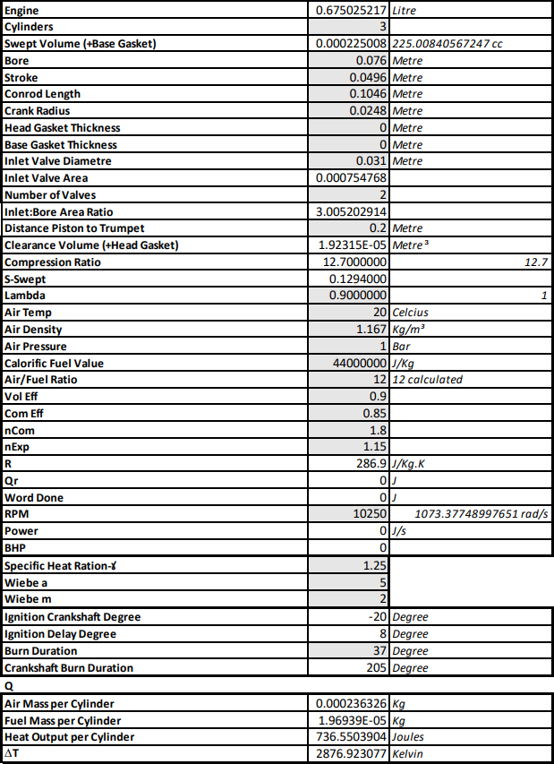

Figure 1: Triumph 675cc technical information

Triumph 675cc engine data
The graph shown in Figure 2, represents the real cylinder pressure data provided for the Triumph 675cc engine. According to the real cylinder pressure data at 10250 and 13000 rpm show the same trends in relation to combustion and expansion. However, 14400 rpm shows from the start of combustion and peak pressure has a greater increase than the other rpm’s due to peak pressure acting earlier on the crank angle.

Figure 2: Real pressure (bar) vs Crank angle (°) (RPM sites- 10250, 13000 and 14400)
Referring to the Appendix, sub-heading; Wiebe and burn rate percentage for each RPM, represents three graphs; Figure 32, Figure 33 and Figure 34, which shows the real data provided by the Triumph 675cc for the Wiebe function curve and burn rate percentage. However, the real burn rate percentage data provided from the Triumph 675cc engine, Figure 33, and Figure 34, are not accurately represented as Figure 32. The graph, Figure 32, shows a smooth burn rate curvature across each crank angle. Furthermore, the real data provided can be compared to the WAVE model later in this study.

From the real data, volume was provided in percentage (%), using Equation 1 will change the following equation back to SI units in cc.
$$=\left(\frac{\left('Swept Volume^{'}*{10}^{6}\right)*Volume \left(\%\right)}{100}\right)+\left('Clearance Volume^{'}*{10}^{6}\right)$$
Equation 1: Volume in SI units (cc)
The graph, Figure 3, represents the pressure (bar) vs volume (cc) for each rpm; 10250, 13000 and 14400.

Figure 3: Pressure (bar) vs Volume (cc)
In this study, using the Triumph 675cc Ricardo WAVE model, represent the maximum pressures shown in Table 1 and analyse and validate the WAVE model.
Table 1: Maximum pressure for each RPM provided by the Triumph 675cc engine
 | 10250 | 13000 | 14400
Max Pressure (bar) | 81.93 | 80.25 | 84.82

Ricardo WAVE model simulation
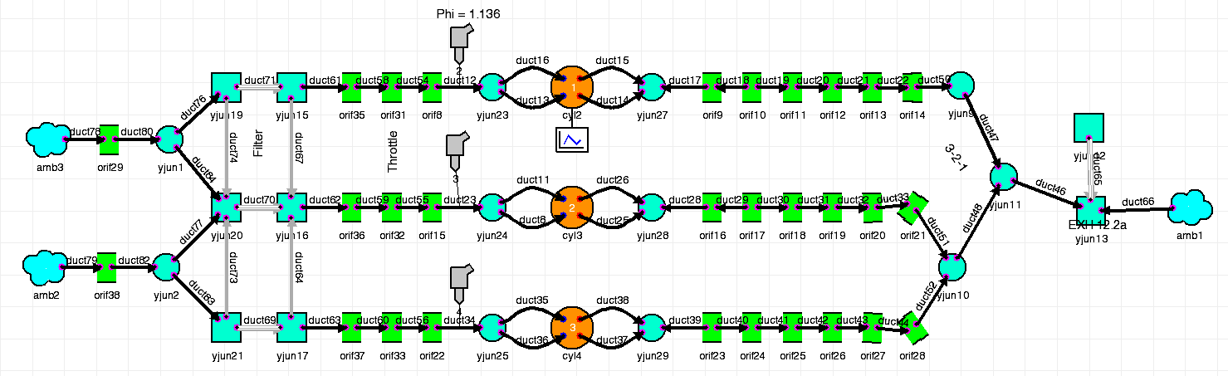
Wave is a standard 1-dimensional engine performance simulation software used in industry worldwide and allows automotive manufacturers to perform engine performance simulation which enables the user to carry out performance simulations for steady-state, in addition for transient simulations related to any intake, combustion and exhaust system configuration, which also includes a drivetrain model to allow complete vehicle simulations, such as the Triumph 675cc being represented in Figure 4 (Gilan, 2012), (Lethwala, et al., 2019).
Figure 4: Ricardo WAVE 1-D engine model of the Triumph 675cc
Firstly, as shown in Figure 4, the WAVE model of the Triumph 675cc engine is loaded. In order to run the model without any changes, the intake and exhaust values need their lift profile, ‘<INT.txt>’, Figure 39, or ‘<EXH.txt>’, Figure 41, and their flow coefficient profiles, ‘<FLOWINT.txt.>’, Figure 40, or ‘<FLOWEXH.txt.>’, Figure 42, where ‘INT’ represents the intake and ‘EXH’ represents the exhaust valves. According to, (Ape Race Parts, 2020), the specifications for the Triumph 675cc engine states the intake diameter equal to 30.5mm and exhaust diameter to equal to 25.5mm; this means changing the default Wave Model, intake valve ducts to 30.5mm shown in, Figure 37, and exhaust valve ducts to 25.5mm shown in, Figure 38. In addition, according to, (Ape Race Parts, 2020), the valve maximum lift is higher in comparision to the Wave model, so a multiplier of lift is calculated and inputted shown in the lift profiles, Figure 39, and Figure 41.
In addition, using the engine parameters required provided from the real data, the Triumph 675cc engine states a compression ratio of 12.7 and a connecting rod length of 104.6mm. However, in the Ricardo WAVE build model, it states a compression ratio of 12.65 and a connecting rod length of 98mm, where these parameters need to be changed to match the real data for the Triumph 675cc engine which have been provided.
Furthermore, the initial ambient pressures, ‘amb3’ and ‘amb2’, shown in Figure 4, need to be changed from 1.065 to 1bar and the intake ducts and junctions need to be applied at 20°C, or 293K. In addition, ‘duct51 and duct52’, have error temperature recordings showing at 900K and 850K, however, need to be changed to 750K.
In the user interface, shown in the WAVE model, Figure 5, shows information errors which are not an issue running the WAVE model. However, these information errors are due to the junction openings not being in the correct position, shown in, Figure 6, which cause these information errors in the user interface.
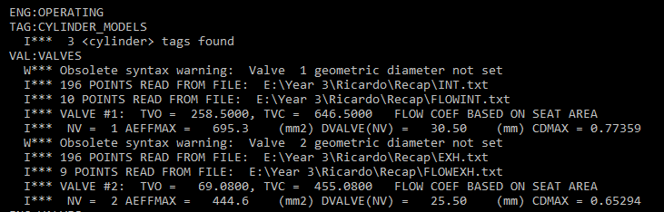

Figure 5: User interface errors in Ricardo WAVE
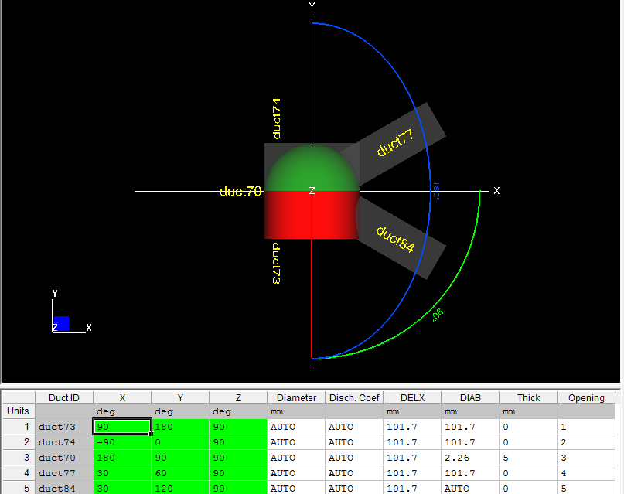

Figure 6: Junction opening errors in the WAVE model
The minimum operating parameters used in Ricardo WAVE, which will allow the simulation run; Inlet and exhaust wall temperatures, engine operating speed, {RPM}, fuel/air ratio, piston head and liner average surface temperatures, ambient conditions and combustion data, (Lethwala, et al., 2019), where these changes have been made for each RPM shown below in each subheading; 10250 rpm, 13000 rpm, 14400 rpm.
As stated above related to intake and exhaust valves; this function can be useful to increase volumetric efficiency of the engine, which increases breathability, where this leads to more torque and power. Adjusting the engine parameters such as valve timing, lift, length and diameter will allow the pressure wave trends in the graphs shown below in each rpm arrive when the exhaust valve closes, this effect is called the inertial ram effect, (Aradhye & Bari, 2017).
There are two physically-based engine sub models in Ricardo WAVE which are used in different aspects, one of which is the Woschni heat transfer model. According to (Caton, 2015), the Woschni heat transfer model in the WAVE model, assess the control with having initial heat flow coefficient and the speed of flow acting on all surfaces of the chamber at each degree on the crank; this model is assumed appropriately precise in this application. The Woschni heat transfer model is based off Nusselt and Reynolds number of the fluids within the system at each degree on the crank in order to calculate the heat transfer coefficients, shown in the equation below, Equation 2, (Sawant, et al., 2018).
$$h={0.0128b}^{-0.2}p^{0.8}T^{-0.55}v^{0.8}C$$
Equation 2: Woschni Function
Furthermore, the second mode of function in Ricardo WAVE is spark ignition (SI) Wiebe, the WAVE model uses the SI Wiebe combustion model using the equation below, Equation 3, which is provided in Ricardo WAVE.
$f=1-exp⁡[ -a ({\frac{θ- θ0}{∆θ})}^{m+1 }]$
Equation 3: Wiebe function

10250 rpm
Once the following valve profiles have been applied to each intake and exhaust, the WAVE model will calculate multiple case titles; however, in this study the main focus is the pressure acting along crank angle (°) and volume (cc). Using these runs, the simulated data was compared to the real data which had been exported in MS Excel, where Table 1, states the maximum pressure acting on the cylinder.

Figure 7: First simulation run on Ricardo WAVE for 10250rpm
According to the first Ricardo WAVE simulation, Figure 7, pressure is stated to be significantly larger. In order to match the real pressure, the values for each variable were changed, as shown in the constants table, Figure 43. Initially the first change made to the Ricardo WAVE model was the value for burn duration (BDUR). The default value for burn duration was 20 degrees, however, according to the real data for 10250 rpm provided the mass fraction burn, also known as the Wiebe function curve, and the burn duration between 10 and 90 is valued at 25 degrees.
As can be seen in the graph, Figure 8, changing the default value of 20 to 25 degrees, creates a slight decrease of pressure, aswell as the compressing the combustion stage tighter which shows the same trends during combustion as Figure 7.

Figure 8: Burn duration (BDUR) value changed from default to 25
Furthermore, staying on topic with burn duration, TBH50 is another value which represents half way between the burn duration of 25 degrees. Initially the default value for TBH50 is 8 degrees on the crank angle where 50% is shown, however, in this case TBH50 is shown at 9 degrees.
In addition, the graph shown in Figure 9, represents the change of TBH50; this is where pressure has slightly decreased but no major changes altered and showing the same trends with the real data, where pressure shows as the main issue during this simulation.

Figure 9: TBH50 value changed from default to 9 degrees
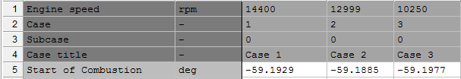
Lastly, the ‘m’ exponent for the Wiebe function curve, the default value is ‘2’, however, the start of combustion according to the real data in MS Excel shows the start of combustion at -59.18 degrees on the crank. Initially, an approximation of ‘6’ was inputted to the WAVE model, as shown in Figure 44. However, later in the simulation, after multiple runs, a value of ‘7.115’ was approximated for the m exponent for the Wiebe function curve, which states in WavePost, shown in Figure 10, Case 3.
Figure 10: Table in WavePost showing the start of combustion, when 'm' = 7.115
Moving forward, the fuel compostion for this engine uses Indolene; according to, (Metghalchi & Keck, 1982), the physical properties and chemical analysis of RMFD-303 (Indolene), states the stoichiometric fuel-air ratio as 0.06988. This value at 1.1phi which is equal to 0.76868 which will be inputted for each injector as the variable, ‘fard1, fard2 and fard3’, with one variable for each injector as shown in the constants table, Figure 43. However, initially at the start of this study, a value of 0.068 was used referring back to the air-fuel ratio of ’14.7’ shown in Figure 44.
Futhermore, in Ricardo WAVE there is a heat transfer model called Woschni. This model represents the heat transfer multuplier when the intake valves are open/closed; a variable was used in the constants table, Figure 43, where the variable, {htiop}, represents the the intake valve opening multiplier and, {hticlo}, where this variable represents the intake valves closed. The initial multiplier for, {htiop}, was 0.8, however, multiple changes from the values of 0.7-1.9 were inputted shown in the graphs, Figure 46. However, the end values inserted in the variable, {htiop}, was 1.5 and, {hticlo} was 0.7, shown in the constant table, Figure 43. These values for, {htiop} and {hticlo}, allowed to keep the same trends shown in the real data, for the area in the P-V diagram, however, the brake power (kw) and BHP decreases as htiop increases.
In addition, using the valve timing data shown in, Figure 39, Figure 41, the values for, {eop} and {iop}, can determine when the intake and exhaust opens and closes shown in Figure 11.

Figure 11: Valve timing used for 10250rpm
When the value of {eop} is changed from default at a value of 85 degrees to 67.08, the curve shown during expansion from the WAVE simulation replicates the expansion curve from the real data. In addition, changing the value for {eop} also creates a slight decrease in pressure. The value of 67.08 was produced according to (Ape Race Parts, 2020), where it states the duration of the exhaust valve timing as ‘247.08’ degrees, for the variable {eop} to open before BDC, take the duration and subtract by BDC, which represents 180 degrees, giving the value ’67.08’.

Figure 12: Exhaust valve opening changed from default to 67.08
In addition, the value of {iop} were changed from default at a value of 250 to 258.5 degrees. In addition, the value of 258.5 was produced according to (Ape Race Parts, 2020), states the duration of the intake valve timing as ‘258.5’ degrees, for the varibale {iop} to open after BDC. This caused the P-V diagram to replicate the real data, where pressure is slightly above maximum.

Figure 13: Intake valve opening changed from default to 260
However, this leads to the biggest decrease of pressure within all variables; before changing the intake and exhaust opening points, the values for the intial temperature conditions for each cylinder makes a dramastic difference to each cylinder pressure, where in the constants table, Figure 43, shows the variable names: Piston top temperature: {ptemp, ptemp2, ptemp3}, Cylinder head temperature: {chtemp, chtemp2, chtemp3}, Cylinder liner temperature: {cltemp, cltemp2, cltemp3}, Intake Valve temperature, {ivtemp, ivtemp2, ivtemp3} and Exhaust valve temperature, {evtemp, evtemp2, evtemp3}, where the number in each variable states what cylinder they represent.
With multiple runs changing the initial temperature condtions, the maximum pressure was recorded in WavePost, this shows the end result of each maximum cylinder pressures in Figure 36. The graph shown below, Figure 14, represents the final P-V diagram recorded, where the maximum pressures reach as accurate to the real data. Figure 14, shows the same trends during combustion and expansion, which represents both data to have the same area.

Figure 14: Final P-V diagram after initial temperature condition changes for 10250rpm
In comparison to the P-V diagram shown in, Figure 14, the trends for the maximum pressure (bar) against crank angle (°) represented in, Figure 15, shows at the start of combustion pressure is slightly more than the real data. However, some late adjustments to the WAVE model, where the intial ambient pressure was recorded at a value of 1.065 bar, in order for pressure to drop, the ambient pressure must be changed to 1bar. In addition, the intake initial condition temperatures and wall temperaures should be set for 20°C (293K), and also an error within the exhaust intial conditions within duct52 and duct48, where intial conditions did not decrease and stayed at maximum, in order for pressure to be correct, a value of 750K was set for temperature and wall temperature instead of 900K.

Figure 15: Final pressure (bar) vs Crank angle (°) according to the maximum pressure values
As shown above, Figure 14, represents the final P-V diagram across 10250 rpm, using the exact pressure and volume data gathered from the WAVE model, a logP and logV diagram can represent the ncomp and nexp of the engine using linear trendlines shown in Figure 16.

Figure 16: logP vs logV at 10250rpm
Referring back to the Wiebe changes above shown in Figure 10, a graph of Wiebe and burn rate was recorded as shown in Figure 17. This represents the same Wiebe function curve as the real data in Figure 32, however, the burn rate calculated in the WAVE model runs slightly higher at peak pressure also showing the offset seen in Figure 15.

Figure 17: Real and simulated Wiebe & Burn rate (%) vs Crank angle (°) for 10250rpm

Through producing and matching the maxiumum pressure against the real data, the final results shows the brake power (kW) and Indicated power (hp) produced at 10,250rpm in WavePost, Figure 16. However, changing the brake power (kW) to brake horse power by multiplying by the constant value of 1.374, will produce 95.49bhp compared to the real data shown in Figure 35.
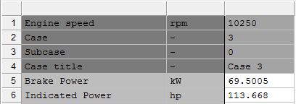

Figure 18: Brake power (kW) and Indicated power (hp) vs RPM

13000 rpm
Furthermore, the initial run for 13000 rpm is shown in, Figure 19, where in comparison to 10250 rpm the pressure is significantly larger. So, using the same procedures based in 10250 rpm, recreate the maximum pressure for 13000rpm according to the real data provided.

Figure 19: First simulation run on Ricardo WAVE for 13000rpm
Referring to the graph, Figure 20, initial constant variables carried over from 10250 rpm, such as the heat transfer close multipliers {iop} and {eop} which is represented in this graph from the previous rpm run. However, the changes from 10250rpm in the beginning, was the wiebe function curve (‘m’), the heat transfer open multiplier is set at 0.8 as default, the injectors (‘fard’), and the initial temperature conditions shown in the constants table, Figure 43.

Figure 20: Constant variables from the run before entering 13000 rpm
Referring back to 10250rpm, the variable {BDUR} represents the burn duration when the values are starting at 10 and ending at 90. Changing this from the default value of 20 to 28 degrees, which was taken from the real data provided, gives the graph shown in Figure 21, which creates a decrease in pressure in comparision to Figure 20.

Figure 21: Burn duration (BDUR) value changed from default to 28
Furthermore, TBH50 was changed from default at 8 to 10 degrees on the crank angle where 50% is represented. In addition, with the changes made from initial temperatures and the wiebe function, TBH50 has made the maximum pressure decrease dramastically.

Figure 22: TBH50 value changed from default to 10 degrees
However, with some last minute changes made to the WAVE model which resorted the maximum pressures to decrease even further, changing the constant values for the initial temperatures in each cylinder, allowed the maximum pressure to increase, giving the graph shown in Figure 23, which represents the final changes to the WAVE model.

Figure 23: Final P-V diagram after initial temperature condition changes for 13000rpm
In comparison to the P-V diagram shown in, Figure 23, the trends for the maximum pressure (bar) against crank angle (°) represented in, Figure 24, shows the same trends at combustion and expansion; however, maximum pressure is slightly offset to the real data.

Figure 24: Final maximum pressure (bar) vs Crank angle (°)

As shown above, Figure 23, represents the final P-V diagram across 13000 rpm, using the exact pressure and volume data gathered from the WAVE model, a logP and logV diagram can represent the ncomp and nexp of the engine using linear trendlines shown in.

Figure 25: logP vs logV at 13000rpm
As previously stated in 10250rpm, the comparision of the Wiebe function curve and the burn rate across the combustion process is shown in Figure 25.

Figure 26: Real and simulated Wiebe & Burn rate (%) vs Crank angle (°) for 13000rpm

14400 rpm
Furthermore, the initial run for 14400 rpm is shown in, Figure 27, where in comparison to 10250 and 13000 rpm the pressure increases significantly more during combustion and decreases rapidly during the expansion process. Using the initial procedures without changing ambient pressure and the intake temperatures, 14400rpm was produced to match the real data, however, because of the rapid increase and decrease of combustion and expansion, the area shown in the graph, Figure 28, is incorrect due to combustion and expansion; however, when using the ambient pressure of 1bar and the initial intake temperature of 20°C/293K, the maximum pressure for cylinder1 and cylinder3 was 4 bar lower than the real data. However, cylinder2 had a major deficiency of 9 bar, which shows a problem within this cylinder at 14400 rpm.
Referring back to 13000 rpm, the initial constant variables carried over from 13000 rpm, such as the heat transfer close multipliers, fuel/air ratio stated as {fard} intake and exhaust openings {iop} and {eop} which is represented in this rpm acting upon the graphs, Figure 48 and Figure 49.

Figure 27: First simulation run on Ricardo WAVE for 14400rpm

Following the same procedures made for 10250 and 13000rpm, according to the real data {BDUR} is calculated at 29 degrees, shown in the graph, Figure 48, where this caused the pressure to decrease even further. In addition, {THB50} where 50% burn rate is produced at 9 degrees which is represented from the real data, where this change is shown in the graph, Figure 49. Furthermore, the Wiebe exponent, {m}, was changed to 5.75, for the start of combustion to ignite at -59.19 degrees, these changes made shows the trends of combustion reacts simularlly to the real data, where it shows the pressure compressing significantly more than the initial run shown in Figure 27.
Referring back to 10250 and 13000 rpm, with multiple runs changing the initial temperature condtions, the maximum pressure was achieved shown in WavePost. However, as seen in the graph, Figure 28, the area shown due to compression in the combustion stage starts later than the real data. Where due to changing the Wiebe exponent, {‘m’}, to 5.75, WavePost shows start of combustion acting at -59.19 degrees, this must mean a discrepency in pressure increase during the combustion process.

Figure 28: Final P-V diagram after initial temperature condition changes for 14400rpm

In comparison to the P-V diagram, shown in Figure 28, the trends for the maximum pressure (bar) against crank angle (°) represented in, Figure 29, shows at the start of combustion pressure is slightly lower than the real data, which is the issue in discrepency in the P-V diagram at the combustion process. However, due to the maximum pressure matching the expansion process shows the same heat loss as the real data.

Figure 29: Final pressure (bar) vs Crank angle (°) according to the maximum pressure values
As previously stated in other rpms, Figure 30 shows the ncomp and nexp for the combustion and expansion process. The trends shown in, Figure 30, shows the discrepnecy previously stated in, Figure 28, in the P-V diagram, where ncomp is slightly larger than the real data.

Figure 30: logP vs logV at 14400rpm
As previously stated in 10250rpm, the comparision of the Wiebe function curve and the burn rate across the combustion process shown in Figure 31.

Figure 31:: Real and simulated Wiebe & Burn rate (%) vs Crank angle (°) for 14400rpm

Conclusion and further work
Further testing methods can be performed in the WAVE model such as; intake and exhaust pressures, in relation to match the real cylinder pressure data precisely and testing the engine performance which include; IMEP, BMEP and volumetric efficiency, where it states for 10250rpm in the data provided that the volumetric efficiency states at 0.9. These tests could have been carried out to find the power (kw) and BHP related to the real data, however, trying to keep the pressure to match the real data.
In addition, looking at each rpm from the default WAVE model; with validation providing with real data from other RPMs the brake power (kW) and BHP, could be varied out in this model. In order to match the volumetric efficiency defines the efficiency of the gas exchange procedure, which is where the burned gases exhaust out of the chamber at the end of the exhaust stroke, which draws back into the cylinder before the start of combustion stroke. The residual gas has key impacts on the performance of an engine, where the larger the volume engaged with the residual gases, the lower charge received producing less torque and power. Other engine parameters which effect the volumetric efficiency apart from the operating parameters conclude of; the frictional losses, wave effect, ram effect, temperature and pressure inside the exhaust runners and finally the burned air inside the cylinder chamber, (Aradhye & Bari, 2017).
To conclude, the real data provided and online sources in relation to the Triumph 675cc engine are not accurate. However, using some information such as the valve timings given from, (Ape Race Parts, 2020), and using the correct compression ratio and conrod length, the results could be calculated in Ricardo WAVE. In addition, the results conducted through this procedure had a few errors, such as; start of ignition, valve timings as seen in the pressure vs crank angle graphs conducted for each rpm. This is because of the offset given for maximum pressure which correlates back to start of combustion and the burn duration. However, using the results provide, these constants were carried out in the following WAVE simulation. A comparision between each rpm shows that the area of the graph in the P-V diagrams show the same errors made, this however could relate back to some constants used in WAVE but with further experimentation, these results could have been solved.

Appendix

Real data; Wiebe function curve and burn rate percentage for each RPM

10,250 rpm

Figure 32: Wiebe and burn rate (%) vs Crank angle (°) @10250rpm

13000 rpm

Figure 33: Wiebe and burn rate (%) vs Crank angle (°) @13000rpm

14400 rpm

Figure 34: Wiebe and burn rate (%) vs Crank angle (°) @14400rpm

Further work calculated in the real Triumph 675cc engine data
The graph, Figure 7, shows the BHP and Brake power (kW) across each rpm from the real data, where in Ricardo WAVE it is given as indicated hp. However, taking the result of the brake power and multiply by the constant 1.374 will give the produced BHP.

Figure 35: Engine BHP and Power (kW) vs RPM
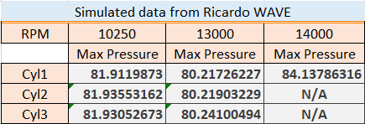

Figure 36: Maximum pressure calculated in Ricardo WAVE in each cylinder

Intake and exhaust value lift profiles in the Ricardo WAVE model
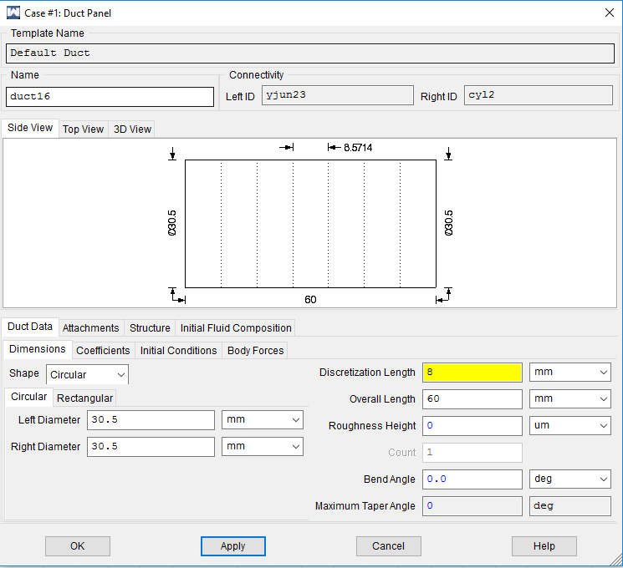

Figure 37: Intake ducts changed from default to 30.5mm
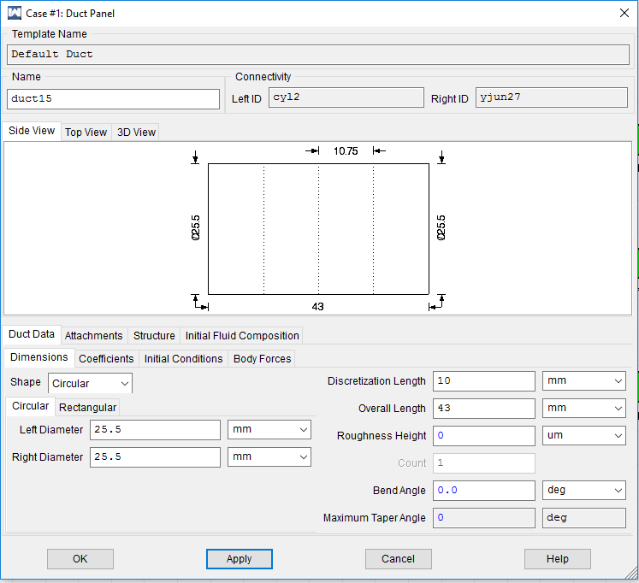

Figure 38: Exhaust ducts changed from default to 25.5mm

As can be seen in Figure 39, cycle {iop} is stated as a variable in the constants table which will be changed for each rpm.
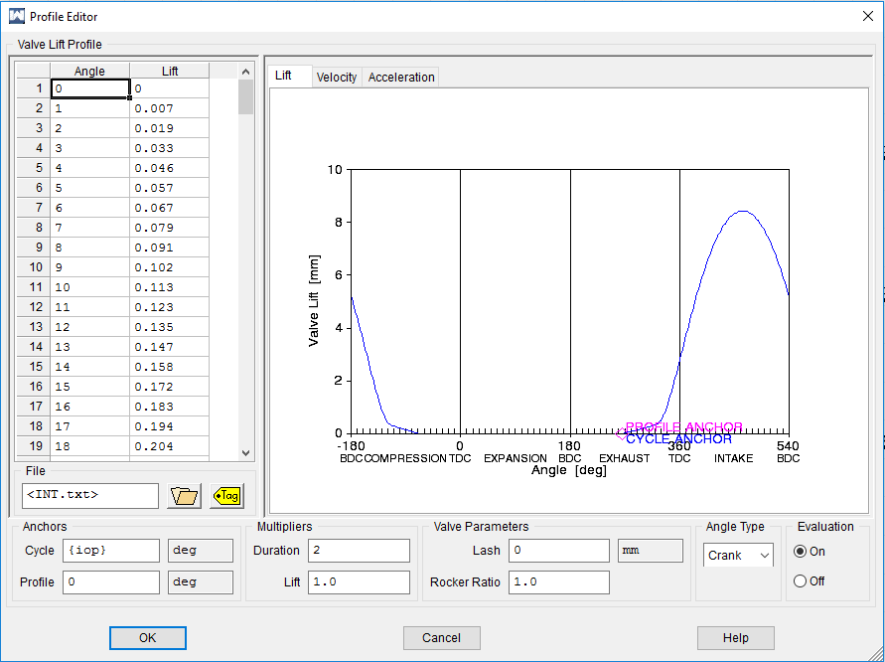

Figure 39: Intake valve lift profile
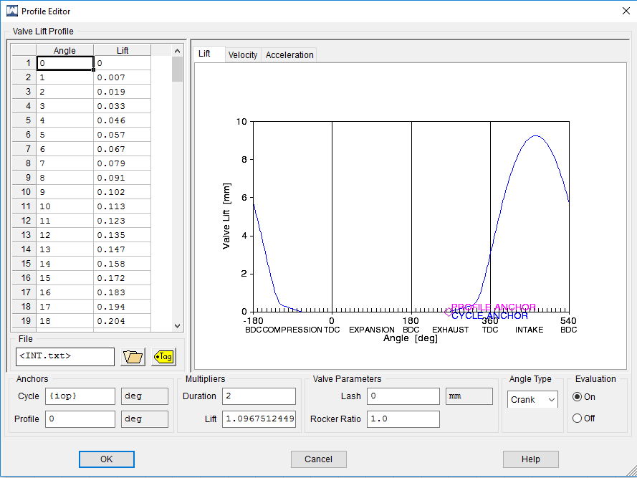

Figure 40: Intake valve lift coefficient profile

As stated above with intake valve lift, Figure 41, cycle {eop} is also stated as a variable in the constants table which will be changed for each rpm.
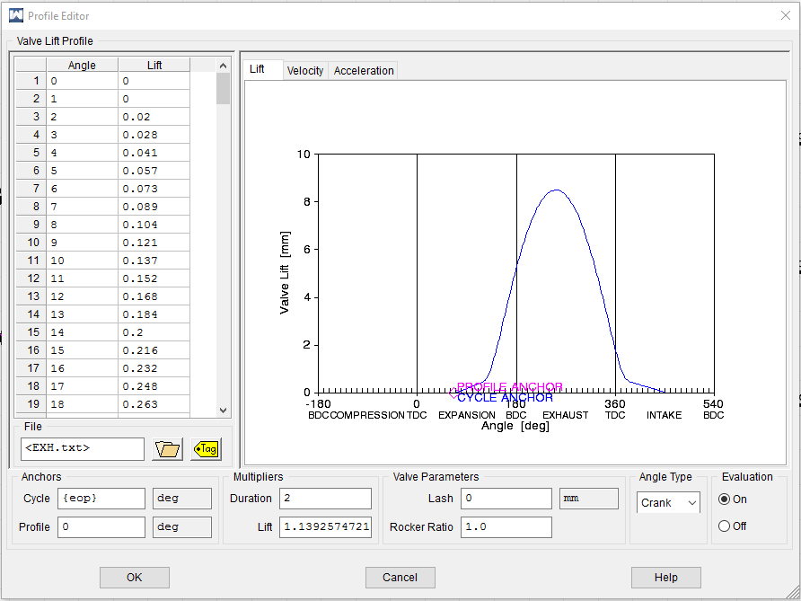

Figure 41: Exhaust valve lift profile
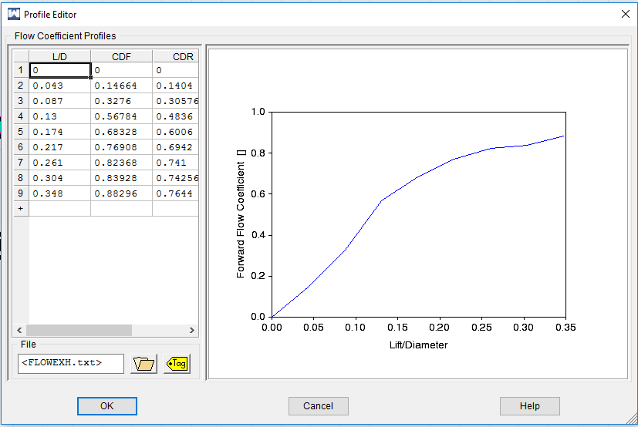

Figure 42: Exhaust valve lift coefficient profile

Ricardo WAVE constants table
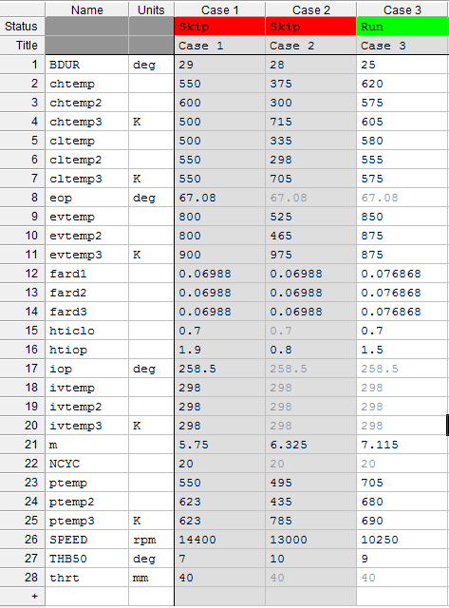

Figure 43: Ricardo WAVE constants table used for the Triumph 675cc engine

Graphs created for real and simulated data for 10250 rpm

Figure 44: Wiebe 'm' exponent changed from default to '6'

Figure 45: Injector value from default changed to 0.068

Figure 46: Heat transfer multiplier intake valve opening and closed changed from default

Figure 47: Cylinder pressures (bar) vs Crank angle (°) per cycle for 10250 rpm

Graphs created for real and simulated data for 14400 rpm

Figure 48: Burn Duration (BDUR) value changed from default to 28

Figure 49: TBH50 value changed from default to 9 degrees

References
Ape Race Parts, 2020. Specifications: 2009 Triumph Daytona 675. [Online]
Available at: http://aperaceparts.com/tech/2009%20Triumph%20Daytona%20675.html
[Accessed 15 01 2020].
Aradhye, O. & Bari, S., 2017. Continuously Varying Exhaust Pipe Length And Diameter To Improve The Performance Of A Naturally Aspirated Si Engine. Proceedings of the ASME 2017 International Mechanical Engineering Congress & Exposition, pp. 1-9.
Caton, J. A., 2015. An Introduction to Thermodynamic Cycle Simulations for Internal Combustion Engines. Chichester: John Wiley & Sons, Incorporated.
Gilan, R., 2012. Engine Simulation Model for a Formula SAE Race Car, Sydney: Luleå University of Technology.
Lethwala, Y., Sharma, N. & Jain, R., 2019. Engine Performance Simulation of Ricardo WAVE for GTDI Optimization. International Journal of Engineering and Advanced Technology (IJEAT) , 8(5), pp. 1444-1448.
Metghalchi, M. & Keck, J. C., 1982. Burning Velocities of Mixtures of Air with Methanol, Isooctane, and Indolene at High Pressure and Temperature. In: Combustion and Flame. Boston: Elsevier Science Publishing Co.. Inc.. , pp. 191-210.
Sawant, P., Warstler, M. & Bari, S., 2018. Exhaust Tuning of an Internal Combustion Engine by the Combined Effects of Variable Exhaust Pipe Diameter and an Exhaust Valve Timing System. Energies, Volume 11, pp. 1-16.

