Marketing fundamental

STUDENT: Violeta Roxana Zanfir
ID STUDENT :1813454
MODULE NUMBER: LCBB4004

Introduction

For a successful business organization like Dove, marketing plays an important role. It analyzes the various concepts of marketing which are helpful to analyze the environmental conditions of the business. It provides data and information about the competitive market, so we easily develop new strategies or mission for accomplished aims and objectives of the DOVE Company. Through SWOT, PESTLE and Porter Five forces Models of DOVE Company are defined under this assignment. They easily develop new marketing plans for become more successful in market.

Task 1A

Marketing definition
Marketing may be defined as the process by which the goods and services are moved from one person to another and from one place to another. Marketing includes the price of product, demand for a product, distribution channel. It coordinates some elements of 4Ps like
- To identify the product.
- Identify the price of product.
- Channel of distribution for the product.
- To implement promotional strategy.

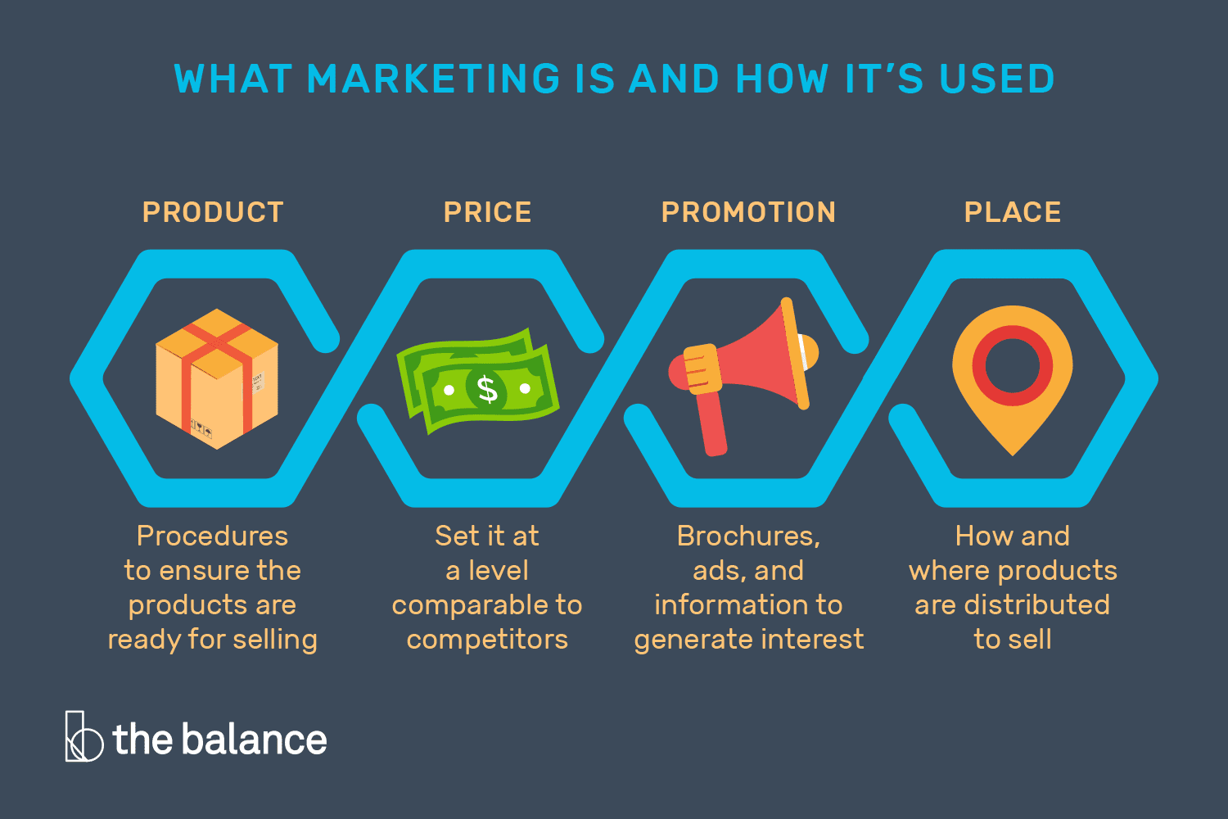

Marketing process
It refers to process to analyze the marketing opportunities, to select the target market, to make the efforts in marketing and to develop marketing mix. The process of marketing includes main four elements- marketing-mix planning, implementation of marketing, control of marketing and analysis based on strategic marketing plan. For achieving the goals of market, the process of marketing is essential. Company makes the production of those goods which fulfills the needs of consumers.

Stages of marketing process:
For identifying the needs of consumers in the market organizations rely on strategic marketing. For the growth of business, the five main strategic marketing plans is helpful for business which creates impact on large and small business, customer loyalty and brand.

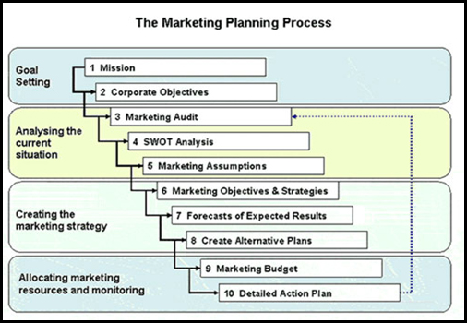

The following steps define the process of marketing:

Mission Identification:
It is the first stage of marketing process, which expresses what the reason is for existence of enterprise is and how target buyers will be benefited in long term. This mission statement identifies the role for product and service of business, make forecast of future.

Analyze the Situation:

Businessman analyzes the situation by the methods of SWOT and PESTLE analysis. This helps the business organization in finding information related to internal and external factors. The second stage is helpful for the mangers of business for understanding the changes which they have to do in business.

To specify objectives of marketing:

The marketing objectives have to be specifying first before starting the business. Companies Objectives are described in following terms such as revenue, profit, sales or market share. Every objective should be achieved within given period of time.

To develop strategy:

This stage includes the target market and the consumers group who are going to buy products and services of firms. The marketing managers must make the selection of effective ways for the use of marketing mix elements like product, price, place and distribution to create impact on customers.

Planning of your evaluation:

This stage defines the evaluation which means to identify when, how and whom the tactics will be monitored and should be analyzed on time. For the success of business planning is essential.

Pestle analysis of DOVE

For the strategic planning PESTLE analysis is important. For analyzing the macro factors this is used by strategic planners. This is used by company as a tool for tracking out environment in which they are operating and also helps in planning for the production of products or services.
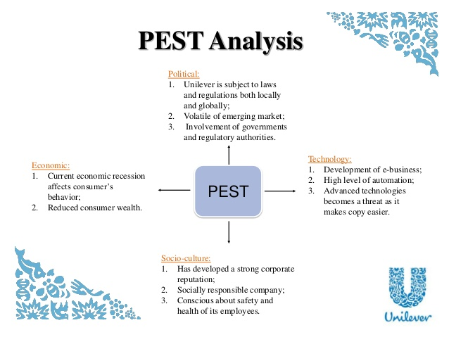
In the context of UK, the following points of PESTLE analysis of Dove are defined as under:
Political environment:
Some EU regulations, directives, legislation, national, international, rights of consumers and taxes have affected the functioning of DOVE Company like the other business organization. There is also an influence on decision making by the war and instability in business. Therefore, the member of Dove Company recognizes the political environment and Dove gets many advantages from political environment in UK.
Political environment is favorable when the Dove systematic appraises the following factors before investment:
- In recent years the political stability of the country.
- Company intellectual property (IP) is protected or not.
- High taxation was de-motivating companies to invest in Dove for increasing their profit.
- Minimum wages increase profit and also increases the chances of survival for Dove.

Economic environment:
Some factors that the Dove includes are pay level, credit cost, demand and supply of labor, energy prices, competitive prices etc. All these factors of economic have the great impact on the Dove pricing strategies significantly.
Some economic factors that Dove is considered before investing are:
- GDP growth rate also affect the fast-growing Dove expected in the near future.
- The financial market affects the signal person borrowing and investment.
- Exchange rate of the Dove country operates also influence the profit of the Dove.
- The Dove can raise their capital at fair prices and efficiently operates the financial market.

Social environment:
The social factors are helpful for Dove in producing new products and services for existing markets. Healthy lifestyle, ageing population are the examples of social changes. These factors help Dove Company in developing its segmentation strategies.
. The social factors also affect the Dove:
- Population of market also influence the targeted market, makeup is mostly used by female, so they target the mostly population of female.
- Dove cannot lose the connection with the target markets.
- Dove needs to fully aware of the market standard and important of environmental protection.
- They also focused on the class of distribution.

Technological environment:
As the technology is changing day by day, Dove has also to have the requirement to make some changes in the production work and in brand which is very important. How to make the use of technology for their work is also an important for company which will also increase the profits.
Technology is favorable for Dove Company; it is important for stability and consist innovative ideas for maximizing the profits. Some technological factors also influence the Dove may include the following points:
- The innovative technology helps to remove competitors and gain popularity in the industry.
- Dove maintains their quality and copying process through technology very quickly and easily.

Environmental environment:
Some points which are important to understand by Dove includes hazardous waste, organic foods, pollution, green economy, carbon footprint. The impact of organizations on environment is also analyzed by people who are aware of impact. Huge pressure is there on company to operate friendly in an environment.
Some environmental factors may influence the Dove are:
- Climate changes are danger for some products useless.
- Companies that produce a large amount of wastage would properly manage by the Company. Dove financial strain was including pollution fines and quotes.

Legal environment:
Dove Company is abiding by the countries rules and regulations which it is doing in business functions. Dove cannot pay to their employees fewer wage in UK and also the employee cannot be dismissing by company. If anything is done wrong by employer to employee, then Dove will be under imprisonment.
. Dove policies are not sufficient to protect efficiently the Dove and its employee. Some Legal factors influence the working of the Dove is:
- Intellectual property laws and other data protection are helps to protect the data of Dove and other company.
- The government Discrimination laws also protect the employee of Dove, it provides same opportunities, gender, age, disability and religion.

SWOT analysis of Dove
Strengths  - Dove had won many awards.  - ¼ moisturizing cream are contained by Dove.  - In 80 countries of the world, Dove products are available.  - There will be no side effect on the skin after using any Dove products. | Weaknesses  - Marketing expenses are high.  - Dove Company is affected by Unilever critics.  - Their focus is mainly based on women products.  - Intense competition is there in Dove Company.
Opportunities  - Make collaboration with fashion industry.  - It can increase its opportunities by also focusing on male audience.  - Dove can increase more by further expansion.  - Marketing communication is increasing. | Threats  - Dove has negative public perception.  - Competitors can copy the products of Dove Company.  - Affected by government policies.

Advantage and Disadvantages of SWOT analysis
Advantages:
- It identifies the problems that can limit its objectives.
- It makes the decisions on direction that are more effective.
- It finds the solution for problems.
- It is simple and flexible.
Disadvantages:
- It is not the source of competitive advantage.
- It is static and ignores the risks.
- It is very subjective.
- It provides shot view for moving target.

Segmentation
Marketers arrange all the targets of company into segments then it will become more efficient with their time, money and other various resources. Grouping same types of consumers allows the marketers to target particular audiences in an effective manner. The process of segmentation also helps in reducing risks related to marketing campaign.
The process of segmentation also helps in reducing risks related to marketing campaign. Markets segmentation done by the Dove Company.

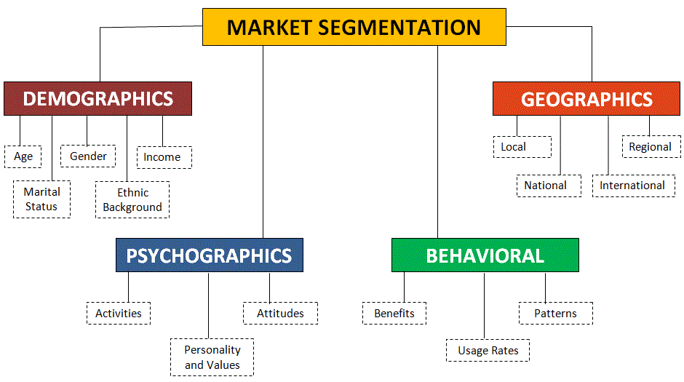
Targeting
After the process of segmenting, the marketer then selects a segment and targets it. In this process, marketers firstly target the single product contained in single segment in the marketplace.
The targeted market of the Dove included in following:
- Dove targets the group of women above 18 years.
- The Brand target the women of all ages, shapes and sizes
- Women who are concern for skin care.
- Primarily they target the working women, who don’t have time for skin moisturizing and who will pay Rs. 90/- for 50g face wash tube.

Positioning
Strategies of marketing aims to make brand that occupy different position in market, have competitive quality and also maintains image in the minds of the customers.
Some points define the position of the Dove in current market:
- According to research 80% women were purchased the products of Dove.
- Dove realized the position of brand marker is women.
- Deep Pure Face washes of Dove position as beauty product in market.
- Real Beauty Campaign is launched by Dove in 2004.
It is the beauty brand and gained various momentums in market. It is the best example of good positioning can be a boon to a brand’s strategy.

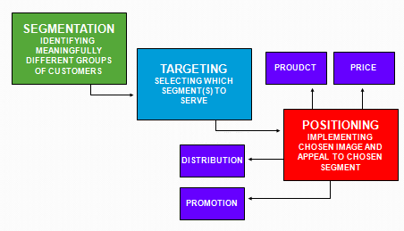

Dove Company Uses 4Ps of Marketing Mix

These 4Ps are described below:

Product:

High quality products are provided by Dove Company. Skin care cream, washing and bathing, hair care products are included production process of Dove Company. Dove Company is popular for their hair care products. Dove Company daily introduces the new products. Baby care products are also introduced by this company like baby location, diaper cream, moisturizer and wipes for babies. Skin care products are also provided by dove such as shampoos, beauty bars and face cream.

Price

The Dove Company focuses on the mechanism through which they can lower the price of their products. For this, the organization is running some successful policies. The demand of Dove products is low as compared to other company products, so they make the price of their products low in order to increase demand. For this, they use competitive price.

Promotion

For the promotion of brand and products the Dove makes the use of unique strategy of promotion. Marketing management of Dove Company always takes initiatives in endorsing new and innovative promotional mechanisms. Dove conducts beauty campaign in order to promote their products. In this, they give live demos to public and then they ask for reviews for their products. In this way they promote their products.

Some promotional activities are performed by Dove are: Advertising, Sales promotion, event and experience, public relation and publicity, direct marketing, interactive marketing and word of mouth marketing. In 2004, Real Beauty Campaign was launched by Dove.

Place

Dove works under the portfolio of Unilever. The products of Dove are sold mainly all over the world. The products are also sold on online mode. In more than 80 countries the products of Dove Company are sold. The distribution of channel which Unilever use is also adopted by Dove. From factory to warehouse the products are transported. In supermarkets, general stores, wholesalers market Dove products are available for consumers.

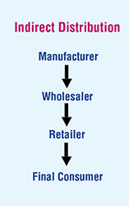

Marketing role in Creating Values for Customers

Concept of marketing
Marketing concept includes the idea of fulfilling the needs of the customer in a successful manner. Organizations which adopt these principles in recognizing that customer is one of the dynamic strengths of the organization. By adopting these principles, the business can reach to the new heights. The concept of marketing is the fundamental part of the marketing arrangement. If the company wants to achieve success then they have to look after the needs of the customers (Study Guy, 2019).
DOVE Company uses the marketing concept, in the functioning of business. For this they use different marketing strategies. DOVE first identifies the competitors and by this they get to know their strengths and weakness. This helps them in developing affecting strategies which help them in growing.

Branding
Branding process refers to providing particular meaning to the organization, commodity or services by creating a brand in the minds of the consumers. It is a type of strategy designed by the organization in order to help the people in quickly identifying the company’s brand and it also provide reasons to consumers for choosing specific commodity of firm as compare to other companies’ brand (Keller).

Advantages of Branding
- Process of branding helps the organization by making advertising process easy.
- It helps the customer in identifying the company’s product.
- Branding helps the company in creation of market.
- Branding also provide more price to business organization through their products.
- By the use of this company are able to expand its product mix.
- It also helps the business firm in maintaining contacts with customers.
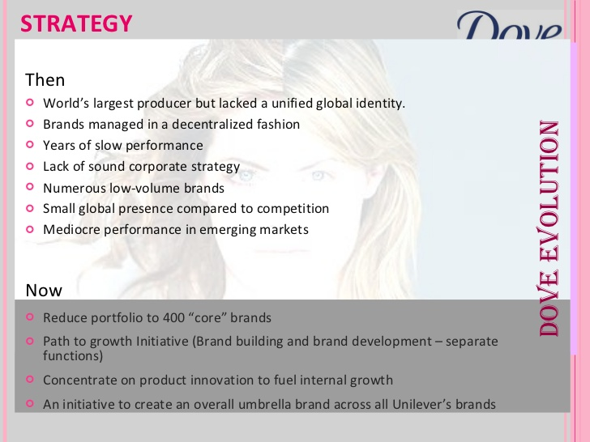

Ansoff Matrix Strategies
Ansoff Matrix was written in 1957 by Igor Ansoff, also known Ansoff growth of matrix. Ansoff proposed a paper on marketing strategy with its growth area, marketing penetration, marketing development and product development, diversification. For creating Ansoff Growth Matrixes requires all of these four areas.

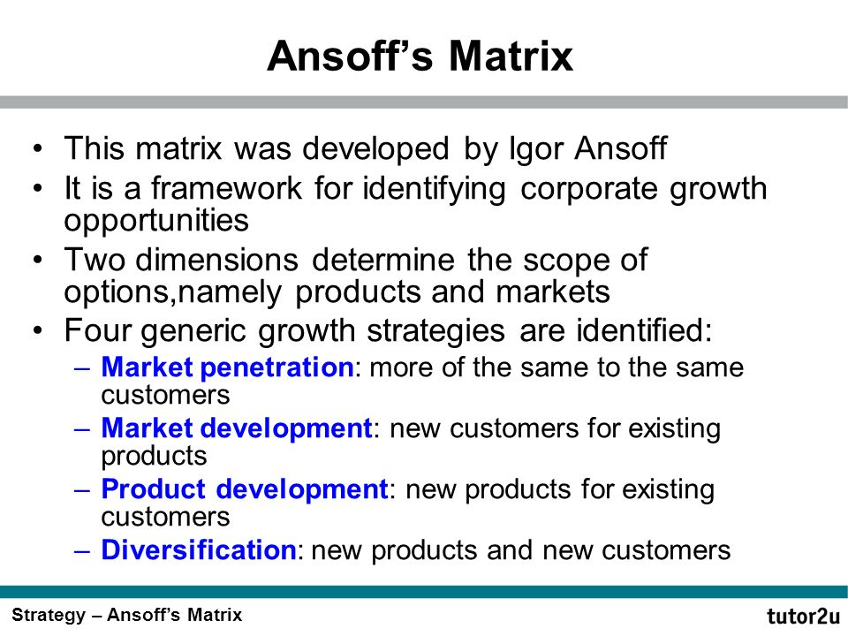

Market Penetration: When the Dove launches few campaigns market penetration will increase, and the representation of the company also provide free sampling ton consumers. It increased the customers of Dove and penetration helps to accomplish the newly market sectors.

Market Development: The main aim of Dove is that they enhanced the beauty of the client which lies in them. It means that customers of Dove become more aware about the products knowledge and information.

Stakeholder engagement and their impact on marketing activities of an organization

Definition of stakeholder:

Any person or entity is stakeholders who have interest in the success or failure of the business. In decisions making Stakeholders have significant impact, which is related with organizational functions and also finance of an organization. Stakeholders can be explained by some examples such as creditors of the company, investors of the company, employees and even it can be local community.

Internal Stakeholders
Nilson (2006: p170) explains the internal stakeholders as the person or entity which works in management of the business organization, act as marketing experts, perform as designers, function manufacturing activities, acts in sales department of the company and who does purchasing activity for the business organization. (Karim, et al., 2007, pp.8)
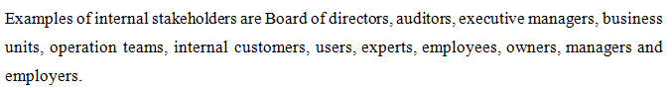

External Stakeholders
Nilson (2006: p170) explains external stakeholders who participate in activities of business and act as a collaborative partner, but they don’t act as the owners. These are related with business organization from outside and all these external shareholders have common interest for business activities such success of the business. (Karim, et al., 2007, pp.8)

Communication with stakeholders
Dove is a large type of organization which internationally operates its business activities. Therefore, they have distributed different functions of business organization in different branches. By doing this activity, company aim is to provide satisfaction to their buyers with their products. For making this possible they communicate with all their stakeholders by using different methods of communication. Dove also makes strategic decisions in order to make customers informed.

Impact of stakeholders on marketing activities

Social responsibility and Governance: The establishment of vision and objectives of the business organization is made by business governance. With the help of business operations, Dove Company had increased their profits. While social responsibility has contributed in balancing the social and environmental responsibilities.

Consumers and Community: Dove consider all the its customers as the kings, as all the activities are done on the basis of customers wants. This helps the business organization in attracting customers and thereby increasing in profits which are of long term and also maintains the relationship with the customers for the success of the business.

Employees: The employees of the business are important because they perform various functions of business with the employer. The employees are treated as most valuable assets and company also provide chance to take active part in decision making.

Business partners: The management system of Dove company is known as the cain supply of management. It has close collaborated between buyers and suppliers so that they can work together to get best results for the company.

Task 1B

Meaning of communication
Communication is referred to as exchanging and sharing the information, ideas, etc. communication can not only be done with human beings, but it also done with non-human beings. It is defined as process by which ideas, thoughts, feeling, and actions are exchanged with one or more people. It is also defined as interaction between two parties.
According to (Haiman): “communication refers to the practice by which information is transferred from one person to another”

Communication model
The communication model is the pictorial presentation that identifies, classifies and explains various elements of process. Process of communication includes sender, message, media and receiver. The communication starts by the communicator’s message and ends with the feedback of receiver. Model does not take all parts of communication process and when process of communication is presented in picture then it is known as communication model.
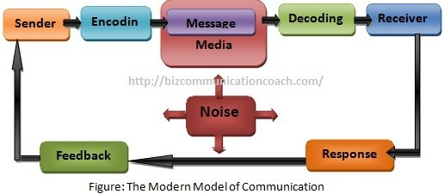

Integrated marketing communication
IMC is an approach for making the experience for buyers to interact the enterprise brand. It is not the lengthy process; it is very simple concept. Various types of communication and messages are linked together by integrated marketing communication. Communication of marketing aspect to work together so that sales can be increase but tom keeps the cost at maximum. It integrates brand promotion methods for promoting the particular product in market for specific customers. According to (Agencies): “Integrated marketing communication is defined as a plan that ensures various communication disciplines role and make combination of disciplines so that clarity can be provided.”

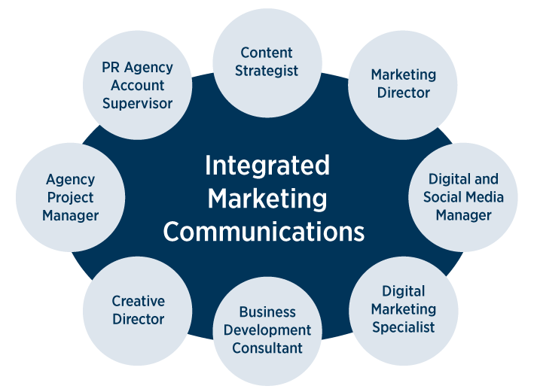

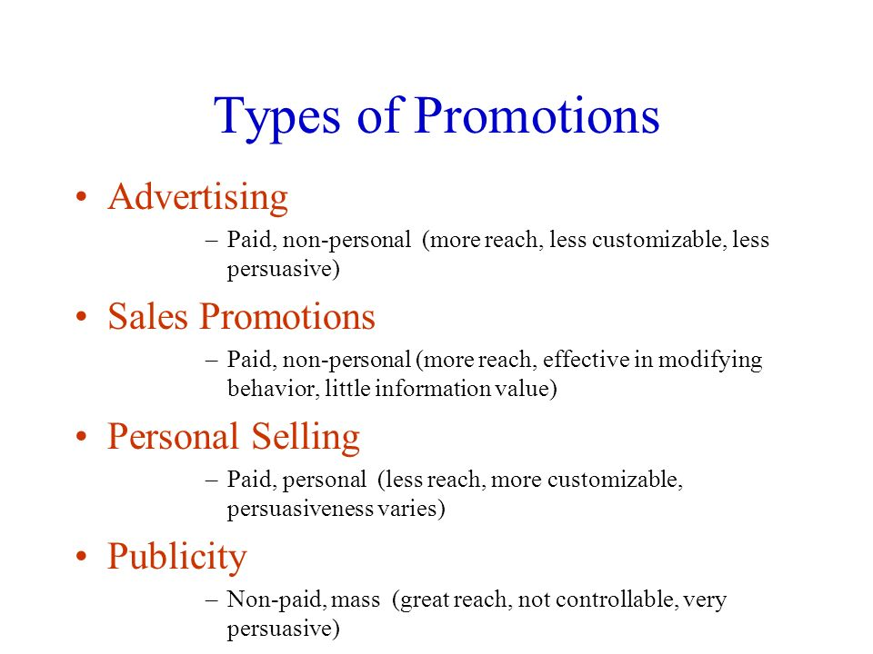

Conclusion

We conclude this assignment after identifying the various concepts of marketing and steps for processing. The assignment used SWOT, PESTLE and Porter five forces models of Dove Company are also identify in it. Company develops new strategies for becoming successful in current market. We have also explained how Dove Company uses marketing mix in their performances. For more clarification, we study marketing concept used by the Dove Company. This assignment also explains concept of branding and Ansoff matrix strategies. Moreover, we have learned the information about stakeholders and communication.

Recommendation
This assignment recommendation that Dove increased their promotion activities to increase their targeted market. They also improve their weakness, so they increased the goodwill of the company. Ansoff Matrix is useful to market development, penetration are strategies used by Dove. They also make more effect to promote their product and target new market.

Reference List

Dibb, S. (2010). Market Segmentation Success–Making it Happen! Strategic Direction, 26(9).
Jaworski, B. J. (2018). Commentary: advancing marketing strategy in the marketing discipline and beyond. Journal of Marketing Management, 34(1-2), 63-70.

Keller, K. L., & Brexendorf, T. O. (2017). Measuring brand equity. Handbuch Markenführung, 1-32.

Khan, M. T. (2014). The concept of 'marketing mix' and its elements (a conceptual review paper). International journal of information, business and management, 6(2), 95.

Kim, K. H., Jeon, B. J., Jung, H. S., Lu, W., & Jones, J. (2012). Effective employment brand equity through a sustainable competitive advantage, marketing strategy, and corporate image. Journal of Business Research, 65(11), 1612-1617.

Lee, K., & Carter, S. (2011). Global marketing management. Strategic Direction, 27(1).
Kotler & Keller: Marketing Management (2015), American Marketing Association (AMA)
Hussain, S., Khattak, J., Rizwan, A. and Latif, M.A., 2013. ANSOFF matrix, environment, and growth-an interactive triangle. Management and Administrative Sciences Review, 2(2), pp.196-206.

Karagiannopoulos, G.D., Georgopoulos, N. and Nikolopoulos, K., 2005. Fathoming Porter's five forces model in the internet era. info, 7(6), pp.66-76.

Level, Q.F.C., SWOT and PESTLE Analysis Assignment.

Miller, K., 2005. Communication theories. USA: Macgraw-Hill.

Munusamy, J. and Wong, C.H., 2008. Relationship between marketing mix strategy and consumer motive: an empirical study in major ASDA stores. Unitar e-journal, 4(2), pp.41-56.
Sanchez, R., 1999. Modular architectures in the marketing process. Journal of marketing, 63(4_suppl1), pp.92-111.

Bowie, D. & Buttle, F. (2011) “Hospitality Marketing” 2nd edition, CRC Press

Bryson, J.M., 2004. What to do when stakeholders matter: stakeholder identification and analysis techniques. Public management review, 6(1), pp.21-53.

Demirbag Kaplan, M., Yurt, O., Guneri, B. and Kurtulus, K., 2010. Branding places: applying brand personality concept to cities. European Journal of Marketing, 44(9/10), pp.1286-1304.
Dibb, S. and Simkin, L., 1991. Targeting, segments and positioning. International Journal of Retail & Distribution Management, 19(3).

