

Student name: | Munir Hussain | Student ID number: | 2531367
Programme: | CertHE Computing Skills for Workplace
Module: | Software Solutions for Business
Module code: | ACCA4026
Lecturer: | Osman Elgawi, Mohd Syafiq Bin Zolkeply | Internal Verifier: | Sadhana Jha
Assignment Title: | Component 1- Coursework: Portfolio | Word count (or equivalent): | 4073

Contents
1. Introduction and Assessment Approach 3
2. Task 1: e-Commerce Website Builders / Software Solutions 3
2.1 Shopify 4
2.2 Wix eCommerce 4
3. Task 2: Mind Mapping and Contemporary Software Applications 6
3.1 Meaning and business value of mind mapping 6
3.2 Mind map of contemporary software applications 6
4. Task 3: Office Applications for Business Operations 7
4.1 Microsoft Word 7
4.2 Microsoft PowerPoint 8
4.3 Microsoft Excel 8
4.4 Microsoft Access 9
4.5 Overall evaluation of office applications 9
5. Practical Testing Evidence: Microsoft Excel IF Function and PivotTable 10
5.1 Feature 1: IF Function in Microsoft Excel 10
5.2 Feature 2: PivotTable in Microsoft Excel 11
5.3 Interpretation of practical testing 12
6. Task 4: Communication and Online Collaboration Applications 12
6.1 Communication application: Microsoft Teams 14
6.2 Practical communication feature test: Teams channel message or meeting 14
6.3 Online collaboration application: Google Workspace / Google Docs 14
6.4 Practical collaboration feature test: Google Docs comments/suggestions 15
6.5 Comparison and recommendation 15
7. Conclusion 16
References 18
Appendix: Excel File 20

1. Introduction and Assessment Approach
The report assesses the potential of the contemporary software applications to assist in the operations of the daily business by enhancing online selling, information creation, data analysis, communication and collaboration. Selected context is a small retail/service organization that requires low cost digital tools, but without the use of live, private or commercially sensitive data. This method is suitable for this assignment as it includes discussion based on research and simulated evidence to test the practical aspects.
The report is structured around the four tasks that are required. In Task 1, you will compare the two e-Commerce website builders: Shopify and Wix. Task 2 explains what mind mapping is and provides a mind map of some contemporary software applications. Task 3 tests Microsoft Word, PowerPoint, Excel and Access then has practical testing for the Excel IF Function and PivotTable. Task 4 compares Microsoft Teams to an online communication application and Google Docs to an online collaboration application.
The assessment criteria are not satisfied with just a list of software features. A good Level 4 portfolio should demonstrate how and why the applications relate to business work; identify limitations; and demonstrate their practical application. A blend of academic, governmental, professional and official vendor sources is therefore used in the discussion. OECD studies on digitalisation of SMEs reveal that digitalisation can provide opportunities for SMEs, but that it can also lead to cost, skill and security barriers if not well planned [1]. NIST also highlights the need for technology risk management by governance, identity control, protection, detection, response and recovery [2] for organisations of any size. Throughout the report these ideas are applied to evaluate software for suitability, risk and operational value and not just popularity.

2. Task 1: e-Commerce Website Builders / Software Solutions
e-Commerce website builders are software solutions that enable organisations to build an e-commerce store without having to start from scratch and build a website, order system and payment process. Typically, these integrate website templates, product catalogues, shopping carts, checkout, payment integration, order management, analytics and marketing capabilities. The greatest benefit to small business is that online sales are made more structured and manual messages, spreadsheets, or social media orders are no longer relied upon. Academic studies on digital transformation in SMEs also identify the digital awareness and strategy, and the capability to adopt digital as critical factors for digital transformation success [3].

2.1 Shopify
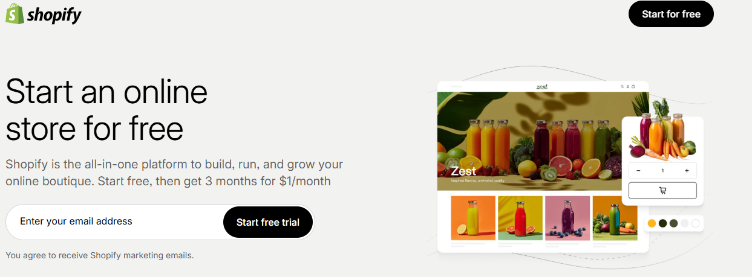
Figure 1: Shopify Platform
Shopify is an ecommerce platform that's built for ecommerce. Shopify states that its products and features include online storefronts, store editing and integrated commerce solutions [4]. It's appropriate when online sales is a key component of the business model, not just an extra feature. Common features comprise product and collection management, themes, checkout, order tracking, payment integrations, discounts, marketing links, app extensions, and reporting.
The best thing about Shopify is integration. The retailer can control products, stock, orders, customers' actions and checkout in one environment without having to mix unrelated tools. Store owners can also check the visitors, sales and product performance on Shopify Analytics dashboards and reports [5]. This helps in decision making as the managers will be able to know which products are selling and if there is any activity in the marketing, they will be able to know if customers are dropping out of the marketing funnel.
The only drawbacks are that it is expensive and it is dependent. Businesses can run into higher costs with Shopify if they include paid apps, premium themes or custom development. While the app ecosystem is strong, if there are too many apps, it can become more complicated and cause compatibility problems. Payment fees, privacy issues, employee permissions and returns policies are other issues that businesses need to take care of. Shopify is, therefore, most suitable for businesses that are willing to treat e-Commerce as a serious business.

2.2 Wix eCommerce
Wix eCommerce is an online selling platform that is integrated into the website builder. Wix offers its eCommerce capabilities under the storefront design, product management, payments, marketing, SEO, analytics and apps [6]. Wix is also a great option for smaller businesses that require a website that is more flexible in terms of design and a store that is not as complex as a retail system like Shopify.
Accessibility is the most important advantage of using Wix. A user can create a page without advanced coding, add an image, edit the layout and create product pages and basic store functions without coding. This is helpful for local services, small shops, start-ups or portfolios that offer a small selection of products. Wix can help you save on having to use a separate design software as website editing, content and basic commerce are all in one platform.
The biggest drawback is its scalability. While Wix is not as efficient for organisations requiring complex inventory management, advanced fulfilment rules, multi-channel retail management or highly customised checkout, it can still function well in these scenarios. In such a case, Shopify is generally a more suitable long-term match. The rational judgement is then based on task fit: Wix is good for website led, small selling, and Shopify is better for commerce led operations.
Table 1: Critical comparison of Shopify and Wix eCommerce for business operations.
Criterion | Shopify | Wix eCommerce
Main purpose | Dedicated online-store and commerce management platform. | Website builder with integrated eCommerce features.
Best suited to | Retailers that actively manage products, orders and selling channels. | Small businesses needing flexible brand pages and simple online selling.
Operational strengths | Checkout, order management, analytics, apps and scalable retail functions. | Visual editing, templates, product pages, SEO tools and accessible setup.
Main limitations | Costs can rise through apps, payment choices and custom development. | Less suitable for complex retail operations and advanced fulfilment.
Recommendation | Use when eCommerce is central to the business model. | Use when website presentation and simple selling are the immediate priority.

In general, both tools can help to streamline workflow and minimize the amount of manual work required to start an online store. But the selection of tools should be related to the maturity of the business process. Wix is a great choice for a small start-up, but if a business anticipates stock control, reporting and frequent online orders, Shopify might be a better choice early on.

3. Task 2: Mind Mapping and Contemporary Software Applications

3.1 Meaning and business value of mind mapping
Mind Mapping is a visual method of structuring information around a central theme. The basic structure of a mind map is a central concept or main idea that branches into sub-branches and keywords. This is not a paragraph or checklist, as it displays relationships between ideas. Miro defines mind mapping as the ability to visualize ideas, prioritize and transform plans into action on a common canvas [7]. MindMeister also offers online mind maps as an organisation tool for complex ideas and to facilitate sharing and presentation.
For business operations, mind mapping is helpful as many business problems are not just a single list of information, but a series of related information. A manager working on digital improvement might need to consider eCommerce, office software, cloud storage, staff training, security, data analysis and communication with the customers simultaneously, for instance. A mind map helps to visualize these relationships and helps a team to discuss priorities before converting ideas into tasks.
There is a connection between the academic value of mind mapping and organisation, recall and critical thinking. A systematic review in 2024 found that mind mapping can be used to aid in understanding, recall and creativity in learning environments [8]. This evidence is educational, but the principle can be applied to workplace planning as staff have to organise information, remember relationships and explain complex topics clearly. Mind mapping is thus used not only as a diagram, but as a planning tool to understand the business software ecosystem for this assignment [9].
Mind maps have their drawbacks, too. They can get too cluttered if not grouped. They can also be professional and have no responsibilities, deadlines or measurable outputs. Thus, a mind map is not intended to be a substitute for a project plan, spreadsheet or database. It should be applied in early thinking and communicating and transformed into actions after decisions are made.

3.2 Mind map of contemporary software applications
The mind map below shows and categorises software applications, which are used today, according to the activities in the workplace. The categories range from e-Commerce, office apps, data and analytics, communication, collaboration and project management, cloud storage, CRM and marketing to security and backup. The structure indicates that today's organisations are no longer using a single application but a network of software applications.
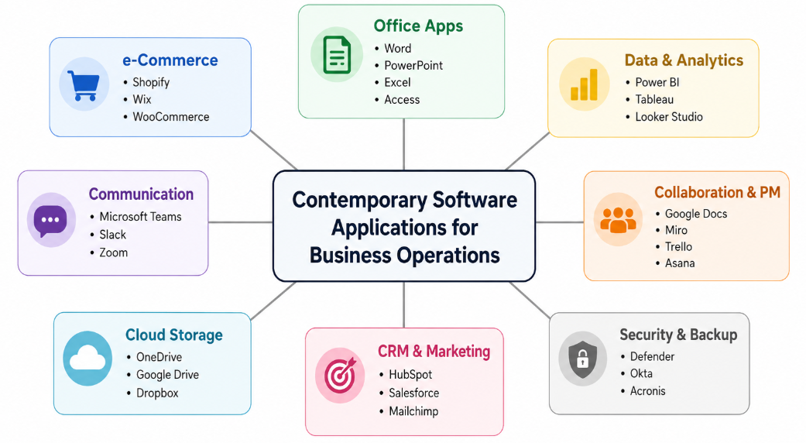
Figure 2: Mind map of contemporary software applications used to support day-to-day business operations.
The map may be read as a process of operation. The customer order can be entered in an e-Commerce platform, data can be analysed in Excel or PowerBI, discussed by staff in Teams, documented in Word and securely stored in the cloud. Tools that don't integrate seamlessly can cause staff to spend time copying data, looking for files, or communicating again. Rational choice of tools can enhance productivity and decision-making and accountability. For a small organisation, a good place to begin is to choose one e-Commerce platform, one office suite, one communication platform and one shared file location to implement before adding specialist CRM or analytics tools.

4. Task 3: Office Applications for Business Operations
Office applications are an integral part of business activities, as they help the employees to create, store, present and analyse information. In the applications tested here, Microsoft Word, Microsoft PowerPoint, Microsoft Excel and Microsoft Access are included. These are tools that are used in the workplace but have a different use. The critical evaluation must consider not only the range of capabilities of each tool but when it is appropriate and when another tool would be more appropriate.

4.1 Microsoft Word
Microsoft Word is a word processor that is used to write, edit, format and share documents. Microsoft support documents focus on creating, formatting, sharing and collaborating with documents [10]. For business use, Word can be used for reports, policies, meeting minutes, contracts, letters, training handouts, procedures and academic submissions. It has the following major features: styles, headings, tables, images, headers/footers, spelling and grammar checks, comments, track changes, references, mail merge and export to PDF.
Word is a controlled professional communication for the benefit of the business. Styles and headings provide structure, comments and track changes are used for review before finalising a document. Using mail merge can help to save time when creating personalised letters from a structured data source. The downside is that Word is not intended for the high-end data analysis and relational database storage. To minimise these risks, shared documents can be stored in OneDrive or SharePoint, review tools can be used, and version naming conventions can be applied.

4.2 Microsoft PowerPoint
Microsoft PowerPoint is a presentation software that is utilized to convey information by using slides. According to Microsoft, PowerPoint is a program used to create slides and pitch decks that have design and collaboration capabilities [11]. PowerPoint can be helpful in business operations for the following: Meetings, sales proposals, training sessions, project updates, investor pitches and management briefings. It has capabilities such as slide layouts, templates, themes, images, charts, SmartArt, animations, speaker notes and presenter view.
PowerPoint is good because it makes information a sequence of pictures. Numerical or process information can be better understood by using charts and diagrams than by using paragraphs. One of the drawbacks is that slides can be simplistic or decorative without supporting evidence. The rule of thumb is to keep the text on slides brief; ensure they are accurate and have a written report or appendix if necessary to provide detailed support.

4.3 Microsoft Excel
Microsoft Excel is a spreadsheet program to perform calculations, analysis, reporting and business modelling. Microsoft 365 is a collection of productivity applications like Word, Excel and PowerPoint [12] and Excel is popular for operational data tasks. In the business world, Excel is often used to track sales, create budgets, generate invoices, maintain inventory lists, build performance dashboards, calculate payroll, and develop decision support models. It has several major features such as formulas, functions, tables, charts, filters, conditional formatting, data validation, PivotTables and Goal Seek.
One of the advantages of Excel is its flexibility. A user can develop a simple model or tracker without having to use a complete database system. Decision rules can be applied automatically using IF functions, data can be looked up from reference tables by using lookup functions and data can be summarised by category by using PivotTables. The problem with spreadsheets is that they can be dangerous if formulas are incorrect, they have some rows hidden, or various versions are floating around. For the professional use, however, validation is required, assumptions must be documented, formula checking is necessary and protected calculation cells must be used.

4.4 Microsoft Access
Microsoft Access is a database management system that is used to develop and utilize structured data. According to Microsoft, Access is a software to create business applications using templates or from scratch [13]. Access is convenient where information must be kept as linked records instead of just the rows in a spreadsheet. Customer records, bookings, inventory, suppliers, service requests, asset registers are examples of data.
The main components of major features include tables, relationships, queries, forms and reports, as well as macros. Structured fields are stored in tables, relationships link records, queries extract data, forms enable data entry and reports display data. These capabilities give Access a significant advantage over Excel in a business environment where data is to be entered in a controlled manner and a relational structure is required. The drawbacks are that Access is more complex and less intuitive than Word or Excel, and is not suitable for large enterprise applications.

4.5 Overall evaluation of office applications
Table 2: Evaluation of Microsoft Office applications for business operations.
Application | Main business use | Major benefits | Limitations / risks
Word | Formal documents, policies, reports and letters. | Structure, formatting, review tools, references and PDF export. | Not suitable for calculations, dashboards or relational data storage.
PowerPoint | Presentations, briefings, training and proposals. | Visual communication, speaker support and audience engagement. | Can oversimplify information or become decorative without evidence.
Excel | Calculations, trackers, budgets and data analysis. | Flexible formulas, charts, validation, PivotTables and modelling. | Formula errors, version-control issues and weak relational control.
Access | Structured records, internal databases, forms and reports. | Relational structure, controlled forms and customised reporting. | Requires database planning and is not suitable for large enterprise systems.

The four applications complement each other. Word conveys formal information, while PowerPoint conveys information visually, Excel analyzes tabular data and Access stores structured records. A rational business isn't selecting one office application to use for each job. It chooses tools that are appropriate to the information problem. Typically, office software is not the problem, but the lack of file control, poor data quality, and inadequate user training.

5. Practical Testing Evidence: Microsoft Excel IF Function and PivotTable
The two features selected are the IF function and PivotTable in Microsoft Excel which represent two types of workplace skills. A PivotTable is a summary of a dataset for management analysis, whereas the IF function is used to apply a logical decision rule to individual records. A supporting workbook called is present in the appendix which contains simulated sales data.

5.1 Feature 1: IF Function in Microsoft Excel
The IF function performs a logical test and returns a value if the test is true, and another value if the test is false [14]. In the simulated sales workbook, the sales question relates to whether each order met the sales goal. The formula used in cell J2 is =IF(H2>=I2,"Target Achieved","Below Target"). The formula is then filled down so each row is automatically classified.
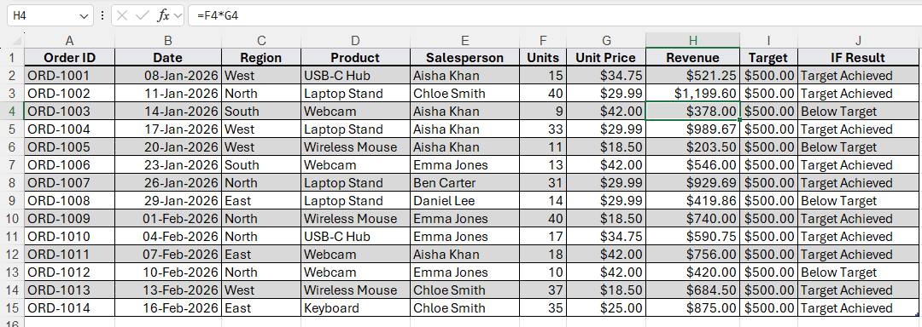
Figure 3: Evidence placeholder for Microsoft Excel screenshot showing multiplication formula
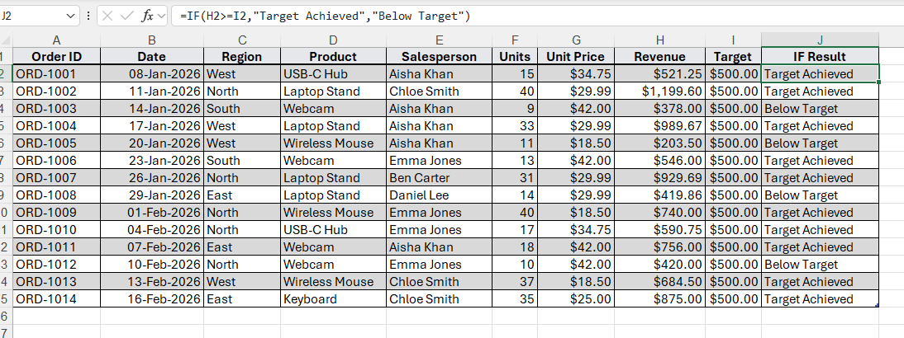
Figure 4: Evidence placeholder for Microsoft Excel screenshot showing IF results across simulated sales records.

This test is important as managers are frequently required to have automated classifications e.g. above target, below target, overdue, urgent or reorder required. The advantage is that it is consistent, meaning that the same rule is applied to all records. This is of course limited by the accuracy of the rule and source data. If the value targeted is incorrect, the classification will also be incorrect. This is an example of how it's important to perform data checking in addition to writing formulas in a practical spreadsheet application.

5.2 Feature 2: PivotTable in Microsoft Excel
A PivotTable is a tool that can be used to calculate, summarise and analyse worksheet data, to help identify comparisons, patterns and trends [15]. The Pivot_Source sheet is included in the practical workbook with simulated sales data, including a Region and a Product column and a Revenue column. The test generates a PivotTable that has Region in Rows, Product in Columns and Revenue in Values. This yields a cross tabulated summary of total revenue by region and by product.
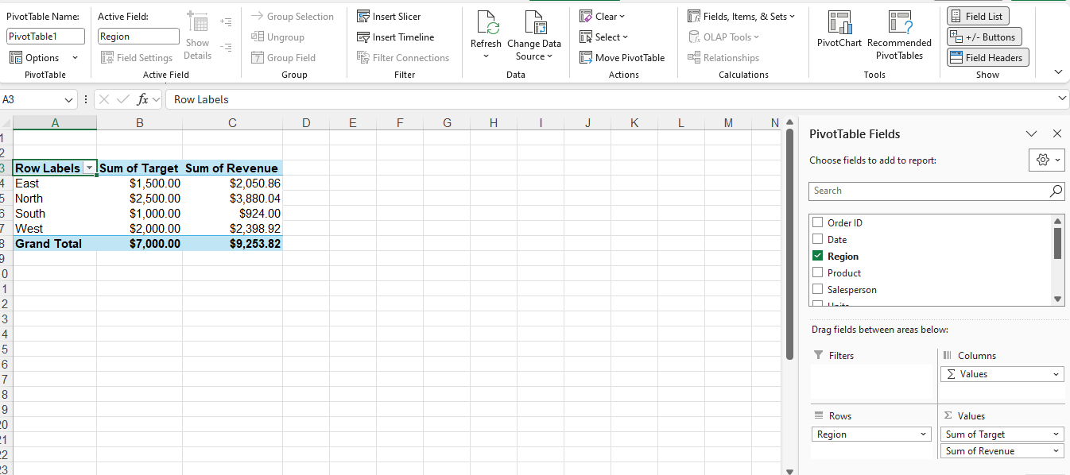
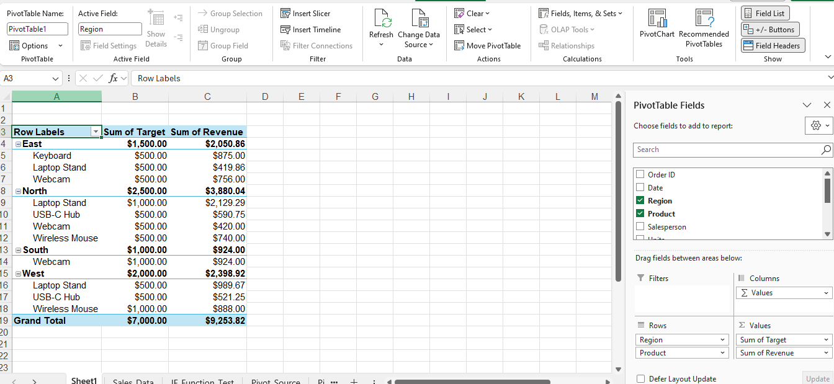
Figure 5: Evidence placeholder for Microsoft Excel screenshot showing PivotTable output.
This test is relevant because managers do not typically make decisions on a row-by-row basis. Typically require a summary by category, time, product or department. A PivotTable helps you to transform raw transaction data into management information. A drawback is that PivotTables rely on clean data in the source table. Source data should be checked prior to analysis, as blank cells or inconsistent product names and incorrect data types can lead the summary astray.

5.3 Interpretation of practical testing
The two tests illustrate various forms of business value. The IF function is used to provide row-by-row control over operations, as it uses a decision rule for every record. Managerial analysis is facilitated in PivotTable because it summarizes a lot of records. They demonstrate the ability of Excel to monitor and make decisions. The practical evidence also relates directly to the module learning outcomes as it shows evidence of knowledge of software packages and the ability to present information structured and managed.

6. Task 4: Communication and Online Collaboration Applications
Communication and collaboration are essential in modern working in business. Communication tools facilitate the exchange of messages, meetings and coordination of tasks. Collaboration tools enable people to collaborate on common files, documents and projects. The two areas intersect, but do not coincide. The study of digital workplace teams also highlights how collaboration technologies affect team communication, coordination and performance in relation to the affordances that they offer [16].

6.1 Communication application: Microsoft Teams
Microsoft Teams is a contemporary communication platform used for chats, channels, meetings, calls and file-based teamwork. Microsoft defines Teams as a tool for meetings, calling, chat and group collaboration [17]. It can be used in conjunction with organisations that are already using Microsoft 365, Outlook, OneDrive or SharePoint as it allows communication and file work to be linked.
It has a one-to-one chat, group chat, channels, online meetings, screen sharing, file sharing, calendar integration, meeting chat, notifications and app integrations as key features. These features help in streamlining operations and minimising the communication silos. A team can structure communication by project or department, which means that updates won't be lost across personal messages, phone calls and email threads. Meetings and chat history also allow the staff who are not present to "catch up" later.
The primary constraint is over-communication. Excessive channels, names that are not clear and too many notifications can decrease productivity. Teams must have rules, such as how to name channels, how to conduct meetings, and how and when to use chat versus email. The need for permission control, identity management and recovery planning in the use of shared digital platforms is also acknowledged in NIST guidance on cybersecurity risk management [2].

6.2 Practical communication feature test: Teams channel message or meeting

Figure 6: Microsoft Teams communication practical test using non-sensitive simulated content.
This evidence shows a communication characteristic, as a channel post or meeting record provides a common area for staff to communicate. The business value is speed and traceability: the message is seen by the intended team and can be responded to later on. The risk is privacy, therefore, only non-sensitive test content should be used.

6.3 Online collaboration application: Google Workspace / Google Docs
Google Workspace is a cloud-based productivity and collaboration platform. Google defines real-time collaboration in Docs, Sheets and Slides as the ability to collaborate on documents, leave comments and suggestions, see the version history, and accept or reject suggestions [18]. Google support instructions also state that Docs, Sheets and Slides have a version history, which can be viewed by users with the right permissions. The advantages of Google Docs are that several users can collaborate on a single document instead of sending multiple copies of the file.
Some of the important collaboration features are shared file access, role-based permissions, real-time editing, comments and suggestions, version history and cloud storage. These functions eliminate version control issues as team members don't have to ask what the latest version of the attachment is. Comments and suggestions also enhance review since feedback can be added to specific text instead of being provided in a general message.
The benefits of Google Docs include accessibility, simple co-authoring and quick review. The restrictions are permission risk, dependence on the internet and formatting issues if exporting to Word or PDF. A user may inadvertently give a document too many permissions or give editing access when viewing access is more appropriate. Companies should therefore educate employees on how to properly use the sharing settings and not put sensitive data in improperly managed files.

6.4 Practical collaboration feature test: Google Docs comments/suggestions
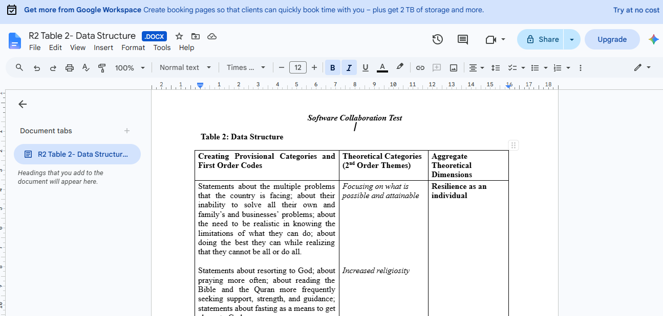
Figure 7: Evidence placeholder for Google Docs online collaboration practical test.

6.5 Comparison and recommendation
Table 3: Comparison of communication and collaboration applications.
Criterion | Microsoft Teams | Google Docs / Google Workspace
Primary role | Communication through chats, channels, calls and meetings. | Collaboration through shared documents, comments and real-time editing.
Strongest value | Fast coordination and meeting communication. | Co-authoring documents and reducing version-control issues.
Best workplace use | Project channels, staff updates, meetings and quick decisions. | Shared reports, meeting notes, policy drafts and group assignments.
Main risk | Notification overload, unmanaged channels and overuse of chat. | Incorrect sharing permissions and dependence on cloud access.
Recommendation | Use with channel naming rules and meeting etiquette. | Use with permission control and version-history awareness.

The best advice is to not confuse communication and collaboration. Teams is more suitable for on-the-spot conversations and meetings in the workplace. Google Docs is better for co-creating documents. A business can employ both, but it is important to establish guidelines. For instance, you can use Teams to discuss and agree on responsibilities and Google Docs to create the shared report. This prevents the usual scenario where a decision is discussed in a chat and documents are attached.

7. Conclusion
It has been demonstrated in this report that the use of modern software applications for business can be beneficial if they are chosen for the task they are meant to accomplish. Shopify and Wix eCommerce are both great options for businesses to sell online, but Shopify is better suited for businesses focused on commerce, while Wix is better suited for a small business website with a simple store. When decisions are taken, mind mapping can be transformed into an action plan, which helps to plan and communicate the relationships between software categories.
The assessment of Microsoft Word, PowerPoint, Excel and Access demonstrates that office applications are still important because they can be used to perform various information tasks. Word is best used for formal documents, PowerPoint for presentations, Excel for analysis and Access for structured records. The practical tests using Excel show how the IF function can categorize data and how a PivotTable can summarise data for decision making. These tests are based on simulated data to ensure confidentiality and still provide evidence of practical skill.
Last, Microsoft Teams and Google Docs demonstrate the role of communication and collaboration tools in today's work. Teams makes it easy to coordinate with staff via messages and meetings, and Google Docs enables multiple people to create documents with comments, suggestions and document history. The bottom line of the lesson is that technology only enhances productivity when it is used for a clear purpose, with reliable data, with the correct permissions and with a structured communication system. This directly relates to workplace readiness and the module learning outcomes.

References
- OECD, The Digital Transformation of SMEs. Paris, France: OECD Publishing, 2021. [Online]. Available: https://www.oecd.org/en/publications/the-digital-transformation-of-smes_bdb9256a-en.html.
- National Institute of Standards and Technology, The NIST Cybersecurity Framework (CSF) 2.0, NIST CSWP 29, Feb. 2024, doi: 10.6028/NIST.CSWP.29.
- Kahveci, E. (2025). Digital transformation in SMEs: enablers, interconnections, and a framework for sustainable competitive advantage. Administrative Sciences, 15(3), 107.
- Shopify, "Shopify products and features," Shopify, 2026. [Online]. Available: https://www.shopify.com/products.
- Shopify Help Center, "Shopify analytics," Shopify, 2026. [Online]. Available: https://help.shopify.com/en/manual/reports-and-analytics/shopify-reports.
- Wix, "eCommerce features that help you sell more online," Wix.com, 2026. [Online]. Available: https://www.wix.com/ecommerce/features.
- Miro, "Mind map maker for collaboration and visual thinking," Miro, 2026. [Online]. Available: https://miro.com/mind-map/.
- Sajadi, A. S., Babajani, A., Maroufi, S. S., & Sarraf, N. (2024). Using the mind map method in medical education, its advantages and challenges: A systematic review. Journal of Education and Health Promotion, 13(1), 483.
- Microsoft, "Word help & learning," Microsoft Support, 2026. [Online]. Available: https://support.microsoft.com/en-us/word.
- Microsoft, "Microsoft PowerPoint: presentations and slides online," Microsoft 365, 2026. [Online]. Available: https://www.microsoft.com/en-us/microsoft-365/powerpoint.
- Microsoft, "Microsoft 365: write, create and collaborate," Microsoft 365, 2026. [Online]. Available: https://www.office.com/.
- Microsoft, "Database software and applications: Microsoft Access," Microsoft 365, 2026. [Online]. Available: https://www.microsoft.com/en-us/microsoft-365/access.
- Microsoft, "IF function," Microsoft Support, 2026. [Online]. Available: https://support.microsoft.com/en-us/office/if-function-69aed7c9-4e8a-4755-a9bc-aa8bbff73be2.
- Microsoft, "Create a PivotTable to analyze worksheet data," Microsoft Support, 2026. [Online]. Available: https://support.microsoft.com/en-us/office/create-a-pivottable-to-analyze-worksheet-data-a9a84538-bfe9-40a9-a8e9-f99134456576.
- Lane, J. N., Leonardi, P. M., Contractor, N. S., & DeChurch, L. A. (2024). Teams in the digital workplace: Technology’s role for communication, collaboration, and performance. Small Group Research, 55(1), 139-183.
- Microsoft, "Microsoft Teams: video conferencing, meetings, calling and group chat software," Microsoft Teams, 2026. [Online]. Available: https://www.microsoft.com/en-us/microsoft-teams/group-chat-software.
- Google Workspace, "Collaborate with real-time editing," Google Workspace Resources, 2026. [Online]. Available: https://workspace.google.com/resources/real-time-editing/.
- Google Workspace Learning Center, "Tips to edit and collaborate on files," Google Support, 2026. [Online]. Available: https://support.google.com/a/users/answer/13004165.

Appendix: Excel File

