

MSc Public Health and Social Care in Practice
Module Name: Social Epidemiology and Public Health Development

Module Code: LCHS7000
Lecturer : Dr. Hamdi Hussain
Assignment Title: Component 2 Analytical Report
Ethnicity and Health Inequalitities

Student Name: Disha Nasit
Student ID number: 2528386
Words: 2683

Table of Contents
Task 1: Social Epidemiological Analysis 4
Title 4
1.1 Introduction 4
1.2 Contextual background and underlying factors 4
1.2.1 Three Diseases and Illness 4
1.2.2 Three social issues 7
1.2.3 National response to reduce health inequality 10
1.3 Organisational support 11
1.3 Conclusion 11
Task 2: Epidemiological Analysis 13
2.1 Introduction 13
2.2 Main body 15
2.2.1 Public health measures for the older population using the 3P's 15
2.2.2 Key risk factors 16
2.2.3 Affected population 17
2.2.4 Explain the main public health approaches and strategies used to monitor 17
2.2.5 Plan and use epidemiology to determine the public health impact/short- and long-term consequences of the disease 18
2.2.6 Design and evaluate an appropriate health intervention program 18
2.2.7 Strengths and weaknesses of the epidemiological approach 19
2.3 Conclusion 20
Reference List 21

Task 1: Social Epidemiological Analysis

Title
Health Inequalities among Black ethnic Groups in the UK: A Socioeconomic and Policy Perspective.

1.1 Introduction
The chosen population group for the topic is the Black minority group in the UK, which includes Black Africans, Black Caribbeans, and Black Britons. According to ONS (2021), people from black ethnic groups make up around 4% of the UK population. The particular group faces a huge health inequality because of minority inequality and socioeconomic disadvantages due to lower income, unemployment rate and poor housing conditions.

1.2 Contextual background and underlying factors

1.2.1 Three Diseases and Illness
The identified three diseases among the Black population are:
Type 2 Diabetes
In the UK, black ethnic groups are more likely to contract Type 2 Diabetes because of genetic inclination, obesity, and socioeconomic deprivation. The National Health Service states that individuals of Black African and Caribbean origin have a higher likelihood of getting type 2 diabetes by up to three times as much as the Whites do (Farmaki et al., 2022). According to Khunti et al. (2023), among black Caribbeans in the UK, the rate is highest due to nutrition, lack of physical exercise, and inadequate access to preventive medical services as risk factors.
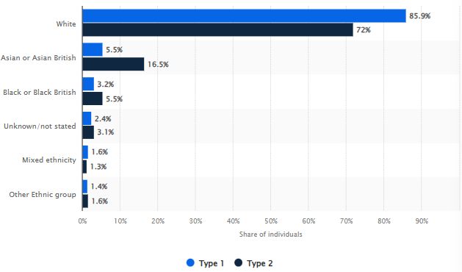
Figure 1: Access of diabetes among different ethnicities
(Source: Statista, 2026)
The figure 1 shows that more type 2 diabetes are more among the black, but the registered individuals are more among white and Asian British due to inequality of health service access.
Some solutions are screening at an early stage, health education in a manner that is culturally empathetic, and lifestyle programmes that tend to promote healthy eating and physical activities in a community.
Hypertension
The Black communities in the UK have a high prevalence of hypertension. According to the data of NHS England (2025), Black African and Caribbean adults tend to develop high blood pressure at earlier ages. According to the NHS England (2022) in figure 2, data from the Caribbean shows that the rate is the highest due to chronic stress, socioeconomic disadvantage, poor housing, and diet.
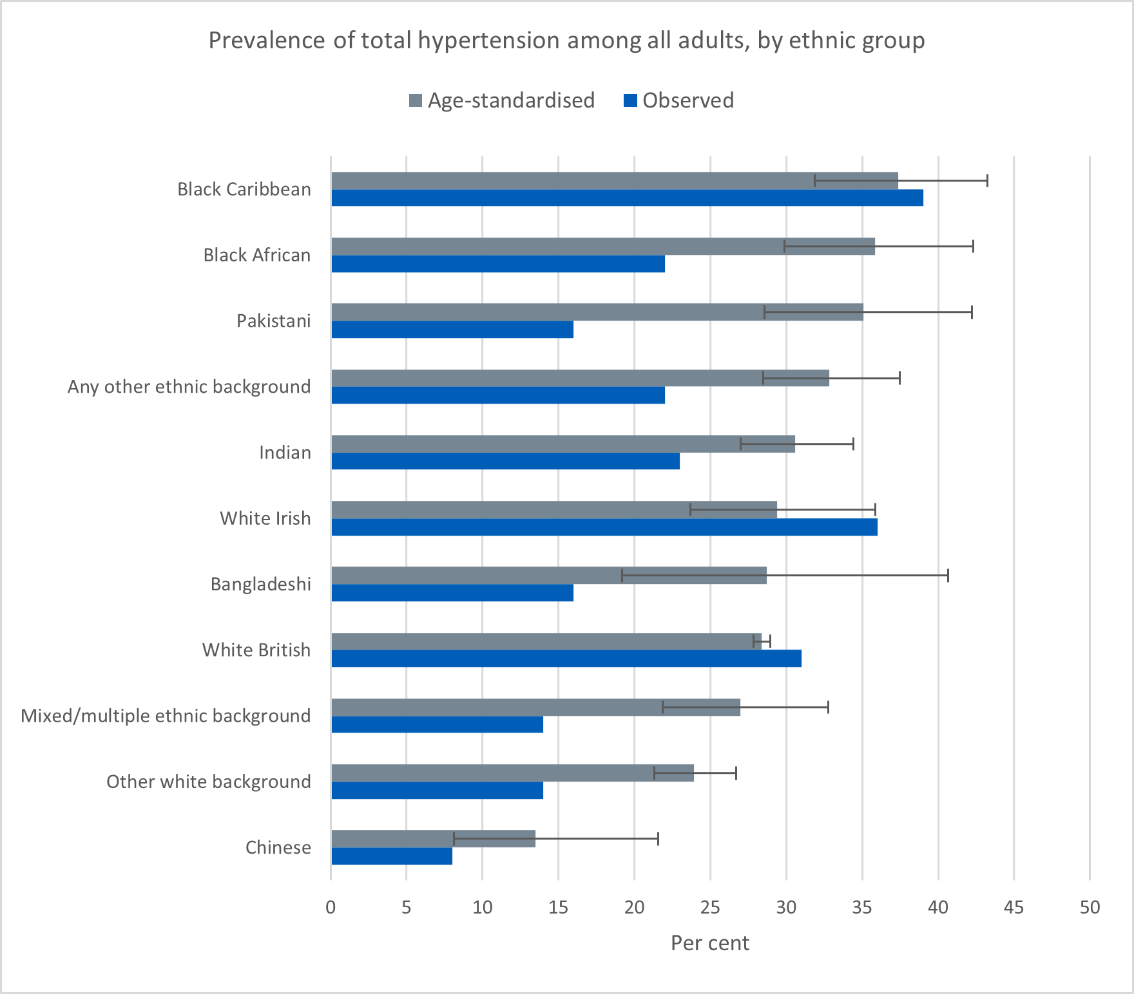
Figure 2: Hypertension rate, ethnicity-wise
(Source: NHS England, 2022)
Regular blood pressure screening, increased access to primary care, and special awareness creation regarding salt consumption, diet and physical activity should be included in the list of public health interventions.
Mental health illness
The Black ethnic groups have a disproportionate impact of severe mental illnesses such as Schizophrenia. According to Devonport et al. (2023), the rate of Black women being detained under the Mental Health Act 1983 is about four times higher than that of Whites. This is predisposed to social discrimination, economic strain, and limitations of culturally sensitive mental health services.
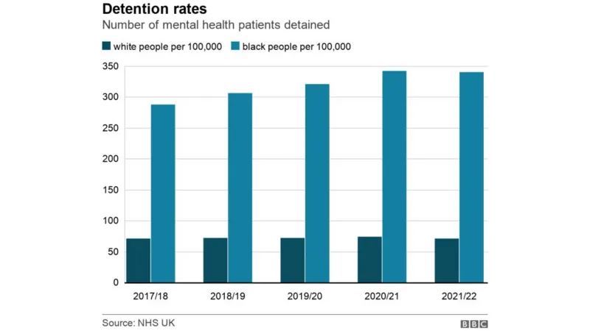
Figure 3: Mental health among different ethnicities in the UK
(Source: Brewer, 2022)
Figure 3 shows that mental health among the black people higher than white people in per 100000 which clearly shows the inequality of healthcare access. The possible solutions are culturally competent mental health services, community support programmes, and early intervention strategies to enhance care access and decrease stigma.

1.2.2 Three social issues
Racial discrimination
The Equality and Human Rights Commission said that persons with black ethnic backgrounds are more likely to report being discriminated against in the working environment, educational and healthcare sectors, according to Drydakis (2024).
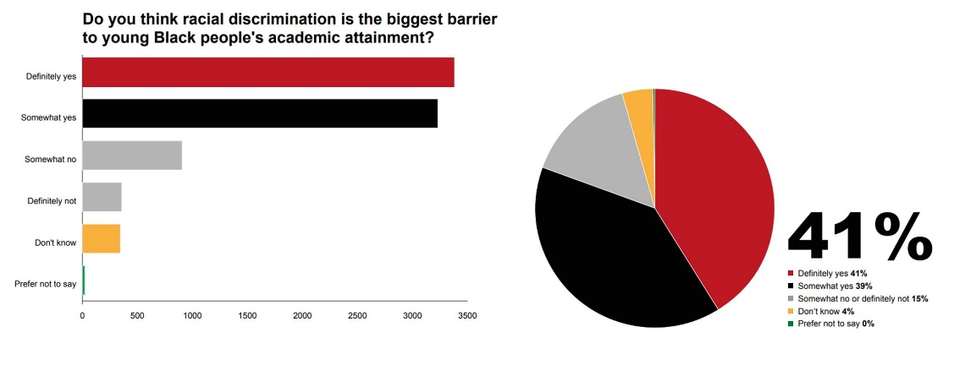
Figure 4: Survey data for racial discrimination
(Source: University of Cambridge, 2023)
As per the survey data in figure 4, 41% students face racial discrimination in ter university so it can show how intense the racial discrimination in the UK.
The solution to this problem should be a more robust anti-discrimination policy, cultural competency education of health workers, and community-based involvement to make the services provided fair and inclusive.
Limited access of healthcare service
The other significant challenge is limited access to healthcare services. According to Bansal et al. (2022), there can be barriers to ethnic minority groups, like language issues, the unavailability of culturally friendly services, and decreased knowledge of preventive healthcare programmes.
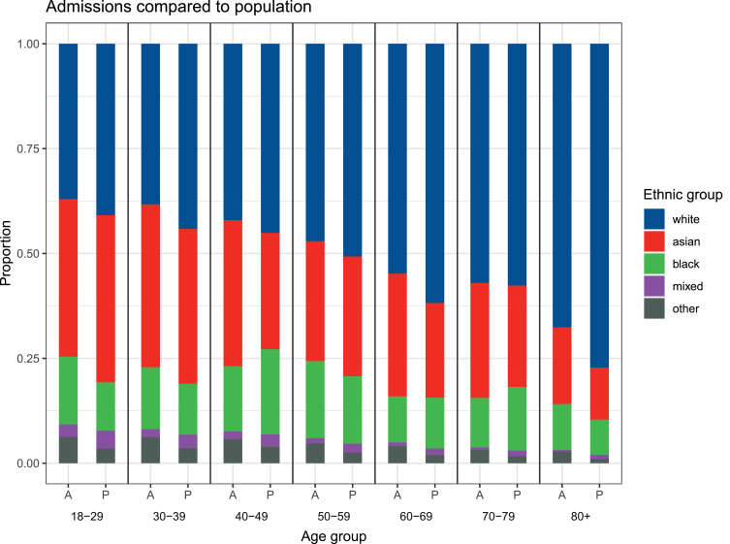
Figure 5: Health access data
(Source: Wan et al., 2021)
Figure 5 shows black population has admits in the hospitals in acute cases more less than white and Asians.
Solutions can be the enhancement of community health education, outreach services, and the diversity of the healthcare workforce to facilitate culturally sensitive health care.
Housing issue
Poor housing is also a cause of health inequality. According to the reports of the Office of National Statistics (2023), figure 6, black households in the UK are also more likely to be overcrowded or of poor quality as opposed to the national average.
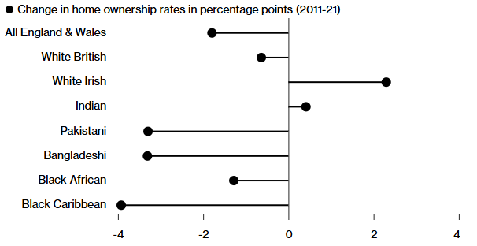
Figure 6: Housing issues based on race in the UK
(Source: Konotey-Ahulu, 2023)
To reduce such inequalities, it is required for the governmental investment in low-cost housing and better housing policies.

1.2.3 National response to reduce health inequality
The NHS Long Term Plan was developed in 2019 by the NHS, which aims to reduce the health inequalities within the UK. It has the purpose to improve access to healthcare services among minority or disadvantaged people (NHS England, 2025). It seeks to increase preventive health care, early diagnosis, and health services in the community. Mental health support, diabetes prevention programmes and the enhancement of primary care in deprived areas are also the priorities of the plan.
The other national campaign is Every Mind Matters campaign, which was introduced by Public Health England. This mental well-being awareness programme will help in promoting mental well-being through online resources and self-care information, as well as customised mental health action plans (NHS UK, 2025).

Figure 7: Every Mind Matters campaign
(NHS UK, 2025)
The campaign promotes early help-seeking, and it will also help to minimise stigma about mental illness.

1.3 Organisational support
The Black Health Initiative is one of the organisations that are significant in reducing the inequity of health among the Blacks in the UK, and it is a charity that aims to enhance the health and well-being of the Blacks and minority ethnic communities (Black Health Initiative, 2026). This organisation strives to create awareness of health inequities, such as increased vulnerability to conditions such as diabetes, hypertension, and mental health problems. Social justice is another agenda of the charity that points out how racial discrimination, poor housing, and socioeconomic disadvantages affect health outcomes.
One of the objectives of the organisation is to help in minimising health inequities in the Black communities through the creation of awareness, accessibility to healthcare services, and promotion of early screening and preventive health practices in the community in the next five years. This goal would help in improving health and increasing health equity in the UK.

1.3 Conclusion
It has been found that Type 2 diabetes among the black African and Caribbean populations, hypertension among the black population and also mental illness among them are much higher in the UK population due to three main social issues: ethnic discrimination, limited access to healthcare and the housing system. All these can be addressed through proper policies and awareness programs of NHS UK.

Task 2: Epidemiological Analysis

2.1 Introduction
Type 2 Diabetes is a long-term metabolic disorder whereby the body becomes insulin-resistant or unable to generate sufficient insulin, as a result of which blood glucose levels build up. It is a significant UK-wide public health issue which impacts millions of individuals.
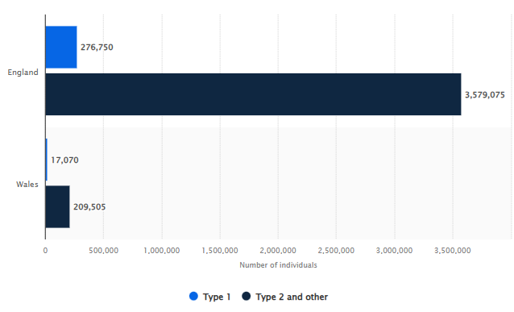
Figure 8: Type 2 Diabetes prevalence in Wales and England
(Statista, 2026)
According to Figure 1, type 2 diabetes is the most common diabetes among the population of England and Wales.
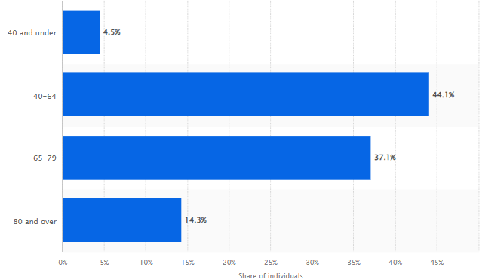
Figure 9: Age-wise prevalence of type 2 diabetes
(Source: Statista, 2026)
Figure 2 shows that 40 to 64 means the older adults are suffering from type diabetes in the UK as per 2023 and 2024 data.
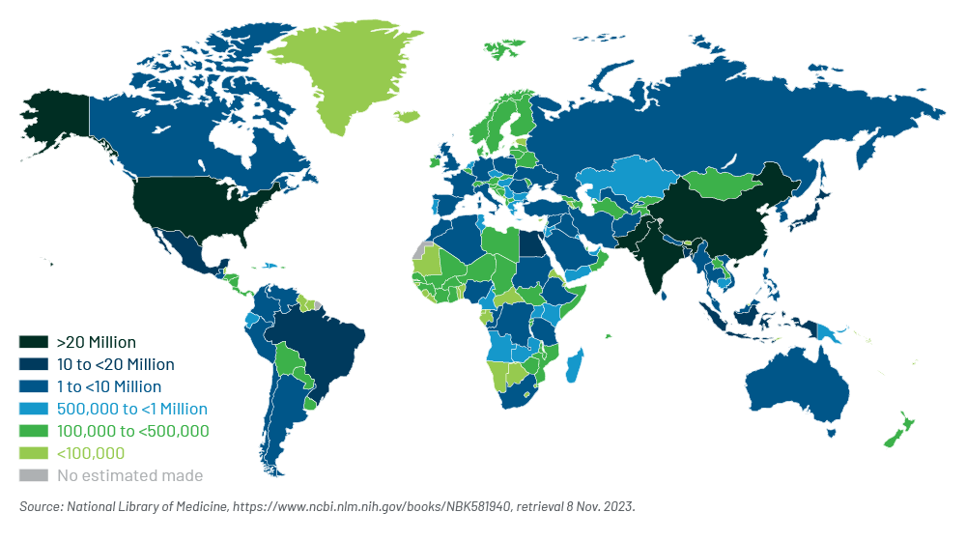
Figure 10: Prevalence of type 2 diabetes in the world
(Source: Oman-Ganes, 2024)
According to Figure 3, the prevalence is highest in Asian and American countries and then in European countries. It is less seen in African regions.

2.2 Main body

2.2.1 Public health measures for the older population using the 3P's
Using the 3P model of healthcare, the public health measures are drawn for type 2 Diabetes among the older population of the UK.

Figure 11: 3P model of health
(Source: Self-developed and idea taken from Bower et al., 2023)
Prevention:
The prevention programs are focused on minimising the susceptibility of the older population in the UK to Type 2 Diabetes. Bower et al. (2023) said the NHS Diabetes Prevention Programme is one of the initiatives being provided by the National Health Service. The programme is aimed at adults who are at high risk of diabetes, such as older adults, and gives them information on healthy eating, maintaining weight, and engaging in physical exercise. Early screening using GP practices enlightens people with pre-diabetes, too, thus early intervention can be carried out to avoid the advancement of the disease.
Protection:
Protective interventions are aimed at preventing complications and safeguarding the well-being of pre-existing vulnerable elderly members. The NHS Health Check programme provides free health check-ups to adults aged between 40 and 74 to identify risk factors, including excessive blood glucose, elevated blood pressure, and cholesterol levels (NHS, 2025). This is controlled with regular monitoring, medication, and lifestyle advice to minimise the disease and cardiovascular problems, renal problems, and so on.
Promotion:
The goals of health promotion are to create awareness and promote a healthier lifestyle among the elderly. Better Health Campaign is a national campaign that encourages healthy eating habits, less sugar and more exercise (Department of Health and Social Care, 2025). Through educational programmes and community outreach, the older adults are advised to change their unhealthy behaviours that can enhance the management of diabetes and the overall effect of diabetes on the entire population.

2.2.2 Key risk factors
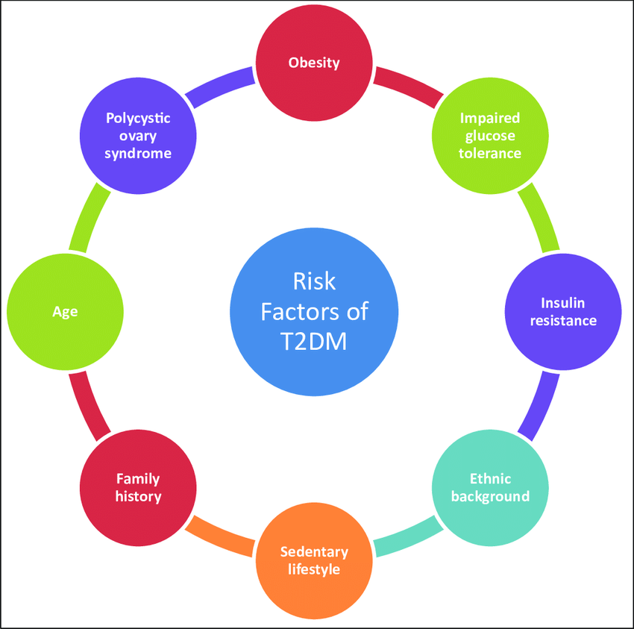
Figure 12: Risk factors of T2DM
(Source: Bandey, Sameer and Nissar, 2020)
There are some determinants and risk factors that are critical in the formation of Type 2 Diabetes in the UK population. One of such factors is the prevalence of obesity and overweight, which makes a person more insulin-resistant and is closely connected with the prevalence of diabetes. Another significant determinant is physical inactivity, where exercise is not performed regularly, and hence it influences the metabolism of glucose. Risk is also fostered by unhealthy diets, especially the large doses of sugar, processed food, and saturated fats. Age is an important factor, and individuals above 40 years are more likely to develop the condition. Also, there are genetic determinants and family history that are also responsible (Bandey, Sameer and Nissar, 2020).

2.2.3 Affected population
The epidemiological studies in Type 2 diabetes shows the most affected people are the older young in the UK. As per the statistics of ONS (2024), approximately 7% adults in England are suffering from type 2 diabetes, and the prevalence rate is higher among the older population. Individuals of old age, especially the obese, with sedentary lifestyles, and other cardiovascular risk factors, have a higher likelihood of developing the disease.

2.2.4 Explain the main public health approaches and strategies used to monitor
Disease Surveillance Systems:
The incidence of Type 2 Diabetes in older adults is monitored using national surveillance systems in the UK. The National Health Service gathers the information with the help of the National Diabetes Audit that monitors the rates of diagnosis, the outcome of treatment, and complications (Johnson et al., 2022). This audit collects data about GP practices and hospitals in England and assists the public health authorities in determining trends and populations that are at risk, especially individuals who are aged 60 and above.
Risk screening and risk monitoring:
The other significant plan is population screening with the help of the NHS Health Check programme. Adults between the ages of 40 and 74 years are encouraged to have regular health checks, which include the blood sugar levels, blood cholesterol, blood pressure and body weight index (NHS, 2025). The checks assist in the early diagnosis of diabetes or pre-diabetes among the elderly population to enable early intervention and constant monitoring of disease prevalence.
Epidemiological Research and Data Reporting
Epidemiological research is also undertaken by the public health agencies like the Office for National Statistics, which also publishes health statistics concerning the prevalence and risk factors of diabetes (Soares Andrade et al., 2023). The reports give evidence to policymakers and healthcare providers on how to design specific prevention programmes and track the long-term trends of diabetes among the ageing population.

2.2.5 Plan and use epidemiology to determine the public health impact/short- and long-term consequences of the disease
The available epidemiological outcomes provided by the National Health Service and the Office of National Statistics can assist the authorities of public health to estimate the prevalence rates, incidence rates, and complications of a disease among adults over the age of 60 (Ahmad et al., 2022). Such data can help health professionals evaluate short-term and long-term effects of the disease and to develop relevant interventions.
The epidemiological studies demonstrate that, in the short term, elderly patients with type 2 diabetes are exposed to risk as manifested by fatigue, frequent infections, and slow healing of wounds. Such problems may create a decrease in the quality of life and heighten the needs in primary healthcare services (Bodke et al., 2023). The epidemiological monitoring also assists in the identification of high-risk groups and promotes the early diagnosis and treatment.
The disease may lead to severe complications in the long term, such as cardiovascular disease, kidney failure, nerve damage, and loss of vision. The National Health Service has reported that diabetes related complications are a major contributor to hospitalisation and healthcare expenses in the UK.

2.2.6 Design and evaluate an appropriate health intervention program
An appropriate intervention to resolve Type 2 Diabetes among the elderly population in the UK is a community-based diabetes prevention and control program implemented in the local health centres and GP practices under the National Health Service. The programme would involve routine monitoring of the level of blood glucose, health education on a balanced diet and physical activities and specific counselling of lifestyle to older adults who are 60 years and above (Akbar et al., 2025). Physical activity of the older adults would be increased with the assistance of community workshops and exercising as a group, and the dietitians would educate the older adults on how to reduce their sugar consumption and weight more than usual.

Figure 13: Proposed community-based T2D prevention program
(Source: self-created and idea taken from Akbar et al., 2025)
The anticipated effects of this intervention can be early diagnosis of diabetes and pre-diabetes, better lifestyle behaviour, and the management of the disease in older adults. Awareness and education can provide healthier eating habits and promote physical activity to decrease blood glucose and obesity (Zehra et al., 2025). Cardiovascular disease, kidney failure and vision issues are complications that can be minimised in the long run by the programme. It can also reduce the number of hospital admissions and spending on healthcare.

2.2.7 Strengths and weaknesses of the epidemiological approach
Strengths
The availability of epidemiological data supplied by organisations like the National Health Service and the Office of National Statistics is the source of reliable and high-scale population data. This assists in identifying the high-risk groups, comprehending the disease patterns and assisting in evidence-based planning of the public health (Perng et al., 2023). It is also able to provide tracking of disease trend patterns and assessment of the prevention programmes against older adults.
Weakness
Nonetheless, this method is chiefly quantitative and may not be able to completely represent personal behaviours, cultural factors, or social obstacles to disease risk. Also, not all of the cases might be diagnosed or reported, which can impact the accuracy of epidemiological estimates (Ahmed et al., 2022). Thus, the methodology must be supplemented by qualitative research in order to have a wider cognition.

2.3 Conclusion
For task 2, diabetes among the older population of the UK has been chosen because the prevalence of type 2 diabetes is very high among the population aged 40 to 65. The epidemiological study has been done using ONS and NHS data, and a community-based diabetes prevention program has been proposed, which is critically evaluated.

Reference List
Ahmad, E., Lim, S., Lamptey, R., Webb, D.R. and Davies, M.J., (2022). Type 2 diabetes. The Lancet, 400(10365), pp.1803-1820. https://www.academia.edu/download/86145616/dme.pdf
Akbar, M.A., Sahar, J., Rekawati, E., Sartika, R.A.D. and Gupta, P., (2025). The Effect of Community Based Intervention on People with Type 2 Diabetes Mellitus: Systematic Review. Public Health of Indonesia, 11(S1), pp.39-51. https://researchonline.lshtm.ac.uk/id/eprint/4677183/1/Akbar-etal-2025-The-effect-of-community-based.pdf
Banday, M.Z., Sameer, A.S. and Nissar, S., (2020). Pathophysiology of diabetes: An overview. Avicenna journal of medicine, 10(04), pp.174-188. https://www.thieme-connect.com/products/ejournals/html/10.4103/ajm.ajm_53_20
Bansal, N., Karlsen, S., Sashidharan, S.P., Cohen, R., Chew-Graham, C.A. and Malpass, A., (2022). Understanding ethnic inequalities in mental healthcare in the UK: A meta-ethnography. PLoS Medicine, 19(12), p.e1004139. https://journals.plos.org/plosmedicine/article/file?id=10.1371/journal.pmed.1004139&type=printable
Black Health Initiative, (2026). Available at: https://www.blackhealthinitiative.org/ [Accessed on 7th March 2026]
Bodke, H., Wagh, V., Kakar, G. and WAGH, V., (2023). Diabetes mellitus and prevalence of other comorbid conditions: a systematic review. Cureus, 15(11). https://www.cureus.com/articles/175241-diabetes-mellitus-and-prevalence-of-other-comorbid-conditions-a-systematic-review.pdf
Bower, P., Soiland‐Reyes, C., Heller, S., Wilson, P., Cotterill, S., French, D. and Sutton, M., (2023). Diabetes prevention at scale: Narrative review of findings and lessons from the DIPLOMA evaluation of the NHS Diabetes Prevention Programme in England. Diabetic Medicine, 40(11), p.e15209. https://onlinelibrary.wiley.com/doi/pdfdirect/10.1111/dme.15209
Brewer. H, (2022). Sheffield: Call to tackle 'systemic racism' in mental health care. BBC News. Available at: http://bbc.com/news/uk-england-south-yorkshire-63313351 [Accessed on 7th March 2026]
Department of Health and Social Care, (2025). Type 2 Diabetes Prevention Week 2025 Toolkit. Available at: https://campaignresources.dhsc.gov.uk/campaigns/healthier-you-nhs-diabetes-prevention-programme/type-2-diabetes-prevention-week-2025-toolkit/#:~:text=It%20will%20encourage%20the%20public,and%20being%20more%20physically%20active.&text=Type%202%20Diabetes%20Prevention%20Week%202025%20toolkit%20and%20supporting%20assets,local%20healthcare%20or%20community%20settings [Accessed on 7th March 2026]
Devonport, T.J., Ward, G., Morrissey, H., Burt, C., Harris, J., Burt, S., Patel, R., Manning, R., Paredes, R. and Nicholls, W., (2023). A systematic review of inequalities in the mental health experiences of Black African, Black Caribbean and Black-mixed UK populations: Implications for action. Journal of racial and ethnic health disparities, 10(4), pp.1669-1681. https://wlv.openrepository.com/bitstreams/d0912df6-dd10-4c76-b6ec-83543571a447/download
Drydakis, N., (2024). Discrimination and health outcomes in England's black communities amid the cost-of-living crisis: evaluating the role of inflation and Bank Rates. Ethnic and Racial Studies, pp.1-29. https://www.tandfonline.com/doi/pdf/10.1080/01419870.2024.2410900
Farmaki, A.E., Garfield, V., Eastwood, S.V., Farmer, R.E., Mathur, R., Giannakopoulou, O., Patalay, P., Kuchenbaecker, K., Sattar, N., Hughes, A. and Bhaskaran, K., (2022). Type 2 diabetes risks and determinants in second-generation migrants and mixed ethnicity people of South Asian and African Caribbean descent in the UK. Diabetologia, 65(1), pp.113-127. https://link.springer.com/content/pdf/10.1007/s00125-021-05580-7.pdf
Johnson, N., Phipps, L.P., Hansford, K.M., Folly, A.J., Fooks, A.R., Medlock, J.M. and Mansfield, K.L., (2022). One Health approach to tick and tick-borne disease surveillance in the United Kingdom. International Journal of Environmental Research and Public Health, 19(10), p.5833. https://www.mdpi.com/1660-4601/19/10/5833
Khunti, K., Feldman, E.L., Laiteerapong, N., Parker, W., Routen, A. and Peek, M., (2023). The impact of the COVID-19 pandemic on ethnic minority groups with diabetes. Diabetes care, 46(2), pp.228-236. https://diabetesjournals.org/care/article-pdf/46/2/228/696460/dc212495.pdf
Konotey-Ahulu. O, (2023). UK’s Sinking Home Ownership Levels Are Hitting Ethnic Minorities Hardest. Bloomberg. Available at: https://www.bloomberg.com/news/articles/2023-04-20/uk-s-sinking-home-ownership-levels-are-hitting-ethnic-minorities-hardest [Accessed on 7th March 2026]
NHS England, (2022). Health Survey England Additional Analyses, Ethnicity and Health, 2011-2019 Experimental statistics. Available at: https://digital.nhs.uk/data-and-information/publications/statistical/health-survey-england-additional-analyses/ethnicity-and-health-2011-2019-experimental-statistics/blood-pressure [Accessed on 7th March 2026]
NHS England, (2025). How Lambeth is closing the health inequality gap for Black and minority ethnic patients with high blood pressure. Available at: https://www.england.nhs.uk/about/equality/equality-hub/case-studies/how-lambeth-is-closing-the-health-inequality-gap-for-black-and-minority-ethnic-patients-with-high-blood-pressure/ [Accessed on 7th March 2026]
NHS England, (2025). Our approach to reducing healthcare inequalities. Available at: https://www.england.nhs.uk/about/equality/equality-hub/national-healthcare-inequalities-improvement-programme/our-approach-to-reducing-healthcare-inequalities/#:~:text=The%20NHS%20Long%20Term%20Plan%20places%20tackling,a%20purchaser%2C%20and%20a%20local%20anchor%20institution [Accessed on 7th March 2026]
NHS UK, (2025). Every mind matters. Available at: https://www.nhs.uk/every-mind-matters/ [Accessed on 7th March 2026]
NHS, (2025). NHS Health Check. Available at: https://www.nhs.uk/tests-and-treatments/nhs-health-check/ [Accessed on 7th March 2026]
Office of National Statistics, (2023). Ethnic group differences in health, employment, education and housing shown in England and Wales' Census 2021. Available at: https://www.ons.gov.uk/peoplepopulationandcommunity/culturalidentity/ethnicity/articles/ethnicgroupdifferencesinhealthemploymenteducationandhousingshowninenglandandwalescensus2021/2023-03-15 [Accessed on 7th March 2026]
Oman-Ganes. L, (2024). Diabetes Type 2 – Global Collaboration, Transformation, and Challenge. Gen Re. Available at: https://www.genre.com/us/knowledge/publications/2024/january/diabetes-type-2-global-collaboration-transformation-and-challenge-en [Accessed on 7th March 2026]
ONS, (2024). Risk factors for pre-diabetes and undiagnosed type 2 diabetes in England: 2013 to 2019. Available at: https://www.ons.gov.uk/peoplepopulationandcommunity/healthandsocialcare/healthinequalities/bulletins/riskfactorsforprediabetesandundiagnosedtype2diabetesinengland/2013to2019 [Accessed on 7th March 2026]
Perng, W., Conway, R., Mayer-Davis, E. and Dabelea, D., (2023). Youth-onset type 2 diabetes: the epidemiology of an awakening epidemic. Diabetes care, 46(3), pp.490-499. https://diabetesjournals.org/care/article-pdf/46/3/490/698836/dci220046.pdf?utm_source=consensus
Soares Andrade, C.A., Shahin, B., Dede, O., Akpeji, A.O., Ajene, C.L., Albano Israel, F.E. and Varga, O., (2023). The burden of type 2 diabetes mellitus in states of the European Union and United Kingdom at the national and subnational levels: A systematic review. Obesity Reviews, 24(9), p.e13593. https://onlinelibrary.wiley.com/doi/pdfdirect/10.1111/obr.13593
Statista, (2026). Distribution of individuals registered with diabetes in England in 2023/24, by ethnicity*. Available at: https://www.statista.com/statistics/387359/individuals-with-diabetes-by-ethnicity-in-england/?srsltid=AfmBOop6LMfWT03gozUxguT_lFEcoGhpDBJOrCFeOM8Sqn5NGf0jWsFQ [Accessed on 7th March 2026]
Statista, (2026). Distribution of people registered with type 2 diabetes in England in 2023/24, by age. Available at: https://www.statista.com/statistics/387343/individuals-with-type-2-diabetes-by-age-in-england/?srsltid=AfmBOorvzDwwOuvpg_sePP2TzU4YQmHm9-ab6TNCYFnFX6vfydbH0fk7 [Accessed on 7th March 2026]
Statista, (2026). Number of individuals registered with diabetes in England and Wales in 2023/24, by type. Available at: https://www.statista.com/statistics/386742/individuals-with-diabetes-by-type-in-england-and-wales/ [Accessed on 7th March 2026]
University of Cambridge, (2023). Black British Voices. Available at: https://www.cam.ac.uk/stories/black-british-voices-report [Accessed on 7th March 2026]
Wan, Y.I., Robbins, A.J., Apea, V.J., Orkin, C.M., Pearse, R.M., Puthucheary, Z.A. and Prowle, J.R., (2021). Ethnicity and acute hospital admissions: multi-center analysis of routine hospital data. EClinicalMedicine, 39. https://www.thelancet.com/pdfs/journals/eclinm/PIIS2589-5370(21)00357-6.pdf
Zehra, A., Gerstle, D., Ali, F.M., Ali, M., Mejia-Lancheros, C. and Fazli, G.S., (2025). A Scoping Review on Community-based Diabetes Screening Interventions: Paving the Pathway to Early Care and Prevention of Diabetes. Current Diabetes Reports, 25(1), p.51. https://link.springer.com/content/pdf/10.1007/s11892-025-01605-2.pdf

