

Assessment Component 1

Case study - Supporting Paper.

Student name: Erkan Paca
Student ID: 2010132

Module name: Children, Young People and Families
Module code: (BMHP5004_LON)
Lecturer name: Bianca Sanfilippo
Word count: 1000

Introduction
This report analyses a case of a family facing adversity. These adversities that this particular family suffer from include domestic violence, which family under a child protection plan, alcohol addiction, anti-social behaviour, poor parenting skills, mental health issues and poor school attendance.

A case study family from Norfolk

Holy, the mother of a single parent of three children, Sarah (13), Mark (9) and Kyle (2). She has an issue with alcohol addiction and suffers from anxiety and panic attacks. She struggles to keep her family intact and finds it hard to set any limitations for her children.
Additionally, the family was subjected to anti-social behaviour on the estate, but they also took part in and caused anti-social behaviour. Additionally, school attendance for children was in poor condition. These factors made children easily vulnerable and exposed to abuse and neglect. This concerned the social services to intervene and implement the proper intervention called ‘The Families Unit’. The agency provided 11 months of work for this family, leading to a quality life.
Vulnerability is someone who is easily exposed to hurt or harmed physically, mentally, and emotionally. (Merriam-Webster, 2022).

The Family

The case is about a family from Norfolk facing adversities.

This particular family have to deal with difficulties like domestic violence, which results in emotional abuse and neglect, alcohol addiction, poor parenting skills, anti-social behaviour, mental health issues and poor school attendance.

The risk factors and vulnerability

The below risk factors are broadly explained in the picture, along with protective measures:

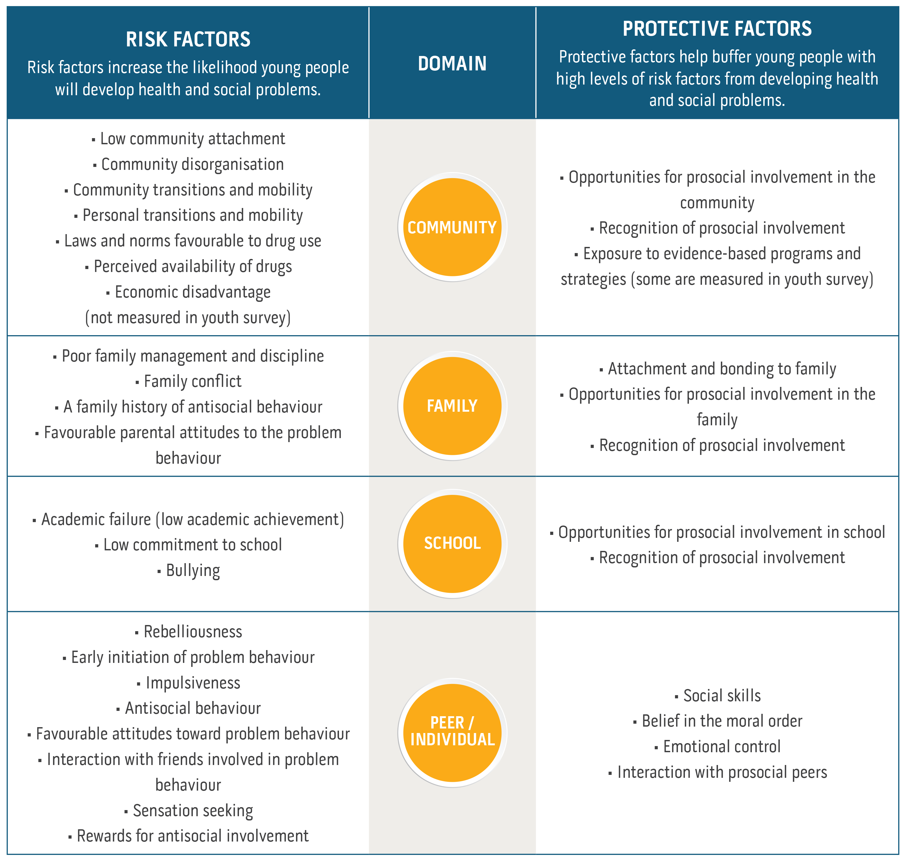(Communities That Care,2022)

Due to these factors mentioned in this report, the family have put children at significant risk and easily exposed to any abuse and harm. The matter was very concerning and created an unsafe environment for the children. Therefore, social services were involved with domestic violence and provided a safer home for the family by applying The Families Unit.
According to (Children Act,1989), the landmark policy in health & social care. Children who are in this type of circumstances are easily exposed to vulnerability, that they can be harmed and be very susceptible to any abuse and neglect, such as the Victoria Climbie murder case, which had made a significant impact on the policy and updated accordingly as, ‘Children Act 2004’, as ‘every child matters’ with the contribution of Lord Laming report, which was published in 2003.
This particular family is different from any other average family because these factors had created an unsafe, unprotected environment in their own home.
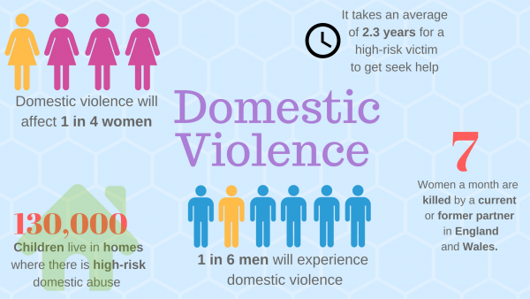
(Solent Journalism, 2017)

In England, the Department for Education is accountable and the main body for child protection. (CPD Online College, 2019).

The impact of these factors on the Children’s health & wellbeing

Domestic violence cripples a child’s fundamental need for safety and security. It can damage a child’s behaviour, cognitive development, educational achievement and general wellbeing. (Holt, Buckley, and Whelan, 2008).
Excessive drinking can impact a person’s mental health, make them depressive, and cause accidents. It can also lead you to become involved in criminal activities. (National Institute for Health & Care Excellence, 2011).
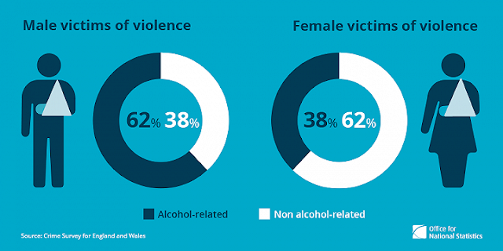

- Parental substance misuse, including alcohol misuse, can scar parents and the effort to acknowledge what children need, consequently exposing them to the risk of abuse. (NSPCC, 2018). Once alcohol misuse becomes excessive, it can create problems such as depression, physical unwell-being and accidents.
- Unpredictable relationships can negatively impact a child’s well-being, feeling depressive, anxiety, inability to make decisions, low self-esteem, and physical complaints. (Women’s Aid, 2015)
- Physical abuse can be triggered by substance misuse and alcohol addiction for parents to cope with their own emotions overall. (Cleaver, Unell, and Aldgate, 2011).
- Parents who have a dependency on alcohol can quickly be involved in criminal activities for financial reasons. (Brophy, 2006).
- The Family were subjected to anti-social behavior, but they were also causing it. As a result, children feel anxious, fearful, isolated, and hopeless. (Victim support, nd)

Factors determining and influencing vulnerability

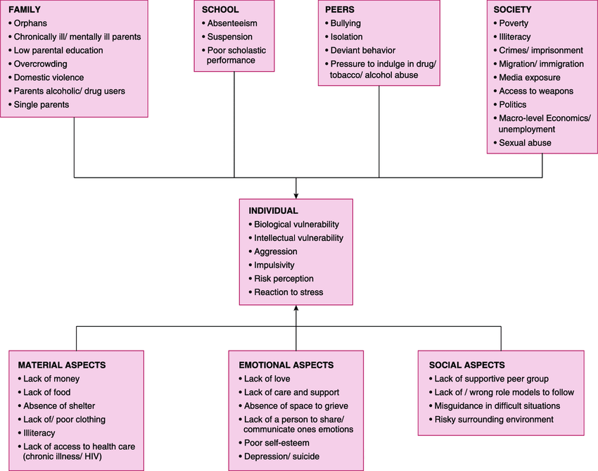
(Indian J Community Med, 2015).

Analysis

Health care professionals’ work should be based on the assessment to discover the concerns and the factors of vulnerabilities; once established, the proper intervention can be made in a multidisciplinary approach. This requires an examination, a holistic approach to the child’s cognitive progression, parents’ capacity to provide basic needs for the children, and the effect of other ecological factors. (Bogg.2013; Cleaver, Unell and Aldgate, 2011).
Preventions for child abuse are made by policies and updated sometimes, such as the murder of the Victoria Climbie case that impacted Children Act 1989 and was replaced with Children Act 2004, which was prepared by Lord laming.
Children Act 1989, section17 identifies the Child in need.
Children Act 1989, section 47 identifies whether there is a reasonable cause to suspect that the child is in danger of harm, abuse and neglect.
Children Act 1989 of section 20 or section 31A if the child needs accommodation.
Data Protection Act 1989 protect shared information in mutual respect.
The Equality Act 2010, which is practised by social services, gives the right to all children should be treated, protected and cared for equally.
United Nations Convention on the Rights of the Child (UNCRC,1991) article 19 places a duty on governments to protect all children. Article 28, in this case, was applied and rescued the children’s right to be educated.
Working Together to Safeguard Children (2018), they have a responsibility to work in multi-agency and promote and protect the welfare of children.

The family was at risk; therefore, the particular intervention was made via an assessment framework to support them;

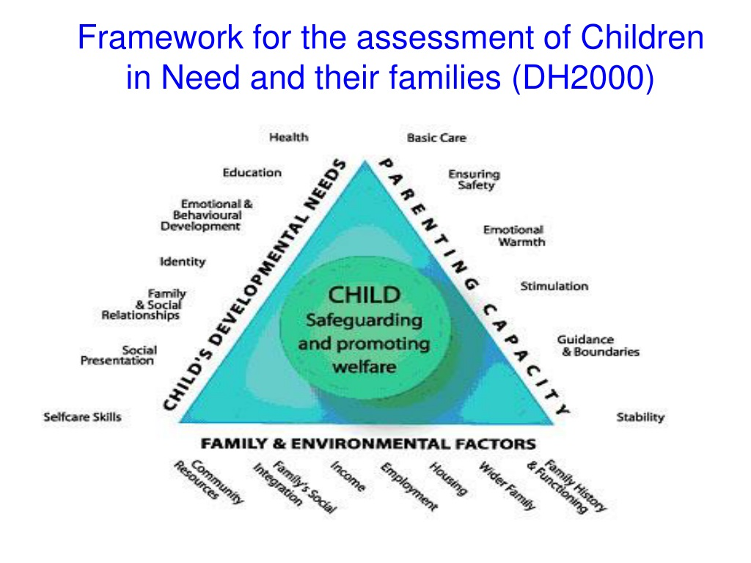
(Pinterest Image, Nd)
Discussion and Evaluation
The interventions had a good impact and were very effective with this family after working with them for 11 months with the Families Unit; these interventions included a poor attendance rate rising to %96, the mother stopped consuming alcohol, parental capability improved significantly. Also, the family was moved to a different location, and the issue of anti-social behaviour was solved efficiently. Children are more involved with activities and happier and no longer under a child protection plan.
According to Working Together to Safeguard Children (2018), the assessment was made as a guide to protect children and promote welfare through a multi-agency approach.
The family needed a specific assessment work based on the parental capability, children’s cognitive needs, and the environmental factors that affect the family; that is a holistic approach because the family had a weak parental ability to support. The basic theory is implemented to keep the family together and invested holistically in line with the policy of the Children Act 1989.

Conclusion
Early intervention timely manner is essential. Responding to a child or family’s needs can significantly minimise the risk elements and maximise the safeguarding aspects of a child’s life. (Early Intervention Foundation, EIF,2021).
Timely support can provide children with the help required to achieve their full prospective and positively construct their adult lives. (EIF,2021).
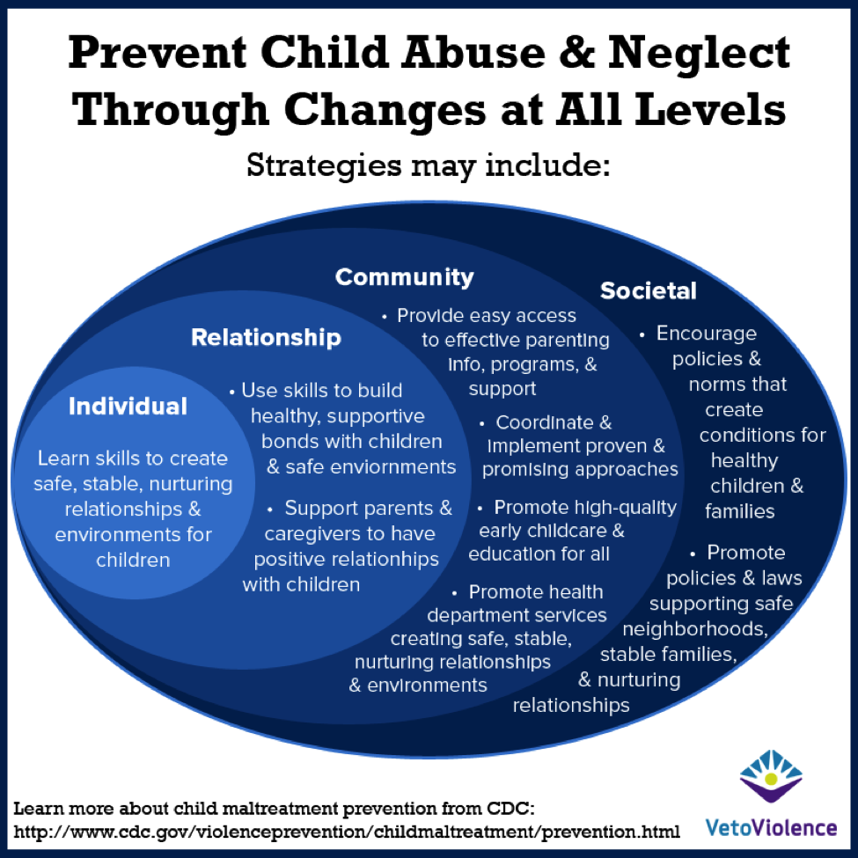(Image CDC, 2019).

References
Bogg, D. (2013) Parental substance use: the challenge for social work. Families up front, 9: 18-19 [online] Available at: https://learning.nspcc.org.uk/children-and-families-at-risk/parental-substance-misuse (Accessed: 03/04/2022)
CDC (2019) Prevent child abuse and neglect through all changes at all levels: [online] Available at: https://vetoviolence.cdc.gov/apps/main/home (Accessed:05/04/2022)
Children Act (1989), [online] Available at: www.childrenact1989.legislation.gov.uk (Accessed: 30/03/2022)
Children Act (2004), c.31 [online] Available at: https://www.legislation.gov.uk/ukpga/2004/31/contents (Accessed; 30/03/2022)
Cleaver, H, Unell, l. Aldgate, J. (2011) Children’s need: parenting capacity: child abuse: parental mental illness, learning disability, substance misuse, and domestic violence (PDF). London: The Stationery Office (TSO) [online] Available at: https://www.learning.nspcc.org.uk/children-and-families-at-risk/parental-substance-misuse (Accessed: 31/03/2022)
Communities That Care (2022) Risk & Protective Factors: Image [online] Available at: https:// www.communitiesthatcare.org.au/how-it-works/risk-and-protective-factors
Early Intervention Foundation (EIF) (2021) About early intervention: [online] Available at: https://www.eif.org.uk/reports (Accessed:06/04/2022)
Equality Act (2010) [online] Available at: https://www.legislation.gov.uk/ukpga/2010/15/contents (Accessed; 31/03/2022)
Indian J Community Med, (2015). Image [online] Available at: https://www.researchgate.net/publication/280103880/figure/download/factors-determining-and-influencing-vulnerability.png (Accessed:04/04/2022)
Solent Journalism (2017) Domestic violence: Image [online] Available at: https://www.solentjournalism.co.uk/local-councils-receive-funding-to-support-domestic-abuse-survivors/ (Accessed:06/04/2022)
S, Holt, H Buckley, S Whealan (2008) The Impact of exposure to domestic violence on children and young people: A review of the literature [online] Available at: https://www.sciencedirect.com/science/article/pii/SO145213408001348 (Accessed: 01/04/2022)
Legislation.Gov.UK (1998) Data Protection Act 1989: [online] Available at: https://www.legislation.gov.uk/ukpga/1998/29/contents (Accessed:03/04/2022)
Merriam-Webster (2022) Definition of Vulnerable [online] Available at: https://www.merriam-webster.com/dictionary/vulnerable (Accessed: 31/03/2022)
National Institute for Health and Care Excellence (2011) Alcohol-use disorders: diagnoses, assessment, and management of harmful drinking and alcohol dependence. London; NICE [online] Available at: https://www.nice.org.uk/guidance/CG115 (Accessed: 02/04/2022)
NSPCC (2018) Parental substance misuse: Children living in families facing adversities: [online] Available at: https://www.learning.nspcc.org.uk/research-resources/2018/children-living-in-families-facing-adversity (Accessed: 01/04/2022)
Pinterest (Nd) Social Work Theory: Image [online] Available at: https://www.pinterest.com/pin/529665606167487682/ (Accessed: 05/04/2022)
Pinterest (Nd) Domestic violence causes: [online] Available at: https://www.pinterest.com/pin/the-real-cost-of-alcohol--372250725426422256/ (Accessed:06/04/2022)
United Nations (1989) The United Nations Convention on the Rights of the Child [online] Available at https://layout 1 (unicef.org.uk) (Accessed: 31/03/2022)
Women’s Aid (2015) Controlling behaviour in relationships: talking to young people about healthy relationships (PDF) Bristol: Women’s Aid Federation of England (WAFE) [online] Available at: https://learning.nspcc.org.uk/safeguarding-child-protection/healthy-and-unhealthy relationships (Accessed: 01/04/2022)

Appendix

