Strategy Recommendation Report for Deliveroo



December 2022

MODULE NAME :Strategic Management (BMMB7013)

NAME:Jinhui Li

STUDENT NUMBER:2217121
Executive Summary

Deliveroo is a UK based company that specialises in food delivery. Deliveroo has been affected by the pandemic, like every other company in the world, due to strict regulations and safety restrictions. The company is looking to improve its customer service and enhance its competitive advantage. The micro and macro analysis are carried out to determine the factors that affect the company internally and externally. The PESTEL analysis highlighted the impact of Brexit and Covid-19 on the company's performance. Deliveroo has been mistreating its employees by not allowing them any rights and depriving them of a minimum living wage and health insurance. Company has been looking to diversify its portfolio by adding ghost kitchens to become the supplier instead of a middleman. There are opportunities to explore in the market, such as using the platform for grocery delivery and improving the sales portfolio.
The company can choose four strategic options based on Ansoff's matrix. Product development, market development, market penetration, and diversification. Of the four strategies, the best one to choose is market penetration. Deliveroo needs to improve its market share by enhancing its customer service. This can be achieved by improving their quality, prices, and delivery times. This all comes under the banner of market development, and they have the capabilities to capture the market. The investment and the capital required to transform this company is available, and the right strategy can help them become market leaders. There is potential to grow for Deliveroo, and the Covid-19 pandemic has helped people realise the need for food delivery service.

Table of Contents
Executive Summary 2
1.0 Introduction 4
2.0 Strategic Analysis 5
3.0 Macro Environment Analysis 6
3.1 PESTEL Analysis 6
3.2 Porters Five forces 9
3.2.1 Threat of new entrants 9
3.2.2 Threat of Substitutes 9
3.2.3 Rivalry amongst existing firms 10
3.2.4 Bargaining power of suppliers 10
3.2.5 Bargaining power of customers 11
4.0 Micro Environment Analysis 11
4.1 Swot Analysis 12
4.2 VRIN/VRIO analysis 14
4.2.1 Valuable 14
4.2.2 Rare 15
4.2.3 Inimitable 15
4.2.4 Organization 16
5.0 Strategic options 16
5.1 Ansoff’s Matrix 17
5.1.1 Market penetration 17
5.1.2 Market Development 18
5.1.3 Product Development 18
5.1.4 Diversification 19
6.0 Evaluation of Strategic Options 19
6.1 Cultural web 19
6.2 Strategic fitness 20
7.0 Conclusions 21
8.0 Recommendations 22
9.0 References 23

Strategy Recommendation Report for Deliveroo

Introduction
Deliveroo is a British online food delivery company. It was founded in 2013 in London by wil Shu and Greg Orwloski. The company is multi-national and operates in more than ten countries. Expansion led to the company founding its subsidiary operation, Deliveroo Editions. It operates ghost kitchens around major cities that are not enlisted as restaurants but only make food for delivery. Another one of their ventures is the Deliveroo HOP which has partnered with grocery stores and delivered groceries to their customers. Deliveroo also provides on-demand groceries to major retailers in the United Kingdom (Ovetz, 2020). The delivery setup is contested by many rival companies such as Uber eats, food panda and Grub hub. During the pandemic and lockdown, food delivery service was a peak business, becoming the best way to buy food online. The customer care and the measures became strict, and the companies competed for market share while bringing special deals from restaurants to run their business (Liu et al., 2021).
The analysis starts with the macro environment explored using the PESTEL analysis and Porter’s five forces. The macro-environment will highlight the challenges in the business. The microanalysis follows the macro analysis that will be done using SWOT and VRIO analysis. These will highlight the strengths and weaknesses of the company as well as the core competencies and resources available at their disposal. Ansoff’s matrix is used to decide upon a strategy and gain a competitive advantage. The four strategies discussed are product development, market development, market penetration and diversification. The strategic fitness of the company is determined using the cultural web, and the strategy is then implemented using the one that suits their future ambitions. The research is summarised in the conclusion, and recommendations are given for Deliveroo to improve its customer care.
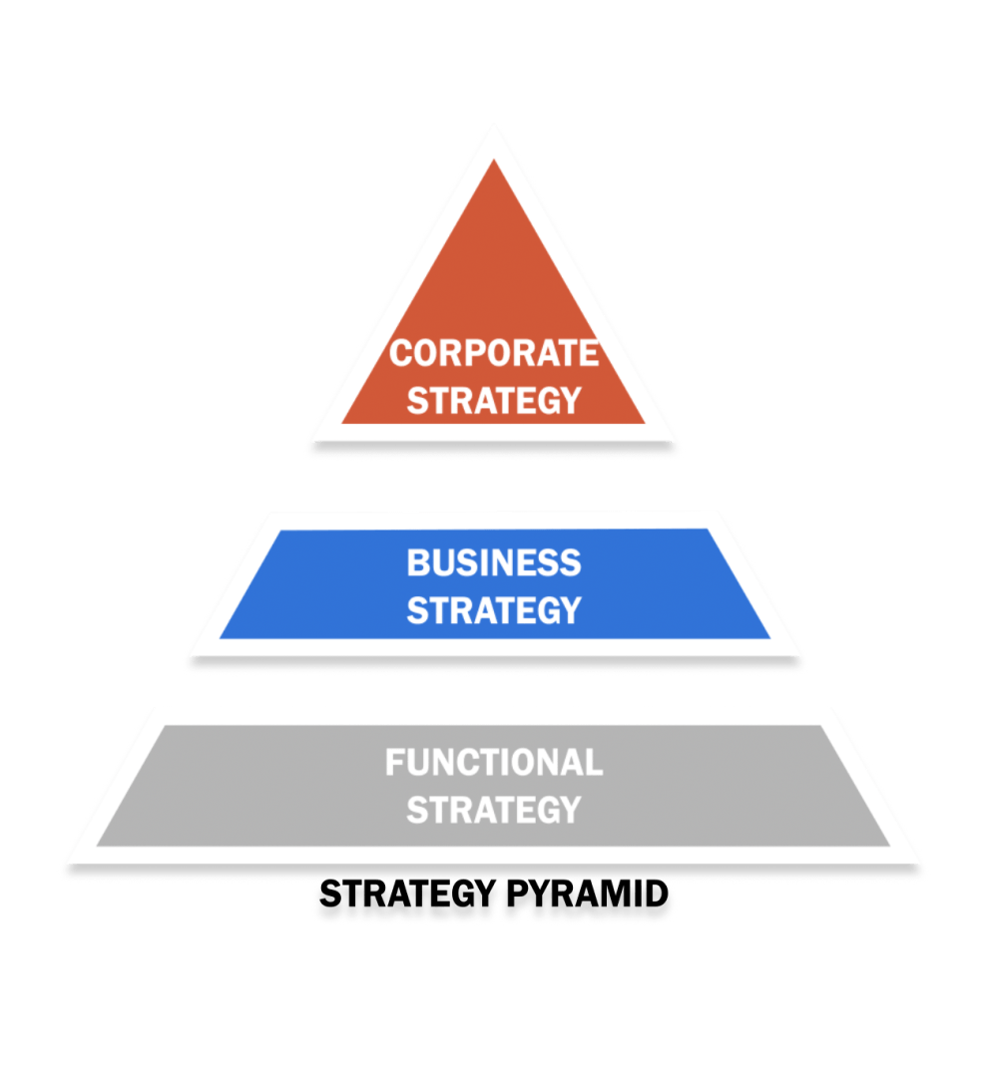

2.0 Strategic Analysis
Strategy is a plan of action used to achieve a long-term goal (Andersen, 2000). The strategy is divided into parts such as planning, implementation and control. A strategy needs to be designed according to the internal and external environment of the company. Different levels of strategy are used to streamline the function of the company. The three levels of strategy are corporate, business and functional. The corporate strategy defines the company's overall direction and sets the goals to achieve. The business level strategy is the one that focuses on competing in the market with others. The functional strategy is the one that defines how the operations are going to be run and how they are going to grow (Oliver, 2002).
Strategy can be viewed from the point of view of Porter's competitive strategy. Porter's strategy provides a road map for all types of organisations to succeed in the market (Porter and Tanner, 2012). The strategies are quite generic and thus can be implemented by various companies. The strategy needs to be the best fit. The four generic strategies are cost leadership, differentiation, cost focus and focus differentiation. The strategies are generic in nature, but they give an overall direction to the company. Goals and objectives are then set according to the strategy chosen (Tanwar, 2013).
Mintzberg's view of strategy comprises the 5 Ps. These 5ps are plan, ploy, pattern, position and perspective (Mintzberg, Ahlstrand, and Lampel, 2009). The starting point of any strategy is the plan. A sound plan is required to execute a strategy, which is the default first step. The ploy is to make a move that would disrupt the market and gain market share. The following strategy is pattern that is an emergent strategy that can arise from past organisational behaviour. Patterns begin to emerge where the situation has played out previously, and now it can be used to capture part of the market. The fourth strategy is position, that is how the company presents itself in the market. Positioning of the company is vital to target the desired customers. The last strategy defined by Mintzberg is perspective; this strategy is based on the company's mindset and culture (Mintzberg and Westley, 1992). An example is an innovative company that will keep innovation as the focus to gain market share and increase profits.

3.0 Macro Environment Analysis
Macro analysis is the part of the company's strategic management that allows them to explore opportunities and avoid hazards that might affect the company's business. This analysis is important so the decision-makers have the information required to formulate a strategy. The macro-environment has been analysed using PESTEL and Porter's five forces.

3.1 PESTEL Analysis
Factor | Analysis
Political | After Brexit, food delivery companies have been asking the UK government to loosen their immigration laws so that they can hire more chefs for their food business (Adam, 2019).  There is a case of minimum labour wage that needs to be paid to the employees. But unfortunately, Deliveroo and some other big names have underpaid riders and exploited the deteriorating financial situation (Adams, 2020).  World Health Organisation has directed governments to regulate food advertisements, and the delivery companies also need to uphold the standards of restaurants they engage on their panel.
Economic | After the UK left the EU the pool of delivery guys reduced and that coupled with the deteriorating rate of pound means that it is difficult to maintain profits without increasing their fees.  Imports have become expensive and the average import tariff has risen by almost 22%. The same cost is then transferred to the customers and thus reduced the business.  Covid-19 was the business boom of delivery service as most of the business shifted online and lock downs forced people to order online rather than going outside. The food would be prepaid and left at the customer’s doorstep (Sandland and Orsbourn, 2021).
Socio-Cultural | After Brexit, the workforce has left UK and Deliveroo is trying to use the student workforce to meet demands. They are facing a HR crisis as the company can’t hire enough to match demand (Schmidt, 2020).  Deliveroo has been accused of neglecting safety standards during their operations and have not given any training to their delivery staff. They need to improve their trainings to comply with British safety standards (Grott & Shay, 2019).  Companies like Deliveroo are highlighting fast foods and unhealthy options as convenient that has swayed them from the cultural norms and the healthy food options.
Technology | The generation Z is reliant on technology and the delivery services have applications that are easy to navigate and orders are placed conveniently.  The customised application created by Deliveroo has allowed them to cut costs and the communication is on a single platform that allows them to cut costs and become the market leader (Tran, 2021).  To meet their rising demand, the company is making their own kitchens that are delivery focused and provide the food directly to the customers so it helps save costs by eliminating the middle man and becoming a B2C on its own.
Environmental | Deliveroo has been emphasising on a fleet of bicycles to reduce their carbon footprint. This is aimed at reducing congestion and pollution that is caused by other vehicles.  Deliveroo has been actively working with other companies to make sure that renewable packaging is used when delivering food (Tajeddin, 2017).  A greener planet drives has also been initiated that limits the use of plastics in the society.
Legal | They are facing major discrimination lawsuit that people are not being paid minimum wage. There is no holiday pay and insurance cover for the employees.  The company is also facing lawsuit for not allowing the workers to join a union and gaining any sort of worker rights. The lawsuit is the same being faced by companies like Uber.

3.2 Porters Five forces
The porter’s five forces model was introduced by Michael E Porter in 1979. The purpose of this model was to assess the competitive positioning of a company to synthesize a strategy (Azadi & Rahimzadeh, 2012). The porter’s five forces are discussed below.

3.2.1 Threat of new entrants
Entry into the food delivery service requires substantial amount of capital and investment. The force is strong however if the new entrant differentiates then the force can become weak. The restrictions and the laws are becoming tougher so the company trying to enter the market will have to go through all the regulations that would cost them time and money. The existing brands like Deliveroo have already taken most of the market share and created loyal customers that will keep purchasing from them. New entrants require access to the distribution channels and companies like Deliveroo have already established themselves as exclusive delivery partners offering deals on their website. Breaking into the market would be difficult unless something spectacular is planned by the new entrant (Morphet, 2021).

3.2.2 Threat of Substitutes
The availability and threat of substitutes is a constant challenge for Deliveroo. The threat of substitute increases when the competitors are cheaper or offer a better service compared to Deliveroo. The psychological switching cost of switching from one service provider to the other is low as they do not offer any loyalty schemes to the customers. The rival companies are also partnering with popular restaurant chains to bring exclusive offers for the customers that would change their delivery brand based on the offer from their favourite restaurant. Deliveroo can reduce the risk of substitute by working on loyalty scheme for the customers to they keep returning to them (Kamilah et al., 2020).

3.2.3 Rivalry amongst existing firms
Every food delivery company is trying to beat each other for an increased market share. The delivery market has become saturated and many firms are competing with one another. Profitability decreases in such industries as the competition gives low pricing strategy and work on aggressive targeting of potential clients. There are a few players in the market that is an advantage and over the last two years the market has grown with more customers opting for delivery rather than going to the restaurant. The rivalry becomes more intense when the competitors start taking over the distribution channels and give better options than Deliveroo. The major restaurants also partner with these companies so they can launch exclusive deals and in turn they can get a higher volume of customers. The only way to reduce losing business from rivals is to invest heavily in loyalty schemes and retain the existing customers (Rodriguez and Piccoli, 2020).

3.2.4 Bargaining power of suppliers
The bargaining power of supplier is simply the pressure that is exerted by the suppliers on the business. These pressures are induced by reducing production, increasing price and compromising on quality. Companies like Deliveroo have limited bargaining power over the supplier as they are the third party delivery unit. The restaurants are the supplier that would command according to their reputation. The pressure is exerted both ways as the restaurant that have better terms will be highlighted above the others and are more likely to get customer orders. Many substitutes are available in the market and thus that would decrease the bargaining power of the suppliers. Many pizza joints and burger points make the same food that would allow easy switching from one supplier to the other. The supplier power can be further reduced as Deliveroo is working on opening their own kitchens that are dedicated towards making food for delivery. This would increase their profit and end their reliance on suppliers (Drahokoupil and Piasna, 2019).

3.2.5 Bargaining power of customers
The bargaining power of customer is the pressure exerted by the customers on the business. The customers want three things, affordable prices, great quality and excellent customer service. These three demands are key towards running any successful business. Bargaining power of customers increases when there are many options to choose from and the switching costs are non-existent. The customers can afford to buy from different vendors and have no loyalty towards the delivery company and more so towards the restaurant they order from. Customer have high power over the delivery service companies and one bad experience would make them shift towards a new vendor. Recent recession and increased costs of living have made customers more aware and they would rather want something good in cheaper prices (Keeble et al., 2022). The bargaining power is reduced by partnering with more restaurants and having a strong repute in the market.

4.0 Micro Environment Analysis
The micro analysis of a company is used to highlight the internal capabilities and strengths of the company while highlighting the weak points that can be improved. The micro analysis can be done using the swot analysis. Tools such as core competencies and stakeholder analysis are done to get a broader view.

4.1 Swot Analysis
Strengths | 110000 riders have been working for the company covering a massive territory. The company is delivering foods in more than 200 cities in the UK.  The company is working in multiple countries and giving services in hundreds of cities where it has self-employed thousands of people (Nemeth, 2020).  The company has had exceptional growth, their popularity has been increasing and more customers are getting on-board with their services.  They have a huge market share as they are the third most popular delivery service in UK and have been expanding rapidly. This has increased their brand awareness and market recognition.  The ghost kitchen is one of its strongest suites as the restaurants are focused on making products that are specifically made for delivery (Festivalia & Swantari, 2022).  They have a strong partnership portfolio and restaurants are joining them with exclusive offers to enhance business. Deliveroo makes use of these to promote both their services and the businesses linked with it (Festivalia & Swantari, 2022).  They have a huge product portfolio and that allows them to serve a vast range of customers. The product line includes a diversity of restaurants from different cuisines.
Weaknesses | The company has been accused of exploiting workers and thus most people do not want this job as first option. Bad reputation scares away potential investors.  The company was inefficient in the pandemic and they had to cut their workforce by 15% even though the company had seen a growth of 120% in the same time (Aday and Aday, 2020).  The company had made a lot of losses over the years and their financial statements reflect that. They need to manage their finances better to make it viable.
Opportunities | Another great service that can be provided is home delivery of grocery. This will amplify their growth rate as it would add many more customers to the fold (Kritz, 2017).  They can further improve their business by introducing more ghost kitchens that focus on different cuisines so they can have a variety of foods exclusive to their applications so that they keep ordering from them.  Market growth opportunities are available as many markets are opening up for the delivery service. After the pandemic people have found it more convenient than going to the store.
Threats | The delivery drivers are all contractual employees and have basically no rights from the company, low wages and longer working hours are making work difficult. A lot of investment is required for insurance and benefits (Busschaert, 2022).  Competitors are gaining ground on the market and taking business from Deliveroo. The positioning of many new companies has started to hurt the market of Deliveroo.  Future projects are not getting investments and the underwhelming IPO is clear indicator of the problem.

4.2 VRIN/VRIO analysis
This strategy is used to assess and evaluate the company's resources and competencies. This strategic tool allows the company to identify a long-term competitive advantage of the company (Rodriguez and Piccoli, 2020). In addition, these resources allow future strategies to be streamlined with the vision of the company. VRIN/VRIO analysis characteristics are valuable, rare, inimitable, and Non-substitutable.

4.2.1 Valuable
Brand image is an important factor in the customers' minds. The brand image is developed over time by providing quality service consistently. The brand image is a unique quality to have that shows the trust of customers.
A great relationship with customers and suppliers allows them to gain a competitive advantage.
The company has always looked towards innovation and expansion. They lead the market with their ghost kitchen setup (Nigro et al., 2022).
They have the ability to raise capital. They have the resources required to raise equity internally for investing in new ventures.

4.2.2 Rare
These capabilities are hard to gain, and only a handful of companies have the ability to attain them. The company has a strong international presence, allowing them to have a multinational tag. This allows them to have a higher financial power as well as increased cultural exposure.
They have proven problem solving skills, and that allows for better teamwork. In addition, they keep customer service as a priority and help them in every way possible.
Deliveroo can take risks, and that is why they started the ghost kitchen setup. The risk takers usually capture the market as they are not scared to express their business interests.
Deliveroo is highly adaptive as they have running operations in more than eight countries. As a result, the different cultural needs are satisfied by them.

4.2.3 Inimitable
These competencies are the ones that give the company a competitive advantage. They have an excellent quality product from the highest rated restaurants that deliver the food hot and accurately. The consistent quality would lead to repeat orders.
Exclusive partnerships with major restaurants that give them special offers and deals that other delivery services won’t get.
They have a great marketing strategy where they target the users on social media by pushing their exclusive offers and making a tempting advertisement that would make the customer order (Palmatier and Sridhar, 2020).
They have competitive pricing and deliver very low prices and excellent customer service so that the customer needs are always a priority (Palmatier and Sridhar, 2020).

4.2.4 Organization
These resources are built by the company within its operations, which are unique for each company. As a result, Deliveroo has a strong financial strength that allows them to invest in new ventures and boost its image in the market. In addition, a strong financial statement allows the company to have the freedom to explore mergers and acquisitions to gain a competitive advantage.
The technological advancement and the integration of menus from different delivery options have become more interactive. In addition, the applications are easy to use and save all sorts of data to ensure that the customer can order quickly (Drahokoupil & Piasna, 2019).
Employee training is an important factor of the job. Not all riders are fully trained; however, the dispatch team and the customer service centre go through extensive training. In addition, the company invests heavily in research and development, and they have been experimenting with different cuisines.
Deliveroo has distribution channels internationally and domestically that cover a lot of territories. This allows them to have a customer base larger than their competitors. In addition, the robust supply chain system allows them to deliver all orders within 45 minutes to the customers (Ingene and Brown, 2019).
The company's intense marketing campaign runs attractive advertisements to attract customers. Their billboards can be seen around major cities while they promote their brand mostly on social media platforms.

5.0 Strategic options
The strategic analysis above has highlighted the company’s internal and external environment. The above analysis has provided enough information to follow a path for the company to follow. As per the company's requirement, a strategy is required to improve customer care post-pandemic.

5.1 Ansoff’s Matrix
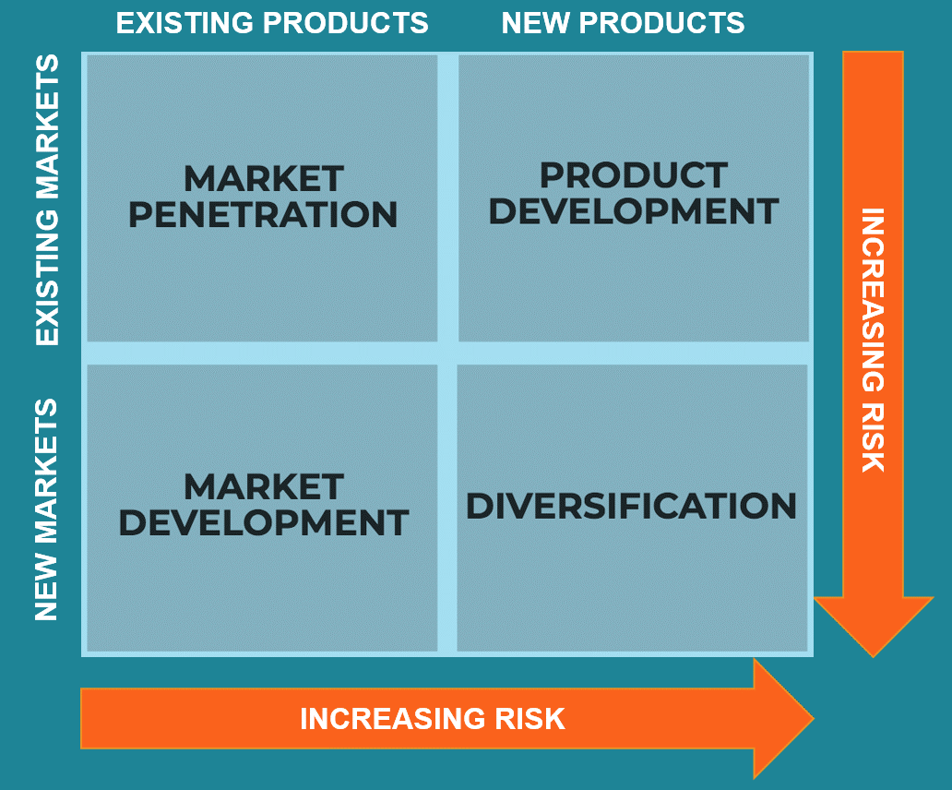

Ansoff's matrix is a strategic tool used to identify a company's strategy for gaining a competitive strategy. This matrix offers four strategic choices: market penetration, product development, market development and diversification. The company can choose any one of the strategies or a combination depending on the business conditions (Kipley et al., 2012).

5.1.1 Market penetration
The market penetration strategy is where the company focuses on the existing market and customers by providing better services and presence. The ghost kitchens that Deliveroo has made need to be opened in different areas so that they can have access to more products. The delivery riders can then efficiently deliver from the designated ghost kitchen instantly. Deliveroo needs to increase its marketing budget. Social media marketing will target people who order online and bring them to Deliveroo's platform rather than the restaurant's delivery system. The marketing team plays a vital role in market penetration, and the ideas must be genuine and unique to attract more users. For increasing market penetration, competitive pricing and reduction of operational costs are very important. The company can get exclusive deals from restaurants in return for increased business and cut their own costs down to relieve the customers and drop their service prices (Rodrigues et al., 2012). Another aggressive approach to this strategy is acquiring their competitors and using their customers and platform to increase business in the market.

5.1.2 Market Development
This strategy is based on selling existing products and services in new markets. The first part of this strategy is research and development to explore the new area and find suitable distribution networks to target a specific market. Another regional expansion strategy is improving customer service and providing coverage to more areas. This would surely enhance their customers but also increase their operational costs. New customer segments can be explored by making ghost kitchens with a wider variety of cuisines. Brand awareness needs to be enhanced as more customers should be able to differentiate the company from other competitors in the market. Finally, customers need to be educated about the benefits of using the application and how it will make ordering online easier (Voronin et al., 2020).

5.1.3 Product Development
Product development is introducing new products and services in the existing market to enhance market share. The current selection of services can be improved to enhance customer care. The improved services will increase sales and bring more customers to the platform. The services and products can be increased. Deliveroo is already doing that by establishing ghost kitchens and becoming a business-to-customer delivery service with the food coming from their own supply. The company can focus on strategic partnerships with all the major food brands to become their exclusive delivery partner (Tajvidi and Karami, 2015). That would eliminate their fleet of riders and use the available workforce of Deliveroo to get the job done. This would help both the restaurants and the platform.

5.1.4 Diversification
It is essential for businesses to diversify as saturation in the market forces businesses to divert from their core services. More and more competition is coming into the delivery business, and thus it has become necessary to diversify. Deliveroo is already looking towards vertical integration, which would mean that they will have their food supply and then directly deliver to the customers. Deliveroo can also use horizontal diversification to enter businesses not currently engaged (Lee, 2018). For example, they can also start delivering groceries and medicines to people, so they do not need to shop themselves. They can then use this to open their warehouses and deliver to customers directly. The company can also look for mergers and acquisitions to diversify; this is helpful to gain a running business that already has existing customers and complete market information.

6.0 Evaluation of Strategic Options
Using Ansoff's matrix, the different strategic options have been explored, which can help the company achieve a competitive advantage. However, these options need to be further evaluated to decide the one that will be most effective for Deliveroo.

6.1 Cultural web
The cultural web model can be used to determine how fit the strategy is for the current company. It is supported by six cultural influences: stories and myths, rituals and routines, symbols, organisation structure, power structures and control systems. The culture of the organisation is important to understand. Deliveroo is looking to implement a market penetration strategy to increase customer service. The cultural norms need to be understood to better serve different sections of the community. Deliveroo needs to understand that different people will react differently to an altercation, and the staff needs to be trained accordingly. The organisation structure and the power structure are adjusted to ensure that people feel welcome in the company. The stakeholders need to be on board to make the changes for the strategic option to fully integrate into the system. The control needs to be established by the area managers, and random feedback calls should be made to the customers to get their opinion and how they can improve the service even further.

6.2 Strategic fitness
The strategy must have a strategic fit to work well for the company. From the four strategies listed above, the best suited to Deliveroo is market penetration. The market is increasing as more and more customers have started ordering online since the pandemic, and the new trend is helping delivery service providers grow their businesses further. The key objective of the new strategy is to improve customer care and enhance the business. With many new companies starting their operations in the food delivery system, it is vital that Deliveroo needs to stand out for its customer service (Fukuda, 2018). The three main requirements of customers are quality food, affordable prices and timely deliveries. The food quality is based on the restaurant, and Deliveroo cannot control that; however, they can hold the restaurant accountable for the food quality and refund the amount to the customers. Improving their services and standards and making the ghost kitchens operational is a big part of this success. The market penetration strategy needs to be implemented throughout the country so they can retain business and not repeat their mistakes in other countries.

7.0 Conclusions
Deliveroo is one of the biggest companies in the food delivery business. They operate in more than eight countries and are the front runners in the UK market. The company has been looking to improve their customer service and would like to devise a strategy that would allow them to increase its business and gain a competitive advantage. The macro analysis highlighted that the company is in a strong position financially and has the ability to capture the market using its ghost kitchen model. The profits increase when the whole process is vertically integrated to benefit Deliveroo (Leo et al., 2022). The Swot analysis then revealed that the company does not support the workers enough, and since Brexit, it has become difficult to hire more riders. As a result, the company has become dependent on the student workforce. However, there are opportunities to grow, such as starting a grocery delivery business and opening warehouses. The company started the ghost kitchens, a great initiative that made them the pioneer in that field. The resources analysis showed that the company has many valuable resources, such as the ability to raise capital and a strong brand image. The future strategy is analysed using Ansoff's matrix, and the four options are product development, market development, market penetration and diversification. The most likely strategy for the company is market penetration as they can use the current workforce and the current customers to give them better customer service and highlight themselves as the best company amongst those competing in the UK market. The entire focus is on retaining customers and adding new ones, and as far as this business goes, the customers usually do not give second chances on a bad performance. The quality and the service have to be top-notch every single time.

8.0 Recommendations
The food delivery market is very competitive, and all the companies are trying to capture the same market share. The market has been growing exponentially, and the competition has been intensifying. The grocery business is very profitable if the material is taken from their own warehouses. Deliveroo is the middleman transporting the material from the warehouse to the customers. The grocery items have chances that a product goes missing from the list, and this problem has been faced by other companies that provide this service. The application must be live at all points so that when the stocks go out of stock, the product is automatically adjusted from the customer's bill, and they do not have to file a complaint for missing products. During the Covid-19 period, many people started ordering online, which increased this trend. Superior customer service will ensure that people keep on ordering from Deliveroo, and they become the go to brand. The ghost kitchens need a range of cuisines catering to a more extensive customer base. Having more options and keeping solid relations with bigger brands would help them attract more customers. Exclusive deals from restaurants such as KFC and McDonalds would increase the number of orders and attract potential new customers to join the platform.

9.0 References
Aday, S. and Aday, M.S. (2020) ‘Impact of COVID-19 on the food supply chain’, Food Quality and Safety, 4(4), pp.167-180.
Adam, R.G. (2020) ‘Brexit Means Brexit: Squaring the Circle’, in Brexit (pp. 125-194). Springer, Cham.
Andersen, T.J. (2000) ‘Strategic planning, autonomous actions and corporate performance’, Long range planning, 33(2), pp.184-200.
Azadi, S. and Rahimzadeh, E. (2012) ‘Developing marketing strategy for electronic business by using McCarthy's four marketing mix model and Porter’s five competitive forces’, EMAJ: Emerging Markets Journal, 2(2), pp. 46–58.
Busschaert, G. (2022) ‘Labour Tribunal of Brussels decides that Deliveroo riders are self- employed workers and not employees (BE)’, European Employment Law Cases, 7(1), pp.50-55.
Drahokoupil, J. and Piasna, A. (2019) ‘Work in the platform economy: Deliveroo riders in Belgium and the SMart arrangement’, ETUI Research Paper-Working Paper. Keeble
Festivalia, F. and Swantari, A. (2022) ‘Ghost kitchen strategy to reduce restaurant loss in COVID-19 pandemic condition’, in Current Issues in Tourism, Gastronomy, and Tourist Destination Research (pp. 441-448). Routledge.
Fukuda, R. (2018) Building organizational fitness: management methodology for transformation and strategic advantage. Routledge.
Grott, R. and Shay, A. (2019) ‘Implementation, training, support, and maintenance’, in Assistive Technology Service Delivery (pp. 159-175). Academic Press.

Ingene, C.A. and Brown, J.R. (2019) ‘Conceptualizing a Comprehensive Theory of Distribution Channels’, in Handbook of Research on Distribution Channels. Edward Elgar Publishing.
Kamilah, N., Kee, D.M.H., Syafiq, M., Aina, S., San Yap, H., Alqallaf, A.A. and Quttainah, M.A. (2020) ‘Factors affecting organizational success: A case study of Foodpanda’, Journal of the Community Development in Asia (JCDA), 3(3), pp.58-69.
Keeble, M., Adams, J. and Burgoine, T. (2022) ‘Investigating experiences of frequent online food delivery service use: a qualitative study in UK adults’, BMC public health, 22(1), pp.1-14.
Kipley, D., Lewis, A.O. and Jeng, J.L. (2012) ‘Extending Ansoff’s strategic diagnosis model: Defining the optimal strategic performance Positioning Matrix’, Sage Open, 2(1), p.2158244011435135.
Kritz, F. (2017) ‘Affordable Options for Grocery Delivery’, Neurology Now, 13(6), p.13.
Lee, Y.H. (2018) ‘Costs and Benefits of Vertical Integration’, in Vertical Integration and Technological Innovation (pp. 8-18). Routledge.
Leo, G., Hurriyati, R. and Hendrayati, H. (2022) ‘Online Food Delivery Service: The Role of e-Service Quality and Food Quality on Customer Loyalty’, in 6th Global Conference on Business, Management, and Entrepreneurship (GCBME 2021) (pp. 252-256). Atlantis Press.
Liu, Y.Y., Chen, S.H. and Zhang, J.X. (2021) ‘Applying Importance–Satisfaction Model to Evaluate Customer Satisfaction: An Empirical Study of Foodpanda’, Sustainability, 13(19), p.10985.
Mintzberg, H., Ahlstrand, B. and Lampel, J.B. (2009) ‘Startegy Safari: The Complete Guide through the Wilds of Strategic Management’, Harlow: Financial Times.
Mintzberg, H. and Westley, F. (1992) ‘Cycles of organizational change’, Strategic management journal, 13(S2), pp.39-59.
Morphet, J. (2021) ‘Taking Back Service Delivery’, in Outsourcing in the UK (pp. 163-178). Bristol University Press.
Nemeth, D.J. (2020) ‘Book Review: Riding for Deliveroo: Resistance in the New Economy’, Economic Development Quarterly, 34(4), pp. 390–393.
Nigro, C., Iannuzzi, E., di Santo, N. and Sisto, R. (2022) ‘Food delivery, ghost kitchens and virtual restaurants: temporary or long-lasting game changers?’, British Food Journal, (ahead-of- print).
Oliver, R.W. (2002) ‘Real‐Time Strategy: Cold Strategy, Hot Strategy’, Journal of Business Strategy.
Ovetz, R. (2020) ‘Organizing at Deliveroo’, in New Labor Forum (Vol. 29, No. 3, pp. 129-132) Sage CA: Los Angeles, CA: SAGE Publications.
Palmatier, R.W. and Sridhar, S. (2020) Marketing strategy: Based on first principles and data analytics. Bloomsbury Publishing.
Porter, L.J. and Tanner, S.J. (2012) Assessing business excellence: a guide to business excellence and self-assessment. Routledge.
Rengarajan, S., Moser, R. and Narayanamurthy, G. (2021) ‘Strategy tools in dynamic environments–An expert-panel study’, Technological Forecasting and Social Change, 165, p.120560.
Rodrigues, L., Maccari, E.A. and Lenzi, F.C. (2012) ‘Innovation strategy for business to business market penetration’, International Business Research, 5(2), p.137.
Rodriguez, J. and Piccoli, G. (2020) Competing within Aggregators: Competitive Moves in the Deliveroo Online Delivery Platform.
Sandland, M. and Orsbourn, C. (2021) Delivering the Digital Restaurant: Your roadmap to the Future of Food. Herndon, VA: Amplify Publishing.
Schmidt, V. (2020) ‘Conclusion–the EU after Brexit: Hard or soft?’, in The European Union after Brexit (pp. 194-212). Manchester University Press.
Tajvidi, M. and Karami, A., 2015. Product development strategy. In Product Development Strategy (pp. 79-124). Palgrave Macmillan, London.
Tanwar, R. (2013) ‘Porter’s generic competitive strategies’, Journal of business and management, 15(1), pp.11-17.
Tajeddin, B. (2017) ‘Packaging Composite Materials from Renewable Resources’, Journal: Handbook of Composites from Renewable Materials, pp.525-561.
Tran, V.D. (2021) ‘Using mobile food delivery applications during the COVID-19 pandemic: Applying the theory of planned behavior to examine continuance behavior’, Sustainability, 13(21), p.12066.
Voronin, A., Gunko, O. and Аfanasieva, L. (2020) ‘Sustainability of a firm’s market strategy’, Economics of Development, 19(4), pp.12-23.

