University of Wales Trinity Saint David

Wales Institute of Science & Art


Torsion of Shafts Technical Report

Mechanics and Dynamics (ACHA4026)

1101 words
Alexander King
2501127
January 2026

Contents
1 Introduction 2
2 Experimental Procedure 3
2.1 Equipment 3
2.2 Methodology 4
3 Results 5
4 Analysis 6
5 Evaluation 9
6 Further Work 10
7 Conclusion 11
8 Reference List 12

Introduction
This report details the angular deformation that occurs to a cylindrical shaft of 3 different materials when it is subjected to different levels of torque. This data can be used to calculate each material’s Shear Modulus (G) which is a crucial value that is used when designing components such as drive shafts and axles. To gather the data needed, the ES5 Torsion of Circular Shafts Kit was used which allows the angular deflection to be measured when increasing load is applied to the test piece. The methodology and results will be explained in greater detail during the report.
Characterizing materials by different strengths and weaknesses is a crucial tool in engineering as it allows engineers to use the material that is most appropriate for a certain application. In this instance, testing torsional rigidity is used in components such as shafts, beams and structural members as excessive torsion can cause permanent deformation due to the material exceeding its elastic limit. In many cases, selecting the incorrect material for a design can not only be inefficient but also dangerous. A common example of this is bridges (especially in windy conditions) as they undergo constant torque which can lead to instability or collapsing which can be catastrophic so using an appropriate material is crucial.

Experimental Procedure

Equipment
In the ES5 Torsion of Circular Shafts Kit, all equipment that is necessary for this experiment is included except for the test material. This includes a work panel attached to a rigid frame, a fixed clamp at one end of the work panel and a rotating clamp at the other end, and finally a pulley attached to the rotating clamp which allowed increasing masses to be applied to one end of the test piece resulting in more torque being applied on the material. The angular deflection was measured through a gauge attached to the rotating clamp.
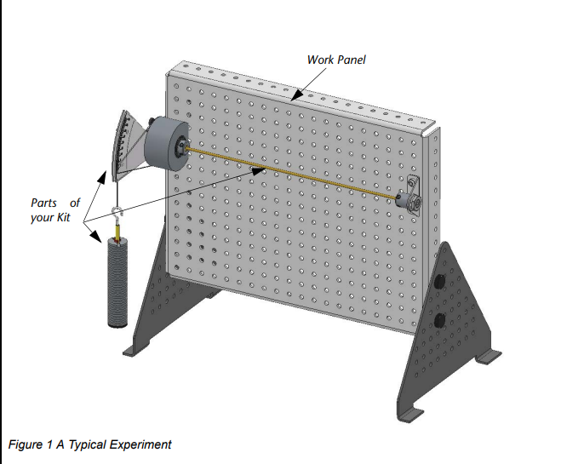
The instrumentation can be seen below:

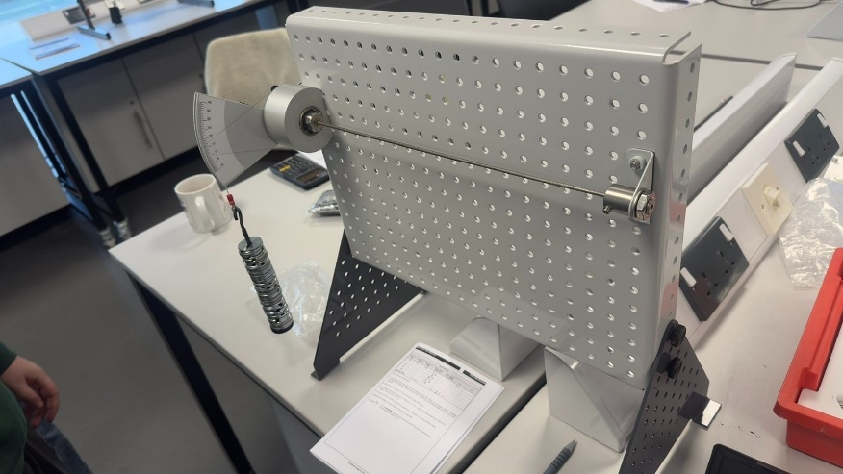
(TecQuipment Ltd, 2012)

(Bath, 2025)

Methodology
The diameter of the test piece was measured using a vernier calliper (this value is used to calculate J or the Polar Moment of Inertia).
The rod was then clamped into place at each end using the grub screws on the clamps and the gauge measuring the twist angle was zeroed before any load was applied.
Masses were then added to the hanger in 100 g increments and a measurement of the angle of twist was taken and recorded until 500 g had been added (only 400 g for aluminium).
The mass was then removed, and the system was zeroed again before the experiment was repeated for the next material.

Results
Below is the raw data that was collected in the lab along with further values which were needed in order to produce the graphs on excel:
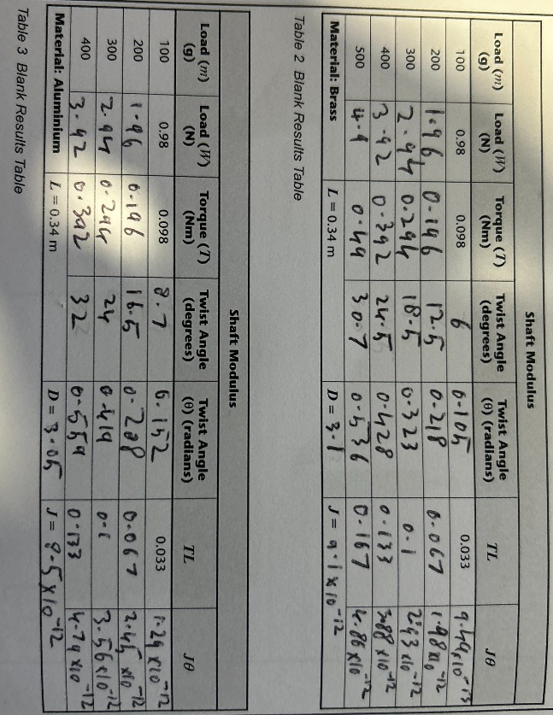
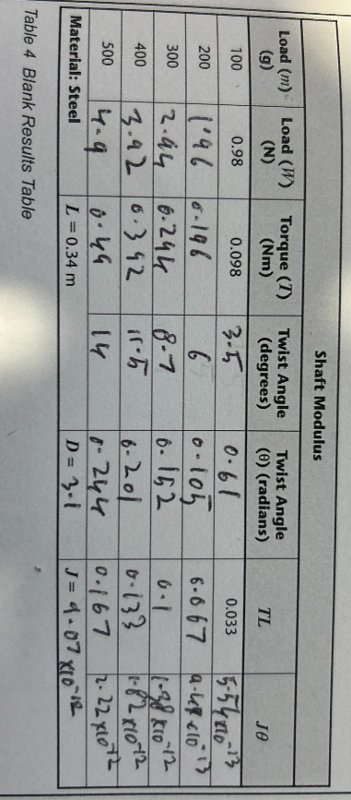

Analysis
The experimental data was used to produce a graph of TL (torque (Nm) * Length(m)) against Jθ (Polar Moment of Inertia(m^4) * angle of twist (radians) for each material. The graphs are as follows:

(E=x10^)
The gradient of these graphs was equal to the value of G or the Shear Modulus because when the equation y = mx + c is applied, y = TL, x = Jθ, making m = G. This equation is present on each graph and the list of the value of G for each graph is as follows:
Brass = 30 GPa
Aluminium = 30 GPa
Steel = 80 GPa
This data can be compared to data collected by other trusted sources such as the textbook values provided by TecQuipment (who make the test rig used for the experiment) or MatWeb.
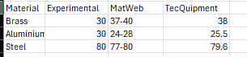
(MatWeb, 2024) (TecQuipment, 2012)
The value of G for steel showed a very strong correlation with the researched values which shows that the kit used can be trusted to gather accurate data however the results from the brass and aluminium tests vary by 21% for brass and 12% for aluminium from the MatWeb data. This discrepancy could be due to a number of reasons including alloy composition and temperature of the material.
All graphs follow a positive, linear correlation which shows that all of the test pieces stayed within their elastic limits, this also shows that the angle of twist is directly proportional to the length and torque and is inversely proportional to the Polar Moment of Inertia.

Evaluation
Many measurements were taken during this experiment which means data can easily become inaccurate without proper technique. An example of this is Parallax Error which can occur when reading any analogue measuring instrumentation and this is when the measurement is taken from an angle instead of the observer keeping their eye perpendicular to the instrumentation, this will cause an incorrect measurement. In this experiment, this can happen either when using the angle gauge or the vernier calliper. This is particularly important when measuring the material’s diameter as J is calculated using d^4 meaning a slight discrepancy in the measured diameter could invalidate all data gathered from that material. To further ensure the measurement of the diameter is correct, three measurements were taken at different points across the material, and an average of the three measurements was used.
Another precaution that was taken in order to keep the measurements valid, was zeroing the angle gauge with the weight hanger before each material was tested in order to account for the weight of the hanger and each material was tested starting at the same amount of torque ensuring accurate readings across all test pieces.

Further Work
Given unlimited time and resources, this experiment could become much more accurate. Firstly, the experiment should be carried out in a temperature-controlled environment to ensure the material does not expand or soften as this would affect the value of G. Digital measurement equipment could also be used in order to mitigate the chances of incorrect readings and this would open the opportunity for more data points across the shaft. The current rig uses bearings to support the rotating clamp so either the bearings could be replaced before the experiment or use another method of supporting the clamp in order to reduce friction and increase the accuracy of the results.

Conclusion
The main objective of this experiment was to find the Shear Modulus of brass, steel, and aluminium by processing data gathered by testing the materials with the ES5 Torsion of Circular Shafts Kit. The experiment has successfully displayed the linear elasticity of each of these materials under increasing torsional loading. While there were discrepancies in my findings, the experiment has proven to reliably characterise the torsional rigidity of materials.

Reference List

Bath,W.(2025) Photograph of ES5 Torsion Kit in Lab IQ007.[Image]. 04 January 2026.
MatWeb (2024) Material Property Data. Available at: https://www.matweb.com (Accessed: 2 January 2026)
TecQuipment Ltd (2012) Engineering Science Guidance Notes: Torsion Kit ES5. Nottingham: TecQuipment Ltd.(Accessed: 3 January 2026)

