University of Wales Trinity Saint David

Science
Investigation of three forces in equilibrium

Rizwan Chishti
1806547
Computing Foundation STEM
23/01/2019
Science/M3X01513

Contents Page

Contents
Introduction 2
Discussion 3
Conclusion 5

Introduction
For this technical report we are going to the experiment how the angles will change when we change the masses between on two strings attached .we are required to produce an experimental report and have to answer some questions on our set of data we have been asked to identify and apply physical principals and relation of the solution to the problem, then we have to use some equations to produce numerical values using engineering units (SI)

Discussion
Each time we increase the mass M we were taking two measurements l1 and l2, then we have to take both angles of the string o1 o2. Then we have to make a table with ten columns including three columns for our derived data, we need to make this table to record our measurements.
Before we started the experiment we made sure that the hanger is positioned correctly at the mark of string. By doing that you take out the element of taking any false readings, then we started our experiment.
Then we measured lengths l1 and l2 and angle, we recorded the data in our tables and used M=50. We added 50g to the hanger which was 100g in total, then measured and record both lengths
Of string.

 | Readings
Mass/g | L1/mm | L2/mm | $$θ$$
50g | 11mm | 11mm | 50
100g | 14mm | 14mm | 60
150g | 16mm | 16mm | 70
200g | 18mm | 19mm | 80
250g | 22mm | 22mm | 90
300g | 24mm | 24mm | 85
350g | 26mm | 26mm | 90
400g | 28mm | 28mm | 95
450g | 30mm | 30mm | 100
500g | 33mm | 33mm | 105
550g | 35mm | 35mm | 110
600g | 37mm | 37mm | 100

We repeated the previ0ous steps and went up to M=600g and then we removed the masses and load from the string. Then we put the mass hanger back on the string in its original position which is right in the centre of the string. We repeated the experiment again and increased masses from 50g to 100g and went up to 600g and took the measurements and angle again and recorded them.

 | Reading 1(before) |  |  | Reading 2(after)
Mass/g | L1/mm | L2/mm | $$θ$$ | Mass/g | L1/mm | L2/mm | $$θ$$
50g | 11mm | 11mm | 50 | 50g | 11mm | 11mm | 50
100g | 14mm | 14mm | 60 | 100g | 14mm | 14mm | 60
150g | 16mm | 16mm | 70 | 150g | 16mm | 16mm | 70
200g | 18mm | 19mm | 80 | 200g | 19mm | 19mm | 80
250g | 22mm | 22mm | 90 | 250g | 22mm | 22mm | 85
300g | 24mm | 24mm | 85 | 300g | 24mm | 24mm | 89
350g | 26mm | 26mm | 90 | 350g | 26mm | 26mm | 93
400g | 28mm | 28mm | 95 | 400g | 28mm | 29mm | 95
450g | 30mm | 30mm | 100 | 450g | 31mm | 31mm | 100
500g | 33mm | 33mm | 105 | 500g | 33mm | 33mm | 104
550g | 35mm | 35mm | 110 | 550g | 35mm | 35mm | 102
600g | 37mm | 37mm | 100 | 600g | 37mm | 37mm | 100

For each value of M we calculated the mean of lengths and angles and recorded them in our table below.
Lm/mm | $θ$m | M  Cos(0m/2)
11mm | 50 | 55.2
14mm | 60 | 115.47
16mm | 70 | 183.12
19mm | 80 | 261.1
22mm | 88 | 347.54
24mm | 87 | 413.56
26mm | 92 | 503.84
28mm | 95 | 592.1
31mm | 100 | 700.1
33mm | 105 | 821.4
35mm | 106 | 914.00
37mm | 100 | 855.65

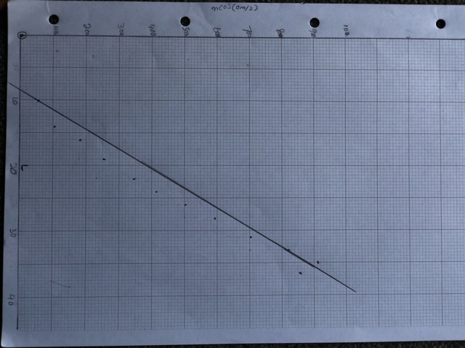

Conclusion

By doing this experiment we have learnt so many things, like how to get accurate results and reliable results. I also learned about uncertainty of the results. When I started the experiment, I made sure that everything is in place properly. The equipment was already setup when we went in the room. I made sure that everything is balance and straight before started tasking the measurements. I started the experiment by putting the weight hanger onto the string which was 50g Mass and took the measurements of both side string and the angle, then recorded them in my table as it shows above. Then took the measurements every time added the weight on the hanger going up by 50g each time and every time took the measurements and angles. Every time I added the weight onto the hanger, I waited for hanger to stop moving before I took my measurement and angles, as it will reduce the chance of getting false reading. When I was taking my taking angles, I made sure that it is not moving, and protector is right in the middle as it will also reduce the chance of getting false readings.
After getting both of the readings I recorded them in my table, I started getting my mean values for length and angles. I recorded the both results in my table, then I produce the graph and I draw a best line of fit, which is not a straight line. That states that my readings are not accurate and reliable. As you can see, I was getting the same readings again and again so I can say my reading were accurate, but they are not reliable but it’s a straight line. To get that straight line I have to repeat the procedure again few times to find out why it wasn’t a straight line of best fit. So, as it shows in graph my according to the readings I got an irregular line of best fit. This can happen due to few this for example due to systematic errors or human errors. Systematic errors can happen when you setup you equipment for experiment and it’s not in balance. These errors will be constant in every reading you take. Human errors can happen due to humans the way you take your measurement and angles due your eyes you take the angles.
After reading through the results I have come to the conclusion that my own human error may be the reason that they are unreliable. In hindsight I believe that I mistakenly took measurements of the forces effects on the string and not the spring. As a result of the string being inextensible, with the mass hanger attached to the string my readings only varied between a range of 10mm and 35mm. It is down to this fact that my graph doesn’t follow the trend I expected it too. In order for me to have more accurate results I would need to do this experiment again, I have to make sure that setup my equipment right and find a better way to get the measurements of length and be sure to lean down when I am taking my angles so I can see better in a straight line from zero what angler is right before I record it on my table. I also have to make sure that I am following the correct scientific process when conducting experiments in the future.

