Professional Career Development
Reflective report on Kolb’s Reflective Cycle and swot analysis
Ana Ivona Misu
2008695

1,068 words

Contents
Executive Summary 2
Introduction 2
Main Findings 2
Conclusion 6
References 7

Executive Summary
The objective of this report is to offer a presentation of Kolb’s Reflective Cycle and SWOT analysis. I will first give some general information about both theories and then I will explain and provide examples for each, using myself as a subject.

Introduction
In this report, I am going to explore the two theories whilst also using practical evidence. Both techniques are constructive instruments that have great efficacy in finding effective strategies in businesses and professional organizations.
Kolb’s theory suggests that the best way to learn is through experience, stating that: “Learning is the process whereby knowledge is created through the transformation of experience” (Kolb, 1984, p. 41 as cited in Kolb, A.I. and Kolb D.A. 2011).
Additionally, SWOT analysis targets problems that might be experienced by an individual, company, or business and helps find tactical solutions for solving and improvement (Gürel, E., 2017).

Main Findings
Kolb’s Reflective Cycle
Kolb first presented this concept in his book “Experiential Learning: Experience as the Source of Learning and Development” in 1948, being inspired by intellectuals like Piaget and Jung (Kolb, D.,2015). His work remains relevant to this day, as a model used successfully by professionals and business students (Dennison, 2010). Kolb’s concept is based on the idea that experience is necessary for the process of learning, and four phases form the reflective cycle: Concrete experience, Reflective observation, Abstract conceptualisation, and Active experimentation. All four stages need to be completed to make the process of learning more efficacious (Kolb, 1981 as cited in Young, M. R.,2018) and to convert experience into knowledge.
I will present a diagram of Kolb’s Reflective Cycle below, to give a visual representation of his concept and I will use my own experience as an example of how it improved my work.

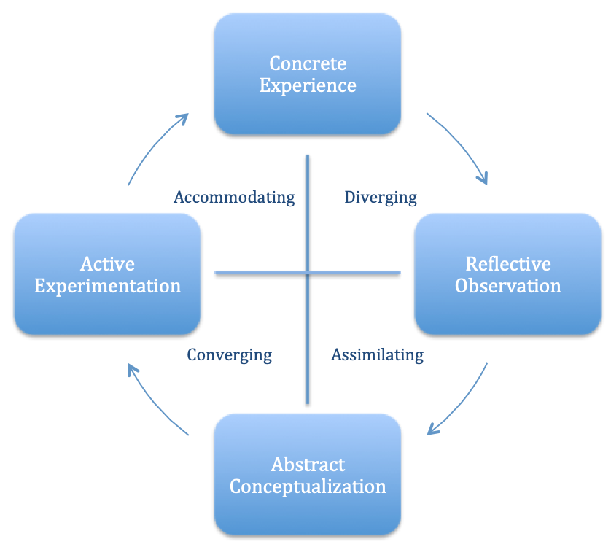

The Concrete Experience: I had to face an issue at the restaurant where I work. The menu had been changed and I was not familiarised with the new dishes and replacements. Upon inspecting the menu, one of the customers asked me what one of the new dishes contained and if there was any vegan option for it. I did not know what to tell him and had to take some time to ask and get back to the table with the information he was expecting.
Reflective Observation: After this incident, I took a step back and started reflecting on the situation. I became aware of the fact that I might have come across as inefficient or unconcerned and that the customer was unhappy about the service and the fact he had to wait longer.
Abstract Conceptualization: I realized that to give the clients the best service I can, I need to be updated with all the changes so I can help them with the information they need and I must know the details of the menu.
Active Experimentation: I addressed the problem to my manager and told him that I wanted to study the new menu and get to know it by heart. I also proposed the idea of being informed in advance when the dishes get replaced and regularly updated with the list of ingredients and allergen information.
Since then, the quality of my service has significantly improved.

SWOT Analysis
SWOT analysis is a structure designed to assess and develop a strategic plan within an enterprise, work, or personal life. It stands for Strengths, Weaknesses, Opportunities, and Threats (Kenton, 2013). Its purpose is to give a different perspective upon what is the situation of a company, business, or individual. Weaknesses and strengths, although opposite concepts, are interconnected and it is beneficial to be aware of them to find effective and realistic solutions to potential problems (Teoli D, Sanvictores T, An J, 2019). Additionally, this analysis can help reduce the threats that may obstruct evolution within a specific field (Yatinesh K. and Deepa A.,2022).
I have decided to apply the SWOT analysis using myself as a subject because this is a tool that I consider beneficial for me. By knowing exactly where I stand, I can use my strengths to my advantage, work on my weaknesses, and use opportunities against the threats I may encounter in the future.
Strengths
After analysing myself I concluded that my strengths are that I know how to manage my time effectively, I am a good and reliable team member, I am a fast learner and I have experience in different job fields. I am also committed to the things I do.

Weaknesses
I have discovered that I struggle to work well under pressure. I am also impatient and expect to see results faster than it is realistically possible. Moreover, I deal with a lot of self-criticism and I am a perfectionist.
Opportunities
A recent opportunity is that I am now being a student and pursuing a higher level of education. I can gain more knowledge and get skills like writing academically and doing research. Additionally, as technology advances at a fast pace, knowing how to navigate the computer is a beneficial tool that I can use to my advantage.
Threats
Due to inflation and the increase of cost of living many businesses close or reduce the number of employees, which has a significant impact on the job market. Moreover, competition is a constant threat in the hospitality industry I work in.
After doing the SWOT Analysis I started to become more aware of myself and the environment I am in. I now know my weaknesses and I have developed a conversion strategy that I can use to my advantage.
Weaknesses become strengths: I can profit from being a perfectionist by continuously improving my service and skills, but I will try to be less self-critical. I also aim to work better under pressure, and I can achieve that by prioritizing my tasks to avoid getting overwhelmed. Next, I can use my impatience to work faster and finish jobs sooner than the other coworkers.
I also started to view threats as new opportunities and competition as a path toward self-development.
Threats become opportunities: I can use the decrease in the job market in my industry as an opportunity to explore new career paths, take courses, and specialize in a different field. Plus, I realized that viewing competition as an opportunity can help me work harder and prove myself, making me a valuable employee.

Conclusion
For me, the main benefit of using SWOT is realizing that things can be changed, transformed, and improved. My mindset is positively different, and I gained new useful skills.
Also, Kolb’s Reflective Cycle has helped me reflect on previous experiences from my personal and professional life and use them as a tool to learn and better myself.

References

Dennison, P. (2010). Reflective practice: The enduring influence of Kolb’s Experiential Learning Theory. Compass: Journal of Learning and Teaching. 1(n.i), n.p. [Online]. Available at: https://www.researchgate.net/publication/277771428_Reflective_practice_The_enduring_influence_of_Kol [Accessed 31 October 2023].
Gürel, Emet. (2017). SWOT ANALYSIS: A THEORETICAL REVIEW. Journal of International Social Research. 10(51), p.994. [Online]. Available at: https://www.researchgate.net/publication/319367788_SWOT_ANALYSIS_A_THEORETICAL_REVIEW [Accessed 2 November 2023].
Kenton, W. (2023). SWOT Analysis: How To With Table and Example. [Online]. Investopedia. Last Updated: 30 October 2023. Available at: https://www.investopedia.com/terms/s/swot.asp [Accessed 30 October 2023].
Kolb, A.I. and Kolb D.A. (2011). The Kolb Learning Style Inventory 4.0: A Comprehensive Guide to the Theory, Psych. [Online]. Experience Based Learning Systems, Inc. Available at: https://www.researchgate.net/profile/David-Kolb-2/publication/303446688_The_Kolb_Learning_Style_Inventory_40_Guide_to_Th [Accessed 2 November 2023].
Kolb, D. (2015). Experiential Learning: Experience as the Source of Learning and Development. [Online]. Pearson FT Press. Available at: https://books.google.co.uk/books?hl=en&lr=&id=jpbeBQAAQBAJ&oi=fnd&pg=PR7&dq=kolb+jung+and+piaget&ots=VobWkT-VS9&sig=aU2T [Accessed 2 November 2023].
Teoli D, Sanvictores T, An J. (07 Feb 2019). SWOT Analysis. [Online]. Europe PMC. Last Updated: 2019. Available at: https://europepmc.org/article/med/30725987 [Accessed 30 October 2023].
Yatinesh K. and Deepa A. (2022). Kahoot! A Comprehensive Formative Assessment Tool in Medical Education: A SWOT Analysis. International Journal of Multidisciplinary Research and Publications. 5(4), p.65. [Online]. Available at: https://researchmgt.monash.edu/ws/portalfiles/portal/424561087/422246740_oa.pdf [Accessed 2 November 2023].
Young, M. R. (2018). Reflection fosters deep learning: The ‘reflection page & relevant to you’ intervention. Journal of Instructional Pedagogies. 20(n.i), p.2. [Online]. Available at: https://files.eric.ed.gov/fulltext/EJ1178730.pdf [Accessed 31 October 2023].

