University of Wales Trinity Saint David


Title: Assessment component - Individual report
Assignment Title: Report
Student Name: Chiya Fayzullah
Student ID: 2208596
Module: Strategic Management
Module Code: LCMB7003
Name of Lecturer: Amare Desta
Zulf Khan
Internal verifier: Vasilios Tavlaridis
Hoang Nguyen
Contents
Section-1 1
1. Organizational Context and Overview 1
1.1 Organizational perspectives 1
1.2 Industry and Competitive perspectives 1
2. External and Internal Environment Analysis 2
2.1 External Environment Analysis (PESTEL) of Tesco PLC External Environment 2
2.2 Critical Success Factors and Strategic Challenges 3
2.3 Strategic Challenges 4
2.4 Analysis of Tesco PLC Internal Environment 4
Key Resources 4
Capabilities 5
Core Competencies 5
2.5 VRIO Framework Analysis 6
2.6 Contribution of Internal Strengths to Competitive Advantage 6
3. CSR and Sustainability Objectives 7
4. Comprehensive and Holistic View of the Organization: The Balanced Scorecard 7
5. Strategic Choices and Implementation 9
5.1 Evaluation and Recommendation of Strategic Choices 9
5.2 Critical Assessment of Change Management and Strategic Implementation 10
6. Strategic Evaluation and Recommendations 12
6.1 Critical Evaluation of Current Strategy 12
6.2 Recommendations to sustain competitive advantage 12
Section-2 13
7. Reflective Account: Researching and Analyzing Tesco PLC Strategic Environment 13
References 16
Appendixes 19
Appendix-I 19
Appendix-II 19
Appendix-III 20

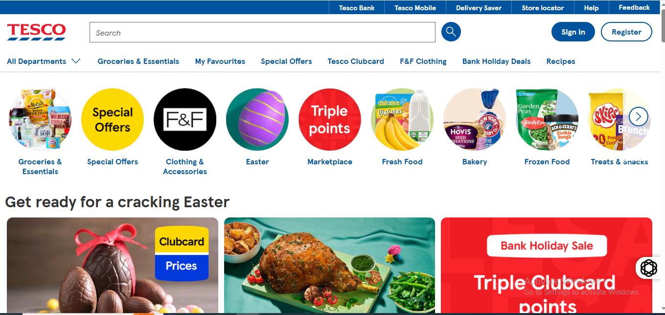
Strategic Management Practices
Tesco PLC

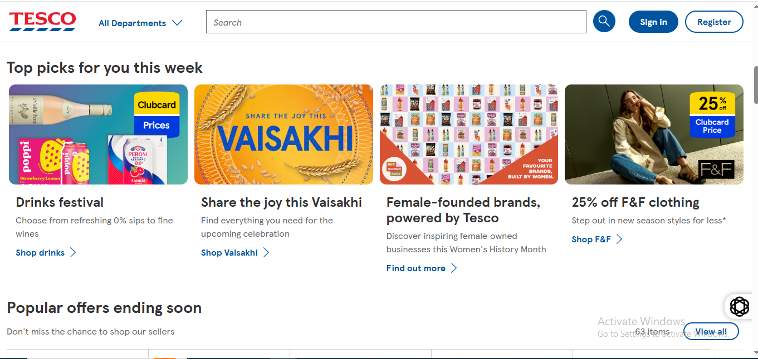

Section-1

1. Organizational Context and Overview

1.1 Organizational perspectives
Refer to Appendix-I, Tesco PLC, founded in 1919 by Jack Cohen, began as a market stall in London’s East End. Its strategic management has been flexible to the fact that it is now one of the largest grocery stores in the world. This business model is based on the core purpose of the company, which is to serve our customers, communities and planet a little better every day, and it is how the company shifted its business model to be not a pure-play retailer, but a multi-format, multi-channel business that operates throughout the UK, Ireland, Central Europe, and a wholesale-based partnership in Thailand (Tesco PLC, 2024). Its vision is implicitly seen in its sustainability programmes of Greener Groceries and Stronger Starts, which focuses on being a leader in successful business and being socially responsible (Tesco PLC). A differentiated portfolio, with big hypermarkets (Extras), convenience stores (Express) and a powerful online retail division forms the business model. By the time of their 2025 Annual Report, Tesco has more than 4,000 stores and it owns the highest proportion of the UK grocery sector at 27.9% (Tesco PLC, 2025).

1.2 Industry and Competitive perspectives
The business environment that Tesco is in is the UK grocery market that is highly competitive with low margins, volume, and highly competitive prices. It has J Sainsbury plc, Asda, and the rapidly expanding discounters Aldi and Lidl as its major rivals that have fundamentally transformed the competitive environment because they have taken away value-conscious consumers. The reaction of Tesco to this is that it has begun to effectively focus on its Aldi Price Match initiative which is a direct attack on the core value proposition of the discounters (Tesco PLC, 2025). Regardless of this pressure Tesco continues to hold its market-leading status, with its scale and vast information regarding the customer loyalty (through its Clubcard scheme) allowing it to out-manoeuvre the other players. The market leadership, in its turn, implies heavy scrutiny of regulators, media, and the general populace, which demands a strong strategy toward ethical business practises and corporate governance, which are stipulated by its Code of Business Conduct and Groceries Supply Code of Practise (Tesco PLC, 2024).

2. External and Internal Environment Analysis

2.1 External Environment Analysis (PESTEL) of Tesco PLC External Environment
Tesco’s strategic decisions are profoundly shaped by a complex external environment. The PESTEL analysis will indicate the macro-economic and socio-political forces that determine its competitive reactions.
Political: The political environment, especially the post-Brexit, has come at a huge strategic cost. New trade barriers and customs declarations have compounded supply chains, and it has become costly in terms of operations. This can be confirmed by the fact that in its Annual Report, Tesco states that it has to continue to pay attention to the effects of new trading relations with the EU (Tesco PLC, 2025).
Economic: The cost-of-living crisis dominates the economic environment and has radically changed the consumer behaviour. The price sensitivity has risen drastically due to inflation and Tesco has no option, but to implement a defensive competitive strategy. Its main reaction is the Aldi Price Match programme that equals the prices of more than 900 core grocery products against the main discounter threat (Tesco PLC, 2025).
Social: One of the key drivers of the long term strategy in Tesco is characterised by social factors. Consumers are increasing their demands in health and sustainability, which Tesco has integrated in its business model. The direct strategic reaction to the increased obesity levels and ethical consumerism is represented by its Health pillar that makes healthy and sustainable diets more accessible (Tesco PLC, 2024). To provide an example, its product development in reaction to this social change can be the expansion of its plant-based "Plant Chef" line.
Technological: Technology is a very essential facilitator to efficiency and differentiation. The calculation of the data analytics enabled by Clubcard is a powerful competitive edge that Tesco has made a strategic investment in. The Clubcard creates a high level of customer insight, allowing it to make hyper-personalised offers and manage stock optimization, which it can hardly achieve with its smaller competitors. It is one of its fundamental components of creating price-free loyalty (Tesco PLC, 2025). The "Low Carbon Concept Store" in Manchester is also used as a real world test laboratory of new technologies.
Environmental: Environmental pressures are arguably the most transformative external factor for Tesco. The company has committed to ambitious climate goals, including a target to reach net zero in its own operations by 2035. This is not just a CSR initiative but a strategic imperative driven by regulation, consumer pressure, and climate risk. Its "Planet Plan" outlines specific, measurable targets, such as halving food waste in its operations by 2025 and removing two billion pieces of plastic from its business (Tesco PLC, 2024). The strategic decision to set these public targets creates a powerful form of accountability. Failure to meet them would result in significant reputational damage, while success positions Tesco as a market leader in an increasingly environmentally-conscious retail landscape.
Legal: the external force that has been the most transformative to Tesco is probably the environmental pressures. The company has committed to ambitious climate goals, including a target to reach net zero in its own operations by 2035. This is not just a CSR initiative but a strategic imperative driven by regulation, consumer pressure, and climate risk. Its Planet Plan has targets, which are specific and measurable, including reducing food waste levels in its operations by half by 2025, as well as eliminating two billion units of plastic in its operations (Tesco PLC, 2024).

2.2 Critical Success Factors and Strategic Challenges
- Price Leadership: Being able to be as competitive as Aldi and Lidl regarding price is a CSF that cannot be compromised. This is provided with the help of the A Aldi Price Match programme and demands unremitting efficiency of operations and supply chains optimization (Tesco PLC, 2025).
- Supply Chain Efficiency and Resilience: It has a large scale and a multi-format business, which requires a high-efficient, agile, and ethical supply chain. It is controlled by the "Groceries Supply Code of Practise" to make sure that the relations with suppliers are long-term (Tesco PLC, 2024b).
- Brand Trust and Reputation: After previous scandals, recovery and sustenance of trust is a primary CSF. It is done by transparent sustainability reporting, ethical governance policies, and investment in community via the Stronger Starts framework (Tesco PLC, 2024).
- Data-Driven Customer Insight: The capability to use Clubcard data to learn about customer needs and foresee customer needs is another distinction and a CSF to personalise offers and elicit loyalty (Tesco PLC, 2025).

2.3 Strategic Challenges
Sustaining the Hybrid Strategy: The most difficult task is to continue the fine balance between cost leadership (to compete in price) and differentiation (through sustainability and quality). The pressure to reduce the costs in order to finance price equivalent might effectively damage its investments in sustainability or relationships with suppliers.
Discounter Competition: Aldi and Lidl are the two rising competitors, and this is a constant structural threat to the market share of Tesco. Their bare-bones model that is cheap is a thorn in their flesh which needs constant strategic attention.
Geopolitical and Supply Chain Volatility: Continuous political instability, environmental and climate change effects on agriculture and global supply chain shocks are always challenges to sustaining the availability of products at a constant price (Tesco PLC, 2025).
Meeting Ambitious Sustainability Targets: he environmental targets of the company, including the 2035 a net-zero target, are public, which poses a high risk of executing those targets. This process is complicated and unpredictable, and it demands huge capital injection and coordination between the industries to reach these objectives (Tesco PLC, 2024).

2.4 Analysis of Tesco PLC Internal Environment
Tesco’s ability to navigate its external challenges is grounded in its internal environment of resources and capabilities.

Key Resources
- Physical: It offers an extensive network of more than 4,000 stores, including large Extras and smaller Express formats, that offer a combination of size with locality (Tesco PLC, 2025).
- Financial: Tesco is the market leader in generating enormous revenue and as a result, the company has the financial capital to invest in price wars, technology and long term sustainability projects.
- Human: A human workforce of hundreds of thousands of colleagues is an important resource. The reason why the company chooses to emphasise the element of Colleagues as one of the pillars of its sustainability strategy is the recognition of the fact that the employees of Tesco are the key to providing service and operational excellence (Tesco PLC, 2024).
- Technological/Data: The Clubcard database is a unique technological and data platform, which includes the purchasing history of millions of active customers in details (Tesco PLC, 2025).
- Reputational: An ethical governance built reputation, based on a clear Core Purpose and Values, is an intangible but the most important resource, as it allows the company to carry out trust-based transactions with its customers and suppliers (Tesco PLC, 2024).

Capabilities
- Advanced Data Analytics: The option to investigate Clubcard data to stimulate micro-segmentation, humanised marketing and dynamic pricing.
- Vertical Supply Chain Integration: The ability to have a multi-tiered supply chain, farm to fork, that is efficient, of high quality, and ethically sourced.
- Multi-Format Retail Management: The ability to effectively run and perform well in different retail formats (Extra, Superstore, Express, Online) all with different operational models and different customer bases.
- Stakeholder and Reputation Management: The capability to manage complex relationships with investors, regulators, NGOs, and local communities, as evidenced by the detailed "Reporting Hub" and community engagement programmes (Tesco PLC, 2024).

Core Competencies
A core competency refers to an ability that is at the centre stage of a competitive advantage of a company. In the case of Tesco the Integrated Cost Leadership and Sustainability-Differentiation is the core competency. It is not only a low-cost operator but also is not only a sustainable brand; it is a strategic union of the two. It applies its size to attain a cost leadership, which supports its price-match strategy, and at the same time, integrates sustainability into its operating cloth, to create brand loyalty beyond price. Pure-play discount competitors (who do not have the sustainability infrastructure) and ordinary supermarkets (who may not have the discipline of the cost) can hardly copy this dual capability.

2.5 VRIO Framework Analysis
Using the VRIO (Value, Rarity, Imitability, Organisation) framework to analyse the Tesco main capabilities is a critical evaluation of the potential of the same to deliver sustainable competitive advantage.

2.6 Contribution of Internal Strengths to Competitive Advantage
Tesco’s internal strengths directly fuel its competitive advantage by creating a virtuous cycle. Its core competency of integrating cost leadership with sustainability is built upon its VRIO strengths.
The competitive advantage generated by Tesco is a direct result of its internal strengths which drive the level of competitive advantage. It has its VRIO strengths that make it its core competency of combining cost leadership with sustainability. The data analysis of the Clubcard (a sustained competitive advantage) enables Tesco to comprehend the exact customers that are the most price-sensitive, and those that are the most concerned with sustainability. This allows it to carry out the so-called Aldi Price Match in the most efficient way, where price cuts would have the greatest impact, and at the same time advertise its so-called Greener Groceries programmes to its society-conscious segments. The ethics governance system makes sure that the desire to lead in cost does not culminate into unethical supplier practises or accounting scandals that will result in the loss of brand trust hence protecting its differentiated reputation.

3. CSR and Sustainability Objectives
As shown in Appendix-II, The CSR and sustainability strategy at Tesco is also instilled in its Greener Groceries framework, which wants to reach net zero emissions in its own operations by 2035, a goal that itself facilitates cost efficiency in its operations and regulatory readiness over the long term (Tesco PLC, 2024). This environmental consideration can be achieved by the operationalisation of the Planet Plan that covers objectives that can be measured, including reducing its own food waste by 50% by 2025 and eliminating two billion pieces of plastic in its operations, hence cutting costs and addressing consumer demand to have a sustainable retail (Tesco PLC, 2024). On the social front, the so-called Stronger Starts initiative, sponsored by the Blue Token Scheme, is to serve over 20 million meals to children by 2030, which can not only eradicate food poverty but also integrate more value-driven families into the community and create trust in the brand (Tesco PLC, 2024). On the same note, the "Fruit & Veg for Schools" initiative is also closely related to the company pillar of Health, which allows promoting healthy and sustainable diets at a young age and establishing long-term customer relationships (Tesco PLC, 2024). Transparency is a strategic approach that Tesco employs to draw a distinction between itself and its discounter competitors by reporting these sets of targets publicly via its Reporting Hub, making sustainability a competitive edge (Tesco PLC, 2024). Nevertheless, there is an underlying conflict: since it needs to keep the Aldi Price Match initiative, there is a risk that it may compromise investment in such sustainability initiatives, making its hybrid strategy questionable in the long run (Tesco PLC, 2025). All in all, the CSR objectives of Tesco are not peripheral, as they are strategically aligned with the core business strategies, which consist of cost leadership, market differentiation and trust of the stakeholders.

4. Comprehensive and Holistic View of the Organization: The Balanced Scorecard
The Balanced Scorecard system (Kaplan and Norton, 1992) offers the holistic prism within which the operational performance of Tesco can be assessed within four fundamental perspectives, showing how its mission and strategy are converted into the action.
Financial Perspective: Tesco has financial goals that focus on the provision of sustainable shareholder value in financing its competitive strategy. Among the key performance indicators (KPI) are the market share which was 27.9% in the UK, as well as the revenue growth based on its multi-format portfolio comprising of more than 4,000 stores (Tesco PLC, 2025). The targets aim at preserving this market leadership with operational efficiencies to sustain the Aldi Price Match scheme on more than 900 core products, a long-term strategic project that trades off short-term margin on long-volume and customer retention (Tesco PLC, 2025). The policy of Our Approach to Tax also guarantees adherence of financial governance to ethical standards and reduces regulatory and reputational risk (Tesco PLC, 2024).
Customer Perspective: Tesco has a customer strategy that is based on value, convenience, and trust. Examples of KPIs are customer satisfaction scores and Clubcard penetration, which is an essential personalisation and loyalty instrument (Tesco PLC, 2025). The campaigns like the Aldi Price Match directly appeal to the price-sensitive customer group, whereas the Stronger Starts programme, including the Blue Token Scheme or the Fruit and Veg for Schools, are meant to create a long-term goodwill to the community as well as brand loyalty, and one of the goals is to provide over 20 million meals to children by 2030 (Tesco PLC, 2024). The code of Business Conduct also strengthens the customer trust as it guarantees ethical treatment in every touchpoint (Tesco PLC, 2024).
Internal Business Processes Perspective: this perspective deals with operational excellence, supply chain integrity and sustainability. Food waste reduction targets fall under KPIs, where the Planet Plan focuses on reducing food waste in own operations by half by 2025, and plastic reduction, where its goal is to eliminate two billion pieces of plastic in its business (Tesco PLC, 2024). As a pilot of energy-saving technologies, including electric car (EV) charging stations and high-tech fridges, such initiatives as the "Low Carbon Concept Store" contribute directly to the goal of the net zero operation by 2035 (Tesco PLC, 2024). Ethical supplier management KPI relies on the requisite compliance with the Groceries Supply Code of Practise, which guarantees that the Tesco scale will not affect the standard of fair trading (Tesco PLC, 2024).
Learning and Growth Perspective: Tesco has a long-term success possibility on its organisational culture, employee growth and developmental abilities and innovativeness. Some KPIs are colleague involvement and retention, with the supporting pillar being the Colleagues pillar, which focuses on training, wellbeing, and inclusive workplace (Tesco PLC, 2024). The integration of the Core Purpose and Values throughout the workforce will make sure the strategic goals are perceived and implemented at all the levels (Tesco PLC, 2024). The initiatives that lead to innovation include the Low Carbon Concept Store that, besides testing the new technologies, also develops new operational skills and capabilities (Tesco PLC, 2024). Additionally, the policies are supported by the culture of integrity, which is implemented through the "Ethics and Compliance policies" (such as the Group Anti-Bribery Policy), and removes the chances of governance failures that tainted the organisation in the past (Tesco PLC, 2024).

5. Strategic Choices and Implementation

5.1 Evaluation and Recommendation of Strategic Choices
On the business level, Tesco adopts a hybrid business model of combining cost leadership and differentiation that is fundamental in the UK grocery business since discounters Aldi and Lidl have taken 10.1% and 7.8% of the market share respectively by ferociously concentrating on price (Points de Vente, 2026). The cost leadership aspect is implemented with the Aldi Price Match programme on hundreds of the most basic products directly opposing the essence of the discounters (Tesco PLC, 2024). This is supported by Clubcard Prices, where it provides more than 8,000 weekly deals (saving up to 50) in the hands of the over 20 million households that make up over 80% of the sales (Tesco PLC, 2024). Such efforts portray a calculated fight to protect market share which is at 27.6% and in the UK against disruptive price-based competition (Morningstar, 2025).
The dimension of differentiation is based on sustainability, quality and customer experience. The Tesco brand stands out among the discounters, which compete in nearly every situation based predominantly on pricing, with a goal of the Greener Groceries structure and the Planet Plan, which has such targets as ruralising food waste by 2025 and eliminating 2 billion units of plastic (Tesco PLC, 2024). The premium range Finest recorded sales growth of 16% and this shows that quality differentiation appeals to the customers even in the middle of the cost-of-living crisis (Morningstar, 2025). This data analytics ability, Clubcard, has been developed since 1995 and offers a unique and valuable personalisation resource that the competitors cannot easily copy (Business Model Analyst, 2025). This mixed positioning is hard to maintain in the long run but is sufficiently working at the moment: Tesco increased its full-year profit expectations to £2.9-3.1 billion in fiscal 2026, and in the first half, revenue stands at £36.04 billion (Morningstar, 2025).
At the corporate level, esco has been working on the policy of focused diversification and strategic retrenchment. The company has downsized its presence in other countries to the core markets of the UK, Ireland, the Czech Republic, Hungary, and Slovakia after previous over expansion in other markets such as Japan and the US (Research and Markets, 2025). The acquisition of Booker Group, which occurred in 2018, was an attempt at vertical integration into the wholesale and foodservice segments of the business, thus diversifying the revenue to four categories, not including the traditional retail (Business Model Analyst, 2025). In more recent times, Tesco sold its banking division to Barclays in November 2024 and left the financial services sector to concentrate on its old grocery business (Quaintel Research, 2025).
Recommended Strategic Choices: I would suggest that Tesco should proceed with its hybrid strategy at the business level but intensify its vertical diversification in food supply chains. The mixed method is justified through the existing financial performance and stability of the market share. Nevertheless, the cost leadership, as well as a differentiation, should also be sustained through the continuous investment. To intensify the differentiation pillar, Tesco ought to quicken their sustainability investments, specifically agriculture as well as packaging since consumers increasingly desire ethical retailing (Tesco PLC, 2024). At the corporate level, I would propose a selective extension of the Booker wholesale model to complementary foodservice channels, with the help of the current logistics infrastructure. Instead of geographical expansion to other countries which involves a lot of risk, Tesco must look at penetrating more in Central European countries where it already operates (Research and Markets, 2025).

5.2 Critical Assessment of Change Management and Strategic Implementation
Tesco has tried its strategic decisions by undertaking major organisational change with mixed results that provide valuable lessons. The company is undergoing a massive governance and cultural overhaul following the accounting scandal of 2014 that badly damaged the trust. Systematic approach to the embedding of ethical behaviour is represented in the implementation of the Code of Business Conduct, as well as specific Ethics and Compliance policies such as anti-bribery and gift policy (Tesco PLC, 2024). This restructuring of governance has played a key role in restoring the confidence of stakeholders and making the present hybrid strategy plausible.
Operationally, Tesco has been aggressive in the cost cutting process; this involves optimising processes, which has brought internal tensions within the company. The programme known as Step Change, which focuses on the decrease in the operating costs, has decreased the payroll amount of the stores, which stood at about 9% of the sales historically and is at about 7.3 per cent as per internal employee feedback (The Grocer, 2026). As much as this has helped the cost leadership strategy and even finance price matching, it has also brought operational pressures: employees complain that stores struggle so much on a daily basis and simply have no leeway to make adjustments to changing trade, with line managers being beaten up because of failing to deliver a number (The Grocer, 2026). This presents one of the most important implementation issues, namely how to be cost-effective without affecting the quality of the services and employee morale that are crucial to the differentiation strategy.
Digital transformation-A more successful change initiative has been the digital transformation. By undergoing a re-implementation of ARIS as its enterprise process management system, Tesco was able to replace the decentralised documentation in Excel and PowerPoint with one source of the truth of standard operating procedures (Software AG, 2025). The outcome has been a total visibility and control of processes all over the globe, 160 active designers, 300 trained personnel, and 1,200 viewers incorporated within business operations (Software AG, 2025). This is a technological shift that has facilitated standardised customer experience by format and minimised duplication in operations that supports the efficiency requirements of the hybrid strategy.
Supply chain transformation-Another successful implementation sphere is supply chain transformation. The Low Carbon Concept Store is a pilot project that tries out new technologies such as EV charge points, heat pumps, and state of the art fridges directly towards the net zero operation by 2035 operational goal (Tesco PLC, 2024). Tesco Sustainable Farming Group is an example showing how the business has applied traceability and environmental responsibility in its sourcing of agriculture (Business Model Analyst, 2025). These projects show that change management has been applied successfully in which sustainability is realised instead of it being a mere rhetorical pledge.
However, implementation risks remain. The conflict between work cost-cutting and the quality of the service is not gone, and the feedback of employees indicates that the payroll cut-off has already come to its diminishing returns (The Grocer, 2026). Moreover, the external environment is also unstable: although the UK food inflation has been stabilised to around 4.1% compared to 2023, when it was estimated at about 16 percent, it continues to put a strain on consumer purchases and Tesco cost base (Points de Vente, 2026). The threat of the discounter continues, and Aldi and Lidl are estimated at the highest sales growth rate of physical grocery (CAGR of 5.2) as at 2029 (Points de Vente, 2026).

6. Strategic Evaluation and Recommendations

6.1 Critical Evaluation of Current Strategy
An evaluation of Tesco using SWOT analysis shows that Tesco has been using dominant market share in the UK of 27.6% and the Clubcard loyalty programme, where the household population of over 20 million customers represents more than 80 percent of the total sales, as its strengths in its strategy of A Aldi Price Match (Morningstar, 2025; Tesco PLC, 2024). The stakeholders had lost their faith in the organisation due to unethical governance, which was once regained by the introduction of the “Code of Business Conduct” (Tesco PLC, 2024).
Being too dependent on the UK and the pressure on employees caused by payroll cuts to about 7.3% of the sales with reported pressure by the line managers are internal weaknesses (The Grocer, 2026; Research and Markets, 2025). Threats include imminent UK food inflation rates of about 4.1% (Points de Vente, 2026; Tesco PLC, 2024; Morningstar, 2025) and projected UK growth between 5.2% and 2029 by Aldi and Lidl (discounts) (Opportunities, n.d.), whereas opportunities are found in sustainability leadership (Planet Plan: halving food waste by 2025, eliminating two billion pieces of plastic) and wholesale expansion via Booker.
Using Ansoff’s Matrix- The strong strategy of Tesco by the use of the Matrix of Ansoff is market penetration (Aldi Price Match, Clubcard Prices). The products that are experiencing product development include the "Finest" range (16% sales growth) and the expansion of the "Plant Chef" (Morningstar, 2025). Central Europe is limited in market development, and diversification by Booker acquisition and banking exit sale to Barclays in 2024 was strategic refocusing (Research and Markets, 2025; Quaintel Research, 2025). The UK retail is a Cash Cow, Booker is a Star, Central European operations is Question Marks, and the divested banking business is a Dog in a BCG Matrix perspective (Quaintel Research, 2025; Morningstar, 2025).

6.2 Recommendations to sustain competitive advantage
- Transform Booker into a third-party logistics platform – Use the existing infrastructure based on non-competing retailers to generate related diversification (Ansoff) and new B2B revenue streams (Porters diversification logic) as in the case of Amazon logistics model.
- Monetise sustainability certification – Have a certification of suppliers to a "Greener Groceries" certification based on a meeting of the Planet Plan (Tesco PLC, 2024). This is in line with differentiation strategy and resource based view, where sustainability investments are made profit centres, as is the case with the Unilever sustainable living plan.
- Invest in frontline automation – Introduce autonomous inventory robots in large stores to decrease the labour load at the cost of the service quality. Such technologies are already being tested in the Low Carbon Concept Store, which is also concerned with the reported employee morale issues (The Grocer, 2026; Tesco PLC, 2024).
- Selective market development in Central Europe – Selective market expansion in Central Europe - and growth penetration in current markets (Czech Republic, Hungary, Slovakia) where discounter pressure is less and expected growth (3 4% CAGR) is higher than in the UK (1 2%).
These ideas relate to the cost service trade off, exploiting the untapped assets, and concur with the hybrid approach in Tesco that has provided a better profit guidance of PS2.9 3.1 billion during fiscal 2026 (Morningstar, 2025). To maintain this status, strict performance and further compliance to the ethical administration model on which the trust of the stakeholders is built must be maintained.

Section-2

7. Reflective Account: Researching and Analyzing Tesco PLC Strategic Environment
As shown in Appendix-III, The reflective account uses Gibbs reflective cycle (Gibbs, 1988) in a critical examination of the research and analysis of Tesco PLC strategic management practises. This is a systematic manner that allows learning through the assessment process.
Description – The assignment involved a detailed strategic analysis of Tesco PLC in the form of given company links and external sources. I started by going through the 30 given Tesco webpages systematically, retrieving the relevant facts such as the 27.9% market share in the UK, the current penetration of Clubcard into 20 million households, and the sustainability goals, including halving food waste by the year 2025 (Tesco PLC, 2024a; Tesco PLC, 2024). After that, I spread out to the industry reports and articles to place Tesco in the context of the competitive grocery industry where discounters Aldi and Lidl forecast 5.2% CAGR growth until 2029 (Points de Vente, 2026). The analysis has been organised in six parts namely organisational context, analysis of the external and internal environment, CSR strategy, Balanced Scorecard, strategic choices, and strategic evaluation with recommendations.
Feelings – Initially, I was overwhelmed by the amount of information that was made available through 30 links and various outside reports. But as I started to organise data in terms of strategic frameworks, I became confident. I was also challenged during the PESTEL and VRIO analysis in integrating unrelated data points into logical arguments especially when balancing employee comments on the pressures of payroll with the companies claim of sustainability. After carrying out the analysis, I was pleased that I had developed a holistic strategic analysis.
Evaluation – The strengths were the quality of primary data to be used in the evidence-based analysis, given the richness of primary data (Tesco PLC, 2024c) in the Tesco own reporting hub, which contained credible and current information. The organised frameworks (PESTEL, VRIO, Ansoff, BCG) were useful scaffolds to organise the complicated information.
Conclusions – I have realised that strategic analysis does not only involve a collection of data but critical synthesis of information on a variety of perspectives. The procedure supported the statement that the triangulation of company self-reported data with independent industry reports presents stronger analysis (Neubert, Rams and Utikal, 2020). I also realised that such frameworks as VRIO and PESTEL are not only descriptive constructs but analytical prisms that provide a strategic implication when properly implemented (Savkin, 2024).
Action Plan – In the future, I will ensure that the data was extracted in an organised and systematic (at least by the analytical frameworks) template before starting the research (Williams, 2024); second, I will critically analyse the credibility of the sources by prioritising peer-reviewed and industry-accepted reports and company disclosures; third, I will explicitly map how each data point fulfils the specific theoretical framework requirements; and fourth, I will devote specific time to the synthesis of findings across the various frameworks to ensure the I will also delve into the experiential learning cycle as developed by Kolb so as to improve the relationship between theory and practise in future case studies (Kolb, Lublin and Spoth, 1986).

References
- Business Model Analyst (2025) Tesco Value Chain Analysis. Available at: https://businessmodelanalyst.com/tesco-value-chain-analysis/ (Accessed: 11 March 2026).
- Gibbs, G. (1988) Learning by Doing: A Guide to Teaching and Learning Methods. Oxford: Further Education Unit, Oxford Polytechnic.
- Kaplan, R.S. and Norton, D.P. (1992) ‘The Balanced Scorecard: Measures That Drive Performance’, Harvard Business Review, 70(1), pp. 71–79.
- Kolb, D.A., Lublin, S., Spoth, J. and Baker, R. (1986) ‘Strategic Management Development: Using Experiential Learning Theory to Assess and Develop Managerial Competencies’, Journal of Management Development, 5(3), pp. 13–24.
- Morningstar (2025) Tesco Boosts Earnings Outlook Despite Grocery Sector Competition. Available at: https://www.morningstar.com/news/dow-jones/202510022338/tesco-boosts-earnings-outlook-despite-grocery-sector-competition-update (Accessed: 13 March 2026).
- Neubert, M., Rams, W. and Utikal, H. (2020) ‘Experiential learning with live case studies’, International Journal of Teaching and Case Studies, 11(2), pp. 173–190.
- Points de Vente (2026) Grande-Bretagne : Une concurrence acharnée. Available at: https://pointsdevente.fr/enquete/grande-bretagne-une-concurrence-acharnee/ (Accessed: 7 March 2026).
- Quaintel Research (2025) Tesco Plc (TSCO:LSE) - Strategic SWOT, PESTLE and Financial Insights. Available at: https://www.marketresearch.com/Quaintel-Research-v4272/Tesco-Plc-TSCO-LSE-Strategic-42553282/ (Accessed: 7 March 2026).
- Research and Markets (2025) Tesco PLC - Company Profile and SWOT Analysis. Available at: https://www.researchandmarkets.com/reports/4029552/tesco-plc-company-profile-and-swot-analysis (Accessed: 27 March 2026).
- Savkin, A. (2024) Tesco Strategy Map and Balanced Scorecard. Available at: https://bscdesigner.com/zh/tesco-balanced-scorecard.htm (Accessed: 21 March 2026).
- Tesco PLC (2021) Code of Business Conduct. Available at: https://www.tescoplc.com/media/ex3hcpad/tesco-cobc_sept-2021.pdf (Accessed: 15 March 2026).
- Tesco PLC (2024) About Tesco. Available at: https://www.tescoplc.com/about (Accessed: 27 March 2026).
- Tesco PLC (2024) Board, Board Committees and Executive Committee. Available at: https://www.tescoplc.com/about/board-board-committees-and-executive-committee/board (Accessed: 27 March 2026).
- Tesco PLC (2024) Code of Business Conduct. Available at: https://www.tescoplc.com/about/how-we-do-business/code-of-business-conduct (Accessed: 12 March 2026).
- Tesco PLC (2024) Core Purpose and Values. Available at: https://www.tescoplc.com/about/how-we-do-business/core-purpose-and-values (Accessed: 27 March 2026).
- Tesco PLC (2024) Groceries Supply Code of Practice. Available at: https://www.tescoplc.com/about/how-we-do-business/groceries-supply-code-of-practice (Accessed: 27 March 2026).
- Tesco PLC (2024) Group Anti-Bribery Policy. Available at: https://www.tescoplc.com/sustainability/documents/policies/group-anti-bribery-policy (Accessed: 11 March 2026).
- Tesco PLC (2024) Group Gift and Entertainment Policy. Available at: https://www.tescoplc.com/sustainability/documents/policies/group-gift-and-entertainment-policy (Accessed: 27 March 2026).
- Tesco PLC (2024) Health. Available at: https://www.tescoplc.com/sustainability/health (Accessed: 27 March 2026).
- Tesco PLC (2024) How We Do Business. Available at: https://www.tescoplc.com/about/how-we-do-business (Accessed: 27 March 2026).
- Tesco PLC (2024) Key Facts. Available at: https://www.tescoplc.com/about/key-facts (Accessed: 19 March 2026).
- Tesco PLC (2024) Low Carbon Concept Store. Available at: https://www.tescoplc.com/sustainability/low-carbon-concept-store (Accessed: 27 March 2026).
- Tesco PLC (2024) Our Approach to Tax. Available at: https://www.tescoplc.com/about/how-we-do-business/our-approach-to-tax (Accessed: 7 March 2026).
- Tesco PLC (2024) Our History. Available at: https://www.tescoplc.com/about/our-history (Accessed: 27 March 2026).
- Tesco PLC (2024) Planet. Available at: https://www.tescoplc.com/sustainability/planet (Accessed: 27 March 2026).
- Tesco PLC (2024) Reporting Hub. Available at: https://www.tescoplc.com/reporting-hub?activeTab=reports (Accessed: 27 March 2026).
- Tesco PLC (2024) Reporting Hub – Policies. Available at: https://www.tescoplc.com/reporting-hub?activeTab=policies#reports (Accessed: 1 March 2026).
- Tesco PLC (2024) Stronger Starts. Available at: https://www.tescoplc.com/sustainability/stronger-starts (Accessed: 27 March 2026).
- Tesco PLC (2024) Sustainability. Available at: https://www.tescoplc.com/sustainability (Accessed: 27 March 2026).
- Tesco PLC (2024) Sustainability Governance. Available at: https://www.tescoplc.com/sustainability/governance (Accessed: 27 March 2026).
- Tesco PLC (2024) Tesco PLC Website. Available at: https://www.tescoplc.com/ (Accessed: 1 March 2026).
- Tesco PLC (2025) Annual Report 2025. Available at: https://www.tescoplc.com/media/ky0bfwpo/tesco_ar25_interactive.pdf (Accessed: 27 March 2026).
- Tesco PLC (2025) Sustainability Report 2025. Available at: https://www.tescoplc.com/sustainability-report-2025 (Accessed: 27 March 2026).
- Tesco PLC (2026) Investor Regulatory News. Available at: https://www.tescoplc.com/investors/regulatory-news (Accessed: 12 March 2026).
- The Grocer (2026) Report Comment - Tesco Employee Feedback. Available at: https://www.thegrocer.co.uk/reportToModerator?storycode=356000&commentcode=18799 (Accessed: 2 March 2026).
- Williams, C. (2024) Strategic Business Case Analysis. New York: Routledge.

Appendixes

Appendix-I
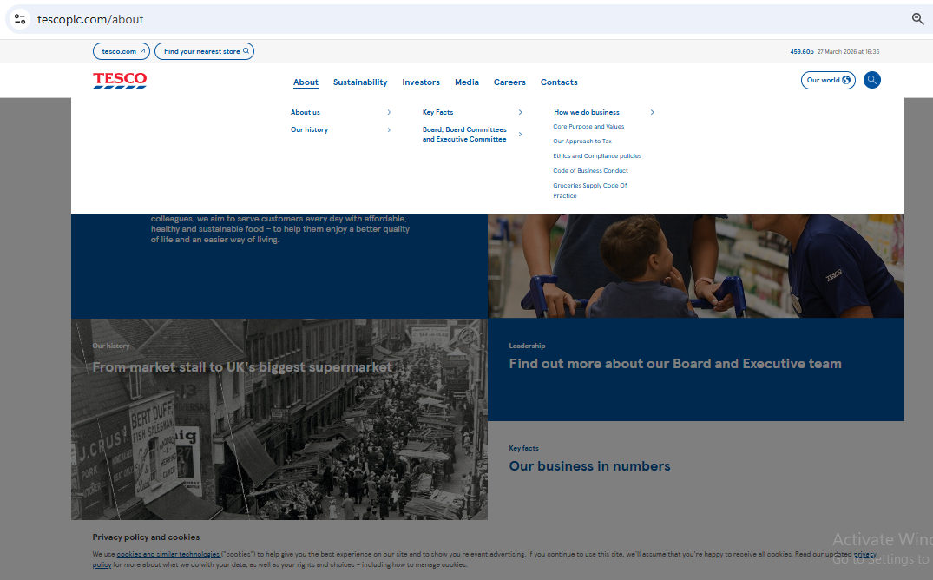
Source: https://www.tescoplc.com/about

Appendix-II
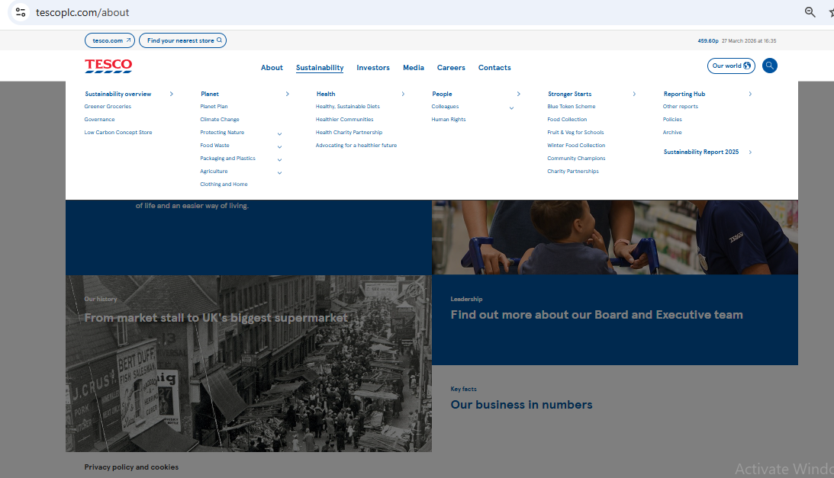

Appendix-III


