Thohura Ahmed
1806406

University of Wales Trinity Saint David’s
29-03-2019
Tesco Report
Problem Solving & Decision Making BK4004

Executive Summary

Tesco have been a successful company for over 100 years. Its renowned success comes after a long history of positively combating rivals and competitions. Market leader now faces more conflicts than ever before. Pestle and swot analysis found Tesco to have problems from losing customers to increasing competition against rivals. Stakeholders analysis pointed to the company’s most important stakeholders are unhappy. Five why’s is used to determine the cause of Tesco’s immediate internal and external problems and issues. Careful analysis of the business environment identified several factors effecting Tesco’s operation. Brexit being the most important political factor affecting the economic growth of the country which is forcing a change in the social trends. Consumers are more conscience of less spending and holding on to their savings regarding the uncertainty of outcome Brexit may bring. In turn it’s affecting Tesco’s operations.
Tesco runs on profit made from customers and aims to grow profit margin. Tesco look to Identifying and satisfying the stakeholder(s) needs. This report displays how the company can overcome its problems and use any opportunities to grow. Tesco must defend its leading market share position and raise profit margin further. Tesco’s recent purchase of Booker should bring in 10% profit. Although Tesco has profit coming from international stores, it heavily relies on the UK market. Way forward for Tesco is to look after the interests of its shareholders and its customers. The company should carry on updating their technology as Tesco’s fortune is built on unrelenting drive to provide for customers and continuous investment in technology which is in greater demand now than ever before. The fears facing supply chain from Europe, Tesco should combine lower prices with a more constructive approach to suppliers.

Contents
Executive Summary 1
1. Introduction 3
2. Findings 4
2.1 Product Portfolio 5
2.2 Table shows past problems and conflicts Tesco faced and the solutions the company came up with. 6
2.3 Problem Tesco facing at present 8
2.4 Pestle Analysis 9
2.5 Swot Analysis table 13
3.3 Power/interest matrix of Tesco’s stakeholders (Mendelow, 1991) 15
4. Five Why’s and Fishbone Analysis 17
5 Why’s 17
5. Conclusion 21
6. References 23
7. Appendices 27
8.1 Stakeholders Analysis 27
8.2 Stakeholders Analysis Model (Freeman, 1984) 27
8.2 Mendelow’s Stakeholders Matrix 28
Diagram 2. Illustrates four categories stakeholders fall in to (Mendelow, 1991) 28

Introduction

Tesco is a public limited company (plc). A UK based multinational retailer company. It is the largest British supermarket retailer selling all kinds of household goods from food, clothing, homeware to electricals. Tesco has become a supermarket giant and is a well-recognised brand around the world (Tesco, 2019). Tesco operates in 14 countries with 7,000 stores worldwide and 520,000 members of staff. Tesco has 3,400 stores in the UK. Its largest success comes after it took over the food wholesaler giant, Booker Group in 2018 for a staggering £4bn. Making it a new powerhouse in Britain’s £200bn a year food market (Guardian, 2018).

Findings

Tesco first started trading in the early 1900’s, 1919 to be precise. The founders of Tesco were Jack Cohen and TE Stockwell. Cohen started selling food items from a stall in East End of London, UK. Tesco used the phrase with aims to ‘put affordable food in the reach of everybody’. Among these items were Tesco’s very first brand of Tesco tea. Stockwell was the main supplier of tea and business partner to Cohen. The business name Tesco was derived from both the founders/owners TES was taken from TE Stockwell and CO from Cohen to form TESCO. Ten years on in 1929, Tesco opened its very first shop in Burnt Oak in Edgeware, London. Cohen saw an opportunity and took the initiative to buy more land for expansion of this business in 1930. Following another 10-20 years, in 1940’s and 1950’s Tesco began to offer self-service stores and supermarkets to customers where they were able to hand pick the produce desired. In 1963 Tesco advanced to develop ‘superstores’ with a selling space of 40,000 sq. ft. Ten years on, Tesco opened up petrol garages in their store forecourts offering customers lower prices for fuel. By 1980’s Tesco faced fierce competition with its rivals resulting in price wars. Tesco soon overcame these conflicts and were on top again. 1990’s saw the introduction of electrical goods to the product portfolio. It also saw the opening of small localised stores called Tesco Extra. During 1993-1995 Tesco saw a record number of new customers increase in the UK. One of the biggest success for Tesco was it expanded around the world with stores opening in Malaysia, Ireland, Poland and India are few to name. Tesco used incentives for customers and drew in a staggering 5 million customers in the first year it launched Tesco ‘Clubcard’ and took over its rival Sainsbury’s in the market share (Tesco, 2019). 1997 saw Tesco providing financial services in the market offering consumers saving accounts. The following year 1998, Tesco drew in affluent customers by launching its ‘finest’ luxury range. Year 2000 saw the launch of Tesco online services with clothing items added to sales portfolio of products, with home delivery options. 2018 saw the biggest accomplishment by Tesco when it brought the wholesaler giant Booker Group for £3.7bn (Guardian, 2018) and launched ‘Jacks’ after its founder. Reviving the initial message ‘great tasting food at the lowest possible prices.’

2.1 Product Portfolio

Tesco have a large selection of product portfolio. Products and services Tesco provide to are:

Mainly fresh produce and food items.
Non-food items- homeware from bedding to home furniture.
Electrical goods-examples, hand blender to jet washes, television to laptops.
Music downloads, DVD rentals.
Finance providers-mortgages, bank accounts, home and building insurance,
Car insurance.
Providing fuel from its onsite petrol pumps.

Tesco currently sells 90,000 items in it stores (the business insider, 2015).

2.2 Table shows past problems and conflicts Tesco faced and the solutions the company came up with.

Problems/Conflicts Tesco faced in past | Steps taken by Tesco to find solutions
1930, Growing customers and not enough space. | Tesco brought more land for expansion.
1960, competition from other supermarket chains. | To retain its customers, Tesco introduced Green Shield Stamps incentives. Customers collected 1 stamp for every pound spent in store and exchanged them for other products in green shield stores.
1963, not enough floor space to cater for the needs of growing customers. | Tesco developed ‘superstore’ with a selling space of 40,000 sq. ft.
1970, profit growth was small. | Tesco opened its own petrol garages in the store forecourts and provided fuel at a lower price compared to competitors.
1980, Tesco faced price wars. | Tesco introduced checkout 82 where 1500 food items were reduced from 3% to 26%.  Encouraged customers to think about healthy eating and purchasing high quality products. This led to rise in profit for Tesco.
1980, Tesco wanted to be known as the largest supermarket in society. | Strategic alliance with other companies. First to develop scheme ‘computers for schools’ from this type of organisation. 1 voucher was given for every £10 spent. This scheme gained recognition and growth in profit by 56% (guardian, 2005).
1990, Tesco faced threats from small local shops. | Developed smaller stores known as Tesco Express. Driving small businesses out using ‘economies of scale’ model with its suppliers (Tesco, 2019).
1990 | New strap line ‘every little helps’ is introduced bringing in 1.3 million new customers.
1993-1995, inconveniences caused to customers due to longer ques at tills. | Tesco brought in ‘one in front’ initiatives. Technology used to count the number of customers entering a store and Informing management of the number of tills needed to stay open hourly. This helped reduce ques by 45% (Tesco, 2019).
1995, Tesco second place in share market and continuously loosing shares. | Tesco opened stores around the world some of which are in Malaysia, Ireland, Poland, Europe.  Launched Tesco ‘Clubcard’ for customer incentives and drew in staggering 5 million customers (in first year) worldwide and took over its rival Sainsbury’s in market share.
2000, Losing customers to competitors. | Tesco ‘Clubcard’ was relaunched using double points incentives to retain customers.  Tesco online services launched for convenient shopping. ‘Tesco online’ and ‘Tesco direct’ services are available to customers 24 hours.
2007, Tesco wanted to grow in US market | Took careful planning and embedded staff with US families prior to launch its USA operations to cater for the American customers.
2010, overcoming and staying ahead of competitors. | Tesco mortgages, Tesco banking, Tesco mobiles, Clubcard rewards, green space project introduced. Worked closely with non-profitable NGO’s to reduce carbon foot prints (Tesco, 2019).
2018, Tesco direct making loss.  Tesco wanting to expand further.  Facing competition from Aldi and Lidl | Closed Tesco Direct to focus on Tesco online services.  Tesco brought the wholesaler giant Booker Group for £3.7bn (Reuters, 2018)  Tesco developed ‘Jacks’ to compete with low price goods sold by rivals.

2.3 Problem Tesco facing at present

Tesco has faced many problems in the past and managed to overcome those problems and came out on top of all its rivals taking the lead position in the market. At present Tesco faces new set of challenges. They are;

Tesco is experiencing increasing number of competitions from its competitors (Tesco, 2019)
Tesco is losing its customers (UK). This would lead Tesco in trouble as the company runs and makes profit from customers buying its products.
The company is seeing financial downturns.
Two of Tesco’s largest shareholders are uncertain about the returns of recent investment booker group (financial times, 2017).
Uncertainty of food and product supply chain from Europe (Tesco, 2019).

To determine the causes of these problems, pestle analysis is used.
Pestle analysis is a framework used by companies and organisations (Tesco) to monitor the macro environmental factors which affect and have impact on a business/organisation (Tesco). These factors are Political, economic, social, technological, legal and environmental factors. Such structures are used by strategists at cooperate level which allows business and Organisations like Tesco to scan business environment and overcome multiple external factors. (J. Aguilar, 1967).

2.4 Pestle Analysis

Political factors affecting Tesco

Tesco trades in 14 countries including Asia and Europe. The company is exposed to many countless global factors which affects its operations. These comprise of tax rates, current and impeding legislations, political instability, unemployment rate, economic condition of the country it’s trading in and if any government initiatives available.

UK leaving the European Union with no agreed deal, Tesco with other supermarket chains will most likely see a rise in Tax of goods on import and export. International trading tariffs will change, and exercise of price control of goods may take place. Additional visa will be required in order to travel and trade in EU countries. Fuel price rise add cost to the company.

Threats Tesco face of its rivals, Asda and Sainsbury’s merging, competitors can take over Tesco’s leading position in the market with over 30% shares between them, leaving Tesco in second Place with 28.1%.

Tesco may also face possible trade barriers to protect domestic suppliers. Overall tax rise will see Tesco customers shopping at discounted stores like Aldi and Lidl.

Some conflicts between Tesco’s shareholders and CEO over purchasing Booker group. (Financial times, 2017).

7,000 stores worldwide with 3,400 stores in the UK.

Opened ‘Jacks’ stores after its founder Jack Cohen.

Economic Factors affecting Tesco

Weaker pound sterling means Tesco will see an inflation on price and transportation of goods. Tesco should focus on borrowing cost in UK.

The Brexit vote suggests gains will go to Tesco’s suppliers.

National average wage is due to rise in the UK, adding to Tesco’s outgoing expense (Guardian, 2017). Tesco has a large workforce up to 520,000 employees.

Tesco’s largest sales are from the UK market

Tesco took over Booker Group for £3.7bn in 2018. Booker is a UK based company founded in 1835. Specialise in food wholesaler and comprises booker wholesale, Makro booker direct, premier family shopper, Budgens, Londis and Booker India with a total of 13,000 employees. (Tescoplc, 2019).

Tesco look to reduce cost by £1.5bn to increase profit. This will come from 1,700 job cuts with reinstating as many colleagues in 900 new jobs created in human resources sector of Tesco.

Technological factors effecting Tesco

Tesco is the first of its kind to introduce and use ‘one in front’ initiative to cut ques by 45% (Tesco, 2019).

Tesco launched a scheme for the local community to benefit from known as ‘computers for schools.

Closed loss-making website ‘Tesco Direct’ to focus on ‘Tesco Online’. Tesco direct sold non-food items and could not compete with its strengthening rival Amazon.com.

Tesco Clubcard was launched and due to this scheme working so well, Tesco relaunched Clubcard for the second time with double points incentive to lure customers in. Clubcard was introduced to reward customers as well as subsequently feed data into the customer management systems. Tesco uses CPFR (collaborative resource planning and replenishment). This helps the company to develop production plan, forecast demands and coordinate stockings, warehousing and shipping to ensure retail inventories are kept at optimal level. This system can exercise quality and quantity control ensuring products meets the manufacturers claims.

Tesco uses a very important tool called the CRM (customer relationship management). This tool helps to monitor and manage a company’s interaction with current and potential customers history with company to improve business relationships with customers. This specifically focusses on customer retention and ultimately driving sale growth. Tesco uses both CRM and supply chain management extending these when entering new markets.

RFID technology is introduced to increase in-store experience for customers.

Social media is a great platform for any business organisations and Tesco have taken full advantages of this and have a significance presence to this. It has more than 20 twitter accounts where it continuously advertises its offers and promotions and updates on books, dieting, kitchens and its stores to name a few. Facebook is another social media where Tesco hold numerous accounts promoting recipes, healthy living and gardening ideas using its products. In return Tesco gets online productive feedbacks from consumers. This method is fast and convenient for both Tesco and its customers.

Tesco provides online services and self-service tills. The company has its own app for quick and easy payment linking to Clubcard resulting in customer convenience in shopping without having to worrying about carry cash.

Tesco has 131 stores in China means the company has access to new and up to date technology.

Legal factors effecting Tesco

Legal issues Tesco faces due to Brexit are changes to laws, regulations and legislations. These include consumer protection legislations. Employment legislations. Trading legislations.

Tesco must follow all rules and regulation imposed by any trading country for overseas trading as well as new regulations instated by the UK government.

Licensing regulations for goods and products must be satisfied and comply with European laws.

Tesco must conduct its operation accordance with strict code of practice with Food Retailing Commission (FRC).

Visa will be required to enter European country. Abiding by Boarder controls. In 2017,

Tesco paid a total of £235m in compensation and avoided legal prosecution for misinformation of share prices and profits to shareholders in 2014 (BBC, 2015).

There will be further checks at border controls.
Outcome of pestle analysis is used to make a Swot analysis of Tesco. Swot analysis is a strategic planning technique used to help identify strengths, weaknesses, opportunities and threats an organisation faces related to competition or planning (Humphrey, 1960).
Strengths and weaknesses are internal issues where as opportunities and threats are external issues Tesco faces.

2.5 Swot Analysis table

Tesco Plc 2019
Strengths of Tesco  Strong brand name. 100 years of service history.  Have financial power.  Market leader, currently at 28.1%.  7,000 stores worldwide with 3,400 stores in UK.  500,000 staff members. Third largest retailer in the world. 13,000 new employees from Booker group.  Offer products of choice and variety. Popular clothing range.  Low cost leadership.  Finance provider-Mobile phone, Mortgage and banking service providers.  Own wholesaler giant Booker Group (guardian, 2017).  Have access to better use of tech marketing.  Environmental-friendly  International trading company | Weaknesses of Tesco  Highly dependent on the UK market.  Difficult to focus on single market for specialisation as organisation is involved in different markets.  1,700 job cuts and 3,000 at risk due to cuts in night shifts.  48 underperforming stores.  Closing of one of the online trading sites ‘Tesco Direct’.  Two main shareholders unhappy and uncertain with purchase of Booker Group with regards to returns (the telegraph, 2018).
Opportunities Tesco have  Introduction of ‘Jacks’ stores.  Increased premium range products  Further diversification strategies (i.e. Tesco Banking).  Focus on ‘Tesco Online’.  Strong product portfolio.  International expansion in overseas ever-growing markets.  Expansion of Booker Group.  Market growth.  900 jobs created (Reuters, 2018).  Online presence. | Threats Tesco faces  Losing customers to rivals.  Falling value of pound sterling resulting in tax/price increase of goods.  Britain leaving EU with no agreed trade deal (Tesco, 2019).  Increased competition (Aldi and Lidl).  Rising cost of imports/exports.  Financial downturns.  Rivals Asda and Sainsbury’s merging.  Decreasing income.  UK average wage rise in 2019.

Swot analysis results suggests Tesco has many internal strengths and weaknesses. Tesco must convert these weaknesses into strengths. It also has many external opportunities it must convert into company’s strengths. Analysis also points out many external threats Tesco faces, and these must be converted into opportunities if Tesco are to success in overcoming its problems. These threats are shown in table 2.5. Internal and external issues must be identified and addressed as soon as possible to avoid conflicts. This is achieved by stakeholder’s analysis and stakeholders mapping.

3.3 Power/interest matrix of Tesco’s stakeholders (Mendelow, 1991)

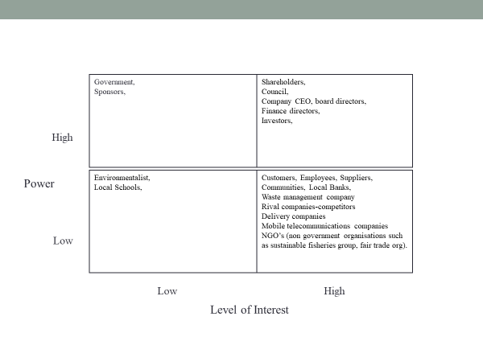

customers
- Tesco’s stakeholders are its customers. Customers buy the goods or services produced by the company.
- These customers may be individuals or other businesses.
- Tesco must understand and meet the needs of its customers, otherwise it will fail to make a profit or even survive.

Suppliers
- Tesco source the resources required to produce goods and services from suppliers.
- Businesses attempt to have effective relationships with suppliers in order to get quality resources on time & at reasonable prices.
- This is a two-way process, as suppliers depend on the firms, it supplies.

Community
- Companies and the communities exist in a two-way relationship.
- The local community may often provide many of the firm’s staff and customers.
- The business often supplies goods and services vital to the local area.
- But at times the community can feel aggrieved by some aspects of what a firm does

The Central & Local Government & It’s Agencies:
- Economic policies affect firms’ costs (through taxation and interest rates)
- Legislation regulates what business can do in areas such as the environment and occupational safety and health.
- The Police, Licensing Authority, Environmental Agency, DHSS.
- Successful firms are good for governments as they create wealth and employment.

The Financial Publics
- Local Bank.
- Stock Exchange - investors will consist not only of personal buyers of securities but also of investment analysts (who advise on share buying) and big share buyers.
- Willingness to buy shares, or invest in new issues, will depend on what is known about the company’s background, performance and prospects. A fall in share price could invite a take-over to bid.

Owners and Shareholders
- The number of owners and the roles they carry out differ according to the size of the firm
- In small businesses there may be only one owner (sole trader) or perhaps a small number of partners (partnership)
- In large firms there are often thousands of shareholders, who each own a small part of the business. Tesco has two large shareholders Schroder Investment management and Artisan Partners.

According to the Mendelow’s matrix. Tesco’s most important primary stakeholders are its shareholders and its investors. These stakeholders have high interests and high power in the company which means these stakeholders have the power to make and take decisions for the company. Tesco must keep these stakeholders satisfied as these stakeholders have the power to vote out directors if they believe they are running the business badly (Reuters, 2017). To run the company, Tesco needs to keep another important stakeholder happy. These stakeholders are its customers as these customers have low power and high interests in the company and the products it sells. These stakeholders bring in sales.

Five Why’s and Fishbone Analysis

5 Why’s
According to Saki chi Toyoda (1930) Five whys strategy is a simple and effective tool to uncover the root of a problem. It is best used in trouble shooting, problem solving and quality improvement initiatives. This method starts with a problem and asks why its occurring and continuous to ask why five times to find the root cause of problem (mindtools.com).

Tesco’s’ whys

Tesco is facing increased competitions.

Why?

Because there are too many discounted stores.

Why?

There is a high consumer demand. Consumers conscious of spending too much Money.

Why?

Rise in household expenditures therefore, consumers shopping around looking for cheaper deals.

Why?

Britain’s inflation causing rise in utility bills.

Why?

Fall in value of pound sterling.

Why?

Brexit, Britain leaving the European Union.

Here we find the reason for more competition Tesco faces at present is due the political factor effecting the economy.

Tesco is losing customers.

Why?

Consumers shopping at smaller discounted stores.

Why?

Discounted stores have better deals and consumers are conscience of overspending.

Why?

Cost of living risen.

Why?

Inflation. Value of pound sterling dropping.

Why?

Britain’s exit from European Union

Here again, political factor Brexit contributes to the change in social trend.

Another problem Tesco face is the rising cost of imports and exports.

Why?

Rise in international taxes and tariffs.

Why?

Due to Inflation.

Why?

Value of pound sterling dropping.

Why?

Financial instability.

Why?

Brexit

Here again the cause for rising cost for Tesco is due to Brexit.

The cause of Tesco’s another important problem that needs to be addressed is Tesco powerful stakeholders are concerned for returns of their investments to buy booker group and therefore, Tesco needs to make cost cuts of £1.5bn. This will be achieved by letting go off 1700 staff in the UK.

Why?

There are 48 underperforming stores in the UK and many middle management staff will be let go off.

Why?

Tesco is losing customers to rival competitors.

Why?

Consumer preferences are changing. Consumers rather shop in discounted stores and hold on to their savings because discounted stores have better deals.

Why?

Consumers fear and uncertainty of UK’s economical future.

Why?

Brexit. UK leaving the EU will see rise in product price.

Here again the cause of problem is the political factor effecting the economy of the country which has resulted in consumers holding on to their saving and shopping for better bargains causing Tesco’s shareholders to concern about profit margins.

Conclusion

The results derived using analytical tools suggests Tesco, supermarket giant is now facing many problems which needs to be addressed as soon as possible and these are;

Two of Tesco’s largest shareholders have concern for financial returns at the latest purchase of Booker group. Shareholders Schroder Investment management and Artisan Partners have taken issues with Tesco’s recent £3.7bn purchase of wholesaler giant Booker. As these shareholders are the primary stakeholders and have powerful influence in the company. It is in the best interest of Tesco to keep these stakeholders satisfied. To do this Tesco will have to let go of its staff in its UK stores. The impact of strong leadership is felt among the staff of Tesco as Dave Lewis CEO is planning on cutting 1,700 jobs in order to reduce costs by £1.5bn (McBride, 2019). Affecting employees from managers to skilled store workers, managers working in recruitment. Compliance managers who are responsible for health and safety measures and customer experience managers, these employees oversee services in 226 of largest stores. Lewis has advised the job cuts will make way for 900 further new jobs in human resources at multiple stores in Tesco’s distribution network. He further quotes Tesco aims to keep as many colleagues as possible for the new roles created (Guardian, 2018).

A weaker sterling since the Brexit vote suggests any profit gains will go to Tesco’s suppliers. The company Directors come under pressure to sacrifice profit by cutting prices. Including any savings derived from buying Booker, will intensify. Schroders and Artisan may be right to worry the deal may not live up to its promise. (Reuters, 2017). CEO of Tesco, Davis Lewis believes the formula for the Tesco overcome this is to combine lower prices with a more constructive approach to suppliers (Financial times, 2017).
If all goes to plan, the cash and shares bid should cover its cost of capital within two years. However, this can only happen if the full cost savings Tesco has forecast comes through. Grocery inflation has turned positive after more than two years of being negative and Lewis argues higher sales are the key to higher profits. He believes profits from Booker group will add 10% to Tesco’s revenue line (Financial times, 2017). Tesco’s CEO Davis Lewis along with chairman John Allan are full of confident and believes Tesco is firmly on track to deliver the medium-term ambitions to reduce costs by £1.5bn to generate £9bn of retail cash from operations and to improve operating margins to between 3.5% and 4.0% by 2019/20. The integration of Booker is well underway, and Tesco is focused on delivering the identified synergies to create value for all stakeholders. The Business anticipates a synergy benefit of c.£60m in the first year, growing to a cumulative c.£140m in the second year and reaching a recurring run-rate of c.£200m per year by the end of the third year. As Tesco leaders look to capitalise on the enhanced opportunities for growth available to the combined Group, Tesco will place increasing focus on growth in earnings and free cash flow generation, in order to deliver strong, sustainable returns for shareholders (financial times, 2017).

Tesco also faces external threat of two supermarkets Sainsbury’s and Asda merging to take over leading shares in the market. Another threat comes from upcoming rivals Aldi and Lidl selling goods at considerately low discounted price. To combat Aldi and Lidl, Tesco has opened ‘Jacks’ stores. ‘Selling slimmer range of products options, customers have a limited choice of stocked items (from 90,000 to 14,000 items). This increases the guarantee that those products will get sold. Larger sales volume helps to drive discounts, and in turn, attracts customers’ (Business insider, 2019). This will increase in Tesco’s all-important stakeholders, customer growth. Tesco should keep a close eye on these stakeholders as they bring in the sales. Without customers, Tesco will not survive. Tesco should use examples from experience and use customer incentives to draw in customers using the local community projects and Clubcard initiatives.

Tesco has closed its loss-making website Tesco Direct. This was largely due to customer preferences changing and its competitor Amazon strengthening in global market providing a better product profile and delivery services. In response, the CEO of Tesco UK and ROI Charles Wilson pointed out Tesco wants to focus on providing customers with one online platform where consumers can purchase both food and non-food merchandise from one place (Independent, 2018).
Tesco’s advantage of having 131 stores in China gives the business access to China’s new and updated technology in the world. It has the infrastructure of providing the sensitive technology to the rest of the world. Tesco can better implement them in the Chinese outlets first before trialling in other Tesco stores around the world.

Tesco have come a long way since its launch in 1919. Tesco has seen its share of ups and downs. Learning from mistakes and experience Tesco have managed to come up on the top. Tesco’s fortune is built on two business elements. These are (1) the unrelenting drive to provide for customers and (2) Tesco’s continuous investment in the latest technologies.

References

Reuters, (2018) The telegraph [online], available at:
https://www.google.com/amp/s/www.telegraph.co.uk/business/2018/03/05/tesco-completes-4bn-takeover-booker/amp/ (Accessed 13-03-2019)

Ecommerce Digest (no date), ecommerce-digest [online], available at:
http://www.ecommerce-digest.com/tesco-case-study.html (Accessed 14-03-2019)

Infusion soft, (2019) Infusion soft [online], available at:
https://keap.com/infusionsoft/product/what-is-crm?ls=social&utm_source=youtube&utm_medium=video&utm_campaign=crmseo&utm_term=whatiscrm180608&utm_content=social (Accessed 14-03-2019)

Infusion soft, (2019) Infusion soft [online], available at:
https://youtu.be/dfjtilfLsuo (Accessed 13-03-2019)

Giraffe social media, (2013) Giraffe social media [online], available at:
https://giraffesocialmedia.co.uk/how-does-tesco-use-social-media/ (accessed 16-03-2019)

Ecommerce Digest, (no date) ecommerce-digest [online], available at:
http://www.ecommerce-digest.com/private-industrial-networks.html
accessed 16-03-2019

BBC, (2015) [online], available at:
https://www.bbc.co.uk/news/business-30886632 (Accessed 17-03-2019)

Financial Times, (2019) [online], available at:
https://www.ft.com/search?q=tesco (Accessed 17-03-2019)

Independent, (2018) [online], available at:
https://www.independent.co.uk/news/business/tesco-direct-website-shut-500-job-cuts-a8363651.html (Accessed 15-03-2019)

Reuters, (2016) [online], available at:
https://www.google.com/amp/s/mobile.reuters.com/article/amp/idUSKBN16Z1A8
(Accessed 14-03-2019)

The Guardian, (2018) [online], available at:
https://www.google.com/amp/s/amp.theguardian.com/business/2018/jan/22/tesco-to-shed-1700-jobs-in-new-management-shake-up (Accessed 12-03-2019)

The Guardian, (2017) [online], available at:
https://www.theguardian.com/business/2017/nov/14/tescos-37bn-takeover-of-booker-given-green-light (accessed 22-03-2019)

Pestle, (2016) [online], available at:
https://freepestelanalysis.com/pestel-pestle-analysis-of-tesco/ (accessed 11-03-2019)

Tesco, (2019) [online], available at:
https://www.tescoplc.com/news/news-releases/2018/preliminary-results-201718/
(accessed 17-03-2019 updated 15-03-2019)

Investment Week, (2019) [online], available at:
https://www.investmentweek.co.uk/investment-week/news/1401129/tesco-stakeholder-plan
(Accessed 17-03-2019)

Learn Marketing, (2018) [online], available at:
https://www.learnmarketing.net/SWOTTesco.html (Accessed 18-03-2019)

Marketing Tutor, (2019) [online], available at:
https://www.marketingtutor.net/tesco-pestle-analysis/ (Accessed 18-03-2019)

The Guardian, (2005) [online], available at:
https://www.google.com/amp/s/amp.theguardian.com/technology/2005/mar/07/schools.supermarkets (Accessed 19-03-2019)

The Guardian, (2017) [online], available at:
https://www.google.com/amp/s/amp.theguardian.com/business/2017/mar/28/tesco-agrees-fine-serious-fraud-office-accounting-scandal (Accessed 20-03-2019)

Mindtools.com, (2019) [online], available at:
https://www.mindtools.com/pages/article/newTMC_5W.htm
accessed 21-03-2019

Business insider, (2019) [online], available at:
https://www.businessinsider.com/tesco-cuts-one-third-of-products-from-supermarket-2015-4?r=US&IR=T accessed 26-03-2019

Appendices

8.1 Stakeholders Analysis

Stakeholder analysis tool is used for clearly identifying Tesco’s key stakeholders. To study the needs and understand where stakeholders stand to develop co-operation between the stakeholder’s project team.
Stakeholders play very important role in any project or organisation. Stakeholders are ‘individuals or groups who can effect or is effected by the achievement of an organisation’s objectives’ (Freeman, 1984).

Two types of stakeholders Tesco have, are known as primary stakeholders (also known as internal connected stakeholders). The other is secondary stakeholders (also known as external connected stakeholders). Primary stakeholders are those with formal official or contractual relationship with Tesco. These stakeholders are affected directly by the action of a company or organisation. Tesco’s primary stakeholders are stakeholders are customers, employees, management teams, stockholders, shareholders, government agencies, communities and suppliers are to name few. Secondary stakeholders are those individuals or groups who are affected indirectly by a firm’s actions or decisions. Tesco’s secondary stakeholders are media, environmentalists, waste management companies, trade unions, associates and many more. See diagram

8.2 Stakeholders Analysis Model (Freeman, 1984)

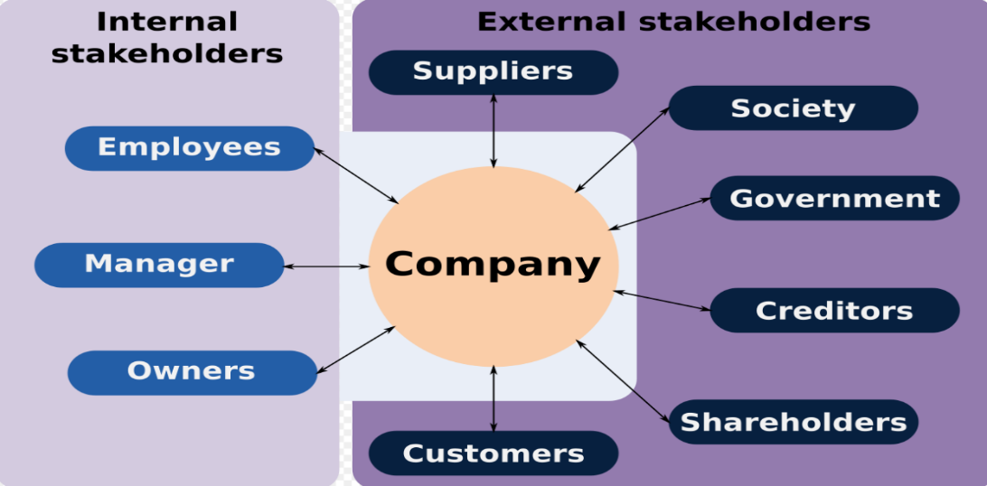

8.2 Mendelow’s Stakeholders Matrix

Gregor Mendelow (1991) proposed a model that ranks stakeholders. This ranking is based according to the power and interest stakeholders have in relation to an organisation.

Diagram 2. Illustrates four categories stakeholders fall in to (Mendelow, 1991)

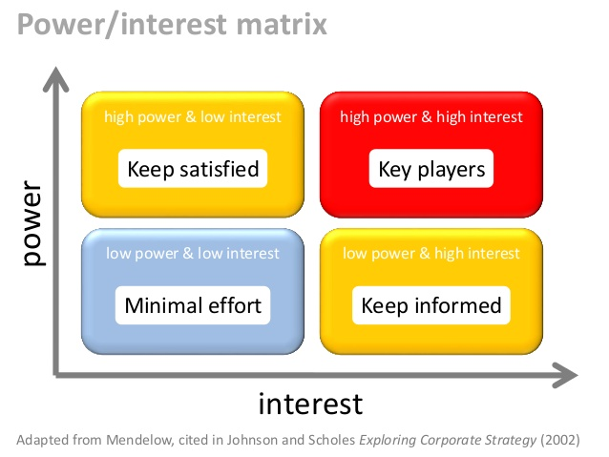
Low High

