

CRITICAL ANALYSIS OF BIG DATA FOR THE RETAIL INDUSTRY

Author Note:Zhang Lidong
Author number：1900867

Coronavirus (Covid-19)
Due to the occurrence ofCOVID-19, the University of Wales Trinity Saint David (UWTSD) has adopted the form of Internet for online teaching. Therefore, it will have some impact on some research. For example: First, only access the school library through the Internet. Collect information instead of going to the library to read more books. In addition, the questionnaire method cannot conduct better surveys, and can only provide people with questionnaires through the Internet. Therefore, there will be some errors in the authenticity and accuracy of the information, and because it is impossible to conduct classes on campus normally Therefore, it is not possible to give feedback face-to-face with the teacher, and can only ask questions and give feedback to the teacher through emails. Therefore, the feedback time is greatly increased.

Acknowledgments
I would like to thank my mentor Caroline Jawad for his support and help in the whole paper and provided me with a lot of valuable opinions.

ABSTRACT
Research Aim
The aim of this research is to analyse the impact of big-data on the retail industry and to identify the limitations and the advantages with big-data.
Research Methodology
The research relies on a quantitative data analysis technique. To conduct the research, the positivism philosophy, deductive approach, exploratory design and the regression data analysis technique has been appropriate. To retract information from respondents, the research utilises a survey strategy based on a Likert-Scale. This strategy has helped transcode qualitative opinions of respondents into quantitative forms. Regression analysis helped identify patterns and themes within observational data, and adoption of the non-probability convenience sampling technique helped narrow down the sample and retract primary data amidst the pandemic.
Findings and Analysis
Data collected from the survey strategy has revealed that big-data is of immense use in the retail industry as it can help ascertain the preferences and requirements of consumers. Retailers can use the benefits of big-data to identify trending products and services, and retailers can use these insights to adjust product inventory and allocations. By pursuing this strategy, retailers can increase their market share. However, cyber-crime related limitations such theft and data privacy are key concerns for retailers as it can hinder the efficacy of big-data and its implementation.
Implications
The use of big-data has important implications for retailers as it has both advantages and disadvantages. In an industry where retail giants such as Amazon dominate, other small-scale retailers need insights about dynamic pricing and shopping trends to identify consumer behaviour and cater to changing business needs.
Keywords
Big-data, consumer preference, cyber-crime, consumer purchase.

Table of Contents
ABSTRACT 3
CHAPTER 1: INTRODUCTION 6
1.1: Background 6
1.2: Research Aim 7
1.3: Research Questions 7
1.4: Research Objectives 7
1.5: Research Structure 7
CHAPTER 2: LITERATURE REVIEW 8
2.1: Introduction 8
2.2: Overview of Big Data 8
2.3: Application of Big Data in the Retail Industry 9
2.3.1: Predictive Analytics using Big Data 9
2.3.2: Product Recommendation using Big Data 9
2.3.3: Using Big Data for Better Sales 10
2.4: Advantages of Big Data in Retail Industry 10
2.4.1: Customer Profiling using Big Data 10
2.4.2: Analysing Customer Journey 10
2.4.3: Demand Forecasting 11
2.4.4: Fraud Detection and Prevention 11
2.5: Potential Challenges from Big Data 11
2.5.1: Loss of Reputation 11
2.5.2: Additional Cost to Business 12
2.6: Research Gap 12
2.7: Summary 13
CHAPTER 3: RESEARCH METHODOLOGY 13
3.1: Introduction 13
3.2: Research Philosophy 14
3.3: Research Approach 14
3.4: Research design 15
3.5: Data Collection and Research Instruments 15
3.6: Data Analysis 16
3.7: Sampling Strategy 16
3.8: Ethical Consideration 16
3.9: Research Limitation 17
3.10: Summary 17
CHAPTER 4: FINDINGS AND ANALYSIS 17
4.1: Findings 17
4.2: Analysis 22
4.3: Summary 26
CHAPTER 5: CONCLUSION AND RECOMMENDATIONS 27
5.1: Conclusion 27
5.2: Recommendations 28
REFERENCES 29
APPENDICES 33
Appendix 1: Questionnaire 33
Appendix 2: Data Sheet 35

CHAPTER 1: INTRODUCTION

1.1: Background
Big-data refers to the collection of data, which is considered to be huge in volume, and it grows exponentially over-time (Columbus, 2018). As a field, it involves the ways through which data is systematically analysed and extracted from large scale data sets (Prasdika & Sugiantoro, 2018). As a term, it describes structured and unstructured forms of data and big-data can be analysed for insights that can lead to better decision-making across different businesses. The importance of big-data does not stem from the amount of data an organisation has (Columbus, 2018).
The recent traction in the market is on account of the rise in investments and spending on different technological projects by key players and government (Columbus, 2018). The recent coronavirus pandemic has also led to an accelerated impact on the big-data market (Prasdika & Sugiantoro, 2018). Forced lockdowns and social distancing norms has compelled organisations to adopt big-data technology for storing information and data regarding people that were infected with coronavirus (Columbus, 2018).
Columbus (2018) opined that growth of big-data across the world has been astounding as revenues of big-data across the world are expected to increase at a compounded annual growth rate (CAGR) of 10.48%. This suggests that companies that do not embrace big-data, will lose their competitive position and they can face extinction (Columbus, 2018). Such astounding levels of growth are in line with the agreements of experts that the amount of data generated will be growing exponentially in the future (Prasdika & Sugiantoro, 2018). Experts believe that this growth is on account of the increase in the number of internet users that are doing everything online. For example, this includes the rise of social networking and communication using technology. This suggests that big-data is set to grow at a rapid pace in the coming future. Different factors have led to the rise of adoption of big-data (Prasdika & Sugiantoro, 2018). For example, artificial intelligence, machine learning and data analysis is changing the entire landscape of the big-data industry. Integration of technologies with big-data is helping organisations augment visualisation capabilities and make complicated data more usable and accessible through visual representation (Columbus, 2018).
Today, consumers are living in a digital world that is fuelled by instant expectations. Rapid transactions of data being conducted today, have led to cloud-based businesses to move fast (Columbus, 2018). The rise in the number of rapid transactions, has led to data being produced and compiled at a speedy rate. Business intelligence is an importance of big-data that is bolstering its growth. Business intelligence acts as a critical weapon and it helps in analysis, ingestion and application of big-data.
The retail industry is plagued with the challenges of intense competition as brands such as Amazon utilise big-data to introduce dynamic pricing and retailers need the help of big-data to stay competitive (Columbus, 2018). Retail brands across the globe are relying on data-driven insights for optimizing pricing, streamlining operations and generating customer experience (Prasdika & Sugiantoro, 2018). To hold a strong foothold in the retail industry, retail companies must address changing consumer dynamics and offer relevant discounts and convince consumers to hop onto newer trends. Before the availability of the cloud, companies were limited to tracking what was actually required out of consumers (Columbus, 2018). With the use of more sophisticated technology, companies tend to capture customer related data. Companies can use such data for predicting emerging trends and targeting the right customer at the right time (Prasdika & Sugiantoro, 2018). In the retail industry, big-data is helping consumers maintain a 360-degree view, optimise pricing decisions, streamlining back-office operations and to enhance customer service (Columbus, 2018). Thus, it is imperative that big-data is excessively important in the retail industry.

1.2: Research Aim
The aim of this research is to analyse the role of big-data in the retail industry and identify the benefits and limitations associated with the use of big-data.

1.3: Research Questions
In light of the research aim identified above, the research questions are as follows.
- What are the benefits and limitations of using big-data?
- What is the role of big-data amongst players in the retail industry?

1.4: Research Objectives
- To identify the advantages and limitations that are associated with the use of big-data in the retail industry.
- To ascertain the role of big-data amongst retailers.

1.5: Research Structure
The current research is bifurcated into five chapters, and each chapter are as follows.
- Introduction: This chapter of the research presents an overview of the entire research followed by the aim, objectives and the questions.
- Literature Review: This chapter of the research has presented a critical review of literature by screening different journals and articles. It also identifies the research gap and the conceptual framework that guides and serves as a motivation for the research.
- Research Method: This section presents the different research methods that have been used for conducting the research and analysing the collected data. This involves identification of the chosen research philosophy, approach, design, data analysis procedure and data collection procedure.
- Findings and Analysis: This chapter of the research presents the findings from the data collection process, and this is followed by the analysis of the collected data to achieve the research objectives.
- Conclusion and Recommendations: This chapter of the research presents an overview of the entire research, and this is followed by recommendations that were generated from the discussion.

CHAPTER 2: LITERATURE REVIEW

2.1: Introduction
This section of the research introduced readers to existing researches on big data and its application. Review of existing literature on Big Data in retail industry helped researcher to focus on the gap in literature. This chapter of the research offers a clear overview about application of Big data in retail industry to readers. Further, from this chapter readers can identify different challenges that retail industry can face by introducing Big Data analytics in business. Finally, researcher analysed the gap found in existing literature based on Big Data. This review of Big Data focus on both positive and negative aspects of Big Data application in retail industry.

2.2: Overview of Big Data
Back in 1960, when the computer was introduced into business, data from business were stored in unstructured manner, as a result it used to take unnecessary effort to derive value from those data (Prasdika & Sugiantoro, 2018). Considering the size and complexity involved in stored data, people started trying to use easy data analysis and analytics technique to generate value from stored data. However, the term “Big Data” made popular by Mr. Roger Mougalas of O’Reilly Media in 2005. Mr Roger Mougalas used the term Big Data to address the large set of data which is impossible to manage and process using existing tools (Gorelik, 2019). Later many definitions of Big Data evolved focusing on different aspects of data, such as size, speed and range. The most popular definition of Big Data states -Big data refers to data which contains greater variety arriving in increasing volume and with ever-higher velocity (Prasdika & Sugiantoro, 2018). Variety, volume and velocity are the major elements of Big Data. ‘Volume’ in Big Data refers to size of the data and whether a set of data can be considered as Big Data depends on the size of the data. Generally high-volume data is considered as Big Data; hence volume should be considered as the primary element while dealing with Big Data. ‘Velocity’ refers to the speed of data generation as the generation and processing speed of data determine the actual potential of the data (Katal et al., 2013). ‘Variety’ refers to diverse sources and nature of data that includes both structured and unstructured. For example, emails, photos, audio, PDF and monitoring devices within retail sector can be considered as source of data in during analysis. With the increased volume of Big Data which is easy to access, business can now make more accurate decision.

2.3: Application of Big Data in the Retail Industry

2.3.1: Predictive Analytics using Big Data
Conducting market research became an essential part for any business including retail industry. Besides conducting market research, it also became necessary for businesses to use the right marketing tool to make new product or service visible to customers. Big Data Analytics can be used as the right tool that can help business to conduct market research as well as a marketing tool to make new product or service visible to customers. According to Pyne et al. (2016) analytics refers to systematic computational analysis of data to derive meaningful insight and applying those insight to make realistic business decision. For example, Amazon uses predictive analytics to reduce delivery time and overall business expenses by making products available to local distribution centre by predicting customers’ future need. However, DeDeo (2014) arguable stated that Big Data Analytics in predictive in nature, as a result sometimes it developed inaccurate prediction. This suggest, not all the prediction made using Big Data analytics are accurate in nature. Although, Krasnow Waterman and Bruening (2014) explained that inaccuracy in Big Data analytics can be easily avoided by collecting data from reliable source. Therefore, retailers are using Big Data analytics system to predict future needs of customers.

2.3.2: Product Recommendation using Big Data
Lately, recommender system became popular across e-commerce giant and triggering impulsive buying. With the help of the recommender system e-commerce giants recommended items to customers based on their previous search and purchase history (Sun et al., 2014). For example, Amazon, using the Big Data analytics, analysed over 150 millions of customers’ account to recommend items to customers based on their searched and purchase history (Hewage et al. 2018). However, recommendations engine (which depends on likes of other users to calculate similarity index between users and based on the similarity recommend items) do not always work appropriately as it depends on user’s opinion rather machine analysis (Provost and Fawcett, 2013). Recommender system is mainly used by online retailers which gets access of customers data such as purchase information.

2.3.3: Using Big Data for Better Sales
In order to remain competitive within the industry and in global market, it became necessary for businesses to focus on improving marketing ROI (return on investment). With the help of Big Data retailers are forming data driven marketing by developing more accurate message for customers (Finger et al. 2018). Supporting the similar idea Müller et al (2018) stated Big Data is helping retailers to analyse how much investment should be done on each of the product line and geographic location. Hence, with the help of Big Data, retailers can easily avoid unnecessary investment in wrong product line. However, misinterpreting the pattern of data shown in the system is the most common problem in Big Data (Al-Htaybat & von Alberti-Alhtaybat, 2017). Such misinterpretation can lead developing wrong marketing strategy. Therefore, accuracy of data plays a major role while using Big Data for sales growth and marketing opportunity.

2.4: Advantages of Big Data in Retail Industry

2.4.1: Customer Profiling using Big Data
Regular interaction with customers over various digital platform is a common phenomenon in retail industry, as result retailer have better opportunities to collect customers data from those digital platforms (Al-Htaybat & von Alberti-Alhtaybat, 2017). As Mavriki and Karyda (2018) stated, customers became constant generator of both structured and unstructured data. However, it remains important for retailers to track new customers and identify their transaction history using Big Data. According to Kosinski et al (2013) in retail industry familiarity with customers demography and their purchase pattern can be further used to develop better promotion. Big Data can help retailers to gain better understanding about customers demography and purchase pattern. However, recently, privacy policies and other regulatory acts formed by government across different countries are restricting collection of Big Data by several retailers (Mantelero, 2016).

2.4.2: Analysing Customer Journey
Big Data can be used to track, handle and analyse customer’s journey in retail industry (Al-Htaybat & von Alberti-Alhtaybat, 2017). Micheaux and Bosio (2019) defined customer journey map as a graphical presentation of a journey from customers point of view. Information such as customer’s action, medium of interaction, customer’s feeling (positive or negative) can be identified using Data mining (Data mining is a process used to extract useful data from a large set of data) technologies (Uddin et al., 2020). Further using Big Data analytics retailers can track customer’s journey and their buying behaviour. As Buhalis and Volchek (2021) opined that customer journey map can offer a direction towards service and product development.

2.4.3: Demand Forecasting
The ability of Big Data to derive insight from different source of data offers huge advantage for any firm (Al-Htaybat & von Alberti-Alhtaybat, 2017). Big Data available in social media, can significantly improve demand forecasting for retailers (Fan et al., 2017). The accuracy of demand forecasting can be increased by automatically identifying emerging issues such as supply chain disruption, new opportunities and external threats from competitors (Wamba, 2017). Supporting similar idea Hahn and Packowski (2015) stated Big Data analytics can be used to eliminate non-performing inventory and less overstock by making accurate prediction about the demand within retail supply chain. However, accuracy of data remains important to make appropriate prediction (Choi, 2018). Retailers can use social media as a major source of data as it contains customer’s opinion, emotion, preferences which also makes social media a potential platform data collection for demand forecasting (Iftikhar and Khan, 2020).

2.4.4: Fraud Detection and Prevention
Big Data analytics technologies can also be used in retail industry to detect various fraud that can take away valuable business from customers (Al-Htaybat & von Alberti-Alhtaybat, 2017). Machine’s learning, text mining and ontology modelling are some of the useful technologies under Big Data that helps to detect and prevent fraud at an early stage. Under the modern method, detecting fraud suggest checking irregularity in user’s behaviour and such users’ behaviours are presented through personality ontology (Fang et al., 2007). By measuring similarity of ontology instance, it becomes easier to detect fraud within a customer’s account (Attigeri et al., 2018). In retail industry where millions of customers made transactions both off-line and online, fraud detection using Big Data can be one of the biggest advantages.

2.5: Potential Challenges from Big Data

2.5.1: Loss of Reputation
Potential risk to data privacy is the greatest challenge posed by Big Data to retail industry (Al-Htaybat & von Alberti-Alhtaybat, 2017). Data are collected from different sources under Big Data system. However, in most of the occasion these data are not consciously provided by data subject or customers. Data are either collected from different transaction or collected by service provider in exchange of some free service (Soria-Comas and Domingo-Ferrer, 2016). Hence, there is hardly any clear vision to retailer regarding how to protect privacy of those collected data. Supporting the similar idea Duhigg (2012) stated, data that are stored in cloud store for further analysis, carries a major threat from hackers. Lack of data security gives easy access of data to hackers, resulting data theft and loss of business reputation. For example, in 2018, Adidas revealed that a “Third party or unauthorised party” claimed that they gained the access to customers private data which are available in Adidas US websites (Lanois, 2019). The company although believe this data breach affected only customers who shopped from US Adidas website. Soon after this news came into light, many customers from US stopped buying online from Adidas, resulting potential business loss for the company. Sharma et al., (2020) stated business which fails to secure data privacy of customers can incur cost such as card replacement, additional policy development and even paying penalty to customer. Further a PwC research revealed that 85% of customers agreed that they will not purchase from a business if they have concern of security policies (FIS Global, 2019).

2.5.2: Additional Cost to Business
In the age of Big Data, retailers have regular access of both structured and unstructured data which can enhance innovation opportunities for business. However, in order to store and manage this huge size (petabyte) raw data for long time, retailers need additional investment which is enormous. There are three cost involved in Big data and those are -cost of collecting data, cost of storing data and cost of implementing new technologies for analysing Big Data. Not only the storage and collection cost, retails need to invest additional cost for hiring data scientist and providing training to existing employee for gaining optimum result from Big data. As a result, industry leaders which are capable of investing more for Big Data Analytics, gaining competitive advantages over small retailers. Hence, additional cost due to Big Data imposing major challenges for small to medium retailers.

2.6: Research Gap
After reviewing several literatures on Big Data and its impact on retail industry, it can be found that most of the researchers made research over advantages and privacy concern associated with Big Data. Very limited researches have been done on how big data can be used to gain competitive advantages over competitors in retail industry. Besides, previous researcher made limited effort in terms of identifying how small and medium retailers can incorporate Big Data for business success. This research would pay special attention to fill this gap in existing research on Big Data.

2.7: Summary
This chapter of this research offer an in-depth idea about Big data and its use in retail industry. An elaborative discussion over application and advantages of Big Data made this chapter more significant for the entire research. This discussion included opinion of previous researcher about Big Data and its application in retail industry. Review has been done on both positive impact of Big Data and challenges associated with Big Data which makes this chapter even more relevant in critical analysis on Big Data in retail industry.

CHAPTER 3: RESEARCH METHODOLOGY

3.1: Introduction
The research methodology is termed to be a credit system or research model that provides a strong philosophical basis or a frame of reference that is associated with research participation that tends to complement the content that is placed within the research (Saunders, Lewis & Thornhill, 2019). It is termed to be a holistic approach that is connected to drive in knowledge about a specific subject, including the issue of the set constraints, principles, analysis, methods and ethical aspect that is alternative to the study (Saunders, Lewis & Thornhill, 2019). The research onion provides a particular framework that is used to base the overall study. As mentioned by Abutabenjeh and Jaradat (2018), the research onion is constructed based on the layer approach and generally consists of three levels (Figure 1).
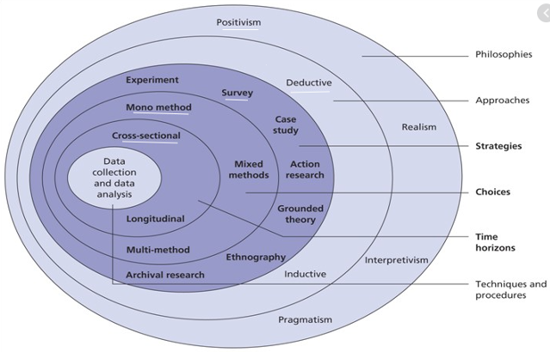
Figure 1: Research Onion
(Source: Saunders, Lewis & Thornhill, 2019)

3.2: Research Philosophy
The philosophy of the research helps to drive a path that is going to be taken by the study to complete its requirements (Saunders, Lewis & Thornhill, 2019). As advocated by Basias and Pollalis (2018), there are four different types of research philosophies and each of them have their own significance within the research study. The four types of research philosophies include positivism, post positivism, realism and interpretivism (Saunders, Lewis & Thornhill, 2019). All these philosophies have their own format of reasoning and are applied in different situations that are included within the research. In the case of this particular study, the researcher has worked on interpretivism theory.
The justification for selecting this particular philosophy relates to the cognitive perception of individuals (Saunders, Lewis & Thornhill, 2019). The use of human observation is done with the use of quantitative data. The difference that arises in the use of primary data is underpinned with the use of positivism philosophy and it helps to lay down a profound foundation to support the overall need of the study by considering both, scientific facts and the psychological perception of respondents (Saunders, Lewis & Thornhill, 2019). Interpretivism is not appropriate for the current study and it is not going to lay down a foundation to achieve the results of the study over the period (Ulmer, 2017).

3.3: Research Approach
The research approach is taken into consideration to complete the research study and it can be stated as the plan used towards the successful completion of the research. The correct incorporation of the approach helps to bring in different concepts and theories that help to underpin the topic ahead (Saunders, Lewis & Thornhill, 2019). It helps to delve deep into the topic of discussion and helps in driving in knowledge about the variable cases in a detailed mannerism. As stressed by Dźwigoł and Dźwigoł-Barosz (2018), the approaches of research are divided into two parts and it includes the inductive approach and the deductive approach. Inductive approach starts from a particular point and then sets its understanding at a generalized form of understanding. On the other end, deductive approach starts from a generalized sense of knowledge and then culminates into a specific point of understanding. Lastly, Lewis, Saunders and Thornhill (2019) opined that the abductive approach is also used in empirical studies, and it covers the limitations of the deductive and inductive approach.
The study is going to use and deductive approach and the justification for the selection is connected with the building of theories with the help of observation is an essential parameter (Saunders, Lewis & Thornhill, 2019). It helps in the validation of the set theories and connects with the best possible approach to reach out to the best of results as a part of the research. For example, it helps in hypothesis testing (Saunders, Lewis & Thornhill, 2019).

3.4: Research design
The exploratory research design eagles the researchers to drive a proper development of ideas over the available ideas that have not been well researched in the past. As indicated by Zangirolami-Raimundo, Echeimberg and Leone (2018), the exploratory form of research works on the power of exploration that is evident within the researcher and the amount of research that is set within the researcher that is connected with the set topic. The exploratory research design is in appropriate for the study as it is not suitable for hypothesis testing, as it is appropriate for the current research.
Secondary data for the current research can be studied using the that explanatory. The most appropriate form of data can be gathered as a part of explanatory research design that helps to address the best of knowledge associated with the idea of delivering subjective growth results over the period (Saunders, Lewis & Thornhill, 2019). The design focuses on a detailed form of knowledge that is gathered that connects with the set agenda of the study and helps in driving profound forms of knowledge within the study. Overall, it focuses on analysing the cause-effect relationship of the research topic (Saunders, Lewis & Thornhill, 2019).

3.5: Data Collection and Research Instruments
There are two significant methods that are used to collect data within the area of research and it includes primary and secondary data collection methods. The result of the collected data has a significant impact on the overall study (Saunders, Lewis & Thornhill, 2019). The particular research study has worked with the qualitative and quantitative method of collecting the set data within the study.
As stressed by Mohajan (2018), the qualitative data collection method is included wherein the power of exploration is used by the researcher to drive in the best of abilities to bring in profound change within the operational characteristics of the study. It sets it focus on collection of profound data in conjunction with the set method of delivering positive results of growth over the primary and secondary data that has been collected (Saunders, Lewis & Thornhill, 2019). The primary data gathered for the research is done through survey that has been conducted and on the other end, the secondary data is collected from the textual sources, which are found online (Saunders, Lewis & Thornhill, 2019). The survey is conducted using an un-structured questionnaire, which is based on a Likert-Scale. The Likert-Scale is graded as follows.
- 1: Strongly Agree
- 2: Agree
- 3: Neutral
- 4: Disagree
- 5: Strongly Disagree

3.6: Data Analysis
The plan for the data analysis is set with the use of closed-ended that is set for the collection of data from researchers through a survey. As stated by Ørngreen and Levinsen (2017), the data analysis plan works with a systematic approach that works with logical approaches for the illustration of the data collected. The use of textual knowledge from google scholar has been implemented to drive in subjective knowledge from the existing authors who have worked on the particular topic of research in the past. In addition, primary data collected through the survey would be analysed by following a regression analysis technique (Saunders, Lewis & Thornhill, 2019). This technique would help identify patterns in observational data and validate it with existing literature. This data analysis is followed in line with a cross-sectional research design. As per this design, researchers collect data from different respondents in a given time frame without influencing them (Saunders, Lewis & Thornhill, 2019). In contrast, a longitudinal design is inappropriate as it focuses on group formation, which is not the case with the current research.

3.7: Sampling Strategy
Sampling refers to a practice of reducing the population size to aid researchers in conducting a research within a stipulated time frame (Ragab & Arisha, 2018). The current research adopts the non-probability convenience sampling technique. Amidst the coronavirus pandemic, the current research relies on respondents known to the researcher. In particular, a sample size of 30 is considered appropriate for survey (Saunders, Lewis & Thornhill, 2019).

3.8: Ethical Consideration
All the ethics and norms have been maintained to conduct this particular research. The prior permission has been gathered from the respondents for the survey. No force or any form of coercion has been included to drive in data within the particular study. Under the ethics, the researcher has adhered to General Data Protection Regulation. As mentioned by Ngozwana (2018), the data protection acts have been taken into consideration and the researcher has kept the collected data confidential and it has not been used for any other purpose except in the use of the research. The collected data has been used for any commercial purpose, and it is used only for academic purposes.

3.9: Research Limitation
The research limitations that have been witnessed as a part of the study is connected with the short time frame to complete the particular study. The pandemic situation has made a strong impact on the overall achievement of the results of the study and has created a strong impact on the overall achievement of the research results. As advocated by Saunders, Lewis and Thornhill (2019), the budget of the study has been another constraint that has limited the collection of data and has posted a strong impact on the overall achievement of the best data collection results over the period.

3.10: Summary
In the section above, the different forms of methodological approaches have been dealt with. The chapter has helped the readers to gather knowledge about how the methodological approaches impact the overall results of the study. Drawing from the insights above, it can be deduced that the current research adopts a deductive approach, explanatory design and a positivism philosophy to conduct a regression analysis of survey data.

CHAPTER 4: FINDINGS AND ANALYSIS
This chapter of the research presents the findings from the data collection procedure, which is followed by an analysis of the findings and its comparison with existing literature. The analysis is conducted using regression, and the hypotheses identified in Chapter 1 are tested at the 5% level of significance.

4.1: Findings
Primary data collected using a survey was transcoded into an excel sheet and later imported into SPSS for regression analysis. Upon conducting the regression analysis, the following results were achieved.
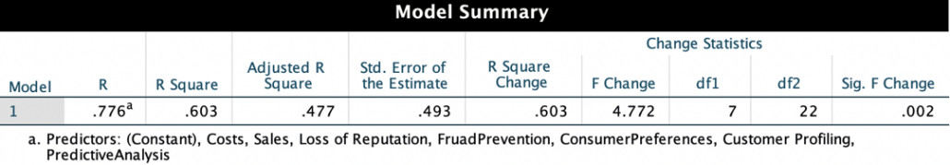
Figure 2: Model Summary
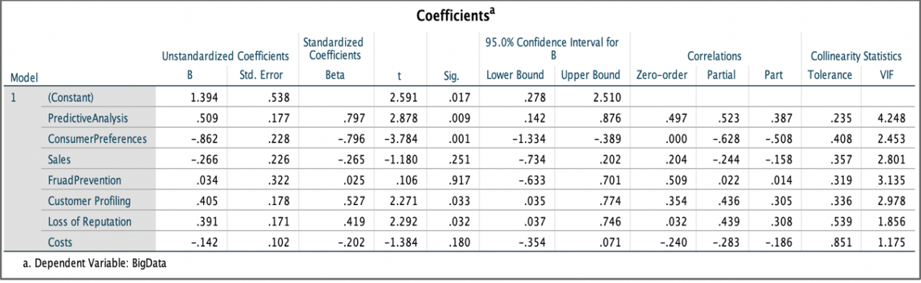
Figure 3: Coefficients
In addition, the survey analysis conducted, yielded the following statistics. These graphical insights present a quantitative measure of the responses. These charts have been generated through SPSS, and they clearly identify the responses of respondents.
Figure 4: Use of Big-Data
Figure 4 shows that 56.67% of the respondents strongly agree that they would use big-data for retail related assignments. Similarly, 33.33% of the respondents “Agreed” that big data is beneficial and is extensively used in the retail industry. None of the respondents disagreed to the first question.
Figure 5: Predictive Analysis
Figure 5 sows that 43.335 of the respondents strongly agree that big-data can be used for predictive analysis, whereas, only 10% of the respondents disagree to it. No respondent “Strongly Disagreed” to it.
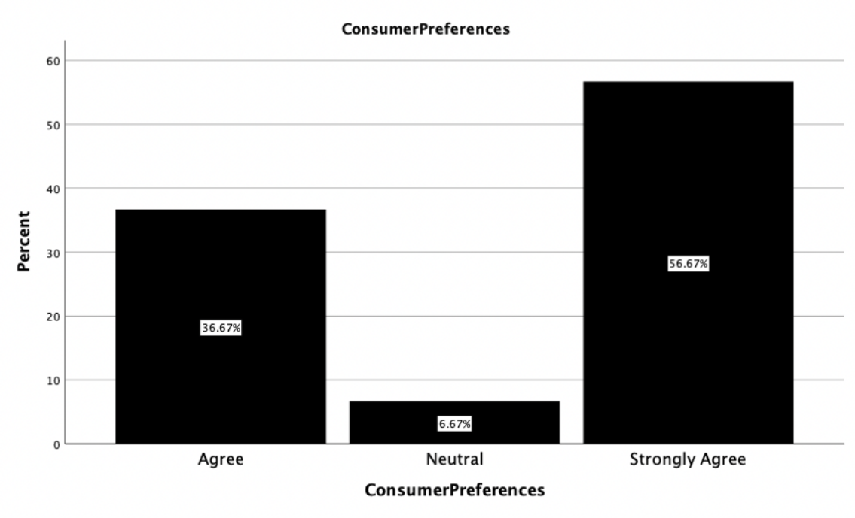
Figure 6: Consumer Preferences
Figure 6 shows that 56.67% of the respondents consider big data to be useful for identifying consumer preferences. Also, 36.67% “Agreed” to this also. 6.67% of the respondents were “Neutral” when questioned about the role of big data in identifying consumer preferences.

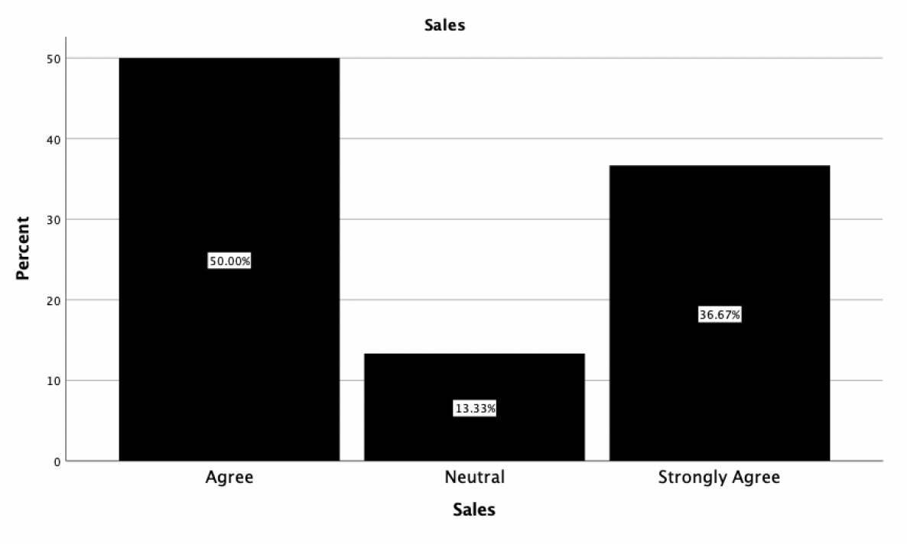
Figure 7: Sales
Figure 7 shows that 50% and 36.67% of the respondents Agree and Strongly Agree that he use of big-data helps increase the level of sales of an organisation. No one of the respondents disagreed to it.

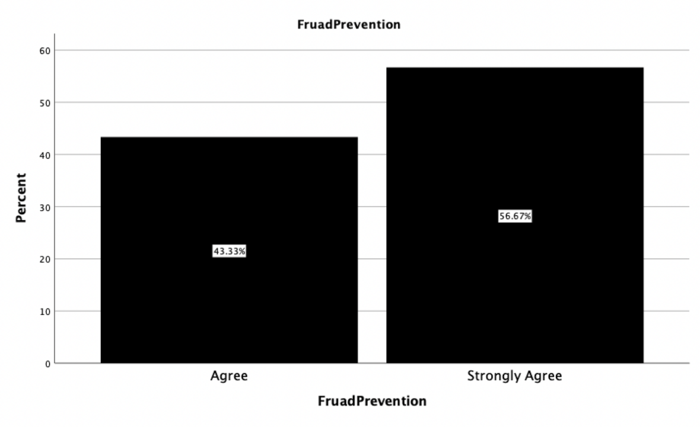
Figure 8: Fraud Detection
Figure 8 shows that 56.67% and 43.33% of the respondents stated that they “Strongly Agree” and “Agree” to the fact that big-data helps in fraud detection. Similar to the inputs above, none of the respondents disagreed to it.
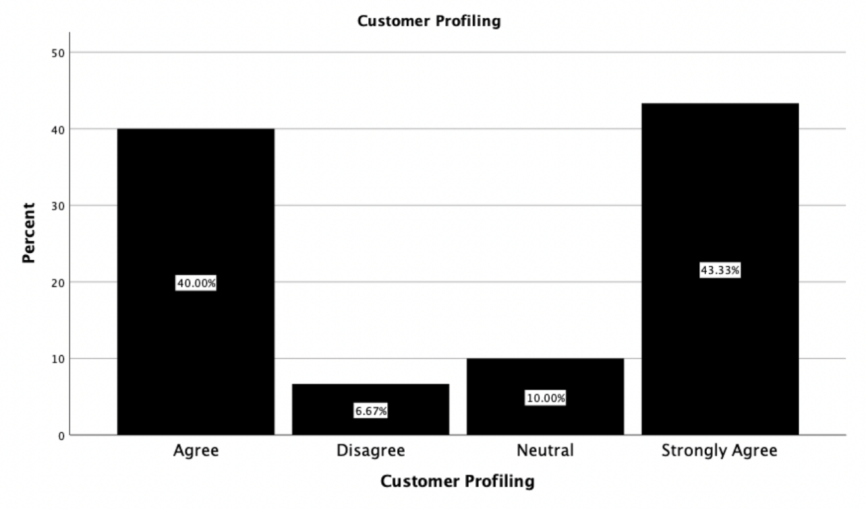
Figure 9: Customer Profiling
Figure 9 shows that 6.67% of the respondents disagree that big-data can be used for customer profiling, and 43.33% “Strongly Agreed” that big-data can be used for customer profiling. None of the respondents strongly disagreed to the statement.
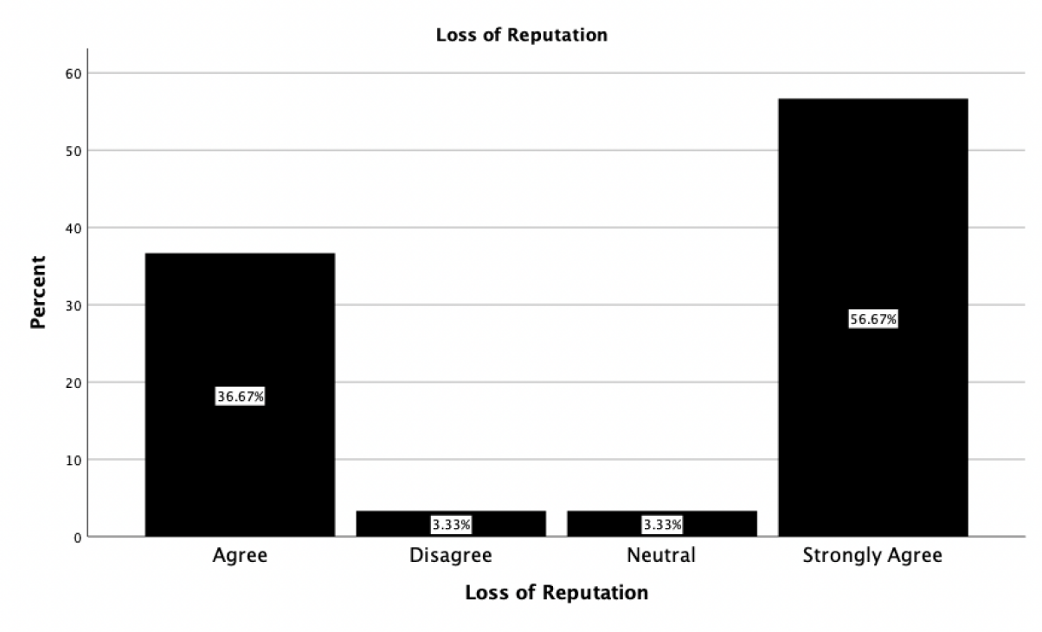
Figure 10: Loss of Reputation
Figure 10 shows that 56.67% of the respondents “Strongly Agree” that big-data can lead to loss of reputation, and no one disagreed to that statement.
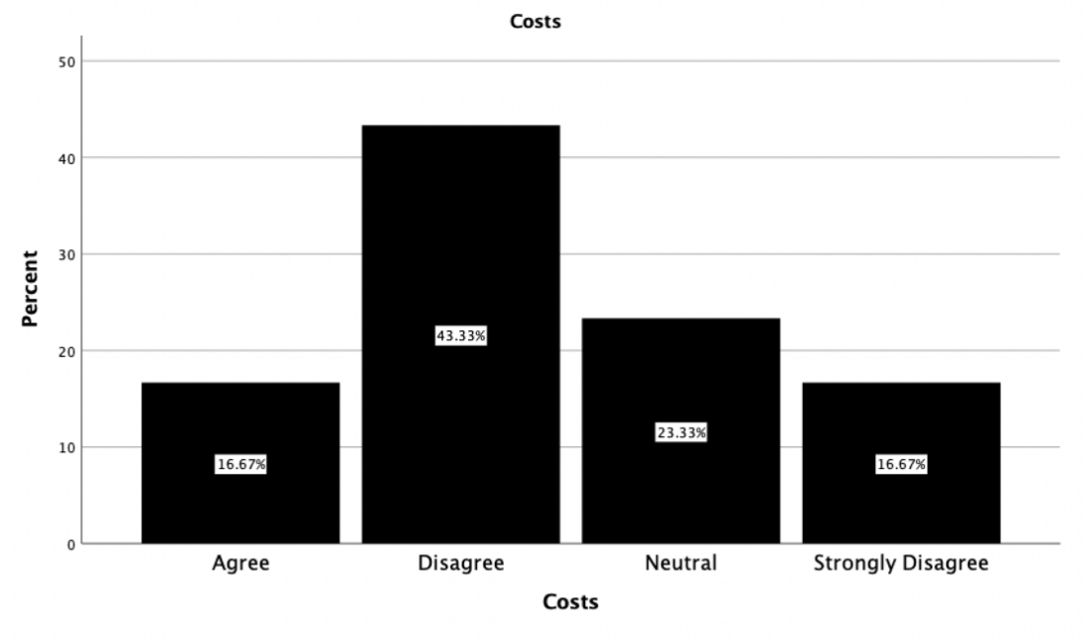
Figure 11: Costs
Figure 11 shows that a very proportion of the respondents disagreed that the use of big-data can lead to additional costs to be incurred. For example, 43.33% of the respondents Disagreed, and 13.67% of the respondents strongly disagreed.

4.2: Analysis
Drawing in from the literature review conducted above, it can be seen that the use of big-data has grown tremendously over the years. As stated by Prasdika and Sugiantoro (2018), big-data refers to a myriad of data that is huge in terms of volume and it is growing in exponentially with passage of time. Empirical literature has highlighted numerous applications of big-data. For example, Pyne et al., (2016) stressed that big-data can be used for predictive analysis. Pyne et al., (2016) suggested that multinational companies such as Amazon use big-data for predictive analysis. In contrast, numerous researchers have highlighted disadvantages associated with the use of big-data. For example, Sharma et al., (2012) and Duhigg (2012) added that the use of big-data is associated with the loss of reputation and it forces organisations to bear additional costs.
The regression analysis conducted yielded an R-Squared of 60.3%. This stated that 60.3% of the variation in the dependent variable is explained by the changes in independent variables. The following discussion provides an analysis of the hypothesis testing that is done using the linear regression model.
Hypothesis 1
The first relationship evaluates the relationship between big-data and its use for predictive analysis. Empirical research regarding the application of big-data is suggestive of big-data being used for predictive analysis. For example, Pyne et al., (2016) added that big-data can be used for a computational analysis to deliver a meaningful insight, and for applying the insights in undertaking realistic business decisions. Even researchers such as DeDeo (2014) have highlighted that big-data is used for predictive analysis. Testing the first hypothesis at the 5% level of significance (α), it can be seen that the p-value is 0.09 (Figure 2), and this is lower than the (α). If (α) is greater than the p-value, the null hypothesis is rejected and the alternate hypothesis has failed to be rejected. This suggests that there exists a significant relationship between the use of big-data and its applicability for predictive analysis in the retail industry. These findings are supportive of the assertions made by empirical researchers such as Pyne et al., (2016) and DeDeo (2014). These findings also suggest that organisations in the retail industry are using big-data to predict the future needs of consumers, and these support the assertions made by Krasnow Waterman and Bruening (2014).
Findings from the first hypothesis testing is supported by descriptive statistics. Drawing in from the findings above, even Figure 5 suggests that big-data can be used for predictive analysis as a strong proportion of respondents (43.33%) suggests that big-data is helpful for predicting future consumer preferences and attitudes. Given that no respondent Strongly Disagreed, it suggests that big-data is commonly used by retail companies for predictive analysis.
Hypothesis 2
The second hypothesis deals with an evaluation of whether big-data can aid retail companies in gathering information about products and services. At the 5% level of significance, H2 is rejected as α (0.05) is greater than the p-value of the independent variable (ConsumerPreferences) (0.001). This suggests that the alternate hypothesis has been accepted and there exists a significant relationship between big-data and consumer information about products and services. In other words, H2 reveals that big-data plays a profound role in ascertaining consumer information about different products and services. These findings support literature presented by Hewage et al., (2018). Hewage et al., (2018) suggested that big-data is useful for retail e-commerce companies as it can help gather information about product searches and their product history. Even Sun et al., (2014) asserted that big-data works in the form of recommender systems and this helps gather information about the purchase information of consumers. Thus, findings from H2 are supportive of empirical evidence. Even Figure 6 above shows that a significant portion of the respondents considered big-data to play a prominent role in ascertaining information about consumer products.
Hypothesis 3
The third hypothesis (H3) tests the relationship between big-data and the increase in sales. At the 5% level of significance, H3 has been accepted as the p-value of the independent variable (Sales) is greater than α (0.05). This suggests that no significant relationship exists between the dependent and the independent variable. These findings directly contradict empirical literature.
Drawing in from the literature presented above, researchers such as Finger et al., (2018) and Müller et al., (2018) stated that companies use big-data to develop data driven marketing strategies. By doing so, organisations can increase the perceived level of sales and add to organisational growth. Even Al-Htaybat and von Alberti-Alhtaybat (2017) added that big-data can help retrieve accurate data for developing appropriate sales strategies. H3 however suggests no relationship between big-data and its benefits to an increase in sales. Thus, this opens up a new gap for research that future can researchers can aim to exploit.
Hypothesis 4
H4 tests the relationship between the use of big-data and fraud detection. At the 5% level of significance, H4 has been accepted as the p-value of the independent (FraudPrevention) is 0.917, and this is greater than the level of significance (0.05, α). As a result, there is no relationship between the use of big-data and fraud prevention. This suggests that big-data cannot aid in fraud prevention.
Drawing in from the literature above, it can be deduced that researchers such as Attigeri et al., (2018) and Fang et al., (2007) have added that big-data analytics is used in the retail industry for detecting different types of fraud. For example, techniques such as machine learning and text mining are used in line with big-data techniques for identifying customer related fraud. Findings from H4 contradict the findings of Attigeri et al., (2018) and Fang et al., (2007) suggesting that retailers do not use big-data for fraud prevention.
Hypothesis 5
H5 tests the relationship between the use of big-data and customer profiling. At the 5% level of significance, H5 has been rejected as α is greater than the p-value of the independent variable (Customer Profiling; 0.33). As a result, there exists a significant relationship between big-data and customer profiling. This suggests that big-data can be used extensively for customer profiling. H5 supports the assertions made by Mantelero (2016) and Mavriki and Karyda (2018). Kosinski et al., (2013)’s study also contributed to academic literature by adding that retailers use big-data for developing customer centric promotions and advertisements. Figure 9 also supports H5 as 43.33% of the respondents strongly agreed that big-data can be used by businesses for customer profiling.
Hypothesis 6
H6 tests the relationship between the use of big-data and whether it can lead to a loss of reputation. H6 is rejected at the 5% level of significance (0.05) as α is greater than the p-value of “Loss of Reputation” (0.32). This suggests that there exists a significant relationship between the use of big-data and the loss of reputation.
Duhigg (2012) and Lanois (2019) has added that the risk to data privacy is a challenge that has poised the growth of big-data. Given that private confidential data of individuals are considered to be scarce. Organisations collect organisational data from different sources and such data is often stored in cloud-based servers for analysis. The rise of cybercrime poses a threat to the authenticity of big-data as cybercrime involves individuals misusing private and confidential data of clients. These findings support the findings of empirical studies conducted by Lanois (2019) and Sharma et al., (2020).
Hypothesis 7
Hypothesis 7 deals with an evaluation of big-data and its relation to additional costs being borne by an organisation. Empirical research as presented above has suggested that big-data adoption causes organisations to bear costs in the form of hiring required employees and training programs. For example, big-data analytics requires costs to be borne for data collection. H7 deals with an evaluation of big-data and the additional costs borne by an organisation. At the 5% level of significance, H7 has been accepted as the p-value of the independent variable (Costs) is greater than the level of significance (0.05). Findings from the hypothesis testing directly contradict empirical evidence suggesting that the use of big-data in the retail industry does not require organisations to bear costs.
Big-data is omnipresent across the globe, and organisations are unaware of the benefits it has for an organisation. Prior to the internet era, information was not available readily and it was restricted and centralised. The only mode of procuring information was through books and newspapers. However, the advent of the internet has resulted in a plethora of information available to businesses and such information can be exchanged amongst each other without any certain limitation. Online retailers popularly use big-data on building recommender systems that can tailor to the needs of consumers. For example, Amazon uses big-data to collate information on consumer purchasing behaviour, cart and browsing history, streaming services and others. In addition to the above, big-data is applied in different sectors such as manufacturing, healthcare and entertainment. This suggests that big-data is important for different industries.
The use of big-data for predictive analysis shows that big-data could play an important role in the retail industry. Retailers are often associated with consumers of varying preferences and requirements. For example, a consumer can request for vegan friendly products and services, and on other hand, a consumer can opt for a colour specific product or a service. As noted above, big-data can be used by retailers to devise consumer centric promotions and marketing plans. This can help businesses gain consumer attention and increase their market share. Drawing in from the insights presented above, retailers should be aware of the use of big-data as it can lead to loss of reputation. From the literature review discussion, it can be deduced that retailers should be aware of cyber-crime related problems. As noted above, issues such as lack of data security and data theft are problems that limit the growth of retailers.
The advent of a technology and innovation has changed big-data. The use of advanced software and related systems have resulted in a reduction in analytical time thereby providing companies with the ability of undertaking speedy decisions for taking speedy decisions and reducing business related costs and for stimulating growth. This suggests that the use of big-data can be advantageous for retailers as it can help them work faster and target consumers effectively.
Traditionally, retailers have been focused on customers, and this has been evident through the commitment and the enthusiasm that retailers shown when they attend to consumers. In common parlance, retailers want to know the requirements of consumers, and given that the use of big-data is associated with advantages such as predictive analysis, increase in sales and customer profiling. However, retailers should be cautious of the disadvantages associated with big-data such as that of loss of reputation and additional costs.
Even prior to the current pandemic, the retail industry was undergoing a significant transformation, which was driven by massive changes in shopping related behaviour. Thus, understanding the different needs and requirements of consumers is the need of the hour and retailers must find different ways to differentiate their brands using better customer service, personalisation and demand forecasting. In line with empirical literature, retailers should develop promotion strategies by collating customer-centric data using big-data.

4.3: Summary
This chapter of the research has presented the findings and analysis of the research. Using regression analysis, this chapter has highlighted that big-data is used for predictive analysis, identifying consumer preferences and customer profiling. Also, the use big-data can lead to loss of reputation. Regression analysis yielded inconclusive results related to costs, fraud prevention and sales.

CHAPTER 5: CONCLUSION AND RECOMMENDATIONS

5.1: Conclusion
The aim of this research had been to analyse the role of big-data in the retail industry and understand its benefits and limitations in the industry. The report has casted light on the benefits and limitations associated with big-data, and it has shown that the retail industry has increasingly adopted big-data to improve retail functions and compete with large-scale retailers.
Big-data, as noted above, refers to collation of data, which is considered to be huge in volume, and such data is expected to grow tremendously over-time. Recent trends as shown above have suggested that the recent appreciation in big-data is on account of the rise in investments over big-data related technology. The critical review of literature conducted above indicates that big-data has been defined differently by researchers. Drawing in on the discussion above, big-data has a myriad of advantages and disadvantages. Big-data’s use in predictive analysis suggests that it is used by businesses to devise marketing strategies. However, researchers have also critiqued big-data to generate inaccurate results. Similarly, the research pinpointed on big-data being used for generating product recommendation and beater revenues. Other benefits such as customer profiling, customer journey analysis and demand forecasting were also noted from the use of big-data. However, disadvantages such as loss of reputation and additional costs were also associated with the adoption of big-data.
The research methodology adopted in the current research has helped the researcher adhere to the research objectives. Drawing in from the methodology used, the positivism philosophy was considered to be appropriate for laying down a foundation for considering the psychological perception and scientific facts of respondents for conducting a quantitative analysis. Using the deductive approach has helped the current research validate existing theories and patterns in observational data. Discarding the inductive approach has been apt as the approach was inappropriate for conducting a qualitative data analysis. Further, using the explanatory research design was appropriate in identifying the cause behind a particular problem and addressing the research questions identified above. Conducting regression analysis has helped validate patterns and identify any contradictions if any. Using the non-probability convenience sampling technique has been appropriate for the researcher to identify the chosen sample for the research.
Regression analysis conducted with the chosen sample has yielded that big-data is present globally and organisations are still unaware of its benefits and uses from a business context. Over the years, big-data has captured every industry across the globe. This has been primarily driven by the rise internet adoption. In the retail industry, big-data’s role for predictive analysis has been the most prominent. Drawing in from the discussion above, big-data is used for identifying different consumer preferences and requirements. Using such measures, retailers can alter their strategies and products to make it consumer centric for generating growth. However, retailers are required to be aware of the potential limitations associated with big-data. As noted above, cyber-crime, threats, loss-reputation and costs are limitations that impede the successful implementation of big-data in the retail industry.

5.2: Recommendations
Drawing in on the discussion above, big-data’s implementation has been prone to several limitations. In light of these limitations, some of the recommendations for improving its efficacy are as follows.
- Customer-Centric Outcomes: Enterprises are required to focus big-data related strategies on efforts that would generate the most business value. To do so, enterprises are required to understand the customers and invest in newer technologies and analytics.
- Enterprise Wise Big-Data: Big-data related strategies should cover the overall vision of the organisation, requirements and the strategy of the organisation. By doing so, retailers can identify can create a basis of developing roadmap for the entire organisation for implementation of big-data.
- Risk-Management: Big-data analytics has contributed to the development of risk-management at an organisational solutions. In the retail industry, it can be used for identifying the consumption patterns of retailers.
- Driver of Innovation: Big-data has the ability of helping retail companies innovate and develop their products in line with the trending requirements. For example, Amazon has used big-data analytics to identify the requirements of consumers of Whole Foods to drive insights whenever changes are required to be made.

REFERENCES
Abutabenjeh, S., &Jaradat, R. (2018). Clarification of research design, research methods, and research methodology: A guide for public administration researchers and practitioners. Teaching Public Administration, 36(3), 237-258.
Al-Htaybat, K. and von Alberti-Alhtaybat, L., (2017). Big Data and corporate reporting: impacts and paradoxes. Accounting, auditing & accountability journal.
Attigeri, G., MM, M.P., Pai, R.M. and Kulkarni, R., (2018). Knowledge Base Ontology Building For Fraud Detection Using Topic Modeling. Procedia Computer Science, 135, pp.369-376.
Basias, N., & Pollalis, Y. (2018). Quantitative and qualitative research in business & technology: Justifying a suitable research methodology. Review of Integrative Business and Economics Research, 7, 91-105. Retrieved from:https://sibresearch.org/uploads/3/4/0/9/34097180/riber_7-s1_sp_h17-083_91-105.pdf
Buhalis, D. and Volchek, K., (2021). Bridging marketing theory and big data analytics: The taxonomy of marketing attribution. International Journal of Information Management, 56, p.102253.
Choi, T.M., (2018). Incorporating social media observations and bounded rationality into fashion quick response supply chains in the big data era. Transportation Research Part E: Logistics and Transportation Review, 114, pp.386-397.
DeDeo, S., (2014). Wrong side of the tracks: Big data and protected categories. arXiv preprint arXiv:1412.4643.
Duhigg, C., (2012). How companies learn your secrets. The New York Times, 16(2), pp.1-16.
Dźwigoł, H., & Dźwigoł-Barosz, M. (2018). Scientific research methodology in management sciences. Financial and credit activity: problems of theory and practice, 2(25), 424-437. Retrieved from:http://fkd.org.ua/article/download/136508/137235
Fan, Z.P., Che, Y.J. and Chen, Z.Y., (2017). Product sales forecasting using online reviews and historical sales data: A method combining the Bass model and sentiment analysis. Journal of Business Research, 74, pp.90-100.
Fang, L., Cai, M., Fu, H. and Dong, J., (2007), May. Ontology-based fraud detection. In International Conference on Computational Science (pp. 1048-1055). Springer, Berlin, Heidelberg.
Finger, V., Reichelt, V. and Capelli, J., (2018). Big Data and Data Driven Marketing in Brazil. In 2nd International Conference on Advanced Research Methods and Analytics (CARMA 2018). Proceedings.
FIS Global. (2021). How the Consequences of a Data Breach Threaten Small Businesses - Insights | Worldpay from FIS
Gorelik, A., (2019). The enterprise big data lake: Delivering the promise of big data and data science. O'Reilly Media.
Hahn, G.J. and Packowski, J., (2015). A perspective on applications of in-memory analytics in supply chain management. Decision Support Systems, 76, pp.45-52.
Hewage, T.N., Halgamuge, M.N., Syed, A. and Ekici, G., (2018). Big Data Techniques of Google, Amazon, Facebook and Twitter. Journal of Communications, 13(2), pp.94-100.
Iftikhar, R. and Khan, M.S., (2020). Social media big data analytics for demand forecasting: development and case implementation of an innovative framework. Journal of Global Information Management (JGIM), 28(1), pp.103-120.
Katal, A., Wazid, M. and Goudar, R.H., (2013), August. Big data: issues, challenges, tools and good practices. In 2013 Sixth international conference on contemporary computing (IC3) (pp. 404-409). IEEE.
Kosinski, M., Stillwell, D. and Graepel, T., (2013). Private traits and attributes are predictable from digital records of human behavior. Proceedings of the national academy of sciences, 110(15), pp.5802-5805.
Krasnow Waterman, K. and Bruening, P.J., (2014). Big Data analytics: risks and responsibilities. International Data Privacy Law, 4(2), pp.89-95.
Lanois, P., (2019). How to prepare for data breaches? Lessons learned from recent incidents. Journal of Data Protection & Privacy, 2(3), pp.213-223.
Mantelero, A., (2016). Personal data for decisional purposes in the age of analytics: From an individual to a collective dimension of data protection. Computer law & security review, 32(2), pp.238-255.
Mavriki, P. and Karyda, M., (2018). Profiling with Big Data: Identifying Privacy Implication for Individuals, Groups and Society. In MCIS (p. 4).
Micheaux, A. and Bosio, B., (2019). Customer journey mapping as a new way to teach data-driven marketing as a service. Journal of Marketing Education, 41(2), pp.127-140.
Mohajan, H. K. (2018). Qualitative research methodology in social sciences and related subjects. Journal of Economic Development, Environment and People, 7(1), 23-48. Retrieved from:https://mpra.ub.uni-muenchen.de/85654/1/MPRA_paper_85654.pdf
Müller, O., Fay, M. and Vom Brocke, J., (2018). The effect of big data and analytics on firm performance: An econometric analysis considering industry characteristics. Journal of Management Information Systems, 35(2), pp.488-509.
Ngozwana, N. (2018). Ethical Dilemmas in Qualitative Research Methodology: Researcher's Reflections. International Journal of Educational Methodology, 4(1), 19-28. Retrieved from:https://files.eric.ed.gov/fulltext/EJ1170655.pdf
Ørngreen, R., & Levinsen, K. (2017). Workshops as a Research Methodology. Electronic Journal of E-learning, 15(1), 70-81. Retrieved from:https://files.eric.ed.gov/fulltext/EJ1140102.pdf
Prasdika, P. and Sugiantoro, B., (2018). A Review Paper on Big Data and Data Mining Concepts and Techniques. IJID (International Journal on Informatics for Development), 7(1), pp.36-38.
Provost, F. and Fawcett, T., (2013). Data science and its relationship to big data and data-driven decision making. Big data, 1(1), pp.51-59.
Pyne, S., Rao, B.P. and Rao, S.B. eds., (2016). Big data analytics: Methods and applications. Springer.
Ragab, M. A., & Arisha, A. (2018). Research methodology in business: A starter’s guide. Management and Organizational Studies, 5(1), 1-14. Retrieved from:https://www.researchgate.net/profile/Mohamed_Ragab7/publication/321769066_Research_Methodology_in_Business_A_Starter's_Guide/links/5a311456aca2724bf72185bf/Research-Methodology-in-Business-A-Starters-Guide.pdf
Saunders, M.N.K., Lewis, P. & Thornhill, A., (2019). Research methods for business students.Harlow: Pearson.
Sharma, A., Singh, G. and Rehman, S., (2020). A review of big data challenges and preserving privacy in big data. Advances in Data and Information Sciences, pp.57-65.
Soria-Comas, J. and Domingo-Ferrer, J., (2016). Big data privacy: challenges to privacy principles and models. Data Science and Engineering, 1(1), pp.21-28.
Sun, C., Gao, R. and Xi, H., (2014) July. Big data based retail recommender system of non E-commerce. In Fifth International Conference on Computing, Communications and Networking Technologies (ICCCNT) (pp. 1-7). IEEE.
Uddin, M.I., Ahmed, T., Raz, R. and Islam, A.S. (2020). Application and Analysis of Retail Inventory using Data Mining Techniques. Global Journal of Computer Science and Technology.
Ulmer, J. B. (2017). Posthumanism as research methodology: Inquiry in the Anthropocene. International Journal of Qualitative Studies in Education, 30(9), 832-848. Retrieved from:https://www.researchgate.net/profile/Jasmine_Ulmer/publication/317547085_Posthumanism_as_research_methodology_Inquiry_in_the_Anthropocene/links/59e4b080458515393d6116fc/Posthumanism-as-research-methodology-Inquiry-in-the-Anthropocene.pdf
Wamba, S.F., (2017). Big data analytics and business process innovation. Business Process Management Journal.
Zangirolami-Raimundo, J., Echeimberg, J. D. O., & Leone, C. (2018). Research methodology topics: Cross-sectional studies. Journal of Human Growth and Development, 28(3), 356-360. Retrieved from: http://pepsic.bvsalud.org/pdf/rbcdh/v28n3/pt_17.pdf

APPENDICES

Appendix 1: Questionnaire
Dear Respondent,
Please take the time to fill the questionnaire on Big-Data and its uses for the retail industry. The questions are graded based on a Likert-Scale where each question is scored as follows.
- 1: Strongly Agree
- 2: Agree
- 3: Neutral
- 4: Disagree
- 5: Strongly Disagree
Using your inputs to the questions, I will gain an understanding of how big-data has evolved over the years, and what are its limitations and uses in modern-day society. After competition of research, your private and confidential data would be deleted and a copy of the inputs would be stored on cloud servers, and it would be deleted after I complete my University program.
Demographic Questions
- What is your age?
  - Below 30 Years
  - Between 30 to 50 Years
  - Greater than 50 Years
- What is your sex?
  - Male
  - Female
- What is your occupation?
  - Businessmen/Businesswoman
  - Working Professional
  - Doctor
  - Teacher
Particulars/Question | Strongly Agree | Agree | Neutral | Disagree | Strongly Disagree
To what extent do you agree to the following statement. Big Data is extensively used in the retail industry!
To what extent do you agree to the following statement. Big data can aid in predictive analysis.
To what extent do you agree to the following statement. Big data can be useful to gather consumer preferences regarding products.
To what extent do you agree to the following statement. Bid data can help an organisation increase their sales.
To what extent do you agree to the following statement. Big data is advantageous as it can be used for fraud prevention and detection.
To what extent do you agree to the following statement. Big data can be used for customer profiling.
To what extent do you agree to the following statement. The use of big data can lead to loss of reputation.
To what extent do you agree to the following statement. The use of big data forces business to incur additional costs.

Thank you for taking the time to fill up this questionnaire!

Appendix 2: Data Sheet


