ACCOUNTING FUNDAMENTALS

Executive Summary
The report has mainly presented a financial analysis of Kedison plc and Chocco plc. The financial projection shows the economical state of Kedison plc. As per analysis, it has found a profit value of £115000. Report has made a result a higher valuation as per profit margin. Financial position has used for making analysis of strength in the business. It has described asset value for Kedison plc in respect to liability margin. A financial analysis has conducted over ratio value for Chocco plc. The estimation of ratio has been resulted a higher liquidity of the company. The current ratio has been decreased from 0.77 to 0.91. Company has further developed the profitability that has impacted on earnings of the organization.
Table of Contents
Introduction 2
Question 1 2
A) Preparation of a statement of income and financial position 2
b) Reason for financial position balanced 4
Question 2 4
A) Computation of the ratio 4
Conclusion 8
References 9

Introduction
Accounting is considered as recording, analysis of the financial activity of an organization. The accounting system involves in determining financial health along with the activity of accounting valuation. The importance of this accounting system is involved in accounting activity for developing business purposes. In this estimation of valuation, it has conducted the analysis over the financial statement for the year. It has also been used for estimating financial factors along with the operation. The business operation involves future analysis and also the justification of value. The study has mainly conducted the analysis overstatement and ratio factor of the chosen value.

Question 1

A) Preparation of a statement of income and financial position
Income statement
The analysis of expenses and also the income value has been developed for making a profit in an organization. The statement has mainly involved determining the financial value of an organization (Amel-Zadeh et al. 2020, p.42). The financial justification has mainly determined the income valuation that has explained revenue and also the profit value.
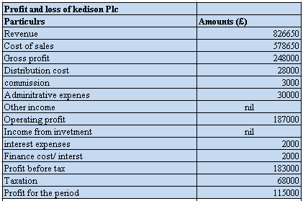
Figure 1: calculation
(Source: self-developed)
The computation of sales value has mainly determined the position of Kedison plc. In this estimation, it has involved in making justification of sales value that has determined the income position of Kedison plc. The activity has mainly involved the determination of income valuation. It has a valued gross profit of £248000. The valuation has mainly found an operating profit value as per estimation at £187000. The profit value has been deducted from the previous year's profit value. The estimated profit value has been estimated at £183000. It has a taxation margin of £68000. It has further valued the ultimate profit margin at £115000.
Statement of financial position
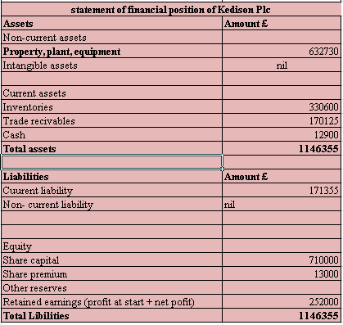
Figure 2: calculation
(Source: self-developed)
The valuation of financial position has been valued as per estimating the strength of the organization. The justification of value has been decided as a profit value that can be used as per asset and liability value. The estimation of the strength of business has been determined as per value. It is used for measuring asset value along with share capital valuation. It has used the asset value that can be developed for the financial value of Kedison plc. The value is mainly used for estimating equity value as per asset factor. It has balanced the total value of assets along with the liability (Zdanovskis and Pilvere, 2019, p.32). It has categorized the current asset value for making the justification. It has projected a total value of £1146355 that can be used for adjusting the value. Valuation has mainly highlighted a margin financial position that can be valued as per the financial strength of the organization.

b) Reason for financial position balanced
In a financial year, the balance sheet is prepared for the estimation of financial liability that can be evaluated as asset value. It mainly measures the strength of a business to evaluate financial value. As per the estimation of the double-entry posting system, the income along with the expenses has been described in a statement. The company usually maintains a balance for justification usage of value. It has analyzed and recorded proper application balancing over financial position (Shah, 2020, p.36). It has reflected a financial value as per the determination of profit value. It has evaluated a machinery value that can be evaluated as a proper transaction for being recorded. The income statement has been valued as per balancing asset and along with a liability margin that has measured the position of an organization. The statement has mainly involved in the determination of asset value that can be valued as per margin. The estimation of the balance sheet has mainly evaluated financial position that can be represented as positional value as per profit of the enterprises. The value is mainly involved in determining the strength of asset margin and liability margin for estimating the profit value. The transection of business activity has mainly involved in determining asset value that has been valued as per accounting activity. It has mainly categorized the activity that can be involved in resolving the financial factor. The activity of business has mainly involved dealing with the financial value of an organization (Haralayya, 2021, p.172). The business factor has mainly been involved in the determination of profit value as per justification of proper transaction.

Question 2

A) Computation of the ratio
1. ROCE
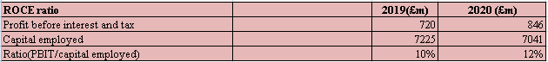
Figure 3: calculation
(Source: self-developed)
The estimation of return value over the capital employed has been computed as per return of profitability. The computation of return has been found as per capital employed value for 2019 and 2020. Comparison has found a return value of 10% in 2019 that has increased to 12%. It has found a higher return value that can estimate a higher as per capital value (M Allo, 2021, p.92). It has mainly returned margin over capital value for two years. In this estimation, it has valued a higher profitability factor. Value can be developed through capital valuation.
2. ROE
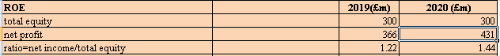
Figure 4: calculation
(Source: self-developed)
The estimation of return has been valued with an equity margin that can be helpful in the determination of profit. The return value has calculated 1.22 for 2018 that has increased to 1.44. Computation of value has reflected a higher return over the equity margin valuation of equity margin has mainly highlighted equity over net profit margin (Amanda and Riyanto, 2020, p.180). Increasing in value has caused a higher value as per position Chocco plc. It has indicated a higher return over the equity value of a business.
3. Earnings per share
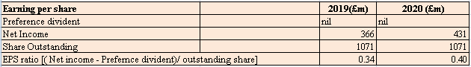
Figure 5: calculation
(Source: self-developed)
The value has further computed income value over the share price. Valuation of share margin has been used for estimating income margin as per business. In 2019, the earning value has been computed at 0.34 that has improved to 0.40. The esteemed value has found higher earrings from 2019 to 2020. Valuation has also mainly caused changes in income margin over share value (Easton et al. 2018, p.56). Improved income margin can develop the position of the organization.
4. NP margin
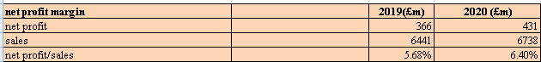
Figure 6: calculation
(Source: self-developed)
The estimation of NP value has mainly been used for determining the earnings of an organization. The usage of sale value has mainly reflected a higher return in 2020. It has computed a 5.68% return in 2019 that has increased to 6.40%. The increased value has impacted net profit value that has developed as per margin Higher return has been reflected in a better position as per value (Chalu and Lubawa, 2018, p.102). The estimation return can be developed by improving net profit value.
5. Asset turnover
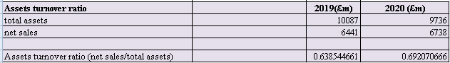
Figure 7: calculation
(Source: self-developed)
The justification of asset value has been computed by the utilization of assets in making returns for an organization. As per computation, the return has been valued at 0.63 in 2019 that has been increased to 0.69. Valuation has mainly highlighted a higher utilization of assets in making profit value (Subalakshmi et al. 2018, p.2396). Value can be improved in determining the asset value as per sales margin.
6. Stock holding
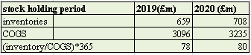
Figure 8: calculation
(Source: self-developed)
The estimation of stock value has been computed for the period that has been for the purchase of stock value. It has computed 78 days in 2019 that has been increased to 80 days. Valuation of study has been computed as per value that has increased to 80 days. It has found a better position as per margin. Value has been developed as an increase in purchase value that has been modified to 80 days. Valuation of data has found a better position for Chocco plc. This can be improved by changing in inventory margin
7. Debtors collection days
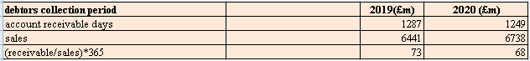
Figure 9: calculation
(Source: self-developed)
The amount which can be effectively identified from the above-placed figure regarding receivable or accounts for 2019 £1287 and the amount of 2020 at £1249. The value has been received as the amount of £6738 for the layer 2020 as per sales of 2019 amount for £6441.
The day has been decreased against the previous year of 2019 which helps to ascertain that the amount has received faster in 2020. The number of days for receiving the money from debtors in 2020 is 68 days and the days required for 2019 is 73 days.
The ratio can be improved by providing a discount to the debtor which will help in faster payments.
8. Current ratio
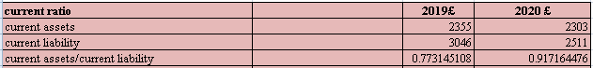
Figure 10: calculation
(Source: self-developed)
The ratio helps to ascertain the liquidity of the company by involving current assets which amount to £2355 in the year 2019 and £2303 in the year 2303. The ratio has been identified for the year 2020 is 0.9171 and the ratio of 2019 has stated 0.77.
The ratio has increased in the current year to 0.91 which helps to increase the liquidity in the firm.
The current ratio has to get improved by selling the unwanted assets.
9. Gearing ratio
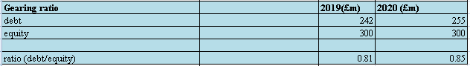
Figure 11: calculation
(Source: self-developed)
The gearing ratio involves debt which amounts to £255 in 2020 and the amount of debt for 2019 is £242. The equity has stated amounts for £300 in 2019 and it will remain the same in 2020.
The ratio of 2020 has been increased to 0.85 from the previous year of 0.81. The reason for the increase is due to an increase in the debt of the firm (Mare and Safta, 2021, p.116).
The ratio can be improved by selling the shares of an organization.
10. Inventor ratio
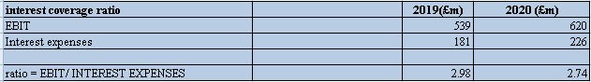
Figure 12: calculation
(Source: self-developed)
The EBIT has been stated for the year 2020 is £620 and the EBIT for the year 2019 is £539. The expenses of interest amount to £226 in 2020.
The ratio has decreased in the current year to 2.74. The ratio of the year 2019 is 2.98.
The ratio can be improved by better forecasting the investment.

Conclusion
The study has concluded usage of ratios and a financial statement has been used for estimating the position of an organization. As per analysis, it has reflected a position value of Kedison plc. It has analyzed a better position in the market. Valuation of income margin has found a higher value as per profit margin. Valuation has found a data margin of operating profit value. In this estimation, value has been determined as per the financial position of an organization. The financial strength has been described as per value that can be involved in the determination of asset value. Valuation has been found to be a better position for estimating a higher profit value. It has described a better position as per the analysis of the ratio.

References
Amanda, Y. and Riyanto, S., 2020. ANALYSIS Analysis Of Influence On Pt. Astra Agro Lestari Tbk Financial Performance In Measuring Financial Statements In 2018-2019 Period. Journal of Social Science, 1(4), pp.178-184.
Amel-Zadeh, A., Calliess, J.P., Kaiser, D. and Roberts, S., 2020. Machine Learning-Based Financial Statement Analysis. Available at SSRN 3520684.
Chalu, H. and Lubawa, G., 2018. Using financial statements to analyze the effects of multiple Borrowings on SMEs financial performance in Tanzania. Inter. J. Res. Methodol. Soc. Sci, 1(4), pp.87-107.
Easton, P.D., McAnally, M.L., Sommers, G.A. and Zhang, X.J., 2018. Financial statement analysis & valuation. Boston, MA: Cambridge Business Publishers.
Haralayya, B., 2021. Ratio Analysis at NSSK, Bidar. Iconic Research And Engineering Journals, 4(12), pp.170-182.
M Allo, Y.R., 2021. The Analysis of Financial Statements Performance: Case Studies PT. Bank Negara Indonesia (Persero). Golden Ratio of Finance Management, 1(2), pp.87-100.
Mare, C. and Safta, I.L., 2021. A Statistical Model of Fraud Risk in Financial Statements. Case for Romania Companies. Risks, 9(6), p.116.
Shah, N.K., 2020. FINANCIAL STATEMENT ANALYSIS THROUGH RATIO ANALYSIS OF SELECTED PHARMACEUTICAL COMPANIES.
Subalakshmi, S., Grahalakshmi, S. and Manikandan, M., 2018. Financial Ratio Analysis of SBI [2009-2016]. ICTACT Journal on Management studies, 4(01), pp.2395-1664.
Zdanovskis, K. and Pilvere, I., 2019. Methods of financial statement analysis for non-governmental organisations. RESEARCH FOR RURAL DEVELOPMENT, 2.

