Is adding Games to the classroom to be used as teaching tools a good idea or not?

Owain Hillier
University of Wales Saint Trinity Swansea
December 11th, 2018
Word count – 5001
Course code – M6X01791

Contents

Image list – 3 94
Abstract – 4 91
Aims – 4 42
Context – 4 169
Methodology – 4-5 160
Introduction - 5 386
Case Studies – 6 389
The Seven Learning Styles – 7 – 8 944
Chapter Supporting Aim 1 Minecraft – 8 – 9 648
Chapter Supporting Aim 2 Kerbal space program -10 -11 877
Chapter Supporting Aim 3 Foldit – 11 -12 556
Summary -12 137
Conclusion -13 536
Bibliography -14 193

List of Illustrations

Figure 1 – Image of the seven learning styles
Learning-styles-online.com. (2018). Overview of learning styles. [online] Available at: https://www.learning-styles-online.com/overview/ [Accessed 11 Dec. 2018].

Figure 2 – Image of Minecraft education edition
MCPE DL. (2018). MCPE Education Mode Exploration (Beta) [Creation]. [online] Available at: http://mcpedl.com/education-mode-exploration-map/ [Accessed 11 Dec. 2018].

Figure 3 – Image of Kerbal space program
GameUP24. (2018). Kerbal Space Program hits PS4 and Xbox One soon – Destructoid. [online] Available at: https://gameup24.wordpress.com/2016/07/08/kerbal-space-program-hits-ps4-and-xbox-one-soon-destructoid/ [Accessed 11 Dec. 2018].

Figure 4 – Image of Foldit
Fold.it. (2018). The Science Behind Foldit | Foldit. [online] Available at: https://fold.it/portal/info/about [Accessed 11 Dec. 2018].

Abstract

In this paper the following will be looking at if gaming in general is a good and useful way to bring into the class room for teaching people new ways to learn in class with their core skills. Giving everyone in the class room a risk-free environment to learn new skills and to grow their existing skills as well. Seeing the good and the bad side of bringing new technology into the class room and to see if it will benefit the class for having it there for them to us.

Aims
Point 1 = Minecraft has a real-life lesson to teach children
Point 2 = Kerbal space program teaches children basic rocket science and physics
Point 3 = Foldit is a game that cured a disease with the help of the gaming community

Context
In this paper we will be looking at games that have an educational part to offer to people of all ages. we will be looking at the effects that Minecraft, kerbal space program and Foldit has on gamers and what lessons that have to teach. To show that gaming should not be showed in the bad light it is shown today. Showing Minecraft and the ways that this game can be use not to just build objects but to teach lessons on a new level to help with all learning groups to bring them all onto the same level and work to their strengths. Looking at Foldit and how the gaming community helped with scientists to find a cure for a HIV type of illness in a fraction of the time it took the scientists to do it. Then we will be looking at Kerbal space program and how this game gets people of all ages into rocket science and how it teaches them physics with out them knowing.

Methodology
This dissertation will try to find links to education and games to see if it is a good idea to add them to the way we teach people in classrooms. These studies will be found out what games help with teaching and how they can teach people new skills. Also, how there are helping more than just the classroom. These studies also will be looking at the good and bad side of adding games into the classroom seeing what benefits and disadvantages there will be had for teachers, parents and most importantly on the students. This will help any reader of this dissertation come to their own conclusion of if it is a good idea of using games in the classroom to teach their children. To make this dissertation not to look as if it is favouring one side or the other there will be good points and bad points in the case studies with the three games in question.

Introduction
This paper will be proving that people playing games are learning without knowing they are learning giving them new skills that they can use in real or future life. Showing that gaming can be used as a tool to teach people new skills. They can be used in schools as a teaching tools giving the children access to a risk-free environment for learning. Proving that games are not a waste of time and should not be shown in a light where they are a problem to young people.

Going to be looking into the ways of learning and how this applies to the games. Also, we will be looking at three games that will be proving the point of games that can teach children, teenagers and adults’ new skills. Theses games are going to be Minecraft, Foldit and then Kerbal space program. Minecraft is a game where you can build anything you want out of the blocks with a risk-free environment, think of it as Lego but a video game. The other game is called kerbal space program, this is a basic physics game that teaches the player the basics of rocket science and plane design giving them the tools to build anything thing they can think of and test to see if it would work and if it does not work it does not matter because you can try again, again proving there is no risk when you play this game letting the player have more fun trying new things and learning what works and what does not as the same time.

The last game we will be looking at is a game called Foldit where the aim of the game is to just fold proteins to the best that you can and try to get the highest score. What makes this game about learning is that when you finish a level that level then goes to a group of scientists that will try to fold a protein the same way in real life to try to find cures for different sicknesses. That game came around when scientists tried for 10 years to find the right way to fold proteins to help with an illness and could not do it, so they made it into a game and three weeks later they had their answer.

Case Studies

The first game this paper will be looking at is Minecraft. The way that this game has been added into the class room for children to play in a safe environment, so they can learn to work as a team and how to express their creativity in building. Giving them a risk-free environment to do as they please, allowing them to work the way they want to work and enjoy learning is the whole idea behind Minecraft. Looking at that fact that Minecraft made an education version of the game for schools to use for lessons like chemistry. Which also shows teaches all over the world that use Minecraft education version of the game can make their own lessons that can be shared to other teachers. Opening new ways for teaches to show their classes new lessons and getting everyone in the class involved.

The second game this paper will be looking at is Kerbal space program. As this game teaches basic rocket science and is involved with NASA to add parts to their game to make rockets. Getting all ages involved into science, showing people that when building rockets, they have to take in gravity and centre of gravity, giving them a physics lesson while having fun doing it. Showing how this game can be used in the classroom would benefit children on the way they choose their education. Which can involve children into many forms of engineering and physics.

The third game that this paper will be looking at, will be Foldit. To start with this game was a science experiment, where scientist had tried for 10 years to work out how to fold protein in a successful way, so as to make a break though with protein folding to cure a disease and had no success. So, they turned it into a game and three weeks after the game was released they had the answer they were looking for and could now start to break down the AIDS virus. They are still trying different diseases to get the cure for them with the help of Foldit and the gaming community. As all the diseases are protein base as it is the workhouse of all living cells this game can be a massive help in working out the answers to how to cure or prevent these diseases.

The Seven Learning Styles
There are seven learning styles that everyone can idea to. They are as follows.
Visual (spatial): You prefer using pictures, images, and spatial understanding.
Aural (auditory-musical): You prefer using sound and music.
Verbal (linguistic): You prefer using words, both in speech and writing.
Physical (kinesthetic): You prefer using your body, hands and sense of touch.
Logical (mathematical): You prefer using logic, reasoning and systems.
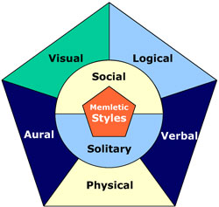
Social (interpersonal): You prefer to learn in groups or with other people.
Solitary (intrapersonal): You prefer to work alone and use self-study.

The first method would be visual, this is the key part in gaming as the player needs to see what they are doing to understand how the game works and to start leaning form it. Spatial understanding can be used in all three of the games that this paper talks about, as for Minecraft uses 3D space this can be used to start the teaching aspect of the game.
The second method of learning is Aural, which is where the person is better at learning with sounds and music. Form the three games in this paper Minecraft is the only game that uses sound and music to teach the player as there is a part of the game that cannot work without sound or music. Foldit does not have any music as there is no need for music in this game. Kerbal space program does have music but only uses it for background noise.
The third method of leaning is Verbal, this is where the person prefers to learn by reading and writing down what they must do to complete the task or being told what they must do. The three games in this paper, only one of them uses text to inform the player on how to play and what to do to complete the mission. Foldit does not gave as much written text on tell you how to play so that might not help people with this learning style work to there best. Minecraft has some elements of written text on how to play the game, but you don’t need to read it to understand how to play or learn in the game.
The fourth method of learning is Physical, this is where the person that prefers to learn this way will learn by using their hands and the sense of touch. The three games in this paper has a limited sense of physical learning as the only part their hands will be touching is the controller. Minecraft, Foldit and kerbal space program only physical method is the controller but the player can learn to use these controllers in different parts of learning. As for learning how to type so they can use there I.T skills to branch over to new skills.
The Fifth method of learning is Logical, this is where the person prefers using logic when sorting out a task or problem. They also prefer reasoning whiles using logic and set systems in teaching pupils to reach a result. The three games in this paper all have a form of logical learning as for Minecraft there is Redstone. This is a basic form a circuitry that allows the player to make anything electrical work in the game that can be made in real life like a working digital clock. Foldit has a form of logical learning as you must move the proteins in the right way to beat the level giving you a puzzle to solve. The other game Kerbal space program has the most in-depth logical learning aspect. This game does it by showing you the weight of the rocket also the centre of gravity and the thrust you need to get it into space, there are more details in how to play this game than the other two games. Minecraft only has Redstone in the sense of basic circuitry where you can take it further. Where on the other hand the Kerbal space program goes into more in-depth detail when it comes to building rockets as there is a lot of physics that you must take on board to understand how the game works.
The sixth method of learning is Social, this is were the person that is learning prefers to be in a group or work as a team. The games in this paper don’t really have a social element to them. Except from Minecraft where in that game you can work with other people from one to eight people at the same time working to solve a problem showing team building and working on your key skills of working as a team. Foldit does not have a social aspect like Minecraft where you can play with others but has a common goal at solving puzzles to a means to an end. Kerbal space program only has a community workshop where other players can share and upload there rockets for other players to use.
Finally, the last method of learning is Solitary, where the person prefers to work alone or do self-studies. the three-game talked about in this paper the only one game that you can choose to work alone is Minecraft where you can play with others or by yourself. The game Foldit you must work on your own as there in no online part of the game where you can work with others at the same time. The same can be said about Kerbal space program as there is not online play where you can join other people to explore space. The only aspect of online play you have in kerbal space program is the gamers community workshop where you can use other peoples rockets for your own leisure.
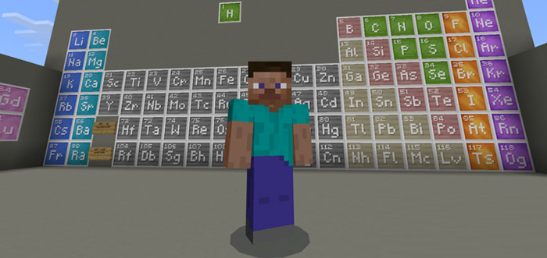
Chapter Supporting Aim 1 Minecraft
The First game this paper will be looking at is a game called Minecraft. Minecraft came out in May 17, 2009, where the player of the game can build and explore and just have fun working out how the game works. Minecraft has many ways it can teach the player in many different ways. For example, you can build anything thing you want with the different types of blocks that the game has to offer. This gives children a way to express their imaginary by there self or with the help of other players in the game either online or on the same console. When Mojang a Swedish video game developer company saw that the people playing their game was using it to teach children life skills they started to make a version of the game just for teachers to use in class. This led to the Minecraft education edition of the game that came out on November 1st, 2016. This opened a lot of new ways for the game to teach the player even in the class room for teachers to get their whole class on the game and start playing as one learning as they go.
The lessons that Mojang have put into the game are language arts, science, history and culture, computer science, math and art and design. Allowing the teacher’s many choices to pick from and to get the whole class involved. One of the lessons that Minecraft has to offer is a time line of humans. This allows students to use their character in the game to walk around and talk to the character in the game and learn form what they have to say about the time where they are from and how life was like. The game gives you the base tools to make any lesson from category of lessons. There are premade lessons that Mojang have made to get the class onto the right track, thus looking into it to see if it will work with the classroom. If the teacher in the class room wants to make a new lesson, they have been giving the tools to do so. So, if the base game does not have a lesson you want to teach the class you can make it your self and then upload it to the main website where all the lessons are, so you can share it with other teachers around the world.
“84 per cent of parents believing there are educational benefits to having access to tablets and smartphones.” The makers of Minecraft made a new version of Minecraft for tables and phones on October 21st, 2013. This meant that children that did not have a console or prefer using their phone or tablet has access to Minecraft on them. Giving people more ways to gain access to the game. Form what channel 4 said is that children now are more into there phones and tables then they where years ago and now they can learn form playing on them opening new paths of learning for the future. One other of the lessons that can be used to teach children in Minecraft is math. There are many different lessons that the website has to offer for example there is a lesson about how to teach area and volume getting the whole class involved with how to work out the area of a piece of land and how to work out the volume of the same land. Giving the students a more fun and innovative way of learning something that would come across as boring to some students if done on the board as I have been for years. There new lessons that have been added to Minecraft is computer science allowing the students to use a coding software that will change the way parts of the game work. With this it allows new lessons to be added for other teachers that can get students into the world of coding at a basic level of understanding. This adds to the key skills of critical thinking that all students must learn in there studies.

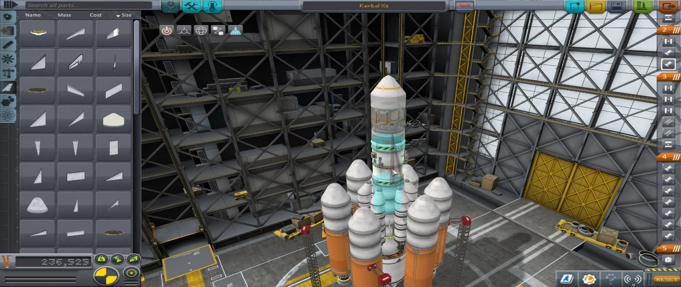
Chapter Supporting Aim 2 Kerbal space program
The second game this paper will be looking at is called Kerbal space program. This game came out in April 27th of 2015. This is a game where you can learn basic physics and start to understand the basics of building a rocket or a plane. Kerbal space program starts you off with the basic tools to make a rocket that you can build in anyway you want and then when you are ready you can test to see if it will work. This then allows the player to fly there rocket up to space and see if there rocket they have built can make it into space. The teaching aspect of this game is the basic start into physics and rocket science. As the player must start to understand how centre of gravity work so that their rocket does not have more weight on one side then the other. Also, they will have to test how much flue they are going to need by building the rocket then launching it up and seeing how far it can make it. This all ready is working on the players key skills as problem solving. As the player must find out how to get up to space but trial and error, becoming better and understanding the game more. This gives the students a risk-free environment to work in where they can have fun and learn at the same time. Giving students the ability to have fun when they learn will make them remember that lesson for a longer time.
“It is popular not just with the public but in particular with many NASA employees, who have used it to recreate historical missions such as the Apollo Program and Curiosity’s recent trip to Mars.” Showing that this game is not just to be used as a means of entertainment but to re-enact passed NASA missions. Where NASA has added parts to Kerbal space program where they are going onto a mission where they are going to move an asteroid so that it will enter the moons gravity, so it does not hit earth. This mission happened in real life as the lunch for the Bennu was done on September 8th,2016 and arrived at the Osiris-rex at December 3rd,2018. Kerbal space program with the help from NASA made this into a mission on the game to get more people into space work and added parts of the rocket that was used in the real mission into the game for the players to use. The asteroid mission is still under going as of today and it want to be back until September 24th,2023 where we can see what the asteroid is made of and try to find out if there are amino acids and sugars as they are the building blocks of life.
“The collaboration with Kerbal Space Program can help drive interest by future explorers in next-generation technology development and deep space exploration, said Bob Jacobs, deputy associate administrator for communications at NASA”. This shows us that NASA are happy to help put more and more into Kerbal space program as this could result in more people taking more interest into space travel or rocket science. “an asteroid redirect mission for KSP based largely on NASA’s own plans to identify, capture, and redirect an asteroid; bring it into the moon’s orbit; and send a manned mission to it”. This show that NASA have forward thinking why try and blow it up when it is flying towards earth, instead they are slowing it down and pushing it so that it will obit the moon. Where they are able to send a maned rocket up to the asteroid and look at it more scientifically to gain data and samples. This has been added to Kerbal space program so that people that are interested in space missions can play with their own style of gaming to complete the mission.
Once Bennu has been fully checked over it can then be safely be pushed back into deep space away from earth.
A German teacher bought the game for himself and then got it into the class room to show his students. When he did this, he saw that the children that only speck German started getting into groups with students that did not speck German and started working tighter to reach the goals of the game as a team. This shows that you don’t need to speck the same language to understand how that game works. The teacher saw that the class was taking a liking to kerbal space program and started looking into the game in more detail asking physics questions that the teach has not answered scene he was in university. “teams are building themselves and including everyone for there tailored skill set. Something you wouldn't have thought possible from kids without being instructed to do so.”
This can be the right step into added kerbal space program into the classroom as from the research we have looked at you can see that is will spear head some of the students to take the path in life of engineering also maths and physics. Giving students a basic insight of how engineering is and if they want to take it on in the future.

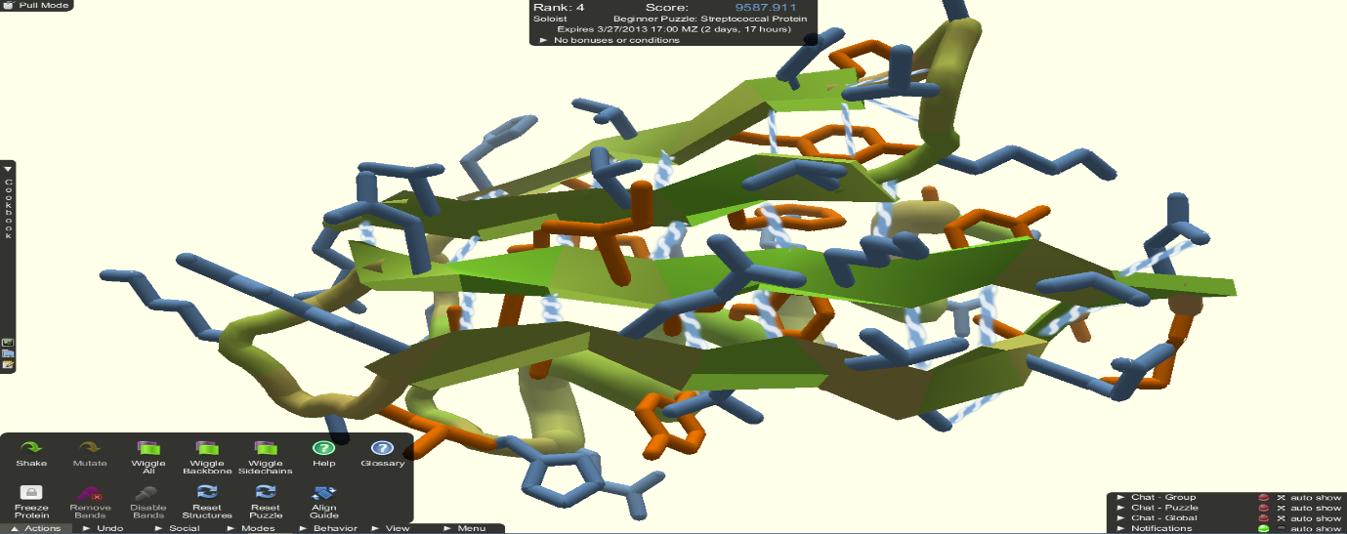
Chapter Supporting Aim 3 Foldit
The last game this paper will be looking at is called Foldit. The game came out May the 8th, 2008. This game was made by the university of Washington. This game is where they get the player to fold proteins in anyway they want and try to get the highest score. When they have done this that protein goes to the scientist, so they can make the same copy in real life and then try to test that with the cure for an illness and see if anything happens. They tried for 10 years on how to work out how to find a way to unravel the structure of AIDS to start cure parts of the illness for one day to get rid of it all together. For 10 years they could not find out the answer they where looking for so they made it into a game and from there they would use the info the game community given them to find out the answer, three weeks later and the gaming community have found the answer and now the scientist are still using the game to work out more of the AIDs illness.
“researchers show how gamers provided the crucial insights to solve the structure of a protein-sniping enzyme critical for reproduction of the AIDS virus.” When this come out that gamers did this in no matter then three weeks the scientist that were apart of the project were over the moon in happiness as now with this new brake though in science they can new use drugs to aim at the part of the AID virus that is responsible for the mass reproduction inside the body of the AID virus, opening the door to further break thought leading to the cure of the AIDs virus.
With this break though with the help of the scientists setting up more puzzles for the gaming community to try and solve, they can start looking into more virus and hopefully get the same feedback and speed the gaming community had with the first virus. The makers of Foldit don’t have any classrooms that use it at the moment, but they have put on there website how to set up a way for your classroom to start working on the Foldit project to get more children into the world of science. With the more people working on the Foldit project the scientists who have more info to work with and can solve the puzzles of the virus faster than they could do on their own, making for a better health care system when it comes to virus cures or preventions.
The whole game is fixed around folding proteins and you get scored on how much you have folded the protein in the best way you can. The reason for this is “Proteins are the workhorses in every cell of every living thing.” With every cell in your body needing proteins to work properly we can see why this game is the way it is and how useful the game can be when more and more people play the game. If this game does go into the class room and becomes a part of the teaching method, we could see massive jumps in the way virus work and how to stop them from spreading or maybe cure them all together.

Summary
From the research that has been done in this paper we can see that gaming can be used in the classroom in a very effective way at helping children and people of all ages to learn new skills. This can help them under take new paths in life that they thought they could not go down. This paper showed us that there is always a method out there to solve major problems. Who would think ten years ago a gaming company would go a long way into solving a problem of a part of AID’s. games like kerbal space program can help many people understand physics in a better way and Minecraft can help people that are to shy to work with others, to get them to work as a team in a much more effective way.

Conclusion
From what this paper has show us is that gaming has come a long way from what its was at the start of gaming in the early fifty’s, giving people who find it hard to learn and to start afresh, new things in life a way of doing so and have fun while they do it. Games like Minecraft and kerbal space program and Foldit are just the tip of the ice burg as there are hundreds of games out there that can teach you all kinds of skills, skills you never thought you may possibly achieve. Bring all types of people the opportunity’s that can set them down the right path in life that can change them for the better and give them a better life. To summarise this paper, in-regards to all the research that has been found about these games in news articles, official websites of the games and forums. In the class room we like to look at the best way to get children of all ages into the mode of learning and to make them feel like they want to come to school giving them a better education and better opinions when they leave school. This has been shown by Minecraft getting more and more into classrooms around the U.S and slowly being added into classrooms around the U.K and the rest of the world. As for Kerbal space program it has been seen in a German classroom where children that don’t speak German and that students that speak English started to work together with a common goal. That is showing that language barriers are not taking into effect when playing games in the classroom. Foldit is not common in the classroom as the other to games but the maskers of the game have added a part to their website where you can set up a way for the whole class to get involved at folding proteins to find a cure for an illness that is affecting millions of people. We have learnt that kerbal space program has been helping NASA get more people into space work by adding real life space missions to the game, as for Foldit we have found out that the gaming community has worked out a science problem that they could not find out for ten years. When that was made into a game it took three weeks for the gaming community to work out the answer for them and are still working on it today with new illnesses. Then Minecraft is opening up to a whole new aspect of the game making a new version of the game just for teaching students. Also adding a place on their website where teachers all around the world can upload their own lesson and then download another teachers lesson adding more to the classroom. In all this dissertation shows that gaming should be added into the classroom as there are hundreds of games not just Minecraft, Foldit and kerbal space program out there to use for learning, changing course of life for thousands of people who have are benefited from a game that helped folding an enzyme to unlock the start of the cure for the AID’s virus.

Bibliography

Kerbal Space Program Forums. (2018). Current Use Of KSP In Schools. [online] Available at: https://forum.kerbalspaceprogram.com/index.php?/topic/43034-current-use-of-ksp-in-schools/ [Accessed 11 Dec. 2018].

Education, T. and LaShera McElhany, P. (2018). The Hidden Value of Gaming in Education. [online] SAGU. Available at: https://www.sagu.edu/thoughthub/the-hidden-value-of-gaming-in-education [Accessed 11 Dec. 2018].

NASA. (2018). Gamers Tackle Virtual Asteroid Sampling Mission. [online] Available at: https://www.nasa.gov/feature/goddard/2016/gamers-tackle-virtual-asteroid-sampling-mission [Accessed 11 Dec. 2018].

Channel 4 News. (2018). Half of parents fear their children are addicted to screens. [online] Available at: https://www.channel4.com/news/half-of-parents-fear-their-children-are-addicted-to-screens [Accessed 11 Dec. 2018].

Kerbal Space Program. (2018). Kerbal Space Program. [online] Available at: https://www.kerbalspaceprogram.com/en/?page_id=11 [Accessed 11 Dec. 2018].

Michael J. Coren, F. (2018). Foldit Gamers Solve Riddle of HIV Enzyme within 3 Weeks. [online] Scientific American. Available at: https://www.scientificamerican.com/article/foldit-gamers-solve-riddle/ [Accessed 11 Dec. 2018].

Learning-styles-online.com. (2018). Overview of learning styles. [online] Available at: https://www.learning-styles-online.com/overview/ [Accessed 11 Dec. 2018].

Spinoff.nasa.gov. (2018). Partnership News. [online] Available at: https://spinoff.nasa.gov/Spinoff2015/partnership_1.html [Accessed 11 Dec. 2018].

Fold.it. (2018). Puzzles | Foldit. [online] Available at: https://fold.it/portal/puzzles [Accessed 11 Dec. 2018].

Fold.it. (2018). The Science Behind Foldit | Foldit. [online] Available at: https://fold.it/portal/info/about [Accessed 11 Dec. 2018].

Minecraft: Education Edition. (2018). Why Minecraft | Minecraft: Education Edition. [online] Available at: https://education.minecraft.net/how-it-works/why-minecraft/#classroom-friendly [Accessed 11 Dec. 2018].

