Michael Cunniffe (P148021)
Mcunniffe.148021@student.ac.uk

CAD & fea
Motion Simulation and FEA on a Formula Ford 1600 Suspension



Motion Simulation and FEA on a Formula Ford 1600 Suspension

Student name: Michael Cunniffe (P148021)

Programme: BSc Motorsport

Module: CAD & FEA

Lecturer: Andrew Harrison

Internal verifier: Owen Williams

Contents Page
1) Introduction 3
2) Motion Simulation and Finite Element Analysis 4
3) Methodology 5
3.1 SolidWorks design 5
4) Results and Analysis 7
4.1 Base Model 7
4.2) Optimised Model 8
5) Conclusion 9
6) References 9
7) Appendix 9

Introduction
In the motorsport field processes have become more automated in terms of producing complex vehicle parts such as suspension geometry, design and construction of these parts so manufactures need equipment for fast flexible movement of goods people and services. In the past engineers used technical drawings to design parts but nowadays with 3D computer aided design software’s such as SolidWorks models are designed and improved without having to produce a real part. For this report we were told choose a suspension type from a vehicle in the university workshop supplied to us by the faculty with the intention that we Cad model the suspension layout. The suspension layout model is to be put through motion study to get an understanding of 3D modelling and show a range of movement in the geometry. For this report I have chosen to do FEA on the upper wishbone of a formula ford 1600 Van Diemen layout in which has double wishbone with on-board pushrod dampers. The suspension has to be simulated moving over bumps in the road and then the loads on the suspension mounting points.

Motion Simulation and Finite Element Analysis
Computer aided design methods are used across the wide engineering industry to create parts but that isn’t there only function. Cad software’s can simulate the performance of these parts by calculating the stresses (tensile forces) and strains (expansion) of the part as it would be under similarly to the real conditions. Once a part is created studies can be done using cad to define what a part and can be shown using Finite Element Analysis (FEA). FEA is a method of numerical analysis used by engineers as a successful ‘’tool for solving simple and complex problems’’ (Muammer, 2001). For example a tensile forces can be put on the part which shows the areas in which the part is most likely to fail when put under these stresses and if the part fails it represents the strain. Strain is the expansion of the part from the stress the part was initially under showing indicating where the part is weak and most likely to brake. For this reason ‘’it has been used for decades to obtain reliable and precise geometry and material parameters’’ (Muammer, 2001). This benefits greatly when considering cost as there is no need for a real life part to be produced when it can be designed and testing of a cad software therefore engineers can have their parts fully tested so that when it comes into production the fatigue points are found and corrected.
The biggest benefit of using cad is how engineers is how it can simulate a part to make the conditions similar to ones it would come across in real life. This study is known as ‘’motion simulation’’. An example of this used in the motorsport industry would be obviously designing a suspension unit for the corner of a race car and putting it through the motion study as it would experience out on the race circuit. The engineers would take into account forces such as cornering forces, aerodynamic forces laterally, longitudinally and how the accelerating/braking forces, caster and camber changes throughout the ride height changes and how these circumstances ‘’impact structural suspension parts such as wishbones or bushings’’ (SolidWorks , 2008). to see the weak points or even fatigue. Also it can be used to find the required damping in the struts from this base point they can optimise the base part by making the stronger (Changing material or adding strengthening beams) or by making it lighter (Changing material or removing material) which ultimately reduces development time, effort and cost to a manufacturer.

Methodology

3.1 SolidWorks design
Much time was spent measuring the components in the university workshop to model them on SolidWorks to get them similar to that of the formula ford. After modelling each part the parts have to be assembled together by mating surfaces and corners together which became difficult when trying to carry out the motion study. For example the rose joints were initially made separate from the wishbones which caused problems when trying to make the motion study. So the design had to be changed to make the wishbones and the rose joints all one part which made the assembly quicker to simulate as there was less mates involved.

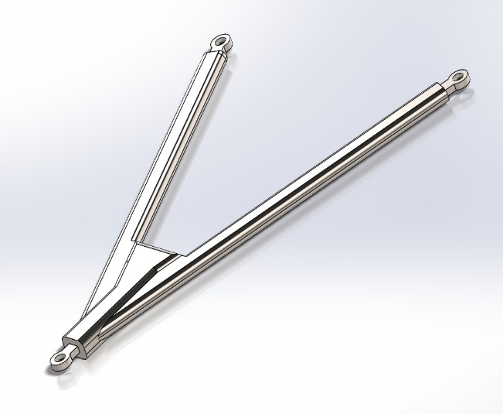
Figure 1- Screenshot, base model alloy steel upper wishbone with included rose joints. By Michael Cunniffe 2020

The Wheel was modelled from a Volkswagon 15’’ rim with the tyre made by revolving the outer part of the rim around the centre of the rim. The inside of the wheel rim had to be extended back to have enough clearance space to mount the wheel hub, hub carrier and brake disc on the inside of the rim. To make the wheel spin, the hub was split into two pieces where the inner part was mated to the rim on one side and the brake disc is mounted on the other side. From then the hub carrier is mounted around the inner hub so that the part stays fixed. At the top and bottom of the hub carrier there is a ball joint so that the upper and lower wishbones can be attached. From then on four chassis mounts were made to mount the chassis side of the wishbones on a ball joint. This meant that the wishbones could be from the rotate up and down from the hub carrier mounts because of the rose joints were concentric mated to the ball joint for an elevation change in the surface. Next the road surface was made in one direction with speed bumps for the motion study analysis
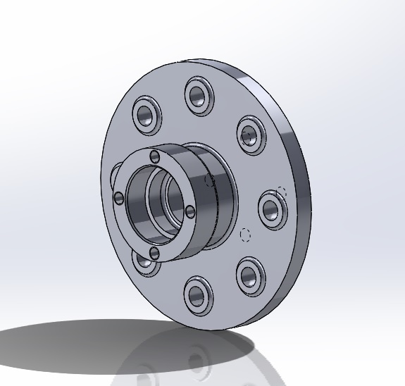
Figure 2- Screenshot, Inner wheel hub. By Michael Cunniffe 2020
When setting up the motion study make sure to pick add in, then use the drop down menu and select motion analysis. The wheel will turn but fail if you don’t take into account gravity and mating the tyre with the surface of the road. To add in the contact patch, the material for the tyre has to be selected as dry rubber and for the dry steel for the surface of the road. For the motor to make the simulation playout, the road surface moves along instead of the tyre moving.
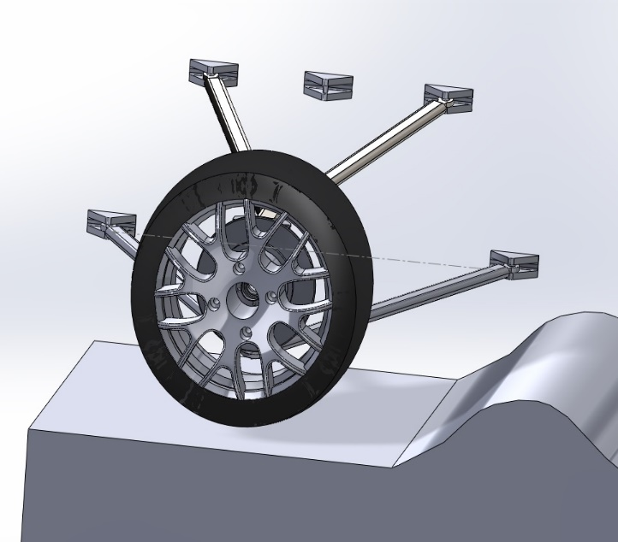
One major setback that occurred during the designing of the suspension system was that the pushrod suspension system that the formula ford has was too complex to design with on-board dampers and the rocker arm so the layout was abandoned. Since the double wishbones and the rest of the parts were modelled I decided to keep the double wishbones layout with a theoretical damper to act as the missing pushrod in which worked carrying out the motion study. The part chosen for the FEA was the upper wishbone in which determined the strength and performance of the suspension system. Initially the simulation would not work as the material for the part was not selected but eventually the material assigned was alloy steel. The plan going forward was to improve on any faults or discrepancies in the part or redesign and reduce the weight of the component if it is over engineered.
Figure 3- Screenshot, The full suspension assembly in motion study. By Michael Cunniffe 2020
One major part to note is to keep the parts needed to a minimum because the more mate redundancies the motion analysis has, the more difficult the FEA is and longer the analysis takes.

Results and Analysis

4.1 Base Model
Once the assembly was defined onto the road simulation to carry out its journey along the path made for it, we could then place the upper wishbone into the Von Mises Stress calculator to retrieve the results and confirm whether our part has an ‘’elastic strain’’ or ‘’plastic strain’’. (Harish, 2019). Elastic strain basically means that the distorted object returns to its original shape and size when the deforming force is removed etc. (Harish, 2019). This depends on the elasticity of the material and the yield strength of the part. Once a part receives a tensile stress beyond the yield limit the shape of the part will not return to its original shape once the stress is removed. This is also known as Young’s modulus or the modulus of Elasticity. ‘’This is where part gets necking in the material and fractures where the part is completely destroyed’’ (Vuslat Odabasi, 2018). Since the suspension design is modelled from a formula ford 1600 Van Diemen chassis it is easy to assume that the part was very strong for its designed application to begin with and after then putting my upper wishbone through the Von Mises Stress simulation, my initial predictions were proven correct, that the part was sufficient. This can be seen in the graph below where we can see the max stress applied to the upper wishbone as (7.352e+07 N/m²) = 73.52MPA.
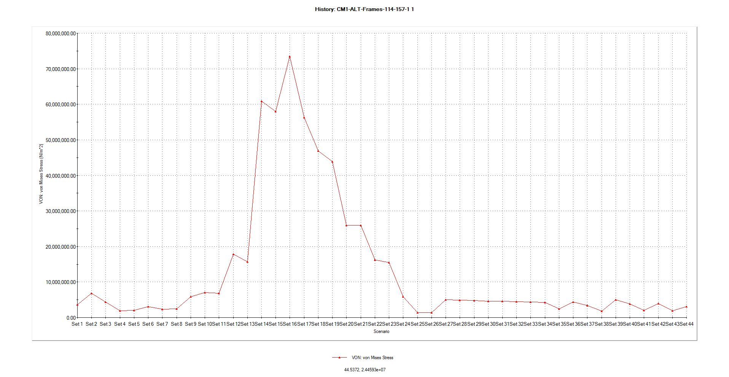
Figure 4-Screenshot, Graph of the base model Simulation. By Michael Cunniffe 2020

The upper wishbone is not suspect to any major strain along the part, it is only suspect to strain in the positions where the Rose Joints are attached to the ball bearings at the point at which it is mounted from the chassis to the Wheel Hub Carrier. The reason ‘’the stress is distributed onto the rose joints is because that is the point at which the suspension pivots’ (Karlsson, 2018). The stress on the part is available to see in scenario 16 in figure 2- below. The tensile forces acting on these rose joints are only between 36.79MPA – 42.91MPA when the max yield strength (yield limit) = 620.40MPA. Therefore proving that the strength of this part is over engineered for this motion simulation granting me with the chance to optimise the part by removing material from the alloy steel wishbone rather than changing the material itself because the structure of the wishbone shape is robust as the current tensile forces are 577.49MPA below the yield limit.
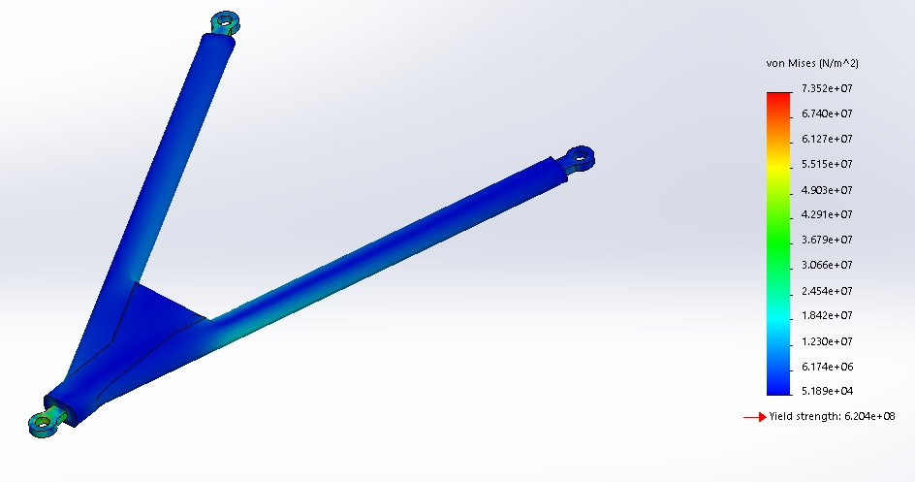
Figure 5- Screenshot, Upper wishbone Von Mises Stress. By Michael Cunniffe 2020

4.2) Optimised Model
As stated above the plan for optimising the wishbone was to remove excess material as the base model wishbone was already a very sturdy component. The same goes for our optimised wishbone to include load bearings again when putting the optimised assembly into the Von Mises Stress calculator. So as you can see in figure 7- that material has been (revolved extruded cut) from the base model on the top and bottom plane.
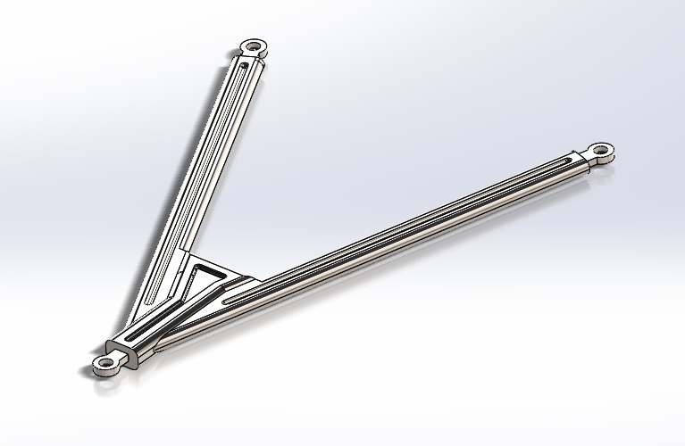
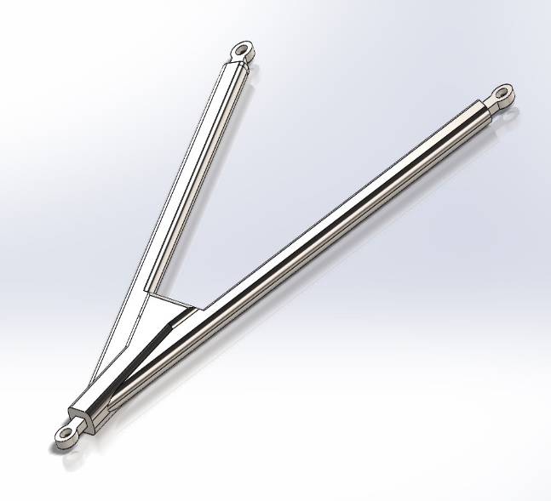

Figure 6- Base model Figure 7- Optimised model
According to the mass properties tab in SolidWorks the Base model mass = 9.4kg and the Optimised model mass = 8.5kg. In just one wishbone it saves 900grams. With nearly 1kg removed the optimised part it has been weakened ever so slightly compared to the base model as you can see from the Von Mises Stress graph below because now that the part has been modified and it is subject to greater stresses over the same bump
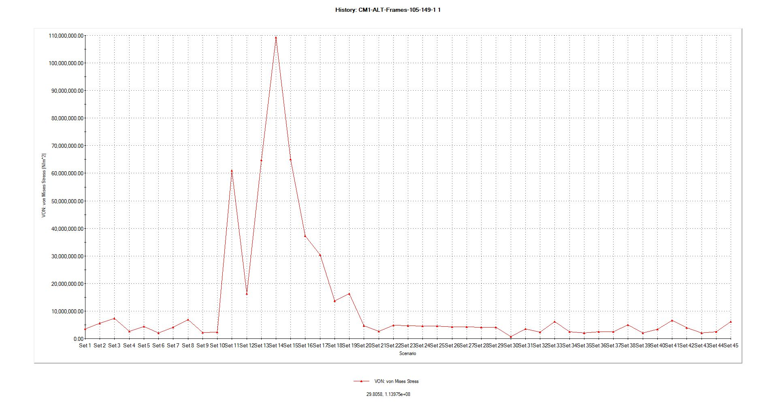
Figure 8- Von Mises Stress graph for optimised part, By Michael Cunniffe

The Max stress that the optimised part now faces is 110MPA at scenario 13 in figure 8- compared to tensile forces of 73MPA from our base model. This is a 37MPA increase in tensile forces applied to the optimised part but for the sake of this report the suspension layout isn’t put under large forces in the motion study. In figure 9- below of the optimised wishbone, the part shows that there is increased signs of stress concentration in regions located either on the mounting points on the wheel hub and the lengths along the wishbone which indicates these points are receiving greater stresses but still within the (yield limit) 620MPA of the part. The stress increases on the optimised wishbone is therefore increased by 50% so I have compromised strength in favour of weight saving as the wishbones were heavier than expected.
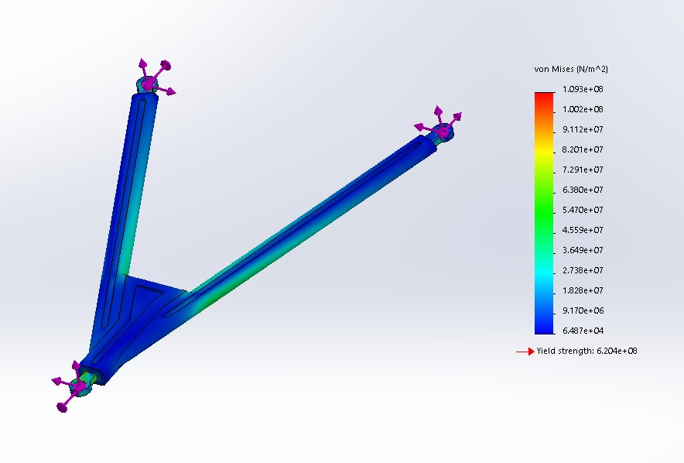
Figure 9- Screenshot, Optimised model Von Mises Stress. By Michael Cunniffe 2020

Results of the Von Mises stress indicate that it would be possible to reduce the weight much more without substantially affecting the parts mechanical properties. Figure 9- above doesn’t indicate signs of failure in the part therefore what also could be done to reduce weight further is representing a more suitable material for the wishbone that gives the additional possibility of tailoring the appropriate resistance needed by the wishbones with optimizing their geometry, like making it a hollow box section instead. According to the best example of a space frame chassis with high torsional rigidity would be a square section rectangular box tied in with ends and sides Combined with the possibility of easily adding reinforcements, these factors make the design different to the base model both in terms of weight reduction and good performance. The optimised wishbone is still heavy being 8.5kg as an alloy steel material so the alternative material that could be used is cold steel used in Nascar or T45 BS4 tubing material is used in Darrian rally cars but this would only be necessary if the objective was just performance gain. T45 BS4 tubing’s properties are a greater than that of our alloy steel wishbones. Its properties are; Tensile 700 – 900MPA, 0.2% yield and 620MPA minimum. It is also much lighter. After researching (Kinne, 2019) The weight of a 25mm x 2mm round tube in T45 is 1.08kg per meter.

Conclusion
Although the modified part shows that there is no signs of stress concentration and deformation regions but in a real life scenario the optimised wishbone would more than likely fail in a real life scenario when travelling fast because the max stress on the part is 110MPA when travelling over a bump very slowly at 2000mm/s when the yield limit is 620MPA. Therefore if a rough surface was hit at speeds like in a formula ford 1600 race the component would more than likely fracture. By utilising the Von Mises Stress calculator on SolidWorks, I was able to calculate the tensile forces from the base model wishbone and the optimised wishbones which are put through during the motion study. The stresses applied to my optimised wishbone increased by 50% from 73MPA to 110MPA but 900grams was shaved off the part so a compromise had to be made to save weight. The stresses may have increased a lot but the part is still very strong and is far from failure as can be seen in figure 9- where the stresses have increased along the lengths of the wishbone due to revolve cutting into the base model wishbone but not a risk in the motion study.

References

Harish, A. (2019, March 14). What is the meaning of the Von Mises Stress and the Yield Criterion? Retrieved from simscale.com: https://www.simscale.com/blog/2017/04/von-mises-stress/
Karlsson, I. N. (2018). Design of a suspension system for a formula student race car. Reykjavik: Ingi Niels Karlsson.
Kinne, S. (2019, October 16th). AeroCom. Retrieved from https://aerocom.mpimet.mpg.de/index.php?id=2404
Nathan, C. (1966). Classic Car Catalogue. Great Britain.
Singh, S. K. (2015 ). CAE Analysis, Optimization and Fabrication of formula SAE Vehicle Structure. Thapar: SAE .
SolidWorks . (2008). Understanding Motion Simulation. 300 Baker Avenue, Concord, MA 01742 USA: SolidWorks Corp.
Vuslat Odabasi, S. M. (2018). Static Stress Analysis of Suspension Systems for a Solar Powered Car. Ankara, Turkey: ReasearchGate.

Appendix

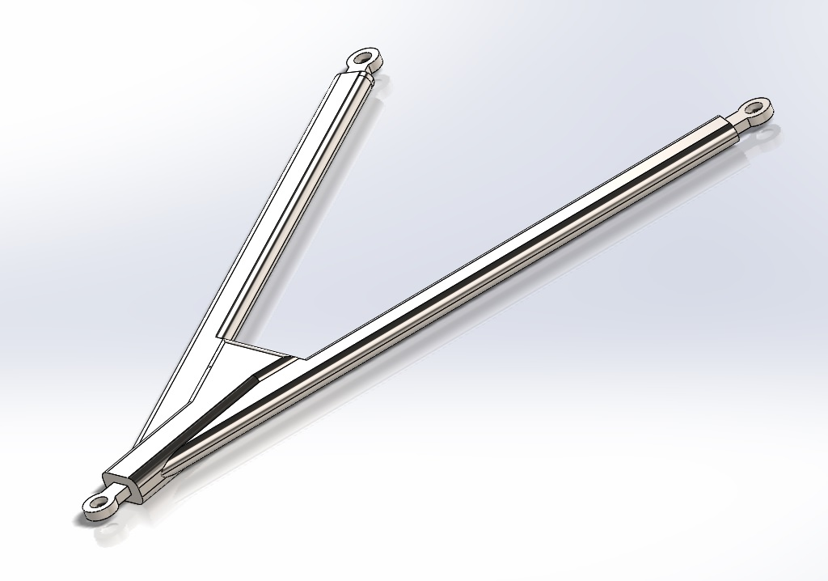
Figure 1- Screenshot, base model alloy steel upper wishbone with included rose joints. By Michael Cunniffe 2020

Figure 2- Screenshot, Inner wheel hub. By Michael Cunniffe 2020

Figure 3- Screenshot, The full suspension assembly in motion study. By Michael Cunniffe 2020
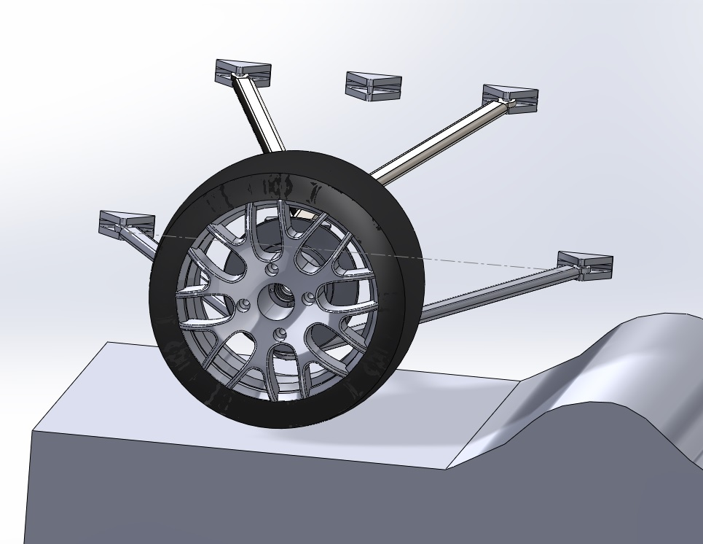

Figure 4-Screenshot, Graph of the base model Simulation. By Michael Cunniffe 2020

Figure 5- Screenshot, Upper wishbone Von Mises Stress. By Michael Cunniffe 2020

Figure 7- Optimised model

Figure 8- Von Mises Stress graph for optimised part, By Michael Cunniffe

Figure 9- Screenshot, Optimised model Von Mises Stress. By Michael Cunniffe 2020

Figure 10- Screenshot, Brake disc. By Michael Cunniffe 2020
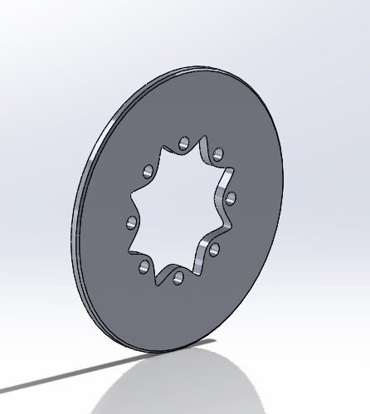

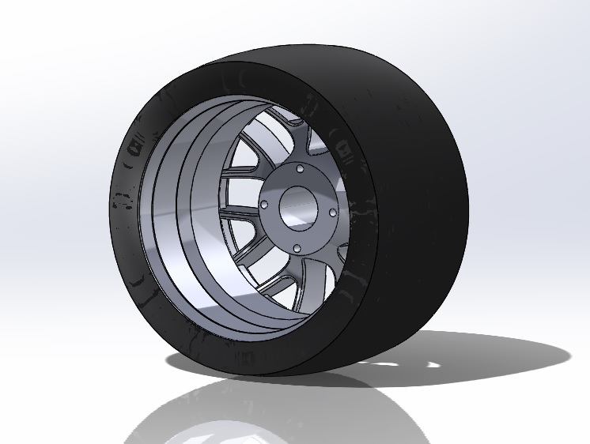
Figure 11- Screenshot, Wheel Rim and Tyre. By Michael Cunniffe 2020

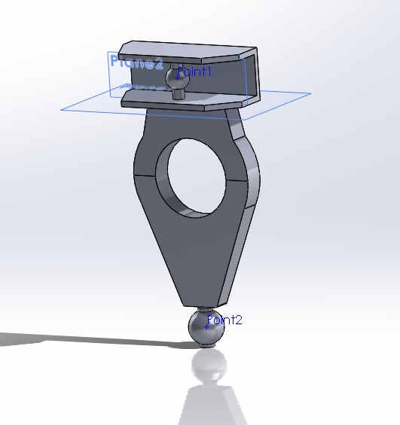
Figure 12- Screenshot, Wheel hub carrier. By Michael Cunniffe 2020

Figure 13- Screenshot, Bottom wishbone. By Michael Cunniffe 2020


