STUDENT: NURUL HUQE
STUDENT ID:1815082
MODULE: EFFECTIVE TEAM WORKING AND COMMUNICATIONS
CODE: BMSW4002
TUTOR: MD NAZMUL HASAN
ASSIGNMENT TITLE: BUSINESS REPORT

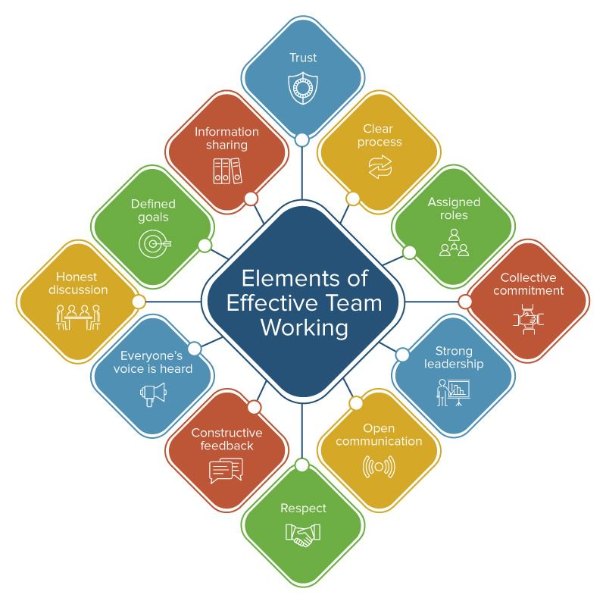

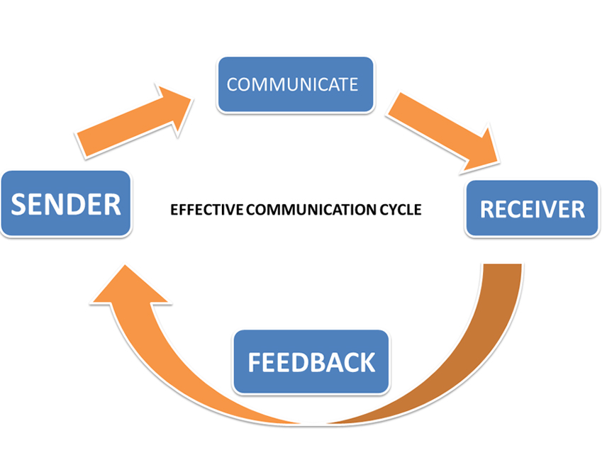
Table of Contents

INTRODUCTION 1

THE IMPORTANCE OF EFFECTIVE TEAM WORKING 2

THE IMPORTANCE OF TWO WAY COMMUNICATION 3. 3.1

RECOMMENDATIONS 4

REFERENCES 5

INTRODUCTION

Communication skill is the beginning for a person, team and organizational success (Kinnick & Parton, 2005)
This report will cover the importance of effective communications in teamwork in all organizations. This will also show examples and the results of good communication in a workplace or any environment where there are more than one person working. Also, without good communication what it may cause to an organization and how workers behave toward their colleagues, affecting the products they are selling or producing. Bad communication can affect the flow of business and have negative vibe causing low morale to workers. This report will also mention how two-way communications is interacted and show relevant models to understand how it works. A case study is used in this report, it explains how these communications is used to improve the business of the person in question. The report will look at the internal and external, formal and informal and verbal and non-verbal communication used in the workplace. It will mention all suggestions and recommendations to show how to improve the communications and getter good result and meet the targets of the business. Having a good communication in any workplace or organizations is essential and it is evident that without it, may not be successful and can eventually lead to a business to close down.

1
THE IMPORTANCE OF EFFECTIVE TEAM WORKING

It is important to have an effective teamwork as it shows the characteristic of successful organisations, the most important impact on the employees is motivation which can lead to employees fulfilling their duties. There is different attribute to identify a successful teamwork, encouraging open and honest communication, clear directions, communicating freely, supporting changes and risk taking and common goals. Effective team work also promotes a close-knit relationship, friendship, loyalty and it can also motivate employees to work harder, cooperate and support each other. Understanding a colleague’s abilities and sharing skills to give the opportunities to use their knowledge in problem solving or decision making, so the business can improve and to succeed. An effective communication can also show where things are going wrong at work or what actions need to take to improve and use various forms of communications, so the message or orders are understood. Managers and employees use communication thru emails, phone, text, messages, letters, notes and the obvious, face to face.

For the case study, the owner of the discount store has 20 people working for Sarah Davis. The employees consist of people with various ages, gender, experience, skills, abilities and qualities. Having people with different abilities can be an aspect for this business and gives the opportunities to share ideas and opinions to carry on with the work to achieve the targets and continue to succeed. The owner of the business, Sarah Davis has the most important role in the communication hierarchy she needs to use her employees to cooperate with her, so her business is successful. She can select the employees with the right skills to carry on with their duties that required and rely on them to forward her orders. The owner needs to communicate with employees to get their opinions, understand their difficulties and motivate them. Having employees with different characteristics can help to contribute with ideas, knowledge, opinions and work behaviours so certain tasks involved in working can be solved and help to reach their targets given. Sarah Davis can have daily or weekly meetings with her employees, if that is not possible then she can arrange once a month meetings or other communication so the employees can share their concerns or success, so her business is running smoothly.

2
THE IMPORTANCE OF TWO-WAY COMMUNICATION

Two-way communication is a structure in channelling information between parties and one of the parties conveys the details and the other party understand the message. This communication can be in various forms, it is not required for the persons to be in the same place or face to face as it can be done thru phones, emails, video conferencing, notes memos and many more. There are communication models available to understand how messages are sent and how it is received.

Schramm’s Interactive Model
Wilbur Lang Schramm is the founding father of mass communications and his study is used across United States universities. Schramm created a model to explain how communication is processed between individuals and others, how each person act as a sender and a receiver of the messages that is conveyed between them. The model consists of components and it identifies the messages travel back and forth by senders and receivers,
For Sarah Davis discount store business, the Schramm’s model can be used to show how she can communicate and interact with her employees, so her business is successful. This communication will benefit Sarah, so her employees understand her messages and then get feedback from them. The feedback can indicate how the message is deciphered then interpreted and converted the messages back to Sarah.

Schramm’s model used for Sarah’s business.
conveyance

SARAH

EMPLOYEES
reaction

Face to face, verbal, non-verbal, phone, emails
Letters, notice, memos.................

3
Sarah can also offer her employees to discuss with her regularly, this can be done by communicating with her managers and supervisor’s that are in charge of each department. The people in charge can then select individual or persons to carry out tasks required to do and are reliable to engage in their work and feel satisfied with their job. Also, Sarah can be available to meet her employees working in the frontline of the jobs, so she can monitor and assess how the production is carried out. This will give the opportunity for her employees to approach her with any concerns or ideas that will benefit the business. Employees can use this communication with the owner of the business and the managers to express themselves and do not feel that they need to hesitate to give their opinions.

The Shannon-Weaver Communication Model

This model was created by Claude Elwood Shannon, who wrote an article ‘’A Mathematical Theory of Communication ‘’ with Warren Weaver, Shannon was a mathematician and Weaver was a scientist. For their communication model they had similar structure was analysed in depth, their model has the sender, encoder, decoder and receiver but channel and noise are added. For Sarah Davis’s business this model can be used to design a better communication system and with added information how message goes across to the relevant employees. Sarah is the sender of the message and can choose which channel to use to transmit the message. If Sarah decided to send the message via email the machine used is the encoder. The network company is the channel used, the noise is the disruption caused by broadband connection and the decoder which can be the computer, the message is reached to the receiver who is the employees. Sarah can use this to monitor any miscommunication in her business which can affect her profit.

Shannon-Weaver model used for Sarah’s business:

SARAH= message= COMPUTER = signal (BROADBAND) signal = COMPUTER = EMPLOYEES

NETWORK

|...................................................................feedback.....................................................|

4
EFFECTIVE METHODS OF COMMUNICATION

The best method of communication between Sarah and her employees should be verbal and face to face so she receives the messages personally, this will give her the opportunity to interpret what she is being told. But Sarah could also give options available for employees to communicate with her, if she is not present or need to be away from her business and have some concerns or a complex matter to give attention then the employees can use phone or email. Sarah can assign a person to handle complaints from employees while she is away, she can create a site online that goes direct to her and to the complaint handler and she can monitor this by using her phone or any digital appliance from anywhere.

The other types of communication methods that can be used:

- Internal

Internal communication is very important in a workplace; this is to promote effective communication in the organization. This is to produce and deliver message on behalf of the employees and vice versa, the employees can understand the message’s clearly and regularly. Sarah can create a responsive email that is designed to engage with employees
so, feedback is collected; also have surveys, comments and other measurements. Internal communication is also useful for Sarah as she can inform all people of upcoming events, changes and any matters that need attention. This type of can help people to engage with their co-workers of all level, the communication can be spread to different departments and sections of the business at the same time and it will give the opportunity to get feedback as soon as possible. The main thing to consider with internal communication is to keep the messages sensible and respective.

- External

External communication is helpful for sending and receiving information from people from other business, customers, suppliers, shareholders and the society. For Sarah’s business she can create a communication platform like Facebook, Twitter and other social media that will help messages to get across so it can be monitored and make any improvement that is required. This will help her to engage with parties involved to monitor reports, marketing and brand awareness,

5
- Formal

Formal communication with employees is in meetings, by issuing notices, written in reports and documents, this communication is not personal, and the message is controlled between sender and receiver. This can be used as an advice, an invitation, discussing business issues or a written note as a reminder, emailing to all staff and dealing with more than one person in one go.

- Non-Verbal Communication

This form of communication does not require to speak to a person and body language plays an important role, when Sarah’s employees communicate with her, she has to maintain her body position, facial expression and gesture’s, so the employees do not feel any negative energy. Employees may feel reluctant to approach Sarah to express their ideas and feel they are appreciated in doing their jobs.

RECOMMENDATIONS

Sarah Davis can look at both communication model’s, this will help to make sure the employees are aware with the work changes, targets and all matters involved in their workplace. She needs to have regular meetings, have one to one communication slots, engage with her employees and keep it informal. She can monitor all channels that is used to send and receive the message, always have back up plan with managers and supervisors to look after this while she is away from the business. Sarah can make sure that her employees know that they can email her or phone her whenever it is required and always response to the message received as soon as possible. If there is problems occurring in her business like not meeting sales targets due to employees communication between them, Sarah should step in if the managers are unable to solve the matter, having regular meeting with all workers will give them the opportunity to say what the problems are and a chance to solve the matter. If there is problem in receiving the messages, Sarah should have someone in charge for this particular matter and they need to update her constantly till it is fixed.

6
REFERENCE

Certificate in Higher Education: Skills for The Workplace Student Yearbook
Maund A, Schriek M, Tinkler P K (2017)
3. Communication
Griffiths B A and Dunham E B (2015)
In Working in Teams
SAGE Ch.5, pp.9 – 12
4. Verbal and Non-Verbal Communication
Quintanilla K M and Wahl S T (2017)
In Business and Professional Communication 3rd Edition
SAGE. Ch.2, 47 – 46

The Business Student’s Guide to Study and Employability
12 Communicating Effectively
Pp 242 – 270

www.google.search.uk
5 Reasons Why Teamwork Matters
https://www.potential.com-articles
By Wehbe S (31/03/2017)
(Accessed online on 30/07/2019)

www.google.search.uk
Importance of Two-Way Communication in The Workplace-Wise Step
https://content.wisestep.com
By Reddy C
(Accessed online 01/08/2019)

www.google.search
https://www.interact-intranet.com
The 8 Types of Internal Communication You Need to Be Doing | Interact
By Hall B (12/07/2019)
(Accessed online 03/08/2019)

www.google.search
https://www.skillmaker.edu.au
Formal Communication Methods
By Skill Maker (10/2014)
(Accessed online 28/07/2019)

7
www.google.search.uk
https://www.skillyouneed.com
Non-Verbal Communication | Skills You Need
(Accessed online 04/08/2019)
www.google.search.uk

https://startupnation.com
The 5 Advantages of Democratic Workplace – StartupNation
By Fenton T (13/05/2008)
(Accessed online 01/08/2019)
S

www.google.search.uk
https://www.thebalancecareers.com
Communication Skills for Workplace Success – The Balance Careers
By Doyle A (11/05/2019)
(Accessed online 02/08/2019)

8

