

Implementation of Front-end Development Technology Based on Vue

by
Zhe Xiao

Supervisor: Stephen Hole

Project submitted as part of the requirements for the award of MSc Software Engineering

November 2021

Declaration and Form of Consent

DECLARATION

I, ............ Zhe Xiao……declare that I am the sole author of this Project; that all references cited have been consulted; that I have conducted all work of which this is a record, and that the finished work lies within the prescribed word limits.

This work has not previously been accepted as part of any other degree submission.



Signed : .............................................

Date : ...........2021/11/12..................

FORM OF CONSENT

I ____Zhe xiao__ hereby consent that my Project, submitted in candidature for the M.Sc. Software Engineering
, if successful, may be made available for inter-library loan or photocopying (subject to the law of copyright), and that the title and abstract may be made available to outside organisations.

Signed __________________________

Date ____________2021/11/12._____

Where necessary replace M.Sc. Software Engineering with your named award.

Implementation of Front-end Development Technology Based on Vue

ABSTRACT
JavaScript is mainly used to deal with page interaction and logic in web front-end development, which is the part that developers pay most attention to and the workload. Currently popular JavaScript frameworks Angular.js, React.js, Vue.js, etc. can help developers write JavaScript logic, and have their own solutions to the problems encountered in front-end development, such as manipulating DOM and rendering data. But to directly use these frameworks for actual project development, developers still need to do a lot of work.

In view of the above problems, through the analysis of the technical evolution of the front-end architecture and the research and development status at home and abroad, combined with the actual needs of front-end development, this paper studies and develops a set of universal front-end framework, which is convenient for secondary development on its basis. The framework uses the MWM software architecture design mode of front-end and back-end separation, and the progressive JavaScript framework vue.js, webpack construction technology, element UI and other technology stacks to develop the framework. This paper puts forward the solution idea of the background front-end, refines the typical business model, encapsulates the components with rich functions, and integrates the common functions of the front-end project. Developers can quickly build the web application product prototype on the basis of the framework to help developers pay more attention to the design and implementation of specific business logic.

Based on the requirement analysis, this paper designs the overall architecture of front-end and back-end separation, and realizes the layered architecture through the separation of concerns. In the specific implementation process, the modular development method is adopted. Through the integration and encapsulation of the universal modules in the front-end project, the basic functions such as token based authentication login, user information acquisition, authority control and so on are realized. At the same time, the communication module is systematically designed, the common service API is encapsulated, a variety of communication protocols are supported, and the communication system between the front-end and the server is constructed. When using the framework for development, users can directly reuse relevant modules or carry out secondary development on the basis of modules, which has good scalability.

Keyword: Vue, Front-end Separation, Layered Architecture, Permission Control

Content
Declaration and Form of Consent 2
ABSTRACT 3
I. Introduction 5
1.1 Research Background 5
1.2 Research Status 6
1.2.1 Development Status of Front-end Framework 7
1.2.2 Front-end Framework Technology Evolution 8
1.3 Project Aim and Objectives 8
1.4 Report Structure 9
II. Literature Review 10
III. Demand Analysis 11
3.1 Introduce of System Demands 11
3.2 System Objectives 12
3.3 System Functional Requirements Analysis 13
3.3.1 Basic Function Module 13
3.3.2 Function Management Module 14
3.3.3 Style Management Module 14
3.3.4 Communication Module 14
3.3.5 Component Function Module 15
3.3.6 Build and Publish 16
3.4 System Non-functional Requirements Analysis 16
3.4.1 Performance 16
3.4.2 Compatibility 17
3.4.3 Accessibility 17
3.4.4 Scalability 17
IV. Design System Framework 18
4.1 Front and Rear-end Separation Architecture 18
4.1.1 Front and rear end separation 18
4.1.2 Layered architecture 19
4.2 Front-end Architecture Design 20
4.2.1 Front-end Modularization 20
4.2.2 Container and Component Libraries 20
4.2.3 Tools and Services 20
4.3 Framework Function Architecture 21
4.3.1 Basic Function Module 21
4.3.2 Component Function Module 21
4.3.3 Communication Function Module 21
4.3.4 Building and Deploying Functional Modules 22
4.4 Framework Communication Architecture 22
4.4.1 Interface Design 22
4.4.2 Communication between Components 23
4.4.3 Implementation of Front and Rear End Communication 23
V. Framework Design and Implementation 24
5.1 Implementation of Login Function 25
5.1.1 Validate Logon 25
5.1.2 User Information Loading 26
5.2 Permission Control Implementation 27
5.2.1 Permission Database 27
5.2.2 Menu Level Permission Implementation 28
5.2.3 Button Level Permission Implementation 29
5.2.4 Role Management Implementation 30
5.3 Component Design and Implementation 31
5.3.1 Svg-Icon Component 31
5.3.2 Charts Visualization Component 34
5.3.3 Chat Component 37
5.4 Implementation of Front and Rear End communication 40
5.4.1 API Encapsulation 40
5.4.2 Agent Configuration 40
5.4.3 Implementation of Global Interceptor 41
5.4.4 Point to Point Real-time Communication 42
5.5 Build and Deploy 44
5.5.1 Ring Block Construction 44
5.5.2 Build Release 44
5.5.3 Deployment Implementation 45
VI. Evaluation 46
VII. Conclusions and Recommendations 47
VIII. Reference 47

- Introduction
  - Research Background

With the advancement of technology, businesses are now pursuing the information highway, and major businesses with a diverse range of operations frequently require the development of a significant number of different types of system software. It will need a lot of personnel, time, material resources, money resources, and other resources to make each product independently. As a result, businesses will seek to create a standard development framework as the foundation for all system software, which will save money on development and maintenance.

On a technological level, web applications have become increasingly popular due to the fast advancement of computer application technology. Web application solutions continue to evolve in order to satisfy evolving consumer demands and enhance the user experience. The old "zero to one" development strategy can no longer match the demands of fast product iteration as front-end apps become more complicated. Front-end engineers typically utilise the front-end development framework to quickly construct the application prototype and enhance development efficiency in order to overcome the challenges of poor code scalability, limited reusability, and onerous maintenance in the front-end development process. There are many outstanding front-end frameworks available today, but because they frequently lack the integration of generic modules and the creation of unique interaction logic, developing customised applications based on them still requires a significant investment. The front-end development paradigm is growing in tandem with the fast advancement of front-end technologies. Web pages were created by the server in the beginning, and the browser was in charge of the presentation. The front and back ends were tightly connected, resulting in mixed business and presentation logic and code that was difficult to maintain. The MVC manner of service layer architecture upgrading appears to lessen the complexity of front-end development. This type of architectural mode, which begins at the back end, enhances the code's structure at the architecture level and considerably improves the code's maintainability. However, in this manner, front-end development is strongly reliant on the development environment, the front-end and back-end duties are still entangled, and development efficiency is still low. The advent of Ajax technology has drastically altered front-end programming. The Ajax interface connects the front-end and back-end, making the separation of labour more obvious. The SPA mode has gained a lot of popularity. However, when the front-functionalities end's get more complicated, the front-development end's become more challenging, and a browser layered architecture akin to spring MVC emerges. The MVVM design pattern appears to simplify the complexity of front-end development. The MVVM architectural pattern[1-2] is based on the MVC pattern, which automates the view and model synchronisation logic and allows for two-way data binding. This mode of development gradually clarifies the division of responsibilities between the front end and the back end; the data required by the front end only requires a request to the back end's interface, resulting in better separation between the front end and the back end, effectively controlling the complexity of front-end development, and improving the project's maintainability.

The goal of this project is to explore and build a collection of front-end development frameworks using the MVVM architectural method of front-end separation. The framework connects many modules and allows extensive front-end and back-end interaction design. Front-end developers may quickly create applications using the framework, substantially reducing development time and increasing development efficiency.

  - Research Status
With the emergence of the Internet and the continued growth of global informatization in recent years, the demand for web application systems by businesses in a variety of areas has increased [3]. Many professional software businesses, including IBM, Oracle, Huawei, and other well-known organisations, have evolved swiftly and made significant contributions to the software system industry, driving the informatization process of enterprises, in response to the industry's pressing demands. Non-internet businesses have traditionally relied on third-party software companies to deliver web application solutions that can swiftly achieve informatization, save time, and reduce administrative expenses.
    - Development Status of Front-end Framework
HTML, CSS, and JavaScript make up the majority of the web front end. HTML is in charge of the page's structure, CSS is in charge of the page's style presentation, and JavaScript is in charge of the page's interaction with the user. The front-end just had to write the page and alter the style in the early stages of web development; the back end handled the majority of the operations. With the fast expansion of online applications, front-end functionality is becoming increasingly important. The front-end now frequently requires complicated logic interaction and UI effect presentation, increasing the development effort.

The advent of a large number of outstanding front-end frameworks and libraries enhances the front-end development ecology, lowers development costs, and encourages front-end technology development. jQuery was initially popular because of its straightforward and beautiful DOM action, component selection akin to CSS selector mode, and Ajax operation encapsulation[4-5]. The code volume continues to grow as the front-end develops. At the moment, developing using jQuery will result in the mixing of business logic, interaction logic, and UI design, making it impossible to reuse and maintain the code. The introduction of the MVVM paradigm enables automated data-view binding and decouples DOM operations from business logic. It makes the code more maintainable and reusable. At the moment, the three most popular web front-end frameworks, Angular.js, React.js, and Vue.js, are all data-driven MVVM frameworks.

Angular is a framework created by Google that includes features such as template, data bidirectional binding, modularization, routing, filtering, dependency injection, and more. It is appropriate for business applications, but it is not user-friendly for individual programmers. [6] React was born out of a Facebook internal project. It implements a virtual DOM to address cross-browser issues. The rationale of the code is straightforward, and it performs well. React, on the other hand, has fewer functionalities than angular. For large-scale project development, it will need to collaborate with other technologies. Even you created Vue, a lightweight front-end framework that allows two-way data binding[7]. It is easier to understand than angular and react because it comes with entire development documents. Vue's development ecology, on the other hand, has to be enhanced because it is a new project.

With the fast advancement of front-end technologies, Internet organisations are paying more attention to web application usability. The update iteration speed of products is expedited, and the front-end framework is extensively employed, in order to further attract people and improve the user experience of goods. However, because existing major Open-source frameworks focus on performance and underlying architecture, there is clearly a lack of interface and logic support for diverse organisations' complicated operations. Using Open-source technology, on the other hand, will certainly result in copyright conflicts and other issues. As a result, significant Internet companies frequently form development teams to create front-end frameworks to satisfy their business objectives, such as Element UI and Ant Design, the front-end UI component libraries built by China's e-mo and Alibaba, respectively.

    - Front-end Framework Technology Evolution
The front-end page was created by PHP, JSP, and other server-side scripts in the early stages of web development, and the website's presentation was entirely controlled by the back-end. The return of JavaScript King ushers in the era of SPA, with the emergence of Ajax technology and the widespread use of CDN in static resource storage. The front and back end interact over an Ajax interface in this mode, and the division of labour becomes obvious over time. However, it is not dissimilar to the JSP era in terms of code complexity; only JavaScript on the browser side substitutes JSP pages on the server-side to deal with complicated business logic on the front end. There is now a front-end hierarchical design in place to better the code structure by separating concerns in order to increase the maintainability and reusability of the code. MVC, MVP, and MVVM are three prevalent architecture paradigms.

A typical hierarchical architecture is MVC. The controller is in charge of the view operation. The controller replies to the view's event call to operate the data. The linked views will be updated synchronously when the application object changes. Between the model and the view, the observer mode is used. To see the application object, the view is registered on the object. The data is updated synchronously when the application object changes. The business logic is mostly centred in the control layer in MVC style. Because the controller handles every event, the control layer gets highly bloated. The view and controller have a one-to-one correspondence in MVC style, however, the close relationship between view and controller leads to poor control layer reusability.

The MVP pattern[8] is a better version of the MVC design. The two designs are similar in that they both have a hierarchical architecture design, are shown by views, and are controlled by models; the difference is that views in MVC mode may directly access application objects. By providing a set of connections for the higher layer action, the view may be detached to create a component.

MVVM mode achieves automatic synchronisation between the view and the model, but MVP mode does not. It merely has to specify the view and model's matching connection and use the framework to finish the data binding. MWM mode, unlike MVC and MVP modes, encapsulates data synchronisation between display and model layers via bidirectional data binding and command[9]. The view model is the MVC mode's version of the controller, and its primary function is to complete data binding. Overall, MVVM mode is considerably easier to use than MVC and MVP mode, and it not only overcomes the problem of frequent data updates that MVC and MVP mode have, but it also lowers the dependency between the interface and the business. The view is unaware of the existence of the model in the MVVM paradigm, and the view model, the model, and the view are all independent of one another. The application's reusability is considerably enhanced by this minimal coupling design style.
  - Project Aim and Objectives
The main purpose of this project is to investigate and build a Vue-based front-end development framework. The MVVM architectural method of front-end and back-end separation is selected to complete the design and development of the framework based on the investigation and analysis of the front-end framework's research progress and development state, as well as the real demands of front-end development.

A large number of generic components are included in the framework, and some of them are reconstructed and encapsulated according to the real requirements throughout the development process, providing developers with a comprehensive set of functional components. When developers use the framework for development, they only need to make a few configuration changes to quickly build up the application's main framework. This allows developers to focus on the implementation of specific business logic rather than spending time on style and underlying interaction design, reducing development difficulty and increasing efficiency. We continue to monitor the framework's use during the application process, and we continually grow and enhance the framework so that it may better suit the demands of front-end development.
  - Report Structure
Chapter 1, Introduction. This paper introduces the background and significance of the subject, investigates and analyzes the research progress and development status of front-end framework at home and abroad, studies the technical evolution of front-end framework, and summarizes its main work and the main objectives of the report.

Chapter 2, literature review, I reviewed the methodology of some previous people who studied the front-end framework, summarized their implementation methods, compared their shortcomings, and paved the way for the development of a general front-end framework.

Chapter 3, demand analysis. This paper generally analyzes the overall requirements of the framework, introduces the main objectives to be realized by the framework, and puts forward the functional and non-functional requirements of the framework. In the functional requirements analysis, it mainly introduces the functional objectives of each module; In the non-functional requirements analysis, the performance, compatibility, ease of use and scalability of the framework are discussed.

Chapter 4, the overall design of the frame. This chapter introduces the overall design of the framework from the perspective of architecture. On the whole, it is based on the architecture design of front-end and back-end separation. The front-end framework adopts a hierarchical logical architecture to realize page modularization and page adaptive design; The overall functional architecture of the framework is introduced, including basic functional modules, component packaging, communication design, construction and deployment; The overall communication architecture of the framework is introduced, the API interface specification is defined, realize the complete front-end and back-end interactive communication;

Chapter 5, framework design and implementation. This chapter introduces the design and implementation of the basic function modules of the system in detail, including the design of the login authentication process and user authority control, the packaging and implementation process of components and application display. The system implementation of front-end and back-end interaction design is introduced in detail, including the introduction of main API interfaces. The performance optimization design, construction and deployment of the framework are introduced.

Chapter 6, evaluation. I analyzed the achievement and effect of my subject according to my goal plan.
Chapter 7, conclusions and recommendations. The report results and overall work of the paper are analyzed and summarized, and the next work is prospected and planned.
- Literature Review
People are becoming increasingly reliant on the Internet as computer technology advances. People's behaviours and routines are altering as a result of the Internet. As a result, certain applications' rivalry is becoming more intense. Because customers engage directly with the front-end interface, front-end technology is evolving in order to improve the product's user experience. [10] Yi et al. put forth the concept and execution of the art and drama library system's front end. They explain the history and significance of the creation of the art and theatre library system, as well as three basic technologies and front-end architecture. Finally, the system's overall structure, as well as the front end's specific design and implementation, are shown. [11] Gong et al. Proposed a spring cloud microservice and react software architecture for a campus information system. This article introduces the system's key technology and implementation. The system's carrying capacity has been substantially increased as a result of the decoupling of front-end and back-end, and the system's strong performance reflects the design benefits of microservices and separation of front-end and back-end. [12] Li et al. Based on the component-based front-end design, a flat front-end framework design idea based on the component concept was provided, and the framework's application and key technologies of the team were assessed. Finally, the front-end framework is used to build a big platform, demonstrating the framework's efficiency and scalability. [13] Zhang et al. The history of Web front-end development was discussed. The report then proposes four solutions: component, modularization, standardisation, and automation. Finally, employing relevant technologies and tools, a single-page cultural content presentation application is planned and constructed. Chai[14] focuses on the application of vue.js framework based on MVVM pattern in logistics software automatic test system, compares the advantages and disadvantages of MVVM pattern with other development patterns, and investigates the underlying principles of vue.js frameworks, such as virtual DOM, diff algorithm, and responsive system, in order to lay the groundwork for system development. The logistics software automatic test system's functional and non-functional needs are then thoroughly studied, and the functions of each module are then created accordingly. Then, create the system's development environment and overall framework, develop the system's common modules, implement the vue.js custom instructions, and create the system's use case management, system under test management, basic script maintenance, test record management, and other functional modules.

Although these individuals have built front-end web page designs for many circumstances, they can only be applied to certain scenarios, and the model's generalisation has numerous flaws. As a result, the front-end structure suggested in this study is universal, with strong expansibility depending on various situations. It may be used for front-end development in a variety of scenarios.

Demand Analysis

Introduce of System Demands
The framework mainly provides services for web front-end developers. With the gradual complexity of web applications, the traditional "from nothing" development mode is easy to cause the problems of poor code reuse rate and low development efficiency. At the same time, this development mode is not conducive to the precipitation and accumulation of technology. Front-end engineers are largely using the framework for development at this point in order to boost development efficiency. Web front-end frameworks come in a variety of shapes and sizes. Angular, React, Vue, and more popular frameworks are currently available. Simultaneously, many Internet organisations form front-end teams to implement self-developed frameworks; however, these frameworks are frequently business-oriented, only fit the demands of particular business situations, and are incompatible with a large amount of business logic. The code is frequently bloated, making it unsuitable for further development. Although the mainstream framework can address most development challenges, the huge framework is frequently excessively bloated, the integration of certain fundamental functions is low, and the business driven architecture frequently lacks sufficient support for the application of unique situations. Some folks work mostly in the background when it comes to front-end development. They haven't studied the required technologies or development framework for front-end development in depth, but they do need to do some front-end development as part of their regular job. The platform's major purpose is to assist developers in quickly building the system architecture and making one-stop site construction feasible by improving standard business models and providing a lightweight, high-performance front-end framework for rapid development based on Vue and element UI.

The framework provides rich functional components and carries out style design according to the unified UI style. The framework needs to integrate necessary external components and package corresponding functional components according to different business scenarios to meet the development needs of different business scenarios. Developers can directly call relevant components according to needs to improve development efficiency. This is also the main goal of the platform.

The framework is built and created using the JavaScript framework vue.js and the element UI component library, and follows the MVVM software architectural method of front-end and back-end separation. The framework must create a full communication system, offer standardised API interface documents, and use API interfaces to communicate between the front and back ends. The front end can become independent of the server by introducing mock data; communication between components is accomplished through parent-child component value transmission, and the timeout problem, exception handling, data return format, and other issues that arise during the interaction between the front end and the server-side are all handled uniformly.

System Objectives
The design and implementation of the framework shall achieve the following objectives:

- The framework's user interface design purpose. The framework's UI style is linked to the application system it supports, and thus influences the system's user experience. As a whole, the framework should be designed in a flat manner. Simultaneously, it must offer a choice of templates from which developers can choose, as well as facilitate easy style swapping. As the solution of the background front end, the overall UI design style should be concise and atmospheric, and the overall layout style of the interface should match each other. Finally, a set of unified UI design schemes needs to be formed to support the design and development of specific application systems.
- The framework's interface design purpose. The framework's interaction design must be done in conjunction with the overall UI design and based on the real demands of users. The integrity of the whole interactive process must be maintained during the design phase, and each link in the process must be continually improved from two perspectives: user experience and performance. With the increasing work carried by the front end, the interaction of the front end becomes more and more complex. In order to improve the ease of use and maintainability of the framework, the interaction logic and business logic need to be separated in the interaction design to avoid excessive coupling between them.
- (3) The framework's component design goals. Components play a significant role in front-end framework development. The framework's overall availability and development efficiency are intimately tied to the development of its components. To satisfy the unified style, it is required to direct development according to the unified UI style during the component design phase. An excellent framework needs to provide rich components to meet the business needs of different scenarios, but it is not advisable to build wheels repeatedly. We can select appropriate components from the existing third-party component library for integration or make appropriate transformations on its basis. The design of components is more precise than more. Everything starts from the actual needs and pays attention to the practical value of components.
- Communication design objectives of the framework. A complete communication system needs to be built in the framework, mainly including API interface design, communication design between components, mock data simulation and front and rear end interaction design. In the process of API interface design, common interfaces and functions need to be encapsulated, and interface documents need to be standardized. The communication design between components needs to meet the communication between components in a variety of different scenarios, such as the communication between parent and child components, the communication between brother components, the communication between intergenerational components, etc. Mock data simulation is an important support for front-end and back-end separation. In the framework, mock data is introduced to help front-end developers simulate back-end data, which makes the front-end get rid of the dependence on the server to a great extent. Front and back-end interaction design is the core of the whole communication system and even the whole framework. In the process of front-end and back-end interaction design, it is necessary to give a detailed communication process, and follow the design idea of separation of front-end and back-end, so as to avoid the coupling between front-end and back-end codes, and conduct data interaction between front-end and server through API interface. At the same time, the timeout problem, exception problem and data format in the interaction process are handled uniformly.
- The basic function design objectives of the framework. The framework needs to integrate some general functions, and encapsulate the basic functions commonly used in the front end, such as user authentication and login, permission management, role management and so on. The basic function module needs to be universal and extensible to support developers to carry out secondary development on the basis of the framework. In the process of basic function design, we should adhere to the design idea of "eliminating complexity and simplifying". On the one hand, we should meet the functional requirements of developers in different business scenarios as much as possible, on the other hand, we need to avoid code bloating and poor maintainability of the framework.
- (6) The framework's optimization design aim. The framework's optimization design must take into account two factors: user experience and performance. The framework's performance is inextricably linked to the framework's user experience. A better user experience is frequently associated with high performance. The performance indicators of the front end include page loading speed, request-response time and security. During the design process, some large files are compressed and placed on the static file server or CDN for preloading or asynchronous loading to reduce the resource loading time. The response time of the request shall be shortened as much as possible to control the waiting time of the user within an acceptable range. At the same time, we should cooperate with UI and interaction design to add a waiting effect and improve the user experience of the framework.
- The construction and deployment design objectives of the framework. The framework's design aim of simplicity of use should be met during its building and deployment. It is required to meet the features of easy operation during the framework construction and deployment procedure. To increase the efficiency of creation and deployment, as well as the overall performance of the framework, the code volume should be reduced as much as possible. The development environment, production environment and other scenarios should be easily switched, and one-click packaging and automatic deployment should be supported. At the same time, there should be perfect solutions to cross-domain and other common problems in the process of construction and deployment.

System Functional Requirements Analysis

Basic Function Module
- Login authentication module, including login and authentication. Abstract the SMS verification code login, mobile phone number one-click login and other related functions in the login module. On this basis, provide multiple sets of highly available development templates to meet the needs of users for development templates of different styles and different business scenarios, so as to quickly build the basic framework of the system. The construction of an authentication system needs to have good scalability, ensure the security of authentication and avoid problems such as CORS and CSRF.
- The user management module is mainly used for user management, including the modification of user basic information, the modification and reset of password, the upload and modification of avatar and the most basic addition and deletion of the query function. At the same time, it needs to be associated with the role management module.
- The main function of the role management module is to manage users' roles. Different roles correspond to different user permissions. It is necessary to easily view and modify users' role information.

Function Management Module
- Routing and sidebar. Routing and sidebar are the key frameworks for organizing a background application. Routes are divided into static routes (routes that do not require dynamic judgment permission, such as landing pages, 404, and other general pages) and dynamic routes (routes that require dynamic judgment permission), and multi-level directories can be generated through route nesting. The sidebar is generated dynamically by reading routes and combining permission judgment, and it also needs to support unlimited nesting of routes.
- The quick navigation bar, also known as the tab navigation bar, needs to support the simultaneous opening of fixed tabs and multiple tabs. Click the tab bar to jump to the corresponding page.
- Permission management: the permission management function of the framework not only needs to realize menu level permission management, but also needs to realize button level permission control. Compare the routing table by obtaining the permissions of the current user, generate the routing table accessible to the current user, and dynamically mount it to the route. Dynamically control the display and hiding of buttons according to the button permissions of users.

Style Management Module
In the style management module, we need to solve the two prominent problems of global pollution and complex selector in the process of style development, and add the concept of domain to CSS to limit its scope to the current component.

- Style override: the project carries out UI style design based on Element-UI component library. The general style variables provided by Element-UI may not meet all style requirements. You can meet personalized development requirements by overriding the default component style.
- Dynamic skinning: the framework needs to provide the function of dynamic skinning, and provide multiple sets of reusable theme templates. Developers can choose the desired theme style according to their actual needs.
- Paging component. The paging component mainly carries out secondary encapsulation based on Element's El-pagination, and expands the scrolling function.

Communication Module
- Communicate with the server. The framework encapsulates common functions and interfaces, provides standard API interface documents, and the front-end and server interact through API interfaces. At the same time, it should meet the communication needs of different scenarios, such as online chat, which requires high real-time, and point-to-point real-time communication is required. At the same time, attention should be paid to compatibility processing. For the front-end framework, it needs to be compatible with the interaction with different business system servers. In the design process, the interaction process should be simplified as much as possible to improve the robustness and security of the whole communication system.
- Mock data. Mock data is an important aspect of the front-end development process and serves as a crucial link between the front-end and back-end development phases. The front-end development may be more independent and not be hampered by server development by deciding on the interface with the server in advance and simulating the request data and even logic. The platform simulates data by starting a Mock-Server locally, and the online environment continues to use Mock-Js for simulation. Whether local or online, all data simulations are generated based on Mock-Js, so as long as a set of mock data is written, it can be used in multiple environments. At the same time, it provides a standardized configuration interface, and users can add, modify and remove operations at any time according to their own needs.
- Component communication. For externally integrated components, the default communication mode between components of vue.js is followed. For custom developed components, a layer of external exposure unified interface is encapsulated on the basis of it, and the communication between components is completed by means of parent-child component value transfer.

Component Function Module
- Icon component. A large number of icons need to be referenced in front-end projects. If each icon needs to be imported manually, it is obviously time-consuming and laborious. By encapsulating the icon component Svg-Icon, it can be used anywhere in the project. Users can add or delete icons by themselves. All icons will be imported automatically without manual operation. Support to manually change the icon colour and introduce external icon links.
- Excel components. Excel file operation is a function often used in front-end projects. The framework encapsulates excel operation components, supports click and drag file upload, and facilitates data import and export.
- Paging component. The paging component mainly carries out secondary packaging based on Element's El-pagination, and expands the scrolling function.
- Tree table component. This component only provides a solution for creating TreeTable. It is implemented based on the table component of Element-UI. Through the row style method of El-table, it judges whether the element needs to be hidden or displayed, so as to expand and collapse TreeTable. And this component makes full use of the characteristics of Vue slots to facilitate user customization.
- Visual components. Visual display of data in Web front-end applications is a common requirement. The framework develops visual components based on ECharts, and simply encapsulates the commonly used chart plug-ins. Users can also introduce relevant plug-ins according to their actual needs.
- Chat component. The framework encapsulates the chat Chat component, which is designed and implemented through the sub protocol stomp of WebSocket protocol. Developers only need to introduce this component to realize the simple chat room function, and can easily encapsulate and expand the component.
- Map components. The framework encapsulates the map components according to the requirements of the visual monitoring project. Here, Baidu map and GaoDe map are provided for users to choose from, and the two maps are encapsulated, providing customized UI interaction design and layer coverage, and providing encapsulation and support for track playback and other functions.
- Video playback component. The video playback component is simply encapsulated based on video.js and Vue-video-player, and the live video function is supported at the same time.

Build and Publish
- The framework is built on vue-cli3.0 as a whole. Vue-cli3.0 has built-in webpack packaging tool. When the project is developed, you can package your application by running the command once.
- The framework provides a global base-URL, which can easily switch the environment. You only need to modify the environment variables configured in. env. development, and they will be injected into the global environment through the plug-in.
- After application packaging, the build file volume needs to be analyzed before publishing. If the build file is large, the dependent module volume distribution needs to be analyzed to optimize the code.
- To publish an application, you only need to publish the final generated static file, usually the static file in dist folder, to the static server or CDN. It should be noted that index.html is usually used as the entry page of the background service. After determining the static of JS and CSS, you may need to change the introduction path of the page. During deployment, the base-URL needs to be switched from the development environment to the production environment. If the path is found to be wrong after deployment, you only need to modify the basic path in vue.config.js.

System Non-functional Requirements Analysis

Performance
The performance of the framework is directly related to the user experience of the system supported by the framework. In the development process, we not only need to realize the specific functional requirements, but also constantly optimize the front-end code to improve the system performance. The optimization design of the framework is mainly carried out from the following aspects:

- Reduce page request response time
Shorten the response time of page requests by reducing the number and frequency of HTTP requests. When the browser page sends an HTTP request to the server, it will consume a lot of time. This problem will be more prominent when the network condition is poor. In addition to the network condition, the request time is also closely related to the loading time of web resources, so we need to optimize the web resources. The main method is to split large files and merge fragmented small files. When the number of files is large, lazy loading technology can be used for optimization.
- Reduce DOM operations
Frequent DOM operations in the front-end development process will seriously reduce page performance. Direct DOM operation should be avoided as far as possible. The framework is developed based on Vue.js and adopts the way of virtual DOM, which can effectively avoid direct DOM operation. At the same time, the front-end application should have the ability to quickly process data and respond to user requests during operation. It can use cache technology to store commonly used data. The data can be directly read from the cache next time, so as to improve the loading speed of data and shorten the response time of requests.
- Use JSON data format to interact with the server
The interaction between the front and back ends adopts JSON data format, which can not only improve the data processing efficiency, but also enhance the readability of the code.
- Picture optimization
In the process of front-end development, a large number of icons and pictures need to be referenced. The large volume of icons and pictures will affect the performance of the system. It needs to be compressed before use, and the volume can be optimized by reducing the image resolution and image storage quality. In addition, the performance can be optimized by streamlining CSS and JavaScript files, building an independent file server and using CDN server.

Compatibility
Compatibility is a problem that must be considered in the development of front-end framework, especially the compatibility of the browser side. The framework needs to support the current major mainstream browsers to ensure the same display effect in different browsers. At the same time, it is necessary to achieve compatibility not only with high-level browsers, but also with low-level browsers. Of course, for low-level versions of some browsers, such as versions below IE6, even the service provider will not maintain them, so there is no need to consider compatibility treatment.

Accessibility
The ease of use of the framework is directly related to the user experience of developers. An excellent front-end framework should have a fresh, intuitive, concise and easy-to-use UI design style, good human-computer interaction experience, perfect basic functions and rich functional components, which can meet the actual needs of users in the development process and effectively improve the development efficiency of developers. Description documents need to be provided for users to view. At the same time, the interaction design should meet users' operating habits, improve the user experience of the specific application system supported by the framework, and enhance the ease of use of the framework.

Scalability
The research topic of this report is the design and implementation of the front-end development framework, which will be used as the basic framework to support the development of specific business systems. Therefore, the scalability directly determines the actual application effect of the framework. As a whole, the framework adopts the MVVM design mode of separating the front and rear ends. The front-end development no longer depends on the back-end environment. The front and rear ends are independent of each other and only interact with data through API interface. The page layout adopts a modular design scheme. The framework encapsulates rich functional components, integrates common functional functions and exposes them into a unified API interface for external calls. Developers can easily expand on the basis of the framework, which improves the maintainability and scalability of the framework.

- Design System Framework

Front and Rear-end Separation Architecture

Front and rear end separation
To design the overall architecture of front and rear end separation [15-16], first of all, we need to find out what is front and rear end separation? The front end, which refers to the end that is comparatively closer to the user, such as an app, desktop programme, WeChat applet, and so on, is generally in charge of page interaction and information presentation. It's referred to as "client" in real-world development. The back-end is in charge of data storage and executing business logic. The back-end, in comparison to the front-end, is more generic. It's sometimes referred to as the end that gives services to the front-end. Front-end and back-end separation, as the name implies, is the separation of the front-end and back-end, which are independent of one another and interact through an API interface.

Secondly, we know that the front-end and back-end separation is not a simple separation of organization / process, position / type of work, but a separation from the technical architecture level. When designing the framework, the selection of this front-end and back-end separation architecture is mainly based on the following considerations:

- Clearer division of responsibilities
In the design mode of front and rear end separation, the front and rear ends are independent of each other. The front end is responsible for page interaction and data display, focusing on improving the user experience. The back-end is responsible for processing business logic and providing data, focusing on improving the performance of the system. By introducing Mock-Server simulation interface data, the front-end development no longer depends on the data provided by the back-end, and the front and rear ends interact through API interfaces. Adding pages and modifying routes do not need to go through the back end. The reuse rate of page templates is greatly improved and the development is more flexible.
- Overall performance improvement
The design mode of front and rear end separation improves the overall performance of the system. The modular design enables the front-end pages to be loaded dynamically on demand. JavaScript in the front-end undertakes most of the data processing work. The server no longer needs to undertake the complex page parsing task like that in the JSP era, which greatly reduces the load on the server; The back-end errors and exceptions will not lead to the crash of the front-end page. At the same time, when the front-end version needs to be updated, it will not affect the normal operation of the back-end service, which improves the interactive experience of the page.
- Reduce maintenance costs
The change of the front-end will not cause pressure on the server. The business upgrade and scheme change of the back-end can be made without knowing the interface. At the same time, when an exception occurs in the application system, the problem can be located and found very quickly, and the code reconfiguration and maintainability are enhanced.

Finally, not all projects require front and rear separation. Whether and how to separate the front and back ends should be determined according to the specific business scenario. The purpose of front-end and back-end separation is to improve efficiency. It is usually applicable to business scenarios such as cross-device compatibility of websites, frequent changes in website display methods, complex page interaction and professional front-end and back-end teams.

Layered architecture
The entire system is built on the MVVM design, which separates the front-end and back-end and performs hierarchical abstraction in a service-oriented manner. This includes the page access layer, front-end UI, interaction layer, server, data layer, database, and infrastructure.

The terminal devices we use, such as phones, computers, and other hardware devices, are referred to as the access layer.

Front-end development The web end and mobile end, such as web browsers, WeChat, Android, and IOS, are primarily utilised for UI interaction and data presentation. Element UI is the basis for UI design. Common components, icons, and external plug-ins are also included in this layer.

Vuex for state management and Vue router for routing management are used in the interaction layer, which is built on the vue-cli3 framework. Axios is used for both the front-end and back-end interaction design. It is further built on this foundation to unify request parameters such as post and get.

The server is primarily concerned with data processing and business logic, and it supports numerous terminals. Each terminal calls the corresponding interface according to its own business scenario. Among them, the mobile terminal, mobile app and WeChat applet usually carry out message publishing and data collection, and some complex businesses are put on the Web terminal for processing. At the same time, the background also carries out unified log management. The front and rear message systems use message queue Rabbit MQ support, and the real-time communication uses stop, a sub protocol of WebSocket protocol. The front and rear ends are separated for authority authentication based on token.

The data layer, also known as the persistence layer, is primarily responsible for database table operations, including adding, removing, editing, and querying. It facilitates the processing of various data kinds at the same time, as well as capabilities like data storage, data caching, and transaction.

Front-end Architecture Design
Figure 3-1 depicts the front-end framework's hierarchy. The entire framework is based on vue-cli3, and the UI component library is element UI. Single-page application with modular architecture and dynamic loading of each page module The data presentation and page interaction are mostly handled by the display layer. Vue router and Vuex are introduced in the page container for routing and status management, respectively. The project's global tool functions are defined by the util tool class, which primarily serves the page container, service layer, and API interface layer. The service layer is primarily in charge of processing the project's business logic, as well as the display layer and API interface layer, as well as calling communication services to provide data support for the display layer. The API interface layer contains the framework's communication protocol and is primarily in charge of interacting with the server.

Front-end Modularization
Modularization is to reduce cyclic dependence, reduce coupling and improve design efficiency. Taking the specific application system developed on the basis of the framework as an example, the whole front end is a single page application with modular design, including head logo, side bar (menu bar), navigation bar, toolbar, content page and other modules.

Container and Component Libraries
The front-end framework is developed and designed based on vue-di3. Vue framework adopts two-way data binding and connects the view layer and model layer through ViewModel. The synchronization between view and model is completely automatic without manual synchronization. At the same time, the framework inherits the way of virtual DOM in vue.js, avoids manual operation on DOM, and improves the performance of the framework.

Tools and Services
The tool class contains some tools and methods commonly used in front-end development, and is divided into different JS files according to different functions, which are placed in the ＠ / util directory of the project. For example, format conversion of date type data is often involved in the development process. Global date format conversion functions are defined in the tool class, which can be directly called by developers when related businesses are involved. At the same time, the tool class also provides common tool functions such as data format verification and data conversion, which improves the reuse rate of the code.

Framework Function Architecture
The functional architecture of the framework is shown in Figure 3-2, which mainly includes the design and implementation of basic functions, the integration and encapsulation of general components, the construction of communication system and the construction and deployment of the framework.

Basic Function Module
In the basic function module of the framework, the functions of common web applications are refined to provide developers with perfect basic functions including authentication login, permission control, user role management and so on. Login authentication is an essential basic function in front-end applications. In actual development, almost every web application needs to realize the function of login authentication. By analyzing the common business requirements, a set of login authentication process based on token is built in the framework, and a complete API call interface is provided.

A complete authority control system is developed in the framework, and the specific implementation schemes of common menu authority control, button authority control and time authority control are given.

The user and role management function is realized with the card of element UI, and the user's role information is presented in the form of cards. The tree component is used in the card to store the user's role and its corresponding resource information, which can easily modify the cross reference relationship between role and resource.

Component Function Module
The front-end development process often involves a large number of icon references. The traditional reference methods often need to import icon resources one by one manually, which is very inefficient. Svg-Icon component loads resources through the icon name, realizes the automatic rendering of icons, supports manual change of icon color and size, and can easily reference online icons; Chat Chat component can help users build simple chat rooms, and realize the functions of user list display, chat information storage, message sending, Charts visualization component is mainly encapsulated based on chart template provided by Echarts, which supports dynamic binding and real-time update of data. At the same time, event monitoring is added to the visualization chart, and click the chart to realize route jump.

Communication Function Module
In the API interface design, the common request and response methods are integrated and encapsulated according to the interface design specification; The communication between components inherits the communication mode between components in vue.js, and realizes the data transmission between parent-child components, brother components and inter generation components; The communication design with the server is realized, and a global request and response interceptor is constructed to deal with exceptions, timeouts and other problems uniformly; Integrate mock server to simulate the back-end interface data, so that the front-end development can get rid of the dependence on the back-end data.

Building and Deploying Functional Modules
Webpack is used for packaging management. Because the framework is developed based on vue-cli3 and vue3.0 and above have built-in webpack configuration, there is no need for additional webpack configuration when using the framework for project construction, After installing node.js, you can quickly package and generate the static files of the front-end project by running the npm run build command.

The framework provides the baseURL environment variable configuration. During project deployment, you only need to modify the baseURL point to simply switch the environment variables.

The cross domain problems often encountered in the front-end development process are handled uniformly, and the performance is optimized by introducing CDN service and load balancing configuration of Nginx.

Framework Communication Architecture
The communication architecture of the framework is shown in Figure 3-4. To send requests, the front end utilises the enclosed api.js. The server receives the requests and, after performing the necessary processes, provides the execution results. The data configuration is finished by inter component communication after uniformly intercepting the information given by the server in api.js. At the same time, fake data is used to imitate request data via the limited API interface design, allowing for front-end development to be done independently.

Interface Design
The front-end and server interact through API interfaces in the front-end and back-end separation design style. In this instance, front-end and back-end development are frequently done separately. Developers use interface papers to call the interface, and the entire development process may be completed in parallel, increasing development efficiency. Interface URL, request mode, request parameters, response parameters, error code, etc. shall be defined in the standard interface document.

Communication between Components
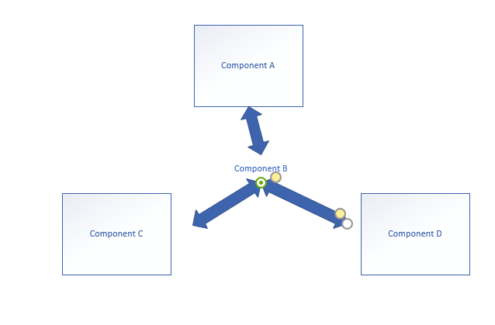
Figure 4-1 component communication diagram
As shown in Figure 4-1 above, there are several relationships between components. Components a and B, B and C, B and D are parent-child relationships, components C and D are siblings, and components a and C, A and D are inter-generational relationships (possibly multi-generational).

Parent component a props to child component B through props, and child group B passes to parent component a through $emit in component B and v-on in component A.

In the framework, we use Vuex for state management. Vuex is the state manager of vue.js, and the stored data is responsive. However, it will not be saved. After refreshing, it will return to the initial state. During the design process, when the data in Vuex changes, we save a copy of the data to localStorage. After refreshing, if there is saved data in localStorage, take it out and replace the state in the store to realize data transfer between components.

Implementation of Front and Rear End Communication
For front-end and back-end communication, the framework employs two protocols: HTTP and websocket. HTTP and webSocket are TCP-based application layer protocols that belong to the reliable transmission protocol.

When the webSocket protocol creates a handshake, data must be sent via the HTTP protocol. It employs the TCP transmission channel for full duplex communication when the connection is established. We employ webSocket protocol for data transfer in the business situation of real-time chat with high frequency and low latency, and the front-end and back-end interaction is mostly based on HTTP protocol.

To transmit queries to the server, the front end utilises encapsulated api.js. Axios is used to encapsulate Api.js. The Axios interception function is mostly utilised here. Request parameters, return data format, errors, and timeouts are all handled similarly in api.js' global request and response interceptor.
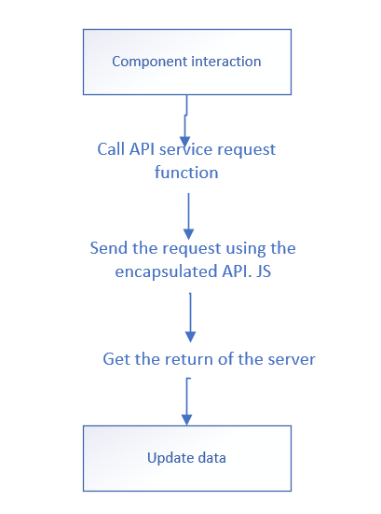
Figure 4-2 interaction flow chart between front end and server end

The interaction process between the front end and the server end is shown in Figure 4-2. The specific operations are as follows:

1. UI component completes interactive operation:

2. Call API interface request function under unified management;

3. Send a request to the server using the encapsulated apijs;

4. Obtain the information uniformly processed by the server;

5. Complete data rendering;

Framework Design and Implementation
The system's implementation section primarily builds and implements the framework based on the findings of the prior requirements analysis and architectural design. This chapter focuses on the following main difficulties in the framework's implementation:

1. Basic functionalities such as login and access management are implemented.

2. In the enclosed components, three main components are implemented, instructions are given, and the impact is displayed.

3. Communication between the front-end framework and the server is implemented.

4. Build and deployment implementation.

Implementation of Login Function
Login is the basic function of Web project. Token based login verification is adopted in the framework. By extracting and encapsulating the business logic of login verification, a set of reusable templates are provided for developers. When in use, the login verification module of the project can be quickly built on the basis of the templates.

Validate Logon
In web projects, there are many ways for users to authenticate when logging in. The traditional way is base

For server authentication, it is generally completed by storing session and identity authentication by storing user login information on the server. However, this session-based authentication method requires the server to create a record to store information every time a user initiates a request. As the number of requests increases, so does the memory overhead. At the same time, because the session is stored in the server memory, when we want to increase the server to solve the load problem, the key information in the session will also limit our expansion.

In order to solve the problems of poor scalability of the above session authentication methods, such as CORS (cross domain resource sharing) and CSRF (Cross Station forged request), the authentication method based on token is adopted in the framework. This authentication method is stateless and scalable, supports multi-platform and cross domain, and can prevent CSRF (cross site forged request) has high security. Based on this authentication method, user information does not need to be stored in the server or session, so it has high flexibility. The login authentication process based on token, and the implementation process is as follows:

1) The user enters the login page, enters user’s name and password, and sends a login authentication request to the server.

2) The server receives the request sent by the client and operates the database to verify the user’s name, password and other parameters.

3) The server returns the verification result to the client. If the information is matched successfully, a signed token (unique identification of user identity) will be returned to the client. If the matching fails, an error code will be returned.

4) The client receives the token sent by the server and stores it in the local cookie. In the future, each request sent to the server carries the token information.

5) The server uses a filter to verify the token information. If the verification is successful, the request data will be returned; if the verification fails, the error code will be returned.

In the process of login verification, cookies are used to store token information on the client, so that the browser can remember the user's login status when the page is refreshed or logged in again, and there is no need to log in again.
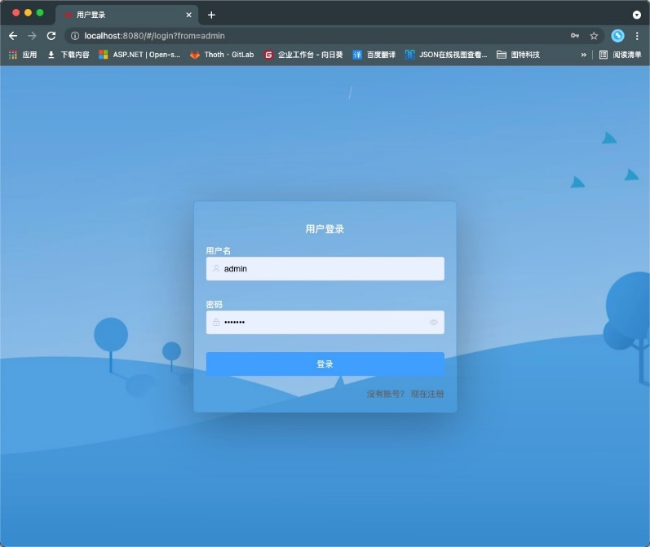
Figure 5-1 user login interface

User Information Loading
The user login authentication and information acquisition are carried out completely asynchronously. After the user logs in successfully, the global hook function router. beforeEach() is used to intercept the route, verify whether the user's request header carries token information, and then pull the user information from the server after passing the verification.

In the process of user login authentication, the client stores the token information returned by the server in the local cookie, but does not store the user's relevant information such as user permission information, role information, user name and avatar in the cookie. This is mainly to avoid inconsistent information when the same account is logged in on different computers because one computer cannot load the latest user information due to information modification on the other computer.

The design strategy adopted here is: when accessing or refreshing the page, first check whether there is token information from the local cookie. If not, go through the authentication process and log in again. If there is token information, it will carry the token to the server to pull the user's details when requesting API, Ensure that the user's information is up-to-date.

In the case of single sign on, when one computer logs in, the other will be offline in advance. The user needs to go through the login process again. At this time, the user login authentication and information acquisition can be synchronized and stored in the database

The user information is stored in localStorage or sessionStorage together with the token. There is no need to worry about the timeliness of the information, because the user information stored in localStorage or sessionStorage is always up-to-date.

Permission Control Implementation
Permission control is the basic and core function of Web project. A complete permission control system is constructed in the framework. The strategies are as follows: the user information stored in the database is associated with the role information. Different user roles correspond to different permissions. The front end will generate different routing tables according to different user permissions. The sidebar is bound with the route, and is generated dynamically after reading the route and judging the permission. At the same time, the framework provides more fine-grained control of button level permissions, and displays and hides buttons according to user permissions.

Permission Database
The permission database mainly contains seven tables: button table, user button table, user table, user role table, role table, resource role table and resource table. The basic information corresponding to each table is briefly introduced in the form of tables:
Table 5-1 permission database
Table name | Essential information
Btn_user | Store button information
User_btn | Association table of user and button information
User | Store user's basic information
User_role | Association table of user and role information
role | Store role information
Menu_role | Association table of resource information and role information
menu | The menu table stores the information of all modules corresponding to the user role. When the user goes to the server to load menu resources, the server will display all module data corresponding to the user role in the menu in JSON string  The form is returned to the front end, which parses the module information from the JSON string and dynamically updates the route. The URL field in the menu table represents the path matching rule. Assuming that there is a request path of / API / * *, when a user initiates a request of / API / getuser on the client, it will be intercepted by / API / *. At this time, the front end will first verify whether the user has a token. After passing the verification, it will then verify whether the user has the role corresponding to this rule, and then carry out permission control.

Menu Level Permission Implementation
Menu permissions involve user and user in the database_ role、 role、 role_ Menu and menu. Different user roles correspond to different menu access permissions. After the user logs in and authenticates successfully, the corresponding menu information will be pulled from the server when the page is loaded. The server side will match the user's permissions and return the corresponding relationship between roles and resources in the form of JSON string according to the role of the current user. The format of JSON string is as follows:
Figure 5-2 menu resource JSON string
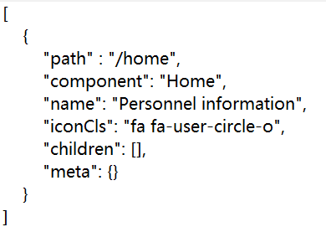
The JSON string returned by the server contains the menu and component information owned by the user. After getting this string, the front-end framework first parses the routing table owned by the user from the JSON string and dynamically mounts it to the current route, and then stores the data in the store, Finally, the rendering of the sidebar is completed according to the routing information in the store.

When the front-end requests routing data from the background is very important. Usually, after the user logs in successfully, he will go to the server to load the menu resources. After obtaining the menu resources corresponding to the user, we will save them in the store. However, this is easy to cause a problem. If the user logs in successfully, click the sidebar to jump to the sub-page, and then press F5 to refresh the page, there will be an abnormal display of the sidebar, Causes the sidebar to fail to load routes. There are usually two ideas to solve this problem: the first scheme is to save the menu resources to localStorage, which can avoid the problem of data loss caused by page refresh; The second scheme is to add the initMenu() method to each page. When the page is loaded, execute this method to pull the menu resources from the server again.

Comparing the above two schemes, because the menu resources are very sensitive and will not be saved locally, scheme 1 is abandoned. Although the implementation of scheme 2 is more reasonable, the operation of loading menu resources once per page is too complex, which leads to slow response speed of the page and affects the system performance. This is simplified on the basis of scheme 2. The method adopted is to use the navigation guard in routing. The implementation process is as follows:

1) First, create an array with an empty initial value in the store to store and access the routing information and turn on the routing global guard.

2) Judge whether the current page needs permission. If it is a login page and other pages that do not need permission, you can directly pass through it; If the current page needs permission verification, then you need to judge the user's login status. If it is detected that the current user is in "guest mode", you need to judge whether this page needs to be logged in to access normally. If you can access in "guest mode", you can pass directly without verification. If you need to log in, return to the login page with the access path of the page you want to jump to. After successful login, the user can directly jump to the corresponding page without rerouting jump.

3) If it is judged that the current user is logged in, the initMenu() method needs to be triggered to initialize the menu data. During initialization, first judge whether the user's menu data in the store exists. If it does not exist, you need to reload the menu resources; If the data exists, first parse the JSON type menu resource data returned by the server through the formatRouters() method to extract the routing table that can be normally recognized by the front-end route. Then dynamically mount the routing table to the route through the addRoutes () method.

4) Finally, the rendering of the menu is completed in the main page.

Button Level Permission Implementation
Button permissions relate to database in the btn_ info. use_ btn and user three tables, btn_ info table stores the details of all buttons, including the button name and its corresponding permission ID. permission filtering will be performed on each button when the previous page is rendered. If the user's permission matches the permission required by the button, the button will be displayed. If not, the button will be hidden.
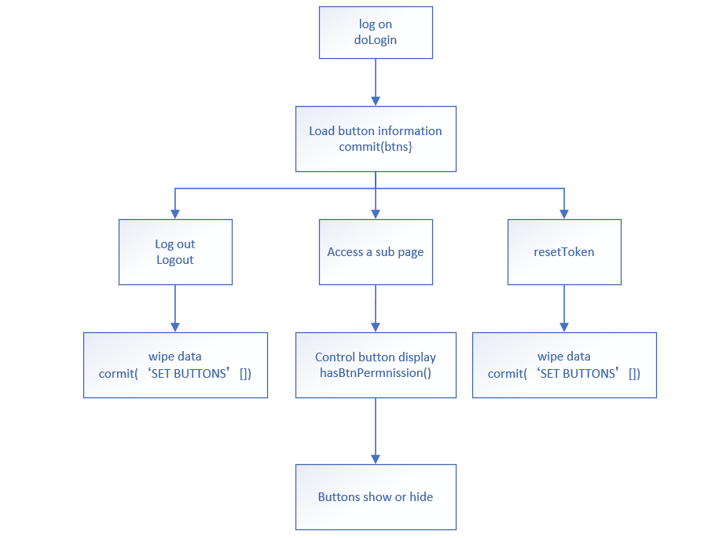
Figure 5-3 logic diagram of button permission implementation

The implementation logic of button permission is shown in Figure 5-3. The specific implementation process is as follows:

- After logging in successfully, the user enters the home page. When loading menu resources on the server side, the button information is loaded at the same time, including the button name and the permission ID of the button. After the background returns the JSON data to the front end, the data is stored in the store. The implementation code is as follows:
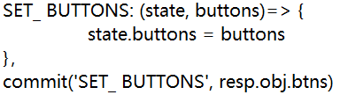

Figure 5-4 button resources stored in store code
- After the button resources are loaded and stored in the store, when accessing a page, we use the hasBtnPermission () method on all the buttons in the page to control the display of the buttons
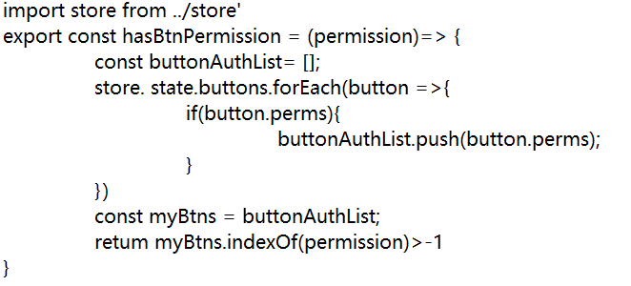
Figure 5-5 implementation code of button display control method
The implementation code of the control button display is as above. First, process the button permission information of the current user stored in the store, uniformly store the button permission ID of the user in the buttonAuthList array, and then compare it with the permission ID required by the button in the page the user wants to access, True is returned for successful matching, and false is returned for failed matching.
- Use the V-IF attribute in the button to display and hide according to the returned matching results. The example code is as follows:
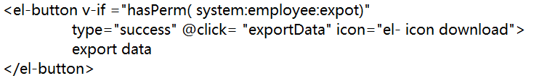
Figure 5-6 example code of button display and hidden implementation

Role Management Implementation
Role management involves five tables (user, user role, role, menu role and menu) in the database, including role resource relationship management and user role relationship management, and realizes the basic functions of addition, deletion, modification and query. Role resource relationship management is mainly responsible for allocating corresponding resources to roles. The role display adopts the accordion design mode, and only - roles are displayed each time; The display of role corresponding resources is based on the design and implementation of tree control, which can intuitively display the resource options corresponding to the role. The administrator can easily check the corresponding options to realize the allocation of role resources.

User role relationship management mainly involves the system administrator to operate the user's role information, such as adding and deleting roles for a user. At the same time, you can also manage the user status to enable or disable a user.

The user's display is realized by using the element UI card, which contains the user's basic information. A switch is set behind the user's status. You can enable or disable the user's status by clicking the switch.

The user role display is implemented by the tag tag design of element UI. Each user corresponds to multiple role tag tags and adds event monitoring for each tag tag. When the user clicks the corresponding role tag, a dialog box named "role list" will pop up. The dialog box contains a role selector, which is designed and implemented based on the select component, Single and multiple choices are supported, and users can be easily assigned roles.
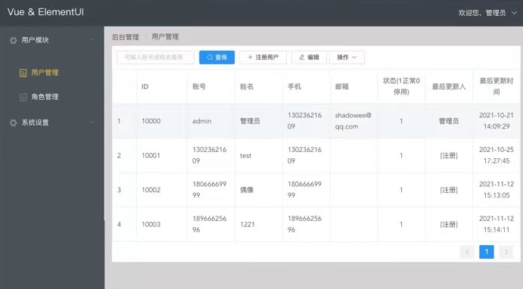
Figure 5-7 user management interface

Component Design and Implementation

Svg-Icon Component
The reference implementation process of Svg-icon component is shown in Figure 5-7:
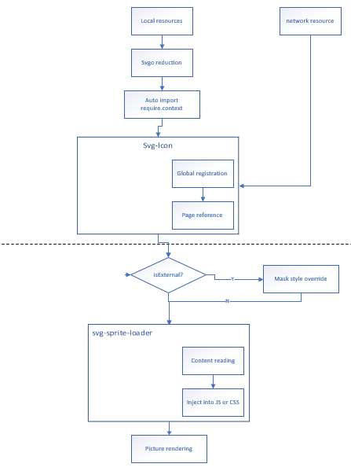
Figure 5-8 Svg-Iocn Implementation flow chart
First, we need to import SVG resources, but usually the SVG icons we need to reference contain a lot of redundant information, which increases the size of icon resources. Here, we filter out redundant information and simplify icons through SVG components. Next, import SVG icon resources. The traditional method is to import icon resources every time you use them, but this is undoubtedly time-consuming and laborious. Here, we use webpackrequire.context to automatically import icons. The implementation code is as follows:
Figure 5-9 icon automatic import code
After the icon is imported, we reference it in the page through the global registration SVG icon, add the icon source judgment in the component, and distinguish the local icon resource reference from the external icon resource reference. If it is judged that the reference is an internal icon resource, we will use the mask attribute of CSS to cover the image, Standardize the format of the icon, and then load it according to the name of the icon. The specific implementation code is as follows:
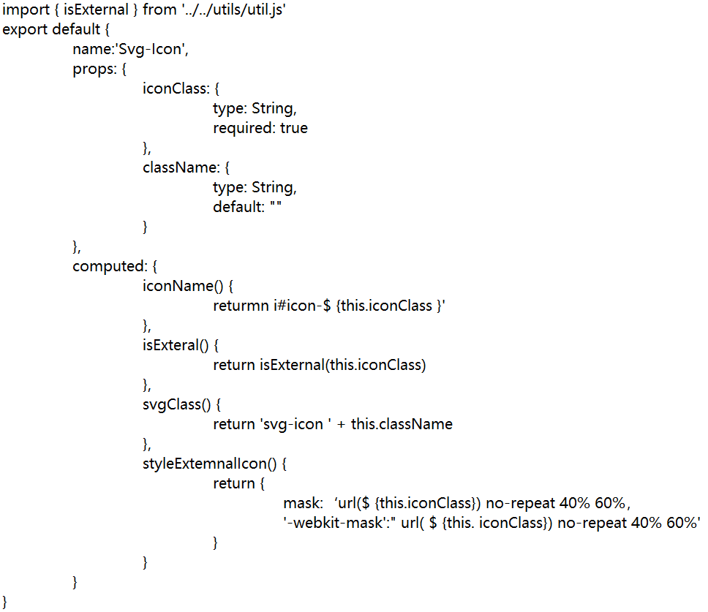
Figure 5-10 icon component Svg-Icon implementation code

isExternal()function is mainly used to judge whether the referenced resource is a network resource. If the referenced resource is a network resource, it needs to be processed separately. The code implementation is as follows:
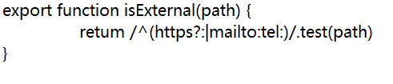
Figure 5-11 implementation code of external resource judgment method isExternal()
Next, read the contents of the file by introducing svg-sprite-loader and inject it into JavaScript or CSS. When the project is run after the introduction, an exception will be prompted, which is caused by the conflict between svg-sprite-loader and the svg processing tool url-loader used by Vue cli by default.

In the framework, the webpack is configured so that svg-sprite-loade is only responsible for handling SVG icons under a specific folder, while url-loader is responsible for handling other SVG icon resources, skillfully avoiding the conflict between the two. The specific implementation code is as follows:
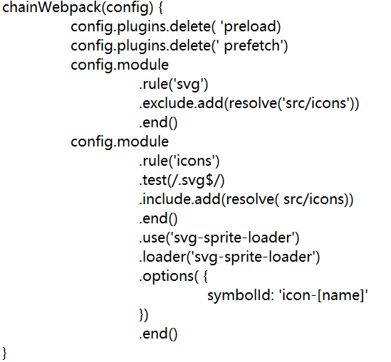
Figure 5-12 conflict resolution configuration code read by webpack resource

Charts Visualization Component
Chart visualization component is mainly implemented based on Echarts. Echarts provides us with a large number of chart templates with rich functions, but the data in these charts are written dead, which is not conducive to repeated calls. Here, the commonly used charts are encapsulated into components to realize dynamic data display by means of parent-child component value transfer. The internal code logic of chart component is shown in Figure 5-11. The following describes the specific implementation process of the component with pie chart component pie-chart.vue as an example.
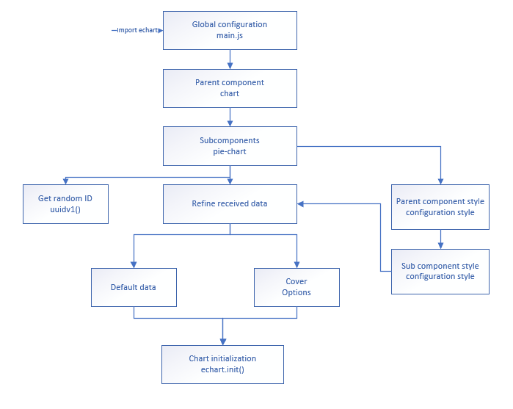
Figure 5-13 chart component internal code logic diagram
First, you need to install Echarts. After successful installation, you need to introduce Echarts into the project. Generally, for the convenience of development, we will directly reference the Echarts component library globally in the project, but this will lead to too large file project volume and slow down the first screen loading. The on-demand loading mode is adopted in the framework, only the used components are loaded, and the unused components are not loaded. Then, the packaging implementation of components is introduced. Here, chart.vue and pie chart.vue are created, in which chart.vue is the parent component used to call charts, Pie-chart.vue is a sub component responsible for generating and rendering charts. Parent and child components transmit messages through props to realize dynamic data binding. The code is as follows:
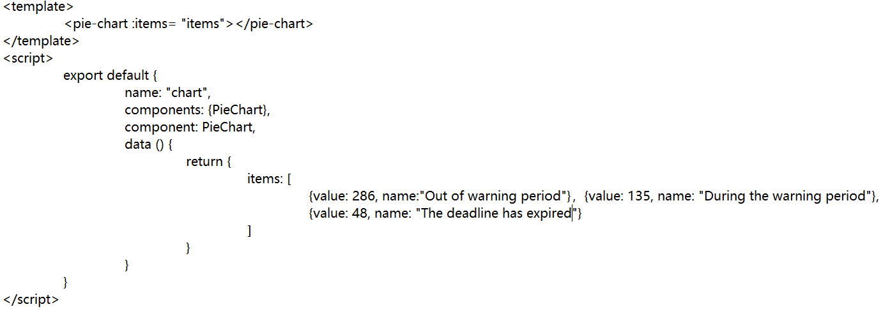
Figure 5-14 code implementation of chart.vue component

In the sub component pie － chart.vue, the echarts plug-in is introduced as required. The entire visual chart is configured in the option, including the setting of title, display style, public components and data options. The code implementation is as follows:
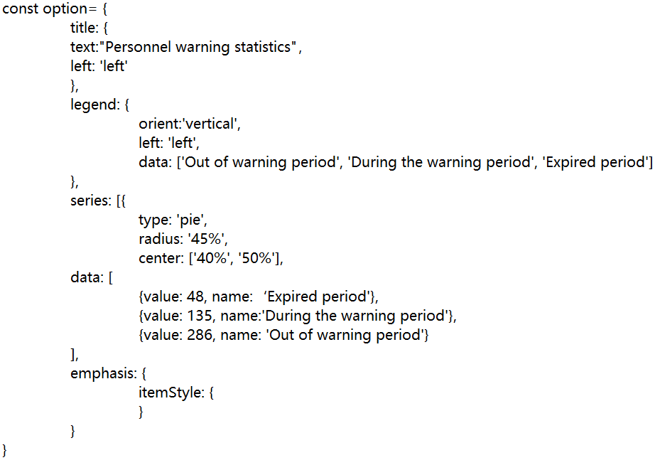
Figure 5-15 option configuration code
The child component receives the data transmitted by the parent component through the props option. After filtering the data, it overwrites the default data in the option. The implementation code is as follows:

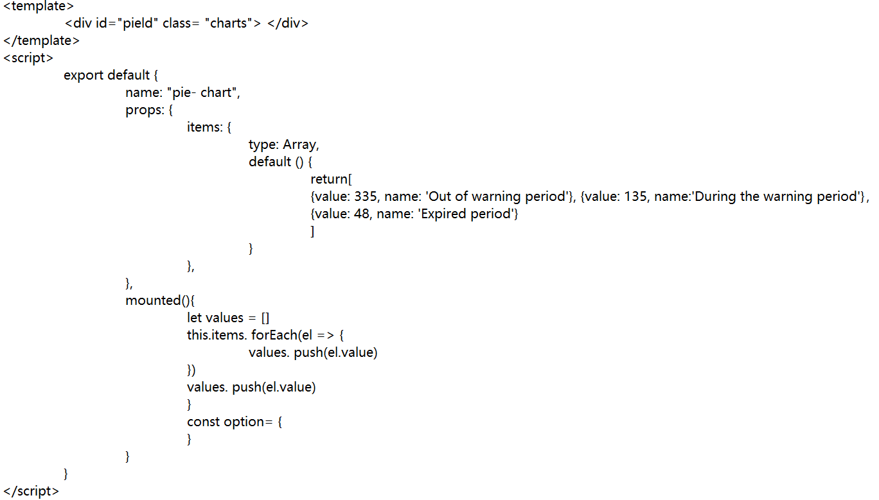
Figure 5-16 pie chart component implementation code

In pie-chart.vue, we found that the ID attribute defined in < template > is a fixed value. At this time, when a page calls the component twice, an error will be reported due to repeated ID. Here, the UUID is introduced to configure a non-duplicate ID for each pie chart. In order to avoid the failure of initialization due to the lack of time to render a new ID, the random ID should be generated in created (). The event monitoring of the chart is also added in the component. The component event monitoring is realized by thisxhart.on() method, such as information prompt The logic operations such as route jump are implemented as follows:
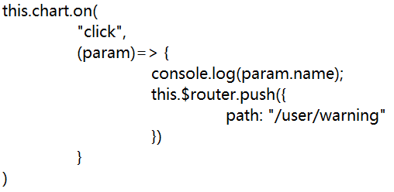
Figure 5-17 component event listening method code

Chat Component
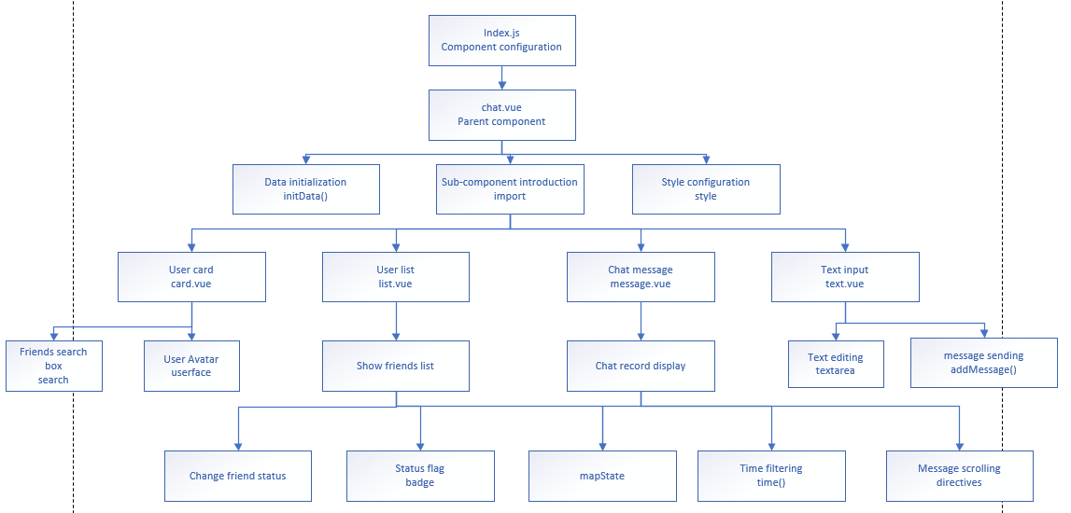
Figure 5-18 chat component code internal logic diagram

The internal logic of chat component code is shown in Figure 5-16. The overall style of the component is defined in chat.vue. When the component is loaded, the initData() method is triggered for data initialization. At the same time, four sub components are introduced into the component: user card component card.vue, contact list component list.vue The dialog message box component message.vue and the text input box component text.vue. The parent component chat.vue implementation code is as follows:
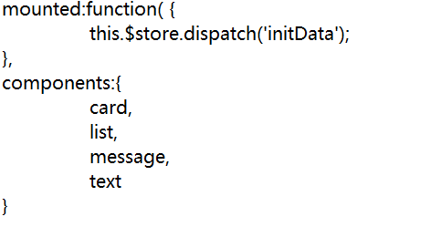
Figure 5-19 implementation code of parent component chat.vue

The user card.vue component is mainly responsible for displaying the current user, and supports the method of fuzzy matching to find friends from the friends list. When displayed, the user information is uniquely identified by user name + avatar. The user information is obtained from the local sessionStorage saved after the user logs in successfully. The user search function mainly depends on the V-model attribute to fuzzy match the keywords searched by the user with the names of good friends stored in the friends list. The implementation code is as follows:
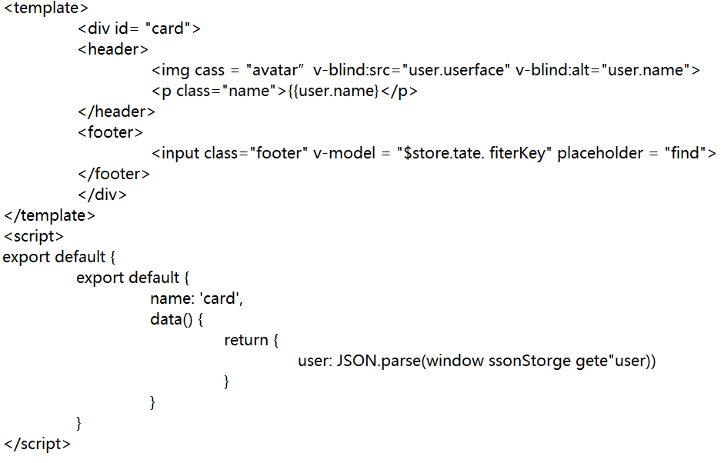
Figure 5-20 code implementation of user card component

The user list component list displays the list of all friends of the current user. When clicking a friend to initiate a chat, first trigger the changeCurrentSession() method to change the currentSession to the friend information the user is currently chatting with, At the same time, the badge component in ElementUI is used to mark the status of current chat friends. The specific implementation code is as follows:
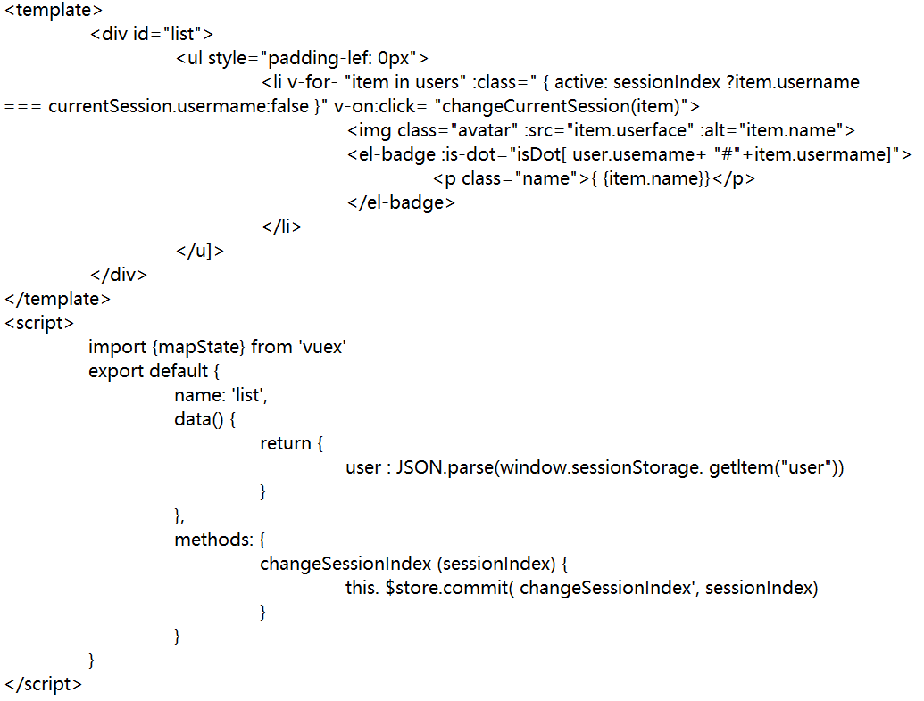
Figure 5-21 implementation code of user list component

The component message.vue acts as the message display window of the chat room, which mainly displays the chat information between users and friends. When users click a friend to initiate a chat, the chat records between the current user and the friend are displayed through V-for loop, Filter user avatars through filters and filter dates as hours: minutes. At the same time, after sending a message, scroll to the bottom of the chat window through Vue user-defined instructions. The specific implementation code of the message component is as follows: 
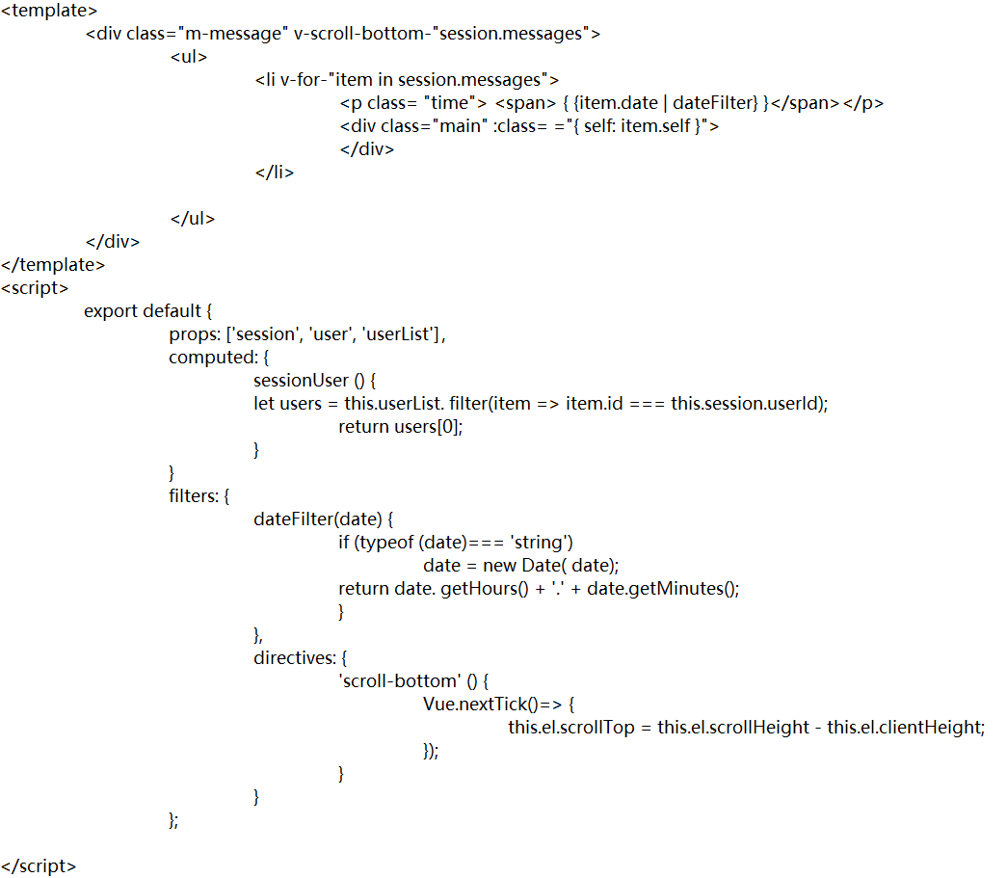
Figure 5-22 implementation code of user chat message component

The text input box component text.vue is mainly responsible for editing and sending chat information. Edit text through the text-area text box and add keyboard event monitoring. Press Ctrl + enter to trigger the addMessag() method to send chat messages. The implementation code of the text component is as follows:
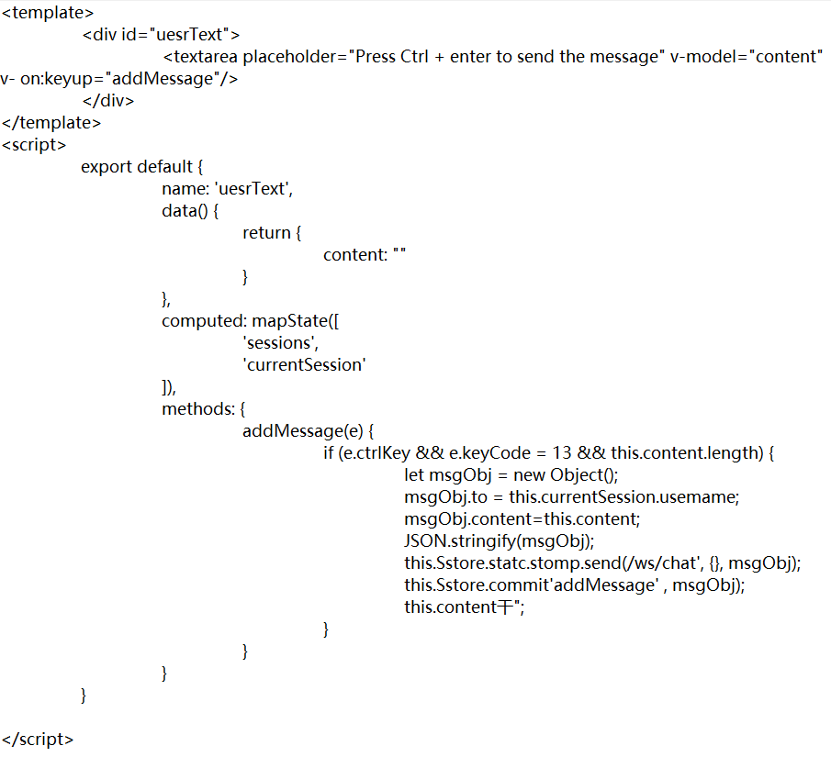
Figure 5-23 implementation code of text input box component
The encapsulated four sub components are introduced into the parent component chat. Users can introduce the chat component into the page or use the chat component as a separate page.

Implementation of Front and Rear End communication
The front end sends an API request to the server, the server receives the request, operates the database and returns the execution result, the front end receives the data returned by the server, and displays the data to the user after rendering to complete the whole API communication process. The framework encapsulates common interface APIs, configures proxy services, defines global interceptors, realizes real-time communication based on WebSocket, and constructs a complete front and rear communication system.

API Encapsulation
After entering the front-end interface, the user sends an API request to the server. At this time, the encapsulated API interface functions in the framework will be called. The encapsulated interface functions include common get requests, post requests, put requests, delete requests, etc. the API example code is as follows:
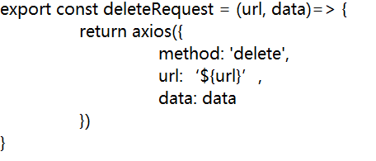
Figure 5-24 interface API example code

Agent Configuration
On the whole, the architecture design of front end and back-end separation is adopted. When users call API interface functions to send requests to the server, cross domain problems will occur. Webpack proxy is used for proxy in the development environment, and Nginx is used for reverse proxy in the online environment. The proxy of the development environment is configured in the vue.config.js file. Because both HTTP protocol and WebSocket protocol are used in the framework, the proxy of the services corresponding to the two protocols needs to be configured respectively. The proxy configuration code is as follows:
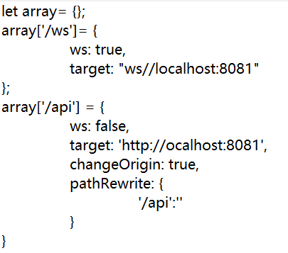

Figure 5-25 proxy configuration code

After the above configuration, the request for / api/ user will be proxied to http: / / localhost: 8081 / api / user request. The online environment needs to configure Nginx for reverse proxy service. The specific configuration will be described in detail in the construction and deployment section of this chapter.

Implementation of Global Interceptor
The server receives the API request from the client, connects to the database, and returns the execution result to the client through the proxy service. In order to avoid judging various network conditions during each request, such as connection timeout, server internal error, insufficient permission, etc., it is encapsulated on the basis of Axios interceptor, The global response interceptor is implemented to uniformly process the information returned by the server. The response interceptor code is implemented as follows:
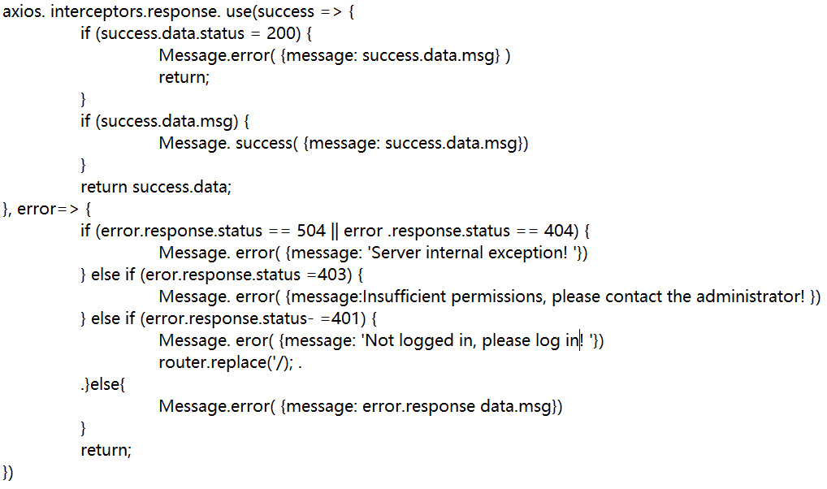

Figure 5-26 implementation code of response interceptor

After the data returned from the server is intercepted globally, it is uniformly transmitted to the front end. The front end completes the data rendering and shows it to the user, and a complete API request process ends.

Point to Point Real-time Communication
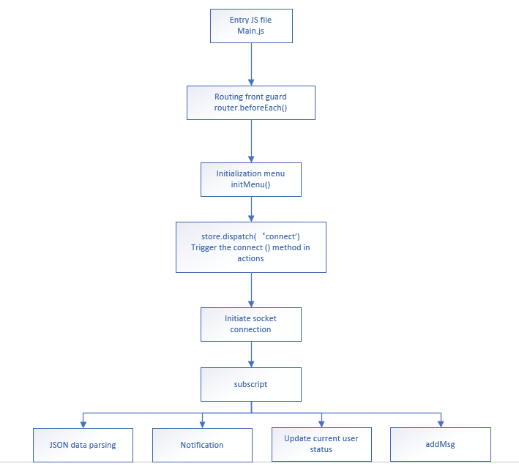
Figure 5-27 flow chart of point-to-point real-time communication

The sub protocol stomp based on WebSocket protocol in the framework realizes point-to-point real-time communication. The specific communication process is shown in Figure 5-25. Its detailed implementation is described below:

First, judge whether the current page to jump is a permission page in the front guard of the main.js route at the entrance. If the page to jump is a page that does not need permission such as login or registration, it will jump the route directly without processing. Otherwise, first judge the login status of the current user. If the current user has logged in, then initialize the menu. The implementation code of the route front guard is as follows:
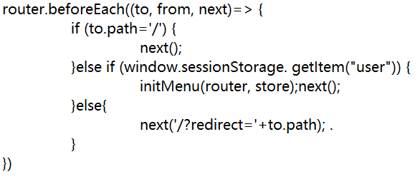
Figure 5-28 implementation code of routing front guard

After initializing the menu in the initMenu() method, trigger the actions method in the store through dispatch. The code implementation is as follows:

Figure 5-29 code of actions method triggered by dispatch

Define the connect () method in the actions attribute of the store. This method realizes the WebSocket communication connection between the front end and the server through the sub protocol stomp of WebSocket. The code is as follows:
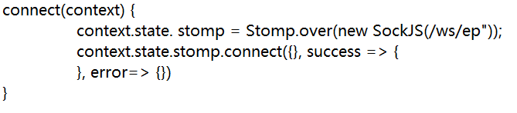
Figure 5-30 WebSocket communication connection code

The client initiates a WebSocket connection to the server. After the connection is successful, it subscribes to messages through / queue, so that the client can receive messages pushed by the server in real time and complete point-to-point communication.

After receiving the message pushed by the server, the client saves the data in localStorage. The format of the message data is: current user nickname, sender user nickname: [{from: 'message sender', MSG: 'message content'. The chat information is stored in JSON array, and the key value is key "Current user's nickname ＃ message sender's user's nickname" to avoid data disorder caused by multiple users logging in at the same time under the same browser. When the supervisor hears that a new message is sent, send a message prompt through notification and update the current user's chat status at the same time. The real code is as follows:
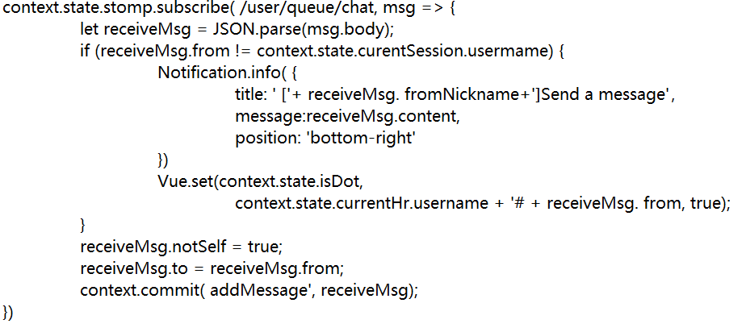

Figure 5-31 message subscription and storage implementation code

So far, the construction of point-to-point real-time communication is completed.

Build and Deploy

Ring Block Construction
1. Install node and related environment

2. Use the NPM install - g @ vue / cli command to install vue-cli globally. After installation, use the Vue version command to check whether the version is correct. The framework is built based on the version of vue-cli3. x.

3. Global variable setting

Create two files. env.development and. env.production in the root directory, and configure them as follows:
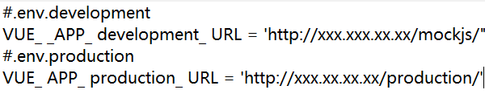

Figure 5-32 global variable setting code

Variables are set in the form of key value pairs, starting with (Vue_APP). After configuration, they are used in main.js.

Build Release
Package the application with one click by running the NPM run build command. After successful packaging, the dist folder will be generated in the root directory of the project.

When publishing online, we only need to publish the static files we finally generated, that is, the static files in the dist folder to the static server, where index.html is the entry page to connect to the background service.

The framework encapsulates the deploy file and provides two function functions: product.js and index.js. Product.js is used to configure the test / production environment and the server SSH remote login account information. The automatic deployment script is defined in index.js. When using, users can modify relevant parameters and run the script to dynamically deploy the project to the static server. The script implementation code is as follows:
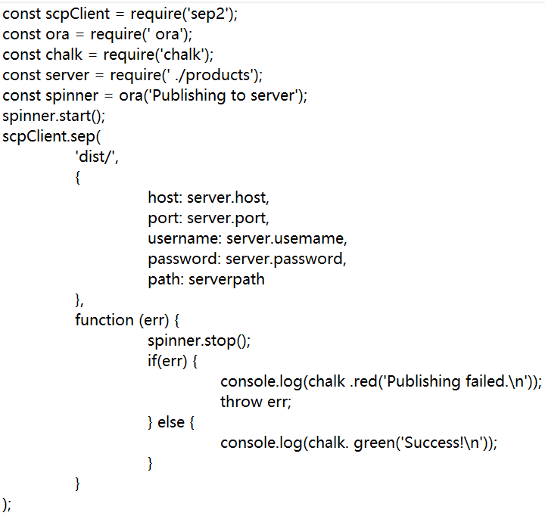
Figure 5-31 automated deployment script code

Deployment Implementation
When the project is developed and deployed online, specific solutions are given in the framework for cross domain and performance optimization.

1. Cross domain issues. If the front-end project is deployed in different protocols, domain names or ports, it will cause cross domain problems, which are often encountered in the deployment process. The specific solution strategy is given in the framework, which mainly deals with the front-end cross domain by means of agent. In the development environment, webpack's proxy is used to cross domains. In the online environment, Nginx reverse proxy is mainly configured. The core configuration code is as follows:
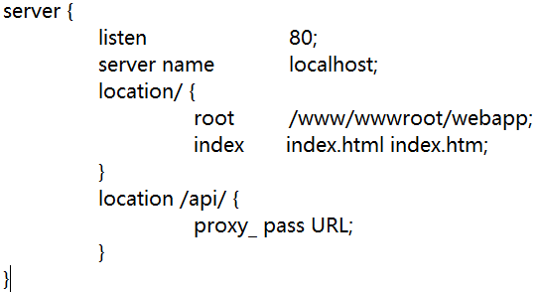
Figure 5-32nginx configuration code

2. Performance optimization. The front-end performance greatly affects the user's interactive experience. During deployment, it is mainly optimized from the following aspects.

1) The static file server Nginx is used for project deployment. During deployment, gzip is enabled for compression,

Reduce the code block size of the request response.

2) CDN resources are introduced into Webpack through the Extramnals configuration of Webpack,

The configuration code is as follows:
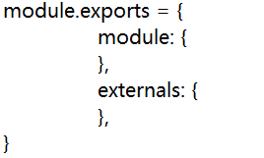

The introduction of CDN service can increase user access speed, reduce network delay, optimize bandwidth, reduce server load and enhance the resistance to attacks.

3) For business scenarios with a large amount of concurrency, load balancing configuration is performed on the Nginx server to reduce the pressure on a single server and improve the service carrying capacity.

- Evaluation
The framework adopts the overall architecture of front-end and back-end separation, designs hierarchical architecture according to different "concerns" of each part, and builds a complete system communication and permission control system. By refining the typical business model, it encapsulates a wealth of functional components and functions, which is convenient for users to call directly. In practical application, the framework will serve the front-end construction of web projects. Users can carry out secondary development on the basis of the framework. Through simple business logic filling, a complete project body can be generated quickly, which makes developers shift their focus from complex interaction design to business logic implementation, and effectively reduces the threshold of front-end development. It improves the efficiency of front-end development and has high practicability.

In recent years, the concept of front-end and back-end separation has just emerged. There are relatively few articles on front-end architecture design in the past papers, and most of these articles focus on the business logic implementation of front-end framework, lacking the description of framework architecture design. Through the paper, readers can clearly understand the implementation principle and technical application of the framework, and help readers better use the framework to build their own front-end projects. But this method still has some limitations, not all scenarios can be fully applicable, so in the expansion also need to continue to improve.

Conclusions and Recommendations
The goal of this topic is to research and develop a set of highly available front-end framework based on Vue to solve the problems of low efficiency, poor code reusability, poor interactive experience and unable to meet the needs of users in the front-end development process of the project.

The framework adopts the overall architecture of front-end and back-end separation, and carries out hierarchical architecture design according to the different "concerns" of each part, so as to build a complete system communication and authority control system. By refining the typical business model, it encapsulates rich functional components and functions, which is convenient for users to call directly. In practical application, the framework will serve the front-end construction of web projects. Users can carry out secondary development on the basis of the framework. Through simple business logic filling, they can quickly generate a complete project subject, so that developers can shift their focus from complex interaction design to the implementation of business logic, effectively reduce the threshold of front-end development and improve the efficiency of front-end development, It has high practicability.

The concept of front-end and back-end separation has just emerged in recent years. There are relatively few articles on front-end architecture design in previous papers, and most of these articles focus on the business logic implementation of front-end framework and lack the description of framework architecture design. The innovation of this paper is to elaborate the design idea of the framework from the perspective of architecture, separate from the level of business logic, and pay more attention to the implementation details of the underlying architecture. Through the paper, readers can clearly understand the implementation principle and technical application of the framework, and help readers better use the framework to build their own front-end projects.

This paper introduces the design and implementation of the framework in detail, and puts forward specific solutions to the problems faced in the front-end development, such as increasing development difficulty, low development efficiency, poor code reusability and maintainability. However, the framework is developed based on the JavaScript framework vue.js as a whole, and relatively little work has been done on the reconstruction and performance optimization of the underlying code of the framework, In the future work, we will strengthen the optimization design of the framework performance on the premise of further paying attention to the actual needs, continue to follow up the user experience, and constantly improve the functions of the framework, so that it can meet the development needs of different scenarios and better serve the front-end developers.
- Reference
[1] Wang Heqin, Zhu Zhenyuan. Research on Web Development Based on MWM [J]. Journal of Heze University, 2019, 41 (02): 7-13

[2] Li Jia, Zhao Kaiqiang, Li Changyun. Research on the evolution of web front end development technology and MWM design pattern [J]. Brain knowledge and technology, 2018, 14 (02): 221-222 + 251

[3] Chen Youling. Research and implementation of a balanced and efficient web front end framework [D]. Beijing University of Posts and telecommunications, 2014

[4] Chen yinliang. The change of jQuery plug-in for web application[J]. Computer CD software and application, 2013, 16 (05): 9-11

[5] Shen Yongfang. Research on web front end development based on jQuery framework[J]. Information communication, 2019 (10): 105-107

[6] Zheng Jie. Design and implementation of angular.js front end framework and back end code automatic generation system [D]. Southwest Jiaotong University, 2016

[7] Vue.js API. Yuxi (Evan) You . http://vuefe.cn/v2/api

[8] Lu Rong, GUI Weixia. Design of mobile digital campus platform based on MVP mode [J]. Computer knowledge and technology, 2018, 14 (24): 68-70 + 75

[9] Tianyang. Research and application of the general development framework of web application system [D] Shandong Agricultural University, 2016

[10] N. Yi, X. Feng and C. Li, "The design and implementation of the front end of the art play library system," 2017 7th International Conference on Communication Systems and Network Technologies (CSNT), 2017, pp. 285-288, doi: 10.1109/CSNT.2017.8418553.

[11] Y. Gong, F. Gu, K. Chen and F. Wang, "The Architecture of Micro-services and the Separation of Frond-end and Back-end Applied in a Campus Information System," 2020 IEEE International Conference on Advances in Electrical Engineering and Computer Applications (AEECA),2020, pp. 321-324, doi: 10.1109/AEECA49918.2020.9213662.\

[12] K. Li, Y. Ding, D. Shen, Q. Li and Z. Zhen, "The Design and Research of Front-End Framework for Microservice Environment," 2020 International Conference on Computer Information and Big Data Applications (CIBDA), 2020, pp. 124-127, doi: 10.1109/CIBDA50819.2020.00036.

[13] N. Zhang, Y. Cao and S. Zhang, "Research of web front-end engineering solution in public cultural service project," 2017 IEEE/ACIS 16th International Conference on Computer and Information Science (ICIS), 2017, pp. 623-626, doi: 10.1109/ICIS.2017.7960067.

[14] Chai Qingshan. Research on the application of vue.js framework based on MVVM mode in logistics software automatic test system[D]. Beijing University of Posts and telecommunications, 2019

[15] Meng Xiangshuang. Research on application development of front and rear end separated Web [J]. Electronic components and information technology Operation, 2019, 3 (06): 40-43\

[16] Chi Dianwei. Web architecture solution with front-end and back-end separation[J]. Smart factory, 2019 (06): 37-38

[17] Sun Yixiao, Zhang Yujun, sun Yucheng, LV Huiyuan. Software development model based on complete separation of front and back ends of WebAPI[J]. Information and computer (theoretical Edition), 2019 (06): 96-97

