Academic and Employability
Skills

LECTURER NAME :MOHAMMAD RAHMAN
STUDENT NAME: BALABAN ANDRADA
STUDENT ID: 1920286
Table of Contents

Contents
INTRODUCTION 1
MAIN BODY 1
Reflection on learning 1
CONCLUSION 6
REFERENCES 7

INTRODUCTION
An academic skill is defined as skills which are aspect of behaviour learned by students from education which is successfully at higher level of satisfaction. By practising this type of skill it develops graduate attributes like analytical ability, problem solving, and creativity, innovation and effective communication. These skills are made up of core skills like presentation skills, referencing and academic writing which also reflects complex skills which reflects critical practice and thinking. Employability skills is refers to transferable skills which is needed by individual for make themselves employable (Bhagra and Sharma, 2018). So for this there must be good technical understanding that has to outlines subject knowledge as they want from an employee. It mainly depends on skills; attitudes and knowledge about use the assets which are presented by employers. The employability skills get affected directly due to the pandemic situation of COVID as it altered the condition of job placing and working standards as well. The report below includes suitable reflection on learning with support of different models of reflection.

MAIN BODY

Reflection on learning
Gibbs Reflective Cycle was introduced by Graham Gibbs in 1988 for providing structure about learning from their experiences. It gives framework for analysing experience and give them cyclic nature which is particularly well in repeated experience. It allows individual for learning and planning from things which are either went well or not. It is a model that is effectively used as in order to promote and advanced the working standards as with this ability to attain higher competitive advantage is enhanced in sustained mode. In support of this model ability to strengthen the strength and removal of weakness is induced as on the basis of adequate learning and development. As an individual having a lot of skills that is somehow gain in relation to academic skills and professional development within which assist to advanced better employability skills as with this capability to gain better job place and position in competitive marketplace (Griffiths and et. al., 2018). As these skills having drastic impact over the working standards and potential of mine as with this sustained level of relatedness and interconnectedness is promoted and advanced. In this I have felt that I have various strength and weaknesses and a different set of skills and with this capability of mine to gain and attain employability skills through which balanced condition is created and developed that induce higher success in career or at future period of instances. There are 6 stages which are under Gibbs Reflective Cycle are discussed below:
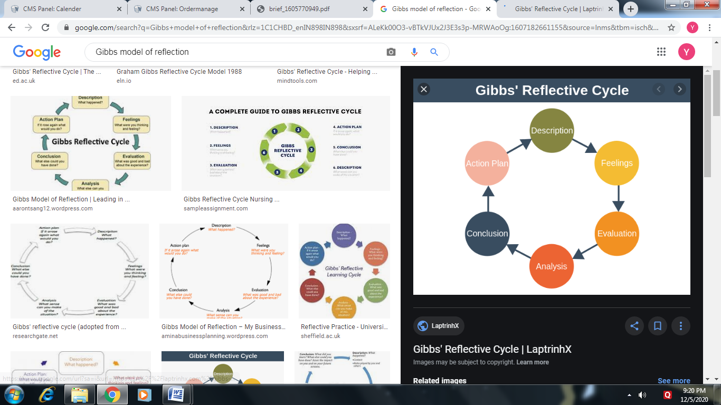
Figure 1https://laptrinhx.com/gibbs-reflective-cycle-860222989/
(Source: Gibb’s reflective cycle, 2019)
- Description: In this stage, individual set scene by questions such as what happened, who was there, when it occurred, what they did, what was outcome. It is very important for remembering to keep information which offers to the point and relevant data. Individual only have to using valuable words which are not waffle about details. In order to secure and safe certain place at recognised company and with this development of different skills is induced with perfection (Nisha and Rajasekaran, 2018). In this I have a clear and sustained knowledge about public speaking and giving presentation that assist me to make profitable changes and modifications as with this long term success and development is induced in overall personality of mine. As I have better knowledge and information and I have precede my career with this by which ability of mine to make better understanding is developed on repetitive basis. For this I have make better analysis of behaviour and perspective of others as with this rate of attractiveness and its attentiveness both get covered with perfection. While making public speaking it is required for me to be more confident and relaxed as with this only I am able to connect with the audience and transfer my views and ideas with simplicity and comfort. It is a skills that requires complete description as along with this while giving presentation also ability of mine to make clear analysis is getting advanced that furthermore advanced adequate feeling of mine to present clear understanding with better framework. It is quite beneficial for me under which working capability and its standards get developed in sustained mode as in this strength of mine and sufficiency to make clear interaction is promoted in advanced mode. It is in my personality that I have easily make strong interrelation under which suitable level of comfort and its achievement get increases with adequateness.
- Feelings: After description, feelings and thoughts are must shared about experiences which an individual identifies. In this individual have to comment on such questions like, what is the feeling at that time, thinking at that time, what is impact of values, emotions and beliefs, what other people are thinking. Generally in this stage there must be discussion about the emotions that must be honest. It is a stage at where I have triggered as with this I have analysed and interpret the thoughts and ideas are required to be considered systematically (Suleman, 2018). For this I have maintain clear focus and concern towards this ability of mine to evaluate and judged various emotions and varied condition is promoted. In this direct detail and feeling is promoted and with this both short and long term goals and objectives is processed successfully. It is somehow difficult to process the working standards along with emotions as with this I have ask repetitive questions to other and to mine to under which better change is implemented as per necessity. In this I have worked for to attain analytical and critical thinking skills as with this I am able to connect and interact with others by analysing and judging their point of views with clarity and transparency. It induce ultimate and positive shift in my skills by which suitable and prominent changes is induced that furthermore promote and advance learning capabilities of mine. The analytical skills assist me to make better interpretation of different consequences as with this sustained outcome is developed with better sufficiency.
- Evaluation: In this step, individual have to focus on negative and positive even if there is primarily one or other. In this they have identify what was good and bad about experience, what is well and what is not, where is their contribution which is negative or positive. It is a stage at where I have worked well as per consideration of well approach and in this suitable situation and condition get analysed with better clarity and transparency. I have worked by getting better clarity and in this sufficient skills related to team management is enhanced. In this skill development is induced as per consideration of managerial skills with this sustained level of delegation is progressed (Cotronei-Baird, 2020). For this I have ensure that overall task is divided into a different slots through which positive support is build by which ability to attain organised goals and objectives get developed with better sufficiency. For this team management assist me to get over all the situations either it is complex and sorted but with this ability to complete standardised task and its objectives is achieved under a sustained period of instance. In this I am able to deliver all the work on time with better quality of work under which working efficiency and productiveness both get advanced in timely basis. It also processed effective controlling over organising study as with this I will make adequate balance in between organised learning through which positive impact over working is induced by which team working and its management get advanced in collective manner.
- Analysis: In this step, it includes situation of sense which is what happened using various theories. Individual should have to answer some questions like how theory explains as what is happened, how their experience is compared to literature, can they use different ways for responding and so on. It is an aspect through which I have analysed the different conditions and situations for that similar formality is analysed in positive mode. In this I have enhanced summarising skills of mine as it is a critical processing with this favourable outcome is developed in systematic manner (Griffin and Coelhoso, 2019). In this suitable level of understanding is developed as with this as a graduate student and learning for that I am able to create positive working environment and in this formularise result is developed. As it is an essential relation and prospect under which the problem solving ability and thinking credibility both get increases. In this analytical and logical framework is induced that assist me to resolve different working solutions. For this I have try to make clear and flexible understanding of working and summarise the overall task with clarity as with this rate of perfection analysis and its attentiveness both get enlarged.
- Conclusion: According to this model, there are actually two conclusions such as transferable and focused on personal situation. They have to identify questions such as what they have learnt, how they can do it in better way, what types of skills they are handling in better way. In relation to this stage I have make sustained level of advancement and with this working sufficiency and its criteria both advanced and improvised. For this I have analysed that Online learning experience is promoted and for this I have worked to develop suitable level of motivation and encouragement through which sustained level of growth and development is induced in future period of instance. In support of this I am able to achieve and accomplish under which ability of mine to develop change and modification is developed and with this I have enhanced leadership skills as with this rate of authority is developed. In addition to this I have prioritise the working abilities in which quality learning is processed in which efficiency of workplace is developed (Menz, 2020). In support of learning experience I am able to make productive amount of changes as with this understanding level of mine is advanced over a regular basis of instance. In this sustained experience of mine is advanced and capabilities of learning is getting advanced under which rate of productiveness and performance enhancement get developed in constrained mode. As with this learning credibilities of mine is increases as I am able to learn every aspects as per my suitability and from desired source of learning
- Action plan: This is last step which shows sum up anything for improving at next time. In this individual have to identify and use their knowledge and experience which helps in improving the situation of individual. In this stage overall action is planed and designed with this ability of mine to develop productive changes in my personality is induced as with this higher level of connectivity towards employability skills is developed in frequent basis. In order to develop and design clear focus and concern is developed by which long term profitability is attained with perfection. In this as per consideration of different stages I am able to develop quality working standards and with this calmness and flexibility is induced as it also induced sustained level of motivation and confidence through which balanced in between arrogance and comfort is developed systematically. In support of action plan I have develop mutual understand about all the skills of mine and with this working effectiveness is maintained with continuity and also assist to make profitable ending is sufficient mode. In this I am able to strengthen varied strengths of mine and in addition weaken areas also get advanced by making clear understanding in about loop holes so that long term sustainability is maintained with perfection.

CONCLUSION
It has been concluded from above report that academic and employability skills is also be promoted as with this learning and knowledge advantage and improvement is induced with perfection. Due to the pandemic condition of COVID there is sustained impact over employability skills as the working skills and its development both get affected on direct basis. There is few learning styles that is required to promote and advanced there is suitable relatedness and for that classes learning and advancement get assist to make productive changes in individual personality.

REFERENCES
Books and Journals
Bhagra, A. and Sharma, D.K., 2018. Changing paradigm of employability skills in the global business world: A review. IUP Journal of Soft Skills, 12(2), pp.7-24.
Cotronei-Baird, V.S., 2020. Academic hindrances in the integration of employability skills development in teaching and assessment practice. Higher Education, 79(2), pp.203-223.
Di Gregorio, A. and et. al., 2019. Employability skills for future marketing professionals. European management journal, 37(3), pp.251-258.
Griffin, M. and Coelhoso, P., 2019. Business students’ perspectives on employability skills post internship experience. Higher Education, Skills and Work-Based Learning.
Griffiths, D.A. and et. al., 2018. Transitioning student identity and sense of place: future possibilities for assessment and development of student employability skills. Studies in Higher Education, 43(5), pp.891-913.
Menz, M., 2020. Integrating academic skills and employability-revisiting the learning journal. Journal of Perspectives in Applied Academic Practice, 8(1).
Nisha, S.M. and Rajasekaran, V., 2018. Employability skills: A review. IUP Journal of Soft Skills, 12(1), pp.29-37.
Osmani, M. and et. al., 2019. Graduates employability skills: A review of literature against market demand. Journal of Education for Business, 94(7), pp.423-432.
Pouratashi, M. and Zamani, A., 2019. University and graduates employability. Higher Education, Skills and Work-Based Learning.
Suleman, F., 2018. The employability skills of higher education graduates: insights into conceptual frameworks and methodological options. Higher Education, 76(2), pp.263-278.

ONLINE
Gibb’s reflective cycle, 2019. [Online] Available through: < https://laptrinhx.com/gibbs-reflective-cycle-860222989/>.
Reflective model according to Kolb, 2017. [Online] Available through: <https://www.nicole-brown.co.uk/reflective-model-according-to-kolb/ >.

