Fluid Ideas
Name Demian Johnston
Student no p148413
Word count 6017

Contents

Figure of images: p2

Introduction: p3

Chapter 1: p6

Chapter 2: p132

Chapter 3: p22

Conclusion: p33

Bibliography: p37

List of Images:

Figure 1: Freud’s levels of consciousness…………………………p11

Figure 2: The Office of Sigmund Freud, London…………………p15

Figure 3: Accommodation of Desire………………………………..p17

Figure 4: Tate Modern floor plan…………………………………….p21

Figure 5: Deformed baby in Eraserhead……………………………p25
Figure 6: Louise Bourgeois, Cell-The Last Climb………………..p26
Figure 7: Demian Johnston, Untitled work…………………………p31

Introduction-

This dissertation aims to explore the relationship between arts, health, psychoanalysis and to understand what inspires and motivates artists and how this relates to the human experience.

Chapter One will look at ideas of The Self; exploring Goffman's papers, followed by Descartes initial proof of being and continuing with The Unconscious with the writings of Freud on psychoanalysis.

Secondly, Chapter two will discuss Freud’s theories on the Expressions of the unconscious and look at how the arts have influenced psychoanalysis. These ideas will be related to Alain de Botton’s social theories to see whether all art forms are expressions of an inward world that can help Art as Therapy.

Thirdly, Chapter Three will look at the practices of David Lynch, Louise Bourgeois and how their work taps into the ideas as mentioned above. There will be a discussion on the artist's practices, and a relation made to the unconscious, dreams, and psychoanalysis where appropriate. The last section of this chapter will be a self-reflexive piece of writing, talking from a personal perspective and related to the theory of my work.

Finally, this dissertation will conclude with why this topic of discussion relevant right now. The contemporary condition, the relationship between arts, health, and psychoanalysis, and to understand what inspires and motivates artists and how this relates to the human experience.

The value of this research is looking show a greater understanding of how artists are affected by the self and unconscious, why art makes a difference in are psychological lives and can more be gained by useing art as therapy. The specific aims are to gain knowledge that will be instrumental in furthering art practice for the development of future work and projects, especially looking at the different levels of the mind as this has been an unknown thematic within my work for the last four years; and then how to use my practice to help other people.

Chapter 1

This chapter aims to explore The Self. Firstly, the works of Erving Goffman will be looked at, then looking at Rene Descartes ideas of self and concluding with an insight into Sigmund Freud’s views on the unconscious and dreams.

Erving Goffman was a major Canadian-American sociologist who played a significant role in the development of modern sociology. "He is considered by some to be the" most influential sociologist of the 20th, century due to his many significant and long-lasting contributions to social theory.

Goffman’s first book The Presentation of Self in Everyday Life (Goffman, 1959) took the form of dramaturgical analysis. Based on his research in the Shetland Islands,
Goffman was trying to clarify what the self is by using imagery of the theatre to portray the importance of human social interaction. He used lines from William Shakespeare’s pastoral comedy As You Like It to make a dramaturgical account of human interaction. The aim of this was to display that people have a series of masks that change how we appear, depending on social roles and whom we are interacting with in public. “We are all just actors trying to control and manage our public image, we act based on how others might see us” (Goffman, 1959, p. 22).

The sociologist is suggesting The Self is not part of the brain or an illusion, but an essential survival mechanism made up of delicate layers to control how we want to be perceived by others and the only time individuals can be themselves is when there is no audience.

The principles of Goffman’s research have found this vital link between animal body and complicated displayed social systems. Humans are much more sophisticated in their social systems compared to other great apes, and as such, they have to possess the capabilities to navigate, self-negotiate and deal with their social world to get vital needs in this increasingly challenging world.

The purpose of Goffman’s analysis is offering a useful structure to life. Within his framework, the ideas do not always fit, but in today's society, the ideas have found new ground. New research is linking Goffman’s studies with online identities. A thesis by Jaime R. Riccio, The Dramaturgy of Young Adult Social Media Use (Riccio, 2013), gives a new look to Goffman’s analysis with reference to online identities, social networking such as Facebook and Twitter, this is where ‘The Self’ is being presented to the entire world and therefore can never be without attention.

Though only a segment of Goffman's theory is presented, this study provides a starting point for future research into the very fitting role of dramaturgy in online self-presentation. All humans are performers, and social media merely provide a large-scale stage on which to enact life’s many roles (Riccio, 2013, p. 95).

The above discussion raises some interesting questions; With the online person separated from an individual’s corporeal self, are humans as mental beings bound to any particular body or do human beings have a self that is hypothetically separable from their bodies? Rene Descartes offered many of the most potent and influential philosophical arguments for the non-physicality of the self at the start of the era that produced modern philosophy which runs roughly from the fifteenth to the eighteenth century.

Many scholars regard Descartes thinking as the cornerstone of modern Philosophy. This French philosopher and mathematician asked himself how one can know one’s existence. By using a tautological trick Descartes proved self-existence via logic, theorising that he could not be thinking and questioning if he did not exist. He went on to write his paper with an individual approach to philosophy, which contains the famous phrase “Cogito, Ergo Sum (I think, therefore I am)” (Descartes, 1637).

The Principles of Descartes thinking is an elementary proof of being, a thought system based on reason with his influence still seen in today’s research. One such example is the writing of Professor Morris Rosenberg of Sociology at the State University of New York, Dr. Rosenberg paraphrases Descartes famous words “I think, therefore I am” with “the totality of an individual’s thoughts and feelings having reference to himself as an object.” (Rosenberg, 1979, p. 7) book

Considering the last statement Rene Descartes first ideas of self-comes from the innate sense of ‘What am I.' Within Psychology, making this theory classed as a self-concept, which is a fundamental idea of who we are and based on personal knowledge about ourselves. An awareness based on the fact that people know they exist; this does not mean ‘we’ are in control. John Locke, an English philosopher from the17th century, is cited as the origin of modern conceptions of identity and the self, theorised that knowledge determines experience derived from sense perception and that we are in control.

Individuals like to think that they are in charge but aren’t they just making the same mistakes over and over again without knowing? Psychoanalysis has been shown to help us as humans understand our behavior, but there is also an ongoing debate regarding the perceived benefits. Psychoanalysis is a disadvantage from not having a scientific beginning and as such not many ideas are not testable with fundamentally different theories that clash with one another.

Despite the differing theories, psychoanalysis has produced useful ideas, ‘What am I’ with the concept of the unconscious, arguably being the most important. The theory that the conscious mind can not access most memories; this is where psychoanalytic notions have been found helpful in understanding the human mind.

To get a better understanding on the unconscious, its best to start with Sigmund Freud, an Austrian Psychologist who is recognised as the father of psychoanalysis, he made a profound impact on his field at the start of the 20th century with his groundbreaking views on the unconscious and dreams with his analytical papers The Interpretations of Dreams. Freud did attempt to understand the unconscious psyche with the idea that empiricism was a defining factor. He was under the opinion that our forces shaped our lives that humans are unaware of, and as such those forces define much of human behavior, which are urges, impulses, thoughts, and emotions that leads people to keep making the same mistakes again and again without knowing.

Freud hypothesises the unconscious to be at work and developed a therapeutic clinical approach to delve into the unconscious. The patient would speak, Freud would follow, however meaningless or random the subject was with the idea that repressed ideas would sneak past their psychical censorship seeking representation. In doing so, these uncovered repressed memories that the unconscious could communicate through imagery and symbolism. This explanation determined that conscious thought is just the tip of the metaphorical iceberg. Freud developed several different models of the mind throughout his career, displaying what he conjectured took place at an unconscious level and writing about the dramatic effects on the lives of humankind. The iceberg metaphor became the topographical explanatory tool showing pre-consciousness and unconsciousness, with the idea that much of what defines human behavior including impulses, urges, thoughts and emotions comes to the individual in the way that they are not entirely aware.

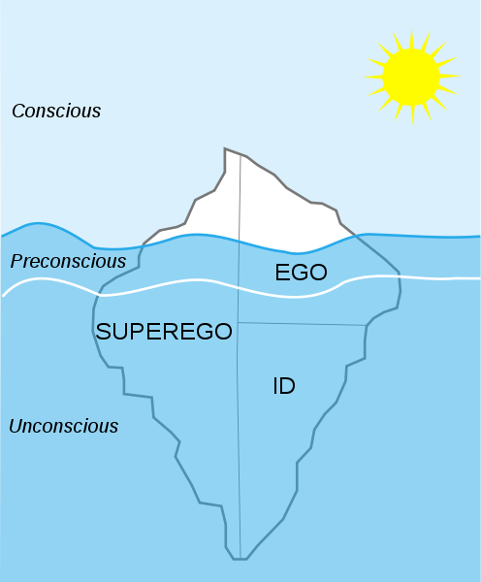
Figure 1: Freud’s levels of consciousness - Boundless Psychology (https://courses.lumenlearning.com/, n.d.)

Freud described "the mind is like an iceberg, it floats with one-seventh of its bulk above the water” (Science, 2014) Figure 1 shown above demonstrates the levels of the id, ego, and superego. The section above water is known as the conscious level; just below the surface and above the white line is the preconscious level; the bottom level is the unconscious. The most significant portion of the hidden mass is the id, the darkest, the most recessed field of human thought, motivation and desire.

In describing the unconscious Freud said it was like an "argument without syntax or grammar; and without temporality or contradiction." (Leader, 2009) Freud's methods sought to discover what was missing from the patient’s conversation and discover the necessary therapeutic technique for undoing the blockage, allowing the unconscious thought to flow into conscious awareness. A method that still holds relevance today.

Chapter 2

This chapter will focus on the Expressions of the unconscious and discuss the influence of psychoanalysis on the arts. Firstly, looking at Freud and his dream theories and then onto Alain de Botton’s social theories to see whether art forms are expressions of an inward world that can help as therapy.
.
Much of current therapy is different from Freud’s. Nevertheless, it began with his premise of searching the deep and dark part of the ‘inner’ lives of individuals, and carefully unraveling repressed knowledge of the unconscious, in a controlled manner, with the guidance of a trained listener. "Researchers including Freud hold that dream is based on life experience and living environment and comes from reality" (Zhang, 2015, p. 112).
Freud formalised the view of the unconscious, showing that logic is bound up with the expression of the repressed wishes and desires, linking this area of mental functioning into the realm of everyday actions.

To begin with, we must answer that the dream has at its disposal no means of representing these logical relations between the dream-thoughts. In most cases, it disregards all these conjunctions and undertakes the elaboration only of the material content of the dream-thoughts. It is left to the interpretation of the dream to restore the coherence which the dream-work has destroyed. (Freud, 2014, p. 10)

Freud’s statement suggests that the perception of the dream world is a constructed image and one that does not directly translate into words. The dream that individuals recount is purely a reflection of mental processes that have already lost some of their meaning in translation. This hallucination experience is a fabrication as is an artwork, artwork that bypasses the censorship of repression, not just for the satisfaction of a sexual drive, as Freud would imply, but in order to expand the range of our capacities for expression.

Freud was interested in art and was a collector. Figure 2 shows the London home of Freud, displaying the collection that came with him when fleeing Vienna in 1938. He used the methods of psychoanalysis to try and interpret his collection, even though he understood that such analyses were not sufficient to unlock the full meaning of an artwork in its wholeness as art. He did say that the content of artworks meant more to him than the techniques exhibited. The idea that this ground can be mapped and brought to conscious study became an essential theoretical basis of Surrealism and continues to be a source of inspiration for artists.

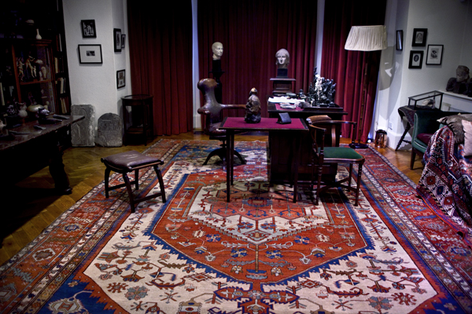

Figure 2: The Office of Sigmund Freud, London (wordpress.com, 2015)

The art movement of Surrealism came about as a reaction to Freud's psychoanalysis.
They paid particular attention to Freud’s book ‘The Interpretation of Dreams’ (Freud, 2014). This book legitimized the importance of dreams and the unconscious inner worlds of sexuality, desire, and violence, which provided a theoretical basis for much of Surrealism. They ignored Freud’s underlying science and used his insights, especially those that explained how the unconscious mind worked automatically and how dreams conveyed inner fantasies and dreams. The result meant the Surrealists produced imagery that analysed their inner thoughts to show their desires and anxieties in symbolic ways through visual means and therefore left out the cumbersome dogmatic superstructure.

Like the Dada artists before them, Surrealists used the juxtaposition to play with expressions and drew attention to the irrationality of everyday life. The Surrealists took juxtaposition to the next level, using it to convey dream imagery. Typical motifs found in Surrealist art include floating objects, transparency, repetition, and exaggerated proportions.

Through various means, such as automatic writing, Surrealists tapped into the unconscious mind, which helped film making, painting, sculpture, collage and so on. Whatever the material, the subject matter was always bizarre and baffled audiences.

Salvador Dali was among the most versatile artists and the most famous Surrealist. People remember him for his visual language, capable of rendering his bizarre dreams into paintings by such methods as self-inducing paranoia as a way to access his unconscious.
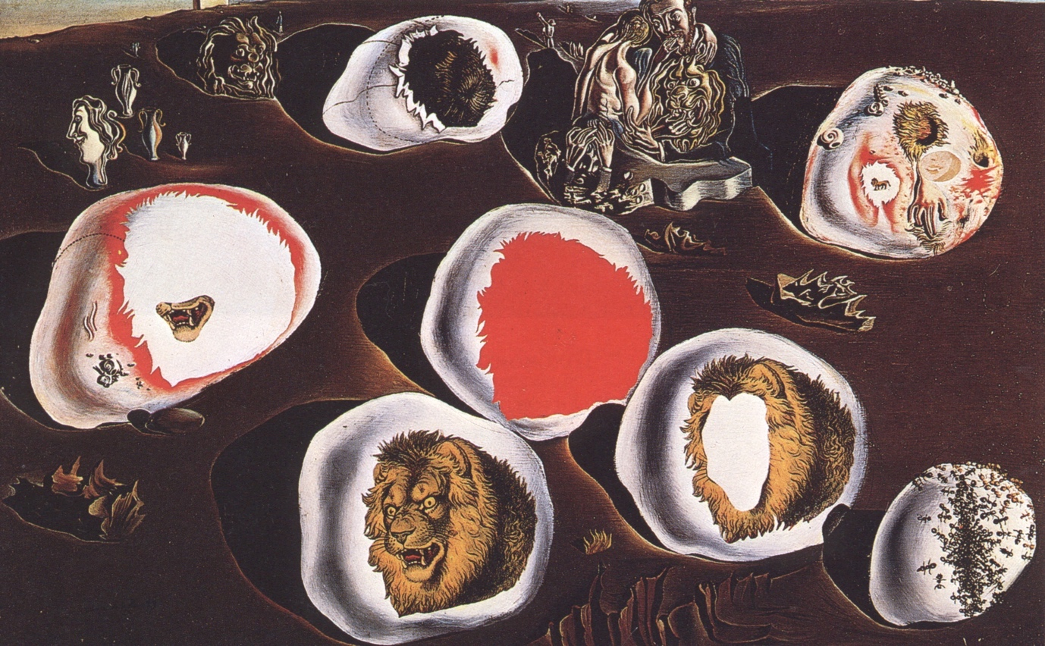
Figure 3: Accommodation of Desire (Dali, 1929)
Obsessive themes of death, decay and eroticism speckle Dali’s work. In his painting “Accommodation of desire” (Dali, 1929) shown in Figure 3 the narrative of his work comes from his anxieties over his affair with Paul Eluard’s wife, Gala Eluard. Within the painting, Dali's most deep-rooted fears are projected on the stones, showing his insecurities about the future with Gala and his thoughts circulating of death and decay.

Looking at Dali’s work there is something valuable to be gained from this tenebrous interrelationship between arts and psychoanalysis. One proposal is the “simple reason for this is that both art and psychoanalysis have a relationship to the unconscious” (Walsh, 2015). They are suggesting that both processes are linked to expressions but are not fully known or controlled by the conscious mind. Such proposals mean there is no readymade interpretation for why artists make the things that they do; there is more of an undetermined discourse, one where distortion occurs in attaching mental ideas to material representation, and where art counts for the expression of the physical effects and desires.

When trying to understand art, the viewer makes suggestions, creates associations and pursues connections. It is impossible to translate imagery back to its source as it has been affected by the artist, as well as the cultural and historical context. In trying to make these connections, Psychoanalysis has been and continues to be, a productive thematic in contemporary art.

If a viewer cannot truly understand art how can they use it to help?. The creator of The School of Life, Alain de Botton believes he has the answer, and questions the purpose of art in his book Art as Therapy (Alain de Botton, 2017). Often it is said that art is meant to be very important, but there rarely seems to be an explanation to why we should appreciate art. De Botton and John Armstrong offer new insights on how people can value art alongside managing their tensions and confusions of everyday life.

De Botton is showing a new process of reading art as a form of therapy. The principles of his theories are that specific artworks offer solutions for peoples problems. The idea is that in order for this potential to be released, the viewer needs directions, a new way, rather than towards the more conventional historical or stylistic concerns with which art books and museum captions are traditionally associated.
The author discusses the particular belief that art should be ‘for art's sake' and argues the point that this view has unnecessarily held back art from revealing its underlying therapeutic potential. De Botton offers examples of re-evaluating artworks from across the ages and genres. With these new ideas, we cam approach artworks for the means resolution of difficult issues in an individual’s life.

The key ideas in the last paragraph are saying that art is a tool, not just for aesthetic indulgence, an essential tool in people’s existence, which can mediate their psychological weaknesses and relax their anxieties about imperfection. De Botton points out that individuals should love art as they love music and use art therapeutically to lift moods of sadness, move feelings along and expand horizons in the imagination.

The above discussion raises some interesting points, individuals create playlists to express and discuss music very naturally, but this is not the case with art, there is a good argument for this to change, but first, what stops people treating art like music? The author claims that for economic reasons art has been in the hands of a narrow elite who have owned museums, their contents and communicated two things to their viewers; it's essential to see the art in their museums and pay attention to the history the materials used, and that ethos almost killed popular enjoyment of art.

From De Botton’s perspective, organisations have lost the plot in explaining art. That is why he is proposing a new way of ordering art.
"The art would not need to change, only the way it was arranged and presented. Each gallery would focus not on dates and provenance, but the important rebalancing emotions encouraged by particular words" (Anon., 2014)

The principle of the theory is that we could reorganise artwork in galleries according to the viewer’s therapeutic vision, Figure 4 is an example showing the Tate Modern floor plan arranged according to a therapeutic vision.

Any debate looking to promote art in the interests of the public and health should always welcome. De Botton’s suggestions strong views and need to considered widely. If used correctly viewing art therapeutically will gain more interest, the way that art moves the mood of an individual can make all the difference in are Psychological lives. If art that people love contains what they need, then more is needed in everyday existence!
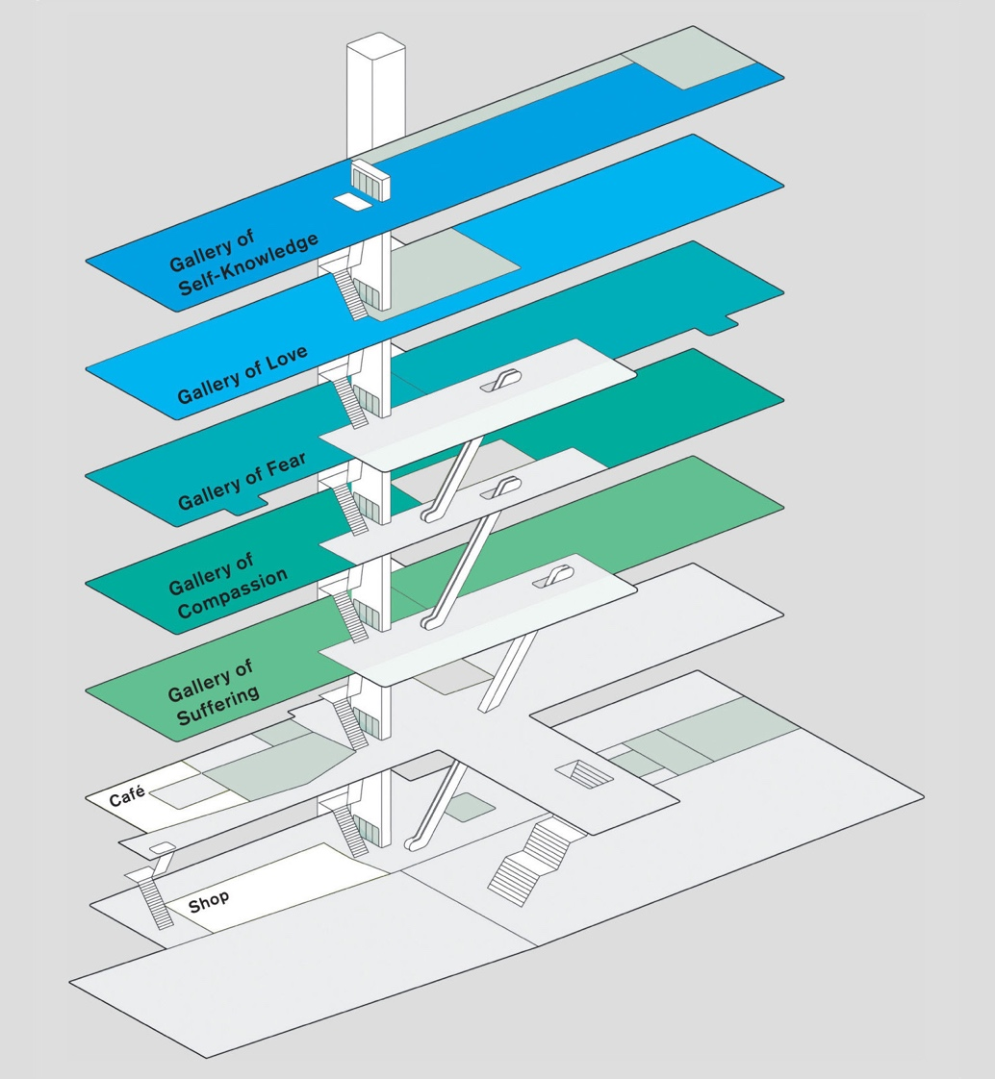

Figure 4: Tate Modern floor plan arranged according to a therapeutic vision of Alan De Botton (Sehgal, 2013)

Chapter 3

This chapter discusses the practices of David Lynch, Louise Bourgeois, and my process to see how creative work can tap into the unconscious, therapy, and self-expression. Firstly, we look at David Lynch who delves into the unconscious with film to get an uncanny view on the world, then onto Louise Bourgeois whose art is considered to be a therapeutic process connected to events from her childhood, and finally onto my practice to see how it has developed through introspection.

For a long-time film resisted the full implications of psychoanalysis to keep the audience happy, David Lynch is one of few filmmakers that has actively taken up the possibilities that an understanding of psychoanalysis affords the cinema. With the films of Lynch, cinema finally registers the potentially radical impact that psychoanalytic insights might have on film form and the relationship between film and spectator.

Lynch is a "straight-up workingman. There is nothin’ ethereal. There’s no big psychological discussions” (O'Neal, 2017) just a regular guy who makes deviant cinema. For over 40 years Lynch's films have gripped, mystified, and provoked viewers by exposing darkness and decay in the normal. From his experimental shorts of the 1960s through to the return of Twin Peaks where Lynch has managed to border between dream and reality while remaining a humorous, charming and traditional Director.
Lynch's films depart from the standard construct of traditional narrative in order to follow the logic of the dream world to draw from a profound unpredictability, which Lynch calls being lost in the darkness and confusion. There is a connection between Lynch's films to Freud's dream theory where he believed that the latent or undeveloped content of dreams is suppressed and hidden by the subconscious mind, protecting the individual from thoughts and feelings that are difficult. Chis Rodley discusses the connection between Lynch and Freud in the introduction to his collection of interviews with Lynch on Lynch.

It transforms the ‘homely’ into the ‘unhomely’, producing unfamiliarity in the evidently familiar. In Freud’s words: ‘The uncanny is uncanny because it is secretly all too familiar, which is why it is “repressed”.’ This is the essence of Lynch’s cinema.” (David Lynch, 2005, p. X)

From the writing of Lynch on Lynch and other interviews, we see multiple references to Lynch’s ability that allows him to probe into the subconscious to use the wealth of conceptual thought that is bubbling inside. This result is his work being obscure with no fixed idea, appearing fragmented for the reason that Lynch relies on his thoughts buried within to reveal their meanings in context to one another, as surrealists used the juxtaposition of everyday objects to raise the awareness of the viewer to their thought processes.

This process used by Lynch was first widely seen by an audience in 1977 when Lynch demonstrated himself as one of the most original and truly personal directors at work in international cinema with the release his first motion picture, Eraserhead. This startlingly original film quietly became a word of mouth sensation, establishing Lynch as one of the most original and truly personal directors at work in international cinema. Eraserhead showed Lynch as a director who puts dreams on to the screen without trying to impose a coherent, readily graspable narrative; leaving the audience unaware what is the dream and what is the reality. Lynch himself has remarked that “I felt Eraserhead, I didn’t think it.” (McKenna, 2018, p. 95)

The narrative of the film is straightforward. Based in a post-industrial dystopian part of America, a young man named Henry Spencer meets a girl named Mary, who becomes pregnant. Henry gets gripped with anxiety at the arrival of their grossly deformed baby shown in Figure 5 and longs for liberation from the horror he feels. He experiences the
mystery of the erotic, then the death of the child, and, finally, the divine intercedes, and the torment ends.
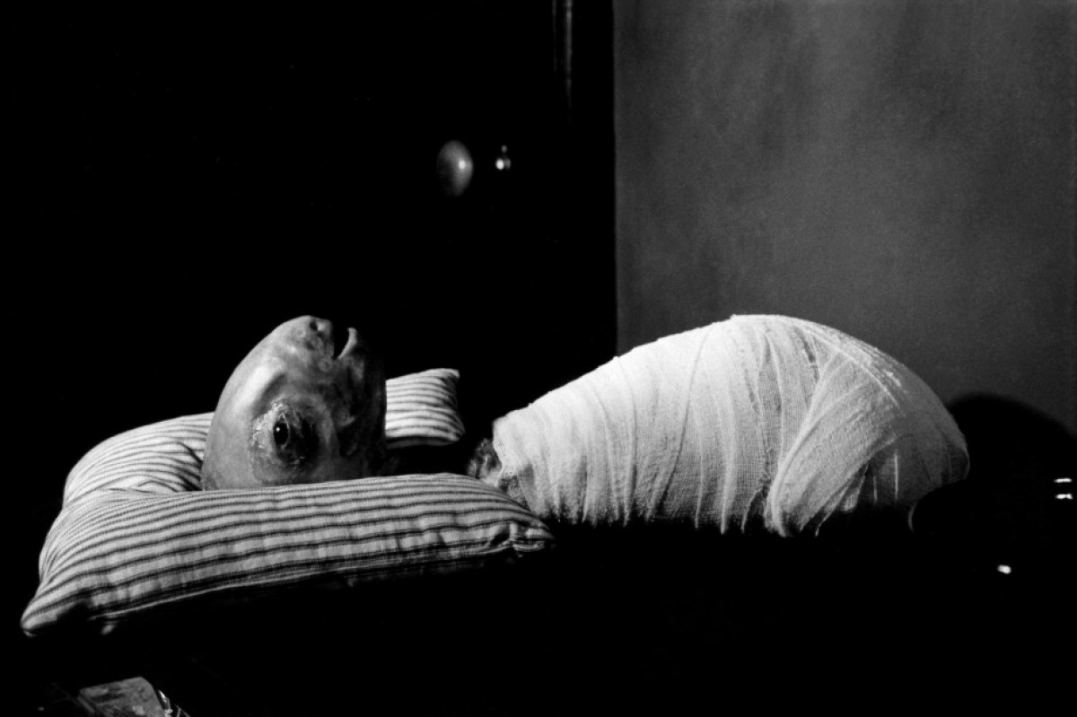

Figure 5: Deformed baby in Eraserhead (https://movies.stackexchange.com, 2017)

After Eraserhead, the uncanny remains an underlying feeling in Lynch’s work. Insecurity, estrangement lack of orientation the sense of balance can be so acute in “lynch land” the questions become whether it is possible to ever feel at home?
To understand Lynch’s films, one must be open to the subconscious and surrender to the big screen. The films pursue the boundaries of cinematic storytelling giving the audience a place to dream and fantasize.

To look closer at Lynch's work reveals recurring themes, films packed with recurrent characters, images, compositions and techniques that view his entire output as one giant jigsaw puzzle of ideas. The usage of dreamlike imagery within his works has a surrealist principle of relying on the subconscious to provide optical drive. The viewer can see this in Agent Cooper's dreams of the red room in Twin Peaks and the otherworldly narrative found in Eraserhead, Mulholland Drive, and Inland Empire. We get a closer understanding of Lynch’s dream thoughts from the following quote where he discusses his walking dreams:

Waking dreams are the ones that are important, the ones that come when I'm quietly sitting in a chair, gently letting my mind wander. When you sleep, you don't control your dream. I like to dive into a dream world that I've made or discovered; a world I choose. (David Lynch, 2005, p. 15)

Lynch makes his characters and film content in a way that shows them in a fantasy state rather than reality. His films are known for their use of magic realism where hidden forces affect the view of reality, Lynch is known to peer behind the curtain and let the viewer glimpse what lies behind to show experimental narrative forms and abstract ideas to express the interior world his characters are faced to inhabit, their disappointments, fears, and extreme actions.

David Lynch and Louise Bourgeois both use a psychological expression as a metaphor. Where Lynch uses characters, Bourgeois used feelings and installation to show disappointment with work spanning most of the 20th century. In looking at her work, we see an artist heavily influenced by traumatic psychological events from her childhood, particularly her father's infidelity. Bourgeois’ father had affairs, particularly a long-term one with his daughter’s governess. This fear and anger incited Bourgeois to express menacing and sexually explicit subject matter within her work with the energy we see transmuted into sculptural form, a rare occurrence for women artists at this time.

For Bourgeois Art was therapy, a way to delve into the unconscious and look at matters concerning sexual desire, the body and issues drawn from her childhood memories. When she died in 2010 over a thousand loose sheets of paper were discovered at her Chelsea home explaining Bourgeois ideas. These consisted of development records, dream notes, and observations for sculptures. This material source is strengthened by Bourgeois psychoanalytical treatment notes, with her most intense period of engagement between 1952 and 1966 being published by (Larratt-Smith, 2012)

This archive of information gives valuable insight into the artist's mind; we see the character of the work and see its highly autobiographical nature. This information allows us to see a grown woman working through childhood trauma by analysing her thoughts and making, the artwork is a manifestation of mental processes that resulted in objects and scenarios that are fantastically in excess.

Its understood Bourgeois received psychoanalytical treatment between 1952 and 1982. The first year of treatment she saw her psychiatrist, Henry Lowenfeld 60 times, strongly suggesting that she was in deep analysis. The following year it was 28 times. These sessions became substantially less over time, strongly indicating that the therapy had an effect and Bourgeois was managing to cope on her own, but there were still times of emotional crisis where sessions increased with Lowenfeld.

It was her experience with Lowenfeld that made herself reflective rather than simply self-absorbed. She was no longer just fascinated by herself but wanted to understand herself. Bourgeois was unusually obsessive, and at times phobic, and her obsession with psychoanalysis enabled her to manage her obsessions and phobias, although she remained obsessive-and, fortunately for her mental health, obsessively creative-to the end of her unusually long life (Kuspit, 2013)

This obsessive creative disorder became an artifice, aiding the cathartic process of making art that involved the use of abstract form and various materials to deal with notions of universal balance and gender. Bourgeois playfully juxtaposes objects, conventionally considered male or female, through the use of rough or hard materials, most strongly associated with masculinity, to sculpt soft biomorphic forms suggestive of femininity.

The spider series of work was arguably the most iconic work from Bourgeois with Maman being the first installation in Tate Modern's newly constructed Turbine Hall in 2000, a true testament to the influence of Bourgeois on the modern psyche. For a closer look into Bourgeois' mind, it is more important to look at a series of installations called “cell,” which Bourgeois began making in 1989.

Cells are a 60-odd collection of thought-provoking and personal guide. These are dioramic, standalone sculptural used objects from Bourgeois’ childhood, as well as penises, breast-like forms and spiders, all within the restrictions of cell-like structures. Through them as shown in Figure 6, you can see she was able to express and investigating her subconscious and dig into memories of anxiety, fear, and pain. These works are an autobiographic attempt at personal therapy. Despite working in almost every imaginable medium during her 70-year career", Bourgeois almost always focused on the human form, realistic and abstract. Nevertheless, all of her work was deeply personal

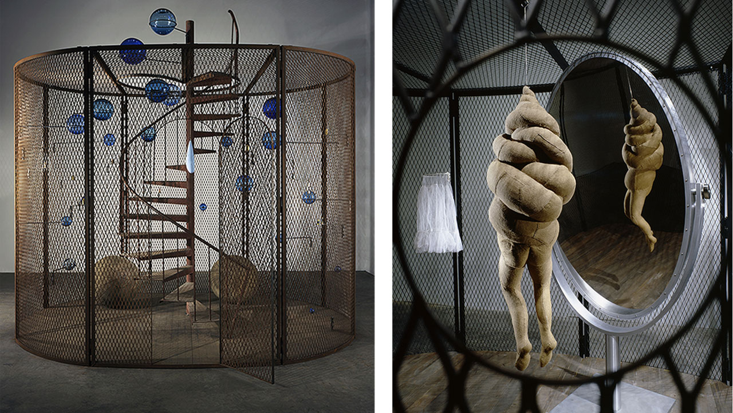
Figure 6: Louise Bourgeois, Cell-The Last Climb (Bourgeois, 2008)
Within my work I explore the senses through installations, paint and other forms of media, using them to represent personal turmoil and inner dialogue. This work process is what Id would consider being an introspective process influenced by psychoanalysis and the confusion of the world. The work aims to provoke a questioning of the unconscious. Practice evoking an uncertain world associating different elements, and involving the disassociated, dark and boring to create discourse and discover some logic in the unconscious.

Looking back at my practice for the last four years, it has been a time where confusion reigned, researching psychoanalysis, Freud and the iceberg metaphor I am making connections within my art and the past. I have gone through three stages which have all culminated in end of year shows. The first being the unconscious where I focused energy into finding and dealing with long lost and emotional thoughts; resulting with my work being placed behind the studio wall, creating a hidden world of dialogue with items to be viewed through a 2 1/2 inch hole.

The second-year show dealt with the subconscious, time of reflection, meditation and thinking through making. The show was called tabula rasa, again not knowing where I was going, I took the name literally and went out in the dark evening rain and started to clean slate which Id previously collected. Transporting the slate to university, I proceeded to make an inner mindscape within a damaged, rusty metal cage, again containment was an unknowing subject. Being left with just thoughts, the material and three days till the show started.

My last but not final show I allowed four days to prepare, this involved smashing a hole in the wall with wire and paint emanating from this void as shown in Figure 7. I would compare this to Freud's Psychiatric couch where he translated unconscious thoughts from people’s uncensored words. I wanted to break the barrier between the unconscious and the real through making.
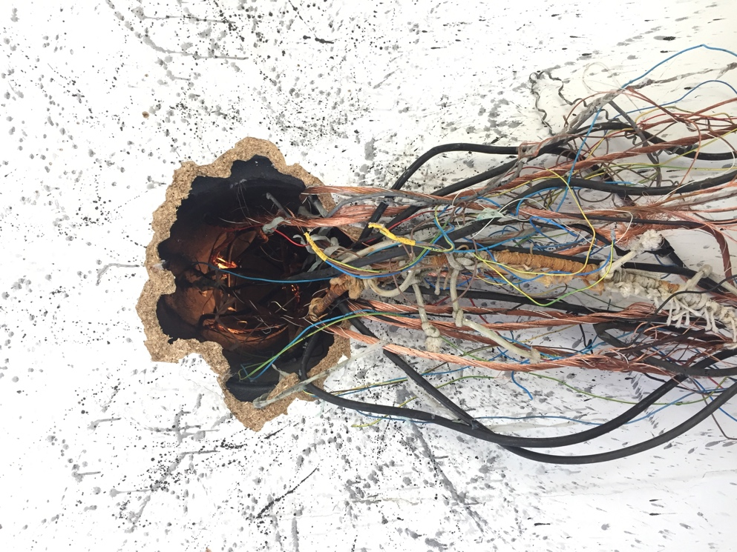
Figure 7: Demian Johnston, Untitled (Johnston, 2018)

This work practice is an ongoing development into internal mindscapes involving multiple symbols, thoughts to bridge the physical process and mental or spiritual state, and between individual and collective consciousness. Work that builds on a growing body of practice featuring dynamic installation with energy concentrated by its confinement. This work is rarely figurative, encompassing dimensions of unpredictability and naturalness, it is about people and life, and inner life. I value spontaneity and the positioning of objects and making of marks purely based on inner instinct and expression. My work responds to space in wich it is sited, but also, I generate ideas through sketching before visiting the space, adjusting it later based on its site.

There are also ideas strong ideas on struggle, desire, and personal thoughts and as such my work continues to be therapy which is asking to go deeper into the self, bringing out expressions.

Conclusion

The challenges bought by this dissertation as the subject matter are broad, the volume of information that is ever increasing with different avenues of research and debate opening with every direction taken. As with my work I have found this a dynamic but confusing subject.

Looking back at Descartes, he claims we are non-physical beings with a self-concept that is an awareness based on the fact people know they exist but might not be in control. John Locke, English philosopher and physician 17th postulated that, at birth, the mind was a tabula rasa and that knowledge is instead determined only by experience derived from the sense of perception. This concept is self-construction, the practice of creating one's identity. This identity still comes with layers as theorised by sociologists Erving Goffman, a way to keep balance with the world and it's ever increasing demands as one face would not suit all.

Continuing with the idea we are in control; I’d like to go further saying we need to become more self-conscious, becoming aware of even the smallest of one's actions. This might not always the healthiest of options as such awareness can impair one's ability to perform complex actions, although this awareness is possibly the key to the future as our actions affect everyone.

Louise Bourgeois spent years examining her feelings through art and therapy, in the 1970's Louise started hosting a salon in which younger artists could show her their work and have their work critiqued by herself. Having an artist of her stature taking the time to look at this work, connecting to the generation of contemporary artists and share her experience is rare. In an ever confusing environment, her actions made artists feel strengthened by that kind of respect.

Bourgeois actions highlight the importance of awareness in helping other people. The world is rapidly changing, and there is not one correct route for the good of the people, there are warning signs of danger, red lights are flashing as we head in the wrong direction, one that the human race might not be able to return from without great sacrifice.

In the 1920s Politicians used Freudian ideas first to convince Americans that they needed free enterprise, leading to capitalism growing and gaining control with a profit-based system driven by ideas of selling on a global scale with little or no ethics. We see human lives are being manipulated for profit; corporations are trying to make record profits. The world is facing significant problems, plastic pollution, global warming, wildfires, and many other disasters are coming from worldwide human expanse. Facebook, Instagram, and other social media sites are gathering data, which is made into algorithms to expand advancements in science and towards worlds where artificial intelligence will be the norm.

As David Lynch uses cinematography to show the uncanny in the world, is it time for everybody to stop and look at the world with this view to see who is watching us and for what reason. It is increasingly important that people step back, look at themselves, their surroundings and the world. Art has this ability to make humans stop, look and take notice, to see what is happening and as such, artists find themselves in a moral obligation.

This responsibility draws links to Alain de Botton questions, what is the purpose of art?
"we argue that art is a tool that can variously help to inspire, console, redeem, guide, comfort, expand and reawaken us.” (Botton, 2018)
We see a change in the purpose of art, sometimes we need to see pretty things to take us away from despair from the ugly, but at this point don’t we need pain because pain is part of the human condition that fights the false optimism from commercial society. Can the power of art helps us be more rounded and show us what needs appreciating? Art is a sort of propaganda that shows the best sides of human nature and supports the encouragement of our better selves, a kind of expression that is hard-wired that allows humans to reach areas of their existence.

As I fished this dissertation, I discovered the work of novelist Pearl Sydenstricker Buck, American writer, recipient of the Pulitzer Prize and the Nobel Prize. She is able to sum up the idea of a creative mind in her inspirational writing so last quote if from her:

The truly creative mind in any field is no more than this: A human creature born abnormally, inhumanly sensitive. To him... a touch is a blow, a sound is a noise, a misfortune is a tragedy, a joy is an ecstasy, a friend is a lover, a lover is a god, and failure is death. Add to this cruelly delicate organism the overpowering necessity to create, create, create -- so that
without the creating of music or poetry or books or buildings or something of meaning, his very breath is cut off from him. He must create, must pour out creation. By some strange, unknown, inward urgency he is not really alive unless he is creating. (Buck, 2011)

Bibliography

Alain de Botton, J. A., 2017. Art as Therapy. 5th ed. London: Phaidon Press Limited.
Anon., 2014. Alain de Botton: Art as Therapy. [Online]
Available at: https://www.youtube.com/watch?v=HkT5W0Iz0xU
[Accessed October 2018].
Anon., n.d. s.l.: s.n.
Anon., n.d. [Online].
Botton, A. d., 2018. https://www.alaindebotton.com/art/qa/. [Online]
Available at: https://www.alaindebotton.com/art/qa/
[Accessed 1st May 2019].
Bourgeois, L., 2008. Cell (The Last Climb). [Art] (National Gallery of Canada).
Buck, P. S., 2011. The Sensitive Mind Is a Creative Mind. [Online]
Available at: https://www.psychologytoday.com/gb/blog/sense-and-sensitivity/201110/the-sensitive-mind-is-creative-mind
[Accessed 7th May 2019].
Dali, S., 1929. Accommodations of Desire. [Art].
David Lynch, C. R., 2005. Lynch on Lynch. 2nd ed. Chatham, Kent: Mackays of Chatham.
Descartes, R., 1637. Discourse on the Method. s.l.:René Descartes.
Elisabeth Bronfen, D. K. P. L.-S. J. M. M. N. P. V. &. D. G. M. H. W., 2012. The Return of the Repressed. London: Violette Editions.
Freud, S., 1900. The Interpretation of Dreams. [online] Classics in the History of Psychology.. [Online]
Available at: http://psychclassics.yorku.ca/Freud/Dreams/dreams.pdf
[Accessed 12 December 2018].
Freud, S., 2014. The Interpretation of Dreams. Aderlaide: eBooks@Adelaide.
Frued, S., 1900. The Interpretation of Dreams. [Online]
[Accessed Decce 2018].
Goffman, E., 1959. The presentation of self in everyday life. 2nd ed. Garden City, N.Y.: Doubleday.
https://courses.lumenlearning.com/, n.d. Introduction to Consciousness. [Online]
Available at: https://courses.lumenlearning.com/boundless-psychology/chapter/introduction-to-consciousness/
[Accessed 23rd October 2018].
https://movies.stackexchange.com, 2017. What is the Eraserhead baby?. [Online]
Available at: https://movies.stackexchange.com/questions/17721/what-is-the-eraserhead-baby
[Accessed 10th November 2018].
Johnston, D., 2018. Untitled. [Art].
Kuspit, D., 2013. Return of the repressed. 1st Edition ed. London: Violette Editions.
Kuspit, D., 2013. The Return of the Repressed. 1st ed. London: Violette Editions.
Larratt-Smith, P., 2012. The Return of the repressed. London: Violette Editions.
Leader, D., 2009. The great unknown. [Online]
Available at: https://www.theguardian.com/lifeandstyle/2009/mar/07/freud-jung-psychoanalysis-behaviour-unconscious
[Accessed 25th November 2018].
McKenna, D. L. K., 2018. Room to Dream. 1st Edition ed. St Ives: Canongate Books.
O'Neal, S., 2017. https://www.gq.com/story/oral-history-of-david-lynch. [Online]
[Accessed 27 March 2019].
Riccio, J. R., 2013. https://surface.syr.edu/cgi/viewcontent.cgi?referer=https://www.google.com/&httpsredir=1&article=1007&context=thesis. [Online]
Available at: https://surface.syr.edu/cgi/viewcontent.cgi?referer=https://www.google.com/&httpsredir=1&article=1007&context=thesis
Rosenberg, M., 1979. Conceiving The Self. 1st ed. New York: Basic Books.
Science, J. o. A., 2014. A Novel Approach to Mind Management (Controlling One's Mental Territory). Journal of American Science, 25 October, 10(10), p. 77.
[Accessed 14th November 2018].
Sehgal, P., 2013. www.nytimes.com. [Online]
Available at: https://www.nytimes.com/2013/12/15/books/review/art-as-therapy-by-alain-de-botton-and-john-armstrong.html
[Accessed 27 November 2018].
Walsh, M., 2015. Art & Pychonanalysis. 2nd ed. Padstow: I.B.Tauris Co Ltd.
wordpress.com, 2015. https://meagainstiniquity.wordpress.com/. [Online]
Available at: https://meagainstiniquity.wordpress.com/2015/02/24/sigmund-freud-is-the-father-of-psychology-but-i-have-a-picture-of-freuds-desk-and-he-has-every-neter-or-statute-of-biological-psychiatry-that-existed-in-the-kemetic-mind-so-how-is-he-the/
[Accessed 24th November 2018].
Zhang, B., 2015. Discussion on the Subconscious and its Visual Expression. Zhengzhou, China, Atlantis Press, p. 112.

