University of Wales Trinity Saint David
BA Business Management
Introducing the Modern Workplace (LCBB4003)

Assignment Title

Organisational structure and organisational culture

Student name:
Angela Celac (2023256)

Contents
Executive summary 3
Introduction 3
Main Body 4
Organisational structure-deffinition, types 4
Organisational culture-deffinition, types 5
The influence of the organisational structure on organisational performances 6
The influence of the organisational culture on organisational performances 7
Individual behavior at workplace 8
Recommendations 9
Conclusion 10

Executive summary
This report represents a totality of information with reference to the business environment and other important aspects of it. In particular I referred to two of the most important parts of an organisation: organisational structure and culture. For a clearer picture I talked about one of the largest pharmaceutical organizations, AstraZeneca, emphasizing the relationship between structure and organizational culture and how they influence employee behavior in the workplace. At the same time, I carefully studied the essence of organizational structure and culture, their different type and representative characteristics. I also researched various information sources to select aspects regarding the influence of these factors on the successes and performances in a company. Respectively, following the studied information, several sources stated that each organization is successful only when the team and all its aspects are properly managed. Once leaders use different strategies for a good relationship between culture and structure, workers are more motivated to implement new strategies for better performance.

Introduction

We live in a fast-paced century, in which society is progressing rapidly, and people have different interests and growing demands. To meet these interests and requirements, people put a lot of effort, invent different methods, respectively they create and work in different organizations, all this having as final goal to satisfy the interests of the citizens.
An organization is a comunity who do a job as a group in a system with well-defined tasks, where all members must show responsibility and competence. (Ahmadi, 2016)
An example about I want to talk in this report is a pharmaceutical and biotechnology company if British origine, which produce contemporary medicine, being used by millions of people. AstraZeneca. It is a successful world leader in the pharmaceutical industry. Their goal is to improve the professional lives of tens of thousands of people, while improving the lives and health of all. This company has approximately 62,000 employees in more than 100 countries.
Organizational environment has become one of the most important sides of society, having a number of functions that voluntarily or involuntarily influence people's behavior in an organization. Member’s behavior can influence many factors of the company, from organizational achievement to organizational innovation. The access to technology, good training, motivation and relationship style have an important role in shaping organizational behavior, all this being important or better performance.

Main Body

Each business organization must be based on a set of managerial rules, to ensure its success. Management is the process of working in a team in order to use the right time to achieve the proposed objectives. All organizations are similar as systems, and management is defined as a set of paths you choose to run a system, while having potential results. In order to be able to manage a team in an organization, you must first know how to manage yourself. This is a path to success as a manager. (Anon., 2019)
There are many aspects which contributes to the performance of an organization, but some of the most important ingredients of any successful business are organisational structure and organisational culture.

Organisational structure-definition, types
In his book on management and organizational behavior, Mullins defines structure as the guide of relationships between members of an organization. Through the structure, the management process is easier. This makes it possible for an organization to have a professional order, the action are well prospective, focused, directed and restrained. The structuring process involves various tasks and the whole set of good skills. (Mullins, 2005) There are some variety of organisational structure like:
Functional OS. - Larger companies like Sturbucks, Costa cofee, represents entirely this type of structure. The aspects of this structure represented the employees a lot. Such a structure is for small businesses, small products for sale and which promote the manufacturing industry, Hierarchical OS. – it is welcome in companies that distribute large quantities of products. During this time of the structure, rigid controls are often organized. They attach importance to the quality of the products and how correctly they are distributed, for example Amazon. Flat OS. - Small companies are followers of this type of structure. They are based on an innovation system that is more about the inside. Employees of such companies are always encouraged to be free to express their ideas, to implement them in practice, to always contribute to change and growth at the professional level, for example IT company like Google, Apple. Divisional OS. – in such companies it is important that there are always sources to supplement and purchase for a long time. It is also important that these organizations always have customers and sales are large, for example McDonald’s. Matrix OS. – such a structure is available to companies that have different types of products, markets such as Nike, Adidas and are always involved in large projects that require time and hard work. This type of structure aims at continuous implementation of new ideas as well as their application in practice. (Anon., 2020)

Organisational culture-definition, types
All organizations need a collaborative environment, employees with values ​​and a favorable psychological environment. All this together forms the organizational culture. All the people who work in a business company have different visions, perspectives and needs. Respectively, the organizational culture is individual to each business, depending on the values ​​promoted by it. This would mean: the managerial attitude towards employees and the whole community, creating a friendly environment where everyone can express their point of view, to develop new strategies. So the value system promoted in a company directly influences the position of employees towards their job - that is, how involved they are in the work system and how much they participate in business growth.
After studying the report of Robert E. Quinn and Kim S. Cameron, I can say that there are four types of organizational culture: Clan, Adhocracy, Market, and Hierarchy.
- Is focused on instruct, developement, and “doing things together.”
- Is oriented on great courage, modernism, and “doing things first.”
- Is based on opposition, creation , and “getting the job done.”
- Is focused on competence, security and “doing things right.” (Kim S. Cameron, 2011)
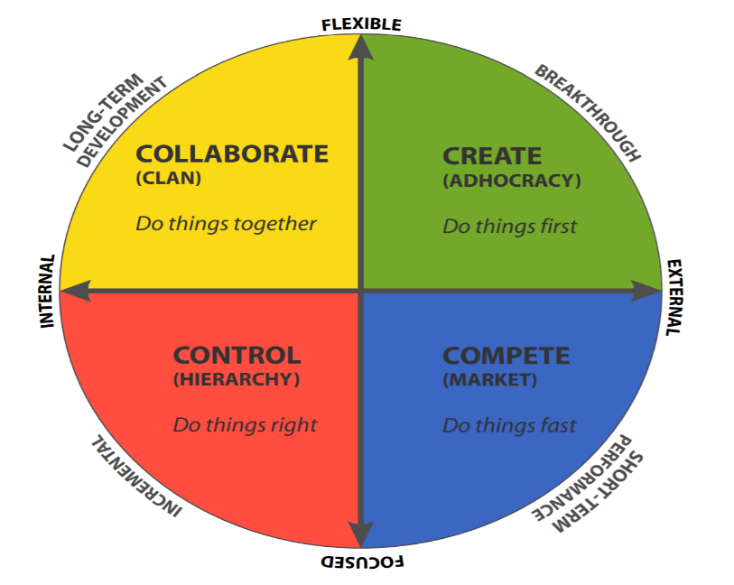
Each culture tolerates certain values ​​and restrain others. Some of them contribute intensely to the development of businesses, others slow down their activity. But each organization establishes its type of culture following an experience, depending on the type of problems that appear in a company or depending on the visions of each management team.

The influence of the organisational structure on organisational performances
The organizational structure is considered by many experts, the right way to improve performance. Recently studied information sources state that a well-arranged structure is the most efficient way to develop the business. An inefficient organizational structure makes good performance impossible, no matter how competent the managers are. Once the management system invests enough for the continuous change of the structure, we can say that this ensures the performance of the organization. (Mullins, 2005)
Getting a good structure is the most important stept in organisational innovation. A good opportunity would be if the structure it would work so that the members of the organization would be motivated to participate in instructive activities that ensure their performance increase. Once a structure of an company affects positively morale and job satisfaction of the workforce, this will also influence performance improvement. The medical system is constantly changing. To cope with these changes, AstraZeneca is constantly implementing new management strategies to attract the most qualified specialists in the world. Talking about the organizational structure within AstraZeneca, administration is answerable for the rule of conduct and the success of the business. The directors supervise with special attention the new objectives and proposals that come from the employees, in order to increase the management.
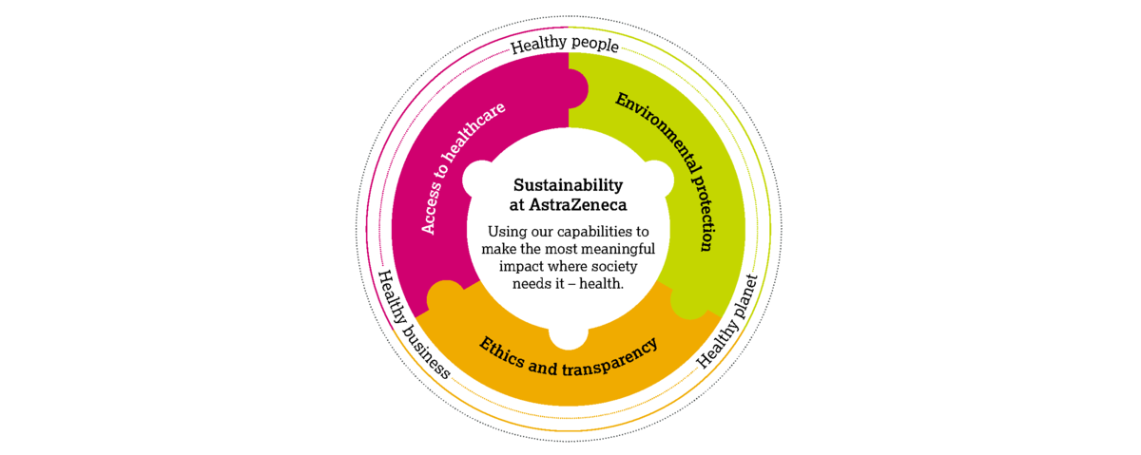

The influence of the organisational culture on organisational performances
Organizational culture has a special role in improving performance in a bussiness company because a “good” culture represent: positive attitude between team members; employees can improve their skills; apply for more employment; punctuality; more and more innovative ideas, each employee to feel important at work, a good image on the labor market. All this ensuring the success of the organization. Respectively, once these aspects happen in an organization, success and performance will always increase.
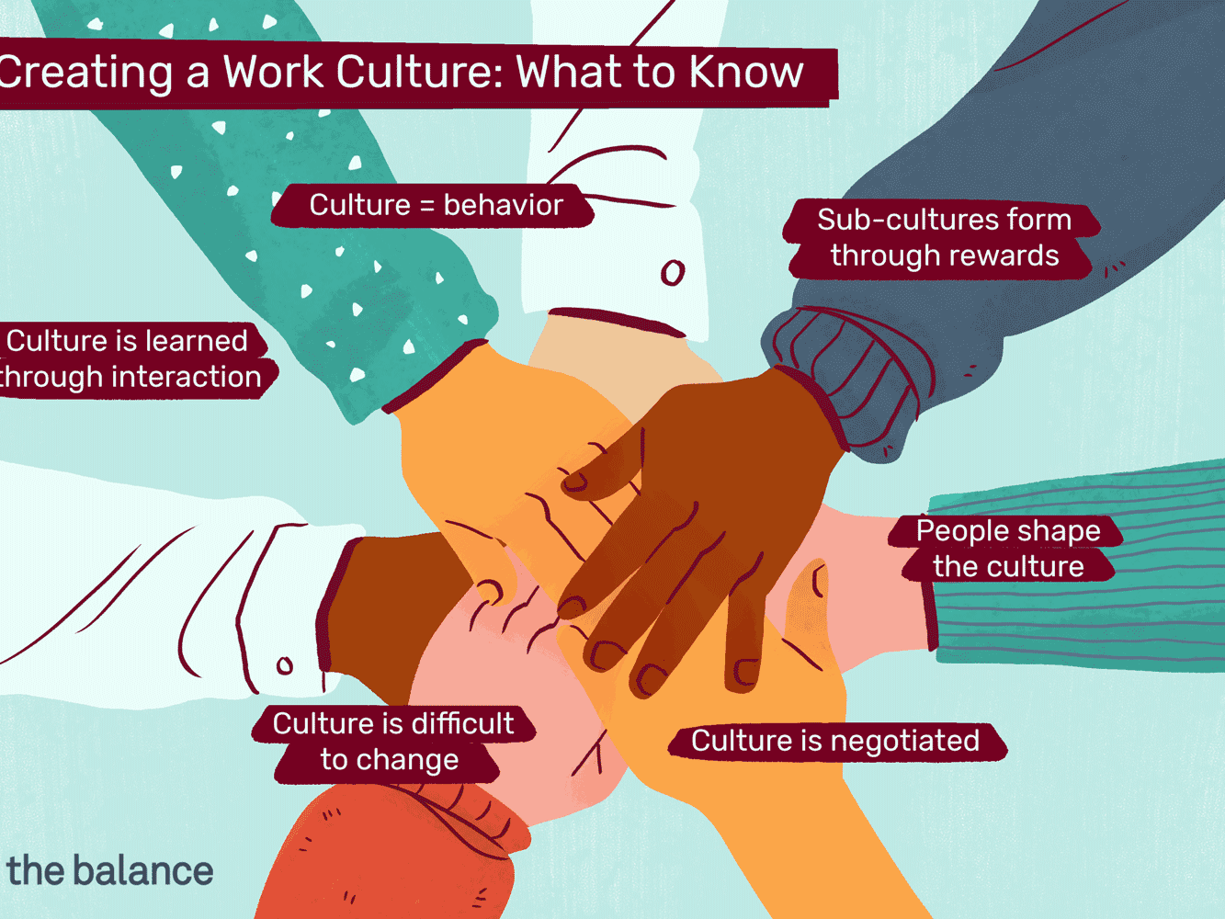
On the values section of its code of ethics, AstraZeneca says that it values agility, customer orientation, innovation, integrity, and performance. According to AstraZeneca’s employees, the most frequently discussed cultural value is innovation, and the most positively discussed value is customer. The presence of culture in a team offers high possibilities to form friendly relationships, comprised of effective communications, innovative strategies.
In a cult business environment, employees face challenges much more easily by being flexible in the diversity of apparent situations. One of the most important strategies of this company is to make employees feel good at work. Thus, they invest a lot in this strategy to keep quality employees. The managers here treat this strategy with a lot of responsibility, being interested in demonstrating their potential within the employee.
Also, several training activities are organized within the team in order for them to perform their potential. To continue to be a successful organization, they must attract the most people in their industry and those who are already employed, must create AstraZeneca an organisation in which qualified specialists want to continue to be in this company. Also, they lend in their working classes aspiration and work cooperatively to intentionally accelerate their evolution. They verify member’s contract periodic to identify areas where they have to improve.
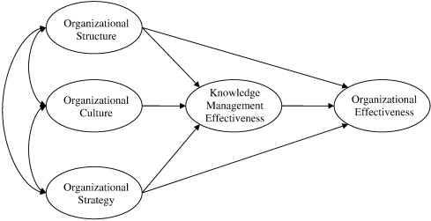

Individual behavior at workplace
The behavior of all employees at work within a company represents the organizational behavior There are a lot of factors which can influence on individual behavior in the workplace. The most present factor is personality, which of course varies from person to person because we all ae different. (Singh, 2016)
The environment in which people develop, the temperament they have and the set of characters they represent influence the employee's condition at work. The function of the worker in a company will also influence their behavior. That is, the supervisor's behavior will always be different from that of his subordinate. Effective communication it is another important factor. An effective communication can ensure the proper and timely flow of the information. To be enjoy of your job and have a positive behavior, ethics are very powerfull, too. This makes it easier for the employee to understand how motivated he can be, marking the attitude towards several things in a company, including the point of view. The organizational factors like structure, design and leadership also are important. In my opinion, to meet their objectives, business managers must give attention to their employees and try to understand the best way to interact with them because relationship and individual behavior are depended each other and have influence on well-being in the workplace.
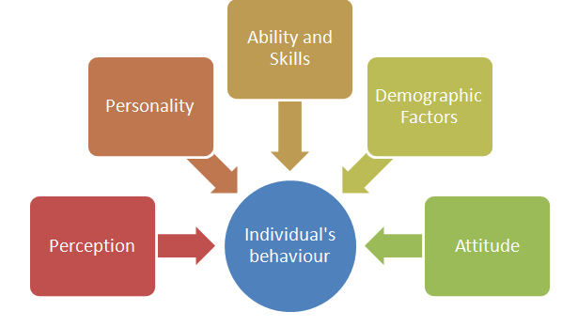

Recommendations
Every business company needs periodic changes, which will certainly ensure better performance. Changing the set of strategies for a better structure and culture is a long-term confrontation that challenges more business people. If I were a young entrepreneur and I had the opportunity to propose some recommendations for improving overall performances by using organisational structure and culture, for one company, these would be:
- Ensure all your stakeholders understand your new strategy and propose different strategy more and more often.
- You must always have a plan in front of you that represents your aspirations in terms of organizational structure and culture. In this way you will be sure of the desired and unwanted situations within the company. You will know what to ask your employees and what you have to offer them. At the same time, it will help you to know the field where you have to work harder and the changes you have to make.
- For a healthy relationship between members of a company - communicate as much as possible with your employees. Encourage members to be free to express themselves, propose special open days so that you can listen to anyone. Thus, you will understand that are the aspects that require more special attention, you will find out the dissatisfaction of the employees that you should improve. Detailed knowledge of what is happening in your company will always ensure the success of the process of changing the culture and organizational structure.

Conclusion
Following the information studied about these two concepts within an organization, I concluded that organizational structure and culture are two pillars without which an organization could not develop and have no future. Organizations can change for the better if its employees correctly address the relationship between culture and structure. Understanding how the culture and structure of an organization works helps both the employer and the employees to make the right decisions at the right time. The way to communicate with each other in an organisations is very significant, this being a relevant factor in the workplace behavior. Respectively, when a correct structure is implemented, so and culture will be in line with positive standards and will also positively affect employee behavior. So, understanding the coherence between value and structure will allow more efficient management of any transition. All of this influence training as a leader and manager. It develops the ability to manage a business, to implement it in a correct structure and a well-targeted culture, all of which contribute to increasing productivity and improving performance.

Reference List

1.Ahmadi, G. A., 2016. Organizational structure. Procedia-Social and Behavioral Sciences.
2. Anon., 2019. An introduction to Management. [Online]
Available at: https://courses.lumenlearning.com/boundless-business/chapter/an-introduction-to-management/
[Accessed 01 April 2021].
3.Anon., 2020. Different types of organisational structure. [Online]
Available at: https://www.gazprom-energy.co.uk
[Accessed 28 March 2021].
4.Kim S. Cameron, R. E. Q., 2011. Diagnosing and Changing Organizational Culture. s.l.:s.n.
5.Mullins, L. J., 2005. Management and Organisational Behaviour. s.l.:Prentice Hall.
6.Singh, J., 2016. Semantic Scholar. [Online]
Available at: https://www.semanticscholar.org
[Accessed 03 April 2021].

